
MODULE NAME: Learning in the Digital Era
ASSIGNMENT TITLE: Assignment 2: Professional
Development Plan (PDP)
STUDENT NAME: Akinwunmi Akinyemi
STUDENT NUMBER: 2515474
COURSE TITLE: CertHE Computing Skills for Workplace



TASK 1: SELF EVALUATION
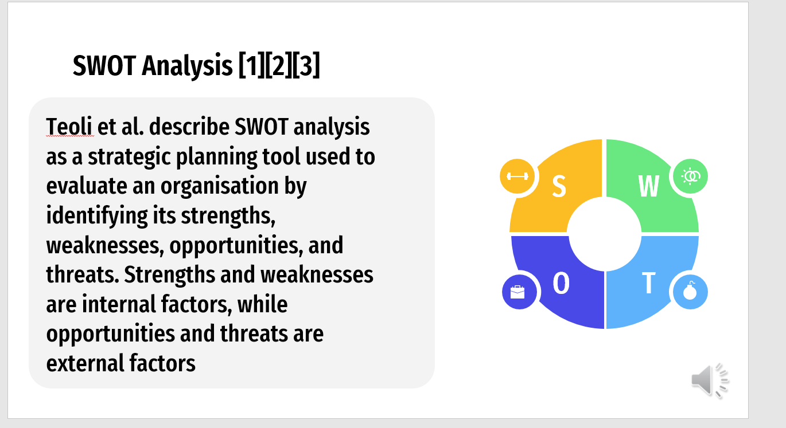
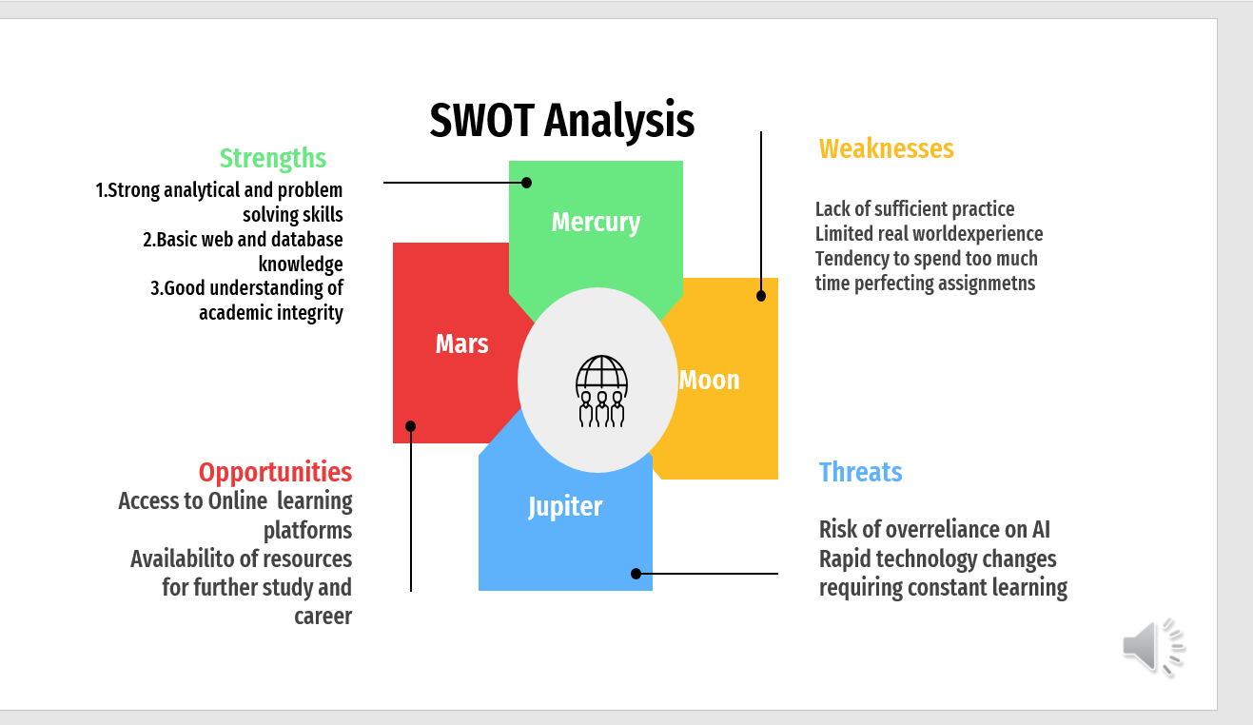

TASK 2: PDP
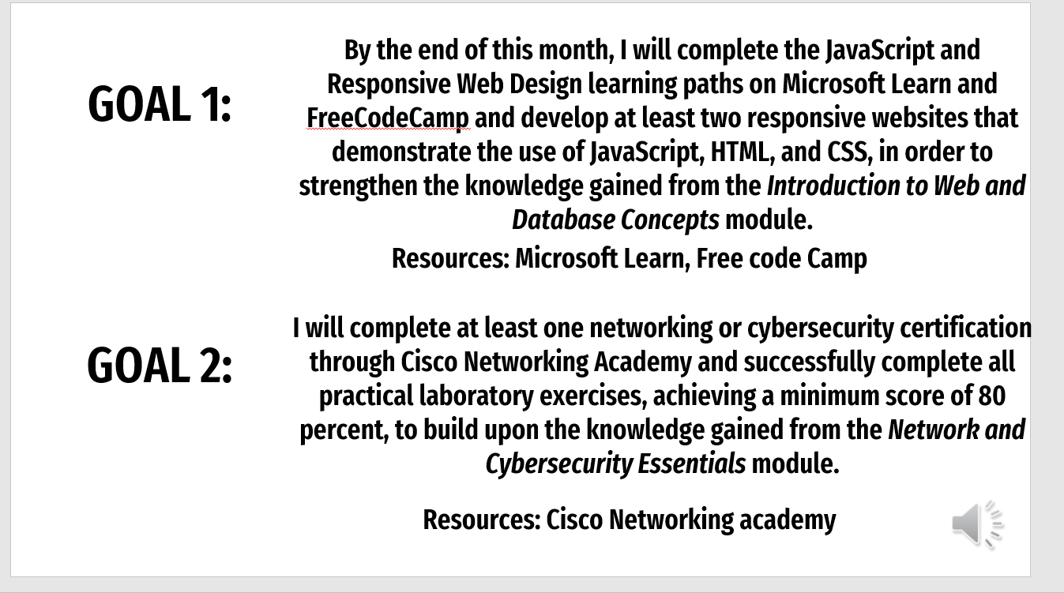
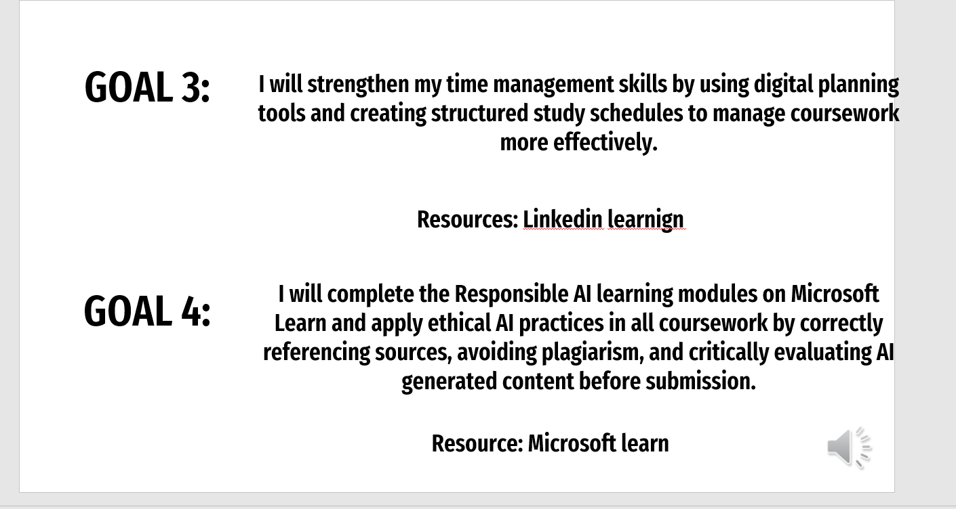

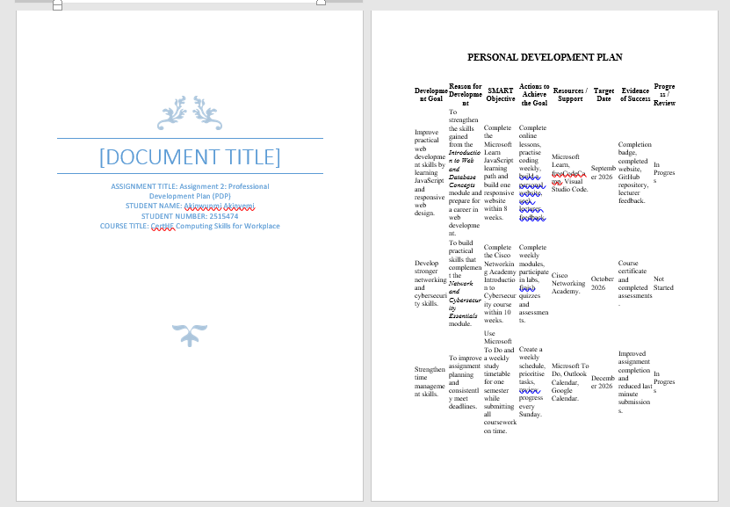
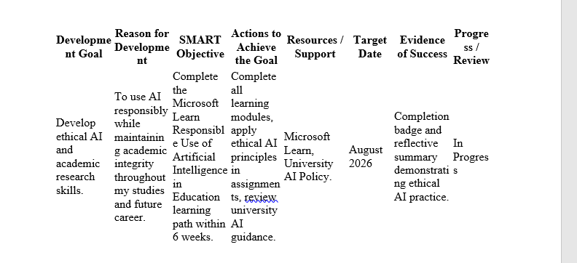
LINK: https://docs.google.com/document/d/14BoQQoeo5u5UFE3amoYfeuSnsawPAlOx/edit?usp=sharing&ouid=103455104849907069880&rtpof=true&sd=true

REFERENCES:
[1] Microsoft, "Learn web development," Microsoft Learn, 2025. [Online]. Available: https://learn.microsoft.com/en-us/training/browse/
[2] freeCodeCamp, "Responsive Web Design Certification," 2025. [Online]. Available: https://www.freecodecamp.org/learn/2022/responsive-web-design/
[3] Cisco Networking Academy, "Networking Academy," 2025. [Online]. Available: https://www.netacad.com/
[4] LinkedIn Learning, "Time Management Fundamentals," 2025. [Online]. Available: https://www.linkedin.com/learning/
[5] Microsoft, "Responsible use of artificial intelligence in education," Microsoft Learn, 2025. [Online]. Available: https://learn.microsoft.com/en-us/training/paths/responsible-use-of-artificial-intelligence-in-education/

GOAL PROGRESS ENGAGEMENT
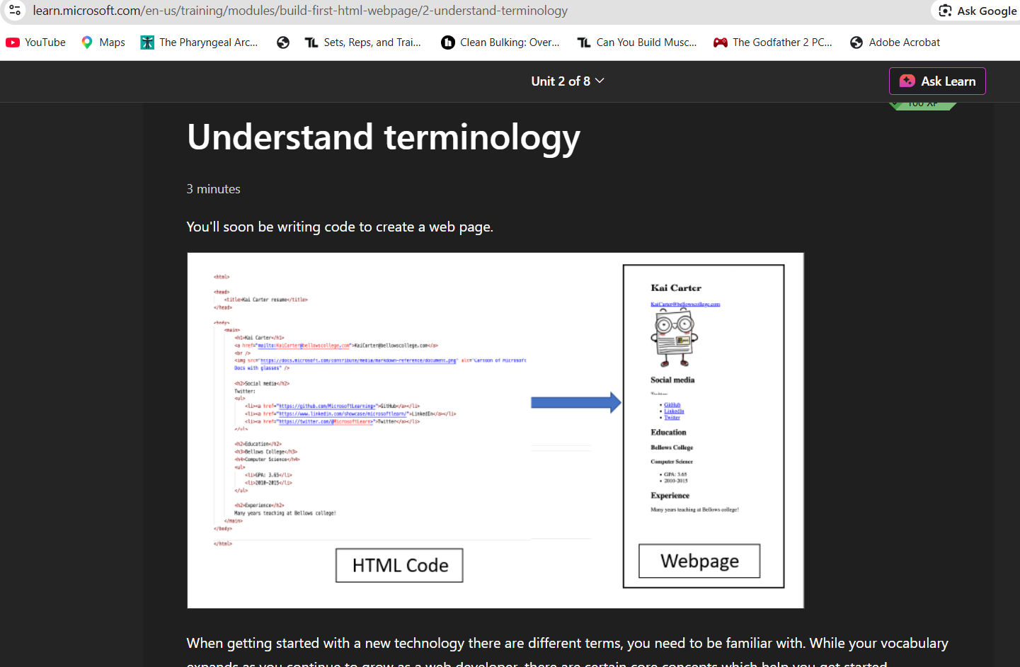
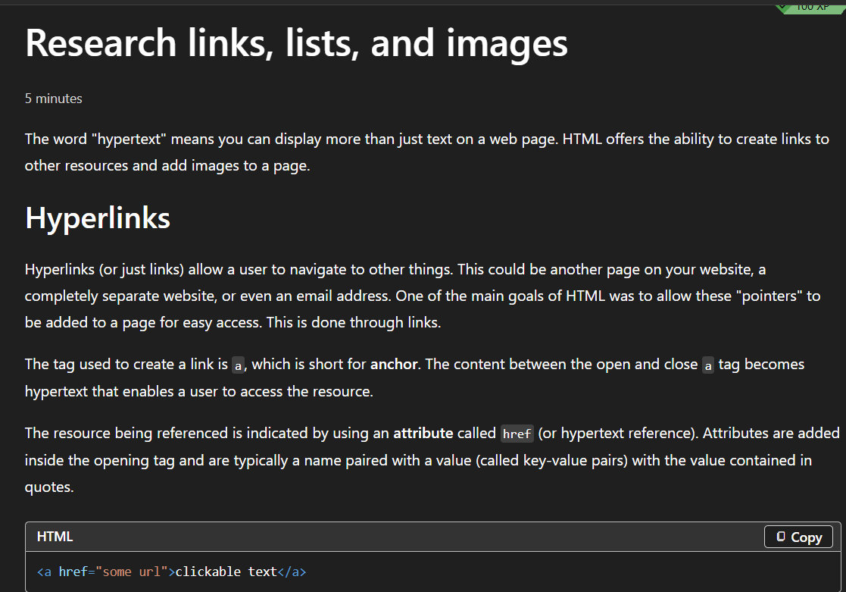
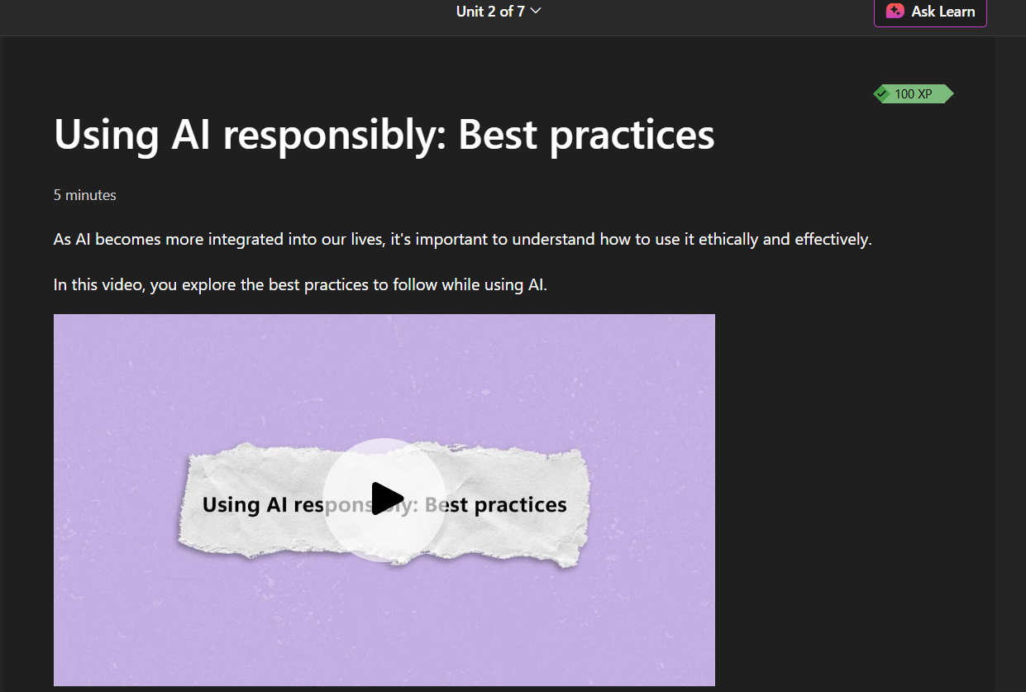

TASK 3: UNIT 4 TOPIC SUMMARY
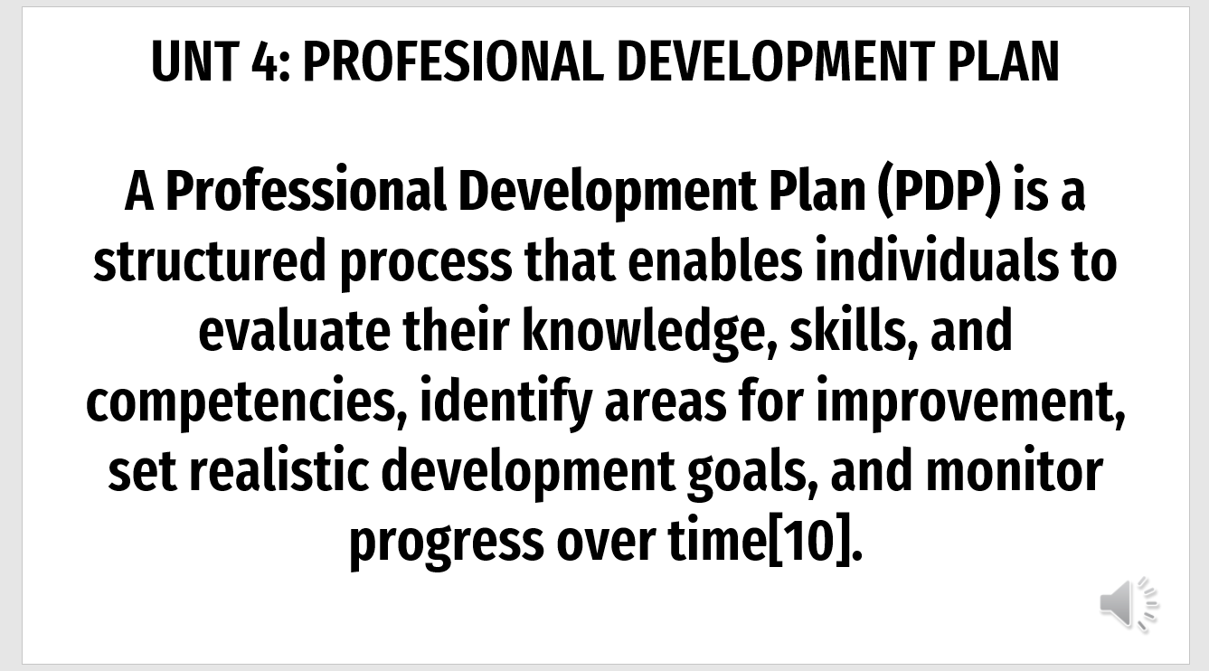
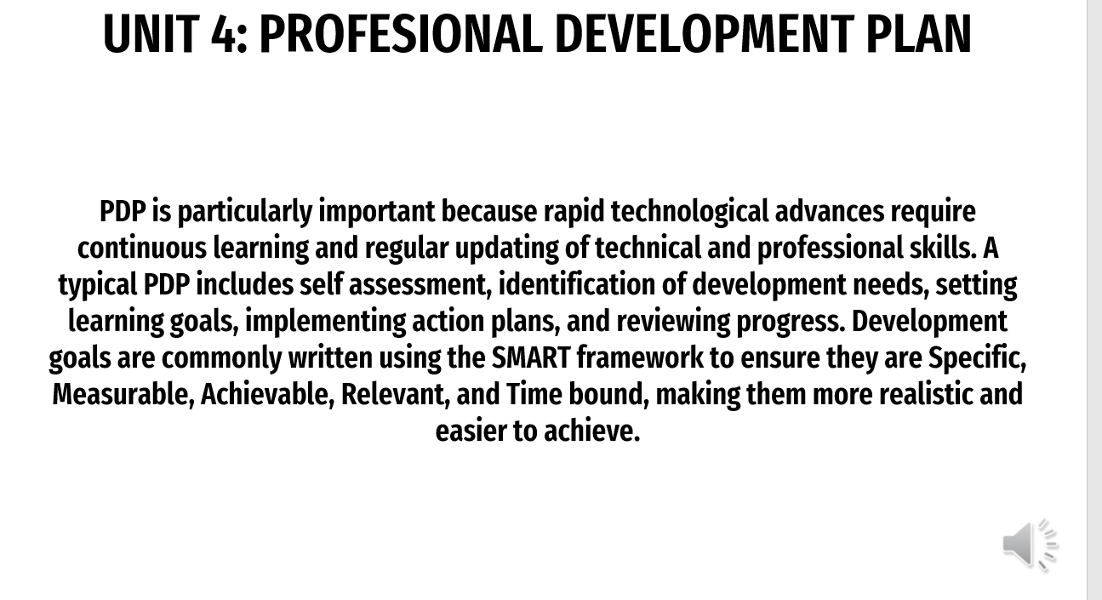

TASK 4: VIDEO PRESENTATION
LINK FOR VIDEO: https://www.youtube.com/watch?v=lK1TCWm3v14
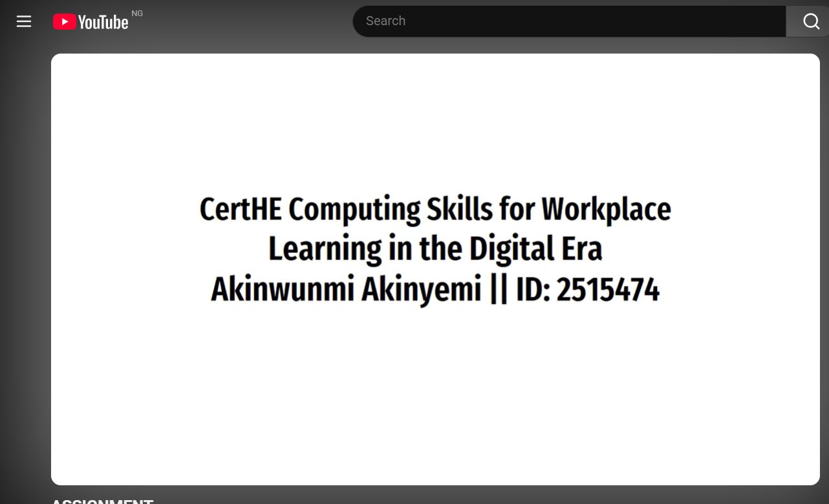
LINK TO VIEW/DONLOAD POERPOINT: https://docs.google.com/presentation/d/1Ure41DSxAyEXmWKUemF4gmCHCOVRWGfD/edit?usp=drive_link&ouid=103455104849907069880&rtpof=true&sd=true

