

Name: Jaseem Ali
Student ID: 2321076
Module: Dissertation
Module Code: LCMB7035
Lecturer: Hoang Nguyen and Vasilios Tavlaridis

Research Proposal

Competitive Strategy and Customer Service: A Comparative Study of DHL and FedEx

Table of Content

1. Introduction 3
2. Aims, Objectives, and Research Questions 4
3. Methodology 5
3.1 Research Design 5
3.2 Sampling Strategy 5
3.3 Data Collection Process 5
3.4 Interview Structure 6
3.5 Data Analysis 7
3.6 Reliability and Validity 7
4. Literature Review 7
4.1 Overview of Strategic Management in Logistics 7
4.2 Customer Service as a Competitive Advantage 8
4.3 Operational Efficiency in Logistics 8
4.4 Comparative Analysis of DHL and FedEx 9
4.5 Framework for Analysis 9
6. Limitations 10
7. Ethical Considerations 10
8. Timeframe 11
9. Conclusion 11
References 12

Introduction
The logistics industry is fundamental to global commerce, enabling the efficient movement of goods and services that underpin supply chains across diverse sectors. In 2023, the global logistics market was valued at approximately 9.41 trillion and is projected to grow at a compound annual rate of 5.6% through 2018, driven by e-commerce expansion, the rise of international trade, and growing demands for streamlined supply chains (Statista, 2023). In the logistics industry the key industry players, DHL and FedEx in particular demonstrated through technological advancement like big data analytics and, IoT, to gain competitive advantage in a highly competitive market pushing such strategies as strategic pathways for success (Sullivan, WAMBA and Dunaway, 2023)​.
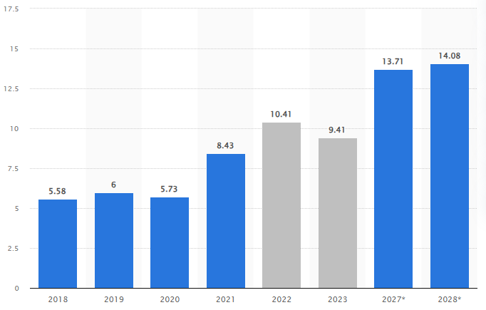
Figure 1: Size of the global logistics industry from 2018 to 2023, with forecasts until 2028
Source: (Statista, 2023)
While both DHL and FedEx operate in the global express mail services industry and vie for market shares, scarce literature compares their respective organisational priorities for customer satisfaction to assess the strategic utility of their distinct approaches. Whereas studies of nontraditional companies’ competitive priorities are still scarce, this gap raises the question of how these companies build up their operational and customer service models and thus affect their market positioning and customer satisfaction. This study, therefore, seeks to explore these elements in depth, aiming to reveal how DHL and FedEx’s unique customer service strategies shape their competitive advantages (Shvydkyi, 2024).
By examining these companies’ strategic focuses, this research will provide insights valuable to logistics firms looking to improve competitive performance and customer satisfaction (Afum et al., 2021). The identification of best practices and the focus on identifying the distinctive characteristics of the implemented strategies at the customer interface explores not only the logistics sector’s efficient procedures but also provides valuable guidance for users to improve their service quality and their organisation’s ability to manage disruptions effectively. This research contributes to the need for successful strategic methodologies to address the growing pressure in logistics tir for technology and customer-oriented change.

Aims, Objectives, and Research Questions
Aim: To examine and compare the strategic focus areas of DHL and FedEx, with a particular emphasis on customer service and other key operational strategies, to identify the primary drivers of competitive advantage in the logistics industry.
Objectives:
- To identify and evaluate the core strategies DHL and FedEx implement in customer service and operational efficiency.
- To analyse which strategic areas DHL and FedEx prioritise and how these focus areas contribute to their market positioning.
- To assess how DHL's strategic focus in customer service and other areas compares with FedEx's approach, identifying opportunities for improvement and differentiation.
Research Question
- What are the main strategic areas prioritised by DHL and FedEx in terms of customer service and operational efficiency?
- How do DHL and FedEx's customer service strategies compare, and what lessons can be drawn from their approaches to enhance competitive advantage?
- In what ways could DHL refine its customer service strategy and other key focus areas to better compete with FedEx in the global logistics industry?

3. Methodology

3.1 Research Design
This study adopts a qualitative approach to explore the strategic focus areas of DHL and FedEx, particularly in customer service and operational efficiencies. Qualitative research is suited to this investigation as it allows for an in-depth exploration of subjective experiences, insights, and perceptions that quantitative data may not capture (Lim, 2024). Semi-structured interviews serve as the primary data collection method, offering the flexibility to pursue relevant themes that may emerge while ensuring that core topics are addressed consistently across interviews. In Semi-structured interviews, participants can give thorough descriptions and therefore provide rich data on the strategic decisions made, as well as their impact in practical contexts (Holstein et al., 2023).

3.2 Sampling Strategy
Consequently, the research employs purposive sampling which involves the identification of customers with precise information concerning DHL and FedEx business strategies and customer relations. This sampling technique is particularly important in gaining data from the sources with first-hand information on any of the companies’ strategies.
The sample includes three groups: (1) logistics industry experts with expertise in competitive strategy and customer service standards, (2) current or former employees of DHL and FedEx who can offer insights into internal strategic focuses and operational priorities, and (3) customers who have used services from both companies, providing a view on service experiences and satisfaction
Considering the sample size, 15-20 people will be interviewed will allow for diversity in perspectives while remaining manageable for in-depth qualitative analysis. This size also allows for theme saturation where any further data collected will not provide new information and thus increases the reliability of this study.

3.3 Data Collection Process
To reach as many persons as possible, interviews will be conducted in person or video format to acknowledge the distance factor and possible conflicts with the respondents’ schedule. For credibility, reliability, and to ensure they are not influenced by the interviewer, selected interviews will be tape-recorded after obtaining the participants’ permission and then transcribed word by word. Interviews require verbatim transcription because minor details of participants’ answers are important and should not be omitted when analyzing the further stages.
This method also has the added advantage that it does not allow for any detail to be left behind and I know from experience that notes may help one miss some details. In addition, the recordings of the interviews assist in eliminating bias since the interviewer is in a better position to remember some of the issues raised than others (Osborne and Grant-Smith, 2021)​.

3.4 Interview Structure
The semi-structured interviews will follow an interview guide to maintain focus on key topics aligned with the research objectives. The guide includes tailored questions for each participant group. For employees, questions will explore strategic priorities within the company, such as “How does DHL/FedEx prioritise customer service compared to other strategic focus areas?” and “What operational strategies are emphasised to enhance service efficiency?”
For customers, questions will focus on service perceptions and decision factors, such as “What factors influence your choice between DHL and FedEx?” and “How would you rate the customer service and reliability of each company?”
Industry experts will address broader competitive and strategic perspectives, such as “How do DHL and FedEx differentiate themselves in customer service, and how does this impact their market positioning?” and “What are notable innovations in operational efficiency within leading logistics firms?”
These questions directly align with the research objectives, ensuring that the responses generate data on strategic priorities, competitive positioning, and customer service effectiveness​.

3.5 Data Analysis
Thematic analysis will be employed to identify patterns and themes within the interview transcripts. Thematic analysis begins with open coding, wherein initial codes are assigned to recurring words, phrases, or concepts in the data. These will be increasingly aggregated into more general codes as coding continues, each of which will relate to themes relevant to DHL and FedEx customer service and business strategy.
The study will then identify higher-level themes, such as “Customer Service Quality,” “Operational Efficiency,” and “Strategic Differentiation,” which will help clarify how each company’s unique strategies drive competitive advantage. A comparative study will also be conducted to understand how DHL and FedEx have differed or resembled each other along these themes with a view of unveiling the DHL or FedEx competitive edge.

3.6 Reliability and Validity
In ensuring the reliability of the study, the interview questions and areas of discussion will be well structured to minimise variations in the interview guide. This minimises variability in data collection hence increasing the reliability of the discovered results. Additionally, independent coding by multiple researchers will minimise researcher bias, as cross-validation in coding will ensure that the themes and codes accurately reflect the data (Baharmand et al., 2022). For validity, member checking will be used; participants will be presented with a summary of analysed themes from their interviews to ensure that the researcher understood their responses appropriately. Triangulation will further enhance validity by gathering data from three distinct groups, employees, customers, and experts thereby capturing a range of perspectives on DHL and FedEx’s strategic approaches (Uwe, 2024). Using this kind of approach is known to give a more comprehensive understanding of the companies’ strategies, making the study more sound and reliable.

Literature Review

4.1 Overview of Strategic Management in Logistics
logically is necessary, especially with the growing logistics market competition, changes in customers’ demands, continuing development of new technologies and the recent focus on corporate social responsibility and sustainability. The logistics industry reached a valuation of $9.4 trillion in 2023, underscoring its significance in global trade and supply chain integration (Statista, 2023)​. Strategic elements that form the basis of strategic management in logistics include the operational factors such as efficiency, customer satisfaction and technology used that improve the competitiveness of logistics. For example, research underlines that the competitiveness of logistics mainly targets supply chain business continuity, digital solutions acquisition, and the creation of partnership web to improve speed and flexibility​ (Al-Banna, Yaqot and Menezes, 2024). While logistics firms persistently integrate new technologies including big data, Advanced Robotic Process Automation, and the Internet of Things, into their operations strategic management, continues to play a critical role in maintaining logistics competitive advantage through the balancing of operational effectiveness and customer value proposition (Sallam, Mohamed and Mohamed, 2023).

4.2 Customer Service as a Competitive Advantage
The aspects that are becoming important sources of competition within the logistics sector include the customer interface where customers highly depend on the timing of pleas, communication made, delivery done and follow-up made. Studied work demonstrates that corporations achieving these elements receive customer loyalty and placement – an example are the schemed tracking and customization performed by DHL (Kang et al., 2024), or strong international delivery done by FedEx (Schank, 2023). Studies evidence that effective customer relations in logistics improve brand image, sales, and immunity to competitor pressure.

4.3 Operational Efficiency in Logistics
Sustainability of operations has often been the key factor in logistics competitive strategy as more often companies need to provide dependable services while controlling costs. Writing on the subject notes that live operational effectiveness is achieved through the enhancement of transportation, storage, and inventory control, all of which are indispensable when it comes to minimising the time taken to deliver goods as well as maintaining high levels of services. More recently, both DHL and FedEx applied state-of-the-art technologies such as route optimization software and automated warehouses to increase practicality, thereby laying down best practices for the industry Kern, 2021). Analysis from various industries indicates that establishing efficient operations leads to the envisaged decrease in operating expenses, and an associated increase in the reliability of service delivery, strengthening the competitive advantage of firms. As the customers’ requirements soar ahead by insisting on short delivery lead times, operational efficiency allows logistics firms to be more competitive in the global market (Asamoah et al., 2021).

4.4 Comparative Analysis of DHL and FedEx
Previous studies on DHL and FedEx focus on each company’s strengths in customer service, global reach, and operational efficiency. DHL, a leader in international logistics, has been noted for its innovative sustainability practices, particularly its extensive use of electric vehicles and commitment to zero emissions by 2050 (Daneshvarshahrodian, 2023). Comparatively, FedEx is recognized for its investment in technology, specifically its time-definite delivery services and AI-powered logistics solutions​. However, existing literature lacks a comprehensive comparative analysis that directly contrasts DHL’s customer service initiatives with FedEx’s approach, particularly in terms of how these strategies enhance competitive positioning (Deweerdt, Dargusch and Hill, 2022). This implies lending itself to further study on the alignment of each firm’s strategic management and customer satisfaction as well as the firms’ market performance to fill the research gap mentioned as valuable for future research.

4.5 Framework for Analysis
For a streamlined analysis of DHL and FedEx's strategy, this study will employ several theories. Erin Gates’s Porter’s Competitive Advantage framework will be used to analyse how DHL and FedEx deliver value propositions that enable them to stand out from industry rivals. Porter’s model based on cost leadership, differentiation and focus strategy, appears most appropriate where companies in the logistics sector are required to balance both cost and value factors. Also, in assessing Customer service quality the Service Quality (SERVQUAL) model shall be used to compare the two deriving the means from Various dimensions such as reliability, responsiveness, and assurance (AlOmari, 2020). This model is rather important for assessing customers’ perceptions that are at the heart of the competitive advantage in logistics​. Using these frameworks, the study shall set out a systematic classification in the comparative assessment of greater prominence on DHL and FedEx’s emphasis besides providing insight into a tactical approach to improvement that can define the competitive logistics arena (Mincė, 2024).

6. Limitations
This research predicts some issues which may have effects on the generalisation of the findings in this study. First, using a purposive sample of 15–20 participants limits the generalizability of the findings collected as the proper amount could mean only homogenous participants from DHL and FedEx will be considered. Nevertheless, it remains Bibliometrically powerful to identify valuable strategical patterns although it is case-based still, which restricts its statistical generalisation in some way. Furthermore, efforts to get participants to complete questionnaires willingly may pose social desirability bias, especially from samples serving in given organisational positions. However, such limitations do not undermine the study goals since various stakeholders’ viewpoints, ranging from experts in the field to DHL and FedEx employees or regular customers, enhance the comparative evaluation of both organisations’ strategic approaches (Bartosz Sawik, 2024).

7. Ethical Considerations
This study follows strict ethical guidelines to protect participants’ rights and confidentiality.
- Informed Consent: Participating individuals will be informed of the nature of the study, what will be done and the individual’s freedom to quit the study at any time without explanation. Informed consent will however be sought before participation to ensure that the participants volunteer to participate​.
- Confidentiality: As an extra measure to protect participants’ identity, all the responses will be made anonymous and participant identifiers will be expunged from the final report and transcripts. Data will be kept by encryption on devices that can only be accessed by the research team and best practice guidelines on data protection will be followed.
- Ethical Compliance: This research will follow institutional ethical procedures, and get clearance from an ethical committee, to make sure all practices in the study will conform to set standard ethical practices. This comprises issues of ethical conduct in the research study, participants’ rights and confidentially issues when dealing with data gathering and explication.

8. Timeframe
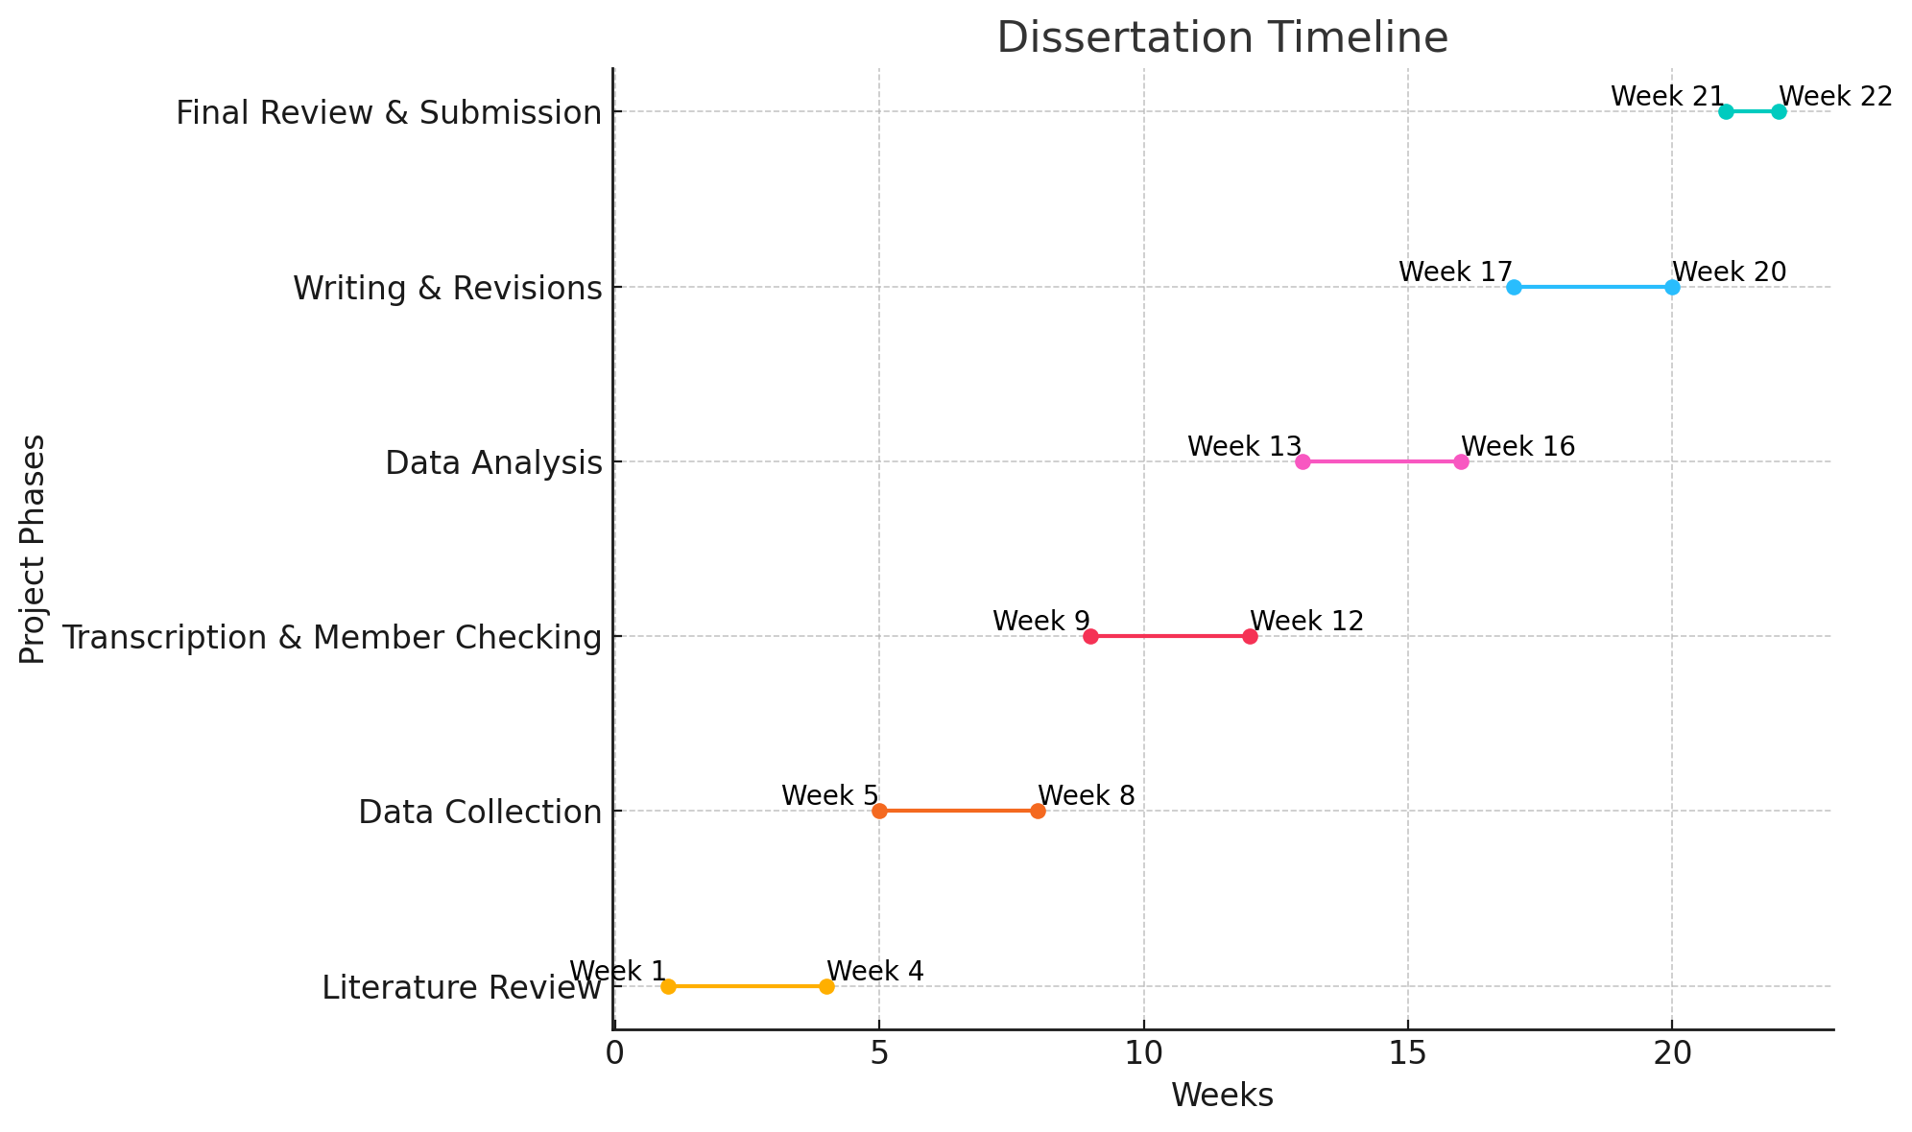
Figure 2: Gantt Chart Source: (Author)
The Gantt chart shows the framework of time that would help complete the dissertation project. It assigns specific time slots to each stage. Literature review in the first month and then follows data collection, transcription, analysis, writing, member checking and revision. The last stage of the project involves the final review and submission in June to complete the project. Each stage is perfectly linked to the next one, which helps to pay enough attention to preparation, data accuracy, and time for refinement to meet submission milestones properly.

9. Conclusion
In conclusion, this proposal seeks to discuss and analyse the various practices embarked on by DHL and FedEx groups relative to their rivalries in the market with a special focus on customer relations and service delivery. Hence, through the analyses of these things, the study will initialise important findings on how strategic priorities affect the competitive landscape in the international logistics sector. From the expected outcomes of this study, practical insights will be gained to guide improvement and further the understanding of what logistics firms should implement to deliver high quality and effectiveness in the strategies they have in place. Finally, one company will be compared to another to show where industry players can enhance their undertakings in an endeavour to attain sustainable competitive advantage.

References
Afum, E. et al. (2021) ‘Examining the links between logistics outsourcing, company competitiveness and selected performances: the evidence from an emerging country’, The International Journal of Logistics Management, ahead-of-print(ahead-of-print). Available at: https://doi.org/10.1108/ijlm-05-2020-0205.
Al-Banna, A., Yaqot, M. and Menezes, B.C. (2024) ‘Investment strategies in Industry 4.0 for enhanced supply chain resilience: an empirical analysis’, Cogent Business & Management, 11(1). Available at: https://doi.org/10.1080/23311975.2023.2298187.
AlOmari, F. (2020) ‘Measuring gaps in healthcare quality using SERVQUAL model: challenges and opportunities in developing countries’, Measuring Business Excellence, ahead-of-print(ahead-of-print). Available at: https://doi.org/10.1108/mbe-11-2019-0104.
Asamoah, D. et al. (2021) ‘The effect of supply chain responsiveness on customer development’, The International Journal of Logistics Management, ahead-of-print(ahead-of-print). Available at: https://doi.org/10.1108/ijlm-03-2020-0133.
Baharmand, H. et al. (2022) ‘A methodology for developing evidence-based optimization models in humanitarian logistics’, Annals of Operations Research, 319(1), pp. 1197–1229. Available at: https://doi.org/10.1007/s10479-022-04762-9.
Bartosz Sawik (2024) ‘Optimizing Last-Mile Delivery: A Multi-Criteria Approach with Automated Smart Lockers, Capillary Distribution and Crowdshipping’, Logistics, 8(2), pp. 52–52. Available at: https://doi.org/10.3390/logistics8020052.
Daneshvarshahrodian, M. (2023) Green Supply Chain Management Practices: Implementation Strat- egy and Green Solutions of Logistics Service Providers. Available at: https://www.theseus.fi/bitstream/handle/10024/813669/Daneshvarshahrodian_Mohammadreza.pdf?sequence=2.
Deweerdt, T., Dargusch, P. and Hill, G. (2022) ‘A Case Study of How DHL Practices Carbon Management’, Advances in Environmental and Engineering Research, 3(1), pp. 1–1. Available at: https://doi.org/10.21926/aeer.2201010.
Holstein, J. et al. (2023) ‘Sanitizing data for analysis: Designing systems for data understanding’, EM, 33(1). Available at: https://doi.org/10.1007/s12525-023-00677-w.
Kang, P.S. et al. (2024) Service 4.0. Springer Cham. Available at: https://doi.org/10.1007/978-3-031-63875-6.
Kern, J. (2021) ‘The Digital Transformation of Logistics’, The Digital Transformation of Logistics, 1(1), pp. 361–403. Available at: https://doi.org/10.1002/9781119646495.ch25.
Lim, W.M. (2024) ‘What Is Qualitative Research? An Overview and Guidelines’, Australasian Marketing Journal (AMJ), 0(0). Available at: https://doi.org/10.1177/14413582241264619.
Mincė, D. (2024) Disruptive logistics: examining the impact of emerging technologies on business models /, epublications.vu.lt. Available at: https://epublications.vu.lt/object/elaba:191573542/.
Osborne, N. and Grant-Smith, D. (2021) ‘In-Depth Interviewing’, Methods in Urban Analysis, pp. 105–125. Available at: https://doi.org/10.1007/978-981-16-1677-8_7.
Sallam, K., Mohamed, M. and Mohamed, A.W. (2023) ‘Internet of Things (IoT) in Supply Chain Management: Challenges, Opportunities, and Best Practices’, Sustainable Machine Intelligence Journal, 2(2). Available at: https://doi.org/10.61185/SMIJ.2023.22103.
Schank, M. (2023) ‘Modeling Platform and Data Infrastructure’, Apress eBooks, pp. 215–233. Available at: https://doi.org/10.1007/978-1-4842-9816-9_10.
Shvydkyi, A. (2024) ‘Customer relationship management of a logistics company’, Nau.edu.ua [Preprint]. Available at: https://er.nau.edu.ua/handle/NAU/65241.
Statista (2023) Logistics industry - market size 2018-2024, Statista. Available at: https://www.statista.com/statistics/943517/logistics-industry-global-cagr/.
Sullivan, Y., WAMBA, S.F. and Dunaway, M. (2023) ‘Internet of Things and Competitive Advantage: A Dynamic Capabilities Perspective’, JAIS Preprints (Forthcoming), 24(3). Available at: https://doi.org/10.17705/1jais.00807.
Uwe, E. (2024) ‘Evaluating the Sustainable Practices in the Delivery of Industry Equipment in Europe’, Theseus.fi [Preprint]. Available at: http://www.theseus.fi/handle/10024/867563.

