Hotel Research Project
Topic: Investigating the Impact of Customer Experience on Guest Satisfaction and Loyalty: A Case Study of Rossington Hotel Doncaster

Student Name: Lavinia – Mariana Apostol
Student ID: 2131344
Lecturer’s Name: Ben Ka Po Chong

Acknowledgement
I would like to mention that no AI has been used in completion of my assignment. All the research and analysis were done manually without the aid of sophisticated research tools and expert opinions. To enhance its general writing style and adherence to basic grammar rules, I used Grammarly, however, this tool was limited to assisting me in editing for the study and did not play a role in its development or organisation in any way. The views and opinions expressed in this work belong solely to the author and do not reflect the perspectives of any other party, and the information was gathered and processed by employing conventional research methods.

Abstract
This research investigates the effect of customer experience on loyalty and guest satisfaction at Rossington Hall, a historic venue in Doncaster, South Yorkshire. The survey focuses on the aspects affecting the consumer experience and aims to explore their correlation with loyalty and guest satisfaction. They used a case study approach based on data from online reviews, social media, and feedback forms obtained from the customers. The study analysis shows that personal touches, history, and contemporary comforts play a role in guest satisfaction. However, some of the main deficiencies relate to operations management and staff professionalism. Thus, the study suggests the following key strategies: improving personalised services with a help of new technologies, increasing staff training, and solving operational problems to counterbalance competition of Rossington Hall. The researches in future should focus on the areas such as, identifying the long-term effects of personalise services, use of technology in servicing customers, and comparative analysis of customer experience measures in various hospitality environments.

List of Figures and Tables
Figure 1 Financial Details of Rossington Hall 16
Figure 2 Location Details of Rossington Hall 17
Figure 3 SWOT Analysis 18
Figure 4 Online Reviews of Rossington Hall 24

Table 1: PEST Analysis of UK 19
Table 2: Competitor Analysis of Rossington Hall 21

Table of Contents
Acknowledgement 2
Abstract 3
Introduction 7
Background Information 7
Aims and Objectives 7
Research Questions 7
Scope and Organisation 8
Literature Review 9
Introduction to Customer Experience 9
Factors Influencing Customer Experience 9
Case Studies and Examples from the Hospitality Industry 11
Relevant theories and models 11
Gaps in Literature 12
Methods 13
Case Study Methodology 13
Netnography 14
Data Collection 14
Ethical Considerations 15
Case Study Hotel Overview and Findings 15
Descriptive Information 15
SWOT Analysis 18
PEST Analysis 19
Competitor Analysis 21
Netnography 23
Reflective Account 25
Discussion 26
Interpretation of Findings 26
Implications 28
Limitations 29
Future Research 29
Conclusion and Recommendations 32
Conclusion 32
Recommendations and Practical Strategies 32
References 35

Introduction

Background Information
Rossington Hall is another historic structure in Doncaster, South Yorkshire that is listed as a Grade II structure originating from the 18th century. Historically, the estate was called ‘Shooters Hill’ and can be proud of its diverse history: from a country residence to the training college for the missionary priests and school for children with disabilities. The hall was purchased in 2011 by Gary and Michelle Gee who then renovated it and returned it to its former Victorian style. After its refurbishment in 2012, Rossington Hall has emerged as the favoured wedding, conference, and dining destination for many guests in the region and beyond (mark, 2023). The ambience of the place gives a historical and classical feel to the visitors while at the same time it provides all the comforts of the present day.
In hospitality context, customer experience is an significant determinant of consumer satisfaction and commitment. A positive consumer experience results in customer satisfaction, And traffic return business and referrals to the hotel (Solakis et al., 2021). On the alternate side, a bad experience may result in consumer’s dissatisfaction, loss of business and therefore reduced revenues. Due to the high competition in the hospitality sector it is critically vital to ensure that customer experience quality is understood and improved to ensure competitive advantage as well as customer retention.

Aims and Objectives
The primary aim of this study is to critically investigate the impact of customer experience on guest loyalty and satisfaction at Rossington Hall. The objectives of this research are:
- To evaluate the key factors influencing customer experience at Rossington Hall.
- To analyse the relationship between customer experience and guest satisfaction.
- To recommend strategies for enhancing customer experience to improve guest loyalty.

Research Questions
- What are the primary factors shaping guests' perceptions of their experience at Rossington Hall?
- How does the quality of customer experience at Rossington Hall affect overall guest satisfaction?
- What strategies can Rossington Hall implement to enhance customer experience and encourage repeat visits?

Scope and Organisation
This research study aims at identifying guest experiences in Rossington Hall and factors that affect customer satisfaction and behaviour. The research will be lead in the following way:
- Introduction: This part presents general information about the research; the subjects covered are: background of the study, purpose and objectives of the research, research questions, and the details of the study.
- Literature Review: This part will review and assess literature in the area of consumer experience, guest satisfaction, and customer loyalty in the hospitality sector.
- Methods: This part will briefly discuss the case study approach to conduct this research and netnography as the main data collection and analysis.
- Case Study Hotel Overview and Findings: This section will include a brief description of Rossington Hall, its strengths, weaknesses, opportunities and threats analysis (SWOT analysis), PEST analysis, Competitor Analysis; and a reflection of what can be observed by a professional.
- Discussion: This section will discuss, evaluate and justify the findings of this research in light of the current literature in response to the research topic, objectives, and questions.
- Conclusion and Recommendations: This segment will comprise a brief synthesis of the results and actionable strategies to improve the worth of service delivery and guests’ satisfaction at Rossington Hall.
Following this structure, this study tries to explain the influence of consumer experience on the satisfaction and loyalty of the guests at Rossington Hall and the areas that need improvement.

Literature Review

Introduction to Customer Experience
Customer experience is a broad concept and incorporates all the interactions that the customer has with the organisation from the first point of contact up to after the purchase of a product (Roy et al., 2022). Consumer experience has significant importance in hospitality sector as it determines the satisfaction levels of the guests and their loyalty. Suleri et al. (2021) describe customer experience as the overall value that a customer derives from an organisation through quality of service, physical environment, and personalisation. These are that it helps in shaping the perception that the customer has about the service, besides their level of satisfaction towards the given facility.
In the hospitality industry, customer experience stands as a competitive weapon between various businesses. According to Paulose and Shakeel (2022), great experience has a good impact on the level of customer loyalty, directly affecting the number of returning guests and recommendations. This has made it crucial to stay abreast with the need to improve on CX to avoid being left behind.

Factors Influencing Customer Experience
Service Quality
One of the most important determinants of the overall consumer experience is service quality in the hospitality industry (Ali et al., 2021). These four elements affect guests to varying degrees, workforce behaviour, service quality, and the actual encounter experience are distinct. In their study, Yeong et al. (2022) have identified five categories of service quality: Reliability, assurance, tangibles, empathy, and responsiveness. They play a vital role in improving consumer satisfaction and loyalty.
Studies by Hossain et al. (2023) have focused on staff behaviour and service delivery as part of a better customer experience. These highlighted that guests expect and prefer high levels of personalization, as well as active employee engagement. Further, consistency and quality in service delivery is another important area that has been noted by Anabila et al (2022) as a driver of customer loyalty.
Physical Environment
Hygiene which is the physical environment includes factors such as facility layout, cleanliness and the general ambiance affects customer experience tremendously (Ali et al., 2023). According to Chang and Lin (2022), customer perceptions and satisfaction can be shaped by physical environment attributes. The three dimensions of environments, which are sanitation, comfort, and appearance, are the basic needs that enhance the experience of a guest.
Ntounis et al (2022)’s study underscores the importance of the physical environment in hospitality settings. They established that comfort and a properly clean and visually appealing physical appearance of facilities can help boost the satisfaction and revisit frequency of guests. Another study, by Liu et al (2024), also notes on the effect of atmosphere on consumer experience, stressing the importance for the hospitality sector to pay attention to lighting and overall setup.
Personalisation and Customisation
Customer personalisation and customisation are some of the essential strategies that have emerged as crucial in improving the consumer experience (Ibrahim and Rasheed, 2024). A study by Ogunnaike et al (2022) states that, customer experience is a key factor that may enhance customer loyalty and satisfaction. Personalisation means that services are provided in a way that specifically addresses the special needs of the consumer.
According to Ruel and Njoku (2021) the fundamental literature also focuses on the use of technology to deliver personalised experiences in the hospitality Industry. They learned that hotels with modern technologies including mobile apps and AI guest personalization technologies improve the guest experience. For instance, the study by Tai et al (2021) establishes that customization is significant in the delivery of services since it increases customer loyalty.
Customer Satisfaction
Customer experience represents vital factors that can positively affect customer satisfaction (Kim and Kim, 2022). According to Olaoke et al (2021), customer experience is a valid predictor of satisfaction in the hospitality sector. Quality service delivery, comfortable physical environment, and human interactions can all lead to increased satisfaction levels.
Recent research by Hallencreutz and Parmler (2021) highlights how important service quality is to drive the consumer satisfaction.. They also identified that quality and service delivery that is consistent can help in improving guest satisfaction. Also, Tomczyk et al (2022)’s study helps establish that there is a correlation between service personalization and satisfaction levels.
Customer Loyalty
Loyalty is therefore one of the ultimate benefits of the overall customer experiences (Guan et al., 2021). According to Akbari et al (2021), the research shows that it is possible to increase customers’ loyalty and encourage them to come again through improving their experience. Some of the techniques used to foster customer loyalty include, offering personalised services, ensuring consistency in the type of services offered, and the physical appearance of the service environment.
Recent research by Dimitriou (2022) highlights the importance of service quality in fostering customer loyalty. They also discovered that the delivery of high quality services and added customer experiences would go a long way in improving customer allegiance. Accordingly, Shin and Jeong (2022) note that there is a role that technology plays in supporting customised consumer experiences, which may result in higher levels of consumer loyalty.

Case Studies and Examples from the Hospitality Industry
Here are some best examples which give great ideas for improving customer experience and customer loyalty in the business of hospitality. Pillai et al (2021) explore the effect of personalised service in a chain hotel operation. They also highlighted that targeted services led to enhanced satisfaction levels and increased customer loyalty among the guests. In the same way, Jain et al (2023) point out that the physical environment is a critical attribute that helps to positively influence guest experiences.

Relevant theories and models
1. The Service Quality Model (SERVQUAL)
The SERVQUAL framework is one of the most popular models which helps to measure service quality (Ali et al., 2021). It consists of five factors: company reliability, assurance, tangible facilities, empathy, and responsiveness. These dimensions are very important in the assessment of customer satisfaction within the hospitality industry. For example, reliability signifies the promise to provide service on given time and with accurate information, while empathy entails friendly and personal treatment of the clients. Out of the antecedents of customer satisfaction, high levels of service quality have been found to positively affect customer satisfaction and loyalty measures indexed through SERVQUAL.
2. The Customer Experience Hierarchy Model
This model suggests that customer experience is created on a set of complex needs that begin with the fundamental wants like cleanliness and comfortable environment before moving on to sophisticated wants like individuality or, sentimental and emotional attachment. In hospitality, customers have both functional and emotional needs; fulfilling functional needs like clean environment are vital, but a little extra in terms of services and numerous, friendly encounters could entice loyalty. According to the hierarchical theory, satisfaction of these needs can result into a more firm and profound customer experience (Olaoke et al., 2021).

Gaps in Literature
The following gaps are apparent in the existing knowledge of customer experience: First and foremost, further research should investigate the effects of technological advancements on CX within the hospitality industry. Nonetheless, the significance of technology in the journey to achieving enhanced CX remains relatively unexplored.
Second, the effect that personalised services have on customer loyalty requires additional research. Even though this sentiment is supported by other works, there is a scarcity of literature with regards to its long term effects on consumer loyalty.
Finally, there is a significant gap in research focusing on comparing the effectiveness of different approaches to CX across diverse contexts in the hospitality sector. This can be useful for finding out what has worked for others and possibly apply it to the current situation.
In conclusion, further literature is required to outline the employee engagement factor in the amplification of CX. Despite appreciating the role of staff behaviour, very limited research exists on how employee engagement can influence CX.
The Literature review aims to present and discuss literature that explores the topic of customer experience in the hospitality industry. This paper thus demonstrates how factors such as service quality, the physical surrounding and personalisation influence CX. The review also leaves very good values in arguing the significance of CX in achieving customer satisfaction and hence customer loyalty. There are limitations posed by the available literature and they include the following The following are the following Research gaps that have been noted from the various studies: Further research should be aimed at the exploration of the influence of technology, customisation, and employee involvement on CX to offer practical recommendations to hospitality organisations.

Methods

Case Study Methodology
The case study research approach is a research strategy that mainly involves the systematic and detailed study of a single organisation or a small set of organisations (Priya, 2021). This approach is convenient for this research as it enables the identification of the extent of the influence of customer experience in shaping the satisfaction level and the loyalty of guests to Rossington Hall. Case studies offer an integrated perspective of the subjects in their natural settings and are therefore suitable to address the multiple subject matters of customer experience in the hospitality industry (Veloso and Gomez-Suarez, 2023).
Advantages:
- Depth of Understanding: For this reason, case studies are useful since they provide an in-depth understanding of the area of interest and use context (Welch et al., 2022).
- Flexibility: It is versatile and can be used in conjunction with other questions and in any form of study; hence, it is generalizable (Saunders et al., 2012).
- Real-World Application: Such case analysis helps to go from theory to a more practical level and examine case situations (Hancock et al., 2021).
Limitations:
- Generalizability: This being the case it is important to note that conclusions drawn from case studies may not be highly transportable to other populations (Maxwell, 2021).
- Bias: The researcher bias may affect the results.
- Time-Consuming: Those studies could be long and exhaustive and they might need many resources to be accomplished (Veal, 2006).

Netnography
Netnography is the collection and analysis of qualitative data in specialised online communities and cultures (Kozinets and Gretzel, 2023). It is particularly useful for analysis of customers and their communicative and emotive states in the digital environment. Netnography is a methodology that focuses on the analysis of information collected from social networking sites, discussion groups, and blogs as a way of analysing participants’ experiences and conduct within their online communities (Kozinets, 2002).
Applying netnography: In the current study, netnography will be used to sample the data from the social sites where customers of Rossington Hall share their experiences. This will entail an assessment of comments on the travel blogs, comments on the social media handles and pages that belong to the hotel, and the website of the hotel. In examining these encounters, the study aims at establishing patterns and concerns concerning customer interaction, satisfaction and, loyalty.

Data Collection
Sources of Data:
- Online Reviews: In order to find out the perception of customers, qualitative analysis of reviews collected from social media platforms, trip advisor, google reviews and booking margins will be conducted (King’ori, 2023).
- Social Media: This will involve analysing data from social media accounts mentioned above such as Facebook, Instagram, and Twitter to get an idea of what customers are saying.
- Customer Feedback: An analysis of the customer experience will be obtained directly from its website and through questionnaires (Kumar et al., 2022).

Ethical Considerations
Protection of personal data and information is crucial in today’s society. All data to be collected will be public data, and any personal information will not be collected (Chang, 2021). Where necessary the permission of the individuals concerned will be sought especially where raw information such as quotes or detailed personal information is being used. In an attempt to reduce bias in data collection, care will be taken to ensure reasonable objectivity when analysing data (Albahri et al., 2023). The researcher will be consistent in being reflective in order to be sensitive to any bias to the study. It will also be important to fully document and report the methods, as well as the sources of data, in order to enhance the transparency and replicability of the study (Cottrel, 2014).
Applying the case study approach and netnography, this study seeks to identify and describe the roles of customer experience on the satisfaction and loyalty of guests at Rossington Hall. The use of multiple data sources and consideration of ethical issues will enhance the credibility of the study’s findings.

Case Study Hotel Overview and Findings

Descriptive Information
Rossington Hall Ltd is a limited company registered in England and Wales under Registration Number: 07359556, which serves as a wedding, conference, and dining place. The venue is located in Doncaster, South Yorkshire, Great North Road, DN11 0HR (Service.gov.uk, 2015). It is a Victorian building that has been refurbished up to the highest standards while retaining its historic appeal and atmosphere.
Turnover
It is for this reason that the financial performance of Rossington Hall Ltd shows how the foundation is expanding its popularity and success. Under the year-end 31st March 2024, the company recorded £2,243,170 in its turnover which is somewhat higher than that of the previous year (Service.gov.uk, 2024). This increase is an indication of the venue’s market advantage, and its ability to appeal to a broad spectrum on both guests, as well as events.
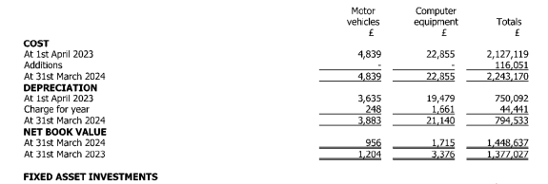
Figure 1 Financial Details of Rossington Hall
Source by- (Service.gov.uk., 2024)
Staffing
To support the effective delivery of services, Rossington Hall Ltd has a strong team of employees. An average of 14 employees was on the payroll for the year and this was less than that of the previous year, which stood at 17 (mark, 2023). This encompasses event organisers, waiters, cooks, and cleaning services which are essential to the effective and efficient running of the venue. This means that the ratio of staff to guests is maintained appropriately to ensure positive experiences with guests.
Number of Branches and Locations
Rossington Hall Ltd specialises in having only one hotel and focusing on the special luxury service for the guests. Indeed, there are no other branches or other locations for this venue but the large area which is surrounded by all kind of amenities and the development is a plus factor in hosting different party or events. They comprise event space, the café, and rooms for accommodation, that effectively target various demographics of guests (Clifton, 2023).
Location and Context
The location of Rossington Hall is fairly remote and isolated, which gives the place a rather quiet and calming impression (Tripadvisor, 2024). It is located in a strategic area that is near main cities and transport centres, thus being suitable for both domestic and international travellers. There is also a good historical feel in the estate mainly due to its location within easy commute distance to Doncaster town centre and most of the important highways.
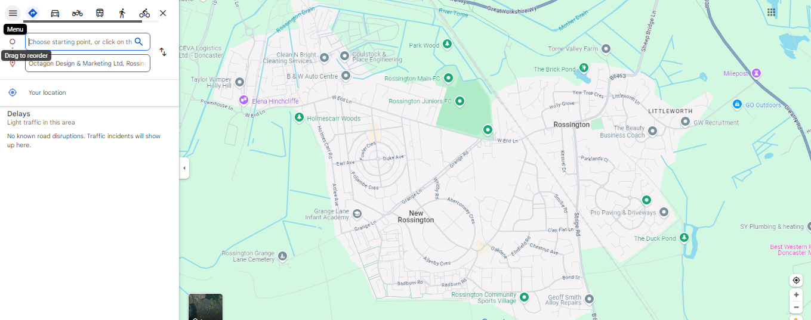
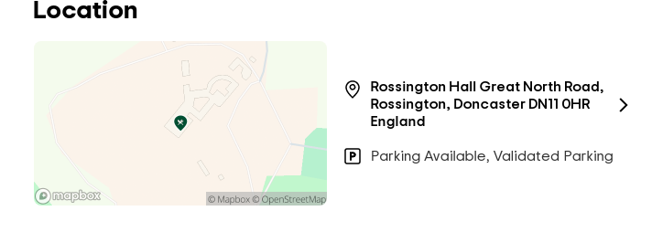
Figure 2 Location Details of Rossington Hall
Source by: (Tripadvisor, 2024)
Because of this, maps and images are crucial to describing the location and setting of Rossington Hall. Such map can give a clear picture of the geographical location of the estate and its environs. Photographs of the external part of the venue, interiors, and the exterior environment provide a clear visualisation of the history and culture of the place. These descriptions, in conjunction with photographs of the estate, will inform readers of the specifics regarding Rossington Hall’s topography and attractions.
Consequently, through the use of detailed descriptions, the following section will provide a clear and detailed account of Rossington Hall Ltd, including details of the company’s financial performance, employees, and location. This information will be useful in the subsequent analysis and discussions undertaken in the present research work.

SWOT Analysis

Figure 3 SWOT Analysis
Strengths:
This 19th century country house has Victorian architectural designs hence it is given grade II listing hence guests who visit Rossington Hall for any occasion, look forward to something that is out of the ordinary. Guest satisfaction is a priority at the venue; this makes its guests loyal and creates a friendly word-of-mouth marketing (Narayanan, 2022). Rossington Hall is fortunate to have positive accounts on social platforms such websites mentioning the park on Trip Advisor and Google Reviews. The venue is capable of hosting a wide range of events from weddings to conferences and dining options, thereby expanding its market access.
Weaknesses:
The venue is too small for large-scale events, which has the potential for loss of potential revenues. Demand varies per season, resulting in some times of low occupancy and revenues. The venue is dependent on a handful of special staff members, and risks arise if one of them decides to leave or is unavailable. Keeping up with a historic building incurs high running costs and thus reduces profit margins (Islam et al., 2021).
Opportunities:
Growing demand for luxury weddings and corporate events offers Rossington Hall a way into high-spending clientele. It can also attract a more international audience through targeting international tourists with marketing efforts. New services, including spa and wellness services, will not only make an individual's time more enjoyable, but they will also raise revenue (Sztorc and Savenkovs, 2021). Integrating technology for better guest experiences, such as mobile check-ins and personalised recommendations, would enhance competitiveness.
Threats:
A weakened economy tends to limit discretionary spending, directly affecting the revenue of the venue. With the new luxury venue entering the market, competition has intensified, and so Rossington Hall needs to distinguish itself. Changes in hospitality regulations can cause more costs for complying provisions. Outdoor events remain vulnerable to weather conditions that may disrupt their operations and guest experiences (Mun and Park, 2023).

PEST Analysis
Table 1: PEST Analysis of UK
Factors | Description
Political | - Brexit and regulatory changes  - Tourism policies and visa regulations  - Health and safety regulations  - Environmental policies
Economic | - Economic uncertainty and inflation  - Fluctuating exchange rates  - Labour market dynamics  - Rising operational costs
Social | - Changing consumer preferences  - Aging population  - Health and wellness trends  - Social media influence
Technological | - Digital transformation and automation  - Data privacy and security concerns  - Online booking platforms and AI  - Sustainability and green technology
Political Factors:
The UK's exit from the EU resulted in vast regulatory changes in trade, labour, and tourism (Baum et al., 2023). Brexit has complicated visa regulations that affect the availability of international labour, a vital resource of the hospitality industry. Changes in visa policies could restrict international tourists from visiting the UK, making it less likely for high-spending tourists to land, although domestic tourism is on the rise in that situation. The COVID-19 pandemic has raised issues on health and safety regulations. Stringent guidelines have increased the operational costs while remaining necessary for maintaining public trust. Moreover, increasing the focus on sustainability and environmental impact has led to new regulations with which hospitality businesses must comply, driving up costs but also an opening for eco-friendly initiatives (Khatter, 2023).
Economic Factors:
Quite a fluctuating state of the UK economy, accompanied by periods of uncertainty and inflation, has always had some impact on consumer spending (Chapter, 2021). Rising living costs can dent discretionary spending on hospitality services. Exchange rate volatility plays out in the prices of imported goods and services, affecting operational costs. Furthermore, it also influences the way international travellers perceive travel affordability. The hospitality industry runs on a pliable labour market, although labour shortages and wage inflation have compounded operational costs and difficulty in staffing following Brexit. Rising utility, raw material, and laboured costs squeezed profit margins, forcing businesses to pursue costs-saving measures or hike their prices (Lea, 2021).
Social Factors:
Modern consumers are increasingly looking for personalized, authentic experiences. Such a shift demands that hospitality businesses come up with innovations in dealing with the evolving expectations (Adekuajo et al., 2023). The rapidly aging population presents challenges and opportunities. While older consumers could possibly have varying tastes, they also represent quite a large market share that has disposable income. With the rise of such an interest in health and wellness, there is a corresponding increase in demand for fitness centers, healthy eating options, and wellness retreats. Social media platforms have changed how consumers research and book travel (Hu and Olivieri, 2021). Positive reviews and recommendations can be incredibly valuable for a business, while negative feedback can cause great damage.
Technological Factors:
Innovation has led to increased automation and digital transformation across the whole lodging and hospitality industry: online booking systems, mobile check-in, and artificial intelligence treated customer service have pervaded nearly every aspect of its segment. The increasing dependence on digital platforms has raised the stakes for data protection and security (Balsiger et al., 2023). The rise of online travel agencies (OTAs) and AI-driven platforms has changed the way consumers book travel. Businesses must adapt to these platforms to remain competitive. Consumers are becoming conscious of environmental impact, which is further driving the demand for sustainable practices (Khalil et al., 2024). Green technology and eco-friendly initiatives can enhance a business's appeal and reduce long-term costs.

Competitor Analysis
Table 2: Competitor Analysis of Rossington Hall
Competitor | Price Range | Quality of Service | Unique Selling Points (USPs) | Market Position
The Crown Hotel Bawtry | £100-£150 per night | High | - Historic charm  - Modern amenities  - Central location | Mid-range luxury hotel in Doncaster
Best Western Premier Mount Pleasant Hotel | £120-£180 per night | Very High | - Premier brand reputation  - High-quality facilities  - Excellent customer service | High-end hotel in Doncaster
The Earl of Doncaster Hotel | £150-£200 per night | High | - Iconic status  - Luxury accommodations  - Fine dining | Luxury hotel in Doncaster
The Regent Hotel | £80-£120 per night | Moderate | - Affordable pricing  - Comfortable accommodations  - Good location | Budget-friendly hotel in Doncaster
The competitive landscape in Doncaster's hospitality industry is diverse, with hotels catering to different market segments. The Crown Hotel Bawtry and The Earl of Doncaster Hotel both offer high-quality service but differ in price range, with The Earl of Doncaster positioning itself towards a more upscale market. The Best Western Premier Mount Pleasant Hotel is some very good service itself with a reputation for strong brand positioning in the up market (Sadhale, 2023). On the other hand, The Regent Hotel caters to the affordable range, which makes its business attractive towards budget travellers.
This analysis put into light the need to understand the price with quality offerings from competitors in order to place the gaps and points of opportunity. Rossington Hall's utmost edge can be its unique historical charm and personal service to entice guests looking for a unique yet quality experience. Rossington Hall will thus be in a position of competitive advantage by utilizing its strengths while addressing the existing weaknesses to restore order in the Doncaster hospitality market.

Netnography
Netnography revolves around a disciplined process concerning analysis and design undertaken to define the customer experience and perceptions (Lewerentz, 2021). Recently, Rossington Hall has received a mixed but predominantly positive reception from its guests, who have submitted 441 reviews, out of which 306 have rated it "Excellent" while 56 say it's "Very good," reflective of high customer satisfaction. The most frequent mentions were: "amuse bouche," "tasting menu," and "wedding venue," indicating major aspects for guest experiences (Tripadvisor, 2024).
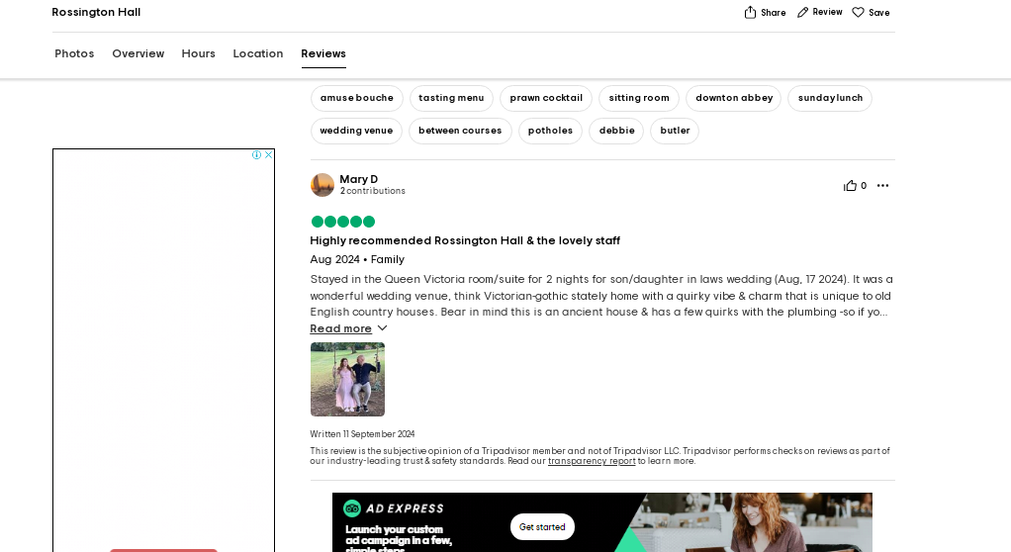
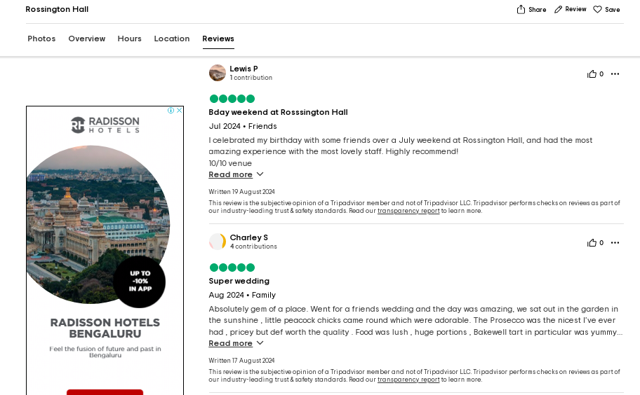
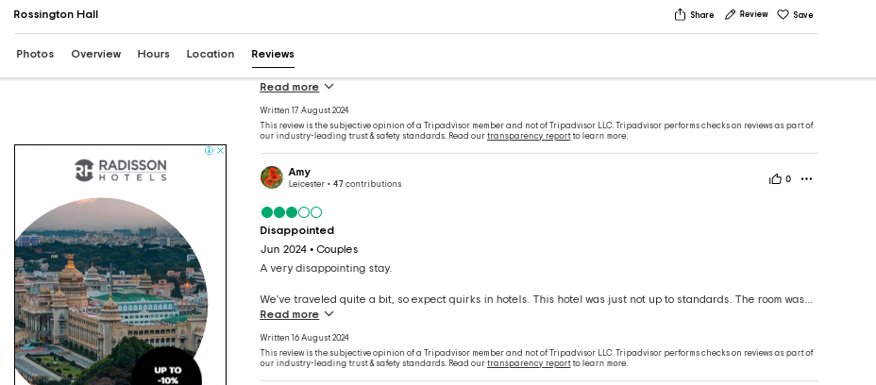
Figure 4 Online Reviews of Rossington Hall
Positive Reviews:
- Mary D praised the Victorian-Gothic charm as well as the lovely attentive staff, although some minor plumbing issues existed.
- Lewis P had a birthday celebration at Rossington Hall and definitely recommended the venue as great for experience with lovely staff.
- Charley S hailed the hall a brilliant venue, stating: "Jewel," in respect of the nice garden, good prosecco, and comfortable accommodations.
Negative Review:
- Amy out of Leicester is quite disappointed stating there were issues with hot water, pricey and poor-quality food, as well as poor professionalism of the staff. It appears that this, among others, needs improvement (Tripadvisor, 2024).
The overall netnography indicates that there is a chance to put forward some operational and service issues that could enhance overall satisfaction-while the experiences of most guests were still quite favourable.

Reflective Account
During my placement at Rossington Hall, I was able to observe various components of hotel operations and their respective functions, and this gave me a better appreciation for the hospitality industry. They were explicitly particular about how important personalized attention is in the increase of guest satisfaction (Vo et al., 2022). Attention appeared to be intertwined into the activity at Rossington Hall, where staff was always attentive and taking proactive measures to guests as needed, which garnered many compliments.
I was so impressed with the hotel's dedication to preserving its authentic and historical character while also providing modern conveniences. The combination of Victorian architecture and modern-day standards created an experience that both guests and visitors would never forget. This compatibility with tradition and modernity is another appealing feature of Rossington Hall.
A hot point to note was how technology was being applied to enhance guest experience. The advent of online booking engines, digital channels, among others, improved the way they made reservations, and it also positively affected the interaction with the client (Bahar et al., 2021). Of course, it was interesting for me to note; while several aspects of interactions were improved by extra touches with these operational systems, the personal point of view (face to face, with recommendations) is still paramount to guest loyalty.
The key experiences during the placement brought out some of the challenges now facing the hospitality industry. They include the seasonal demand for various services and embattled operational efficiency. However, the staff maintained high-quality service due to ownership commitment, while the establishment's backing allowed promotion in responding to all issues raised by guests.
Upon reflection, I realize that my placement made me understand the significance of flexibility and continuous improvement in hospitality or a service provider. Running operations and marketing in the hospitality industry needs to react instantly to guest feedback and changing trends in market conditions to remain relevant or maintain competitiveness. This experience has solidified my knowledge of the dependencies of hospitality management, explaining customer service as the bedrock for enhanced success.
My placement at Rossington Hall was encouraging and illuminating, offering insights into life and aesthetics in the hospitality industry. I am sure that the lessons in service delivery will be paramount in advancing my career and pursuing a professional growth course with better results referenced earlier.

Discussion

Interpretation of Findings
Customer experience, as a driver of guest satisfaction and loyalty, is a well-established phenomenon in the hospitality literature. The findings that service quality, ambience, and personalization are key contributors to guest satisfaction are congruent with Rossington Hall's deep historical charm and modern amenities, which make up the guest experience.
Alignment with Existing Literature
From the research that has been conducted on the link between customer experience and guest satisfaction and loyalty at Rossington Hall, some conclusions relative to theories and standards garnering support within humanitarian literature were established. The conclusion states that both guest satisfaction and loyalty are directly related to customer service, which should be resonating within the hospitality industry (Paulose and Shakeel, 2022).
High Levels of Satisfaction
The research findings reveal that guests at Rossington Hall report high in the level of guests' satisfaction as luxuriously gleeful customer reviews abound and are snugly rating high. This note with the existent literature on customer experience arguing for the need of administering a runaway personalized yet high-quality service. The reviews from customers reflect a great many facets that made up the overall guest experience at Rossington Hall:
- Personalised Service: Personalised service by the Rossington Hall staff was an important contributor to overall guest satisfaction. This phenomenon can be explained by the good-interaction approach that creates satisfaction and encourages customer loyalty (Xu et al., 2024).
- Historical Charm: Rossington Hall, with its uniquely charming and rich Victorian-gothic architecture set amidst an air of history, considerably contributed to guests' satisfactory visitation experience. The historical charm of Rossington Hall gives a sense of unique and memorable experience to its guests, considering the expectation of customers for their overall satisfaction.
- Modern Amenities: Relating to historical ambience, Rossington Hall provides contemporary amenities to exceed current guests' expectations. The idea of offering up-to-date comforts and services is very much important in relation to enhancing overall guests' experiences. The idea of balancing an historical charm with modern amenities for fulfilling the guests' overall experiences (Shahidul Islam, 2025).
Comparison with Other Hotels and Industry Standards:
Other than for the unique historical blend with modern comforts, Rossington Hall really positions itself differently from all hotels in the region. Positive reviews and high ratings correlate with the finding of studies on luxury hotels saying that personalized service, coupled with an attention to detail, is of utmost importance (Shahid and Paul, 2022). Nonetheless, the unfavourable review pointing out problems with hot water and personnel conduct indicates that Rossington Hall has opportunities for enhancement to consistently align with industry standards.
When comparing it to competitors like The Crown Hotel Bawtry, Best Western Premier Mount Pleasant Hotel, The Earl of Doncaster Hotel, and The Regent Hotel, it becomes clear that Rossington Hall effectively occupies its place within the mid-to-high-end market segment. Its distinctive features, such as Victorian-gothic architecture and a proactive team, set it apart from other establishments. Yet, the results also reflect the necessity for on-going improvements in service quality and operational effectiveness to sustain a competitive advantage.

Implications
Impact of Customer Experience on Guest Satisfaction and Loyalty:
The research highlights how crucial customer experiences are for guest satisfaction and loyalty. Many guests express satisfaction when visiting Rossington Hall because of unique features such as customised services, historical structure, and modern facilities. These findings tally with prior studies done on customer experience aimed at establish that service quality, environment, and customised products enhance satisfaction levels (Anderson, 2025).
Positive statements and higher ratings indicate that the visitors find value in the uniqueness of history-focused activities offered in Rossington Hall. Combinations of extremely hardworking and attentive staff along with the ethos of the establishment provide an optimal environment for bolstering guest satisfaction. This is in line with the literature on consumer loyalty, which shows that exceptional experiences lead to repeat business and positive word of mouth (Abdullah et al., 2022).
Areas for Improvement Identified Through the Analysis:
Although many findings portray an optimistic view of Rossington Hall’s performance, they also point out several areas needing attention. Issues regarding hot water availability alongside staff professionalism identified in negative reviews hint at operational shortcomings and gaps in service delivery warranting immediate action (Kabay, 2024). Such conclusions resonate with research concerning service quality accentuating the vital role of delivering consistent services efficiently.
The following assessment shows that further investment in staff training and development would increase service quality at Rossington Hall. The proactivity and attention of staff could be considered a great strength and would present an opportunity to improve professionalism and responsiveness of staff. This agrees with literature on employee engagement that stresses the significance of a well-trained and motivated employee in providing strong customer experiences (Ruiter, 2021).

Limitations
Acknowledging Limitations in the Research Methodology:
While the research methodology adopted, including a case study approach and netnography, has provided valuable insight into the customer experience at Rossington Hall, there are several limitations inherent within it. Depending on online reviews and social media data may introduce bias as they may not fully represent the experiences shared by all guests (Zheng et al., 2021). The case study approach further inhibits the generalization of the results to other hotels or contexts.
The analysis did not take notice of seasonal variation in fulfilment experiences, which may affect the overall assessment of customer satisfaction. Future research may benefit from a well-defined data collection plan, including surveys and interviews, to shed light onto a more balanced and representative view of guest experiences.

Future Research
Going forward, the customer experience and loyalty in the hospitality industry needs to be explored by research within critically important areas of research. These areas not only fill gaps left by the current literature, but they represent an opportunity to innovate and improve current practices across the industry.
Impact of Technology on Customer Experience
First, the growing need for empirical studies relating to the impact of technology on customer experience. There are numerous new opportunities to use AI-enhanced digital platforms that address personalisation. AI-powered Chatbots, mobile check-ins, and personalized recommendations are some of the technologies sought to enhance the guest experience (Thakur, 2024). However, there is scant empirical evidence now in literature reflecting on how such technologies will be best integrated and their long-term impact on customer satisfaction and loyalty. Authors further advanced the proposition that future studies shall examine the influence of digital platforms and AI in-depth on targeted, personalized service with the view to discover best practices and opportunities to innovate (Mariani and Nambisan, 2021). Such investigation could include cases of hotels where such technologies had been embraced successfully and also cases where problems were evident in doing so.
Long-Term Impact of Personalized Services
Further work is necessary on the long-term effects of personalised service on customer loyalty (Shams et al., 2021). Many recent studies have addressed the idea that personalization is helpful in improving satisfaction; however, studies are missing providing insight on whether this effect lasts. Offering personalised experiences, including offers to customers, personalised rooms, and dining experiences, is an increasing trend in every niche of the hospitality sector (Deri et al., 2023). Nevertheless, little is known about how these strategies help build a long-standing relationship with customers. Future studies should do a sort of categorization on the long-term effects of various modes of personalization regarding their durability.
Comparative Studies on Customer Experience Strategies
Comparative studies to assess various customer experience strategies across various hospitality settings would mitigate the learning curve. The hospitality industry is wide-ranging, and hotels, resorts, and boutique properties provide different experiences (Giousmpasoglou and Marinakou, 2024). Comparative studies could help get the best practices and tailor them further to the specific contexts which will enhance overall industry performance. For instance, a luxury macro-resort would prefer different customer experience strategies than a cheap hotel would. By comparing and contrasting these strategies, the future research can provide actionable insights to the hospitality establishments within their reach for the enhancement of their customer experience initiatives.
Role of Employee Engagement
Concerning further research, more studies on the role of employee engagement in the improvement of customer experience are necessary. Further research is needed into the influence of employee training and development programs on service quality and guest satisfaction (Papademetriou et al., 2023). There is substantial evidence that high employee engagement is related to increased customer service and guest satisfaction. Nonetheless, there tends to be limited information available on which interventions or practices do produce actual changes in employees' engagement. Future work should look at the role of staff training and development in service quality and guest satisfaction. These could include case studies of hotels that have successfully introduced training courses and those that have struggled in that respect to keep their stake engaged in a good manner (Silverman, 2011).
The research throughout explains the effects of customer experience on guest satisfaction, customer loyalty to Rossington Hall and how satisfaction rates inform issues relating to customer experience, such as personalized service, historic charm, and modern amenities. The hospitality sector finds in these largely positive results referred to some areas in need of improvement, for instance, operational efficiency and gaps in service (Prakash et al., 2023). The implications of the research thus present a need for continuous improvement in service delivery and operational efficiency as underlying factors maintaining competitiveness (Abdelhamied, 2019). Future research could explore numerous possible areas of research to enhance understanding of customer experience and loyalty in the hospitality sector, including elements of technology, personalization of services, and employee engagement. The changes mentioned in the limitation could suggest avenues of furthering research in Rossington Hall regarding the improvement in customer experience strategies and enhanced guest loyalty from it, thus leading to the sustained success of such a competitive hospitality business.

Conclusion and Recommendations

Conclusion
The research into the impact of customer experience on guest satisfaction and loyalty at Rossington Hall provides a good insight into the critical factors that lead to attaining a positive guest experience. The results emphasize, in simple terms, the significance of such aspects in ensuring personalised service, historical charm, and modern amenities (Robson, 2016). Responses from guests indicated high satisfaction levels, hence laying credence to the effectiveness of Rossington Hall's current customer experience strategies.
From this research, some areas for improvement are operational inefficiencies and service gaps that can be made to offer a competitive edge. This is consistent with the literature on customer experience regarding service quality, ambiance, and personalisation as drivers of satisfaction and loyalty. The very positive reviews and high ratings could indicate that Rossington Hall does very well in the mid-to-high-end market segment, which combines historical charm with modern comforts.
This study indicates that customer experience plays a significant role in increasing satisfaction and loyalty in hotel guests at Rossington Hall. Addressing the areas for improvement should ensure continued excellence in customer experience and permit Rossington Hall to maintain leadership in the hospitality industry. These findings provide a firm foundation for an enduring pledge to continuous improvement in service delivery and operational efficiency as a pathway to long-term guest loyalty.

Recommendations and Practical Strategies
The research requests for certain actionable recommendations and practical strategies to fully enhance customer experience and improve guest loyalty at Rossington Hall.
1. Enhance Personalised Services:
A personalised service which addresses guests' individual preferences significantly drives loyalty. Rossington Hall could further develop personalized service, with technology harnessed to tailor the experience. AI-driven platforms, for example, could analyse preferences for customized recommendations for dining, activities, and room configurations (Mishra et al., 2025).
2. Invest in Staff Training and Development:
Shortcomings in professionalism from staff and operation inefficiencies were suggested to be targeted for improvement. A focused investment in training and development will enhance the quality of the service being provided, and also streamline all processes involved. This is well-supported by literature dealing with employee engagement, which notes that a well-trained and motivated staff are key in delivery of superior customer experiences.
3. Address Operational Inefficiencies:
A negative review centred on issues with hot water and hospitality has brought to light the operational inefficiencies that should be dealt with. If services are properly delivered with operational loopholes being worked quickly, guests will find real satisfaction with their stay.
4. Leverage Technology for Enhanced Guest Experience:
Technology in the enhancement of customer experience cannot be emphasized enough. Rossington Hall should advance into incorporating digital platforms and incorporating AI in their operations to speed them up and provide services that meet personal standards. Indeed, this is in line with literature discussing the technology impact on customer service which values the use of digital solutions as a way of delivering great service (Adekuajo et al., 2023).
5. Foster Long-Term Customer Loyalty:
The research emphasizes the importance of long-term customer loyalty. In creating customer loyalty, Rossington Hall must develop strategies that fill continually returning customers and positive word-of-mouth. It goes hand in hand with literature on customer loyalty, which emphasizes the pivotal role of customer experience in generating repeat business.
6. Comparative Studies and Best Practices:
Comparative studies on the effectiveness of various customer experience strategies in different hospitality settings could also bear some useful fruit. Rossington Hall might consider having benchmarks made on competitors to establish best practices and use these to find a way to customize appropriate strategies for specific contexts. This correlates with the literature on comparative studies that view development as identifying industry standards and best practices (Kuo et al., 2022).
7. Enhance Employee Engagement:
The effect of employee engagement on some of the essential features of service delivery and guest satisfaction is very worthwhile to take key notice of. Rossington Hall should put serious thought into establishing projects that would promote employee engagement and motivation.
The recommendations and implementation strategies proposed above would greatly help Rossington Hall to improve customer experience and insights into guest loyalty. This is further supported by research findings which show that specific service quality attributes such as personnel, training and technology could go a long way in improving the satisfaction of the guests. Further advancements on the elements of improvement depicted in the previous paragraph and sustained innovation in the strategies for expanding customer value will help entrenched Rossington Hall’s competitiveness and extend client loyalty.

References
Abdelhamied, H.H.S., 2019. The impact of training activities on quality of service, customer satisfaction and behavioral intention. Journal of Tourism and Hospitality Management, 7(1), pp.135-148.
Abdullah, O., Sufi, T. and Kumar, S., 2022. Service quality and its influence on customer satisfaction and customer loyalty in the restaurants of five-star hotels. African Journal of Hospitality, Tourism and Leisure, 11(6), pp.2173-2189.
Adekuajo, I.O., Fakeyede, O.G., Udeh, C.A. and Daraojimba, C., 2023. The digital evolution in hospitality: a global review and its potential transformative impact on us tourism. International Journal of Applied Research in Social Sciences, 5(10), pp.440-462.
Akbari, M., Nazarian, A., Foroudi, P., Seyyed Amiri, N. and Ezatabadipoor, E., 2021. How corporate social responsibility contributes to strengthening brand loyalty, hotel positioning and intention to revisit?. Current Issues in Tourism, 24(13), pp.1897-1917.
Albahri, A.S., Duhaim, A.M., Fadhel, M.A., Alnoor, A., Baqer, N.S., Alzubaidi, L., Albahri, O.S., Alamoodi, A.H., Bai, J., Salhi, A. and Santamaría, J., 2023. A systematic review of trustworthy and explainable artificial intelligence in healthcare: Assessment of quality, bias risk, and data fusion. Information Fusion, 96, pp.156-191.
Ali, A.S.M., Nurin, S.S. and Mohi, Z., 2023. Room guest satisfaction towards guestroom physical environment quality in the theme hotel. JOURNAL OF TOURISM, CULINARY AND ENTREPRENEURSHIP (JTCE), 3(2).
Ali, B.J., Gardi, B., Othman, B.J., Ahmed, S.A., Ismael, N.B., Hamza, P.A., Aziz, H.M., Sabir, B.Y., Sorguli, S. and Anwar, G., 2021. Hotel service quality: The impact of service quality on customer satisfaction in hospitality. International Journal of Engineering, Business and Management, 5(3), pp.14-28.
Anabila, P., Ameyibor, L.E.K., Allan, M.M. and Alomenu, C., 2022. Service quality and customer loyalty in Ghana’s hotel industry: The mediation effects of satisfaction and delight. Journal of Quality Assurance in Hospitality & Tourism, 23(3), pp.748-770.
Anderson, M., 2025. Understanding the Impact of Service Quality on Customer Loyalty in the Hospitality Industry.
Bahar, V.S., Nenonen, S. and Starr Jr, R.G., 2021. From channel integration to platform integration: Capabilities required in hospitality. Industrial Marketing Management, 94, pp.19-40.
Balsiger, P., Jammet, T., Cianferoni, N. and Surdez, M., 2023. Coping with digital market re-organization: How the hotel industry strategically responds to digital platform power. Competition & Change, 27(1), pp.163-183.
Baum, T., Rubio, J.C., Congreve, E., Alberti, G., Clifton, N., Guthrie, J., Hetherington, G., Ladkin, A., Nickson, D. and Simpson, B., 2023. ReWAGE Evidence Paper: Work, wages and employment in the UK’s hospitality sector.
Chang, T.Y. and Lin, Y.C., 2022. The effects of atmosphere on perceived values and customer satisfaction toward the theme hotel: The moderating role of green practice perception. Sustainability, 14(15), p.9153.
Chang, V., 2021. An ethical framework for big data and smart cities. Technological Forecasting and Social Change, 165, p.120559.
Chapter, I.G.B., 2021. UK economic outlook: the future isn’t what it used to be. The Institute for Fiscal Studies.
Clifton, D., 2023. Hospitality security: Managing security in today’s hotel, nightlife, entertainment, and tourism environment. CRC Press.
Cottrel, S. (2014), Dissertation and Project Reports - A step by Step Guide, Palgrave Macmillan: Basingstoke.
Deri, M.N., Zaazie, P. and Singh, A., 2023. Digital Future of the Hospitality Industry and Hospitality Education Globally. In International Handbook of Skill, Education, Learning, and Research Development in Tourism and Hospitality (pp. 1-23). Singapore: Springer Nature Singapore.
Dimitriou, C.K., 2022. The critical role that national culture and ethical leadership play in fostering employee commitment to service quality in the hotel industry. Research in Hospitality Management, 12(3), pp.255-271.
Giousmpasoglou, C. and Marinakou, E., 2024. The Contemporary Hotel Industry: A People Management Perspective. Springer Nature.
Guan, J., Wang, W., Guo, Z., Chan, J.H. and Qi, X., 2021. Customer experience and brand loyalty in the full-service hotel sector: the role of brand affect. International Journal of Contemporary Hospitality Management, 33(5), pp.1620-1645.
Hallencreutz, J. and Parmler, J., 2021. Important drivers for customer satisfaction–from product focus to image and service quality. Total quality management & business excellence, 32(5-6), pp.501-510.
Hancock, D.R., Algozzine, B. and Lim, J.H., 2021. Doing case study research: A practical guide for beginning researchers.
Hossain, M.S., Sambasivan, M., Abuelhassan, A.E. and Khalifa, G.S.A., 2023. Factors influencing customer citizenship behaviour in the hospitality industry. Annals of Leisure Research, 26(1), pp.65-88.
Hu, L. and Olivieri, M., 2021. Social media management in the traveller's customer journey: an analysis of the hospitality sector. Current Issues in Tourism, 24(12), pp.1768-1779.
Ibrahim, M. and Rasheed, A., 2024. Exploring the Link Between Customer Relationship Management and Hotel Performance. Journal of Policy Options, 7(1), pp.1-10.
Islam, R., Nazifa, T.H., Mohammed, S.F., Zishan, M.A., Yusof, Z.M. and Mong, S.G., 2021. Impacts of design deficiencies on maintenance cost of high-rise residential buildings and mitigation measures. Journal of Building Engineering, 39, p.102215.
Jain, V., Wirtz, J., Salunke, P., Nunkoo, R. and Sharma, A., 2023. Luxury hospitality: A systematic literature review and research agenda. International Journal of Hospitality Management, 115, p.103597.
Kabay, M.E., 2024. The Expert in the Next Office: Tools for Managing Operations and Security in the Era of Cyberspace. CRC Press.
Khalil, N., Che Abdullah, S.N., Haron, S.N. and Hamid, M.Y., 2024. A review of green practices and initiatives from stakeholder’s perspectives towards sustainable hotel operations and performance impact. Journal of Facilities Management, 22(4), pp.653-682.
Khatter, A., 2023. Challenges and solutions for environmental sustainability in the hospitality sector. Sustainability, 15(15), p.11491.
Kim, Y.J. and Kim, H.S., 2022. The impact of hotel customer experience on customer satisfaction through online reviews. Sustainability, 14(2), p.848.
King’ori, S.W., 2023. Travel agency recommender system based on social media sentiment analysis (Doctoral dissertation, Strathmore University).
Kozinets, R.V. and Gretzel, U., 2023. Qualitative social media methods: Netnography in the age of technocultures. The Sage handbook of qualitative research, pp.403-420.
Kumar, P., Mokha, A.K. and Pattnaik, S.C., 2022. Electronic customer relationship management (E-CRM), customer experience and customer satisfaction: evidence from the banking industry. Benchmarking: An International Journal, 29(2), pp.551-572.
Kuo, F.I., Fang, W.T. and LePage, B.A., 2022. Proactive environmental strategies in the hotel industry: Eco-innovation, green competitive advantage, and green core competence. Journal of Sustainable Tourism, 30(6), pp.1240-1261.
Lea, R., 2021. Recovery continued in May, despite weaker-than-expected GDP growth. Arbuthnot Banking Group, 12.
Lewerentz, E., 2021. Customer Experience and its Implication for Value Creation within the Night-Time Economy.
Liu, C.H., Chou, S.F. and Vu, H.T., 2024. Valuation of customers’ service quality, affective, sensory experience and entertainment to behavioral intention. Total Quality Management & Business Excellence, 35(13-14), pp.1509-1541.
MacCarthy, M., 2023. Nethnography, complementing Netnography: a defensible praxis for the online researcher. Current Issues in Tourism, 26(23), pp.3782-3793.
Mariani, M.M. and Nambisan, S., 2021. Innovation analytics and digital innovation experimentation: the rise of research-driven online review platforms. Technological Forecasting and Social Change, 172, p.121009.
mark (2023). About Us | Rossington Hall. [online] Rossington Hall. Available at: https://rossingtonhall.co.uk/about-us/ [Accessed 11 Feb. 2025].
Maxwell, J.A., 2021. Why qualitative methods are necessary for generalization. Qualitative Psychology, 8(1), p.111.
Mishra, S., Anifa, M. and Naidu, J., 2025. AI-Driven Personalization in Tourism Services: Enhancing Tourist Experiences and Business Performance. In Integrating Architecture and Design Into Sustainable Tourism Development (pp. 1-20). IGI Global Scientific Publishing.
Mun, S.G. and Park, S., 2023. Effects of abnormal weather conditions on the performance of hotel firms. Journal of Hospitality & Tourism Research, 47(7), pp.1299-1324.
Narayanan, E., 2022. The impact of social media and information technology on service quality and guest satisfaction in the hospitality industry. In Handbook on Tourism and Social Media (pp. 148-159). Edward Elgar Publishing.
Ntounis, N., Parker, C., Skinner, H., Steadman, C. and Warnaby, G., 2022. Tourism and Hospitality industry resilience during the Covid-19 pandemic: Evidence from England. Current Issues in Tourism, 25(1), pp.46-59.
Ogunnaike, O.O., Agada, S.A., Ighomereho, O.S. and Borishade, T.T., 2022. Social and cultural experiences with loyalty towards hotel services: the mediating role of customer satisfaction. Sustainability, 14(14), p.8789.
Olaoke, R.O., Bayighomog, S.W. and Tümer, M., 2021. Nonlinear relationship between brand experience and customer satisfaction in the hospitality sector: an exploratory study. Journal of Brand Management, 28(6), pp.643-656.
Papademetriou, C., Anastasiadou, S. and Papalexandris, S., 2023. The effect of sustainable human resource management practices on customer satisfaction, service quality, and institutional performance in hotel businesses. Sustainability, 15(10), p.8251.
Paulose, D. and Shakeel, A., 2022. Perceived experience, perceived value and customer satisfaction as antecedents to loyalty among hotel guests. Journal of quality assurance in hospitality & tourism, 23(2), pp.447-481.
Pillai, S.G., Haldorai, K., Seo, W.S. and Kim, W.G., 2021. COVID-19 and hospitality 5.0: Redefining hospitality operations. International Journal of Hospitality Management, 94, p.102869.
Prakash, S., Sharma, V.P., Singh, R. and Vijayvargy, L., 2023. Adopting green and sustainable practices in the hotel industry operations-an analysis of critical performance indicators for improved environmental quality. Management of Environmental Quality: An International Journal, 34(4), pp.1057-1076.
Priya, A., 2021. Case study methodology of qualitative research: Key attributes and navigating the conundrums in its application. Sociological Bulletin, 70(1), pp.94-110.
Robson, C. (2016), Real World Research, 2nd Ed, Blackwell: Oxford
Roy, S.K., Gruner, R.L. and Guo, J., 2022. Exploring customer experience, commitment, and engagement behaviours. Journal of Strategic Marketing, 30(1), pp.45-68.
Ruel, H. and Njoku, E., 2021. AI redefining the hospitality industry. Journal of Tourism Futures, 7(1), pp.53-66.
Ruiter, V.N., 2021. Humanizing hospitality industry human resources management to improve recruitment and retention of resilient hospitable talents in the sector. University of Derby (United Kingdom).
Sadhale, M.V., 2023. A study of customer engagement as a business strategy with reference to five star hotels in pune city (Doctoral dissertation, Tilak Maharashtra Vidyapeeth).
Saunders, M., Lewis, P. and Thornhill, A. (2012) Research Methods for Business Students, FT/Prentice Hall: Harlow
Service.gov.uk. (2024). Unaudited Financial Statements for the Year Ended 31st March 2024 for Rossington Hall Ltd. - GOV.UK. [online] Available at: https://s3.eu-west-2.amazonaws.com/document-api-images-live.ch.gov.uk/docs/jTyFxBH3vfdi8IduvpjYMd-8k6n3HhlTCWtxFP3Omwk/application-pdf [Accessed 10 Feb. 2025].
Shahid, S. and Paul, J., 2022. Examining guests’ experience in luxury hotels: evidence from an emerging market. Journal of Marketing Management, 38(13-14), pp.1278-1306.
Shahidul Islam, M., 2025. Striking a paradoxical balance: Shakespearean insights for hospitality management. Tourism and Hospitality Research, 25(1), pp.147-164.
Shams, G., Rather, R., Abdur Rehman, M. and Lodhi, R.N., 2021. Hospitality-based service recovery, outcome favourability, satisfaction with service recovery and consequent customer loyalty: an empirical analysis. International Journal of Culture, Tourism and Hospitality Research, 15(2), pp.266-284.
Shin, H.H. and Jeong, M., 2022. Redefining luxury service with technology implementation: the impact of technology on guest satisfaction and loyalty in a luxury hotel. International Journal of Contemporary Hospitality Management, 34(4), pp.1491-1514.
Silverman, D. (2011), Qualitative Research Methods, 2nd Ed, Sage: London
Solakis, K., Pena-Vinces, J., Lopez-Bonilla, J.M. and Aguado, L.F., 2021. From value co-creation to positive experiences and customer satisfaction. A customer perspective in the hotel industry. Technological and Economic Development of Economy, 27(4), pp.948-969.
Suleri, J., Meijer, R. and Tarus, E., 2021. Exploring hotel identity by focusing on customer experience analysis. Research in Hospitality Management, 11(2), pp.113-120.
Sztorc, M. and Savenkovs, K., 2021. Business model to create value for a client of SPA and wellness hotels.
Tai, Y.F., Wang, Y.C. and Luo, C.C., 2021. Technology-or human-related service innovation? Enhancing customer satisfaction, delight, and loyalty in the hospitality industry. Service Business, 15, pp.667-694.
Thakur, N., 2024. AI and Technology Are Used in Hospitality and Tourism. In Hotel and Travel Management in the AI Era (pp. 55-78). IGI Global.
Tomczyk, A.T., Buhalis, D., Fan, D.X. and Williams, N.L., 2022. Price-personalization: Customer typology based on hospitality business. Journal of Business Research, 147, pp.462-476.
Tripadvisor. (2024). Tripadvisor. [online] Available at: https://www.tripadvisor.in/Restaurant_Review-g4597293-d3314860-Reviews-Rossington_Hall-Rossington_Doncaster_South_Yorkshire_England.html [Accessed 10 Feb. 2025].
Veal, A J (2006), Research Methods for Leisure and Tourism, 3rd Ed, Financial Times/ Prentice Hall
Veloso, M. and Gomez-Suarez, M., 2023. Customer experience in the hotel industry: a systematic literature review and research agenda. International Journal of Contemporary Hospitality Management, 35(8), pp.3006-3028.
Vo, N.T., Hung, V.V., Tuckova, Z., Pham, N.T. and Nguyen, L.H., 2022. Guest online review: an extraordinary focus on hotel users’ satisfaction, engagement, and loyalty. Journal of Quality Assurance in Hospitality & Tourism, 23(4), pp.913-944.
Welch, C., Paavilainen-Mäntymäki, E., Piekkari, R. and Plakoyiannaki, E., 2022. Reconciling theory and context: How the case study can set a new agenda for international business research. Journal of International Business Studies, 53(1), pp.4-26.
Xu, S., Ashton, M., Li, Y., Staunton, G. and Li, Y., 2024. Hotel Employee Engagement During the Pandemic: A Mixed-Method Approach. Cornell Hospitality Quarterly, p.19389655241276511.
Yeong, S.N., Knox, D. and Prabhakar, G., 2022. Customer satisfaction and loyalty in Malaysian resort hotels: the role of empathy, reliability and tangible dimensions of service quality. International Journal of Services and Operations Management, 41(4), pp.444-462.
Zheng, T., Wu, F., Law, R., Qiu, Q. and Wu, R., 2021. Identifying unreliable online hospitality reviews with biased user-given ratings: A deep learning forecasting approach. International Journal of Hospitality Management, 92, p.102658.

