

Student name: ​Gergana Koeva
Student ID: 1906187
Module name: Mental Disorders and Psychopathology​
Module code: BMHP6006
Assessment 1 Supporting paper
Lecturer name: Bianca Sanfilippo ​
Date: 15/12/2021

Page content
Introduction………………………………………………………………………..……3
Definition of mental disorders and overview and statistic…………………………3
History of mental disorder and general treatment………………………………….4
Defenition and types of depression………………………………………………….5
Depression ICD-10……………………………………………………………………..5
Causes of Depression………………………………………………………………….6
Signs, symptoms and diagnose of the depression………………………………….7
Historical and current treatment. Discussion……………………………………..…..7
Principles for working with people with depression……………………………….…8
Past and present services related to Depression……………………………………8
Advantages and disadvantages of the current treatments for depression……….10
Case study………………………………………………………………………………10
Statistic depression in UK and world wise…………………………………………...10
Advantages and disadvantages of the current treatments for depression………..11
Case study……………………………………………………………………………….11
Statistic depression in UK and world wise……………………………………………11
Appendix: Power Point Presentation – Debate: 03/12/2021……………………….15

Introduction
This report providing a definition of mental disorder and statistic in UK and world wise. Overview from the historical perspective, treatment, and diagnosis. The research is focused on depression, classification within ICD-10, symptoms, signs, diagnosis, historical overview, historical and current treatment. NICE guidance for working with people with depression same as past and present services involved are included. The research is supported with case study and finished with recommendation and conclusion.

Definition of mental disorders and overview and statistic

What is mental health disorder? According to Medline Plus, condition, which is affecting the feeling, thinking, mood and the behaviour is called mental disorder. There are recognised different kind of the condition above, such as schizophrenia, anxiety, depression, personality disorder, bipolar disorder etc... (Medline Plus, 2020).
Source: https://www.gettyimages.com/photos/mental-illness
Mental disorders could be chronical or occasional illness, affecting everyone every one in five people worlds wise, and every one in four people in United Kingdom, regardless the age, social standards, or ethnicity. The research shows that the females are prone to mental disorders more than the men (WHO, 2019). This statistic is very worried, which is requires attention, awareness, and adequate majeures to be managed. During the Covid pandemic the numbers of affected people is seriously increased with approximately 20% (WHO,2021).
There are not specific causes of the mental disorders, but there are some factors, which contributing and increasing the risk of mental illness, for instance family history, bad life experience, chemical imbalance in the brain, traumatic brain injury, alcohol or drug abuse, medical condition, loneliness, and isolation (Medline Plus, 2020).
Diagnosing of mental disorders includes the medical history, physical exams and laboratory tests and psychological evaluation ((Medline Plus, 2020).
The treatment of the mental disorder is depended on the type of the condition, usually includes the complimentary therapy, social support, counselling, or medications. Some cases are required more intensive treatment, such as admission into the psychiatric hospitals due to the severity or risk of harming (NHS, 2021).
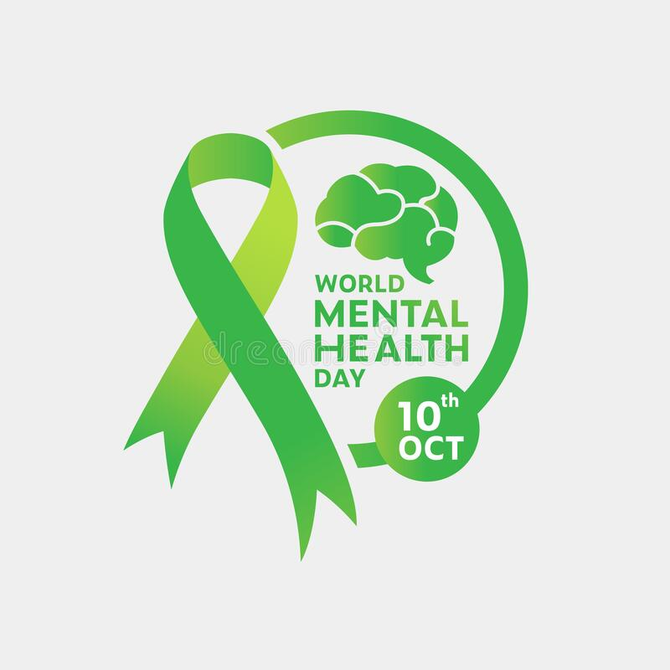
To manage the pandemic of mental disorders, the main things is to be recognised and admitted by the people. Since 1992 every year 10 of October is Mental Health Day and Mental Health Awareness Week take a place every year in May (WHO, 2021). Such events have a significant role in terms of informing the people and reassure them that help is always available and “is ok, not to be ok”.
Source: https://images.app.goo.gl/MXMU9iXph9CjbvQ7A

History of mental disorder and general treatment
Mental disorders were present way before they are classified as illness. During the early 20th century, the mental disorders has been acknowledged and the doctors were able to provide treatment. Going back in the time, the exile was usual treatment for this people during the 19th century, they have been deprived and their liberty has been taken away. Looking at that time perspective, the mental ill people are witches or demon possessed. With the time the spiritual idea went more far, and the people become more discriminated.
During the 16th century the doctors used to implement very intensive surgeries, which causes serious health concern. This surgery was involving invasive methods, for instance making holes on the skull according to historical documents. People with mental problems often has been put into the jail and treated as a criminal.
Before 18th century the first mental health hospitals have been made presuming that there will be provided a moral treatment method, but the treatment available there was cruel in a horrible environment and not moral at all. The techniques such as electroshock, antipsychotic drugs, lobotomy, or psychosurgery implemented there is life threatening (Baton Rouge Behavioural Hospital, 2020).

Defenition and types of depression
Seeing a problem with doing day-to day routine and feeling that life is worthless is called major depressive disorder or clinical depression. Is affecting the feeling, changing of emotions and physical problems. Depression is accompanied by hopelessness, emptiness, sadness, and tearfulness (Mayo Clinic, 2021).
Types of depression:
- Major depression
- Bipolar disorder
- Perinatal depression
- Seasonal depression
- Atypical depression
- Persistent depression
- PMDD
- Situational depression (Ann Pietrangelo, 2021)

Depression ICD-10
“This block contains disorders in which the fundamental disturbance is a change in affect or mood to depression (with or without associated anxiety) or to elation. The mood change is usually accompanied by a change in the overall level of activity; most of the other symptoms are either secondary to, or easily understood in the context of, the change in mood and activity. Most of these disorders tend to be recurrent and the onset of individual episodes can often be related to stressful events or situations” (ICD-10, 2010).

According to ICD-10, F30 to F39, the depression is a mood disorder with depressive episodes. Mild depressive episode is when two or three of the symptoms are present, and the patients can continue with their daily routine. Moderate episode of depression is, when four of the symptoms are present and there it is a difficulty for the patients to do the usual daily activities. Severe depressive episode without psychotic symptoms is usually the agitated depression, major and vital depression, is characterised with loss of self-esteem, ideas of worthless or guilt and suicidal thoughts. Severe depressive episode with psychotic symptoms is when all the sings are present plus hallucination and delusion, in this case patients are not able to do the daily activities and is risk for their lives. Other depressive episodes – atypical depression, single episodes of NOS. Depressive episodes unspecified is NOS depression and NOS depressive disorder (WHO, 2010).

Causes of Depression
According to the research, there not only one cause of the depression, but it is also a combination of reasons, which can boost the signs and symptoms and catalyse the onset of the disease.
Stressful events- bereavement, money wise problem, unhealthy relationship etc.…
Personality – some people are more vulnerable than others and prone to depression.
Family history – is more likely to develop depression if some of the family members already had it in a past.
After giving birth the women can get the depression due to the increase of the hormones.
The loneliness is one of the great prerequisites for developing depression.
Alcohol and drug abuse – when the life not going as is expected, people trying to “balanced” with different substance, which can bring their life out of control.
Another big reason of developing depression are the illnesses, life threatening diseases, underactive thyroid gland, or head injuries (NHS, 2019).

Signs, symptoms and diagnose of the depression
Tree type of signs and symptoms is recognised according to NHS.
Physical symptoms - Changes of the appetite and the weight, speaking and moving slower than usual, unexplained pain, luck of energy, sleeping problems, constipation, and loss of libido.
Psychological Symptoms-Low mood and sadness, feeling of hopeless and helpless, low self-esteem and tearfulness, feeling irritable towards others, no motivation and difficulty on making decisions, anxious and worried, no satisfaction of the life, suicidal or harming thoughts
Social symptoms- avoiding the contact with people, struggling with cooping at homework and family life, neglect of interests and hobbies (NHS, 2019).
To diagnose the depression, the doctor’s paid attention on the symptoms. There is not laboratory test that can diagnose the depression, but test of blood and urine can provide information helping to exclude the diagnose of depression. Zung scale is screening tool helping to assess depression, it is 20 questions with score range from 20 to 80. Hamilton Depression Rating Scale is a tool to calculate the severity of the depression for already diagnosed people. Beck Depression Inventory is questioner designed to help health professionals to assess the mood (Healthline, 2018).

Historical and current treatment. Discussion
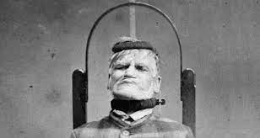
Methods used back in the time are very limited. In terms of treatment, people suffering from depression has been locked, and their liberty has been taken away, as they were classified as a dangerous. To treat the depression has been used methods such a beating, physical restraint, and starvation, tempting to take the demons out of the body. During 19th and 20th century the lobotomies and electroconvulsive therapy has been used for treatments, but very often those therapy causes permanent damage or dead (Nancy Schimelpfening, 2020).
Source:https://www.vice.com/en/article/vbpqwj/life-inside-victorias-19th-century-lunatic-asylums
Current treatment of the depression involving a combination of self-help, talking therapy and medication. Now days the treatment of the depression is starting first with complimentary therapy such as massage, aroma therapy, acupuncture etc. Self-Help therapy is including talking to the family, close friends or to the self-help groups for people with depression. Cognitive behaviour treatment and counselling. Antidepressants are used for moderate or severe depression Combination therapy – CBT plus medication therapy. Mental Health Teams- phycologists, psychiatrist, specialist nurses and occupational therapist. Interpersonal Therapy (IPT)- helps to cooping bereavement or assisting solving the problems in the relationships. Psychodynamic therapy is helping with taking out the tings of the mind, which catalysing the problem. Counselling is helping the people with depression to solve the problems themselves. Antidepressants for mild and severe depression. Selective serotonin reuptake inhibitor for mild and severe depression. Mindfulness and brain stimulation (NHS, 2019).
The treatments for the people suffering from depression in historical time are cruel and it seems more like methods of torture. Consider the research, they are not only ineffective, but cause the permanent damage or even dead. They liberty has been taken away and no choice has been given to them or their relatives, more over they have been treated as a criminal.
Comparing to the historical treatment, the current methods are very effective and seems like luxury. There are numbers of treatments, combined with the complimentary or holistic therapy which makes the prosses of treatment more effective and a bit pleasant.
The current treatment is a way better than the historical, if can be called treatment at all

Principles for working with people with depression
NICE guidance for working with people with people diagnosed with depression are very clear. Building trust and relationship during the treatment /person-centred care approach. To always Involve the service users in taking decisions regarding their treatment. Awareness of stigma and discrimination. To keep confidentiality, privacy and treat the patients with dignity (NICE, 2021). Respect policy and legislation, such as Human Rights Act/Equality Act 2010/Mental Health Act.
Past and present services related to Depression
There are many services working with the people interacted of depression at this present such as: Community mental health teams – support people with mental disorders in the community. Social care- supporting the patients with their day -to day tasks. Residential care- for patients which are not confident at home alone. (Mind, 2020).
In the historical time was only hospitals for mental disorders available. One of the proves of the poor environment and the state of the hospitals where the people with mental disorders have been treated is Victorian Lunatic Asylum, it is considered as a place of mystery.
"It would not have been a particularly enjoyable place to find yourself"(Rebecca Kamm, 2018).



Source: https://www.vice.com/en/article/vbpqwj/life-inside-victorias-19th-century-lunatic-asylums

Advantages and disadvantages of the current treatments for depression
Advantages- Awareness of the treatment, holistic and complementary therapy available, Numbers of trained stuff allocated, help is always there, medications with low side effects, treatment provided while following the guidance for working with people with depression and awareness of stigma and discrimination.
Disadvantages – side effect of some of the medication for depression and long way waiting on the list to start treatment.

Case study
Working at Health and Social care sector daily I face the people with depression due to their loneliness, illness or just because they cannot coop with their life.
Recent report to the social services for an old lady with signs of depression, which she was hiding, helps to save her life perhaps.
The social worker referred her to the health professionals, where she admitted that she has problem and suicidal thought at times, then she started taking a treatment immediately. She was very pleased that the care workers done their job professionally, help her in the way, where she was not feeling a shame or any discomfort and respect her dignity.

Statistic depression in UK and world wise
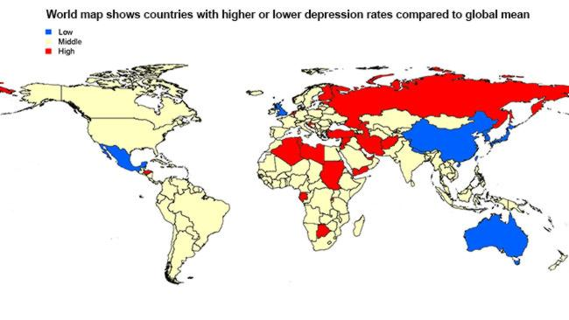
According to the WHO, 5%of the world populations have been interacted with the depression, 13% of the men population and 24%of the women in UK (MHFA England, 2020). During the COVID-19 pandemic the numbers is increased with 19%(WHO,2021).
Source: https://images.app.goo.gl/2mB2fmis2Do9Nhbd9
Issues with professional support
Considering increasing the numbers of the people diagnosed with the depression, there it is a shortage with Psychiatrists, Mental Health providers or professionals working with mental health. Must be more awareness of that they are needed. Increasing the benefits and providing more courses for mental health professionals will increase the interest of young people to direct their careers in this field.

Conclusion
Depression located on time is easy to be treated and can even save lives. There it is the adequate way to be diagnosed, to be treated and to provide a long-term support for managing the further life. Progression with the way of treatment is obvious, this is reassurance of the positive results. People should not be afraid to admit the mental disorder problems as the help is out there and “is ok not to be ok”.
The knowledge we get while study this module is very helpful and can be implemented into our workplace and in our personal life as well.

References:
Cleveland Clinic (2013) Alternative Therapies for Depression | Cleveland Clinic [Online] Cleveland Clinic. Available at: https://my.clevelandclinic.org/health/treatments/9303-depression-alternative-therapies
[Accessed: 20 November 2021].

Find Your Words (2021) Who Does Depression Affect? [Online] Available at:https://findyourwords.org/understanding-depression/who-does-it-affect/.
[Accessed: 20 November 2021].

gettyimages (2021) Mental Illness Photos and Premium High Res Pictures - Getty Images [Online] Available at: https://www.gettyimages.com/photos/mental-illness
[Accessed: 20 November 2021].
Guideline scope Mental wellbeing at work (2021) [Online] Available at: https://www.nice.org.uk/guidance/gid-ng10140/documents/final-scope
[Accessed 1 December 2021].

Guideline scope Mental wellbeing at work (2021) [Online] Available at: https://www.nice.org.uk/guidance/gid-ng10140/documents/final-scope.
[Accessed: 20 November 2021].

Healthline (2021)Type of Depression and how to recognize them [Online]Available at: https://www.healthline.com/health/types-of-depression
[Accessed:20November 2021]

Hospital, B.R.B. (2020) The Surprising History of Mental Illness Treatment [Online] Baton Rouge Behavioral Hospital. Available at: https://batonrougebehavioral.com/the-surprising-history-of-mental-illness-treatment/.
[Accessed: 20 November 2021].

MedlinePlus (2021) Mental Disorders [Online] Available at: https://medlineplus.gov/mentaldisorders.html.
[Accessed: 20 November 2021].

MHFA England (2020).Mental health statistics [Online] MHFA Portal. Available at: https://mhfaengland.org/mhfa-centre/research-and-evaluation/mental-health-statistics/.
[Accessed: 21 November 2021].

MHFA England (2020).Mental health statistics [Online] MHFA Portal. Available at: https://mhfaengland.org/mhfa-centre/research-and-evaluation/mental-health-statistics/.
[Accessed: 21 November 2021].

Mind (2019) Support services | Mind, the mental health charity - help for mental health problems [Online] Available at: https://www.mind.org.uk/information-support/types-of-mental-health-problems/mental-health-problems-introduction/support-services/.
[Accessed: 20 November 2021].

NHS (2019) Symptoms - Clinical depression [Online] Available at: https://www.nhs.uk/mental-health/conditions/clinical-depression/symptoms/.
[Accessed: 20 November 2021].

NHS (2019) Treatment - Clinical depression [Online] Available at: https://www.nhs.uk/mental-health/conditions/clinical-depression/treatment/.
[Accessed: 20 November 2021].

NHS (2021) Causes - Clinical depression [Online] Available at: https://www.nhs.uk/mental-health/conditions/clinical-depression/causes/.
[Accessed: 20 November 2021].

NHS (2021) NHS Vale of York Clinical Commissioning Group - Mental health awareness week - it’s ok to not be ok [Online] Available at: https://www.valeofyorkccg.nhs.uk/mental-health-awareness-week-its-ok-to-not-be-ok/
[Accessed 1 December 2021].

NICE (2021) CKS is only available in the UK [Оnline] Available at: https://cks.nice.org.uk/topics/depression/diagnosis/diagnosis/.
[Accessed: 23 November 2021].

Pietrangelo, A. (2018) Types of Depression: 9 Forms of Depression and Their Symptoms [Online] Available at: https://www.healthline.com/health/types-of-depression.
[Accessed: 25 November 2021].

Schimelpfening , N. (2014) The History of Depression [Online] Verywell Mind Available at: https://www.verywellmind.com/who-discovered-depression-1066770.
[Accessed: 22 November 2021].

Science Museum (2018) A Victorian Mental Asylum | Science Museum [Online] Science Museum. Available at: https://www.sciencemuseum.org.uk/objects-and-stories/medicine/victorian-mental-asylum.
[Accessed: 20 November 2021].

Shutterstock (2021) Causes Depression Images, Stock Photos & Vectors | Shutterstoc. [Online] Available at: https://www.shutterstock.com/search/causes+depression
[Accessed 1 December 2021].

vice (2021) Life Inside Victoria’s 19th-Century “Lunatic” Asylums [Online] Available at: https://www.vice.com/en/article/vbpqwj/life-inside-victorias-19th-century-lunatic-asylums. [Accessed: 20 November 2021].

World Health Organization (2019) Mental disorders [Online] Available at: https://www.who.int/news-room/fact-sheets/detail/mental-disorders.
[Accessed: 20 November 2021].

World Health Organization (2020) COVID-19 disrupting mental health services in most countries [Online] Available at: https://www.who.int/news/item/05-10-2020-covid-19-disrupting-mental-health-services-in-most-countries-who-survey.
[Accessed: 23 November 2021].

World Health Organization (2021).Depression [Online] World Health Organization. Available at: https://www.who.int/news-room/fact-sheets/detail/depression.
[Accessed: 20 November 2021].

Appendix: Power Point Presentation – Debate: 03/12/2021


