  - Learning In The Digital Era
BMPL4007/BMPL4009

E-Portfolio REPORT

Sophie Evans
2204080
Contents
Written Summary – 3
Mind Map - 4
Presentation - 5
Reflection - 6
Reference list - 7

Task 1
Creating a quiet and comfortable study environment is beneficial and correlates to successful study sessions and good results, it is shown that “there were significant relationships between approaches to study and learning environments” (Mona Faisal Al-Qahtani, 2015). Fewer distractions help to remain focused when studying, planned sessions and an established routine maximise productivity as it allows for adaptation based on the individual. Regular breaks would allow for a steady pace of revision as well as a balanced approach, without affecting focus or impacting mental health; which is more likely to happen when cramming or studying without scheduled breaks. Studies show that taking purposeful breaks returns “mental and physical functional systems to their baseline” (Sonnetag S, Fritz C,. 2007). This is linked to time management, which is one of the key aids in academic success; as well as being “one of the biggest challenges you will encounter as a student” (Moore et al,. 2010) Developing good time management builds better studying habits, however having poor management issues will lead to inaccuracy which leads to strain on mental wellbeing as well as poor assignments, etc; by learning to prioritise important tasks, students are more likely to work efficiently and avoid procrastination. As well as a good study environment, the use of technology is beneficial in completing good-quality assignments. Using various software, individuals can produce pieces in different formats; whilst using collaborative features. Using verified software allows students to demonstrate academic honesty; by referencing correctly and acknowledging the sources of information. Many Microsoft applications such as word, teams, PowerPoint, etc. are said to enhance the learning experience and give students the chance to produce better quality work; it’s said to be “critical to our modern society” (Briggs, 2022). It is initially vital to understand thoroughly any assignment that is given, by carefully reading assignment briefs and recognising any directive verbs.

Mind map –

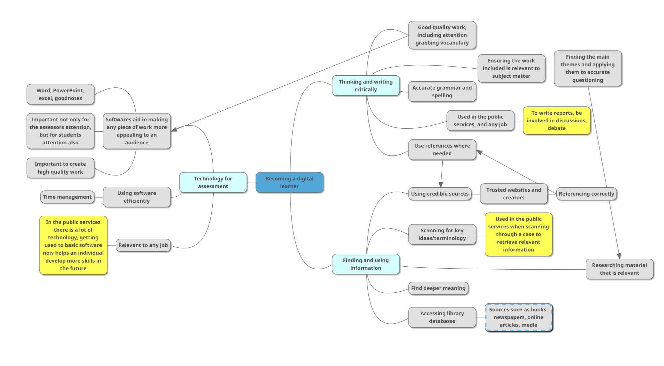

Becoming A Team Player – Presentation

https://youtu.be/yuYFEdsCa5c

Task 4
This assignment aimed to display the findings of traits of a digital learner, whilst attempting this assignment I found myself distracted and struggled to find a writing point. To overcome this I used the advice of my peers and tutor, whilst organising myself more effectively.
On reflection of my attempt at writing this assignment, I understand that my struggle to find a writing point was exaggerated by my procrastination. On reading the content, I learned that taking regular breaks and organising my study sessions better would help with my assignment writing process. I learned that the module content was valuable in writing the main sections, I took the advice that I was creating with and used it to write the assignment.
After writing this assignment, I am aware that I need to work on my time management and organisational skills; as well as my procrastination issues. I acknowledge that these issues devalued my report quality. The consequences of my actions have resulted in rushed work and increased levels of anxiety, which in turn has led to low attendance. To resolve the situation, I improved my routine and established a better studying schedule; this will result in better quality work being produced.
From this experience, I have learned that my bad studying habits decrease my work quality and in turn, increase negative emotions. In a positive light, I have learned better techniques concerning better studying habits. In the future, I will use the content for my personal gain to create a natural routine in which studying and assignment writing is done with ease.

- Mona Faisal Al-Qahtani, Journal of taibah university medical sciences, Associations between approaches to study, the learning environment, and academic achievement, March 2015, https://www.sciencedirect.com/science/article/pii/S1658361215000232
- Sonnentag S, Fritz C, The Recovery Experience Questionnaire, Development and Validation of a Measure for Assessing Recuperation and Unwinding From Work, 2007, http://www.ub.uni-konstanz.de/kops/volltexte/2008/5591/
- Moore et al., 2010
- Bill Briggs, ‘Critical to our modern society’; How datacenters power everyday necessities, Microsoft, 26th October 2022, https://news.microsoft.com/europe/features/critical-to-our-modern-society-how-datacenters-power-everyday-necessities/

