
Skills for the Workplace
Module Assignment Submission
Student Name: | Sam Lloyd
Student Number: | 2012879
Module No: | BMSK4004
Module Title: | Problem Solving and Decision Making

Statement of Confirmation of Authenticity
By the act of making this submission, the student declares that this is the work of the student named above. The work has not, in whole or in part, been knowingly presented elsewhere for assessment, or where assessment has been built on a previous assessment, this has been identified. Where materials have been used from other sources it has been properly acknowledged. If this statement is untrue, the student acknowledges that an assessment offence has been committed.
Attention is drawn to the plagiarism and unfair practice policies of UWTSD.

Table of Contents
1. Introduction 3
2. Complex Problem in the Security Workplace 4
2.1 Scope 4
2.2 Impact 4
2.3 Who is the owner of the problem? 5
2.4 Why is a solution needed? 5
3. Analyse information on the identified problem, to help inform the decision-making process 6
3.1 What has caused the problem? 6
3.2 The 5 Why’s 6
3.3 The root cause analysis 7
3.4 Mind mapping 7
3.5 Brainstorming 8
4. Propose a range of alternative solutions to the problem 8
4.1 Solution 1: Hire and fire 8
4.2 Solution 2: Decrease work hours 9
4.3 Solution 3: Set staff to set sites 9
4.4 Solution 4: Definition of day and night shifts 9
4.5 Solution 5: Transport 10
4.6 Obstacles and barriers 10
5. Using a decision-making technique, evaluate a range of solutions to identify the most appropriate option 11
5.1 Evaluation of solution 1 11
5.2 Evaluation of solution 2 11
5.3 Evaluation of solution 3 12
5.4 Evaluation of solution 4 12
5.5 Evaluation of solution 5 12
5.6 Ranking of solutions: Grid analysis 13
5.7 Ranking of solutions: Cost benefit analysis 13
6. Develop a detailed plan for implementing the solution 14
6.1 Objectives 14
6.2 Tasks and deadlines 15
6.3 Progress charts 15
6.4 Gnatt Chart 16
7. Communicate the plan to relevant stakeholders 16
7.1 Who are the stakeholders? 16
7.2 What are the stakeholders’ expectations of the security company? 16
7.3 Effective communication with stakeholders 17
8. Assess appropriate monitoring and review techniques to ensure successful implementation of solution 17
8.1 Monitoring and review techniques 17
8.2 Communication plan linked with monitoring 18
References 19

1. Introduction

The formula used for “continuous improvement” states that for improvement a business needs innovation, incremental and problem solving. (Weiss, 2012). Innovation is big changes to the business objectives or ideas; it is important but not urgent. Incremental is small changes to the business to make it more efficient, once again this is important but not urgent. Both innovation and incremental are proactive methods for continuous improvement. However, problem solving can be big or little changes to the business for it to be efficient, it is both important and urgent, it is a reactive method, when a problem arrives it need to be solved as soon as possible, whether the problem is big or small (Imai, 1986). There are three definitions of problems:
- Strategic problems- These are long term problems; they effect a wide range of areas within the business and can have significant consequences to the efficiency of the business or on the entire business.
- Operational problems- These are medium to short term problems, they tend to involve the management of relevant resources, this will allow for the achievement towards current objectives.
- Administrative problems- These are short term problems, they usually have a direct right or wrong answer, they fit around the objectives and procedures of the business. (Hicks, 2013)
The main problem in the security workplace is the covering of multiple sites. The main problem is during the pandemic there was an increase in security staff for full time sites and housing projects, due the closing of pubs and nightclubs, these meant sites that required 24-hour surveillance could be covered day and night, 12-hour shifts being available with time between shifts fitting to current legislation and laws.
“Workers have the right to 11 hours rest between working days, e.g., if they finish work at 8pm, they shouldn’t start work again until 7am the next day”. (Gov.uk, 2021)
Unfortunately, with the opening of nightclubs, pubs etc where shorter shifts are available, staff shortages are appearing where current staff are leaving full time site and housing projects for shorter repetitive shifts. This leaves remaining staff to become overworked with less time off between shifts or having to stay on for longer shifts before cover can be found, not sticking to the laws and legislation put in place by the Welsh Government.

2. Complex Problem in the Security Workplace

2.1 Scope

Scope is the definition of the how wide the problem can be become, is it just the administrative area of the business, does it effect production, in the case of security does it lead to a loss of contracts, is efficiency effected?
The problem stated above in the security industry at the moment with a loss of trained security staff from full time sites, affects not only the sites, the residents of the site, the current (full time) staff to those sites, can lead to a loss of contracts or loss of sites to other security companies, effect the integrity of the company, put pressure on the management team, but also effect the company on a legal basis where employee standards are not being met. This problem is stated as a wide range problem, it can be defined as both a strategical and operational problem. With it being both it makes it urgent as it can have huge impact on the business, the company (its standards and objectives), the contracts held, the employees, and the profit to the business. (Dr Eric Bolland, 2012)

2.2 Impact

The employees are affected by not have stated and designated time off with relevant breaks during the shift, they are also working extra for example a single employee working an originally 2-manned site. “The minimum rest period in a 24-hour period should not be less than 11 consecutive hours. In general, workers are entitled to at least 11 hours rest per day, at least one day off each week” (Done, 2018). With staff shortages the remaining staff are not having sufficient time between shifts or working the maximum, this affecting their normal working standards, their enthusiasm for the job. They feel exhausted, rate of sick leave has increased, leading to more staff shortages. Also, it can lead to higher pressure on management staff, with management staff unable to keep up with paperwork as they must also cover sites where employees are not available, and so are working two job roles without sufficient time off.
The contracted sites and the residents on site are improperly manned, increase of a chance of incidence with local authority involvement. The contracted sites during inspection are showing low standards of care, sites unkept, unclean, paperwork not up-to-date or missing. This impact to the sites can lead to loss of contract or find for the employees, loss of SIA licence for them, a fine for the company.
The integrity of the company is affected with governing bodies of the contracted sites giving poor feedback, ending the contracts to choose another security company with sufficient staff. This poor feedback affects the image of the business and can also lead to the loss of other contracts, or a reduction in new contracts. This in turn will lead to a loss in profit, where the business will not be efficient or be sustainable.
Laws and legislations are not being followed correctly, this can lead to a fine of the business, or the business being dissolved. By not following the laws and legislations put in place by the Welsh Government, its stated as malpractice.

2.3 Who is the owner of the problem?

The owner of the problem is down to the management team of the business to ensure there is sufficient staff to each site, with the staff at each site having sufficient time between each 12-hour shift for rest with a at least a day off each week. The management also must ensure that if there are staff shortages that they themselves are taking on the responsibility of covering the sites and advertising employment opportunities with the business to increase staff numbers. They need to ensure that they are employing the maximum number of staff to cover the sites and ensure that each member of staff is having the legally required period of rest, this also includes ensuring that staff to sites are fully trained, with outlined roles and objectives of what the job entails.

2.4 Why is a solution needed?

A solution is needed urgently to protect the integrity of the business is being protected, that the employees’ needs are being met, to meet the companies’ objectives and standards. Also, a solution is needed to ensure that all laws and regulations of the protection of vulnerable adults is being met, as several the contracted sites are under government contract, designed for the homing of vulnerable adults; homeless, those recovering from addiction, those protected from abuse, in temporary housing to personal difficulties.

3. Analyse information on the identified problem, to help inform the decision-making process

3.1 What has caused the problem?

One of the main causes of the issue is economic change, with the Covid-19 pandemic there was little option of jobs for security personnel, with the closure of venues, security staff found full time work on specific sites, sites that required 24-hour surveillance. This gave security personnel full time work, steady pay over a period of job uncertainty, with the re-opening of venues, they could then take work with less hours, less responsibility and more easily available, to a time that suited then, e.g., nights instead of days and vice versa. With this from the beginning of the pandemic there was an increase in security personnel to the business, where that is now decreasing as they are leaving to their previous employment.
Another issue is the length of the hours in which security personnel are required to work at these sites, 12-hour shifts, having multiple sites that are required and the need to work both days and nights depending on shift availability, gave them very little social hours and required them to be flexible. In many cases this led to little time for social activities, family lives and other engagements outside of work, added with the responsibilities of paperwork and the behaviour of the residents, this made it a difficult work environment from those coming in from venues. So, when the venues reopened, they chose to leave.

3.2 The 5 Why’s

What is the issue – Higher number of Security staff leaving the company, not enough staff to cover the sites.
Why 1 – Why are the security staff leaving?
Why 2 – Why is there limited number of new security staff coming in?
Why 3 – Why are the sites difficult?
Why 4 – Why is there an increase in the number of remaining security staff calling in sick?
Why 5 – Why are they choosing venues of 24-hour sites?

3.3 The root cause analysis
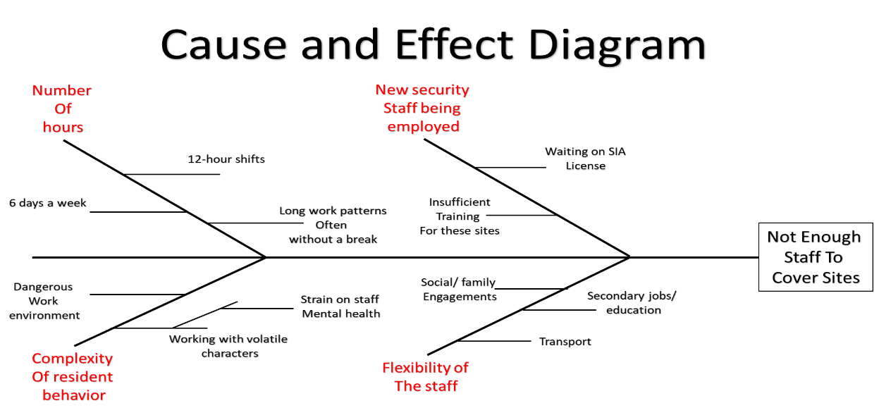
There are several root causes for the issue of reduced number of staff to cover the sites, above is a cause-and-effect diagram stating why there are limited number of staff.

3.4 Mind mapping
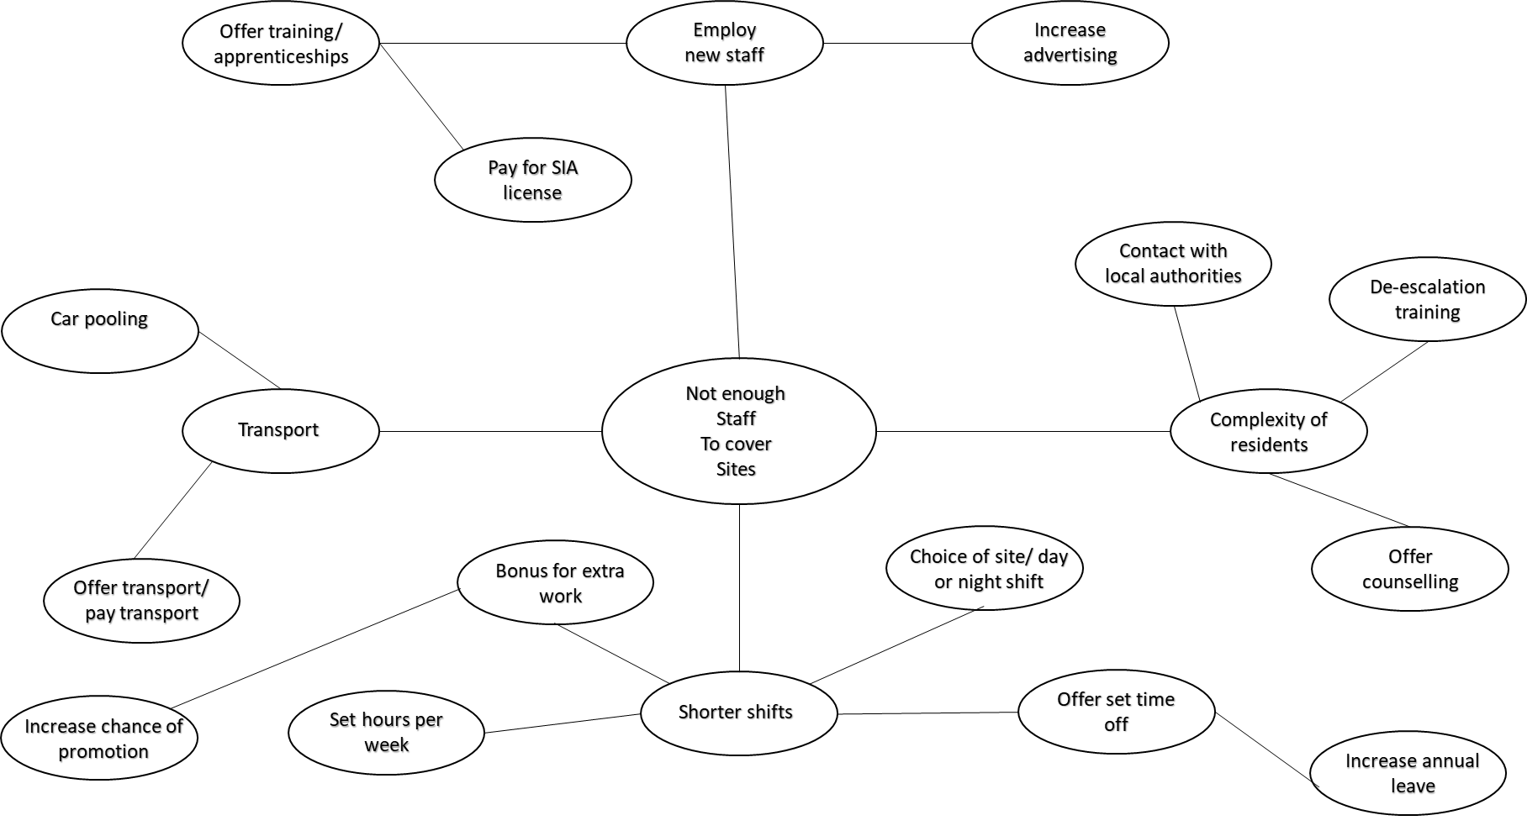

3.5 Brainstorming
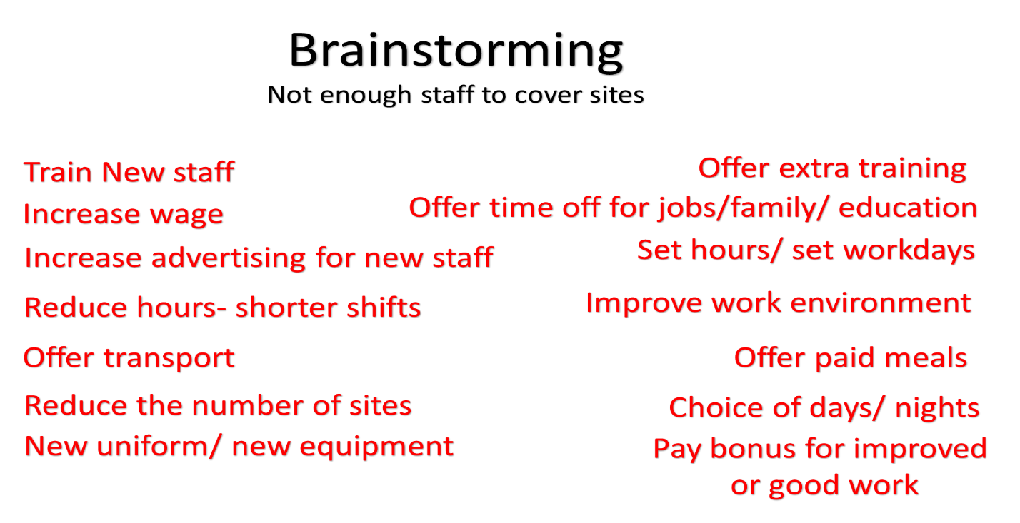
(Wilson, 2013)

4. Propose a range of alternative solutions to the problem

4.1 Solution 1: Hire and fire

One solution is to increase the advertisement of security staff needed by the company, this would involve posting on several platforms and researching other competitors to offer a better rate of pay. Increasing the number of new staff, and ensuring they are trained appropriately that fits the need of the sites. Also, by removing member of staff from site that are having increased number of sicknesses, where they are not showing a good work ethic, or having them work only specific sites on specific shifts to see if this would affect the number of sick days.
Usually with staff changes there is a change in work ethic amongst current staff, where they will either thrive or show their weaknesses, this will then become a less urgent problem and then small adjustments can be made. In this way sites will be covered, with the main issues to staff shortages being more evident.

4.2 Solution 2: Decrease work hours

By decreasing the work hours from 12 hours to 6 hours, splitting the shifts, current staff can have choice of night and days, with the option of split shifts. Also, by shortening the shifts staff don’t feel as under pressure or worn down, with is better for their mental health, and may even decrease the number of sick days. Shorter shifts would even mean that there is no need for staff breaks, there is also time for family/ social engagements, time for secondary jobs or education. This also increases the number of hours staff would have between shifts to allow for sufficient rest, sticking to the laws and legislations put in place by the Welsh Government.

4.3 Solution 3: Set staff to set sites

By having Set Staff to Set sites this allows the staff to know where they are going have transport put in place to and from the site. The staff will also have familiarity with the residents on the site, this professional relationship will allow for a case of less incidents at the sites and less need for local authority involvement. The staff knowing the sites as well will develop a routine, making is possible for training of the new staff to the site. A set routine increases work ethic, knowing what to expect, how situations should be handled, relieves stress from the workday. Another way in which this solution works, is that if a member of staff is struggling at a site, they can be moved to another site more fitting to them, matching the security guard to the need of the site and the requirement of skills to fit the residents.

4.4 Solution 4: Definition of day and night shifts

Separation of the night and day staff, instead of members of staff switching between working nights and days, they can have preference to their sleeping pattern. For those capable of working early till late and vice versa, they will be put on a work pattern more suitable to them. Having a set work pattern helps with stress, routine, mental health, and work ethic. The continuous switching between night and day work patterns, especially on long shifts such as 12-hour shifts can make it difficult for staff and they do start looking for other options of employment more suitable to them, and their level of flexibility. Also, this would decrease the number of sick days or times where member of staff has been late to work, with current staff on site having to stay on longer till the next security guard is able to get in or having to find cover from other sites until the next security guard is able to make it to site.

4.5 Solution 5: Transport

By offering transport to members of staff, this way it can be assured that members of staff are making it to site on time, also it relieves the stress of travel from the day, having to ensure they have transport or find money from their wages to afford transport cost. Transport is also needed between sites in time of emergency, where in the case of an incident of member of security staff may need a secondary security guard to de-escalate a situation or make contact to local authority if needed.

4.6 Obstacles and barriers

One of the main obstacles is cost to the company, with shortage in staff there is an increase in the amount of tax to pay to the staff working more hours. Cost for the solutions as well, in the case of offering transport, how much will transport cost, how much of a distance from the sites is the security guard, how much will it cost in transport each week, how many shifts does this security guard work each week. Cost is also important when being in new members of security staff, how much will it be advertising for new security guards, where in the budget will the cost of advertising come from? These are important expenditures to be considered in each solution.
Barriers to the solution as well is the staff themselves, will they be happy with any of the solutions offered to them, or will this encourage the remaining staff to also leave the company. Members of staff may not want to decrease their shifts or have changes to the sites or may even be happy working multiple sites instead of being placed at one site. Another barrier is the laws and legislations around working hours, it must ensure that the number of hours and the rate of pay is suitable for a living whilst also have set number of hours between shifts to allow for all members of staff to have a suitable rest.

5. Using a decision-making technique, evaluate a range of solutions to identify the most appropriate option

5.1 Evaluation of solution 1

To hire more staff increases issues of having to train and prepare the new staff to the sites, being reliant on current staff and management to have them trained which can be pressurising to current security guards on top of their current duties on shift. There is also a cost to advertisement for job availability in the company, and time for management to conduct interviews, the cost of background checks ensuring they have a CRB check when working with vulnerable adults, and a current in date SIA license with no criminal record that can affect their application. Another issue is with changes to the security guard team, by adding newer or less experienced members it can make an effect to the team, causing disruptions to other security guards working pattern, or by making the team less strong, every time a new member is added the team will change, this could be for the worst, changing work ethic, increased sick days.

5.2 Evaluation of solution 2

By decreasing the work hours so instead of 12-hour shifts, switched to 6- hour shifts, it may not be sufficient for current security guards who are comfortable working long hours, or set days/ nights. They may have issues with transport, having transport at beginning and end of day but struggling with transport in the middle of the day if they do not have their own transport. Security staff may also not see benefit and consider it a loss in hours and to which a loss in wages. Also, by having shorter shifts, more staff are required for handover, means a handover is required in the middle of the working shift, an increase in staff to cover 4 shifts in a 24-hour period, instead of 2 staff in a 24-hour period. It would be beneficial for security staff with secondary jobs, in education, or with family commitments, this short shift would be tailored to them and would encourage them to stay rather then take shorter shifts at venues. Although by having shorter shifts it does allow for more availability of shifts for current staff who do want more flexible shifts, by making the shifts more flexible than the security guards have a greater choice of shifts, when to work, give them a greater job satisfaction.

5.3 Evaluation of solution 3

Having set staff to set sites can be beneficial, staff will know the residents, know what to expect, know the routine they will feel more comfortable. Now staff are only aware of the site in which they are working the day before there shift is to begin, from there they must plan their own transport, if they are not aware of the site they must arrive early for full handover of the residents, the layout and routine of the site. An issue with set staff to set sites is that security guards may have an incident at a site the previous day and not wish to attend that site again and be unable to move sites, which may cause them to call in sick, lead to poor job satisfaction, lower work ethic.

5.4 Evaluation of solution 4

Having a definition of day and night staff although beneficial to security guards being able to set sleeping patterns, work rest patterns and work patterns, there is always an issue of changes in circumstances. Change in circumstance could be a change in a person’s personal life to mean that can no longer work that pattern, someone working nights and taken up education so would prefer to move to days, but there is no availability on days, and so their education and sleep pattern suffers, work ethic suffers, sick days increase, punctuality decreases; they start increasingly becoming later to work, missing shifts, oversleeping.

5.5 Evaluation of solution 5

Transport being provided to the security guards can be both beneficial to covering the sites and ensuring staff are punctual, but also come at a cost to the company. It’s important to work out cost of the transportation for each member of staff that requires it, compared to their working pattern. For example, it would not be cost effective to provide transport to a security guard working 2/3 days a week and lives more then 10miles away or provide extra money for train fares. If a train per week is costing £150 but the security guard is only able to work 2/3 nights a week but not full shifts to be able to make their transport, it would not be cost effective.

5.6 Ranking of solutions: Grid analysis

From the grid analysis above having set staff to days and nights, is the best solution, with little effect to cost, fits with the laws and legislations, sites are safe and secure, with set 12-hour shifts available. Although scoring low on staff satisfaction it still is considered the best option for the company.

5.7 Ranking of solutions: Cost benefit analysis

Estimating that the price of fuel is 117.0p per litre, which is £5 to the gallon. If they are being paid 40p per mile and travelling 15 miles to work and 15 miles home. Fuel cost per security guard per day would be £12 per day. If a security guard works 5 days a week for 4 weeks fuel cost would be £240 per month. If the company has 6 security guards that drive, the cost would be £1440 per month for all 6 guards.
Monthly train ticket from the valleys to Newport £198.0 if 5 security guards travel along that route over the period of a month the cost would be £990 per month.
This cost analysis shows that it would not be beneficial to the company to pay for transport for the security staff to attend work, they need to ensure that they have their own transportation and are attending their shifts to be able to afford their own transport. However, compared to the profit made from the contact, the benefit analysis shows.
Benefit to cost ratio = total benefits/ total costs = £76,000/£17840 = 4.3:1
Net monthly benefit = monthly benefit – monthly cost = £9500 – £2230 = £7270
Total monthly benefit = total benefits – total costs / 8 = £76000 – £17840 / 8 = £7270

6. Develop a detailed plan for implementing the solution

6.1 Objectives

- Ensure sites are covered
- Ensure staff job satisfaction
- Ensure cost and expenditure are low
- Ensure low number of incidents
- Ensure all staff are correctly trained to the sites
- Ensure there is a low number of sick days
- Ensure are having appropriate rest between shifts with rest

6.2 Tasks and deadlines

6.3 Progress charts

6.4 Gnatt Chart
(Wallace Clark, 1922)

7. Communicate the plan to relevant stakeholders

7.1 Who are the stakeholders?

The stakeholders in the company are the one who have the most to lose if the company were to struggle. With the loss of sites, there would be a loss of hours to the employees including management, this includes the security guards, having an affect on their wages and to their families. There would also be an affect to the residents on the sites, not having a consistent security company for their protection, for the social officers to the site that support the residents, to local authority where they would have little report in the case of incidents and support in the event of an incident. (Archie B. Carroll, 2014)

7.2 What are the stakeholders’ expectations of the security company?

The stakeholders have expectation of having fully train security that work consistent hours, hour that are available with living wage. The company must ensure that all security guards are fully trained and checked, that the company are supporting their rights and ensuring they are getting sufficient rest between shifts. That the company not only has outlined but are aiming to support their set out objectives.

7.3 Effective communication with stakeholders

It is important to always have communication with the stakeholders. With the employees there is always direct communication between management and employees via mobile communication, whether text, or using relevant apps such as WhatsApp. Management and administration also maintain communication with site owners and site contracts, in this case the local county council, with weekly updates and reports with list of residents, daily changes to resident’s situations, emails with updates to changes to the site and site directives. The social workers are communicated with Monday to Friday, their usual working pattern, by the security guards to ensure that residents on that site are following rules and guidelines set in place for their housing with local county council.

8. Assess appropriate monitoring and review techniques to ensure successful implementation of solution

8.1 Monitoring and review techniques

There are many different forms of monitoring and review techniques, in the security company it is mostly monitored and reviewed via the management from feedback from the security guards and during inspections. Security guards will check in whilst on site every hour to ensure that the site is running correctly that other member of staff have made it to site, that outside sources are on site; inspectors, representatives from the county council, support workers, new residents, evictions on old residents, local authority have been reported to site. In the case of solving problems security guards will report back to staffing difficulties, and managers will adjust to support the security guards regular working pattern, covering sites, finding cover, etc.
The most important method is progress reports and monthly reports accepted from each site, this way it is easy to define which member of staff has been to which site at what time. In this case it is then able to outline whether a member of staff is working more, has covered shifts compared to the rota, here sick leave can be reported. This can then be charted on the number of hours each security guard has worked and trends defined and spotted quickly over the month, from here adjustments can be made.
Progress appraisals are then used 3 monthly to get one to one feedback from staff, outline where staff are doing well and where improvements can be made. The feedback can then be used to improve or make changes to the functioning of the company, this feedback is documented straight to the management. (Dietrich, 2014)

8.2 Communication plan linked with monitoring

References
Archie B. Carroll, A. K. B., 2014. Business and Society: Ethics, Sustainability, and Stakeholder Management. First ed. Georgia: Cengage Learning.
Dietrich, G., 2014. Communication and Reputation Management in the Digital Age. First ed. Chicago: Pearson Education.
Done, P., 2018. What is the legal number of hours employees can have between shifts?. [Online]
Available at: https://smallbusiness.co.uk/what-is-the-legal-number-of-hours-employees-can-have-between-shifts-23066/
[Accessed 26 08 2021].
Dr Eric Bolland, D. F. F., 2012. Business Problem Solving. Surrey: Ashgate Publishing Limited.
Gov.uk, 2021. Contracts of employment and working hours. [Online]
Available at: https://www.gov.uk/browse/employing-people/contracts
[Accessed 08 26 2021].
Hicks, M. J., 2013. Problem Solving in Business and Management. First Edition ed. Thames Valley: Springer US .
Imai, M., 1986. Kaizen (Ky'zen), the key to Japan's competitive success. Japan: Random House Business Division.
Wallace Clark, W. N. P. F. W. T., 1922. The Gantt Chart, a Working Tool of Management. New York: Ronald Press Company.
Weiss, A. E., 2012. Key Business Solutions: Essential Problem-solving Tools and Techniques that Every Manager Needs to Know. London: Pearson Education Limited.
Wilson, C., 2013. Brainstorming and Beyond. First ed. Oxford: Elsevier Science.

