Management Economics

ASSIGNMENT 1
Module code: LCBB5008
Emil Slavov (2122223)
Lecturer's name: Stephen Asafo Agyei

Table of Contents
Question 1 2
Question 2 6
References 12

Question 1
- The main economic problems highlighted in the case study are the effects of the pandemic on the overall economic system of the UK. The main impact was seen in the supply side of the economy where firms and organisations had to stop their production due to the lockdown. This reduces the total output of the country and induces the country into a temporary recessionary phase. Given that the lockdown was severe and places were shut down it also gave rise to high levels of unemployment. Not only the lockdown was imposed on the domestic transport system but also it involved the international logistics and hence affected the global supply chain
(Griffith 2003)). In the domestic economy the supply chain runs smoothly when each and every party timely maintains their supply of the raw materials that are used in the final production. The supply chain starts from the procurement of the raw materials to making it into the final product through technology and use of human labour along with it's packaging and final distribution to the markets for consumers use. The distribution of the raw materials from one place to another and again from the production unit to the market inverse the use of the transportation system. During the pandemic this aspect of the supply chain was halted which resulted in severe shortage of various goods and necessary products which were demanded by the consumers for surviving the lockdown. It is important to note that the supply chain issue was not only within the United Kingdom but also on the external side of the economy and hence the global supply chain was impacted by the pandemic. The pandemic was not the only problem that triggered the supply chain issues; however (Kreps 2019), the exit of the United Kingdom from the European Union was also another reason. Brexit initiated a series of supply chain issues due to shortage of suppliers from the European Union, importers from the UK lost many of their suppliers due to this brexit which also led to shortage of fuel supply and other products. During the pandemic certain consumer behaviour also leads to shocks in the market because a demand shock can also destabilise the market. Consumers went on panic buying various necessities and essential goods in fear of not getting them when they might need or run out of their inventory (Stevenson and Wolfer 2020 ). This was known as panic buy that led to shortage of various necessary goods off the shelf in many supermarkets for the UK. Panic buying also results in lack of access to medicines, food, tissue papers, staple foods like noodles for many low income households. Due to high levels of unemployment it also leads to people utilising their savings to sustain their consumption and this results in a complete shift of consumer behaviour in the economy.
In the post pandemic period on the other hand the supply chain issues did not resolve mainly because of the bottlenecks that triggered during the pandemic. Due to shortage of supply the price of fuel in the United Kingdom increased to a very large level which made it unaffordable for many households (Osadiya 2023),. Their cost of living increased because fuel shortage was acute throughout the economy. There was an inflationary situation due to the shortage of supply of fuel that led to higher cost of production for many goods and this resulted in a general rise in the prices of food, vegetables, imported goods along with housing and mortgages. Another issue witnessed during the post pandemic period was high demand for consumer goods which were otherwise not accessible during the pandemic due to supply chain issues. Most of this consumer goods are manufactured and imported from China, and resultant outcome of such high demand for consumer goods was seen in high prices for storage containers and delay in shipment in Major ports of China as well as the UK (Pindyck 2018).
- Market economy is that economy where the operations and function of the market is given importance. The issues are mainly related to the supply of the goods and products during the crisis situation and also the disruptions in the domestic as well as the international supply chains. According to classical economics the market can work on its own to reach equilibrium when due to external factors the equilibrium is not attended or the market is destabilised. However the market is not always self correcting because there are backlogs and restrictions that are connected which can resist the process of attaining equilibrium. This is where government intervention is required to boost the economy and reach a suitable equilibrium (Bagwell 2005). Given the aspect that markets might not always be self correcting in temporary situations there is a need for government intervention. Given the issues related to supply chain along with temporary inflationary situations and households drawing down their savings to sustain during the lockdown demanded for policies by the government that stabilises the economy. The UK Government under various immigration regulations and other financial support suffered heavy losses for the consumers who were divided in any form of employment and their monthly salary (Baker (2003). During the crisis period like that of the pandemic, there are various managerial strategies that can be taken to ensure the firms and companies do not run out of their inventory for they are able to calculate and forecast the market demand very quickly. Undertaking a stakeholder analysis function businesses can keep their communication clear with the consumers and suppliers about their productivity and output along with initiating changes within the supply chain that makes the procedure of supply cost efficient and easy. Furthermore companies can undertake their own renovation and research to reduce waste materials such that they can be recycled and used as raw materials for manufacturing. This way the supply chain is generally diversified and greater communication with the suppliers can also lead to better advantages in terms of price of the raw materials or intermediate goods. It is also important to note that this type of communication and diversified supply chain can actually make the economy resilient towards crisis periods like that of the pandemic and can also reduce the suffering of the consumers as they face very high inflationary prices for fuel and other goods (Foot and Gomez 2006)). In understanding the role of the government it could also be said that during the pandemic the supply chain issues could have been reduced with lesser stringent rules about healthcare which could be altered and manipulated safely. For example this is mainly seen in cases of companies that offered working from home employment to their employees because in this manner the supply of necessary products and raw materials were not delayed and the process of production and supply was possible by providing a different working environment for important employees. Hence the government can always define rules and regulation based on some benefits acquired to the employees and working class as a whole. Any recessionary period is unproductive for the banking sector and this induces the banks to go bankrupt without much business and this creates a lack of liquidity in the economy. With shortage of liquidity and financial aid available the investments go down, and this is why the government might need to take up fiscal and monetary policies to support the whole economy (OECD 2015)). The fiscal policies mainly include changing the government expenditure and taxation rates to raise the income of the consumers and hence the aggregate supply. While the monetary policy is taken by the central bank of the economy where they change the money supply in the economy and change the interest rate which incentivises the firms to make more investments and raise the market supply (Griffith 2003).

Question 2
- Demand and supply are relevant in the businesses and running firms because firms can set their prices according to the market conditions. Furthermore, pricing strategies are based on the market demand and hence the demand determines the supply quantity of the firms. The firms are able to analyse their own demand and hence sets the prices under an imperfect competitive market. However in a perfectly competitive market the firms are the price takers as demand and supply forces determine the prices. In perfect competition there are numerous firms competing against each other, they do not have a high supply share in the market and thus they cannot control the prices. Due to this high competition a perfectly competitive market sets the price according to the marginal cost of production which for most firms are taken as constant as they all produce homogeneous goods. In an imperfectly competitive market the goods produced are different for each firm and hence their cost of production is different, this allows the prices to be set according to the markup known as the Lerner's Index (Besanko and Braeutigam 2020). The prices are set according to the elasticity of the price, thus with higher degree of competition it drives down the prices much lower. The firms are not able to earn supernormal profit with higher levels of competition. The aspects of demand and supply are important for making business decisions, because they can tackle necessary steps to increase their supply and expand their business in different markets and other foreign countries. For example, many multinational companies expand in international markets or markets of other countries when the domestic market is saturated and there are very few opportunities to grow the business. Growth and expansion into new markets require the opportunities and benefits of production in a foreign market. The demand and supply are the key aspects firms need to know to promote their business and enhance their marketing techniques (Acemoglu, D., Laibson and List 2019). With forecast and study of market demand the firms are able to analyse their supply capabilities and this helps them maintain their inventories at optimum levels. In recessions it is normal that the firms are not able to clear their inventories and they are not able to sell their products, while during boom inventories need to be replenished frequently. From this perspective the demand and supply analysis keeps the inventories at a required level to get the maximum profits. Forecasting the demand can also let the firms finance their investments in time and lead to better flow of resources needed for manufacturing. Furthermore the firms are attracting investors from foreign nations to invest in new technology which they might have developed that can reduce their costs of production. With better forecasting of demand the firms can set a target of profit and sales and initiative policies that allow the workers to boost their productivity, this can retain the employees and enhance their employee satisfaction as with higher productivity comes perks and benefits of incentives and rewards. With firms able to reach their targeted sales they also are able to capture the market with their products. With the knowledge about market conditions the firms can avert risks within their production system and enhance their resilience through techniques of inventory manipulation and plan their production aligned with their goals and interests. The firms are also able to plan their supply ahead of time and lead to a market clearing when the demand might rise suddenly and the equilibrium can be achieved in the process. For example in seasons of say food festivals in a region food based firms are able to contact the suppliers and start their manufacturing in time. When they have some knowledge about the number of visitors in the food festival they can plan their sales target and costs of production in case of bulk production (Kreps 2019. ).
- Demand elasticity is the change in the quantity of demand when the price of the commodity changes. Elastic demand means that the quantity changes to a larger extent than the changes in the prices. Elastic demand is seen for those goods which are not necessary goods, these goods have higher number of substitutes and the consumers have options to choose when the prices rise. For example elastic goods are luxury goods like automobiles with many substitutes available in the market. There are many other variations of a car and they are not necessarily good as public transport is always there. In this case a 5% rise in the prices of cars will lead to a 10% fall in the quantity demanded by the consumers. The demand curve below shows the elastic demand (a flatter curve) (Mankiw, Kneebone and McKenzie 2020). Then there is inelastic demand for goods which are necessary goods, necessary goods are those goods whose requirement generally does not fall in the short run period. A very good example of inelastic goods is rice, a staple food product whose demand does not fall with rise in the prices. It is essential to note that consumers do not reduce their food consumption drastically, there are very few substitutes for rice. Here when the price rises by say 10% the quantity demanded does not fall by even say 5%. This creates a stepper demand curve as shown in the figure below.
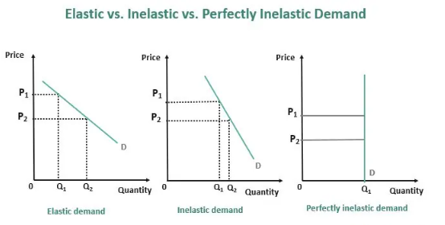
Figure 1

Businesses give importance to understanding the elasticity and inelasticity of demand because they set their prices accordingly. Elasticity helps the businesses understand their prices and revenues as in case of elastic demand revenues move in opposite directions. While in case of inelastic demand the firms can increase their revenues when the price rises. The most important disadvantage of elasticity of demand is that the firms have to change their prices with time as elasticity can change with time. Furthermore the disadvantage of inelasticity of demand is that the firms cannot reduce their prices to boost their sales, as revenues and inelasticity are indirectly related to each other. The setting of the prices are thus based on the Lerner’s index which says that the firms cna put the highest markup when the elasticity is low and hence earn higher profits (Acemoglu, Laibson and List 2019).
- The law of demand governs the consumers behaviour while the law of supply governs the behaviour of the firms. The laws of demand are related to how the demand changes with respect to prices, income and prices of related products. While the laws of supply are related to how the supply from the firms changes with respect to prices of the product, cost of production of the firms and the availability of new technology of production. For example the demand curve shifts to the left and keeping the supply the same the equilibrium price falls and the total quantity in the market also falls as shown in the figure 2 below (Pindyck 2018)
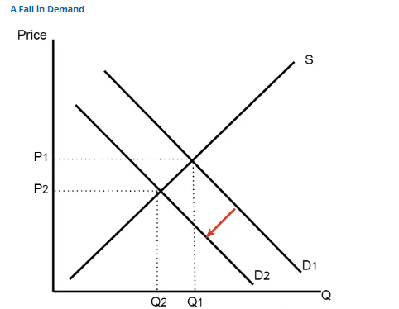
Figure 2
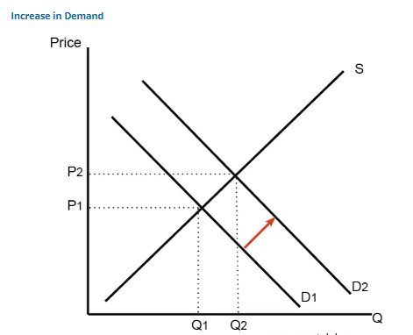
Figure 3
For example in figure 3, the demand curve shifts to the right or increases mainly due to rise in the income of the consumers. This causes the market equilibrium to increase and the price too rises.
Figure 4 shows that the supply has fallen due to a rise in the cost of production this cause the supply to shift to the left, and overall the market equilibrium will fall and the price will rise.

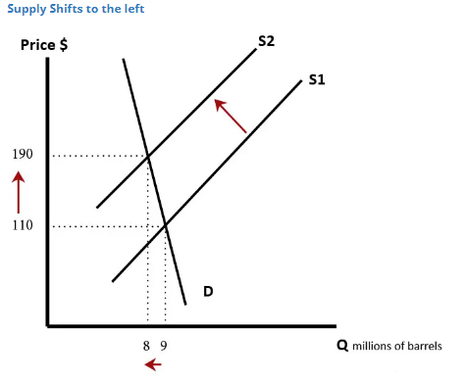
Figure 4
The Figure 5 on the other hand shows that due to a automated technology of production the supply has increased and the supply curve has shifted to the right, keeping the demand same the total market equilibrium will rise and the price will fall (Browning and Zupan 2020).
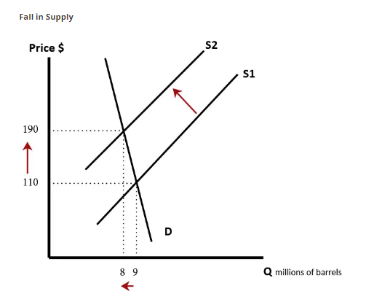
Figure 5

References
Acemoglu, D., Laibson, D. and List, J.A., 2019. Microeconomics.
Bagwell, K. (2005) The Economic Analysis of Advertising. Columbia University Discussion Papers No. : 050601
Baker, J. (2003) Competitive Price Discrimination: The Exercise of Market Power Without Anticompetitive Effects (Comment on Klein and Wiley). Articles in Law Reviews & Other Academic Journals. Paper 278.
Besanko, D. and Braeutigam, R., 2020. Microeconomics. John Wiley & Sons.
Browning, E.K. and Zupan, M.A., 2020. Microeconomics: Theory and applications. John Wiley & Sons.
Ellickson, P. (2013) Market Structure and Performance. International Encyclopedia of the Social & Behavioral Sciences, Forthcoming; Simon School Working Paper No. 13-21
Foot, D. and Gomez, R. (2006) Population aging and sectorial growth: the case study of the UK, 2006- 2026. OJBE, 5:1
Griffith, G. (2003) The Impact of Supermarkets on Farm Suppliers. The Australian Economic Review, 37, 3, 329–336
Kreps, D.M., 2019. Microeconomics for managers. Princeton University Press.
Mankiw, N.G., Kneebone, R.D. and McKenzie, K.J., 2020. Principles of microeconomics. Nelson Education Ltd..
OECD (2015) GENERAL ASSESSMENT OF THE MACROECONOMIC SITUATION. OECD Economic Outlook Volume 2015/1
OECD (2015), OECD Employment Outlook 2015, OECD Publishing, Paris. Available at: http://ifuturo.org/documentacion/Employment%20outlook%202015.pdf
Osadiya T. (2023), Introduction to Economics. Amazon Rauch, D. and Schleicher, D. (2015) Like Uber, But for Local Governmental Policy: The Future of Local Regulation of the 'Sharing Economy'. George Mason Law & Economics Research Paper No. 15-01. Available at: http://ssrn.com/abstract=2549919
Pindyck, R.S., 2018. Microeconomics.
Stevenson, B. and Wolfers, J., 2020. Principles of microeconomics. Worth Publishers.
Tahir, S. and Aidit Ghazali, S.O.S.A. eds., 2017. Readings in Microeconomics: An Islamic Perspective. In The Name of Allah, The most Beneficent, The most Merciful, p.104.

