Laura Glover

ECIE5004 – Celebrating Language and Culture Belonging to Wales

Prepare a portfolio that includes an activity or activities that promotes Welsh language in your setting.

Contents Page.

Page 3-5: Rationale

Page 6-7: Activity 1.

Page 8: Activity 2

Page 9-10: Appendices

Page 11-13: References

This portfolio will be exploring the history of the Welsh language and how it has impacted education in Wales throughout the years. It will consider how education in Wales is contributing to the desired increase of bilingualism to broaden the use of the Welsh language. This portfolio will also demonstrate two activities used in a school setting to promote the Welsh language and culture.

Rationale

The Welsh language is one of the oldest languages in Europe believed to have originated between 400 and 700 AD and is identified using poetry during this period. (Brain, 2024). The language has been the subject of political pressure and social discrimination, yet it remains an integral part of Welsh history and culture. One of the earliest examples of Welsh literacy is the Black Book of Carmarthen, which is thought to date around 1250 and is the oldest surviving manuscript written entirely in Welsh (National Library, 2025). The book contains poems, religious scripture and references to legendary figures, such as King Arthur.
The Welsh language and bilingualism have been the subject of oppression and scrutiny from as early as the 1500’s and its decline began following the Laws in Wales Acts between 1535 and 1542. Under the reign of Henry VIII, the Act dissolved any political or law-making difference between England and Wales, which had a devastating impact on the Welsh identity. Welsh Laws which had been in place since medieval times in Wales were abolished, and the Welsh language was eradicated from the public administrative system (Senedd Cymru, 2025). This means that at a time when the Welsh language was dominant in Wales, Welsh speaking citizens who found themselves in a court of Law could not access legal representation in their first language as it was illegal. The change in legislation marked years of social ostracization that contributed to the perception that the English were superior and better educated.
The perception of the Welsh language continued to decline, especially within the education system. Welsh speakers were considered poorly educated and the use of the Welsh Knot became a symbol of punishment for Welsh learners (Johnes, 2024). Children caught conversing in Welsh were humiliated and forced to wear pieces of wood around their necks, and the child wearing it at the end of the day would be punished. This behaviour discouraged children from using their first language and led parents to stop teaching their children Welsh for fear of punishment, leading to a further decline in the Welsh language (Felin Fach 2025). Sociolinguists research suggests this is a common pattern in language replacements and there are three stages in which replacements occur (Johnes, 2024). By the nineteenth century stage three was already impacting young children who were using their first language less due to the social and economic impact within the education system despite having parents who were fluent in Welsh (Johnes, 2024). See Appendix 3.
The twentieth century saw opinions begin to change towards the Welsh language and this was encouraged by The Welsh Courts Act 1942 and The Welsh Language Act 1967, both legislations were victories for Wales as it gave power back to the Welsh courts and legislation as people were now permitted to use Welsh in legal proceedings (Language Commissioners, 2017). This was followed by The Welsh Language Act 1993, which legislated that a small number of public administrators, including education authorities were required to treat Welsh and English equally. The introduction of the act gave some status back to the Welsh language and bilingualism in Welsh education as it was removing the stigma attached from previous years (Iorwerth. R, 2024).
The Welsh Language (Wales) Measure 2011 was a pivotal piece of legislation as it established a legal framework to impose a statutory duty on public bodies in Wales to comply with new Welsh standards (University of South Wales, 2025).
In 2014 the Welsh Government asked Professor Graham Donaldson, an expert in his field to carry out an independent review of the Welsh Curriculum with the aim of improving education and practice. Donaldson travelled to Wales, visiting schools and discussing the current curriculum with children, their parents and school staff (Educate group, 2019). The review found that education in Wales was outdated and focused too heavily on testing. Children reported they wanted to experience and learn more about life skills and the current curriculum also lacked digital input and IT involvement (Senedd Cymru, 2024).
Once he had conducted his findings, Donaldson published, a modern more intentional curriculum built around four purposes and six areas of learning and experience (AOLE). This curriculum includes an emphasis on skills including digital involvement and its use within the AOLE’s whilst providing teaching staff more freedom in the way they teach. (Impact Wales, 2025).
One of the AOLE’s is language, literacy and communication, this area puts an emphasis on the importance of learning about Welsh culture and language within education whilst also providing the opportunity for children to develop bilingual skills. The aim of this is not only to breathe new life into the Welsh language, but to assist the Government in their pledge to have one million Welsh speakers by 2050. (Welsh Government, 2025). The Cymraeg 2050 Welsh language action plan is working alongside the new curriculum in Wales, and The Welsh Language and Education (Wales) Bill to create more Welsh speakers in Wales. The plan is to promote bilingualism primarily through education beginning at pre-school age with Cylch Meithrin, a Welsh nursery provision. (Welsh Government, 2025). This will filter through to flying start programmes and into compulsory education for all ages. Research shows the cognitive benefits of being exposed to more than one language and why the chance of bilingual success improves when introduced at a younger age. (Early education, 2022). The Governments approach to promoting and supporting bilingualism from preschool age will not only provide the child with opportunities and learning experiences but will also expose the non-Welsh speaking families of those children to the Welsh language and bilingualism.
Donaldsons review was welcomed by the Welsh Government and became the foundation for the new Curriculum for Wales. Donaldsons’ findings became embedded in Welsh legislation and saw the end of key stages and assessments that were believed to limit a childs ability to learn individually (Senedd Cymru, 2024). The report has been both celebrated and criticised, and whilst widely supported. Some critics believed the changes were too broad and rapid to be effective in the long term due to the pressures faced with a lack of teaching staff and growing numbers of learners with additional learning needs (Donaldson. G, 2024). However, it is also argued that the flexibility offered by the new curriculum in Wales with its new focus on practical learning is a more free and accessible approach to learning and the curriculum benefiting learners with additional learning needs (Welsh Government, 2025).
The history of the Welsh language reflects centuries of political suppression, discrimination and education exclusion that his contributed significantly to its decline. From the Laws in Wales Act 1535 Welsh speakers of all ages were systematically discouraged from using their first language. These measures not only reputation of the Welsh language and its people but has also shaped a narrative about the Welsh language and culture that is still felt today. Despite history and its efforts to eradicate the language it remains an intricate piece of Welsh culture.
While challenges remain and the number of Welsh speakers isn’t what it once was, the current approach to Welsh language and culture under the new Curriculum promotes bilingualism, cultural identity and inclusive learning experiences in an active attempt to revive and secure the Welsh language and is strongly encouraged by the practice we see in Welsh classrooms today.

Activity 1

The first activity School A uses to promote the Welsh language, and bilingualism is Dewi y Ddraig also known as Dewi the Dragon. He is the class mascot for the children in reception, and every Friday he is taken home by one of the children in class A.
Dewi is accompanied home with an activity book where children and their families are encouraged to document their weekend with Dewi with photographs and bilingual descriptions. Families are also provided with instructions, bilingual flashcards with colours, numbers and popular phrases to assist the children and their families. This supports families who do not have any experience with the Welsh language and makes the activity accessible for users who use English as an additional language or households who have adults with additional learning needs or limited literacy skills. The concept is built around Vygotsky’s zone of proximal development theory (ZPD), Vygotsky’s theory suggests that we learn as there is no physical more knowledgeable other (MKO) to assist families during their weekend, they are encouraged to scaffold and develop their ideas from pictures of Dewi’s past adventures.
The children thoroughly enjoy taking Dewi home and including him in their adventures. The excitement on a Friday afternoon is palpable, and the children fully immerse themselves into the role of Dewi’s companion. The effort and contributions from children and their families is always excellent, parents and carers follow a similar format in terms of the layout of Dewi’s adventures, but the effort is usually collaborative between child and adult. This approach is supported by the National Policy of Welsh language remission to family’s policy; the framework has been initiated alongside the Governments pledge to achieve one million Welsh speakers by 2025. The framework aims to promote bilingualism through intergenerational language transmission (Evas, Morris & Whitmarsh, 2017). The initial study indicated there was a rapid decline in Welsh speak children between the 2001 and 2011 consensus and whilst there could be many factors impacting this decline, it highlighted the importance of the not only promoting the Welsh language for school learners but for their families too. Appendix 4. Activities and practices such as Dewi bridge the gap for Welsh learning between school and home. The children draw pictures and attempt to write their own Welsh phrases. Dewi provides a practical, bilingual approach to learning which is the foundation of the new Curriculum in Wales, and the AOLE’s legislated by the Welsh Government.

Activity 2

The second activity School A participates in is the Eisteddfod yr Urdd, held by Urdd Gobaith Cymru in various locations throughout Wales annually.
The event is a family friendly festival that invites schools and young people all over Wales to celebrate their art, talent and achievements at the Eisteddfod. The children can compete on a local, regional and national level and the Eisteddfod is an even that instils pride and awareness for Welsh language and culture. (Urdd Cymru, 2025).
Participating schools encourage the children to get creative in their efforts with poems, music, dance and creations. The event is inclusive to all to promote and encourage bilingualism and promote Welsh language and culture. It is an anticipated event in the Welsh calendar and now provides business opportunities to Welsh venders and business owners to hold stalls and join the celebrations. The Eisteddfod is an inclusive family friendly event and School A is a proud and active participant.
Whilst not all children are chosen to present their creations at the event, the entire student body are included in the preparation and lead up to the event by attending weekly Welsh assemblies. The assemblies encourage a sense of pride and belonging for the children, they are used as practice for the performers to allow them to develop resilience and to evaluate any changes they wish to make before they take the stage. School A encourage Eisteddfod participation to mirror the recently updated Curriculum for Wales and their introduction of areas of learning and experience (AOLE). Welsh Government (2025) states, ‘Engagement with the expressive arts can enhance learners’ employability as they are encouraged to manage their time and resources to achieve meaningful work and meet deadlines’. Whilst individual children perform at the event, the whole school becomes a part of the process and are encouraged to attend and bring their family and friends.
There is a tangible excitement around the school in the lead up to the National Eisteddfod and the children are not only able to express themselves through the arts, but they are improving their bilingual skills at the same time.

Appendices

Appendix 1: Photo’s provided by families of Dewi’s adventures and the bilingual description.

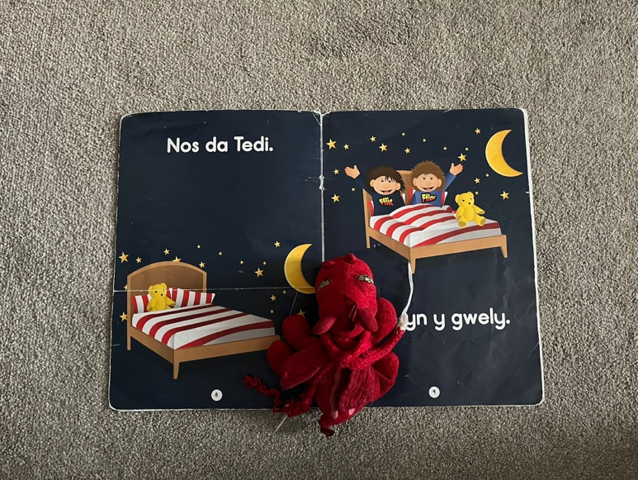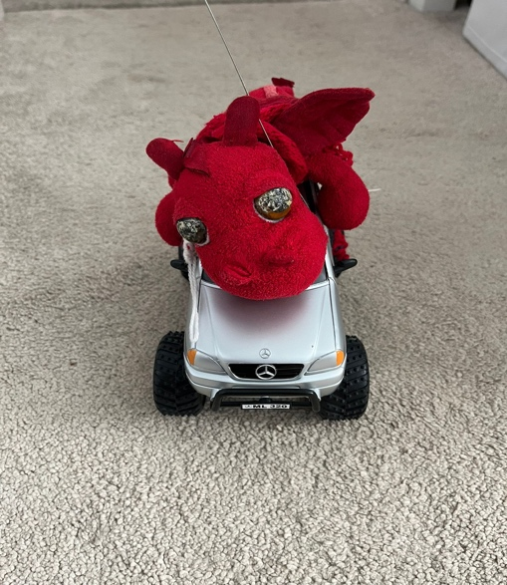
Tegenau - Toys
Stori Nos Da – Goodnight Story

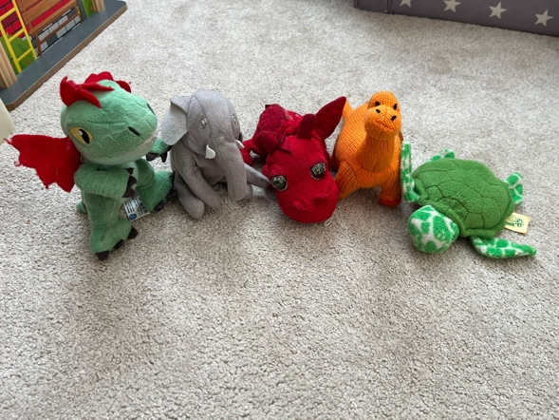
Ffrindiau - Friends
School A images (2025). Provided by parents of a reception aged child in Class A.

Appendix 2: Images during a local Eisteddfod held by School A

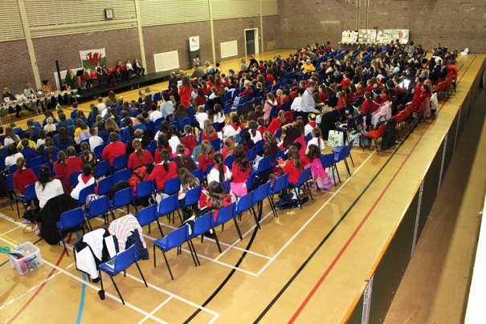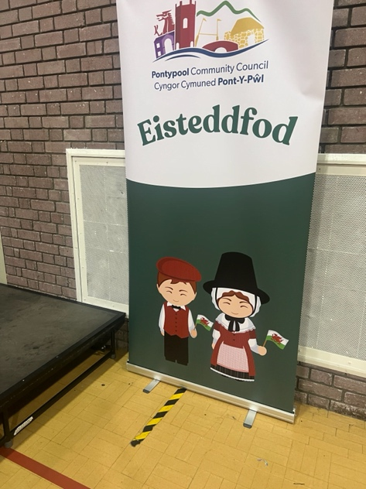

Appendix 3

This table reflects Welsh speaking children vs parents in Wales (Johnes, 2024).

Appendix 4

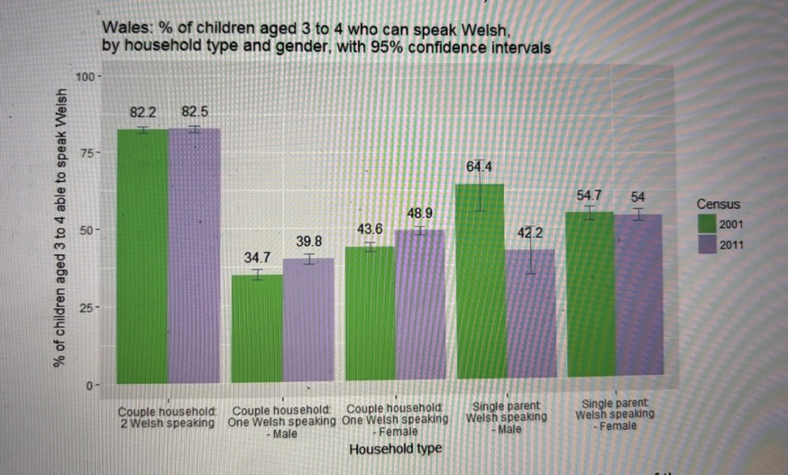

References

Brain, J (2024). The Welsh Language. Available at: https://www.historic-uk.com/HistoryUK/HistoryofWales/Welsh-Language/ [Accessed on: 02/01/2026].

Donaldson, G., (2016) “A Systematic Approach to Curriculum Reform in Wales”, Wales Journal of Education 18(1), 7-20.

Dunn, W.E. and Lantolf, J.P. (1998) ‘Vygotsky’s Zone of Proximal Development and Krashen’s i+1: Incommensurable Constructs; Incommensurable Theories’, Language learning, 48(3), pp. 411–442. Available at: https://doi.org/10.1111/0023-8333.00048.

Educate Group (2019). The Donaldson Review. Available at : https://educate-group.co.uk/2019/09/24/what-you-need-to-know-about-the-donaldson-report/ [Accessed on: 08/01/2026].

Education Wales (2025). Education is changing: Additional learning needs. Available at https://www.gov.wales/education-changing-additional-learning-needs [Accessed on: 08/01/2026].
Evas, J, Morris. J, Whitmarsh. L, (2017). Research into Conditions Influencing Welsh Language Transmission and Use in Families. Available at: https://www.gov.wales/sites/default/files/statistics-and-research/2018-12/170612-welsh-language-transmission-use-in-families-en.pdf [Accessed on: 08/01/2026].
Felin Fach (2025) Welsh not – A form of punishment. Available at: https://www.felinfach.com/pages/welsh-not-welsh-knot?srsltid=AfmBOooGntbTCrY7rX5TCXIqD6R18m95ST32purErxXMOTIsr5jyZ9lE [Accessed on: 04/01/2025].

HWB (2025). Areas of learning and experience: Expressive arts. Available at: https://hwb.gov.wales/curriculum-for-wales/expressive-arts/ [Accessed on: 02/01/2025].

Impact Wales (2025). Successful futures ten years on: Has it delivered success? Available at: https://www.impact.wales/news/successful-futures-ten-years-on-has-it-delivered-success/ [Accessed on: 08/01/2025].

Iorwerth, R (2024) Introduction of the first set of Welsh language standards. Available at: https://research.senedd.wales/research-articles/introduction-of-the-first-set-of-welsh-language-standards/ [Accessed on: 07/01/2026].

Johnes, M 2024, Welsh Not: Elementary Education and the Anglicisation of Nineteenth-Century Wales, Gwasg Prifysgol Cymru / University of Wales Press, La Vergne. Available from: ProQuest Ebook Central. [7 January 2026].

Language Commissioners (2017). The Welsh Language Act 1967: The first 50 years. Available at: https://languagecommissioners.org/userfiles/files/20170614%20DG%20S%20Sir%20David%20Lloyd%20Jones's%20Address.pdf [Accessed on: 06/01/2026].

School A images. Taken from parents of a child in Class A to use for their time with Dewi y Ddraig.

School B images. Available at: https://pontypoolcc.gov.uk/community-information/annual-events/schools-eisteddfod/ [Accessed on: 02/01/2025].

Senedd Cymru (2025). History of Devolution. Available at: https://senedd.wales/how-we-work/history-of-devolution/ [Accessed on 4/1/2025].

Senedd Cymru (2024). The Donaldson Review: The purposes and content for a curriculum in Wales. Available at: https://research.senedd.wales/research-articles/donaldson-review-the-purposes-and-content-of-a-curriculum-for-wales/ [Accessed on: 08/01/2026].

Senedd Cymru (2024). The Donaldson Review: The purposes and content for a curriculum in Wales. Available at: https://research.senedd.wales/research-articles/donaldson-review-the-purposes-and-content-of-a-curriculum-for-wales/ [Accessed on: 08/01/2026].

The National Library of Wales (2025). The Black Book of Carmarthen. Available at: https://www.library.wales/discover-learn/digital-exhibitions/manuscripts/the-middle-ages/the-black-book-of-carmarthen [Accessed on: 03/01/2025].

Urdd Cymru (2025). Eisteddfod yr Urdd Ynys Mon 2026. Available at: https://www.urdd.cymru/en/eisteddfod/mon-2026/ [Accessed on: 02/01/2025].

