Susana Raquel Da Cunha Balinha (2016797)
2016797@student.uwtsd.ac.uk
Emily Williams
Module code BMIH5005
Module Personal Resourcing and development
research project proposal

Contents page

2.Introduction & Background
3.Methodology
a) Research type
b) Research philosophy
c) Data collection
4.Discussion
a) Employee engagement
b) Benefits of engagement
c) Employee retention
d) Employee needs
e) Employee Wellbeing
5.Results and conclusion
a) Results
b) Conclusion
6.Tables & Graphics
1. Table
2. Table
3. Table
7.References

Introduction & Background

Hilton Leicester hotel is the base chosen for this project, with easy access just off the M1, strategically close to Fosse Shopping Park and Grove Park corporate offices and Everards Meadows. Only 20 minutes away from Leicester city centre and the University of Leicester and also 5 miles away from the National Space Centre. With 179 guest rooms, the Hilton Leicester hotel also has a health club, indoor pool, restaurant, café, and bar, and also provides a 24-hour business centre (Hilton, 2021).
This report was structured to evaluate a proposal on employee engagement after the impact of Covid 19 within the industry and the hotel itself. In the last two years, the pandemic had an unprecedented impact worldwide, and for this reason, many workplace transformations were not expected or even think of before the covid 19. In the work environment, this was negatively mirrored by the employees. In this report, we will discuss and demonstrate some implications in the most relevant area in need of support, as well as employee engagement and their benefits, employee retention.
At Hilton Leicester hotel relevant issues raise some concerns and require all our attention at this critical moment. Training and support will need to be put in place to support all of those who needed.
In the last two years organizations have had to reconsider how to engage and, more critically, how to retain the staff, (Phoenixoutcomes, 2021). And this proposal will demonstrate a better understanding of how Hilton hotel needs to perform concerning employee engagement and retention.

Methodology

Research type

- The understanding of the actual employee engagement and wellbeing in the hotel and the impact of covid 19 in the different areas

So on engaged employees are not only happy employees, are, according to Gallup, (2017), "those who are involved in, enthusiastic about and committed to their work and workplace".
Further research demonstrates that the raise of engagement and wellbeing has a favourable impact in some important aspects in organisation behavioural and this included an increase of productivity, a decrease of absence, and better customer service with a positive impact on the people involved, (GOV.UK. 2015).

Research philosophy

- The research will define the need of the employees and provide some solutions and conclusions.

Maslow’s Hierarchy of needs theory is the right tool to help us define and understand the needs and the motivational effects. A five-stage model and builds upon the preceding one, which improves motivation and creative thinking by making a person feel more gratified, (Indeed, 2021).

Data collection
- The primary source used is a survey with further research as a secondary source that will support the information, (survey photo for example).

The researchers suggest that an online survey is convenient to use and operate in real-time, anonymous, graphics and helps keep track of contexts by automating and introducing discussions online (Voicesifter, 2021). Often the employees have some feedback or even complaints that find difficult to raise face-to-face and an online survey when they can confidentially give their opinion openly. Since Hilton employees are back to work post-pandemic they are facing a high demand on their performance and feel that the management team and human resources department does not fulfil their actual need and fears.
Further researches suggests that regular researches, surveys, questionnaires or any gathering of feedback from part of the employer will help identify any uncertainties and will help to create a better bond with the employees.

Discussion

The research shows that by answering to customers, Hilton, (2021) post on its FAQ’s page that extra cleanliness procedures and more demanding have been put in place, guidelines from the local government like, like social distancing from team members and from the customers, to make them feel as safer as possible and hand sanitizing stations are displayed trough the diverse hotel areas. But what about the employees? Is Hilton hotel do enough support? Not much information has been passed through so the reason for this proposal is to take care of the employee engagement and wellbeing of the staff and make sure the retention rate is higher than the redundancy rate. Moreover, the information gathered in the survey showed once again the lack of support of the team and in consequence the lack of knowledge to give assistance necessary to the customers.

Employee engagement

Employee satisfaction surveys have been conducted frequently by organisations all over the world through decades, and the results have revealed a strongly positive between employee satisfaction, and overall organization's performance, (Scharn, 2019). HR is the main part when comes to employee engagement strategies but is up to the management and team leaders to get involved in the developing and implementing along with the organisation, (Lalwani, 2021). Moreover if knowing the engagement statistics will help to understand the actual status of the employee engagement the graphic in the table contents shows us the actual numbers, (Jouany and Mäkipää, 2021).
The survey in question aims to approach the employees spontaneously and the collection of these data will help the hotel to see what are the vulnerabilities of their employees and implement a solution for the engagement of their employees.
Moreover, the expectation of this survey to the Hilton hotel is to show is where the training or support is required.

Benefits of engagement

What are the biggest desire of any organisation? Profit, is obvious but to reach that goal is some steps that need to be completed and the main one is to maintain employee engagement, Workplace engagement and performance are connected and, employees that are more engaged will perform better as a result, but higher efficiency will also lead to more engaged employees. (Gifford and Young, 2021). Moreover the as more engaged is the staff as more benefits will this employee bring to the hotel, and according to deBara and St-Aubin, (2021) the following 7 benefits are the most important ones:
- Higher performance,
- An improvement in efficiency
- Lower employee turnover and higher employee retention
- Achieving group goals
- Reduced absenteeism
- Workplace stress is less harmful
- Reduced risk of burnout

Employee retention

“Retaining employees remains a primary concern for many organizations during days of intellectual property “, (Borges Gouveia and Fidalgo, 2012, p.7).
Nowadays the competitiveness between organisations has grown and they feel the need retain the best employees and this will avoid unnecessary costs to the organisation. But to retain the employees is necessary to keep them engaged.
Moreover, has passed over a year since the beginning of the COVID19 pandemic, this drove the organisations to undertake drastic changes in order to combat all the challenges, and when things start to go back to normal a new variant has arrived and again fighting against the insecurity and instability, personal and professional, (Wood, 2021). The future is unknown but the present is now and is where the focus is, to retain an employee this one has to be engaged and more important to be in a good health and well-being, and the combination of those two factors will bring the main keys for any company, grater productivity, better finances higher motivation and will make the employees want to be there and make part of this “family”.

Employee needs

Abraham Maslow demonstrate his Hierarchy of Needs theory in 1943, and according to him, employees need the reach their basics before the full potential is revealed, (Dolan, 2021).
To identify the need of the employees the researcher follow the table to demonstrate the most important needs by starting from the basics:
- Physiological/disengaged - The minimum basics to survive, where the employee does work only to get paid for and very likely to leave the organisation.
- Safety/ not engaged – someone that most likely does not like the organisation or the work conditions, and looking for favourable circumstances.
- Social / almost engaged - Love and belonging, on the right pattern, part of the team but may consider a better offer.
- Esteem / engaged - Someone who has self-respect, autonomy, and a sense of capability, and believes that their performance has a significant and essential function in the company is more likely to succeed.
- Self-Actualization / highly engaged- Perform with full potential, is an example and an inspiration to his colleagues, and is very unlikely to leave.
(Ovationincentives, 2021).
Moreover, something to have in consideration is that the employee spends, in most cases more time at work than in their own homes, the biggest need from them is to feel like home, have good teamwork, an appraisal word in recognition of their work or offer some extra training if they see the performance is not to the standards instead of criticism.

Employee Wellbeing

Employee wellbeing is important in any sector, but in hotels is far more important than in other industries, so that a positive guest experience is dependent on the well-being of hotel staff, (Okumus, 2013). Employee engagement also might be harmed if the well-being of employees is not acknowledged. Global competitiveness and difficulties in the economy have led to organisational revamps and cutbacks in the previous decade, leaving staff to deal with increased demands and fewer resources, (Lewis, Donaldson-Feilder, and Tharani, 2012).
The importance of mental health should not be ignored, and organizations need to evaluate how they might assist employees in preserving their emotional well-being during these stressful moments, (Aon, 2021).
The key is to invest in employee wellbeing, this is one of the most significant methods of retaining the staff in the everyday life, and this is a challenge that needs to be faced by employees and employers in a pandemic time.

Results and conclusion

Results

After meticulous research and analysis of the employee, survey gets to the conclusion that Hilton Hotel is a great place to work and overall the employees are happy and most engaged within the workplace, no wonder the company has been nominated the UK’s best place to work and this is grateful and meaningful special in the hard times faced due to the COVID19 pandemic,(Hilton, 2021).
Moreover, the study reveals that Hilton Leicester hotel has been leaving some important points out. The proposal present to the head of the hotel is to be more present and support more the employees.
- The front-of-house employees are requesting some more training and support – to lead with the more demanding customers related to the COVID19 rules and requirements, to be considered a supervisor or manager to be more present until they feel confident with their new part of the role to perform.
- The implementation of a wellbeing plan- so the employees feel more confident not only with themselves but with others.
- Attendance bonus – will reduce the turnover, is an incentive to make them go work
- Practice some incentives – the employees are scared of the world, with the pandemic. Make the workplace a place where they like to be. For example, give them an extra rest day for the happiest employee this month, a free restaurant meal for 2, or for the family in the following month for the employee with the best reviews or feedback.

Conclusion

In conclusion, the Hilton Leicester Hotel has found itself in a good overall situation with the employees' improvements will have to be considered and some focal points have been marked. The future is very vague support has been requested, within the framework of this research, a evaluate a proposal of employee engagement marked by the pandemic has been.

Tables & Graphics

Table
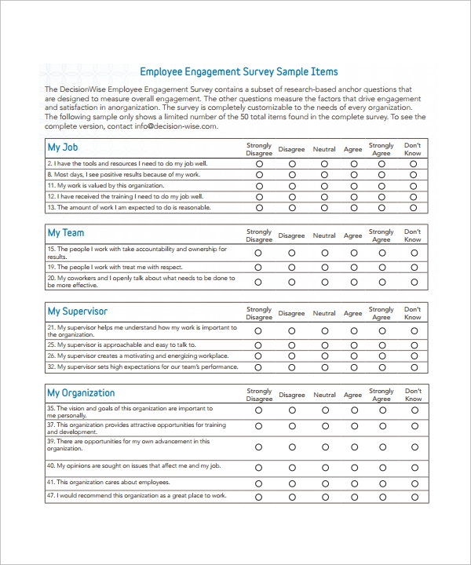
Example

Table
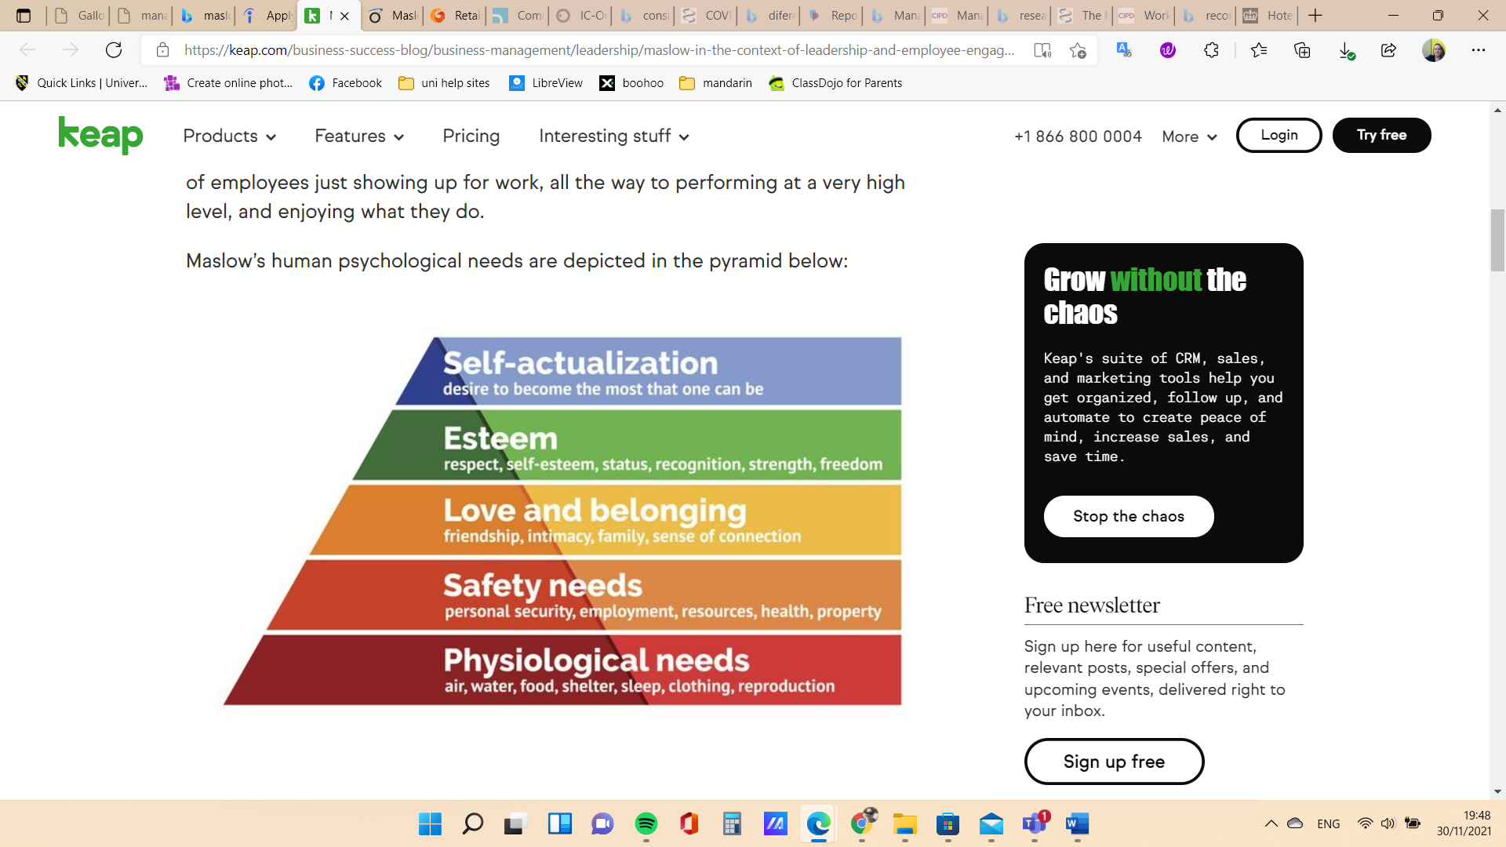
(Maslow, 2020)

Table
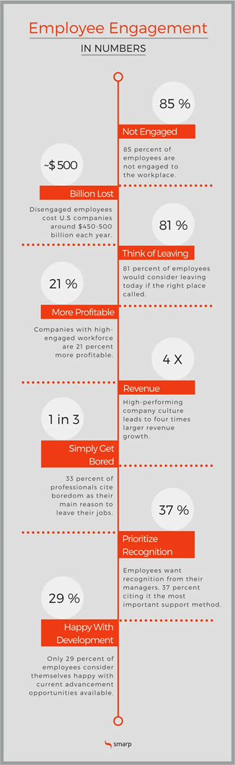
(Jouany and Mäkipää, 2021)

References
- Aon.com. 2021. Employee Wellbeing | Covid-19 | Aon. [online] Available at: <https://www.aon.com/unitedkingdom/insights/uk-covid-19/employee-wellbeing.jsp> [Accessed 3 December 2021].
- Borges Gouveia, L. and Fidalgo, F., 2012. Employee Turnover Impact in Organizational Knowledge Management: The Portuguese Real Estate Case. of Knowledge Management, Economics and Information Technology, [online] 02(02), p.7. Available at: <https://www.scientificpapers.org/knowledge-management/employee-turnover-impact-in-organizational-knowledge-management-the-portuguese-real-estate-case/> [Accessed 2 December 2021].
- Dolan, L., 2021. Maslow in the Context of Leadership and Employee Engagement. [online] Keap.com. Available at: <https://keap.com/business-success-blog/business-management/leadership/maslow-in-the-context-of-leadership-and-employee-engagement> [Accessed 3 December 2021].
- deBara, D. and St-Aubin, N., 2021. 7 Benefits of employee engagement, and why it’s so important. [online] Officevibe. Available at: <https://officevibe.com/blog/employee-engagement-benefits#how> [Accessed 3 December 2021].
- Gallup, I., 2017. Gallup Daily: U.S. Employee Engagement. [online] Gallup.com. Available at: <https://news.gallup.com/poll/180404/gallup-daily-employee-engagement.aspx> [Accessed 30 November 2021].
- Gifford, J. and Young, J., 2021. Employee Engagement & Motivation | Factsheets | CIPD. [online] CIPD. Available at: <https://www.cipd.co.uk/knowledge/fundamentals/relations/engagement/factsheet#gref> [Accessed 1 December 2021].
- GOV.UK. 2015. Engagement and wellbeing: Civil Service success stories. [online] Available at: <https://www.gov.uk/government/collections/engagement-and-wellbeing-civil-service-success-stories> [Accessed 30 November 2021].
- Help.hilton.com. 2021. Customer Support. [online] Available at: <https://help.hilton.com/s/article/COVID-19-hotel-reopening-FAQs> [Accessed 2 December 2021].
- Hilton.com. 2021. [online] Available at: <https://www.hilton.com/en/hotels/emalehn-hilton-leicester-hotel/> [Accessed 20 November 2021].
- Hilton. 2021. Hilton Named as the UK’s Best Workplace: Meet the Team Members Who Made it Possible. [online] Available at: <https://jobs.hilton.com/us/en/blogarticle/hilton-named-as-the-uk-s-best-workplace-meet-the-team-members-who-made-it-possible> [Accessed 3 December 2021].Indeed.com. 2021. [online] Available at: <https://www.indeed.com/career-advice/career-development/maslows-hierarchy-of-needs> [Accessed 1 December 2021].
- Jouany, V. and Mäkipää, M., 2021. 8 Employee Engagement Statistics You Need to Know in 2021 [INFOGRAPHIC]. [online] Blog.smarp.com. Available at: <https://blog.smarp.com/employee-engagement-8-statistics-you-need-to-know> [Accessed 3 December 2021].
- Lalwani, P., 2021. What Is Employee Engagement? Definition, Measurement, Drivers, and Strategies, with Examples - Toolbox. [online] Toolbox. Available at: <https://www.toolbox.com/hr/engagement-retention/articles/what-is-employee-engagement/?zd_source=hrt&zd_campaign=4323&zd_term=chiradeepbasumallick> [Accessed 3 December 2021].
- Lewis, R., Donaldson-Feilder, E. and Tharani, T., 2012. Managing for sustainable employee engagement Guidance for employers and managers. [online] Cipd.co.uk. Available at: <https://www.cipd.co.uk/Images/managing-for-sustainable-employee-engagement-guidance-for-employers-and-managers_2012_tcm18-10753.pdf> [Accessed 3 December 2021].
- Maslow, 2020. The Maslow leadership theory in the context of employee engagement. [image] Available at: <https://keap.com/business-success-blog/business-management/leadership/maslow-in-the-context-of-leadership-and-employee-engagement> [Accessed 30 November 2021].
- Okumus, F., 2013. Editorial. International Journal of Contemporary Hospitality Management, 25(6), pp.903-921 [Accessed 2 December 2021].
- Ovationincentives.com. 2021. Maslow’s hierarchy for employee engagement | Ovation Incentives. [online] Available at: <https://www.ovationincentives.com/articles/maslows-hierarchy-of-needs-applied-to-employee-engagement#:~:text=%20Maslow%27s%20Hierarchy%20of%20needs%20can%20also%20be,with%20the%20management%20and%20possibly%20their...%20More%20> [Accessed 3 December 2021].
- Phoenixoutcomes.com. 2021. Retaining a Talented (and Happy) Workforce – Phoenix Outcomes. [online] Available at: <https://phoenixoutcomes.com/news-and-insights/retaining-a-talented-workforce/> [Accessed 30 November 2021].
- Scharn, J., 2019. Understanding Employee Engagement: A Mixed-Methods Study - ProQuest. [online] Proquest.com. Available at: <https://www.proquest.com/docview/2377996794?accountid=130472&pq-origsite=primo> [Accessed 2 December 2021].
- Voicesifter.com. 2021. 4 Effective Methods to Obtaining Anonymous Employee Feedback. [online] Available at: <https://www.voicesifter.com/blog/4-effective-methods-anonymous-feedback> [Accessed 2 December 2021].
- Wood, J., 2021. Retaining a Talented (and Happy) Workforce – Phoenix Outcomes. [online] Phoenixoutcomes.com. Available at: <https://phoenixoutcomes.com/news-and-insights/retaining-a-talented-workforce/> [Accessed 3 December 2021].

