

University of Wales Trinity Saint David
School of Engineering

Structural Integrity & Materials Evaluation
ACEA7013

Jonathan Lloyd-Williams
MSc Motorcycle Engineering
1805620

24/12/2021
Table of Contents

1 Introduction & Aims 1
1.1 Introduction 1
1.2 Aims 1
2 Literature Review 2
2.1 Non-Destructive Testing 2
2.1.1 Ultrasonic NDT 4
2.2 Probability of Detection (PoD) 4
2.3 Probability of Sizing (PoS) 6
3 Data 8
3.1 Provided Data Set & Calculation Procedure 8
3.2 Results & Statistical Analysis 10
4 Conclusion 16
5 Bibliography 17
6 Appendices 19
6.1 Appendix 1 - Operator XY Scatter Plots 19
6.2 Appendix 2 – Operator Histograms 24
6.3 Graph Displaying Operator Mean Error Values 29
6.4 Graph Displaying Operator Standard Deviation Values 29
6.5 Graph Displaying Operator Trendline Gradients 30

Introduction & Aims

Introduction

This report will investigate probability of detection (PoD) & sizing (PoS) methods. It will consist of a literature review on the development and history of PoD and PoS methods employed within non-destructive testing (NDT). Non-destructive testing refers to a range of methods used to identify and characterise defects within a test specimen without damaging or altering the specimen (Dwivedi, et al., 2018). Following the literature review, a statistical analysis is performed on a data set of through wall thickness measurements, collected as part of a larger PoD study, used to assess the performance of a new ultrasonic thickness gauging procedure. Ten technicians/operators are assessed on their ability to correctly size 21 sample defects present on a test specimen ranging from 0.25mm to 7.5mm. Following an analysis of the operators’ performances, the effects of the equipment and procedure as a whole is also considered. Conclusions are then drawn as to the capabilities of the operators, as well as the NDT method used.

Aims
In preparing this report the aim is to:
- Provide a brief literature review on the development and history of probability of detection and sizing methods employed within NDT.
- Using the data sample provided, assess the sizing accuracy of the individual technicians, as well as the equipment and procedure as a whole.

Literature Review

Non-Destructive Testing
NDT incorporates a variety of different methods for material testing that allow a specimen to be inspected for surface or interior defects without damaging or altering the specimen. Whilst some of today’s most popular NDT methods have been developed in recent decades, the concept of NDT has been used throughout history. NDT is widely applied in many industries and includes a variety of methods such as ultrasonic testing, radiographic testing & electromagnetic testing (Dwivedi & Mahto, 2013). Over time, methods for assessing the reliability of these NDT methods have been developed, including the probability of detection (PoD) & sizing (PoS).
In its simplest origins, examples of NDT could include a simple visual inspection of a specimen to identify defects. Nowadays, NDTs can more commonly be seen through use of every-day technologies such as MRI & X-Ray imaging. In recent years, various NDT techniques have been developed not only to improve the accuracy of results, but also to suit specific circumstances and test requirements. For example, tests that require an area of the human body to be examined are likely be carried out using NDT techniques such as ultrasonic testing as opposed to radiographic testing, due to the health & safety implications imposed via the inclusion of radiography (Dwivedi & Mahto, 2013).
The range of NDT methods available provides a variety of benefits to the observer. Firstly, with the exception of radiography, the majority of NDT testing methods available are safe to perform without causing potential human harm. Further benefits include efficiency and manufacturing cost reduction, as often NDT tests are able to be performed without requiring the disassembly or removal of a specimen from its operational service (Dwivedi & Mahto, 2013).
During the Second World War, NDT technology became increasingly vital in manufacturing due to strict restrictions on material usage, cost, and time restraints. Testing methods that did not affect a components usability became preferable, in order to meet these requirements. This led to further development of NDT methods for improved capability and accuracy (World of NDT, 2020).
The ability to perform NDT testing, without the damaging or removal of a component from an assembly is one of the key benefits of NDT. The ability to reuse the specimen once the test has finished, reduces manufacturing costs when compared with other destructive test means. However, performing NDT’s generally requires a large sample group of components, thus requiring more tests and increasing the cost of testing (Keprate, 2016).This may be further exacerbated through the potential of false readings or inaccuracies. Figure 1 shows an image depicting the relationship between cost and effectiveness with regards to different methods of NDT testing.

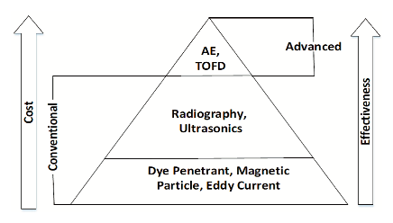
Figure 1: NDT Cost against Effectiveness (Keprate, 2016)

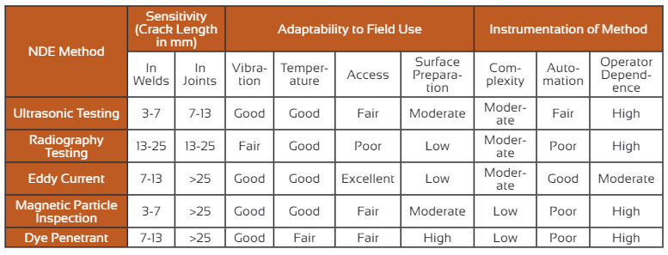
Table 1: A table of comparison for conventional NDT Methods (Keprate, 2016).
Table 1 shows a range of varying NDT techniques and the characteristics determining their capabilities. A large range of literature has been published on the subject of NDT methods. Dwivedi & Mahto (Dwivedi & Mahto, 2013) indicate that NDT techniques are primarily used in manufacturing & aerospace industries and may also be used for evaluation of civil infrastructures. Lim & Cao (Lim & Cao, 2003) suggest that the reliability and confidence level of NDT is generally increased by using combination of varying NDT methods to evaluate a specimen. NDT of composite materials often requires additional testing methods in order to properly evaluate defect characteristics due to the limitations of testing composites (Dwivedi & Mahto, 2013).

Ultrasonic NDT
Dwivedi & Mahto (Dwivedi & Mahto, 2013) suggests that the preferred NDT method to evaluate the sub-surface characteristics of titanium alloy type materials was Ultrasonic testing. They also suggest that for critical and complex specimen evaluations, Ultrasonic testing produces the best results with respect to accuracy, and probability of detection. We also know that ultrasonic testing can be used to identify variations in a specimen’s density & elasticity (Dwivedi & Mahto, 2013),
Ultrasonic testing may also be appropriate in several other scenarios, such as evaluating fatigue degradation of polymer composites (Rojek, et al., 2007). Chunguang (Chunguag, et al., 2015) indicates that Ultrasonic critical refracted wave method has the characteristics of high resolution & high penetration testing, whilst also posing no risk of damage to human tissue. Due to this, it is suggested that this is the most promising technology to be used in residual stress testing.
For the data set provided, an Ultrasonic Thickness Measurement (UTM) method was employed. UTM is an NDT method that works be precisely measuring the length of time taken for a sound pulse to travel through the test piece and reflect back from the inside surface or far wall.
As can be seen from figure 1, ultrasonic testing generally offers good cost effectiveness for conventional purposes when compared to other testing methods. However, for advanced circumstances, other testing methods may be preferable such as Time-of-flight diffraction (TOFD), which is a different form of Ultrasonic testing which will be discussed further later in this report (Keprate, 2016). TOFD is often used as an accurate means of investigating defects in welds (Hecht, 1997).
It is apparent that there are various NDT techniques available to inspect a component for defects, and that the choice of technique may be dependent on a variety of factors such as the specimen material, geometry, & the type and size of defects investigated. Various forms of Ultrasonic NDT are widely used for the examination of complex components as well as in many other circumstances (Dwivedi & Mahto, 2013).

Probability of Detection (PoD)
The PoD method is defined as a means of assessing the reliability of an NDT and involves calculating the detection probability as a function of defect size (Muller , et al., 2006). Once a test procedure has been selected, there are four possible outcomes regarding the specimen’s evaluation. These outcomes make up the probability of detection matrix and can be seen below.
- True Positive – A defect exists & the NDT indicates presence of defect.
- False Positive – A defect does not exist & the NDT indicates presence of defect.
- True Negative – A defect does not exist & the NDT indicates no presence of defect.
- False Negative – A defect exists & the NDT indicates no presence of defect
(Ginzel, 2006)
False readings may be introduced not only due to potential faults with the testing equipment or procedure, but also as a result of human error (Keprate, 2016). The PoD is dependent upon a number of variables such as the NDT method & procedure itself, specimen’s material & geometry, the type of defect, & of course a number of factors introduced through operators.
PoD curves, such as the one exampled in Figure 2 are a popular means of visually relating PoD to a defect’s size, and is the most utilized tool within PoD. However, despite PoD’s increasing popularity within NDT, it was suggested in a report by the Health & Safety Executive, that a large proportion of users that employ such technique, may not understand or interpret curves correctly (Health and Safety Executive , 2006). Figure 2 shows a realistic case versus an ideal case. This is because in an ideal situation, any defect over a certain size would be detectable, and anything smaller would be undetectable, highlighting the step function seen in the ideal case. In a realistic scenario, defects are either found or not found, with an overlap present. This results in the need for a binary regression curve function to be added to the datapoints.
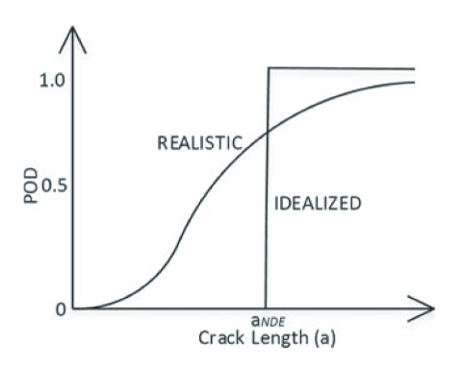
Figure 2: An example PoD curve, displaying realistic and ideal values (Keprate, 2016).

The probability of detection (PoD) method was originally developed for aerospace purposes by Nasa & the United States Military. In 1973 the concept of the PoD method was incorporated into the design process for NASA’s space shuttle program, and the NASA PoD development project went on to be the pioneering work in assessing NDT capabilities. The PoD development project later became accepted as the standard for NDT evaluation (Keprate, 2016).
Since its original conception in the early 70’s, a range of papers have been published. Figure 3 shows the number of publications produced on PoD since 1975, and the trend suggests that the concept is becoming increasingly accepted and implemented with a particular surge in recent years.
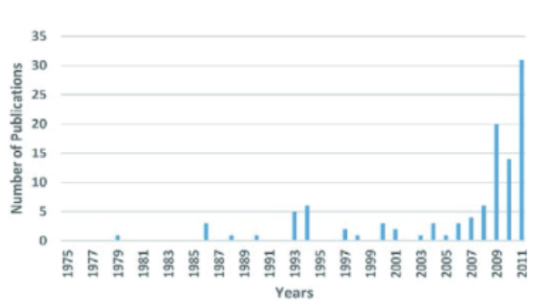
Figure 3: A graph showing the number of publications on PoD per year (Keprate, 2016).
The concept of the PoD method is being continually adapted and developed for use within a range of industries. For example, since the early 2000’s the national NDT Centre UK has worked in unison with the London Underground with the aim of improving inspection standards through the use of PoD (Health and Safety Executive , 2006).

Probability of Sizing (PoS)
Whilst the PoD is used to assess the probability of a defect being detected by an operator, probability of sizing (PoS) provides a means of assessing an operator’s sizing accuracy. In other words, the probability of correctly sizing a detected defect.
A major factor influencing flaw characterisation is the selected flaw sizing method. A variety of sizing methods may be employed, and each has its own advantages and disadvantages as exhibited in table 2.

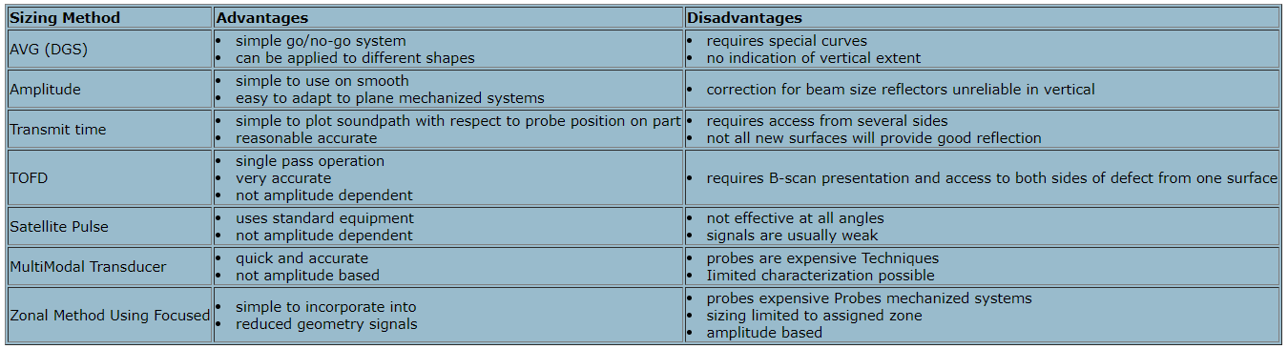
Table 2: A table displaying various flaw sizing methods and their respective advantages and disadvantages (Ginzel, 2000).
One sizing technique that may be employed is the previously mentioned TOFD method. The TOFD method was developed in 1977 by Maurice Silk. Since then it has become an increasingly popular form of NDT. TOFD is gaining popularity due to its ability to produce a more accurate representation of a defect’s size, location and orientation than more traditional NDT methods. Unlike other ultrasonic testing methods, TOFD relies on detection of forward-scattered diffracted signals originating at the defects edges which allows for more precise measurement of defect characteristics (Mondal, 2000)
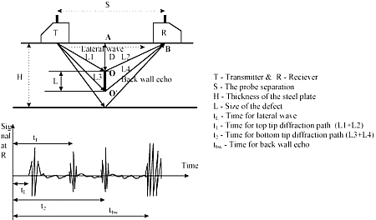
Figure 5: An image depicting the two-probe mathemateical model of the TOFD technique (Mondal, 2000).

Figure 5 shows a basic TOFD setup in which two ultrasonic angle probes in a transmitter-receiver mode are used to monitor signals diffracted from the edges of the defect. Broad beam probes are used so that the entire defect area is flooded with ultrasound (Mondal, 2000).
The ability to correctly size a defect is an essential NDT tool in industry, particularly in cases where slight misestimations of a defect’s characteristics could create dangerous conditions. Underestimates may cause specimen failure, which could be drastic, whilst overestimates may increase waste and costs if it results in a specimen being incorrectly decommissioned. Ultrasonic NDT methods have significantly improved the reliability of determining PoS as testing procedures can be custom suited to the desired specimen. Ultrasonic NDT is now heavily favoured in industry when test specimens are inaccessible, such as in pipelines where defects caused by corrosion in the pipe’s interior can be identified and characterised without requiring disassembly of the pipeline (Moles, 2009).

Data

Provided Data Set & Calculation Procedure
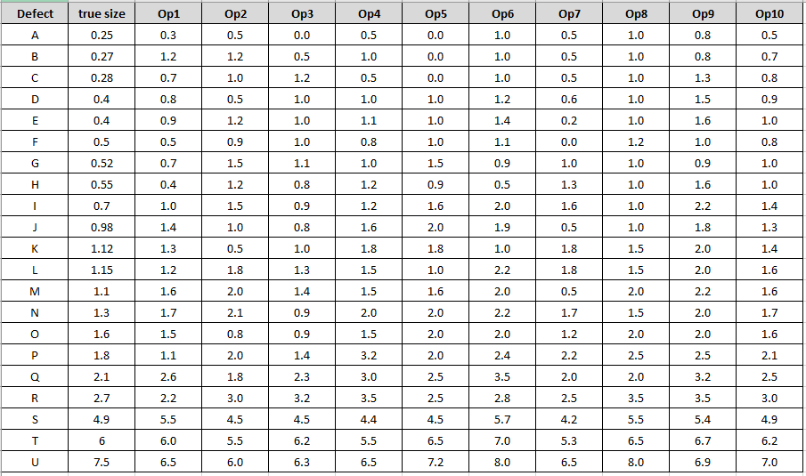
Table 3: A table displaying the true size of defects (mm) and operator estimates (mm).
The data set in Table 3 above, was provided in order to perform statistical analysis & assess the sizing accuracy of the individual technicians, as well as the equipment and procedure as a whole. Each operator was tasked with estimating the size of each individual defect, the results of which are displayed above.
Firstly, an error value was calculated for each operator and defect. A mean value was obtained for the error values at each respective defect, and subsequently the standard deviation was calculated. Following this a 95% confidence value was obtained by multiplying the standard deviation by 1.95, and the normal distributions were calculated in excel. An example of the resulting histogram chart that was produced for Operator 1 can be seen below in Figure 6.
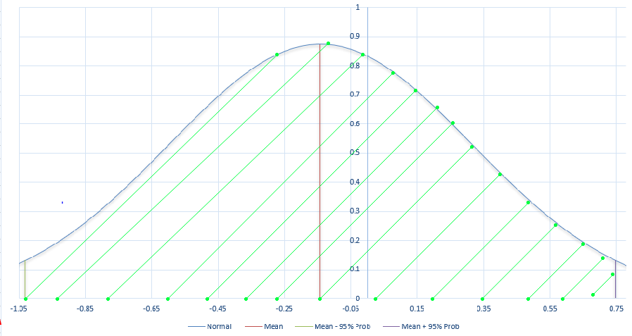
Figure 6: Operator 1 Histogram
The true size of the defects and the operators respective estimate were then plotted against each other on scatter graphs and a linear trendlines were produced. The equation of these lines could then be expressed in terms of y = mx + c, where “m” refers to the gradient and “c” refers to the Y intercept. The gradient of each operator’s trendline can be used to assess their tendency to misestimate a defect’s size and provide an indication as to whether there is a trend of over or under sizing.
When the gradient > 1 it can be inferred that the operator’s estimates are becoming increasingly over-sized as defect size increases, and conversely, when the gradient < 1 the operator’s estimates are becoming increasingly undersized with defect size. In an ideal situation, the gradient would be equal to 1 providing an estimated size equal to that of the true defect size.
The R² value for each operator’s trendline was also established. This value provides a measurement of the data’s correlation to the fitted regression line and is known as the correlation coefficient (R²). In an ideal situation where 100% correlation exists, the R² would be equal to 1.

Results & Statistical Analysis
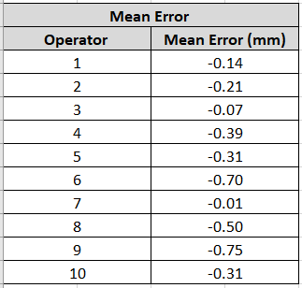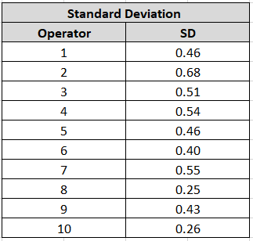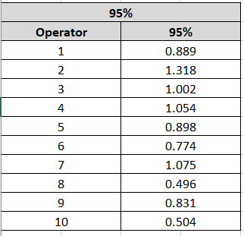
Table 4 (Left): A table of the mean error results for each operator. Table 5 (Middle): A table of the standard deviation results for each operator. Table 6 (Right): A table of the 95% confidence values for each operator.
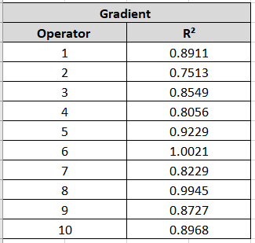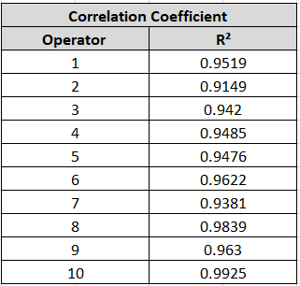
Table 7 (Left): A table of the gradient results for each operator’s trendline. Table 8 (Right): A table of the correlation coefficient values for each operator’s trendline.

Figure 7: A graph displaying the operators estimates plotted against true defect size, and each operator’s respective trendline.
Figure 7 features each operator’s estimates plotted against true defect size and their respective trendlines. On examination of Table 7 which displays the gradient of each operator’s trendline, we can see that 90% of operators had a gradient < 1, suggesting that 90% of operators’ estimations became increasingly undersized as true defect size increases. Operator 6 showed the highest consistency with regards to sizing accuracy with a gradient of 1.0021. On examination of Figure 8 below, it can be suggested that Operator 6 exhibited a generally good trend with regards to sizing consistency. Operator 6 consistently overestimates the size of the defect to some extent. The type of trend exhibited can be useful in instances where extra attention must be paid to the margin of safety employed. However, as aforementioned, whilst overestimations can provide an additional margin of safety, it can also lead to increased manufacturing costs. Therefore, it is important to consider the degree to which overestimations are being made when analysing a trendline such as the one shown in Figure 8. Each operator’s respective scatter plot can be found in Appendix 1.

Figure 8: The scatter plot created for Operator 6 featuring the trendline in blue, and the ideal line in orange.

Figure 9: A graph showing the 95% confidence values calculated for each operator.
Figure 9 shows the aforementioned 95% confidence values that were calculated for each of the operators. This value originates from the “90/95” for NDT, which is often referred to as having “90% PoD with 95% confidence” and is a value often used a reference. The confidence value can be considered as a statistical tool to estimate the PoD for a given testing method. Figure 10 shows a PoD chart that features the 90/95 confidence. The 90/95 confidence tool can effectively be translated as there being a 90% of a defect of the size of discontinuity being detected, with 95% confidence in that statement (Topp, 2020).
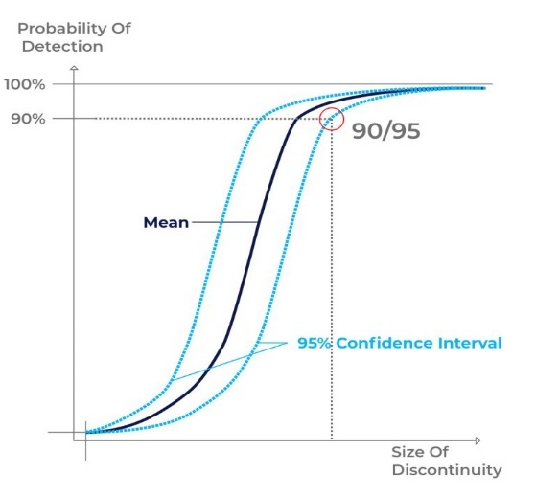
Figure 10: An example PoD chart featuring the 90/95 confidence (Topp, 2020).
By examining Table 6 & Figure 9, it can be seen that Operators 8 & 10 had the lowest 95% confidences at +/- 0.496 & +/- 0.504 respectively. The smallest defect that can be found in a system is referred to as the intrinsic capability, between this and the 90/95 confidence value exists a performance gap as exampled in Figure 11. The aim should be to produce a 90/95 confidence value as close to the point of intrinsic capability, effectively reducing the performance gap. The larger the performance gap, the more improvement can be made (Topp, 2020).
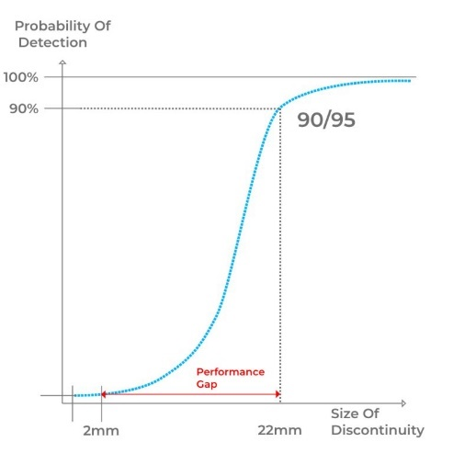
Figure 11: An example PoD chart featuring the performance gap between the point of intrinsic capability and the 90/95 confidence (Topp, 2020).
Operators 8 & 10 displayed the lowest 95% confidence values and thus had the smallest performance gaps. Conversely, Operator 2 produced a 95% confidence value of +/- 1.318 and would subsequently result in the highest performance gap.

Figure 12: Original graph produced to display histogram data produced for each operator.

Figure 13: A version of the graph of operator histogram data later modified to account for the 95% confidence values and mean error.
Figure 13 displays the distribution for each operator with respect to calculated mean error & 95% confidence values. The individual graphs produced for each operator can be seen in Appendix 2. For the curves displayed in Figure 13, the value of x at the peak of each curve corresponds to its mean error value. The area under each curve can be considered to be split by a vertical line at its mean, with the area to the left corresponding to the error mean minus the 95% confidence value, and conversely the area to the right corresponding to the error mean plus the 95% confidence. This is highlighted by Figure 13 as Operators 8 & 10 produce narrower, taller curve shapes due to their low 95% confidence value, whereas Operator 2 displays the broadest, shortest curve due to its high 95% confidence.

Figure 14: A graph showing the correlation coefficients obtained for each operator’s trendline.
Table 8 & Figure 14 show that every operator is within 10% of a R² value equal to 1. Operator 10 has the highest coefficient at 0.9925, and Operator 2 has the lowest coefficient at 0.9149. There Is vast range of potential explanations as to why an operators estimate may not reflect true defect size. For example, the UTM method employed has the potential to introduce inaccuracies through improper equipment calibration or handling. Ultrasonic thickness gauges require precise calibration to account for factors such as material type, which effects the speed of the soundwaves travelling through the specimen.
However, the inaccuracies mentioned above do not explain the variance in estimated defect size between operators. As each operator was tasked with sizing the same set of defects using the same equipment, if inaccuracies were introduced solely through factors born out of the procedure or equipment used, we would expect each operator to obtain the same estimate value. This of course assumes that the operators all use the same thickness gauge as opposed to their own. The introduction of inaccuracies due to a human (operator) element is evidenced through the variance in operator estimates.
There are innumerable factors that may potentially influence an operator’s capability at a given time, the most obvious of which being experience. Undeterminable levels of experience between operators could mean that one operator has 10 years of experience using the NDT method, whereas another has only 10 days. It has been suggested that Ultrasonic NDT methods require a higher level of skill and training than other NDT methods, and as such when assessing the evaluations made by operators, consideration should be paid to their individual level of experience & the overall difficulty of the procedure (Health and Safety Executive , 2006).
Further evaluation of the data set suggests that Operators 8 & 10 are likely to be considered as providing the most accurate results throughout. Operator 8 had the lowest standard deviation value, and subsequently the lowest 95% confidence value, and also displayed the second most preferential m & R² values. However, Operator 8’s main drawback was seen when examining the operator’s mean error value which was the third highest out of all operators. Similarly, Operator 10 exhibited the second most preferential standard deviation & 95 % confidence value, the most preferential R² value, and the fourth most preferential gradient. Further, Operator 10’s downfall was also seen when examining the mean error values, in which Operator 10 was the fourth highest.
Conversely, the data suggests that the operator with lowest overall accuracy to be Operator 2. This is evidenced by Operator 2 producing R² and gradient values furthest from 1 when compared with other operators, and also featured the highest standard deviation and 95% confidence.

Conclusion
In conclusion, this paper has highlighted the importance of PoD & PoS methods within NDT. The benefits of PoD & PoS have been explored, and potential limitations identified. These limitations are a combined result of a variety of different factors, including the nature of the testing procedure, as well as factors introduced through means of human error.
This paper has also provided a statistical analysis of the provided dataset of through wall measurements. It was determined that Operators 8 & 10 could be considered the as being the most accurate throughout, whereas conversely it was determined that Operator 2 provided the least accurate results overall.

Bibliography
Alvi, T., 2020. Detectability of fatigue cracks in metals , Stavenger : Universirty of Stavanger .
Bato, M., Hor, A., Rautureau , A. & Bes, C., 2019. Impact of human and enviromental factors on the probability of detection during NDT control by eddy currents. Measurement, Volume 133, pp. 222-232.
Chunguag, X. et al., 2015. Nondestructive Testing Residual Stress Using Ultrasonic Critical Refracted Longititudinal Wave.. Physics Procedia, Volume 70, pp. 594-598.
Dwivedi , S. K. & Mahto, G., 2013. Recent trends in industrial and other engineering applications of non destructive testing: a review.. International Journal of Scientific & Engineering Research , 4(9).
Dwivedi, S. K., Vishwakarma, M. & Soni, A., 2018. Advances and Researches on Non Destructive Testing: A review. Materials Today: Proceedings , 5(2), pp. 3690-3698.
Falcetlli, F., Yue, N., Di Sante, R. & Zarouchas , D., 2021. Porbability of detection, localization, and sizing: The evolution of reliabiity metrics in Strucural Health Monitoring. Structural Health Moninitoring , 0(0), pp. 1-28.
Ginzel, E., 2000. Ultrasonic Testing (UT) sizing technique. NDTnet .
Ginzel, E., 2006. Introduction to the statistics of NDT. NDTnet , 11(5).
Hanley, G., 2010. Applying Signal-Detection theory to the study of observer accuracy and bias in behavioural assessment. Journal of Applied Behaviour Analysis , 43(2), pp. 195-213.
Health and Safety Executive , 2006. Probability of Detection (Pod) curves , London : s.n.
Hecht, A., 1997. Time of Flight Diffraction Technique (TOFD) An Ultrasonic Testing Method for all Applications?. NDTnet, 2(9).
Honarvar , F. & Yaghootian , A., 2008. Refernce wavelets used for deconvolution of ulrasonic time-of-flight diffraction (TOFD) singals. Shanghai, 17th World Conference on Nondestructive Testing .
Hull, B. & John, V., 1988. Non-Destructive Testing. London: MacMillan Education Ltd .
Keprate, A., 2016. Probability of Detection: History, Development and Future. Pipeline Technology Journal, 8(2), pp. 41-45.
Koskinen , T. & Virkkunen , I., 2018. Hit/Miss POD with model assisted and emulated flaws. Gothenburg , 12th European Conference on Non-Destructive Testing .
Kurz, J., Jungert , A., Dugan, S. & Dobmann, G., 2012. Probability of Detection (POD) determination udsing ulrasound phased array for considering NDT in probablistic damage assessments. Durban, 18th World Conference on Nondestructive Testing .
Lim, M. & Cao, H., 2003. Combining multiple NDT methods to improve testing effectiveness.. In: Construction and Builidng Materials . s.l.:s.n.
Moles, 2009. Accurate Defect Sizing Using Phased Array and Signal Processing , Toronto: University of Toronto.
Mondal, S., 2000. An overview TOFD method and its Mathematical Model. NDTnet , 5(4).
Muller , C. et al., 2006. POD Evaluation of NDT Techniques for Cu-Canisters for Risk Assessment of Nuclear Waste Encapsulation, Berlin : Federal Insititue for Materials Research & Testing .
Raj, B., Jayakumar , T. & Thavasimuthu , M., 2002 . Practical Non-Destructive Testing. 2nd ed. Cambridge : Woodhead Publishing Ltd .
Rentala, A., Mylavarapu, P. & Gautam, J., 2018. Issues in estimating probability of detection of DT techniques- A model assisted approach. Ultrasonics , 87(1), pp. 59-70.
Ribay , G., Artusi, X. & Jenson , F., 2016. Model-based POD study of manual ultrasound inspection and sinsitivity analysis using metamodel, s.l.: AIP Publishing .
Rojek, M., Stabik, J. & Sokol, S., 2007. Fatigue and ultrasonic testing of epoxy-glass composites. Journal of Achievements in Materials & Manufacturing Engineering, 1(2), pp. 183-186.
Schneider, C. et al., 2012 . Estimation of probability of detection curves based on theoretical simulation of the inspection process , Cambridge : TWI .
Topp, M., 2020. What is the POD - Probability of Detection in NDT?. [Online]
Available at: https://sentin.ai/en/what-is-the-probability-of-detection-pod-in-ndt/
[Accessed 20 12 2021].
Virkkunen, I., Koskinen, T. & Papula , S., 2019. Comparison of a Versus a and Hit/Miss POD-Estimation Methods: A European Viewpoint. Journal of Nondestructive Evaluation , 38(89).
World of NDT, 2020. History of Non Destructive Testing (NDT). [Online]
Available at: https://worldofndt.com/history-of-non-destructive-testing/
[Accessed 20 12 2021].
Zemp, R., 2005. Detection Performance Theory for Ultrasouns Imaging Systems. IEEE Trans Med Imaging , 24(3), pp. 300-310.

Appendices

Appendix 1 - Operator XY Scatter Plots

Appendix 2 – Operator Histograms

Graph Displaying Operator Mean Error Values

Graph Displaying Operator Standard Deviation Values

Graph Displaying Operator Trendline Gradients

