Student Number:2105959
Krishnadas Pachery Chandradas

Series Hybrid Vehicle CW1

ACEA7007: Hybrid Powertrain and Control
M.Sc Motorcycle Engineering
University of Wales Trinity Saint David



Contents

1.Abstract 4
2.Introduction 4
3.Dual Purpose Course 5
4.Calculations 6
4.1 Assumptions 6
4.1.1 Gear ratios 6
4.1.2 Masses 6
4.1.2.1 Test mass 6
4.1.2.2 Wheel assembly 7
4.1.2.3 Reduced Mass 7
4.1.4 Frontal Area 7
4.1.5 Coefficient of Aerodynamic Drag 8
4.2 Forces acting on the course
4.2.1 Aerodynamic Resistive Force 8
4.2.2 Rolling Resistance 9
4.2.3 Gradient Resistance 9
4.3 Power and Torque 10
4.4 Brake Specific Fuel Combustion (BSFC) 11
4.5 Drive Torque and Force 11
4.5.1 Drive Torque at Shaft 11
4.5.2 Drive Torque at Wheels 11
4.5.3 Driving Force 12
4.6 Fuel Usage 12
4.7 Acceleration and Deceleration 12

5.Graphs 13
5.1 Velocity 13
5.2 Power and Torque 14
5.3 Kinetic energy 14
5.4 Rolling Resistance 15
5.5 Gradient Resistance 15
5.6 Net Driving Force 16
5.7 Tractive Effort 16
5.8 Acceleration 17
5.8.1 Traction limited Acceleration 17
5.8.2 Traction limited Deceleration 19
5.9 BSFC 20
5.10 RPM 20
5.11 Gradient Change 21
5.12 Fuel Usage 21
6.Conclusion 22
7.References 23

1.Abstract
In this simulated study, the duty cycle of the off-road buggy (renegade dx 10C) over a dual-purpose race course is generated to analyse the fuel consumption and vehicle performance. The course is a combination of 5 different surface, designed to utilise optimum performance of torque-oriented powertrains that consists of a total climb of 20 metres. To analyse the dynamic behaviour of the buggy, the document will explore the resistance forces acting on buggy and fuel consumption for one lap.

2.Introduction
The overall purpose of a buggy is to efficiently accelerate in different course irregularities such as bumps, surface conditions, and transfer torque for a hassle-free enduring experience without compromising on the agility of the vehicle. The geometry with very low center of gravity helps the vehicle to perform in tricky weather conditions. The primary objective of this test is to obtain the fuel consumed under maximum performance, using appropriate calculations regarding the dynamic processes experienced throughout a lap, to output a simulated lap time for Renegade Dx-10C.Secondly, obtaining maximum fuel consumption for a full tank of gasoline gives the maximum fuel efficiency of the buggy.
Mapping the track layout is the first step into creating the model and categorise the circuit into a series of straights and corners, with which the dynamic processes can be split into steady state cornering, acceleration, and braking.

3.Dual purpose course

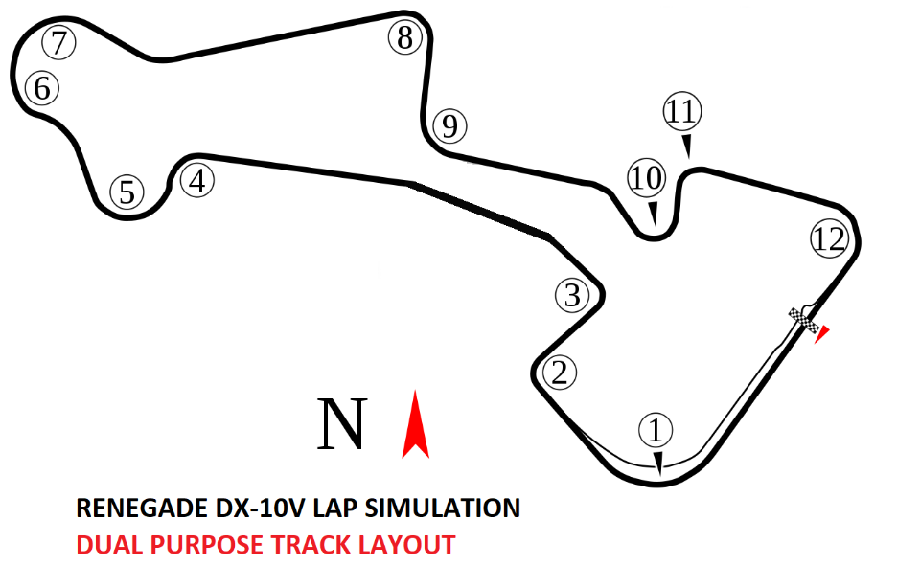
Figure 1: Track Layout
The course layout developed in this experiment is a real-world road racing circuit (Madras Motor Race track) where certain assumptions are made to consider different surface criteria for renegade dx 10c.The track layout consists of 12 Corners with 9 braking zone and 3 fast flowing corners. The total length of the track is 1286 meters divided into 5 sectors with an elevation of 20 meters and decent of 20 meters.
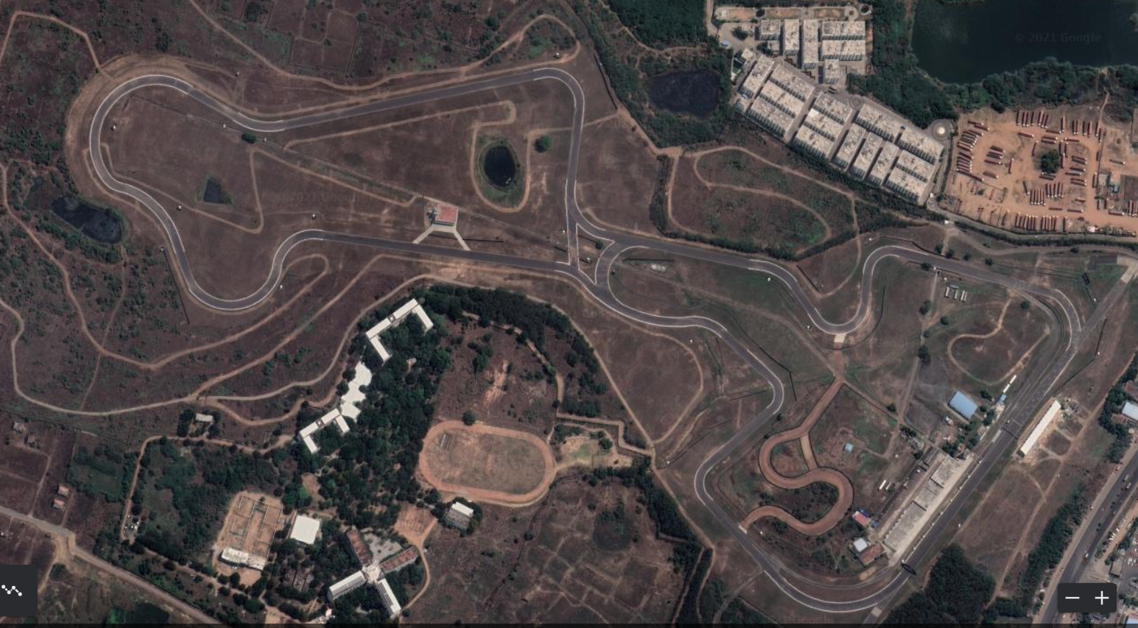
Figure 2: Top view of the course

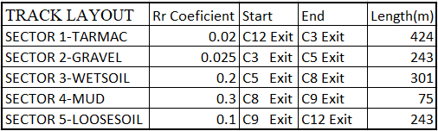
Table 1: Classification of Sectors
4. Calculations
4.1 Assumptions
Multiple assumptions are developed due to the deficiency of information about the renegade dx-10c online.
4.1.1 Gear Ratios
Renegade Dx-10c consist of a CVT transmission assembly where traditional gear ratios are not used. In order to calculate the vehicle performance for suitable engine specifications provided an assumption has been made to replace the CVT transmission with a 3-speed gearbox. The gear ratio assumed can be changed according to the manufacture based on the application. Since the powerplant is torque oriented the assumed gear ratios of the buggy is mentioned on Table 2.

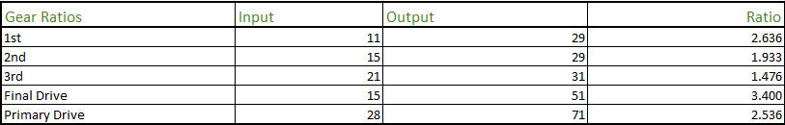
Table 2: Gear Ratio
4.1.2 Masses
4.1.2.1 Test Mass
Kerb weight of renegade was mentioned in the specifications data. The buggy was assumed to be tested with a fuel of 10 litres, pouring 1.5 litres of oil and a passenger for prime dynamics at challenging sectors during corporate event. The values of lubricant and fuel in kg are considered by multiplying the available quantity in litres with the density of respective liquid.
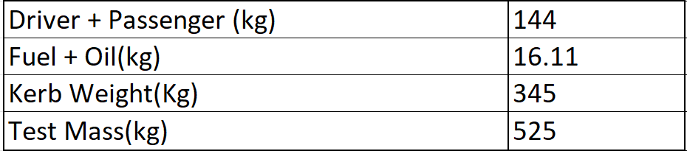
Table 3: Test Mass
4.1.2.2 Wheel Assembly
The wheel and tyre masses are assumed by converting the relevant tyre specifications 24*8*12 to 175/60R12. The more mass an object has, more energy it takes to accelerate. To accelerate a rolling object such as wheel, you must both accelerate its mass plus overcome its rotational inertia.

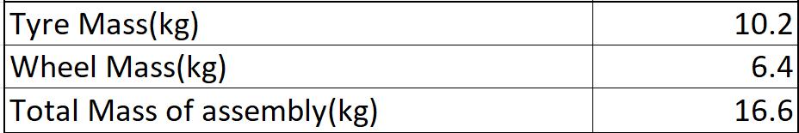
(the-welters.com/racing/rotational.html, March-17-2002)
Table 4: Wheel and Tyre Mass

4.1.2. Reduced Mass
The equivalent mass of the buggy in different gear ratio was calculated using equation 1. According to Newton’s second law of motion, 𝐹 = 𝑚𝑎 states that the force required to accelerate an object is proportional to its mass. Equivalent mass is a concept introduced here as an alteration of regular mass inclusive of rotational inertia which makes equivalent mass higher in lower gears and decreases when driver upshifts. Meanwhile the lower gear ratios provide more load transfer to the road surface.
$Reduced Mass=Actual Mass+4*\left(\frac{Wheel Inertia}{Wheel Radius^{2}}\right)+Engine Inertia*(\frac{Overall Gear Ratio}{Wheel Radius^{2}})$
Equation 1: Reduced Mass
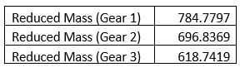
Table 5: Reduced mass in each gear

4.1.3 Frontal Area
Renegade Dx-10c buggy have drag effects on 2 tyres, wide outside the body panel as it is open to longitudinal acceleration. From specifications, the frontal area of the tyre can be calculated by considering it as a rectangular area of cross section from front view. Driver and passenger should experience the drag. The frontal area can be calculated as the sum of Frontal area of driver, passenger and panel, tyres.

4.1.4 Coefficient of Aerodynamic Drag
The drag coefficient for renegade had to be assumed as .95 which is an average of values of drag coefficient of Open top convertible vehicle and flat plate (face on flow). The assumption is made from (J. Carvill “Mechanical engineers Databook”).
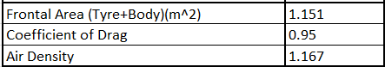
Table 6: Drag parameters

4.2 Forces acting on the course
4.2.1 Aerodynamic Resistive Force
An aerodynamic drag force is the force exerted on a body by the air as a resistance to the forward linear motion of the vehicle.

$$Aerodynamic Resistance=0.5*CD*Frontal Aera*Density*Velocity^{2}$$
Equation 2: Aerodynamic Resistance Forces
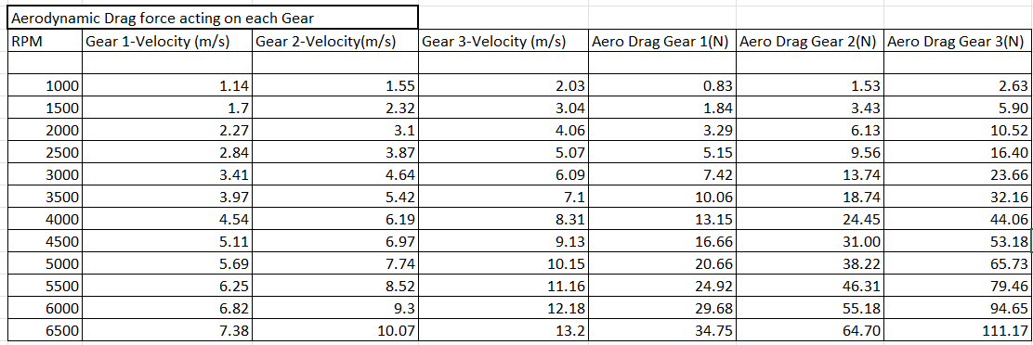
Table 7: Aerodynamic drag in each gear
From the equation it is clear that drag is directly proportional to frontal area and velocity. Graph 1 clearly outlines the rate of change of Aerodynamic drag forces with respect to velocity.
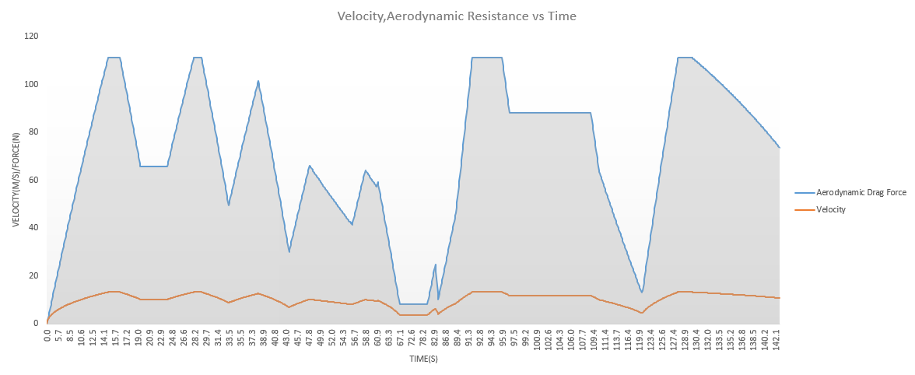
Graph 1: Velocity and Aerodynamic Resistance
4.2.2 Rolling Resistance
Vehicle tyres transfer the load to the pavements or surface and plays a vital role in torque transfer. Resistance developed due to rolling is directly proportional to the coefficient of rolling resistance of surface. Equation 3 determines rolling resistance. In the lap simulated for Renegade there are 5 different surfaces where rolling resistance fluctuates.

$$Rolling Resistance=Mass*Gravity*Rolling Resistance Coefficient$$
Equation 3: Rolling Resistance Force
Table 8. Rolling resistance in different terrain

4.2.3 Gradient Resistance
The force acting against the acceleration of a vehicle due to gradient change is Gradient resistance. The gradient resistance is directly proportion to the angle of elevation.
$$Gradient Resistance=Gravity*\sin\left(Gradient Change\right)*Mass$$
Equation 4: Gradient Resistance Force

4.3 Power and Torque
Power and torque are related to each other in every increment of rpm to that of gear ratios. According to the higher gear ratios used for the simulation of renegade dx-10c the torque is more than power until 6500 rpm where both power and torque curves intersect as obtained in Graph2

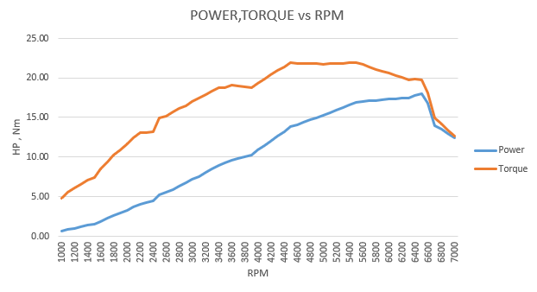
Graph 2: Dyno graph
$$Power=\frac{Driving Force*Velocity}{746}$$
$$Torque=\frac{(Power*7127)}{RPM}$$

Equation 5: Power and Torque

4.4 Brake Specific Fuel Combustion (BSFC)
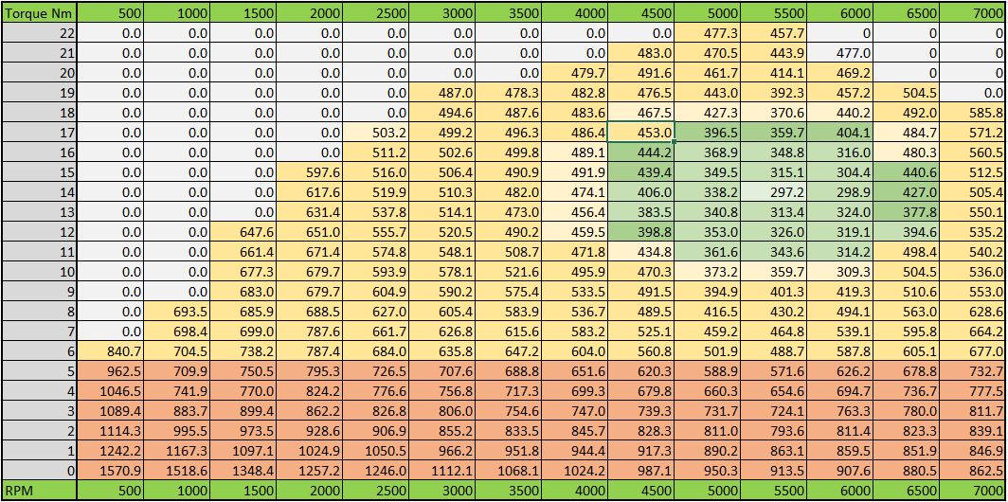
Table 9: BSFC Table Generated.
Brake specific fuel consumption is a parameter that reflects the efficiency of a combustion engine which burns fuel and produces rotational power. Bsfc is calculated by dividing the fuel mass flow rate to the engine output power. According to the limitation of data to interpolate BSFC for Renegade, data from a petrol aspirated engine is taken as reference to meet the performance of buggy. (x-engineer.org/brake-specific-fuel-consumption-bsfc/)
4.5 Drive Torque and Force
Each rotational component has its own moment of inertia and directly have an influence on torque needed to produce a specific angular acceleration about a rotational axis.

4.5.1 Drive Torque at Shaft
Equation 7 can be used to calculate the drive torque at primary shaft.
$$Drive Torque at Shaft=Torque*Gear Ratio*Efficiency$$
Equation 6: Drive torque at primary shaft

4.5.2 Drive Torque at Wheels
The drive torque at rear wheels can be calculated by Equation 8.
$$Drive Torque at Rear Wheels=Driver Torque at Shaft*Final Drive Ratio*Efficiency$$
Equation 8: Drive torque at rear wheels

4.5.3 Driving Force
The maximum driving force was calculated using Equation 9.
$$Driving Force= \frac{Driving Torque at Rear Wheels}{Rolling Radius of the Wheel}$$

Equation 9: Driving Force

4.6 Fuel Usage
The fuel usage per metre and across the whole lap was calculate using equation 10. From the simulated data buggy consumes around 2.65 litres of fuel in one complete lap, considering performance with torque utilisation in competitive terrains. The fuel usage is strictly dependant on the driver where a professional sportsperson is considered to drive the lap. For calculations density of petrol is taken as .755 kg/cm^3.(Gillespie,1992)
$$Fuel Usage \left(g\right)=BSFC*Energy (kwh)$$
$$Fuel Usage \left(l\right)=\frac{\frac{(BSFC*Energy \left(kwh\right))}{1000}}{Density of Petrol}$$

Equation 10: Fuel usage in grams, litres (De and carvalheira,2018)

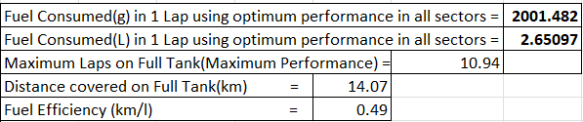
Table 10: Fuel Consumption

4.7 Acceleration and Deceleration
Acceleration of the buggy is inversely proportional to the equivalent mass. As the buggy is subjected to lower gears acceleration is strictly dependant on mass and outperforms at higher RPM. Acceleration is calculated by using Equation 11. Deceleration is dependent on gear and helps to manoeuvre with improved corner stability.
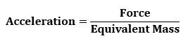
Equation 11: Acceleration

5.Graphs
Data to analyse the performance of renegade dx-10c in different parts of the simulated track conditions are follows. Manufacture can have a wide analysis into each parameter to understand the performance where necessary change can be bought to the test and development.

5.1 Velocity
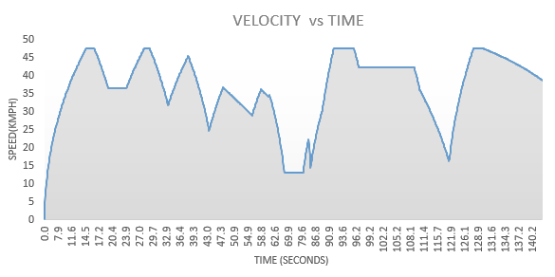
Graph 3: Velocity against Time
Velocity vs time graph plotted from the simulated data outlines the performance of buggy in different parts of the corner, different sectors and throughout a whole lap for a total distance of 1286 metres. Speed is constant at the corners and decreases due to gradient and competitive terrains.

5.2 Power and Torque
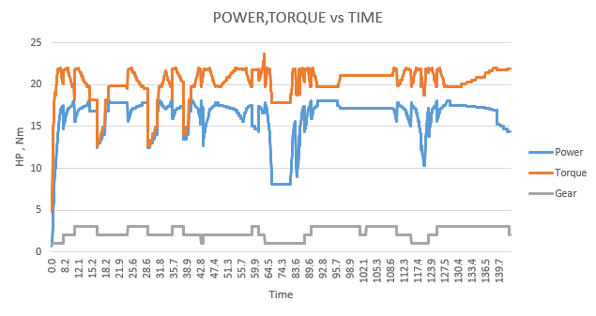
Graph 4: Power and Torque against Time
Graph 4 outlines the power and torque curves at different part of the track. The values change according to the gear shift done by the driver. Power and torque curves coincide at higher rpm.

5.3 Kinetic energy
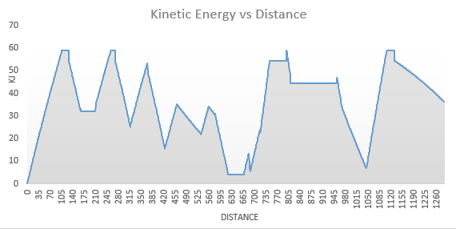
Graph 5: Kinetic Energy vs Distance
Kinetic energy of the buggy throughout the track is obtained from graph 5. According to the modern technology, Kinetic energy can be considered as a recovery system to improve the fuel economy to a great extent. Kinetic energy curve is similar to the speed curve as kinetic energy is directly proportional to the square of the velocity.

5.4 Rolling Resistance
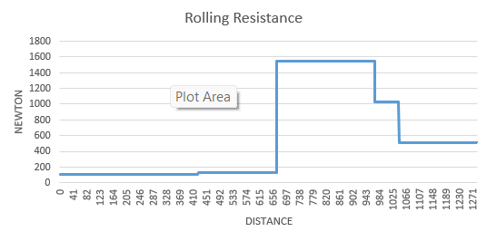
Graph 6: Rolling Resistance vs Time
Rolling resistance of the buggy varies with respect to the coefficient of rolling resistance and can be seen using Graph 6. There are 5 sectors where 5 different rates of change of rolling resistance forces act on the buggy. The highest resistance forces act on sector 3 with peak values and least on sector 1.
5.5 Gradient Resistance
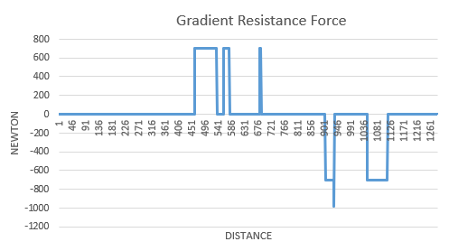
Graph 7: Gradient resistance Force vs Distance
A total gradient of 20m is assigned in the first half of the track distance which opposes the acceleration of the buggy. Meanwhile gradient resistance force becomes negative on downhill which decreases the fuel consumption.
5.6 Net Driving Force
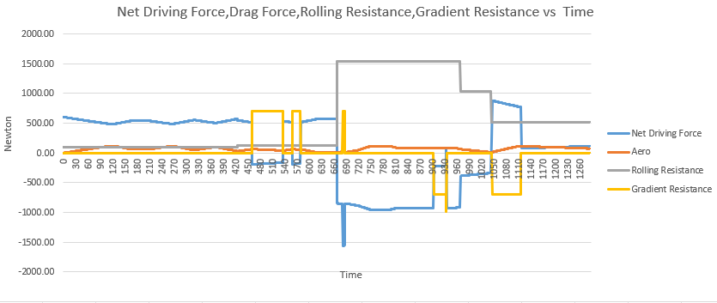
Graph 8: Net Driving Force, Drag Force, Rolling Resistance, Gradient Resistance vs Time
Net driving force is the power available at wheels while a vehicle is accelerating. It decreases when the resistive forces like rolling resistance and gradient resistance changes.Net driving force is directly proportional to the equivalent mass of the buggy and acceleration.

5.7 Tractive Effort
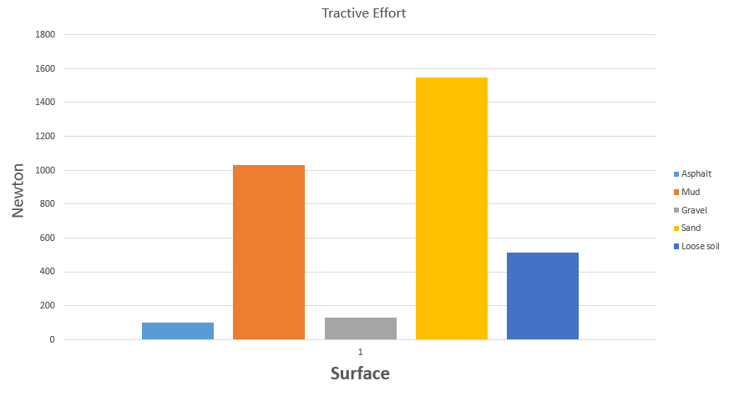
Graph 9: Tractive Effort on different surfaces
Tractive effort is the resistance acting on the tyre contact surface due to change in the surface irregularities. Tyre coefficient of friction varies according to the type of compound used whereas road or terrain surface influence greatly providing resistance to traction offered by the tyres. Data from graph 9 represents the tractive effort on 5 different surfaces of different part of the course. Coefficient of rolling resistance is taken from [carvill,1994](semischolar.org/paper/A-lightweight2c-modular-robotic-vehicle-the-bawden-ball)
5.8 Acceleration and Deceleration
Acceleration vs Time graph 10 outlines the performance of the driver at different part of the course. Acceleration decreases gradually when speed increases and gear changes for the renegade dx 10c. Acceleration turns negative with deceleration when the buggy enters braking zones. A constant acceleration will be maintained at the corners as speed is constant to get maximum time at the corners.
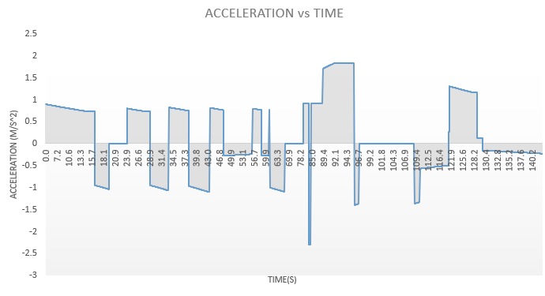
Graph 10: Acceleration vs Time
5.8.1 Traction limited Acceleration
Traction limited acceleration is directly proportional to the terrain and the gear used. From graph 11-15 traction limited acceleration increases in each gear

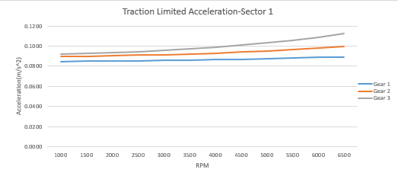
Graph 11: Sector1-Traction limited acceleration vs Rpm
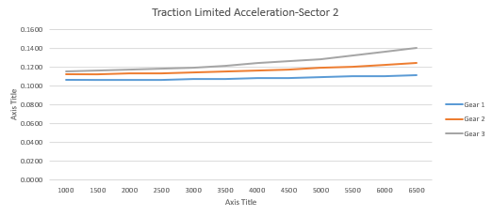
Graph 12: Sector2-Traction limited acceleration vs Rpm

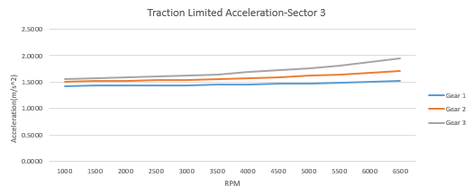
Graph 13: Sector3-Traction limited acceleration vs Rpm

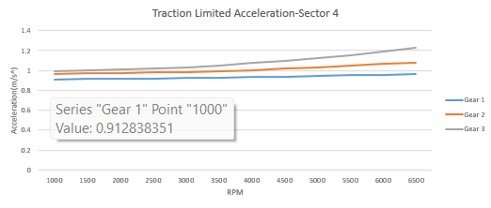
Graph 14: Sector4-Traction limited acceleration vs Rpm

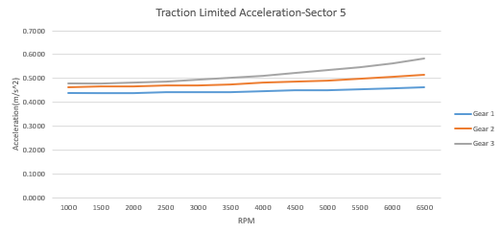
Graph 15: Sector5-Traction limited acceleration vs Rpm

5.8.2 Traction limited Deceleration
From graph 16 traction limited deceleration changes according to the type of terrain.
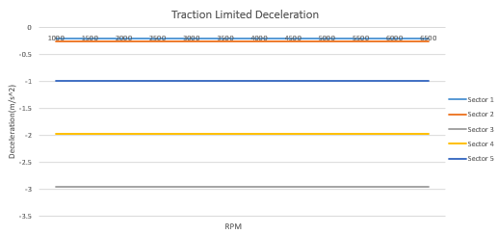
Graph 16: Traction limited deceleration vs Rpm

5.9 BSFC
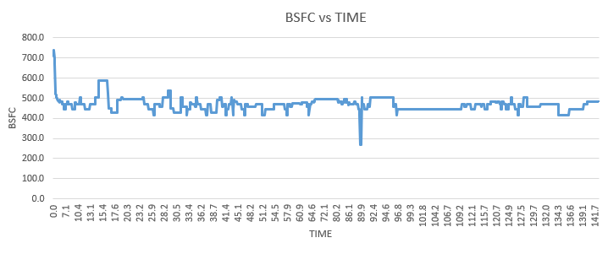
Graph 17: BSFC vs Time
Graph 11 represents the brake specific fuel consumption of the buggy which represents fuel usage on renegade at different terrains. To maintain optimum performance in competitive terrain a BSFC of 420-550 kg/J is the average consumption at higher rpm with the range within maximum torque. BSFC of an engine is directly proportional to fuel mass flow rate and inversely proportional to the effective brake engine power which is a function of effective torque and rpm(x-engineer.org/brake-specific-fuel-consumption-bsfc).

5.10 RPM
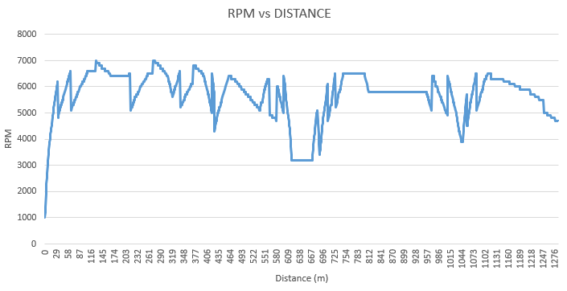
Graph 18: Rpm vs Distance
Graph 12 represents the driver performance in different sector of the course where sector tractive effort resists the vehicle performance. An average rpm range of 5000 to 7000 rpm is maintained in each gear to keep the buggy within maximum torque range.
5.11 Gradient Change
A total slope of 20 metres is located in sector 2 of the course. A downslope of 6 metre is located in sector 3 followed by 14 metres in sector 5. Graph 13 explains about the role of gradient in the course.
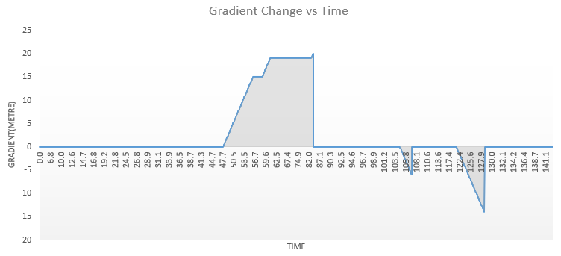
Graph 19: Gradient change vs Time
5.12 Fuel Usage
Graph 14 indicates the fuel consumed by the buggy in 1 lap. The fuel consumed by the buggy will be solely dependent on driver throttle control and gradient characteristics.
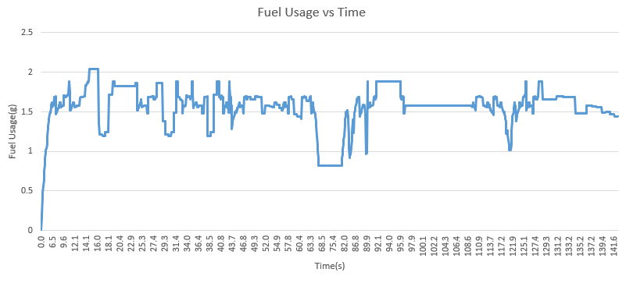
Graph 20: Fuel Usage vs Time

6.Conclusion
This report has shown the renegade dx 10c characteristics on a dual-purpose terrain course across a lap. Considering the design of renegade to driver characteristics the test was conducted by a professional sportsperson to obtain maximum fuel consumption for the given engine specifications. Looking for the wide perspective of renegade users there are long distance tourers and adventure seekers who definitely want to serve the purpose where terrain and weather challenges needs to be considered. The test was conducted at dry conditions. The wet conditions would be difficult to obtain the maximum efficiency where the real performance should have been tested to ensure the reliability of Renegade in outdoor conditions.
Rolling resistance and gradient resistance forces acting on renegade influence considerably on the buggy performance. Introducing adventure tyres which can accumulate a vast volume of terrain surface between the grooves can improve the rolling characteristics in different terrains. Due to the absence of front wheel drive, buggy finds it hard to negotiate with the gradient and drive conditions, introducing an electric motor drive for the front wheel drive can considerably improve the efficiency of the renegade on real world terrain conditions.
The quantity of fuel used by the renegade is a considerable amount at maximum performance considering the brake specific fuel consumption generated. The CVT transmission of buggy can save a considerable amount of fuel loss due to gear shifting. Meanwhile introduction of all wheel drive can have supplementary improvement in fuel efficiency.

7.References
(x-engineer.org/brake-specific-fuel-consumption-bsfc, Not Available)
(DX10 Renegade Corporate Buggy Off Road Buggy from Blitzworld (no date). Available at: https://www.blitzworld.co.uk/Adult-Buggies/Renegade-DX10-CORPORATE-300cc-Auto)
(semischolar.org/paper/A-lightweight2c-modular-robotic-vehicle-the-bawden-ball, n.d.)
(Wong, J. (2008) Theory of Ground Vehicles)
(the-welters.com/racing/rotational.html, March-17-2002)
(Gillespie, T. D. (Thomas D. . (1992) Fundamentals of vehicle dynamics. Society of Automotive Engineers.)
(De, P. and Carvalheira, F. V (2018)https://paginas.fe.up.pt/~tem2/Proceedings_TEMM2018/data/papers/7429.pdf)

Appendix

Table 1: Classification of Sectors
Table 2: Gear Ratio
Table 3: Test Mass
Table 4: Wheel and Tyre Mass
Table 5: Reduced mass in each gear
Table 6: Drag parameters
Table 7: Aerodynamic drag in each gear
Table 8. Rolling resistance in different terrain
Table 9: BSFC Table Generated
Table 10: Fuel Consumption
Graph 1: Velocity and Aerodynamic Resistance
Graph 2: Dyno graph
Graph 3: Velocity against Time
Graph 4: Power and Torque against Time
Graph 5: Kinetic Energy vs Distance
Graph 6: Rolling Resistance vs Time
Graph 7: Gradient resistance Force vs Distance
Graph 8: Net Driving Force, Drag Force, Rolling Resistance, Gradient Resistance vs Time
Graph 9: Tractive Effort on different surfaces
Graph 10: Acceleration vs Time
Graph 11: Sector1-Traction limited acceleration vs Rpm
Graph 12: Sector2-Traction limited acceleration vs Rpm
Graph 13: Sector3-Traction limited acceleration vs Rpm
Graph 14: Sector4-Traction limited acceleration vs Rpm
Graph 15: Sector5-Traction limited acceleration vs Rpm
Graph 16: Traction limited deceleration vs Rpm
Graph 17: BSFC vs Time
Graph 18: Rpm vs Distance
Graph 19: Gradient change vs Time
Graph 20: Fuel Usage vs Time
Equation 1: Reduced Mass
Equation 2: Aerodynamic Resistance Forces
Equation 3: Rolling Resistance Force
Equation 4: Gradient Resistance Force
Equation 5: Drive torque at primary shaft
Equation 6: Drive torque at rear wheels
Equation 7: Driving Force
Equation 8: Fuel usage in grams, litres
Equation 9: Acceleration

