Material Science

Material Failure Report:
Corrosion Resistance Failure of a Trivalent Chromium Conversion Coating of Aluminium Alloy Grade 2014A

Student:
Creighton Rees
1910564
Lecturer:
Phil Holden
Course:
Ordinance Munitions and Explosives: ACDA6016: Material Science
Executive Summary

The failure selected for this report is regarding the corrosion resistance of a new trivalent Chromium Conversion Coating (CCC) of Aluminium Alloy 2014A test panels. The existing Hexavalent Chromic Acid Anodizing (CAA) process has been added to the REACH* Authorisation List.
Hexavalent Chromium (HC) compounds, including Chromic acid were given a sunset date of the 21st of September 2017 [1] as they are extremely carcinogenic to humans and when used in processing produce harmful waste byproducts. Therefore, a suitable alternative was required to replace the current surface coatings of approximately 80% of components used for munition production.
The new Trivalent Chromium (TC) Conversion Coating down selected for the replacement of current HC CAA surface coatings was SurTec 650V© as this showed promising initial results and appeared to be a suitable alternative.
The approach to qualifying the SurTec 650V© coating for use in a military environment was conducted in accordance with Military Detailed specification (MIL-DTL)-5541-F Chemical Conversion Coatings on Aluminium Alloys.
The sub-contractor application of SurTec 650V© was successfully qualified for Aluminium Alloy (AA) Grades 6082 and 7075. AA Grades from the 2XXX series have yet to be tested, results form the basis of this report and have been shown in Section 5.
Five Test Panels of AA2014A were tested for corrosion resistance after processing, all five panels failed to meet the performance requirement of MIL-DTL-5541-F. Several corrosion spot ‘pits’ were found on each panel after 168 hours exposure.
Additional Test Panels of AA214A must be procured and supplied to the sub-contractor for coating with SurTec 650V© implementing the process improvements identified by the coating manufacturer, qualification is ongoing.

Contents
1 Introduction 4
2 Background 5
3 Qualification Requirements 6
4 Grade of Aluminium Alloy under Test 9
5 Test Results 11
6 Discussion 12
7 Conclusion & Recommendations 13
References 14
Annex A SurTec 650V© Technical Data Sheet (Sheet 1 of 2) [5] 16
Annex A SurTec 650V© Technical Data Sheet (Sheet 2 of 2) [5] 17
Annex B Aluminium Alloy 2014A Data Sheet (Sheet 1 of 3) [11] 18
Annex B Aluminium Alloy 2014A Data Sheet (Sheet 2 of 3) [11] 19
Annex B Aluminium Alloy 2014A Data Sheet (Sheet 3 of 3) [11] 20

Table of Figures
Figure 1 – CCC Process (Left) and CAA Process (Right) [4] 4
Figure 2 – Illustration of a Typical Salt Spray Test Cabinet [7] 7
Figure 3 – Visual Representative of Adhesion Ratings - ASTM-D3359 Procedure A [9] 8
Figure 4 – Representative component – Pipe Coupling AA2014A [10] 9
Figure 5 – SurTec 650V© Process Sequence [5] 10
Figure 6 – Typical Appearance - AA2014A T6 Test Panel Coated with SurTec 650V© [13] 11
Figure 7 – Typical Appearance - Coating Adhesion Result [14] 11
Figure 8 - Typical Appearance – Corrosion Resistance Result - Post 168 hours Salt Spray [15] 12

Table of Tables
Table 1 – Aluminium Alloy Grade 2014A – Chemical Composition [11] 9
Table 2 - Aluminium Alloy Grade 2014A – General Properties [11] 10
Table 3 - Aluminium Alloy Grade 2014A – Mechanical Properties [11] 10

Introduction
  - It has been asked that a failure report be produced on a component used within an industrial setting. The report must outline the material characteristics, intended application, methods of processing and analysis of failure using experimental methods.
  - The failure selected for this report is regarding the corrosion resistance of a new trivalent Chromium Conversion Coating (CCC) of Aluminium Alloy 2014A test panels. The existing Hexivailent Chromic Acid Anodizing (CAA) process has been added to the REACH* Authorisation List.
*REACH, (Registration, Evaluation, Authorisation and Restriction of Chemicals) is a European Union regulation (EC No 1907/2006). Substances are included in the Authorisation List (Annex XIV) of REACH, where their use in the European Economic Area (EEA), whether on their own or in mixtures or articles, are prohibited after the relevant sunset date unless an Authorisation is held by the user or an upstream supplier. [1]
  - Hexivailent Chromium (HC) compounds, including Chromic acid were given a sunset date of the 21st of September 2017 [1] as they are extremely carcinogenic to humans and when used in processing produce harmful waste byproducts. Therefore, a suitable alternative was required to replace the current surface coatings of approximately 80% of components used for munition production.
Hexavalent chromium is included in the REACH directive as it is a known human carcinogen. It is a SVHC (Substance of Very High Concern), and the waste produced from industrial processes involving it poses a serious threat to human health. [2]
  - Current aerospace and defence technologies rely heavily on HC coatings and the use of the CAA process for critical parts as it is well understood, established in terms of process equipment but mainly because the HC and CAA process produce surface coatings that have superior corrosion and abrasion resistance relative to coating thickness in comparison to CCC. [3]
  - Figure 1 [4] below shows a basic overview of both the CAA and CCC process. Note that both processes implement Chromic Acid, therefore both processes would need amendments to ensure compliance with the new REACH regulation.
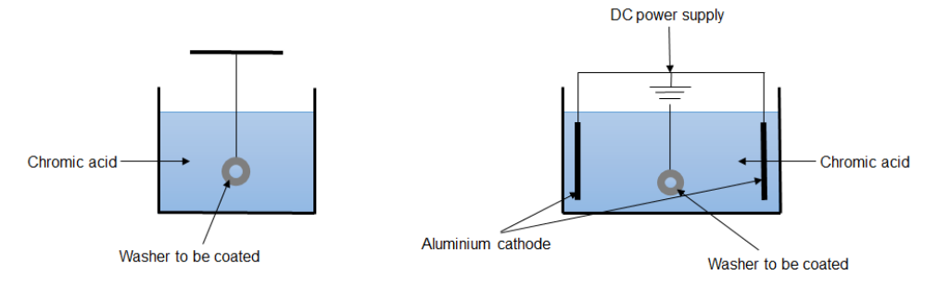
Figure 1 – CCC Process (Left) and CAA Process (Right) [4]
  - As shown in Figure 1 the CAA method of application differs from CCC, simply, CCC is applied by immersion of the substrate in tanks containing the coating in an aqueous form. CAA requires electrical current and specific jigging to allow the substrate being coated to become the anode while submerged in an electrolytic solution which includes a cathode. The difference between the two processes are CCCs chemically convert the substrate by oxidising the surface while CAA uses an electrochemical method to create an oxide film. [4]

Background
  - The new Trivalent Chromium (TC) Conversion Coating down selected for the replacement of current HC CAA surface coatings was SurTec 650V© as this showed promising initial results and appeared to be a suitable alternative.
  - It was noted that the replacement coating was not expected to perform as well as the previous coating regarding its corrosion resistance. At the time of down selection current understanding was the coating would perform adequately to achieve the qualification requirements outlined in Section 3 of this report.
  - See Annex A for SurTec 650V© Technical Data Sheet [5], an extract has been shown below:
SurTec 650V© is a Trivalent Chromium (Hexavalent Chromium-free) conversion coating for aluminium, which produces a visible blue grey to yellow iridescent layer.
• Excellent corrosion protection.
• REACH, RoHS and WEEE compliant.
• Designed for immersion application but can also be spray or wipe applied.
• Can be used to repair anodised coatings and refresh them before painting.
• Approved for aerospace use to MIL-DTL-81706 and MIL-DTL-5541F. Also approved by Qualicoat for architectural aluminium.
• Supplied as a concentrated liquid.
• Low electrical resistance.
• Drop-in replacement for hexavalent chrome passivation. [5]
  - The approach to qualifying the SurTec 650V© coating for use in a military environment was conducted in accordance with Military Detailed specification (MIL-DTL)-5541-F Chemical Conversion Coatings on Aluminium Alloys.
  - Processing materials must be listed within MIL-DTL-81706 - Chemical Conversion Materials for Coating Aluminium and Aluminium Alloys. The activity was split into two phases as outlined in Section 2.6 and 2.7.
  - Phase 1 - Test panels
    - A quantity of Test Panels was produced from the same grade of aluminium alloy which are currently used during the manufacture of components contained within a munition.
    - Test Panels were coated by the plating subcontractor with all processing parameters validated and recorded, using process control testing as specified by MIL-DTL-5541-F.
    - When it was understood that the test panels met the performance requirements of MIL-DTL-5541-F, authorisation was given to proceed to Phase 2 of the programme, Component Testing.
  - Phase 2 - Component Testing
    - A sample of un-treated components were allocated to the plating subcontractor for coating with SurTec 650V© in accordance with the requirements of MIL-DTL-5541-F.
    - The processing parameters used during Phase 1 of the programme were maintained throughout Phase 2.
  - The sub-contractor application of SurTec 650V© was successfully qualified for Aluminium Alloy (AA) Grades 6082 and 7075. AA Grades from the 2XXX series have yet to be tested, results for the basis of this report and have been shown in Section 5.

Qualification Requirements
  - To qualify the SurTec 650v© for use on production components, testing must be conducted in accordance with MIL-DTL-5541-F. The classification of the new CCC as specified by MIL-DTL-5541-F, is Type II, Class 1A. [6]
- Type II: Compositions containing no Hexavalent Chromium
- Class 1A: For maximum protection against corrosion, painted or unpainted.
  - The subcontractor has already shown compliance with the application requirements of MIL-DTL-5541-F on other grades of AA, for the purpose of this report focus will be given to the performance requirements of the specification detailed in Section 3.6 of MIL-DTL-5541-F.
  - Performance Requirements
    - Based on the coating Type, and Classification, outlined in para 3.1, to determine the performance characteristics of the applied coating, test specimens ‘3 inches wide, 10 inches long, with a nominal thickness of not less than 0.020-inch’ [6] were produced of the same grade AA and temper intended for subsequent production components.
    - In addition to a visual inspection, MIL-DTL-5541-F specifies that a class 1A coating must undergo Corrosion Resistance Testing in accordance with ASTM-B117 on five specimens prepared in accordance with 3.3.1 [6]
    - As the coating is to be subsequently painted or lacquered, Wet Tape Adhesion Testing on two specimens, prepared in accordance with 3.3.1., must be conducted in accordance with FED-STD-141 Method 6301, to ensure conformance to ASTM-D3359 Procedure A. [6]
    - Visual Appearance of Coating
      - As specified by MIL-DTL-5541-F the appearance of the finished coating shall be;
‘Continuous in appearance and visibly discernible in daylight. It shall be free from areas of powdery or loose coating, voids, scratches, flaws, and other defects or damages which reduce the serviceability of parts or are detrimental to the protective value and paint bonding characteristics.’ [6]
    - Corrosion Resistance Testing
      - The corrosion resistance performance of coatings is typically determined by subjecting the coated component or test specimen to a high salinity mist within a sealed environment for agreed periods of time. This process artificially ages the coating which can give a good indication of its life expectancy in service. Figure 2 below shows an images of a typical salt spray apparatus.
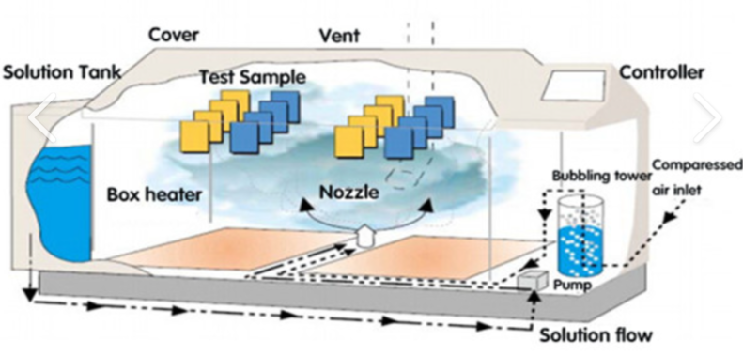
Figure 2 – Illustration of a Typical Salt Spray Test Cabinet [7]
      - The corrosion resistance test conditions defined by MIL-DTL-5541-F have been summarised below.
- Test specimens must be dried at 16 to 38 ºC for 24 hours prior to test.
- Test specimens to be subjected to a 5 percent salt spray test in accordance with ASTM-B117. The cabinet temperature shall be 35 ºC +/-2 ºC.
- Salt spray test duration of 168 hours, with the significant surface inclined between 15º and 30º from the vertical.
- Post-test test specimens to be cleaned in running water not warmer than 38ºC, blown with clean, dry unheated air.
- Temperatures during processing must not exceed 60 ºC at any point, as this can be detrimental to the corrosion resistance performance of the coating. [6]
      - The corrosion resistance performance requirements defined by MIL-DTL-5541-F are outlined below.
- No more than 5 isolated spots or pits*, none larger than 0.031 inch in diameter, per test specimen.
- No more than 15 isolated spots or pits, none larger than 0.031 inch in diameter, on the combined surface area of all five test specimens.
- Areas within 0.25 inch from edge or identification markings shall be excluded due to edge effect. [6]
* As a general rule a corrosion spot or pit usually displays a characteristic tail or line, however, any visible corrosion or pitting except scratches or substrate surface defects is to be counted. [6]
    - Wet Tape Adhesion Testing
      - The adhesion performance of a surface coating is typically tested by applying the final coating, whether it paint or lacquer to the test specimen, then intentionally scratching the surface. The scratched surface then has a low tac tape applied to the test area, when the tape is removed some of the final coating may come away from the CCC, this would show a low/poor adhesion performance, if no paint or lacquer was removed it would be considered to have good adhesion performance.
      - MIL-DTL-5541-F specifies testing must be conducted in accordance with FED-STD-141 Method 6301, to ensure conformance to ASTM-D3359 Procedure A ‘X’ Cut Tape Test [6]. The conditions of the test are summarised below.
- An X-cut is made through the film to the substrate of the test specimen.
- Pressure-sensitive tape peel strength between 6.34 N/cm (58 oz/in.) and 7.00 N/cm (64 oz/in.), is applied over the cut and then removed.
- Adhesion is assessed qualitatively on a 0 to 5 scale. [8]
      - The adhesion performance requirement defined by MIL-DTL-5541-F are outlined below.
- No inter-coat separation shall occur between the paint system and the conversion coating.
- No inter-coat separation shall occur between the conversion coating and the base metal.
- Must have an adhesion rating of 4A or better according to ASTM-D3359 Procedure A. [6]
      - Adhesion Ratings detailed in ASTM-D3359 Procedure A are outlined below, Figure 3 [9] shows a visual representative of the corresponding ratings.
- 5A No peeling or removal.
- 4A Trace peeling or removal along incisions or at their intersection.
- 3A Jagged removal along incisions up to 1.6 mm (1 ⁄ 16 in.) on either side.
- 2A Jagged removal along most of incisions up to 3.2 mm (1 ⁄ 8 in.) on either side. 1A Removal from most of the area of the X under the tape, and 0A Removal beyond the area of the X. [8]

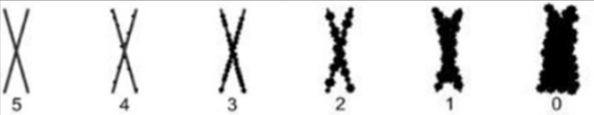
Figure 3 – Visual Representative of Adhesion Ratings - ASTM-D3359 Procedure A [9]
  - In addition to the testing outlined in Section 3.3.4, for use of the coating within a munition it must be tested for compatibility with explosives that are within proximity or direct contact with said coating. Testing has been conducted in accordance with North Atlantic Treaty Organization (NATO) Standardization Agreement (STANAG) 4147. Due to security classification restrictions the specific test details regarding explosive compatibility has been omitted from this report.

Grade of Aluminium Alloy under Test
  - The component that requires a new surface coating is a simple pipe coupling, similar in form and function to the component shown below in Figure 4 [10], the exact component has not been named or the detailed drawing shown due to security classification restrictions.
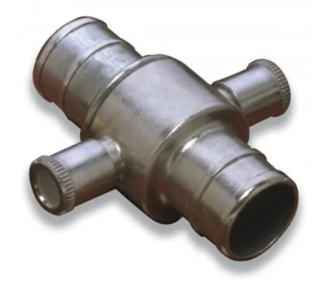
Figure 4 – Representative component – Pipe Coupling AA2014A [10]
  - The component is manufactured from AA2014A in accordance with BS EN 573-3:2009 - Aluminium and Aluminium Alloys, Chemical Composition and Form of Wrought Products.
  - AA2014A is manufactured in bar and plate form and has good machinability [11]. The chemical composition of the material is show below in Table 1 [11]. The full material data sheet can be found in Annex B.
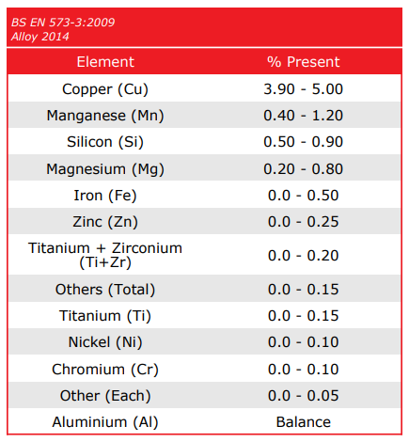
Table 1 – Aluminium Alloy Grade 2014A – Chemical Composition [11]
  - The materials general, and mechanical properties have been shown below in Table 2 and Table 3 respectively [11]. The material date sheet shown in Annex B states the temper condition as T651, due to material availability, AA2014A to a temper condition of T6 was procured for Phase 1 Test Panel Qualification, both temper conditions are comparable [12].
Temper - Condition of metal of aluminium or aluminium alloy produced by mechanical and/or thermal processing. Typically characterized by a certain macro or micro metallurgical structure and specified properties. These properties may be mechanical, corrosion, electrical. [12]
T6 - Solution heat-treated and then artificially aged. [12]
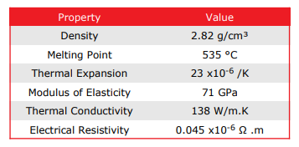
Table 2 - Aluminium Alloy Grade 2014A – General Properties [11]
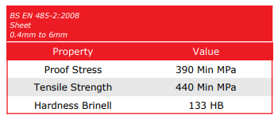
Table 3 - Aluminium Alloy Grade 2014A – Mechanical Properties [11]
  - Ten off test samples manufactured from AA2014A T6 were prepared in accordance with para 3.3.1 and supplied to the surface coating sub-contractor for processing with SurTec 650V© using the same processing parameters implemented for the qualification of AA6082 T6 and AA7075 T6.
  - Due to company Intellectual Property (IP) the exact processing parameters used for the qualification activities have not been included in this report. An overview of the process is shown below in Figure 5 [5].
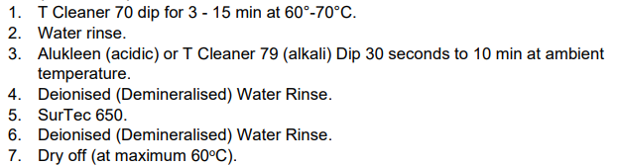
Figure 5 – SurTec 650V© Process Sequence [5]

Test Results
  - The visual appearance of the ten Test Panels on return from processing with the sub-contractor was found to be compliant with the requirements detailed in para 3.3.4. The coatings typical appearance has been shown below in Figure 6 [13].

Figure 6 – Typical Appearance - AA2014A T6 Test Panel Coated with SurTec 650V© [13]
  - Two Test Panels were lacquered using the intended final lacquering process including the materials used, then after sufficient drying time, allocated for coating adhesion testing as specified in Section 3.3.6. A typical image of the result has been shown below in Figure 7 [14].
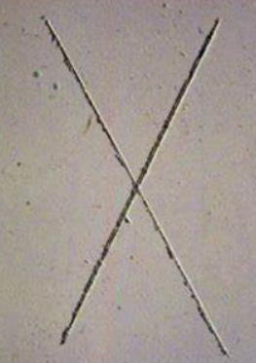
Figure 7 – Typical Appearance - Coating Adhesion Result [14]
  - Five Test Pannels were allocated for corrosion resistance testing in accordance with Section 3.3.5. A typical appearance of the Test Panels post-test (168 hours) has been shown below in Figure 8 [15].

Figure 8 - Typical Appearance – Corrosion Resistance Result - Post 168 hours Salt Spray [15]
  - One Test Panel was allocated for Explosive Compatibility testing as outlined in para 3.4, against the applicable explosive compositions. Results of testing proved satisfactory and compliant with STANAG 4147.

Discussion
  - When assessing the performance of the SurTec 650V Trivalent conversion coating applied to AA2014A T6 by the subcontractor, the coating met the visual appearance requirement of MIL-DTL-5541F as specified in Section 3.3.4. The coating appears continuous in form, with no areas of powdery or loose coating and a bluish iridescent which is discernible in daylight. A typical image of the result is shown in Figure 6.
  - Two Test panels were tested for coating adhesion as specified in Section 3.3.6. Both Test Panels met the requirements of MIL-DTL-5541F. A result of 4A was observed on both panels, some minor coating separation occurred at the incision but did not result in a failure, although due to this result a recommendation has been made to ensure compliance for future batches, see Section 7 a typical image of the result has been shown in Figure 7.
  - Five Test Panels were tested for corrosion resistance as specified in Section 3.3.5, all five panels failed to meet the performance requirement of MIL-DTL-5541-F. As shown in Figure 8, several corrosion pits were found on each panel after 168 hours exposure, all pits highlights exceed 0.030” in diameter. The pits are clearly visible by the classical black spot, typically, with a white tail governed by the orientation of the panel within the salt spray test chamber.
  - When AA2014A is compared to both AA6082 and AA7075, the chemical composition is considerably different. AA6082 has a relatively high Magnesium and Silicon content, while AA7075 has a relatively high Zinc content, AA2014A has a high Copper content. Copper is generally well known as having a poor resistance to corrosion, the root cause of the failure is believed to be due to this high copper content.
  - The manufacture of the surface coating has identified possible processing improvements which can be made when processing this grade of alloy to improve corrosion resistance, this has been detailed further in Section 7.
  - As the performance requirement for Phase 2 of the qualification programme defines a corrosion resistance test for a duration of 72 hours. A possible mitigation could be to process production components at risk and subject to a 72-hour salt spray exposure to ensure conformance. This may be a suitable suggestion as the components are of a low value to machine.

Conclusion & Recommendations
  - TC coatings have been found to be a suitable alternative for HC coatings due to their less hazardous nature to the environment and use within manufacturing processes. Although there is still additional work required to improve the corrosion resistance of the TC coatings on alloys with a high Copper content, as found during this report.
  - Analysis of the performance of a coating relies heavily on qualitative not quantitative results which require human interpretation. At times results can be subjective, as seen in the coating adhesion test.
  - SurTec 650V© has been successfully qualified by the subcontractor for application on AA6082 T6 and AA7075 T6 in accordance with the requirements of MIL-DTL-5541-F. Processing parameters and materials have been verified and validated by the quality department.
  - The result of the coating adhesion test was not as expected, although it met the requirement of Section 3.3.4 rated 4A, a higher level of performance was desired 5A, is belived that minor deviations in processing will have a significant effect of this result, which could quite easily fall within the non-compliant rating of 3A. It is recommended to the strict adherence to the finalised processing parameters (note Para 7.5) are maintained at all times with particular stringency around process control testing.
  - Additional Test Panels of AA214A must be procured and supplied to the sub-contractor for coating with SurTec 650V©. The coating manufacturer has been engaged for advice on the topic and have suggested to implement a nitric acid rinse prior to the application of the coating, it is recommended that the sub-contractor coat the Test Panels provided including the additional process step and controls suggested. Coating adhesion testing must be repeated on Test Panels processed using this alternative method.
  - If after the additional process improvements, the coating of AA2014A still fails to meet the corrosion resistance requirements of MIL-DTL-5541-F, it is recommended that an investigation be conducted on the suitability of manufacturing the production component from another type of AA, ideally AA6082 or AA7075 as the new coating has already been qualified on these grades.

References

[1] | I. (. Y INTERNATIONAL AEROSPACE ENVIRONMENTAL GROUP, “REACH Authorisation and Hexavalent Chrome,” 24 03 2021. [Online]. Available: https://www.iaeg.com/binaries/content/assets/iaeg-legacy/elements/pdf/iaeg_wg5_chromate_authorization_communication-final.pdf. [Accessed 23 10 2023].
[2] | B. Stones, “Hexavalent Chromium/Chromium (VI) and REACH,” Envirocare, 20 12 2021. [Online]. Available: https://envirocare.org/insights/hexavalent-chromium-chromium-vi-and-reach/. [Accessed 26 11 2023].
[3] | A. D. Juhl, “Overview of the different Anodizing processes for Aerospace,” LinkedIn, 24 08 2021. [Online]. Available: https://www.linkedin.com/pulse/overview-different-anodizing-processes-aerospace-anne-deacon-juhl. [Accessed 06 11 2023].
[4] | J. P. a. J. S. M. Isaac Omari, “Chromate conversion coating and alternatives as corrosion-resistant treatments for metal parts.,” Department of Chemistry, University of Victoria, Victoria, Canada , 2020.
[5] | T. G. Coatings, “Technical Data Sheet - SurTec 650V,” 27 09 2022. [Online]. Available: https://www.trimite.com/wp-content/uploads/2023/03/SurTec-650V_0922.pdf. [Accessed 09 11 2023].
[6] | N. A. W. C. A. Division, “DETAIL SPECIFICATION - CHEMICAL CONVERSION COATINGS ON ALUMINUM AND ALUMINUM ALLOYS,” Department of Defence, Lakehurst NJ, 2006.
[7] | K. T. I. Co, “Touch Screen Laboratory Salt Spray Test Chamber For Corrosion Resistant Testing,” KOMEG Technology Ind Co, 01 01 2015. [Online]. Available: https://www.climatictestchambers.com/sale-8290647-touch-screen-laboratory-salt-spray-test-chamber-for-corrosion-resistant-testing.html. [Accessed 18 11 2023].
[8] | A. International, “Standard Test Methods for Rating Adhesion by Tape Test,” 01 03 2017. [Online]. Available: file:///C:/Users/Creighton/Downloads/kupdf.net_astm-d3359-17-standard-test-methods-for-rating-adhesion-by-tape-test.pdf. [Accessed 18 11 2023].
[9] | A. Chandrashekar, “Adhesion Testing for Protective Coatings ASTM D 3359,” Annayya Chandrashekar, 16 01 2018. [Online]. Available: https://annayyachandrashekar.blogspot.com/2018/01/adhesion-testing-for-protective.html. [Accessed 23 11 2023].
[10] | T. (TSSC), “Aluminium Alloy Coupling - 2.5 Inches - Manufactured to BS 336 UK Fire Service Standards - [HS-AAC1],” TheSafetySupplyCompany, 01 01 2023. [Online]. Available: https://www.thesafetysupplycompany.co.uk/p/8692107/aluminium-alloy-coupling-25-inches-manufactured-to-bs-336-uk-fire-service-standards-hs-aac1.html?msclkid=a6b801dc21c21677259d64af13cdb164&utm_source=bing&utm_medium=cpc&utm_campaign=UPP_SSC_UK_PMAX_TRO_SR. [Accessed 20 11 2023].
[11] | A. M. Ltd, Aluminium Alloy 2014A T651 Sheet and Plate Data Sheet, Wednesbury, UK: Aalco Metal Ltd, 2019.
[12] | Aluminium-Guide.com, “Tempers of heat-treatable aluminium alloys,” Aluminium-Guide.com, 01 01 2013. [Online]. Available: https://aluminium-guide.com/en/tempers-heat-treatable-aluminium-alloys/. [Accessed 21 11 2023].
[13] | C. Rees, AA2014A Test Panel, Swansea: UWTSD, 2023.
[14] | T. Korea, “Cross-cut Adhesion Testing - ASTM D3395,” TQC Korea, 17 02 2023. [Online]. Available: https://blog.naver.com/PostView.nhn?blogId=tqc-korea&logNo=221084620864. [Accessed 23 11 2023].
[15] | M. e. al., “Nanostructured Coating for Aluminum Alloys Used in Aerospace Applications,” Journal of The Electrochemical Society, vol. 10, no. 169, p. 1149, 2022.

Annex A SurTec 650V© Technical Data Sheet (Sheet 1 of 2) [5]
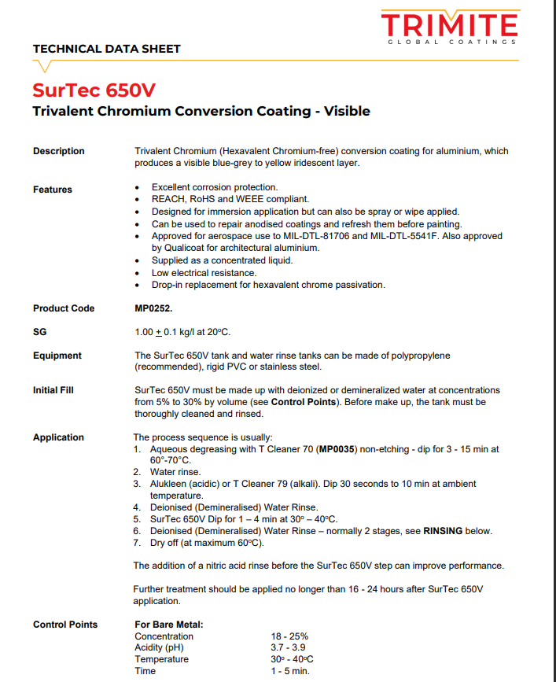

Annex A SurTec 650V© Technical Data Sheet (Sheet 2 of 2) [5]
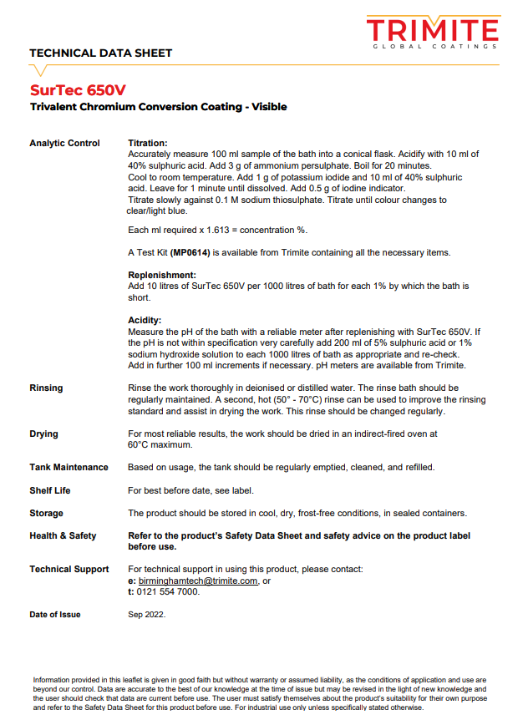

Annex B Aluminium Alloy 2014A Data Sheet (Sheet 1 of 3) [11]
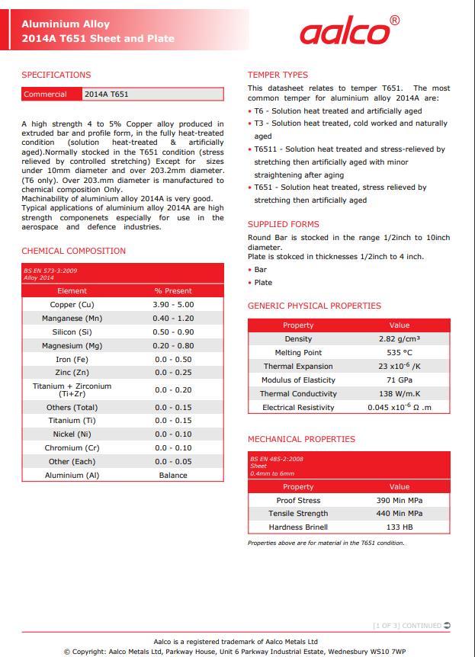

Annex B Aluminium Alloy 2014A Data Sheet (Sheet 2 of 3) [11]
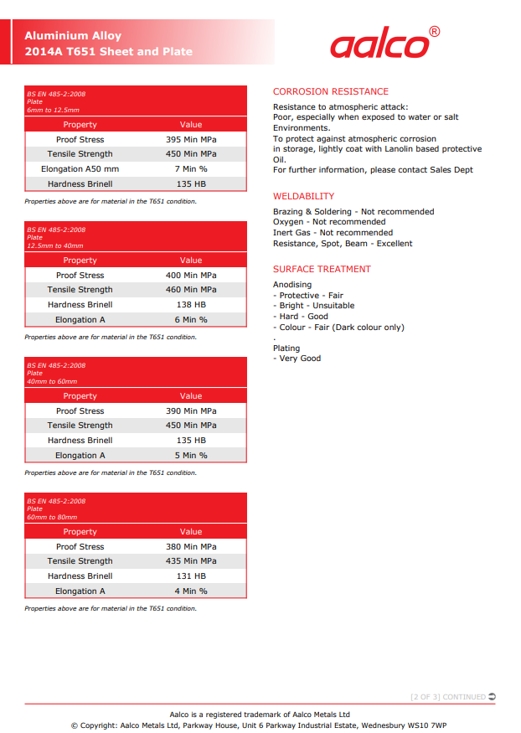

Annex B Aluminium Alloy 2014A Data Sheet (Sheet 3 of 3) [11]


