

Assessment Component 1
Case study - Written Report

Student name: Roland Nwaosu
Student ID: 1917495

Module name: Children, Young People and Families
Module code: (BMHP5004_LON)
Lecturer name: Bianca Sanfilippo
Word count:

Table of Contents
Introduction: 1
Presentation of case study 1
Risk Factors of Vulnerability 1
Analysis 2
Intervention 2
Evaluation 4
Conclusion 5
Reference 6

Introduction

This report is about an analysis of a case regarding a family facing adversity. Often, some families face adversities. Substance misuse as well as domestic violence, involvement with criminal justice system etc might be the specific issue. Generally, these factors will make any child in such family vulnerable. But what is vulnerable? According to dictionary.cambridge.org, means ‘when someone or something is able to be easily physically, emotionally, or mentally hurt, influenced, or attacked’. (Cambridge Dictionary, 2021)

Case Study

The case in this analysis was about a family of eight that was living in Bradford. Julie was a single mother with six children – four boys and 2 girls. Her sister, Sonia was also living with them. Julie was addicted to heroin and in order to fund the addiction, she was involved in in criminal behaviour and suspected prostitution. She was mostly absent from home to look after her children and this left Sonia to act as primary carer of the children. One of the children called Tom was associated with youth offending team as a result of his criminal behaviour. In terms of children's education, truancy was the order of the day: Three of the boys were permanently excluded and should be attending alternative education. The youngest child was behind in her immunisation and her nursery record of attendance was only three percent. The children's general neglect was worrisome. Although this family need to be rehoused as the estate, they lived on was earmarked for demolition, it was difficult to rehouse them because the providers were worried of their high levels of anti-social and criminal behaviour. Lastly, there was no love lost between the family and the local community due to their problems. Even some local took law unto their hands by smashing windows in their property.

The risk factors of vulnerability

The adversity the family was facing stemmed mainly from Julie's substance misuse. Substance misuse means using in a harmful or hazardous way alcohol and illicit drugs that are harmful to health. (Buckinghamshire Council, 2021). Julie’s substance misuse was a primary risk factor for the family. (Smith & Wilson, 2016) suggested that “parents substance use may affect their ability to consistently prioritize the child's basic physical and emotional needs over their own need for substances". This primary risk factor was consequential to secondary factors and they include criminal behaviour and prostitution on the part of their mum. Risk factors for the children are: truancy, exclusion, criminal behaviour, threat of violence in the community, anti-social behaviour, lack of trust on the agencies and behind in immunisation.

In comparison with other average families, this primary risk factor in addition to other consequential risk factors made the children vulnerable and in need. According to NSPCC this vulnerability would lead to neglect, physical and emotional abuse, impact on brain development, criminal behaviour and psychological effects (NSPCC, 2021). Children's educational and behavioural development would be affected as well. In this context, a child is vulnerable if he is assessed as being in need under section 17 of the Children Act 1989 (scie.org.uk, 2012). According to Public Health England (see statistics below) around 20% of children ‘in need’ are affected by drug misuse (Public Health England, 2020).

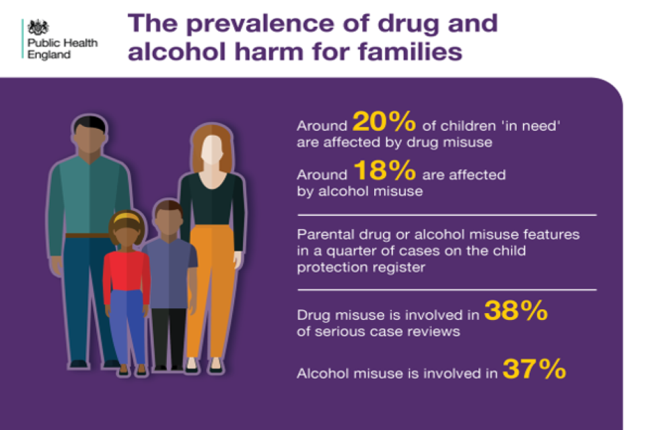
Image1 Source: Public Health England

Analysis:

The assessment, intervention of multi-agency and results

The adversity this family faced was exposure to multiple risk factors including neglect. This in turn made them vulnerable and in need. Legally, children in need is defined as those children under 18 who, in other to accomplish and uphold a reasonable standard of health and development and, to avert significant or additional harm to health and growth would need local authority services (citizensadvice.org.uk, 2021). According to children act 1989 “when a situation is considered as child in need, then the child became a subject of an assessment”. Ones there are worries about a child's wellbeing anyone can make a referral to Children's Social Care. Those that can make the referral include the child himself or herself, experts such as teaching staff, early year's workers, the police, probation service, GPs and health visitors in addition to family members and members of the public (Buckinghamshire Council, 2021) (SWCPP, 2020).

When carrying out the assessment the sections practitioners should focus on in terms of Children Act 1989 are sections 17, 47 and 31A.
- Section 17 seeks to justify if this indeed is a child in need.
- Section 47 focuses on, ‘if there is a rational to be suspicious that the child is suffering, or is likely to suffer, significant harm'
- Lastly Section 31A asks, 'Is this child in need of accommodation?'
Interventions

On the back drop that children/family in this case were at risk and specific assessment was required, the practitioners implemented a specific intervention. This intervention was based on assessment framework called 'Working Together to Safeguard Children A guide to inter-agency working to safeguard and promote the welfare of children' (2018). This framework opinionated that everyone who comes into contact with children and families has a role to play. (BASW, 2018)

This assessment framework was based on parental capacity and children developmental needs and family environmental factors. In this case parental capacity was judged poor due to Julie's substance misuse. She was deemed incapable as a mother to pay sufficient attention to her children's needs because her focus was on obtaining drugs. This in turn affected their developmental needs and exposed them to physical and emotional neglect in that environment (Hardy, 2017). Under section 17 of children's act 1989 local authorities are obliged to encourage the nurturing of children in need by their families. (Publications.parliament.uk, 2013). Based on this assessment, the practitioners started a plan to support this family: Julie, the children's mother was referred to local drug rehabilitation centre; Sonia was sent on 10- week parenting programme to improve emotional health of both adults and children by family links Nurturing Programme; and Tom, who had become bad influence on other children left home to live somewhere else with his dad may be due to the intervention. For this case study the partners (multi-agency) include Police, NHS, Children Services, Housing, Education Authority, Youth Offending team and Rehabilitation Offices.

The intervention made is rooted to children's act 2004. The act places duty on local authorities and their partners to work as team to promote the well-being of children and young people under the age of 18 and to make arrangements for protection and promotion of welfare of children. (Evans, 2013). As well, UK ratified United Nations Convention on the Rights of the Child (UNCRC) in 1991. The act requires governments to meet the basic needs of children and assist them to reach their full potential. This practitioners' intervention was based on articles 24, 26, 27 and 28 of the convention (savethechildren, n.d.)

The multi-agency intervention in this case study relates to article 24. The article states that “parties shall endeavour to make sure that no child is disadvantaged in relation to his or her access to such health services”. With respect to article 26, it mandates the government to identify that every child has right to benefit from social security, including social insurance, financial support and other benefits, to families in need of assistance. Article 27 supports the right of every child to a standard of living adequate for the child's physical, mental, spiritual, moral and social development. In this case as well, the intervention was based on article 28 of UNCRC 1991. This case study featured low school attendance by the children. The intervention based on article 28 ensured that their school attendance improved. It states that 'Every child has the right to an education’. It promotes the children’s right to education. (UNICEF, n.d.)

In other to make sure that the intervention was fair, the family and the children were assessed fairly and objectively without discrimination. Equality Act 2010 guided the assessment to ensure that the children have equal access to the health and social care services and support. The Act states that professionals should remove any barrier to equal access (www.gov.uk, 2015). In terms of Data Protection Act in relation to child protection, it is emphasised that there is need for parties to be transparent and responsible in relation to their use of data. It highlights the importance of effective information sharing amongst practitioners for integrated working and early intervention and safeguarding. So, in some case consent seeking is override by practitioners in the interest of the child.:

Following the intervention, the following results were achieved: Julie, the children mother’s referral to local drug rehabilitation centre positively impacted her life. She went on to complete basic literacy course; the family was rehoused on short term tenancy. However due to improvement in their behaviour, it was later changed permanent; Sonia learned for improvement to parenting and was educated on money management and executing routines for children; the children's record of school presence enhanced to 90 percent, they started living peaceful with neighbours; and social workers kept the family together against the initial contemplated removal of younger children: This was laudable achievement as this is supported by children's act 1989. It is important to keep siblings together as it largely boosts their emotional wellbeing.

Evaluation of Current Policy

From the mentioned results it should be said that the policy of 'Working Together to Safeguard Children: A guide to inter-agency working for protection and promotion of welfare of children' (2018) is worthwhile. It helped to protect the rights and the health and safety of the children as it is rooted on main legislations like Children Act 1989 and Children Act 2004, UNCRC 1991 and Equality Act 2010. This policy advances a child-centred approach. According to the policy there is need that assessment should be personalised according to individual needs of children. It places obligation on local authorities to provide suitable accommodation for children in need. Amongst other things the policy stresses the importance of keeping family together, the sacrosanct of multi-agency was upheld. The agencies include NHS housing officers, education welfare officers, social workers teachers, police and youth officers. When these agencies work together, the children's Holistic health and wellbeing are maintained.

Still on intervention, it is been propounded that intervention could be linked to Maslow's hierarchy of needs theory. The theory revolves round meeting basic needs. In the self-actualization pyramid of Maslow, children pass through five levels as needs are met. At the lowest level are needs for food, water, air etc. Children struggle to move to upper level which is safety and security and freedom from fear without these commodities. Belonging and love is the next level above safety. It is categorised by acceptance, love and affection. The fourth level called achievement and prestige is attained through approval and recognition. The highest level after all other needs is fulfilled is called self-actualization termed the ability to reach their full potential. (Early Childhood Education, n.d.) This theory is important considering the intervention of keeping children together in their family. It gives them that sense of belonging and love and save them the trauma of being in strange environment. Also, in relation to housing, children need shelter first as basic need. According Maslow, children need this basic need first in other to reach their full potential.
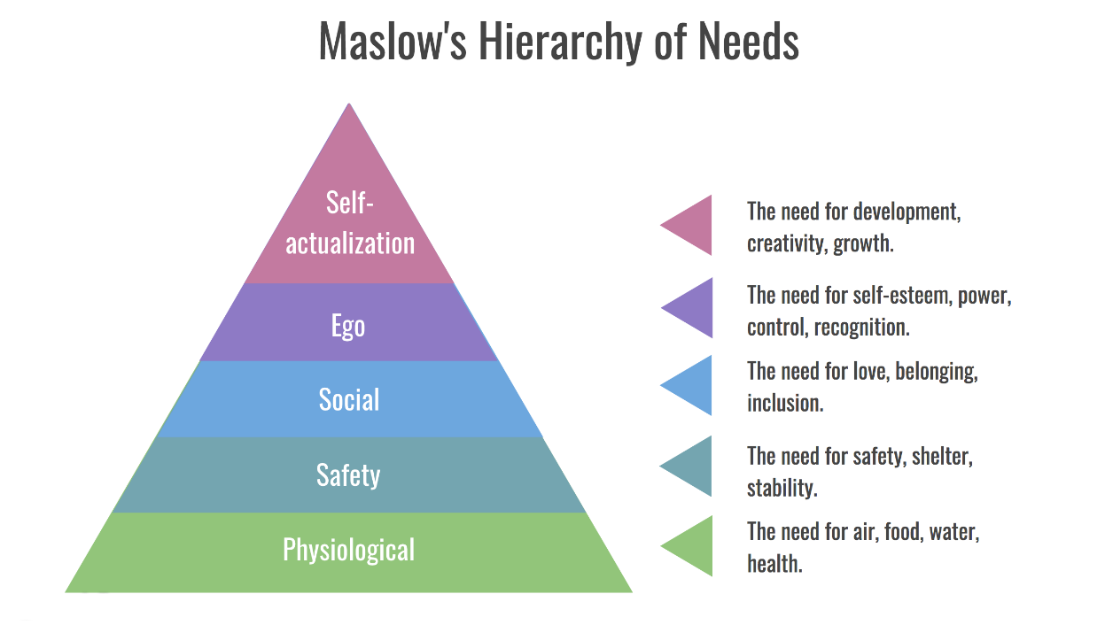
Image 2 source: Maslow theory of hierarchy - Bing images
In conclusion, it is essential to recognise that health and well-being of a child is not sole responsibility of the parent. This counters the early concept that child neglect should be blame solely on the parents. Bronfenbrenner shared more light on the importance of knowing that child development is not only influenced by the parents. According to his theory, Bronfenbrenner's ecological model of individual development, ‘parental influence as well as economic, political and cultural factors influences child development’ (MacBlain, 2018). He postulated that child development is influenced by five layers: Microsystem, Meosystem, Ecosystem, Macrosystem and Chronosystem. While microsystem refers to child's immediate environment like family, meosystem is about connection a child makes between, for example their home and their playgroup. Ecosystem refers to things like father and mother workplaces. They are external settings but they impact on child development indirectly. Macrosystem relates to child's wider cultural context like economy and changes in government. Lastly is Chronosystem: This refers to forms of events and transitions in the child's life. This theory, having pointed out that child development is not only influenced by parent is important as it encourages provision of services for children; it makes sure that there are resources for intervention. There was a turnaround for Julie and her family because their adversities were viewed as combination of factors. This theory also stresses on the need for child benefit which is about creating a culture and policy that child's development is not influenced by parent only but teachers, neighbours and different organisations.

Bronfenbrenner’s ecological model of individual development
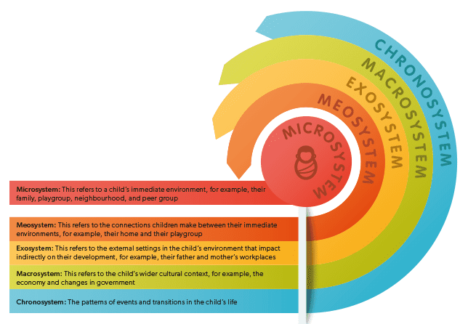
Image 3 source: Parenta.com

References
BASW. (2018, July 09). Working Together to Safeguard Children A guide to inter-agency working to safeguard and promote the welfare of children: July 2018. Retrieved August 17, 2021, from /www.basw.co.uk: https://www.basw.co.uk/resources/working-together-safeguard-children-guide-inter-agency-working-safeguard-and-promote
Buckinghamshire Council. (2021, March 11). Alcohol and Drug. Retrieved August 14, 2021, from https://www.healthandwellbeingbucks.org/s4s/WhereILive/Council?pageId=3372
Cambridge Dictionary. (2021). vulnerable. Cambridge: Cambridge Ubiversity Press. Retrieved August 16, 2021, from https://dictionary.cambridge.org/
citizensadvice.org.uk. (2021). Local authority services for children in need. Retrieved August 19, 2021, from https://www.citizensadvice.org.uk/family/looking-after-people/local-authority-services-for-children-in-need/
Early Childhood Education. (n.d.). Abraham Maslow: Hierarchy of Needs. Retrieved August 19, 202i, from /sites.google.com: https://sites.google.com/site/ece50018final/historical-roots/abraham-maslow
Evans, M. (2013, December 03). Policy guide: Children Act 1989 Amended 2004. Retrieved August 12, 2021, from https://www.nurseryworld.co.uk/search?q=Policy+guide%3A+Children+Act+1989+Amended+2004
Greatermanchesterscb.proceduresonline.com. (2021). Data Protection, Information Sharing and Confidentiality. Retrieved August 20, 2021, from greatermanchesterscb.proceduresonline.com: https://greatermanchesterscb.proceduresonline.com/chapters/p_info_sharing.html
Hardy, R. (2017, August 18). Communitycare. Retrieved August 18, 2021, from www.communitycare.co.uk: https://www.communitycare.co.uk/2017/08/18/parental-substance-misuse-affects-children-key-points-research/
MacBlain, S. (2018, September 01). Bronfenbrenner: children’s learning in a wider context. Retrieved August 17, 2021, from www.parenta.com: https://www.parenta.com/2018/09/01/bronfenbrenner-childrens-learning-in-a-wider-context/
NSPCC. (2021, June 03). Parental Substance Misuse. Retrieved August 18, 2021, from NSPCC Learning: https://learning.nspcc.org.uk/children-and-families-at-risk/parental-substance-misuse#:~:text=The%20impact%20of%20parental%20substance%20abuse%20varies%20a
Public Health England. (2020). Prevalence of Drug and Alcohol Harm For Families. Retrieved August 21, 2021
Publications.parliament.uk. (2013). The Rights of Children and Families. Retrieved August 16, 2021, from www.publicationsparliament.uk: www.publicationsparliament.uk/pa/ld201213/ldselect/ldadopt/127/12706.htm
savethechildren. (n.d.). UN CONVENTION ON THE RIGHTS OF THE CHILD. Retrieved August 20, 2021, from www.savethechildren.org.uk: https://www.savethechildren.org.uk/what-we-do/childrens-rights/united-nations-convention-of-the-rights-of-the-child
scie.org.uk. (2012). Introduction to children's social care. Retrieved August 18, 2021, from The Children Act 1989: https://www.scie.org.uk/publications/introductionto/childrenssocialcare/legalandpolicycontexts.asp#:~:text=Section%2017%20of%20the%20Act,authority%20to%20meet%2
Smith, V. C., & Wilson, C. R. (2016, 2016 18). Families Affected by Parental Substance Use. Pediatrics(138). doi:DOI: 10.1542/peds.2016-1575
SWCPP. (2020, November 10). Somerset Children Safeguarding Partnership. Retrieved August 20, 2021, from proceduresonline.com: https://www.proceduresonline.com/swcpp/somerset/p_referrals.html
UNICEF. (n.d.). A summary of the UN Convention. Retrieved August 15, 2021, from www.unicef.org.uk: https://www.unicef.org.uk/rights-respecting-schools/wp-content/uploads/sites/4/2017/01/Summary-of-the-UNCRC.pdf
www.gov.uk. (2015). Equality Act 2010: guidance. Retrieved August 21, 2021, from www.gov.uk: https://www.gov.uk/guidance/equality-act-2010-guidance

