Student name: Shaera miah
Student number: 1711954
Assignment title: Developing innovation and
Creativity for Business Advantage
Module: (BMSW6102)
Lecturer: Md Nazmul Hasan

Innovative product or service proposition.
Throughout this essay, I will deliver an innovative product and service that I have created, identify and discuss the impact of Covid-19 on the society; and how my service and product can have a positive influence on the lifestyles of individuals. It is clearly known that lockdown has had a major influence on individual’s lifestyle as it put a stop to everything and affecting them physically, emotionally and socially. During this national pandemic and due to Covid-19 rules and guidelines, individuals have difficulties with synchronising their daily routines and not being able to perform at gym centres is putting is negatively impacting most people. Due to this, some individuals are having to work from home but are finding it challenging to stick to a workout routine at home as they may have limited access to exercise facilities or may not have the appropriate fitness equipment or none at all.
Consequently, I created an inventive product which is a six-in-one fitness kit which I will offer customers through an online market at an affordable price. Exercise can help provide a sense of accomplishment. My six in one fitness kit will include: free face mask, a digital skipping rope, a resistant band which can improve muscle strength and maintain good posture; a roller kit with knee pads for abdominal fitness muscles and lightweight spring trainer, ideal for toning and strengthening the body and a fitness tracker bracelet and a duffle bag, tailored to fit all pieces of equipment and suitable for travelling. My target audience is individuals who are 18 years and over as it is essential for young people and adults to carry out physical activities each week such as aerobic exercise as this will increase muscle strength and help them maintain an active and healthy lifestyle. For example, the resistance band gives the versatility one needs to exercise and workout from the comfort of their own home. Using this tool can be facilitated to physical therapy purposes such as strength and flexibility. (NHS, 2019)
This kit will also include an instruction leaflet, guiding users how to use each piece of equipment. For those whos English is a language barrier, I will be using the amazon translation service where I will translate my product listing target languages of the market I want to sell on – this will assist to expand my business. As stated by a recent survey, 80% of customers would purchase items if description is displayed in their own language. https://ylt-translations.com/amazon-listing-translations/

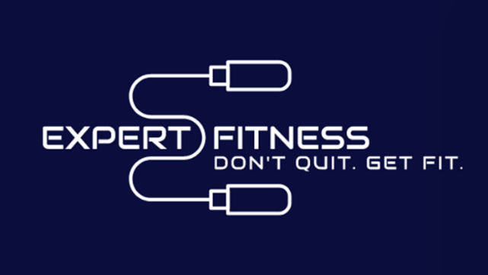
The bag will be a navy colour showcasing a white logo and the slogan ‘Don’t Quit, Get Fit’. I created this logo on Wix. Displaying an image of the product can communicate information about the brand, thus changing brand beliefs. Consumers who placed the most importance on these beliefs also have a better evaluation of the brand itself when its package includes a product image. In addition, Klein (2015) points out consumers reported a more positive attitude toward the package itself when a product picture is incorporated.

I would continue to work on my service and sell my product if sales increase after Covid-19, because products like this have high demands on the market as customers of all ages are ages ways looking for different ways to keep fit, according to their age. The higher increase in sales, the easier it will become to sustain my business. Hence to maintain my business, it is vital to increase the value by taking feedback from customers and suppliers, this is called co-creation – where online management can be viewed as interactions among four elements: people, organisation, technology and service design. High levels of engagement occurs when customers search for product information, promotions and updated news regarding the brand organisation; purchasing products online; downloading product-related apps or promotional coupons, resulting in contributing to the company’s innovation process and co-creating value with the firm. This is ensured by service and product feedback, suggestions and ‘liking’ innovative the organisation promotions (Zhang et al., 2018). Customer engagement represents the dynamics of networked customers, organisations and other stakeholder, interactively co-creating value through service delivery (Vargo et al., 2008).
Overview of competitors
My product is classed as an imitative innovation product as there are also other competitors who sell products comparable to mine. For instance, a company called Powerhouse Fitness sells fitness kits online and advertise through social media platforms. They sell items such as utility bench, dumbbell sets and treadmill. Their aims and objectives of their organisation are highly different to mine as they provide various gym equipment such as weight and cardio packages This means that their selling point is most likely to be high e.g. ranging from £200 up-to £2000. This differs very much to Expert Fitness because what I am starting with suitable, travel friendly and lightweight exercise tools which users can use at any time. Another company called ‘Fitness Superstore’ who also sell very similar products to the company mentioned previously however, their pricing is reasonable. The difference between these organisation and mine is that my product is beneficial during this time as I will be including free face masks and a fitness trackers along with the fitness kit, which would detect the user of this product, if they have any symptoms of Covid-19 and what they can do to protect themselves. Another way that my product is different to others in the market is that I will also offer 50% discount to NHS workers as well as key workers, to show my appreciation in this challenging period. I will only charge the minimum delivery charge which is £2.99 as I want my customers to stay content with their service during this challenging time. When customers purchase my product, it will highly come to my advantage because I can develop a business proposition by creating an inspiring statement that keep customers engaged to purchase goods from the service. In terms of price tags, I have to be aware as there are similar products in the market. Proposition will provide profitable and excellent customer value and create differentiation between other companies. Our target is to generate revenue by providing excellent and profitable customer value. However, value proposition is not only about our needs, our expectations or offerings but rather it is about customers experience of our offering in terms of consumer’s needs and it is an organisational approach to building in value to the customer experience (Barnes at el., 2009).
.

E-Commerce- propose to set up an online website
The name of my brand product will be called ‘Expert Fitness’. The price I will be selling at is £30.00. I believe the name will grasp the attention for Amazon customers who are interested and looking to purchase sports goods especially during this pandemic as we all know sport and gym centres have been shut down.
I will sell my product on Amazon I have chosen that plat form because it’s easier to reach out to customer, and it is an international technology corporation focusing on digital streaming, e-commerce, an artificial intelligence. Within Amazon, my product fits within the Sports & Goods category. I would then choose a professional selling plan, in which I must pay a monthly subscription fee of £25 (excl.VAT). The next stage would be to create and open an account on Seller Central, the web interface where I will list, price, and market my product directly to Amazon customers and use the Seller Central dashboard to keep track of and organize reports, pricing, advertising, and more. After being officially registered, I would add my product to the Amazon Marketplace and indicate how many items I will be selling within the description where I will briefly discuss my fitness kit I will also promote an ads on social media platforms such as Facebook. The benefits of this advert will notify and advise you on how to stay fit and healthy while in quarantine. It will advise and share information regarding fitness and how to stay in shape or to become healthy. Originally, this type of exercise equipment was only used by professional body builders but eventually, it became popular to the majority because of its numerous benefits. From my perspective, constructing a fitness exercise kit is vastly suitable and beneficial investment as many people are able to opt and purchase a multi-equipment exercise kit rather than pay for a gym membership; saving money in the long run, and purchasing durable ones that are long lasting. Another reason is that it saves a significant amount of time for those who have difficulty attending gym and sport centres due to reasons e.g. lack of transport, workplace meetings or several duties at home.

Marketing
Here I will discuss how I will promote and advertise my product on social media platforms for example Facebook, I have chosen this platform for advertisement purposes as it is one of the cheapest and most used platform. Facebook advertisements allows users to target them by location, gender, age, relationship status, job title, workplace or through keywords and a user selects their target audience, Facebook provides information on an approximate number of users that their targeting will cover. Business that have advertised also receive feedback on how to improve their marketing skills and whether the product would be better shown to another group of individuals (Graham at el., 2011). On the Facebook there is a marketplace section which you can use it to sell your product, I would then create a business account where I will post various images of my products and inspirational posts. I will also enable a comment section so people can feel free to comment and leave reviews about anything of the service or products. I can also use the Facebook messenger page to send and receive comments from my target audience in this way I will be able to increase engagement with customers and improve my service. I will set up a link on my social media profile which will send customers directly to my Expert Fitness website where customers can explore the page at any time and purchase my product. I will also get started with a new ad campaign. There are three types of identical ads objectives where it shows daily estimated reach of audience choosing the right objective is the first step in making sure my cost stays low. objectives are consideration, brand awareness and conversion. Hence I will therefore go for the lower objective to start with, which is conversion. The Facebook conversion targets individuals to take action with the face book ads, it’s all about getting your target audience to make commitment to buy. Conversion occurs when a customer to your website completes a desired goal such as filling out a form or making purchase. It also contains things such as store visits or catalogue sales. Using product catalogue allows your Facebook ads to keep up to date with the latest product pictures, pricing and text from your own website. Consideration is the traffic objective focusing on driving people to your website. And brand awareness focuses on reaching people who are going to be interested in your ads.
I will define how much I would like to spend on the ad budget by selecting £5 as my daily budget for one month. This sums up to a total of £140. Down below shows an example of a table that displays the process of the budget and schedule for promoting Facebook businesses. Facebook will target my profile to specific Facebook users, in this instance, individuals who are have an interest and passion for fitness. Face book also allows you to set a date and time schedule for your lifetime price range. Thus, it allows you to setup minimum daily limits. The lifetime budget may be used in case you want to run an advert campaign for at a certain period of time. Allowing Facebook to auto set optimal bids for you within your budget constraints it means you don’t have to maintain or adjusting your ad budget and settings.

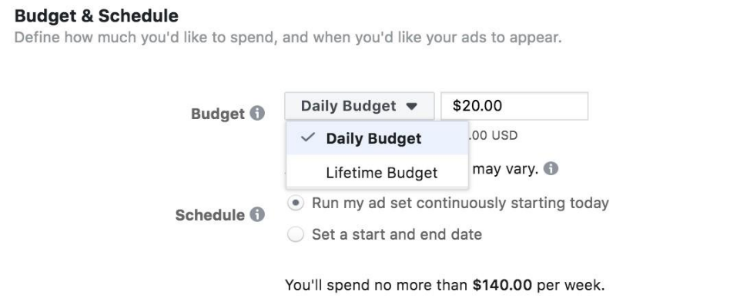

The link of my website will be on my Facebook profile. If the customers click the link they will be directly sent to my website.

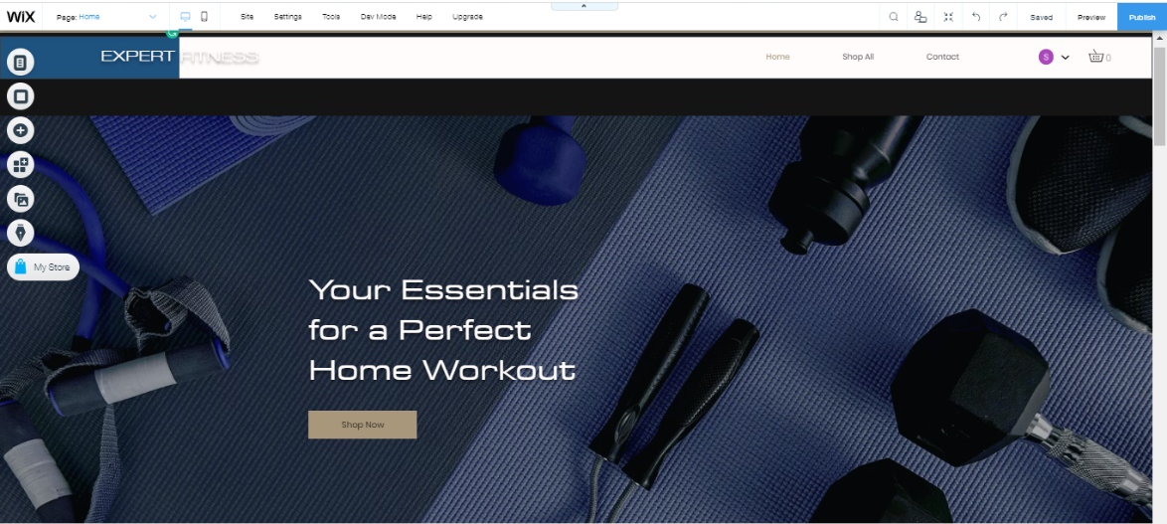

Link of the website is attached below
https://editor.wix.com/html/editor/web/renderer/edit/921167a9-66ba-4089-890f-30f4894c929a?editorSessionId=14eaa948-f6e1-4fc8-a744-55242ce5abac&metaSiteId=c2f
I am going to create a link on my website along with the prices for the product. Customers would click on the checkout link and will be taken to the checkout page where they only need to enter the basic but essential information to register and become a member, such as their name, email address and password, contact number and home address. This will therefore make their next shop from my website company easier as they would only have to log in using their email and address and password. At the time of purchasing they would only have to input their payment information by using PayPal and skip entering financial data and speed up imbursement. They can choose to save payment information for faster transactions in the future. However, paypal transactions would not work without security. Consequently, I would have to set up the Secure Sockets Layer encryption in order for paypal transactions to be taken safely and securely. Using this would protect customers’ personal data from frauds and identity thieves.
As a seller, I would choose the Paypal Payments Standard which means, when a customer is purchasing and chooses to use paypal, they will be taken to the Paypal site to complete the transactions. They would only have to simply enter their username and password and rest of the personal information is retrieved from the paypal database or they can create an account. At this point, the paypal transaction is complete. On the other hand, if the customer chooses to pay through their bank account, they would enter their account information on the checkout page and click the pay button to authorise payment which the bank would issue and approve of. PayPal would send the customer a message saying the purchase is complete and notify me via email. Once notified I would start the processing order and gradually inform the customer of the shipping date. When the funds are confirmed from the customer’s bank company, it would be deposited into my PayPal business account minus the applicable fees which is 2.9% per transaction. I believe PayPal is a very protected and secure platform because if I have come across an unauthorised payment, for instance from a hacked account or a purchaser claims they haven’t received their order, PayPal’s Seller Protection Policy provides you with the full quantity of the payment on eligible sales (Paypal 2020).
I have chosen not to set up direct debits because direct debit payments can fail for various reasons. One for example, would be an individual’s bank was not in role for payment, which typically means there was not sufficient cash within the payer’s account. Due payment being higher than expected or invalid bank detail, bank accounts would be cancelled and closed, and the individual would have specifically solved this issue, so it is avoided in the future.
GDPR policy is a data protection system that applies to most UK businesses and agencies. It covers the General Data Protection Regulation (GDPR) as it applies in the UK, tailor-made by the Data Protection Act 2018. As an online seller I will comply with the GDPR policies for my online business as it gives people more control over how my organisation uses their data. The organisation will deal with customers and process information about them, from the point when customers purchase goods and service. This may include their name, address, and phone number. This data is capable for recognising an individual, which is called 'individual personal data. The organisation may even request information like their date of birth, their education and their recent job (Consumer rights, 2020).

References
About Facebook. 2020. Keeping People Safe And Informed About The Coronavirus - About Facebook. [online] Available at: <https://about.fb.com/news/2020/10/coronavirus/#coronavirus-info-center> [Accessed 9 October 2020].

Barnes, C., Blake, H. and Pinder, D., 2009. Creating And Delivering Your Value Proposition. Business and Economics.

Bavel, J., Baicker, K., Boggio, P. and Capraro, V., 2020. Using social and behavioural science to support COVID-19 pandemic response. pp.460-471.

Berry, L., Danaher, T., Aksoy, L. and Keiningham, T., 2020. Service Safety in the Pandemic Age. Journal of Service Research,.

Facebook.com. 2020. Powerhouse Fitness. [online] Available at: <https://www.facebook.com/powerhousefitness.co.uk/> [Accessed 19 October 2020].

Fitness-superstore.co.uk. 2020. Fitness Superstore | Sale On Fitness, Gym And Exercise Equipment Fitness-Superstore.Co.Uk. [online] Available at: <https://www.fitness-superstore.co.uk/> [Accessed 19 October 2020].

Graham, s., 2011. advertising on facebook. International Journal of E-Business Development (IJED), [online] 1(1), pp.30-31. Available at: <https://d1wqtxts1xzle7.cloudfront.net/57980171/Advertising_on_Facebook.pdf?1544629845=&response-content-disposition=inline%3B+filename%3DAdvertising_on_Face> [Accessed 31 October 2020].

Merchant Machine. 2020. Online Payment Systems: 11 Easy To Use UK Options For 2020. [online] Available at: <https://merchantmachine.co.uk/online-payment-systems/> [Accessed 9 October 2020].

Services.amazon.co.uk. 2020. Become An Amazon Seller Today - Amazon.Co.Uk. [online] Available at: <https://services.amazon.co.uk/> [Accessed 10 October 2020].

Zhang, T., Lu, C., Torres, E. and Chen, P., 2018. Engaging customers in value co-creation or co-destruction online. Journal of Services Marketing, 32(1), pp.57-69.

graham, s., 2011. advertising on facebook. International Journal of E-Business Development (IJED), [online] 1(1), pp.30-31. Available at: <https://d1wqtxts1xzle7.cloudfront.net/57980171/Advertising_on_Facebook.pdf?1544629845=&response-content-disposition=inline%3B+filename%3DAdvertising_on_Face> [Accessed 31 October 2020].

2018 (GDPR). [online] Available at: <https://www.which.co.uk/consumer-rights/regulation/gdpr-data-protection-act> [Accessed 13 November 2020].

