
Skills for the Workplace
Module Assignment Submission
Student Name: | Rebecca Leismeier
Student Number: | 1910915
Module No: | BMSK5011
Module Title: | Developing Workplace Critical Thinking

Statement of Confirmation of Authenticity
By the act of making this submission, the student declares that this is the work of the student named above. The work has not, in whole or in part, been knowingly presented elsewhere for assessment, or where assessment has been built on a previous assessment, this has been identified. Where materials have been used from other sources it has been properly acknowledged. If this statement is untrue, the student acknowledges that an assessment offence has been committed.
Attention is drawn to the plagiarism and unfair practice policies of UWTSD.

Contents
Introduction 3
Concept of Critical Thinking 3
Understanding beliefs, attitudes, and values 5
Identify own beliefs, attitudes, and values. 6
Critically assess the impact of beliefs, attitudes, and values on own workplace behaviour. 7
Management Theories 7
Identify a management theory relevant to own role 8
The impact of management theories on the student’s beliefs, values, and attitudes. 9
How someone with different beliefs, attitudes and values might interpret the theory differently 10
Conclusion 11
References 12
Appendix A 13
Appendix B 14

Introduction
Critical thinking is an essential skill in today's workplace, as it allows employees to solve problems, make decisions, and evaluate information effectively. Developing critical thinking in the workplace can lead to better decision-making, increased productivity, and improved employee engagement. In order to develop workplace critical thinking, employees need to learn how to analyse information, evaluate evidence, and make sound decisions. This report will explore the different ways in which the student could develop workplace critical thinking with the application of management tools and theories, which can then help the student to identify their beliefs, values, and attitudes and understand their impact on workplace behaviour.

Concept of Critical Thinking
Critical thinking is the development and use of information beyond memory and repetition. Morgan, P. (2017). P.69. In order to think critically, one must gather appropriate data and information and carefully examine and question its reliability and authority. Critical thinking is not only used within the workplace, but also in university and everyday life experiences. As a critical thinker its important to weigh the pros and cons and formulate an argument for each potential option. One must ask themselves; Why is this the right decision for me? And what are the possible outcomes? The University of Edinburgh explains that by asking what, where, when, who, why, how questions encourage purposeful reading that can help with critical thinking and also help to construct an argument.
The RED Model of Critical Thinking is a framework developed by the Foundation for Critical Thinking, which outlines a systematic approach to critical thinking. The RED Model is an acronym that stands for the following four steps:
- Recognize Assumptions: This step involves identifying the underlying assumptions that are being made in a particular situation. Assumptions can be explicit or implicit, and they can influence how individuals perceive and interpret information.
- Evaluate Arguments: This step involves analysing and evaluating the evidence and arguments that are being presented. It requires identifying strengths and weaknesses in the arguments and assessing the credibility and relevance of the evidence.
- Draw Conclusions: This step involves synthesizing the information and evidence that has been gathered and using it to form conclusions. It requires considering alternative perspectives, and making logical inferences based on the available evidence.
- Take Action: This step involves using the conclusions that have been reached in order to guide decision-making. It requires assessing the potential consequences of different courses of action and selecting the most appropriate approach.
By following the RED Model of Critical Thinking, individuals are able to approach problems and situations in a systematic and objective way and are better equipped to make informed decisions and solve complex problems.
Another example of critical thinking framework is Blooms Taxonomy. In 1965 a group of psychologists lead by Benjamin Bloom created Bloom’s Taxonomy (Taxonomy means classifications or structures). The original taxonomy consisted of six levels, which are often depicted as a pyramid, with lower-level skills forming the basis and higher-level skills at the top. The six levels are, remembering, understanding, applying, analysing, evaluating, and creating. A diagram of the Taxonomy is included below:
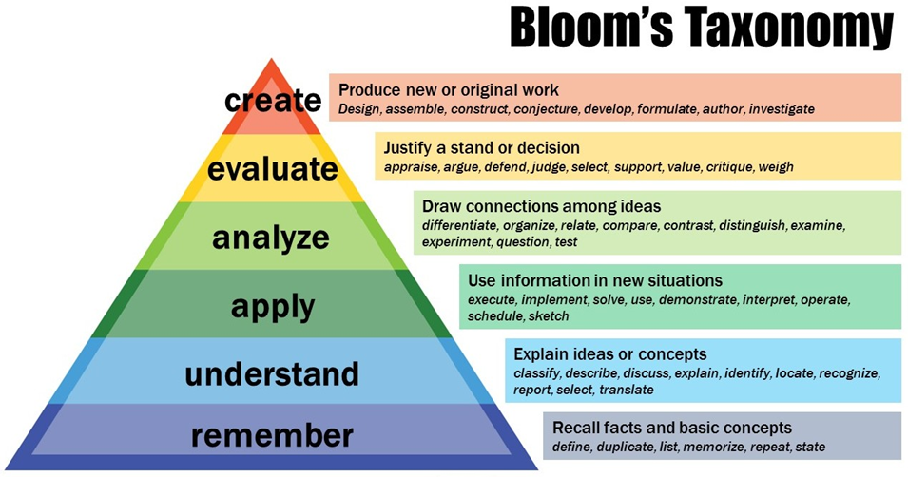
(Bloom, 2023)

Developing critical thinking skills can lead to better problem solving, decision making, creativity, communication, and self-awareness, which are all valuable skills in both personal and professional contexts. Critical thinking can also help individuals to evaluate arguments more effectively and make more informed decisions based on sound reasoning and evidence.

Understanding beliefs, attitudes, and values
Understanding Beliefs, attitudes, and values and how they impact a person’s view of the world.
What are beliefs?
Anderson and De silva (2009) state that, ‘A belief is an internal feeling that something is true, even though that belief may be unproven or irrational. e.g., I believe that walking under a ladder brings bad luck, or I believe that there is life after death’ (p. 1) The internal feeling that Anderson and De silva refer to can come from different sources, such as religion, family upbringing, life experiences and education and can influence the assumptions a person makes about themselves, others, and their own perspective of the world and how things should be. A belief will develop into a value when the person’s commitment to it grows, and they perceive it as being important.
What are values?
Anderson and De silva (2009) define values as ‘a measure of the worth or importance a person attaches to something’. For example, an individual might think that kindness, trust, and loyalty are essential personal values and the basis to building a relationship. Values are the principles or standards that guide a person’s behaviour and attitude.
What are attitudes?
Vaughan and Hogg’s (2005) definition of attitudes refer to an individual's positive or negative beliefs, feelings, or disposition towards a person, object, idea, or event. Attitudes can be reflected in a person’s behaviour and can influence their choices, decisions, and actions. Anderson and De silva (2009) state that attitudes play a significant role in shaping an individual's beliefs and behaviour. They are built up over time and essentially become the motive for an individual’s actions.
From these definitions, it is clear to see how beliefs, attitudes, and values are interconnected in several ways and how they are formed and strengthened over time. A person’s beliefs can shape their attitudes and values, and their values can influence their beliefs and attitudes. An example of this could be, a person who believes in the importance of honesty (value) may develop a negative attitude (attitude) towards people who lie (belief). Also, a person who believes that climate change is a serious issue (belief) may develop a positive attitude (attitude) towards actions that mitigate climate change (value).
The connection between beliefs, attitudes, and values is demonstrated in Homer and Khale’s (1988) cognitive hierarchy model. According to the model, values indirectly influence behaviour through attitudes. However, the main element of this model is its emphasis on the mediating role of attitudes on the values and behaviours relationship. An adapted version of this model can be seen in Appendix A.

Identify own beliefs, attitudes, and values.
Beliefs attitudes and values are developed throughout a person’s life and can have a significant impact on the way in which they work. These three components are interconnected and can influence each other in various ways. In order to critically assess the impact of beliefs, attitudes, and values on own workplace behaviour, the student must first identify what they are. The student identified the following two techniques.
The Rokeach Value Survey (1973) is a psychological tool used to measure an individual’s values. It was developed by social psychologist Milton Rokeach and consists of two sets of values, terminal values, and instrumental values (Tuulik et al., 2016) .Terminal values are desirable goals that individuals strive to achieve, such as happiness, freedom, or self-respect. Instrumental values are the means by which individuals achieve their terminal values, such as honesty, responsibility, or creativity. The Rokeach Value Survey asks individuals to rank their values in order of importance, both in terms of terminal and instrumental values. The survey consists of 36 values, including values such as independence, loyalty, and wisdom and is a widely used tool for understanding individual values and their impact on behaviour.
The Barrett Values Centre (https://www.valuescentre.com) provide a personal values assessment that helps individuals identify their core values or beliefs. The assessment is based on a model developed by Richard Barrett and was inspired by Abraham Maslow’s Hierarchy of Needs (2015) and identifies the seven most important areas of human motivation. The theory proposes that individuals have a hierarchy of needs that must be satisfied in order, starting from basic physiological needs to higher-order needs. The purpose of the assessment is to help individuals understand their core values, which can guide decision making, goal setting and actions within their personal and professional lives.
The student decided to use The Barrett Centre assessment in order to identify their beliefs, attitudes, and values. The results of the assessment showed that the student scored highest in the area of self-interest. This is the first three areas of awareness and determine that the student values relationships (feeling protected and loved), self-esteem (feeling a sense of self-worth) and survival (satisfying physical and survival needs). The upper three areas of awareness are, internal cohesion, making a difference, and selfless service. This is where the student scored the lowest, meaning future development is needed. A screenshot of the results can be found in Appendix B.
The student agreed with the results and used the information to assess how core values influence workplace behaviour and attitude.

Critically assess the impact of beliefs, attitudes, and values on own workplace behaviour.
Values can have a significant impact on workplace behaviour as they shape an individual's beliefs and attitudes towards their work and colleagues. The student works in a busy hair and beauty salon and believes that communication is the key to success. The student values effective communication skills and prefers direct communication that is clear and straight to the point, whereas the student’s manager uses indirect communication which is less obvious. An example of this was when the student’s manager asked if the salon were going to be busy, instead of asking if a colleague would be available to do a friend’s hair and nails. The indirect question gave the student no information and therefore led to the disruption of the booking system when the manager brought in a friend. The student developed a negative attitude towards their manager and gossiped with colleagues about the misunderstanding. The disruption in the salon created stress, tension, and conflict between colleagues and led to poor communication, as the student was reluctant to collaborate, share ideas or provide constructive feedback. The student also felt demotivated which influenced the negative behaviour of procrastination and resulted in decreased work quality
The assessment of this situation aligns with the student’s Barrett’s Values results and demonstrates how beliefs, attitudes, and values play a critical role in shaping the student’s work behaviours and experiences.

Management Theories
Management theories are frameworks or models that provide guidance and insight into the practice of management. These theories attempt to explain how managers can best manage their organisations, people, and resources in order to achieve their goals. Some of the most prominent include:
Scientific management: Frederick Taylor developed the scientific management theory in the late 19th century. This theory emphasizes the use of scientific methods in order to improve efficiency in production processes. It involves breaking down work into smaller, simpler tasks and enhancing each task for maximum efficiency.
Human relations: Elton Mayo developed the human relations theory which emphasizes the importance of social relationships and employee motivation in the workplace. The theory suggests that employees are not just cogs in a machine, but individuals with social and emotional needs that must be met in order to be productive and satisfied in their work.
Administrative management: The Administrative Theory of Management was first developed by Henri Fayol in the early 20th century. This theory focuses on the functions of management, such as planning, organizing, coordinating, commanding, and controlling. It highlights the importance of clear lines of authority, unity of command, and division of labour (Gordon, 2021).
Contingency theory: Fred Fiedler developed the contingency management theory in the 1960s. The theory suggests that there is no single way to manage, and that the most effective approach depends on the situation. It emphasizes the importance of adapting management practices to fit the unique needs of each situation.
Theory X and Y: Theory X and Theory Y are two contrasting management theories developed by Douglas McGregor in the 1960s. These theories are based on assumptions about human nature and behaviour and provide different perspectives on how managers should approach their employees. Theory X assumes that employees are lazy, dislike work and need to be closely monitored. Whereas, Theory Y assumes that employees are self-motivated, enjoy work and are capable of making decisions.
The use of management theories can help businesses and organizations to improve their operations, build stronger teams, and achieve their goals more effectively. Some benefits include increased productivity, simplified decision-making, increased collaboration, and increased objectivity (Indeed Editorial Team, 2022)

Identify a management theory relevant to own role
Upon research, the student discovered that management theories were originally developed for industrial and organizational settings, however some principles and ideas can be applied to hairdressing and the service industry in general. The student identified that the human relations theory and the contingency theory were most relevant to their job role.
Human relations management: This theory emphasizes the importance of social relationships and employee motivation within the workplace and can be applied to the student’s job role of being a hairdresser. In the context of a hairdressing business, this means that the salon owner or manager should focus on creating a positive and supportive work environment that promotes good relationships among employees and between employees and customers. This can be achieved by promoting open communication, providing opportunities for employee feedback and input, recognising, and rewarding good performance, and offering training and development programs in order to help employees grow and advance in their careers. Additionally, the human relations theory highlights the importance of understanding the needs and motivations of customers. The student applies this theory by providing personalised services and creating a welcoming and comfortable atmosphere that makes customers feel valued and appreciated.

Contingency theory: The contingency theory is relevant to the student’s job role and can be applied to the hairdressing industry. The student works in a busy hair salon, but also runs a small mobile hairdressing business. This theory suggests that there is no one best way to manage an organization, and that the most effective management approach depends on the specific situation and context. For example, the student runs a small mobile hairdressing business with a good number of loyal customers. This requires a more personalised management approach, with the student taking a more hands on role in managing the business and engaging with customers. Whereas the salon is a larger hairdressing chain with multiple locations and has a more diverse customer base. This requires a more formal management structure, with clear guidelines and procedures for employees to follow. This means that the most effective management approach can depend on various factors such as the size of the business, the experience and skills of the employees, the needs of the customers, and the competitive market.
Both of these management theories can provide the student with a clear understanding of their job role and expectations. However, these theories can also impact the student’s personal beliefs, attitudes, and values within the workplace.

The impact of management theories on the student’s beliefs, values, and attitudes.
The contingency theory
Contingency theory is a management theory that primarily focuses on the most effective way to manage or lead an organization based on situational factors. As such, it does not necessarily have a direct impact on the student’s beliefs, attitudes, and values; however, it can influence the student’s behaviour. The contingency theory emphasizes the importance of leaders adapting their relationship strategies to fit the specific situation they are facing. By applying the values of the theory, the student believes they can adapt their working style to suit the needs of different clients, situations, and environments, encouraging the student to work with a more flexible and adoptive mindset. This helps with the development of good relationships clients, which is what the student values most.
The human relations theory
The human relations management theory can have a significant impact on the beliefs, attitudes, and values of the student, as the theory emphasizes the importance of positive workplace relationships, employee engagement, and job satisfaction. The theory suggests that employees are motivated not just by financial incentives, but also by social and psychological factors, such as the need for recognition, belongingness, and self-esteem. In the context of the student’s job role, this means fostering positive relationships between managers, employees, and customers, and creating a culture of mutual respect, trust, and support. For example, by adopting this theory, the student can:
- Prioritize customer satisfaction by emphasizing the importance of building positive relationships with clients and providing excellent service.
- contribute to a positive work environment
- Increase job satisfaction and better performance
- Make decisions and provide feedback on workplace policies and practices
- Collaborate with colleagues, share ideas, and best practices
These principles of the human relations can create a more positive and supportive workplace environment, which can have a positive impact on the student’s beliefs, attitudes, and values.

How someone with different beliefs, attitudes and values might interpret the theory differently
Contingency theory proposes that the most effective leadership style depends on the situation and that different situations call for different leadership styles. Someone with different beliefs, attitudes, and values to the student might interpret the theory differently, it depends on their unique perspectives and experiences. Here are a few examples of how different individuals might interpret the contingency theory differently:
- An individual who values consistency and predictability might interpret the contingency theory as an endorsement of rigid adherence to rules and procedures. This person may believe that there is a single "correct" leadership style for each situation, and that leaders must always follow that style in order to achieve success.
- An individual who values creativity and innovation might interpret the contingency theory as an offer to experiment with different leadership styles and approaches. This person may believe that there are many effective ways to lead depending on the situation, and that leaders should be willing to take risks and try new things.
- An individual who has a strong belief in the power of hierarchy and authority might interpret the contingency theory as a way to reinforce traditional power structures. This person may believe that the "right" leadership style for each situation is determined by the hierarchical position of the leader and that leaders should always assert their authority.
- An individual who values collaboration and consensus-building might interpret the contingency theory as a way to promote teamwork and shared decision-making. This person may believe that effective leadership requires working closely with others to identify the best course of action and that leaders should prioritize building strong relationships with their team members.
in summary, the interpretation of the contingency theory can vary depending on one's beliefs, attitudes, and values. Some individuals may view the theory as supporting strict adherence to rules and procedures, while others may see it as promoting innovation and experimentation. Ultimately, the way in which individuals interpret the contingency theory will depend on their unique perspectives and experiences.

Conclusion
In conclusion, developing workplace critical thinking is crucial for organizations to thrive in today's complex and rapidly changing business environment. Critical thinking skills enable employees to analyse information, evaluate evidence, and make sound decisions. They also facilitate problem-solving and innovation, leading to better organizational performance and increased employee engagement.
This report has outlined how beliefs, attitudes, and values can impact workplace behaviour in a variety of ways. Employers can help shape these behaviours by encouraging a positive work ethos that values diversity, ethics, and communication, and by providing training and support for employees to develop these skills. The report has also outlined how individuals can benefit from management theories by developing a deeper understanding of management principles.

References
- Chatfield, T. (2018). Critical thinking. London, UK; Sage Publications Ltd.
- Morgan, P. (2017). The business student’s guide to study and employability. London, UK; Sage Publications Ltd.
- University Of Edinburgh, Critical Thinking - https://www.ed.ac.uk/institute-academic-development/study-hub/learning-resources/critical
- Anderson, M. and De Silva, S., 2009. Beliefs, Values and Attitudes. 1st ed. Cumbria: Me and US Ltd, p.1.
- Vaughan, G. and Hogg, M., n.d. Social psychology. Page. 150
- Homer, P. M., & Kahle, L. R. (1988). A structural equation test of the value-attitude-behavior hierarchy. Journal of Personality and Social Psychology, 54, 638-646
- The hierarchy model of human behaviour. (n.d.). Retrieved March 14, 2023, from https://www.researchgate.net/figure/Cognitive-hierarchy-model-of-human-behavior-adapted-from-Fulton-et-al-1996_fig1_291953406

- Tuulik, K., Õunapuu, T., Kuimet, K., & Titov, E. (2016). Rokeach’s instrumental and terminal values as descriptors of modern organisation values. International Journal of Organizational Leadership, 5(2), 151–161. https://doi.org/10.33844/ijol.2016.60252

- M. (2015). Maslow’s Hierarchy of Needs: Gain vital insights into how to motivate people. 50 Minutes.

- Gordon, J. (2021, September 23). Administrative Theory of Management - Explained. The Business Professor, LLC. https://thebusinessprofessor.com/en_US/management-leadership-organizational-behavior/administrative-theory-of-management

- Indeed Editorial Team. (2022, November 16). Types of management theories (with tips and benefits). Indeed Career Guide. https://uk.indeed.com/career-advice/career-development/management-theories#:~:text=Types%20of%20management%20theories%201%20Scientific%20management%20theory,theory%20. . .%207%20Theory%20X%20and%20Y%20

Appendix A

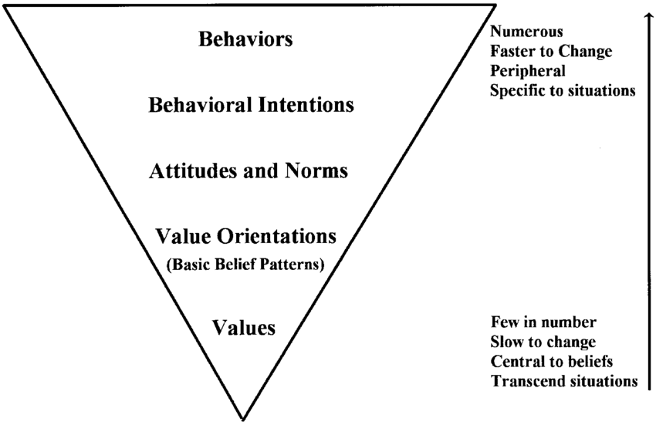 The cognitive hierarchy model of human behaviour. Adapted from Fulton et al. (1996).

Appendix B



