Student Name: Mihaela Moraru ID: 2113340
Lecturer name: joanna walsh
Academic and Employability Skills (BMSW4001_LON)

ACE Practical Portfolio - Report

Table of Contents
Introduction 2
Personal reflection model 2
Personal reflection in public speaking and giving presentations 6
Conclusion 6
References 7

Introduction
Success in a profession or academic area is measured through the skills that have been bestowed and the way of their best practices. Moreover, while both emerged as academic and employability skills it seeks effective and potent skills. Hence, one must chase after a few obvious skills which optimize their ability for performing in the professional or academic area. The thesis or report aims to present a reflective over the speaking capacity for presenting in public along with some fundamental skills as such time management, academic writings and summarizing. Most precisely, the researcher might include a personal reflective model for better understating of the specific skills.

Personal reflection model
Time Management
The model selected for the part of bringing accurate understanding of the topics based on time management, summarizing and Academic writing are done with the application of the Gibbs Reflective Cycle. I have learned that the respective model associated with Gibbs Reflective Cycle starts from description, feelings, evaluation, analysis, conclusion and Action plan. The initial step description provides accurate information regarding the actual situation, activity or event in detail. According to my learning, it is the most important segment of time management. I have learned that an effective time management process is beneficial for the part of increasing the focus along with improving the productivity of the individual. According to my real experience during the time of managing the time, will help in bringing an increased level of focus on productive activities (Edinburgh, 2021). The second stage is feelings that describe the actual situation that was undertaken during the time of the event. I believe that effective time management offers a supportive part in reducing the stress factor of the individual along with prioritizing their valuable time to remain competitive for the future. The activities to be undertaken within the respective segment include for remaining productive the first and foremost objective must be to identify and evaluate the daily priorities. It is performed by me but I faced certain positive and negative experiences while moving on with the activities.
As mentioned above the other most important stage is evaluation. I have learned that in time management procrastination happens during the point of time when the time is not systematically managed for the activities. According to my idea when we are not clear about our achieving goals it will lead to procrastination. On the other hand, within the respective segment, I would like to highlight that weak time management leads to procrastination and distraction. While I was facing the respective problem I kept a strong system of initiative in identifying the actual situation behind the cause of procrastination. It will help in bringing accurate elimination of the identified sources one by one. The other most important segments are based on the factor of analysis and conclusion (Brown, 2021). The analysis stage is all about the actual learning that has been made from the situation and concluding it with the activities that could have been performed under the respective situation. Bringing enhanced time management will help me in working on my goals along with giving important prioritization on important tasks to be completed from my part. On the other, it will be vital for me to invest energy and time for part of producing the actual outcomes based on my expectation. Lastly, as a part of the action, I will have to take note of the activities that are to be completed by me in the beginning and at the end. At the end of every week, I will have to study the instance and the areas I was lagging for the part of eliminating the biggest causes.
Academic Writing
According to Gibbs reflective cycle in the initial stage of description, I have learned that academic writing has an important role in building and developing the academic career of the students. I have realized this in my class during the point of time we are graded based on the quality of our writing. For me, bringing improvement in my academic writing will enhance me in development of a strong system of academic integrity. It plays a vital role during the time the scholars and the students share and exchange their information with their instructors and peers. In the segment of feeling, I would like to state that the methods and techniques of academic writing are different compared to other writing processes. As per the opinion of authors, Adeani, Febriani. and Syafryadin (2020), it has helped in several ways through developing my written communication along with my formal style of writing. It has also offered in bringing a better system of understanding of the subject along with offering increased enhancement on working on my language skills. Under this, I have analyzed and evaluated certain core aspects to be followed along with determining the positive and negative effects of the same in my writing quality. According to my learning experience, I would like to state that analytical thinking and critical evaluating is the major phase of academic writing.
However, it requires a strong system of surveying skills, independent research and independent research for designing qualitative content in my research. The positive aspects identified from my part have supported me in working on the same for bringing effectiveness in my way of writing for the future. On the other hand, negative aspects require a strong dedication and hard work for the part of preventing any mode of complication in the future. I would like to conclude that the core areas of academic writing are based on making the content argumentative, logical and analytical that will benefit me in guiding to development of attractive content with the application of the conducted research. According to Bopp et al. (2021), academic writing also has helped me in improving my communication skills. However, it accurately reflects on the assimilation level the individual has on their topic or issues. Under the statement of the author's Hill and Fitzgerald (2020), students demonstrate an accurate level of learning on scrutinizing and bringing a strong system of understanding on their topic and their writing style. Based on the evaluation made on my part I would like to state that critical thinking is the area that requires bringing improvement from my part. For this, I will have to spend my time reading research articles, attending learning courses and seminars. However, through the complete process is based on brainstorming it will take a long time for me to develop the quality of becoming an effective academic writer. I believe the initiated quality will benefit me in organizing my essay with an increased level of consistency along with expressing my content in such a way that it will bring an increased level of attractiveness to the readers. I will also have to take continuous feedback from my professors to evaluate the results I gained after working on my writing quality.
Summarizing
In this to determine the stages and importance of summarizing my study was conducted systematically through following the phases Of the Gibbs Cycle. Initially, I would like to state that summarization is the act of summarizing. However, summarizing the information requires a strong system of critical thinking capability. The reason is that under this the topic needs to express in a precise and understandable form. During the time of performing my academic writing, I was marked for the respective segment. From this, I feel that apart from the developed quality content it is also vital to have the capability in summarizing the content accordingly. From the performed project in my universities, I have evaluated that summarizing offers a beneficial platform for the students in gathering the most important information and ideas from the available texts. On the other hand, it is also important to ignore and eradicate the availability of irrelevant information from the text. In my made evaluation and analysis about summarizing along with considering my experience within the respective segment summarizing has helped me in improving my concentration, memory ability along with developing my internal skill. On the contrary, the beneficial part is that the summarizing strategy is implied in all the academic and professional careers of the students.
In my analysis, summarizing has been a supportive segment for me in learning the process of determining essential ideas along with identifying different details that will play an important part in supporting the formed ideas and bringing the application of the same in my future. On the other hand, it also benefitted me in increasing and developing my focusing skills such that it will help me in giving important focus on keywords and texts from the available long text. I was able to focus on the parts that are the core segment of remembering and noting. As per the research of Ivanova et al. (2020), I was able to learn the technique and approach associated with converting the large text into small text. Moreover, the short text under this comprises the main points. It has helped in developing my way of writing summarization through concise and proper understanding. For the upcoming times through evaluating my positive and negative aspects associated with the same, I have identified those core areas that require further improvement to be initiated on my part. During the time of developing the content initially, I will have to bring a better understanding of the content by reading it carefully. I will have to understand the purpose of the topic and collect the information that matches with the topic for the part of summarizing it effectively. Most importantly, I need to develop the quality of extracting major ideas for the developed long text where it can be found in the sentence. As per Dansieh, Owusuand Seidu (2021), I learned that summarizing requires the capability to distinguish the main points from the available subsidiary points along with developing irrelevant information. I need to focus on the respective activities to bring strong summarization for my writing on my upcoming university projects.

Personal reflection in public speaking and giving presentations
According to the made evaluation and analysis of myself, I have identified certain positive and negative parts of myself. It is systematically mentioned in my developed PDP plan. However, the main area I was struggling with during giving presentations and public speaking is verbal communication. For this, I total I have taken 5 weeks time to improve the respective quality. I will have to undertake certain activities to develop my inner potential within the respective segment for remaining sustainable and competitive in the future.
Firstly, in the beginning, I will have to thoroughly think about the topic that I am intended to speak about. Moreover, the respective approach can help me in organizing my thoughts into clear and concise statements. Secondly, according to the opinion of Netta, Trisnawati and Helmanda (2020), I will have to understand the audience to whom I am presenting my ideas and thoughts. It is an important quality during the time of presenting complex ideas and thoughts. During the time of presentation, I will have to give important focus on my tone along with paying major attention to my body language. It will help me in conveying a strong sense of confidence and authority that will offer better enhancement for the people to listen to my speech.

Conclusion
It can be concluded that summarizing the information requires a strong system of critical thinking capability. Moreover, it plays a vital role during the time the scholars and the students share and exchange their information with their instructors and peers. However, it is also important to ignore and eradicate the availability of irrelevant information from the text. On the other hand, the activities to be undertaken within the respective segment include remaining productive. Most importantly, to remain qualitative on any skill the first and foremost objective must be to identify and evaluate the daily priorities.

References

Adeani, I.S., Febriani, R.B. and Syafryadin, S., 2020. USING GIBBS’REFLECTIVE CYCLE IN MAKING REFLECTIONS OF LITERARY ANALYSIS. Indonesian EFL Journal, 6(2), pp.139-148.
Bopp, N.E., Bouyer, D.H., Gibbs, C.M., Nichols, J.E., Ntiforo, C.A. and Grimaldo, M.A., 2020. Multicycle autoclave decontamination of N95 filtering facepiece respirators. Applied Biosafety, 25(3), pp.150-156.
Brown, N., 2021. Reflective model according to Gibbs - Dr Nicole Brown. [online] Dr Nicole Brown. Available at: <https://www.nicole-brown.co.uk/reflective-model-according-to-gibbs/> [Accessed 22 November 2021].
Dansieh, S.A., Owusu, E. and Seidu, G.A., 2021. Glossophobia: The Fear of Public Speaking in ESL Students in Ghana. Language Teaching, 1(1), pp.p22.
Edinburgh, 2021. Gibbs' Reflective Cycle. [online] The University of Edinburgh. Available at: <https://www.ed.ac.uk/reflection/reflectors-toolkit/reflecting-on-experience/gibbs-reflective-cycle> [Accessed 22 November 2021].
Hill, K. and Fitzgerald, R., 2020. Student perspectives of the impact of COVID-19 on learning. All Ireland Journal of Higher Education, 12(2).
Ivanova, T., Gubanova, N., Shakirova, I. and Masitoh, F., 2020. Educational technology is one of the terms for enhancing public speaking skills. Universidad y Sociedad, 12(2), pp.154-159.
Netta, A., Trisnawati, I.K. and Helmanda, C.M., 2020. Indonesian EFL students' strategies in dealing with speaking anxiety in public speaking course. ACCENTIA: Journal of English Language and Education, 1(1), pp.1-9.

Appendix
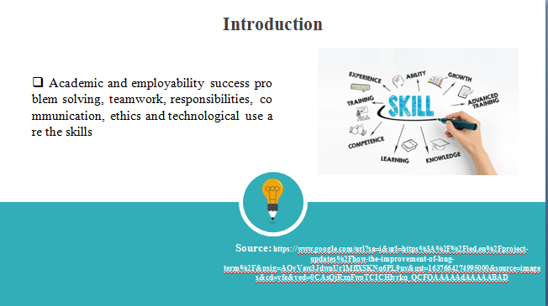

Debates and dilemmas over the concepts of career readiness have been always escalated that bear true success in the academic and professional areas. In case, the strategy for academic and employability get emerged with it might be pinpointed the specific skills as such problem solving, teamwork, responsibilities, communication, ethics and technological use. Moreover, the presentation aims to confer the skills with self-analysis as such time management tool, SWOT and PDP. The presentation is entirely focused on addressing academic and employability skills which get success.
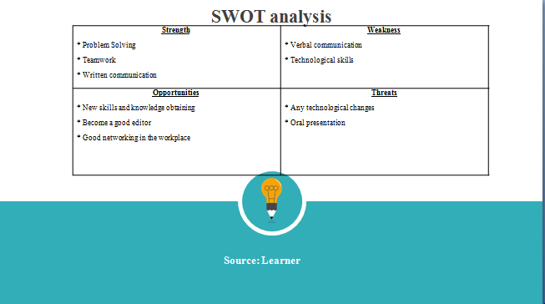
Strength: During the class and modules of academic and employability skills I have identified multiple skills categorised as strengths and weaknesses. Problem-solving, teamwork and communication skills are enough compatible to achieve academic and professional skills which have to optimise my further opportunities.
Weakness: Despite these strength factors, I have such typical weakness that affects my potentiality highly. As per the statement of Janis and Zulkipli (2020), I can better communicate with written communication whereas lack of verbal communication hinders my position.
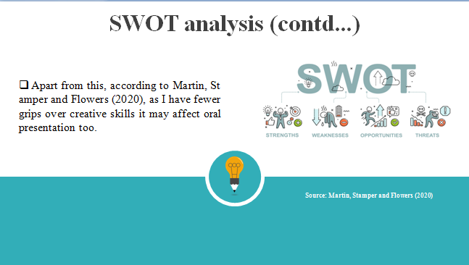
Opportunities: In order to the opinion of Mahfoodh and Hashim (2021), to achieve success and for career growth, I might have different opportunities as such new skills and knowledge can be obtained. In addition, learning with experience will be definitely a better opportunity to learn and grow and can maximise editing capability.
Threats: Besides on, the strength and opportunities threats factor might be highlighted as well as each year’s students learns new techniques and skills which might have to minimise opportunities. Apart from this, according to Martin, Stamper and Flowers (2020), as I have fewer grips over creative skills it may affect oral presentation too.
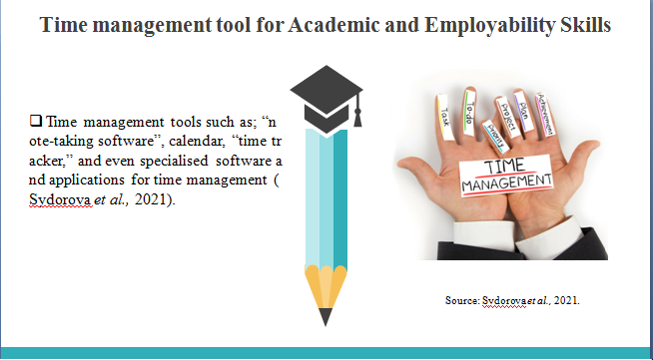
In part of career development and professional growth time management is never be negotiated rather practised most possibly. Hence, it must be in practice from the initial stage incorporating different tools and techniques for time management. Moreover, it helps to even organise daily chores for considering all-mighty factors (Sydorova et al., 2021). One can better include different effective time management tools such as; “note‑taking software”, calendar, “time tracker,” and even specialised software and applications for time management.
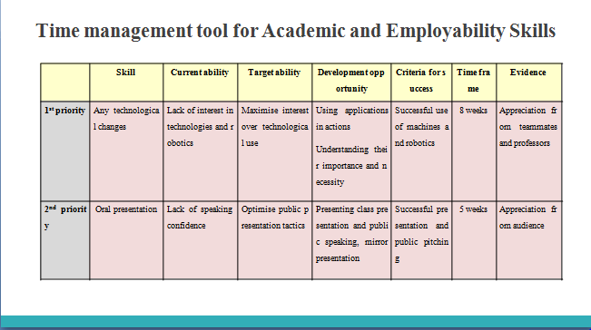
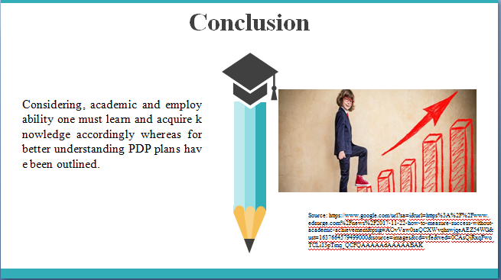
The above presentation has successfully represented regards to, everywhere students or employees are set out with aim and career objective that requires of the bulk of tools and skills differently. Considering, academic and employability one must learn and acquire knowledge accordingly whereas for better understanding PDP plans have been outlined.

