Control Room Lighting Upgrade

L5 – Engineering and Project Management (ACDA5025)
HND/BEng Electronic Engineering/Embedded Electronics

Rhys Davies – 2407080
(2407080@students.uwtsd.ac.uk)

Contents
1. Introduction 3
2. Aim and Objectives 4
3. Research 5
3.1 Environmental 5
3.2 Life 5
3.3 Energy Usage/Cost 6
3.4 Emergency Lighting 6
4. Proposal 7
4.1 Scope of Work 7
4.2 Layout 8
4.2 Selection 11
5. Resources 12
5.1 Estimated Budget 12
6. Planning 13
6.1 Gantt Chart 14
7. Expected Outcome 15
8. Constraints 17
8.1 Health and Safety 17
8.2 Ethical 17
8.3 Diversity and Inclusion 18
8.4 Delays 18
9. Conclusion 19
10. Appendices 20
Appendix A 20
Appendix B 21
Appendix C 22
Appendix D 24
11. References 25

Introduction
Lighting systems play a crucial role in ensuring safe functionality and minimising the environmental impact of any business. In recent years, the shift toward sustainable practices has highlighted the need to replace outdated lighting technologies with modern, reliable, and energy-efficient alternatives. This project aims to upgrade all existing fluorescent lighting to light-emitting diode (LED) lighting in a local control room (LER). The control room is occupied 24/7 by shift employees; therefore, it is a requirement for the control room to be illuminated continuously.
By undertaking this upgrade, the project seeks to reduce electricity costs, and environmental impact, improve lighting quality, and reduce maintenance and operational costs.
This document outlines the aims, objectives, scope, and implementation strategy for the lighting upgrade project, establishing a clear pathway to achieving a more energy-efficient lighting infrastructure.

Aim and Objectives
The aim is to replace all fluorescent lighting within the control room, consisting of 46-panel lights with three 18W fluorescent lamps and 4 escape luminaires with one 8W fluorescent lamp. These lights are to be replaced with light-emitting diode (LED) light fittings. Thus, reducing environmental impact, improving lighting quality and reliability, reducing the risks of meeting harmful substances like mercury, enhancing energy efficiency and therefore reducing energy costs. The Objectives listed below conform with the business ethical principles and have a positive impact on the employees’ attitude towards continuous improvement:
- Reduce Energy Consumption - Achieve a reduction in electricity usage related to lighting.
- Lower Carbon Emissions- Decrease the carbon footprint associated with lighting by replacing mercury-containing fluorescents with LEDs.
- Improve Lighting Quality and Safety - Provide brighter, more consistent, and flicker-free lighting to improve occupant comfort and productivity. Eliminate the risks associated with mercury exposure and glass breakage.
- Reduce Maintenance and Operational Costs - Extend lighting lifespan (LEDs typically last 5–10x longer than fluorescents). Minimise maintenance interventions and lamp replacement frequency.
- Ensure Responsible Disposal of Old Fixtures - Safely dispose of fluorescent tubes through certified recycling programs.
- Complete the Upgrade Within a Defined Timeline and Budget - Complete the full conversion to LED lighting within the allocated time frame and budgetary constraints. Track project milestones and expenditures to ensure accountability.

Research
Fluorescent lights, while once a standard in commercial and institutional settings pose several drawbacks, including high energy consumption, short lifespan, and the use of hazardous materials such as mercury. In contrast, LED lighting offers substantial benefits: significantly reduced energy usage, longer operational life, improved light quality, and a safer environmental profile.

3.1 Environmental
The use of fluorescent lighting is under scrutiny by Governments across the world largely because of the presence of mercury found within them. Mercury a toxic substance that is harmful to both humans and the environment [1]. When disposed of incorrectly, mercury can contaminate water, soil, and the atmosphere posing a threat even in small concentrations [2]. Various countries have already made steps towards replacing fluorescent lighting with more environmentally friendly and sustainable options, including LED’s (Light emitting diodes) [1].
LED's, the alternative to the environmentally unfriendly fluorescent lamp are also more cost and energy-efficient. Replacing all lights with LED technology would decrease C02 emissions and other pollutants currently released into the atmosphere.

3.2 Life
LED’s outperform fluorescent lights in terms of lifespan. Although complex studies show the average life of a fluorescent lamp lies between 7,500 – 20,000 hours [3], where a new LED light fitting will boast an average 50,000-hour service life, most with a guarantee of 5 years. Thus, making LED a cost-effective, low-maintenance option and making them favourable for high bay ceilings in warehouses and other industrial and commercial applications [4].

3.3 Energy Usage/Cost
The average cost of a KW/h (electricity) in the UK = 25.37p [5].
Using this figure an approximate calculation can be made to discover how much energy and how much it would cost to illuminate the control room for a year with the existing lights in service:
- 600x600 panel light with 3x18watts fluorescent lamps (54watts) 46 units.
- Escape luminaire (8watts) 4 units.
Panel lighting
= 54W/1000 = 0.054KW/h x 24 (Hours) = 1.296KW/h x 365 (Year) = 473.04KW/h
473.04KW/h per light x 46 (lights) = 21759.84KW/h x 25.37p = £5520.47
Escape Luminaire
=8W/1000 = 0.008 x 24 (Hours) = 0.192KW/h x 365 (Year) = 70.08KW/h
70.08KW/h per light x 4 (lights) = 280.32KW/h x 25.37p = £71.11

Totals per year
Total KW/h = 22040.16KW/h
Total cost = £5591.58

3.4 Emergency Lighting
Emergency lighting is crucial for safety in occupied buildings, it is a legal requirement to provide such safety systems and should comply with BS 5266 [6]. Its purpose is to provide a safe, illuminated escape route during a power outage or emergency.
The control room has ten emergency light fittings, these light fittings will be replaced by emergency LED lights. The site requirement is for the emergency lights to last no less than 60 minutes during a power outage.

Proposal
This proposal outlines the plan to replace all existing fluorescent light fixtures within The Control Room (LER) with energy-efficient LED lighting. The primary goals are to reduce energy consumption, lower maintenance costs, improve lighting quality, and support the organisation's ethical initiatives.

Scope of Work
- Planning – Site survey, inventory of current fluorescent fittings and power consumption. Risk Assessment.
- Procurement - Selection and purchase of appropriate LED fixtures or retrofit kits.
- Installation - Removal of old fixtures and installation of LEDs. Disposal of fluorescent bulbs (hazardous due to mercury content).
- Testing - Post-installation inspection to ensure lighting levels and performance meet expectations.
- Record & Update – Update drawings and job plans.
Replacement of.
- 46 x 600x600 (3x18W) panel lights.
- 6 x emergency battery kits for 600x600 panel lights.
- 4 x 8W emergency exit lights.
The existing lighting wiring structure will be sufficient and will not require modernising. It provides safe electrical isolation for individual lights and efficient fault finding with the use of click connectors.
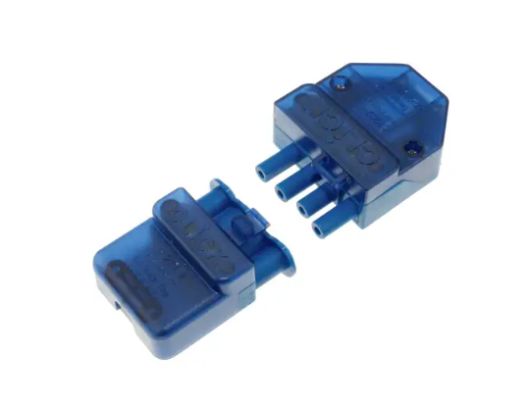
Fig 1. Example of connectors in use.
Source: Adapted from [7]

4.2 Layout
Current and finished lighting arrangement of the LER and amenities area.
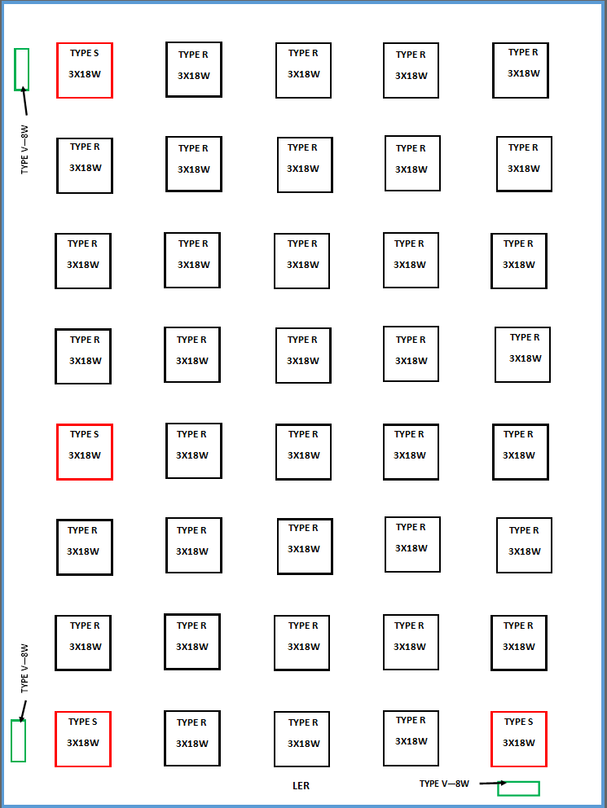
Fig 2. LER Lighting arrangement.
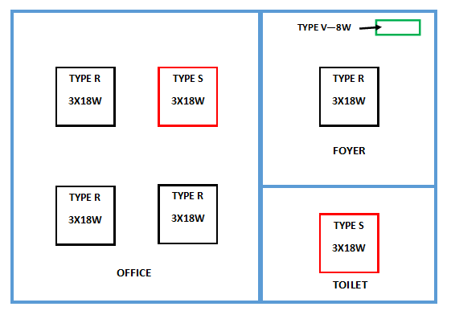
Fig 3. Amenities area lighting arrangement.
Key
Type R – 600x600 3x18W Panel
Type S – 600x600 3x18W Emergency Panel (Battery backup)
Type V – 8W Maintained Escape luminaire

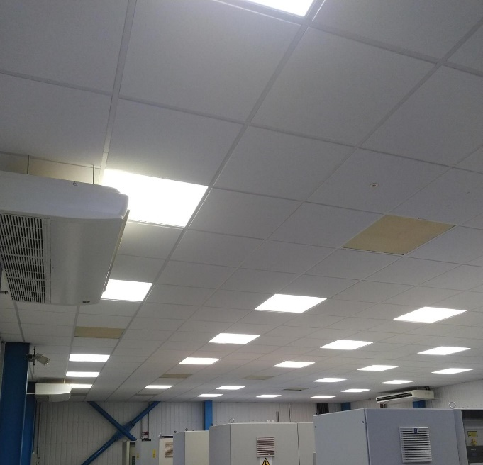
Fig 4. Photo of LER panel lighting.
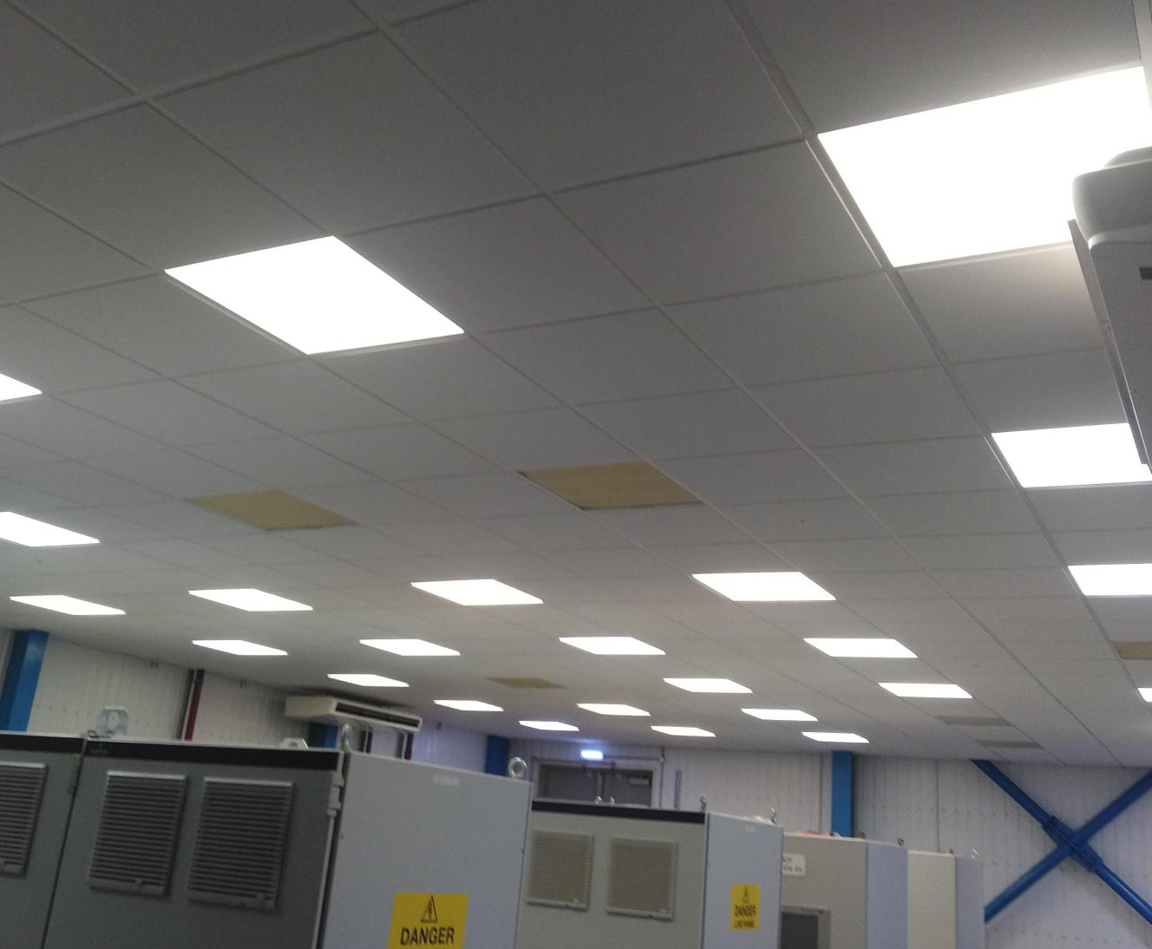
Fig 5. Photo of LER panel lighting.
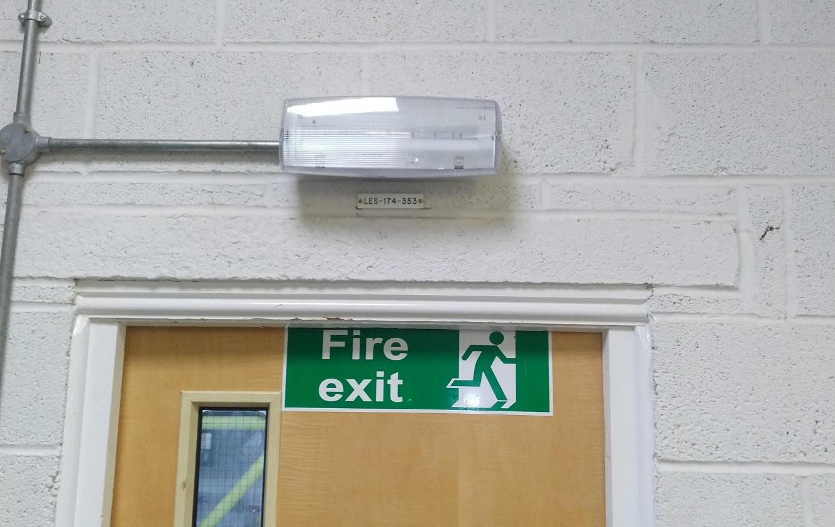
Fig 5. Photo of LER escape luminaires.

Selection
The following table shows the selected equipment as an example of replacement light fixings available.
Equipment | Image | Specification | Cost
Robus Atmos 40W 600mm x 600mm LED Panel 5000K | 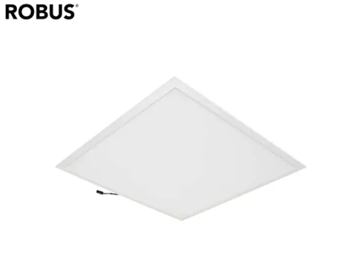 | 5 Year  guarantee.  50000 hours.  40W.  5000K. | £41.40
Robus Atmos LED Panel 3-Hour Emergency Pack | 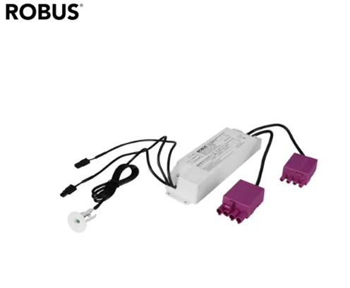 | 3-year guarantee.  3 hour battery life. | £58.20
Eterna 7W LED Maintained / Non Maintained Emergency Bulkhead | 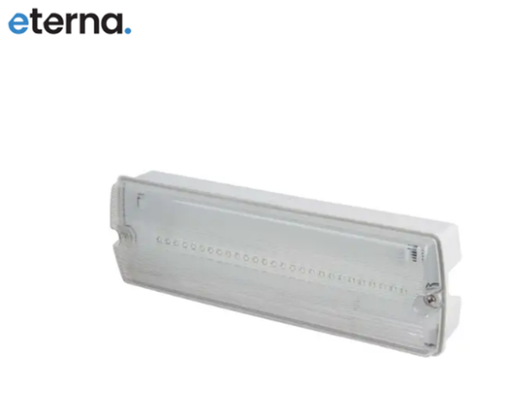 | 5 Year  guarantee.  30000 hours.  7W. | £24.00
Table 1: Equipment selected for the lighting upgrade project
Source: Adapted from [7]

Resources
The resources required to complete the lighting upgrade;
- Human resources – Project Lead/Manager, 2 x Qualified Electricians.
- Materials – Light fittings (46 x panel LED’s, 6 x emergency battery packs, 4 x emergency exit luminaires.
- Equipment – Access equipment (mobile working platform).
- Waste Disposal – Certified waste disposal specialists for hazardous materials or substances (fluorescent lamps).

Estimated Budget
 | COST (inc VAT) | UNITS | TOTAL
600x600 LED Panel | £41.40 | 46 | £1904.40
LED Panel Emergency Pack | £58.20 | 6 | £349.20
LED Emergency Bulkhead | £24.00 | 4 | £96.00
Mobile working platform | £353.62 | 1(25 days) | £353.62
Project Lead/Manager | £1500.00 | 6(weeks) | £9000.00
Electricians x 2 | £2250.00 | 4(weeks) | £9000.00
Waste disposal | £254.46 | 1 | £254.46
Contingency (5%) | £897.88 | 1 | £1047.88
 |  | TOTAL | £22005.56
Table 2: Estimate cost of materials and services required to complete the project.
These are all approximate figures, services and materials that would be sourced fairly and ethically in line with the organisation's procedures that ensure professional codes of conduct are adhered to. A contingency figure of 5% has been added to cover any additional costs that are unforeseen.

Planning
The lighting upgrade will be executed over six weeks and divided into five phases.
Installation
Removal
Installation
Disposal
Planning
Site Surveys
Risk Assessments
Procurement
Selection (equipment & Vendors)
Purchase & Delivery
Quality Control

Record
Update Drawings
Update Job Plans
Testing
Function Check
Duration Test
Log Results

Fig 6: Flowchart showing five phases of the project.

There are 50 lights to be replaced, an estimated time of two hours per light fixing has been allocated for two electricians. A Gantt chart has been created as a visual aid to track progress. Responsibilities have been assigned to the Project Lead and Electrician to ensure smooth execution.
The Gantt chart gives a visual representation of the task involved in the lighting upgrade project and the approximate durations of each task. It should be noted that no contingency for duration has been included as the project is only at the proposal stage, the Gantt chart would evolve throughout the project to show a true representation.

6.1 Gantt Chart
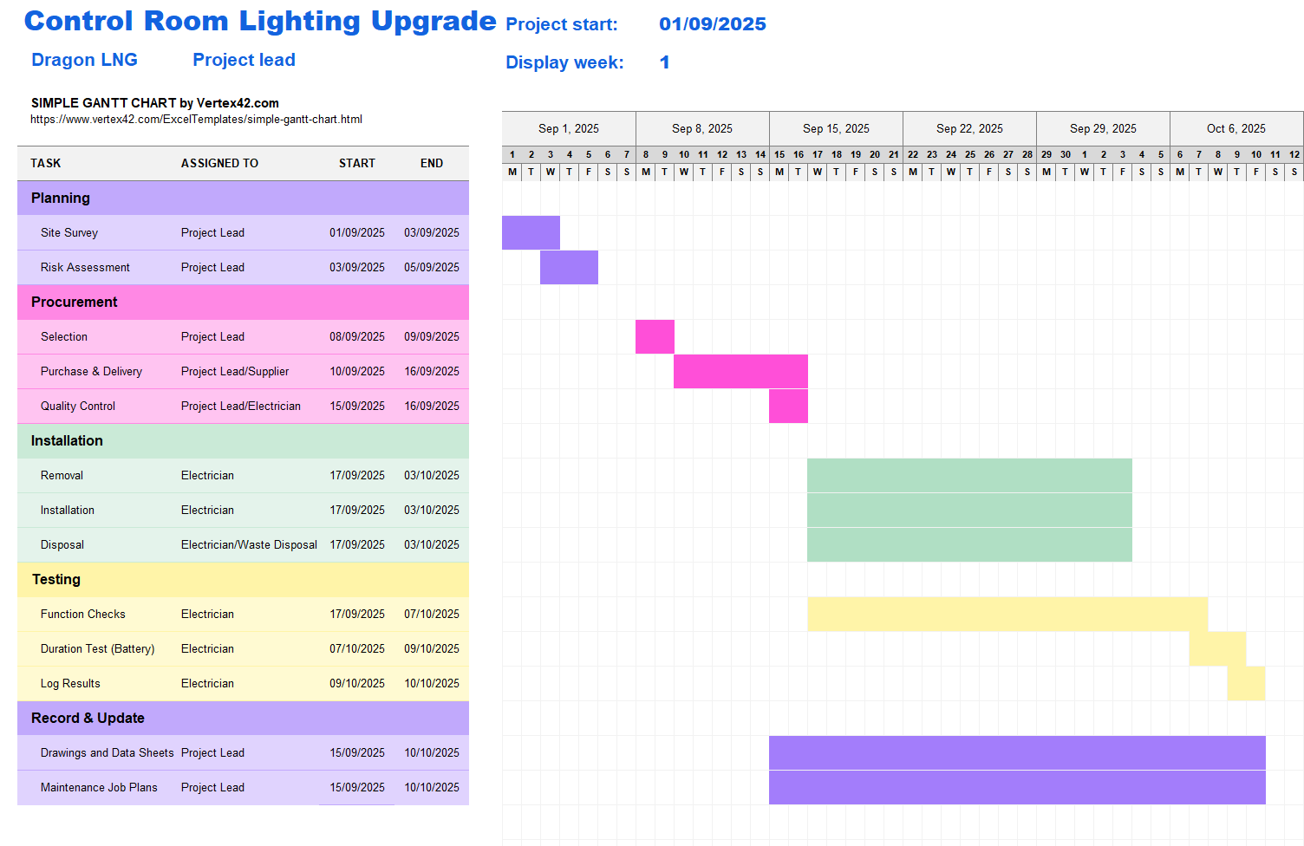
Fig 7: Gantt chart showing steps and durations of tasks for the lighting upgrade.

Expected Outcome
Environmental Sustainability
LEDs use less energy than fluorescent lamps. Lower energy use reduces fossil fuel dependence, cutting greenhouse gas emissions and mitigating climate change. Upgrading to LEDs can significantly reduce the organisation's environmental impact, aligning with ethical principles [8].
Elimination of Toxic Materials
Fluorescent lamps contain mercury, a toxic heavy metal that poses serious environmental and health risks if lamps are broken or disposed of incorrectly. LEDs are safer to dispose of and recycle, reducing harm to waste workers and ecosystems.
Cost-Efficiency
LEDs have a longer life span, which means less waste and fewer resources spent on manufacturing and transport. This also has a positive impact on resource allocation as the use of LEDs reduce the maintenance burden. This translates to long-term savings.
Based on the example LED light fixings, approximate savings can be calculated:
- 600x600 40W LED panel light 46 units.
- 7W LED Escape luminaire 4 units.
Panel lighting
= 40W/1000 = 0.04KW/h x 24 (Hours) = 0.96KW/h x 365 (Year) = 350.4KW/h
350.4KW/h per light x 46 (lights) = 16118.4KW/h x 25.37p = £4089.23
Escape Luminaire
=7W/1000 = 0.007 x 24 (Hours) = 0.168KW/h x 365 (Year) = 61.32KW/h
61.32KW/h per light x 4 (lights) = 245.28KW/h x 25.37p = £62.23

Totals per year
Total KW/h = 16363.68KW/h
Total cost = £4151.46

This provides a total savings per year
Total KW/h = 5676.48KW/h
Total cost = £1440.12
Total cost savings will increase if reduced maintenance costs and the purchase of materials are considered.
Social Responsibility
Organisations show commitment to sustainability and public wellbeing by taking on projects like LED upgrades that also can have a positive societal impact on others to adopt sustainable practises.
Human Health & Well-being
LED’s generally provide better quality light without the flicker or noise common in fluorescent lights, reducing discomfort, eye strain, and potential neurological triggers (people with epilepsy). It is important to consider these concerns that align with diversity and inclusion [9].

Constraints

8.1 Health and Safety
Working/falls from height
Electricians are to be provided with safe mobile working platforms that are to be placed on level flooring or base. Two personnel are to be present, one on the platform at a time. Obstacles moved if necessary. Work area to be barriered off to prevent dropped objects from coming into contact with adjacent workers.
Safe Isolation Procedures
'Click' connectors are installed on the previous lighting system. These provide safe and efficient electrical isolation when unplugged. One light fixture can be isolated at a time, meaning other lights can stay illuminated, providing the control room with sufficient lighting.
Permit to Work
A risk assessment was carried out (See Appendix C). Hazards, risks and mitigations are listed to ensure personnel carrying out the task, adjacent workers, and control room inhabitants are kept safe. A Permit to Work is to accompany the risk assessment providing a safe system of work.

Ethical
Toxic Materials
Working on or near equipment that uses toxic materials will be reduced and therefore the number of fluorescent lamps being purchased will decrease. This will have a positive impact on the environment and only improve the organisation's sustainability incentives.
Waste Disposal
Licensed vendor who specialises in hazardous waste to dispose of the fluorescent lamps, this is to ensure the lamps containing mercury are disposed of correctly. This service would be put out to tender.
Hazards and mitigations when dealing with fluorescent lamps are stated in the risk assessment (See Appendix C).

Diversity and Inclusion
Disruptions
Communicate with all personnel that may be disrupted or affected during the installation. Provide multilingual notices and updates.
Inclusion
High-frequency LED fixings may disturb or harm some personnel, those who suffer from migraines or epilepsy. Choose LED’s with a high CRI (Colour Rendering Index) for better visibility and comfort.

8.4 Delays
Materials delayed/damaged
Communication is to be kept with the provider and delivery updates are to be available. Quality checks are carried out upon delivery, and damaged units are to be reported and returned to the provider so replacements can be delivered in place of the damaged goods.
Absence
Delays are to be expected if an absence occurs. Contingency is put in place to counteract. Regular communication and updates are expected from labour providers, they are to provide replacement or additional personnel with no further cost to the organisation.

Conclusion
Upgrading the Control Room lighting from fluorescent to LED is a smart, sustainable, ethical and financially sound investment. Approximate calculations show that energy savings can reach up to 5676.48KW/h a year, which equates to £1440.12 saved. For such a small section of the organisation's lighting structure, this energy and cost savings could be multiplied if the incentive was to grow sitewide. However, more focus should be on the ethical benefits that this project brings:
- The reduction in toxic materials (Mercury) present, which personnel may encounter.
- The duration of working at height when maintaining the fluorescent lamp fixings.
These show that the organisation has the health and wellbeing of employees, contractors and vendors at a very high importance, this in turn will have a positive societal impact.
The organisation and the project can benefit from having good EDI (Equality, diversity and inclusion) principles:
- Diverse teams bring a wider range of perspectives, experiences, and ideas.
- Inclusive environments build trust and respect among team members.
- People who feel valued and included are more engaged and committed.
- Demonstrating EDI principles shows that the project (and the organisation) is socially responsible and ethical.
- Promotes respect for individual differences and reduces the risk of discrimination or bias.
These points are important as found when selecting labour to complete tasks within the project, also considering the personnel that may be affected by ongoing works around them or the new lighting systems present (Appendix A).
Applying quality management systems will have a positive impact on a project and will likely lead to a successful project. A Gantt chart was used to portray the tasks involved in completing the lighting upgrade project, this is a management tool that can help track the progress of each task. Several versions of the chart can be introduced to show setbacks and new time frames as the project goes on, this is useful when considering continuous improvement and engineering learning.

Appendices

Appendix A


Appendix B


Appendix C
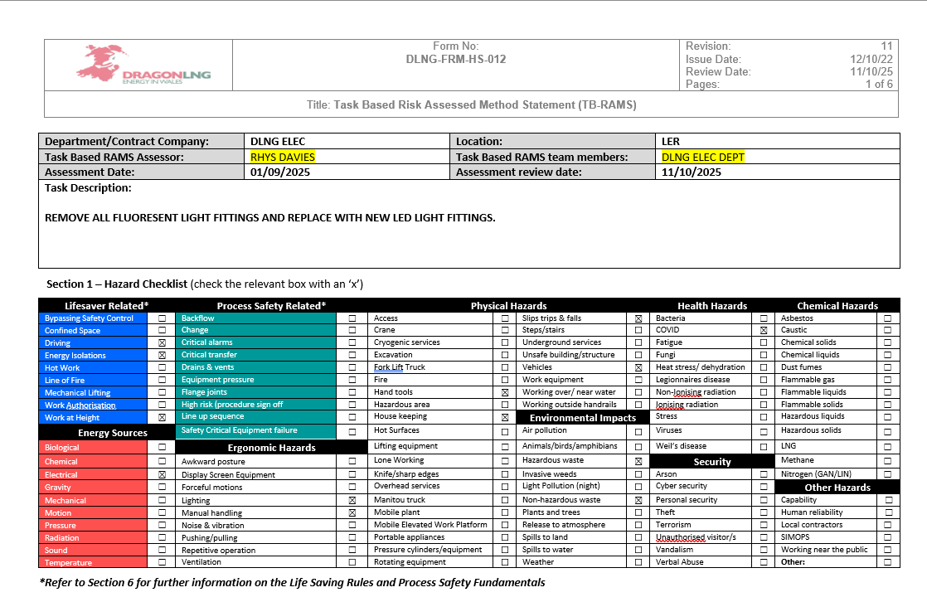
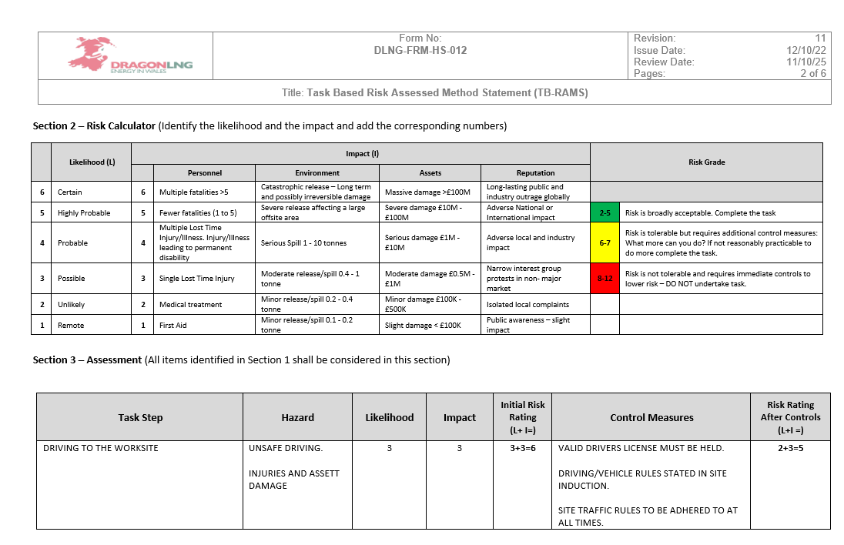

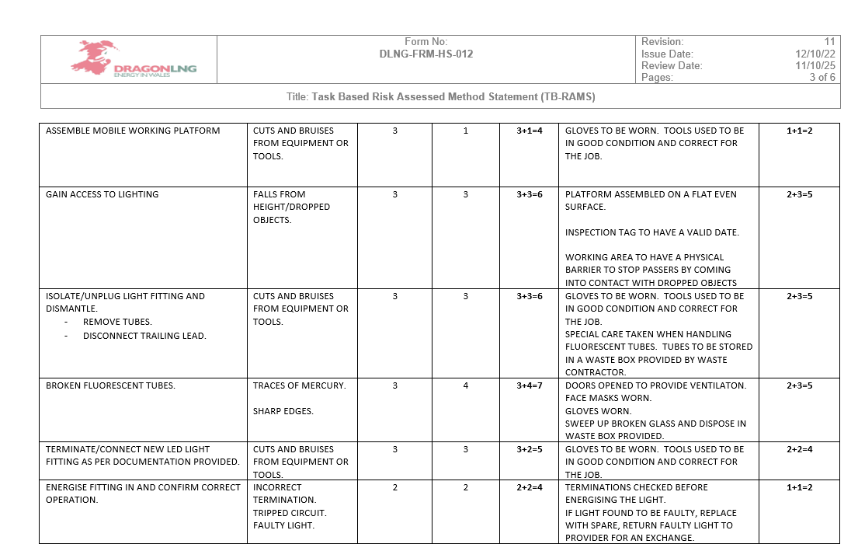
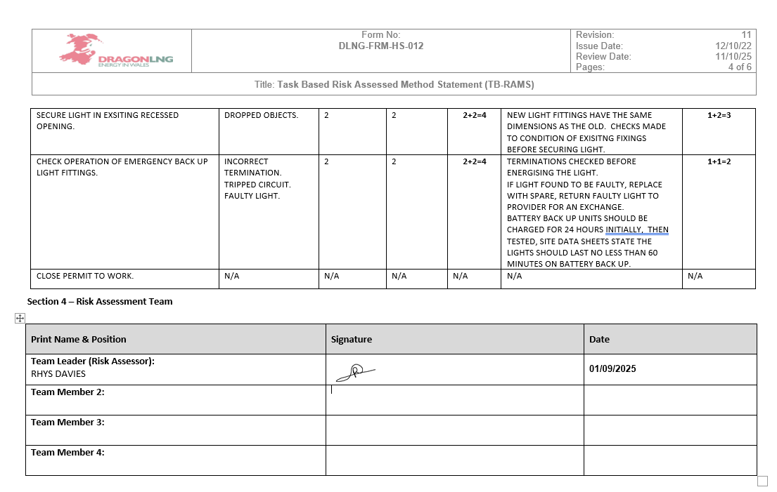

Appendix D
Reason | URL
Mobile Platform Hire | https://www.hss.com/hire/p/p85970/adjustable-safety-platform-steps
Lamp Disposal | https://www.ecoshreduk.com/shop/lamp-disposal-costs/
Lamp Disposal | https://ecolamp.co.uk/lamps/
Table3: Websites visited to gain approximations

References

[1] | Mount Lighting, “Mount: Lighting the way,” [Online]. Available: https://mountlighting.co.uk/. [Accessed 30 May 2025].
[2] | Ollie, “The Ultimate Showdown: LED vs. Fluorescent Lighting – Which Reigns Supreme?,” 30 November 2023. [Online]. Available: https://lumiretro.co.uk/. [Accessed 30 05 2025].
[3] | J. D. Bullough, “Lighting Futures,” vol. 4, no. 3.
[4] | L. N. Viana, Fluorescent lamps: A review on environmental concerns and current recycling perspectives highlighting Hg and rare earth elements, vol. 10, no. 6, 2022.
[5] | A. G. &. E. P. p. k. i. t. UK, 03 June 2025. [Online]. Available: https://www.theenergyshop.com/. [Accessed 04 July 2025].
[6] | Britsh Standards Institution, “BS 5266-1: 2016 Emergency Lighting,” BSI, London, 2016.
[7] | Image. [Online]. Available: https://www.cef.co.uk/. [Accessed 16 June 2025].
[8] | U.S. Department of Energy, “Energy Savings Forecast of Solid-State Lighting in General Illumination Applications,” Washington DC, 2016.
[9] | Chartered Institution og Building Services Engineers, “Lighting Guide LG7: Offices,” CIBSE, London, 2015.

