Principles of Human Resource Management (LCBB5012)
Academic Interview for HR Processes
Dr Eric Osei
Floarea-Stanca Costea
2323250

Slide 1 Recruiting a Graduate AI Strategist

Welcome. My name is Floarea Stanca Costea, the hiring manager recruiting a graduate AI strategist at UWTSD. The appointment is expected to assist students in responsible use of AI in 2026-27 and enhance independent learning and employability. I will present the job, describe the selection strategy and pose seven questions. The candidate should show evidence and examples of practical judgement. Studies define AI literacy as the ability to interact and critically analyse AI, so educational judgement is at the heart of this appointment (Long and Magerko, 2020).

Slide 2 The AI literacy support gap
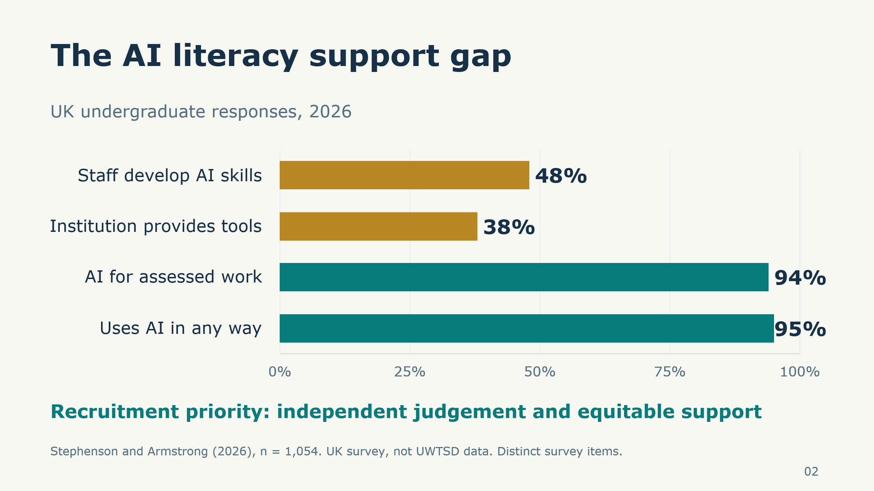
According to the 2026 HEPI survey, 95% of the respondents use AI, and 94% use it in order to support assessed work. Institutional AI provision is reported by only 38%, and 48% feel that staff assist in their AI development. These reactions reveal a support gap, yet they are about UK undergraduates, not UWTSD students (Stephenson and Armstrong, 2026). I would also set a local baseline and then invest. Employment claims are also a concern that should be taken seriously in the recruitment rationale. Job losses are not created by occupational exposure. According to ILO (2025), the transformation of the tasks will be significant, helping to prepare the changing work instead of unsubstantiated forecasts of graduate redundancy.

Slide 3 The proposed graduate role
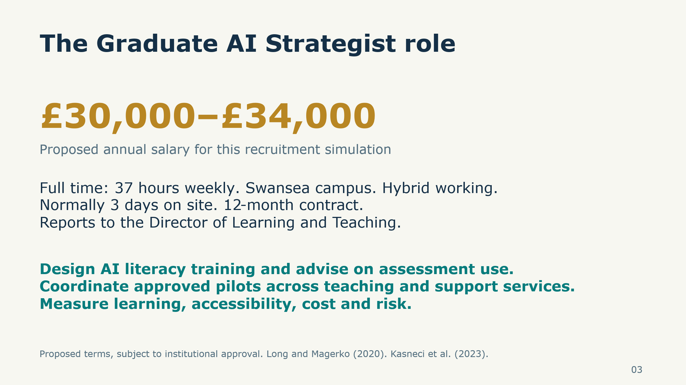
The suggested post is full-time, 37 working hours per week, with a base at the Swansea campus and hybrid working as usual with three days on-site. The salary suggested is £30,000-£34,000/year, with a twelve-month contract under the Director of Learning and Teaching. These are institutional recommendations on recruitment. Roles involve available training, guidance on assessment authorisations, piloting of tools and review of learning and risks. The graduate must organise services with senior staff still in charge of the consequential decisions. The advantages of education require verification and human control, so the recruitment process should not be based only on enthusiasm but on good judgement (Kasneci et al., 2023).

Slide 4 The person specification
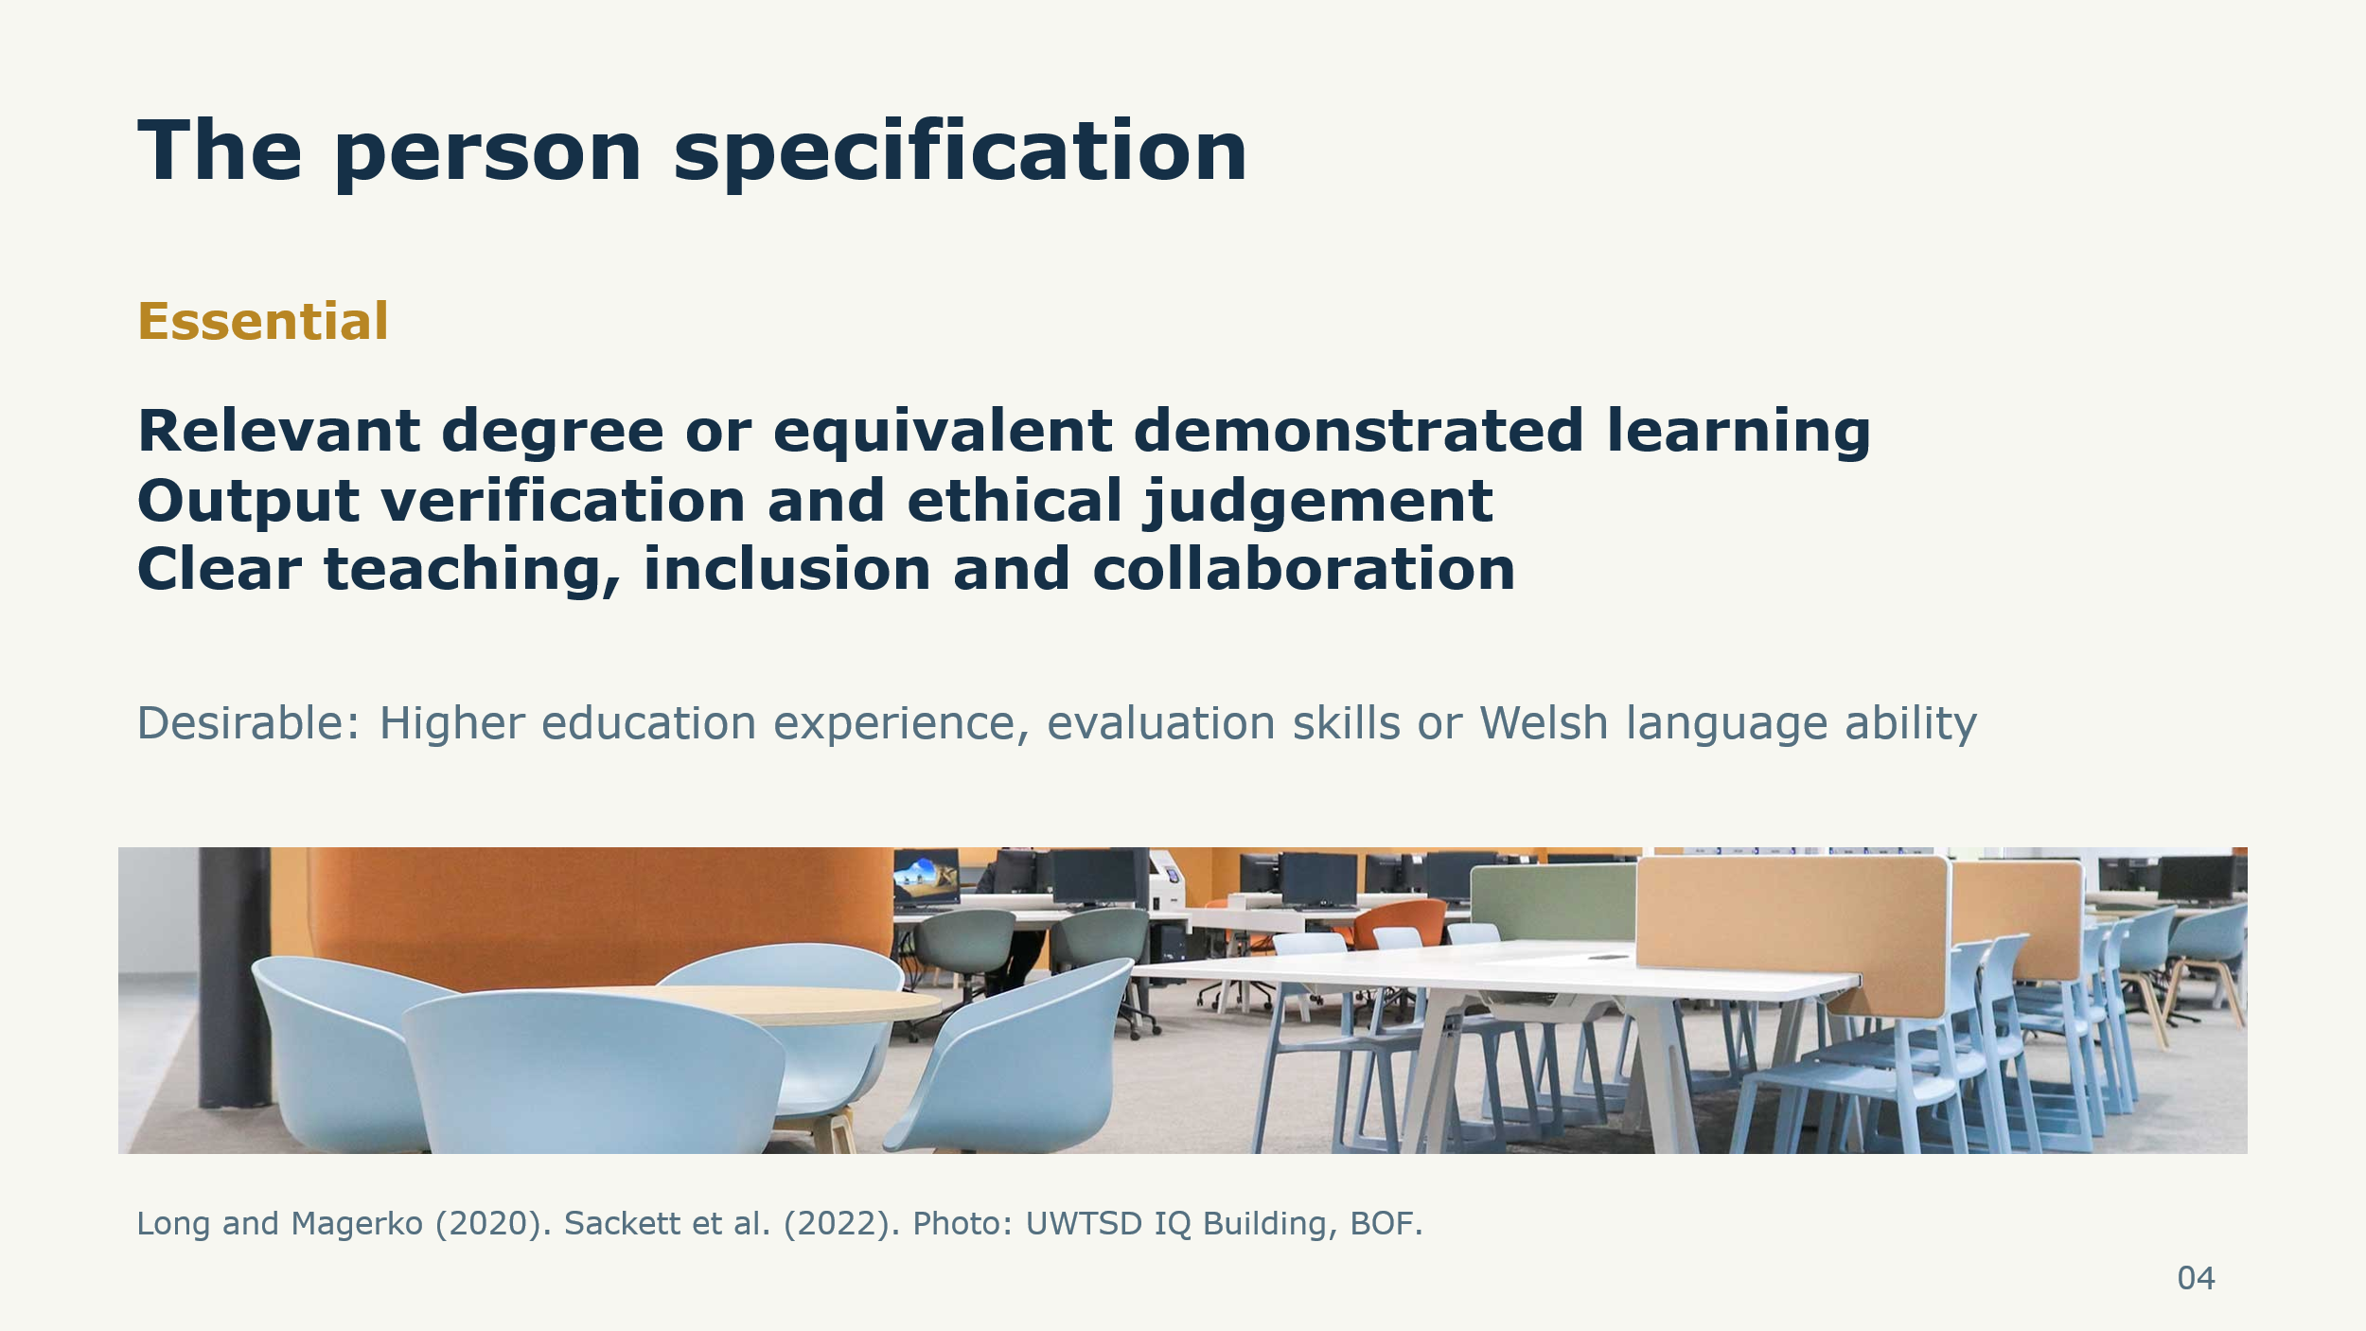
Among the key requirements, there are a degree or its equivalent based on a relevant field of study, the capacity to analyse AI outputs, effective communication, and practical teamwork. Applicants are to elaborate upon bias, privacy, and limitations of automated decisions. Higher education experience, evaluation skills and Welsh language facility are attractive and not universal barriers to entry. It can be evidenced by academic projects, volunteering or work. I would evaluate a portfolio and the interview, connecting each criterion with the responsibilities. This would ensure that recruitment is more transparent and does not equate confident presentation with competence. The useful prediction is supported by structured selection, but research also warns against overestimating its accuracy (Sackett et al., 2022).

Slide 5 Student training in 2026 to 2027
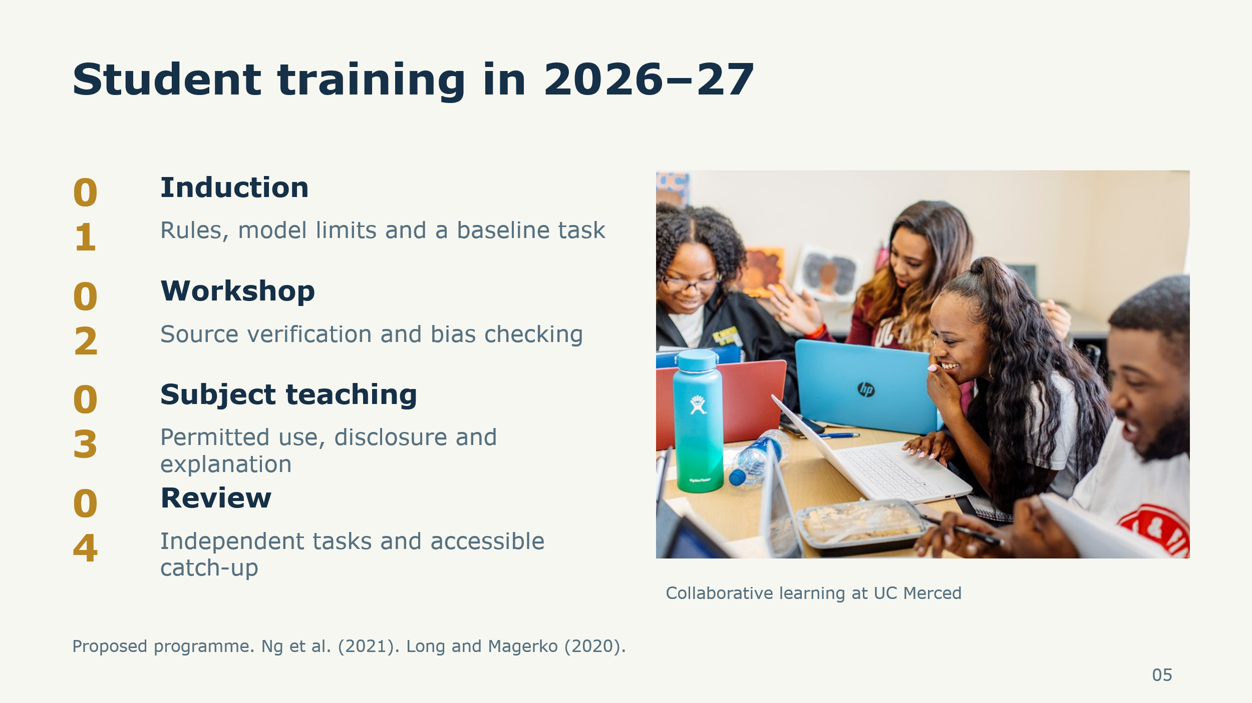
The proposed programme begins with induction on model limitations and assessment rules. This is followed by a workshop that challenges students to confirm claims using original sources and analyse biased outputs. Subject teaching gives the chance to use allowed tools, reveal their input and justify choices on their own. Similar assignments at week six and at the end of the term evaluate progress. This cycle represents knowledge, practice, critique and moral judgement in AI literacy studies (Ng et al., 2021).

Slide 6 Institutional readiness
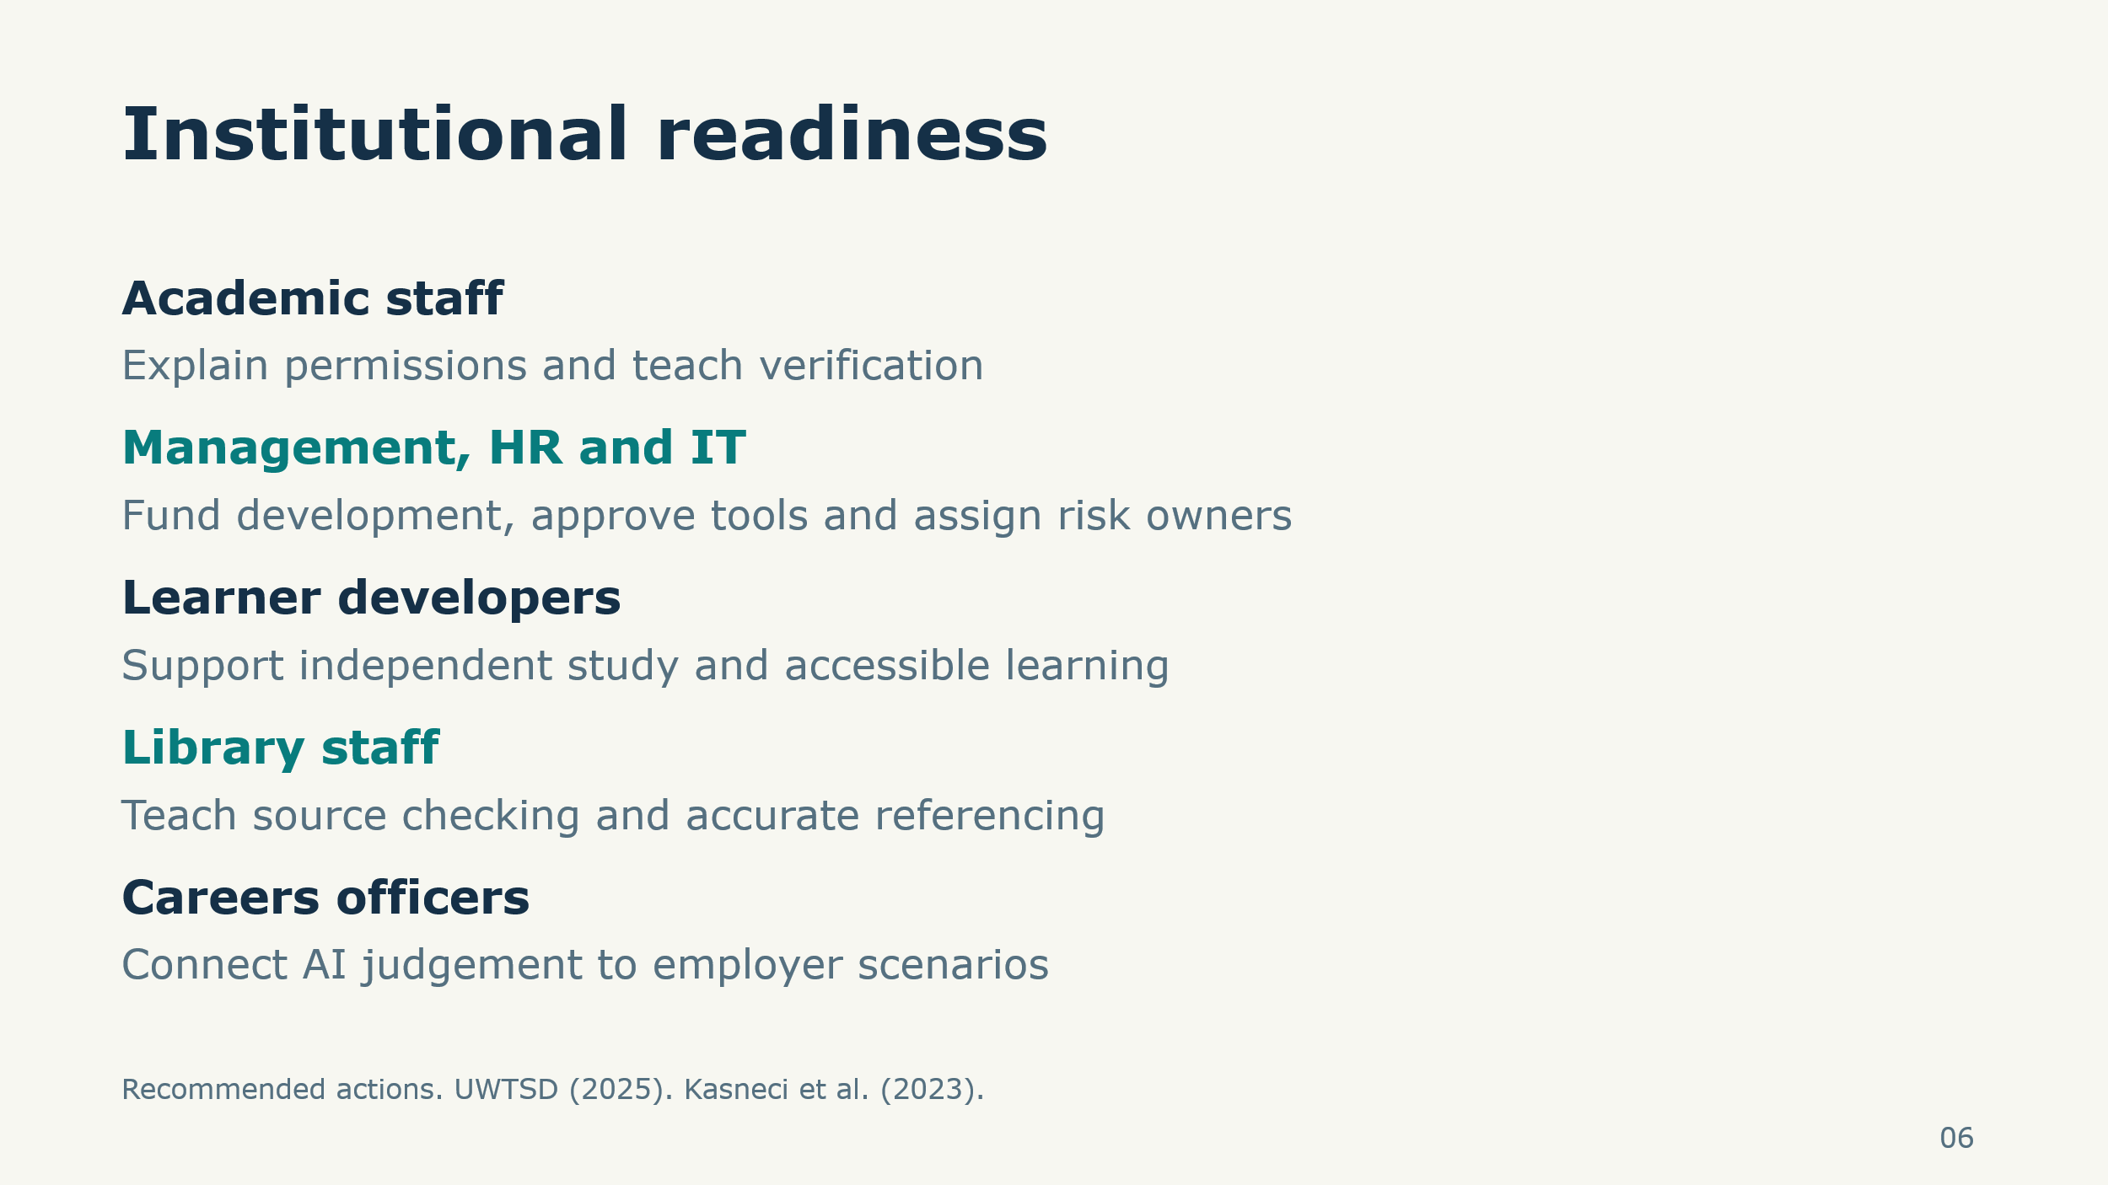
Assessment specific permissions need to be clarified and verification needs to be explained to the teaching staff. Development time to be paid for by management, HR and IT, tools to be approved and risk owners assigned. Independent study support is offered by learner developers. Careers officers connect with scenarios from employers and library staff train in source checking and referencing. There is guidance for decisions specific to assessment in place at UWTSD and this should be used as guidance for implementation (UWTSD, 2025). The strategist is responsible for arranging tasks rather than controlling all services. When there are differing opinions about the interpretation, a consultation approach and an escalation path should be provided for regular guidance. The challenges identified by Kasneci et al. (2023) in education affect the technology and staff capacity and ownership in the institution.

Slide 7 Structured selection
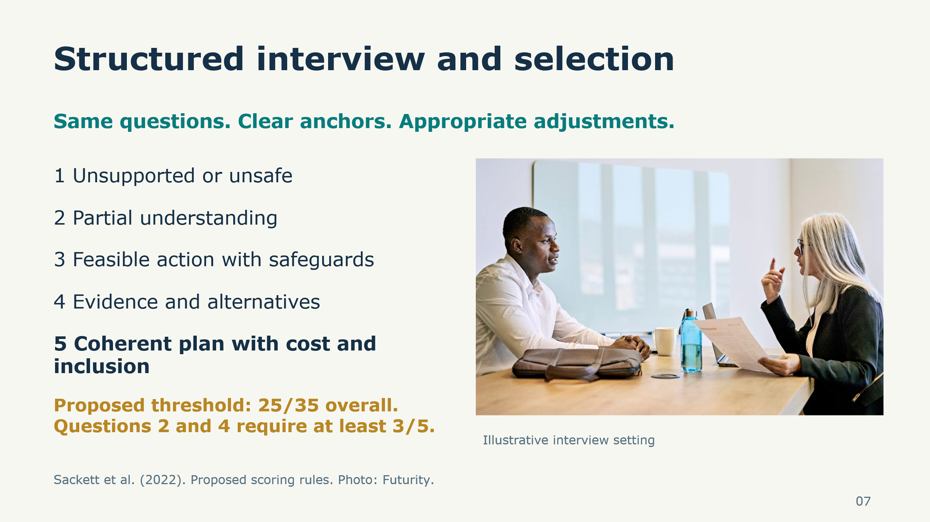
All applicants are given identical seven core questions, published criteria and relevant modifications. Responses are rated on a one-to-five scale, with unsupported or unsafe reasoning at one and a coherent, evidenced plan at five. The suggested threshold is 25 of 35, with three or more on oversight and integrity questions. Before discussing differences, assessors document evidence separately. They are supposed to put reasoning into consideration and not accent, confidence or resemblance to them. Sackett et al. (2022) endorse the use of structured interviews, but they acknowledge their limitations. The threshold is a suggested decision rule and not an established predictor. An appointment recommendation is still informed by essential requirements, portfolio evidence and references.

Slide 8 Question 1 Strategic priorities
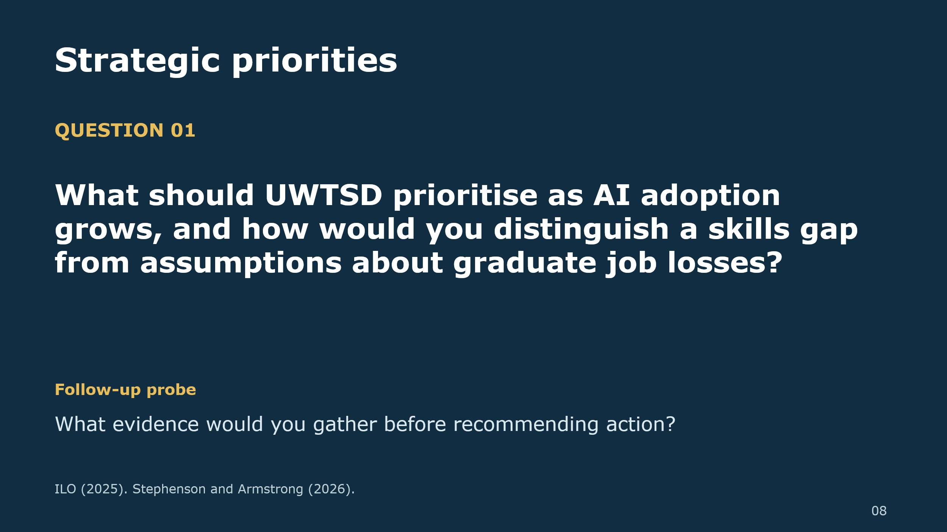
Spoken prompt: When AI is increasingly becoming more prevalent, what should be UWTSD's priorities, and how would you differentiate between a skills gap and assumptions that graduates will lose their jobs? What information would you need to obtain before making a recommendation?
Advice on preparation: Local needs assessment, employer consultation and well-considered learning priorities. A good response is one that includes a discussion of the exposure of a task relative to the displacement measured and uncertainty (ILO, 2025). Ask the candidate for neutral clarification: Does the candidate believe that employment is taken away because of adoption? The increased scores demand a justifiable resource decision and alternatives. While evidence gathered from the national survey provides a context, it cannot supplant evidence of learners and programmes at UWTSD. (Stephenson and Armstrong, 2026)

Slide 9 Question 2 Responsible AI agents
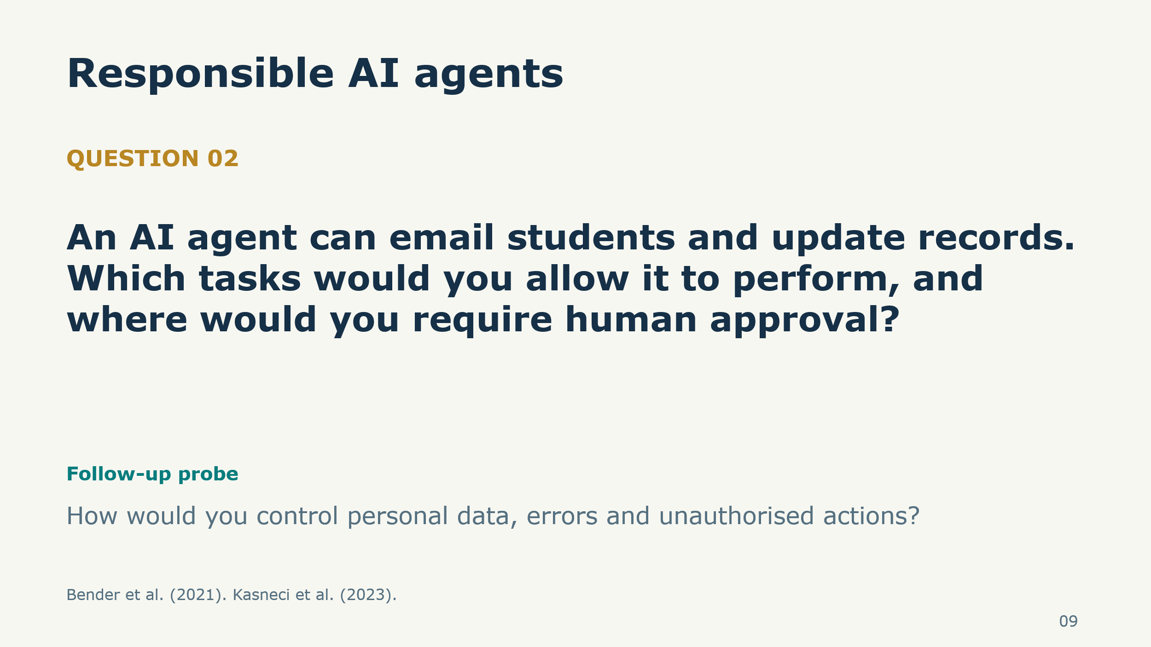
Spoken prompt: The AI agent can send e-mails to students and update records. What jobs would you let, and where would humans have to give permission? How would you manage personal data, errors and unauthorised actions?
Preparation guidance: This situation is a test of risk awareness in practice. Listen to limited permissions, allowed data processing, testing, logs and a way to terminate the process. These controls are based on the general language-model risks detected by Bender et al. (2021). Good applicants know how to draw the line between drafting information and consequential action and who should make the decision. However, human oversight is required in the process, not as a future aspiration after the system has been put in place (Kasneci et al., 2023).

Slide 10 Question 3 Inclusive training
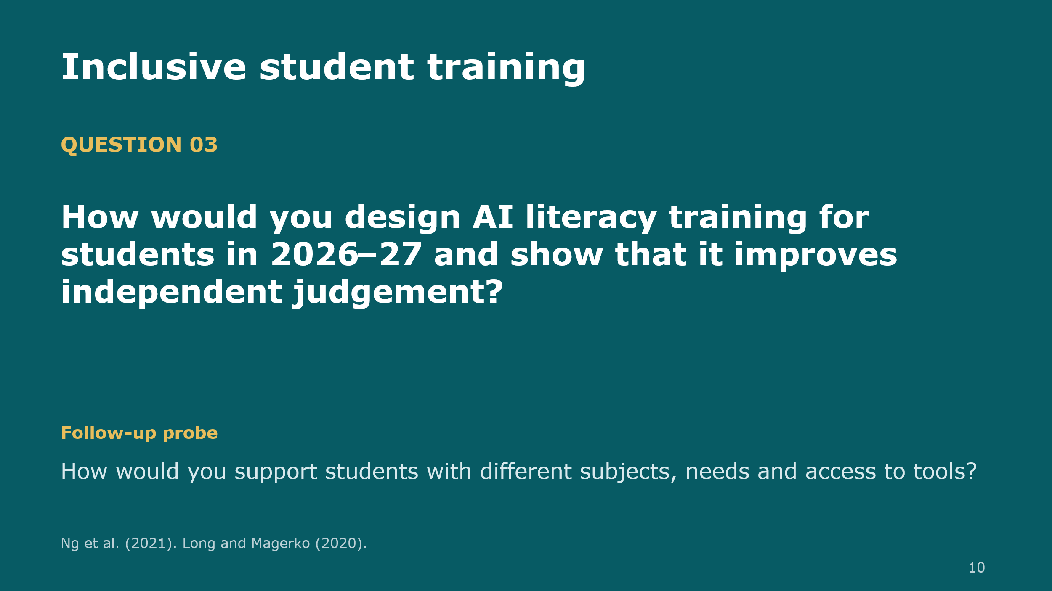
Written prompt: What would your AI literacy curriculum look like for 2026-27, and how will you demonstrate the enhancement of independent judgement? What would you do to support various subjects, needs and access to tools?
Provision for preparation guidance: Search for explicit results, source checking tasks and opportunities to justify decisions not using a generated response. Based on the dimensions of literacy described by Ng et al. (2021), the candidate needs to be able to make bridges between teaching activities and evaluation. Accessible delivery and supported access are important, but a confidence questionnaire does not equal competence. Better responses are tailored to the disciplines and clarify how independent understanding will be assessed. Evaluate viability and rationale, rather than the number of workshops proposed (Long and Magerko, 2020).

Slide 11 Question 4 Academic integrity
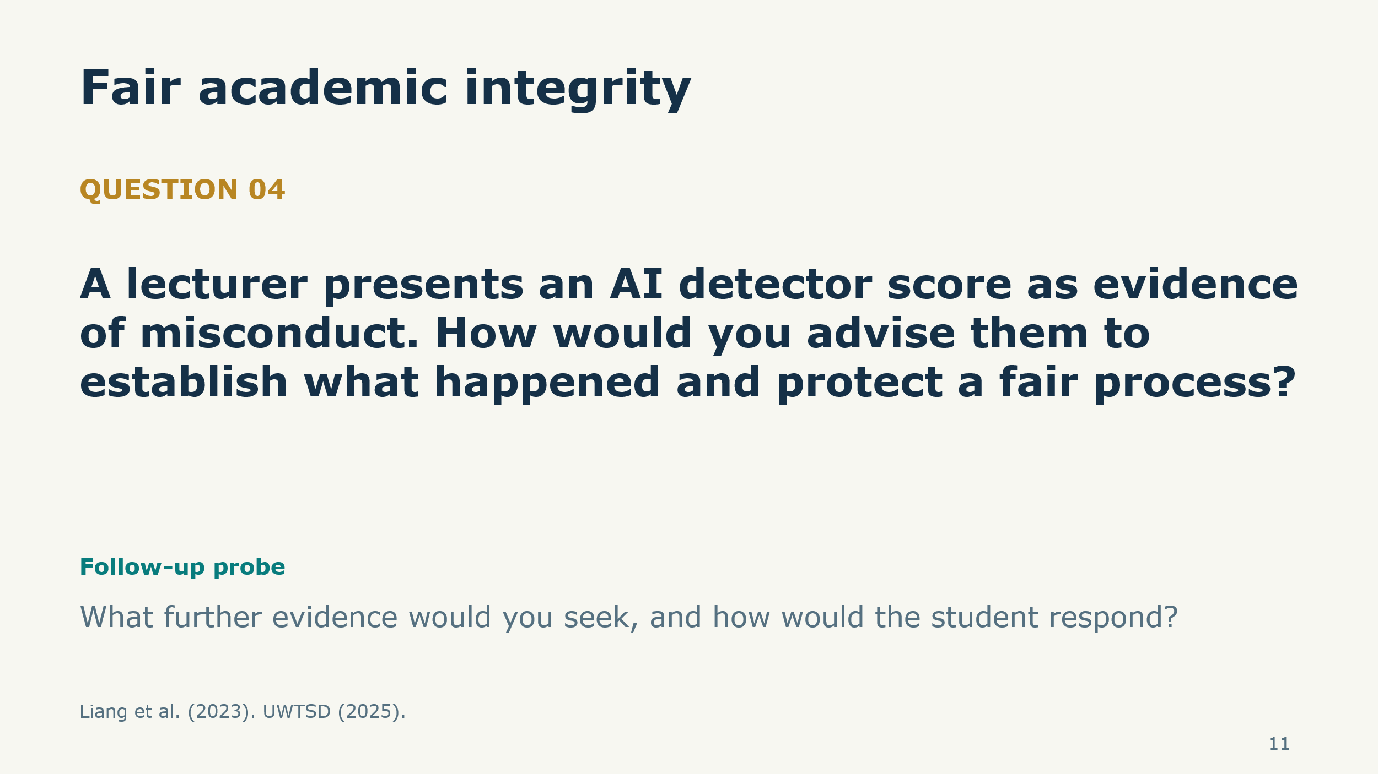
Spoken prompt: A lecturer presents an AI detector score as evidence of misconduct. How would you establish what happened and protect a fair process? What further evidence would you seek?
Preparation guidance: Find checking assessment permissions, consider the drafts and sources related to it, and give the student a chance to discuss their work. In their work, Liang et al. (2023) show that detectors are biased against non-native English writings, and they warn that a score should not be treated as a verdict. Candidates must discuss doubts and boundaries of their power. The strategist counsels employees as institutional processes decide on results. A proportionate response should be informed by evidence of learning and allowed use (UWTSD, 2025).

Slide 12 Question 5 Institutional coordination
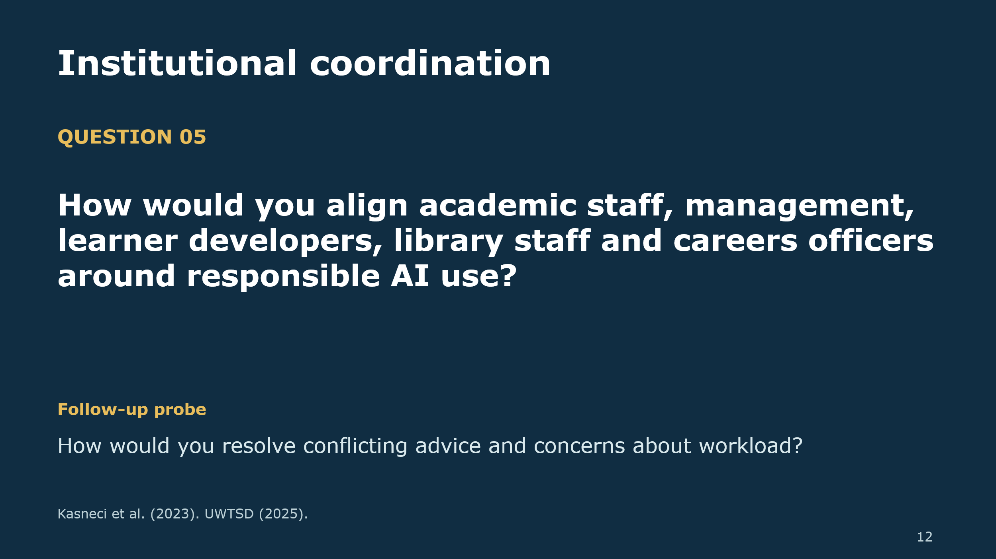
Spoken prompt: How would you align academic staff, management, learner developers, library staff and careers officers around responsible AI use? How would you resolve conflicting advice and workload concerns?
Preparation guidance: Listen to named owners, consultation, shared assessment guidance and realistic development time. Good candidates are those who know who makes decisions and how student feedback is passed to management. Current guidance provides a point of departure, yet services require agreed interpretation and resources (UWTSD, 2025). Reward realistic coordination and decent treatment of opposition. A graduate appointment cannot cover unfunded organisational duties. Responsible educational adoption requires staff capability and regular support as highlighted by Kasneci et al. (2023).

Slide 13 Question 6 Pilot evaluation
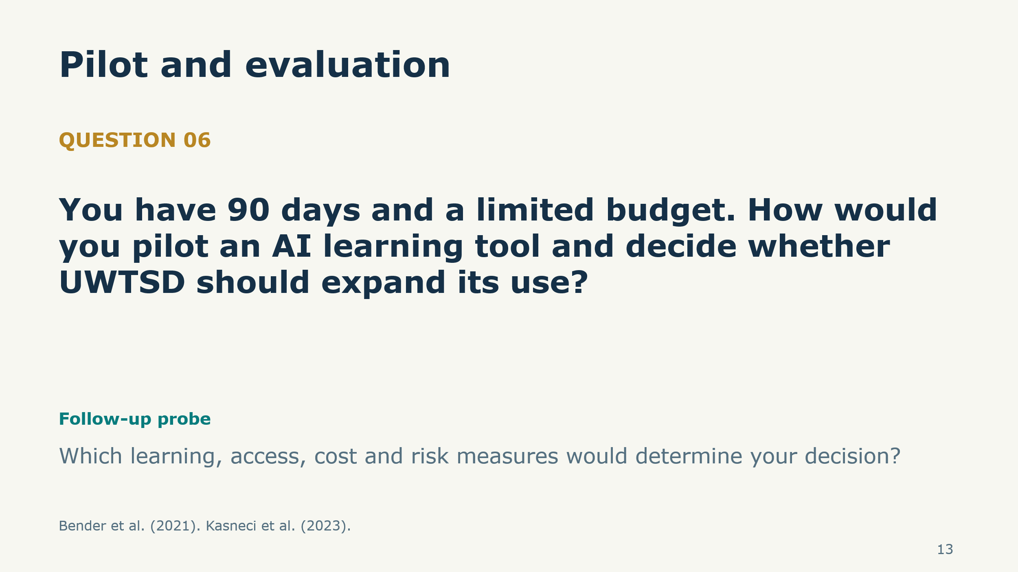
Spoken prompt: You have ninety days and a limited budget. How would you pilot an AI learning tool and decide whether UWTSD should expand its use? Which learning, access, cost and risk measures would guide your decision?
Preparation guidance: request a limited pilot, baseline evidence, approved data practices and comparison with an appropriate alternative. Expenses involve both personnel time and subscriptions. Strong answers give expansion, redesign, or abandonment conditions. Bender et al. (2021) recommend that risk evaluation should be based on unequal outcomes and unintended effects. Increased tool use does not create superior learning. They must rely on established educational value and ongoing human supervision (Kasneci et al., 2023).

Slide 14 Question 7 Innovation and closing
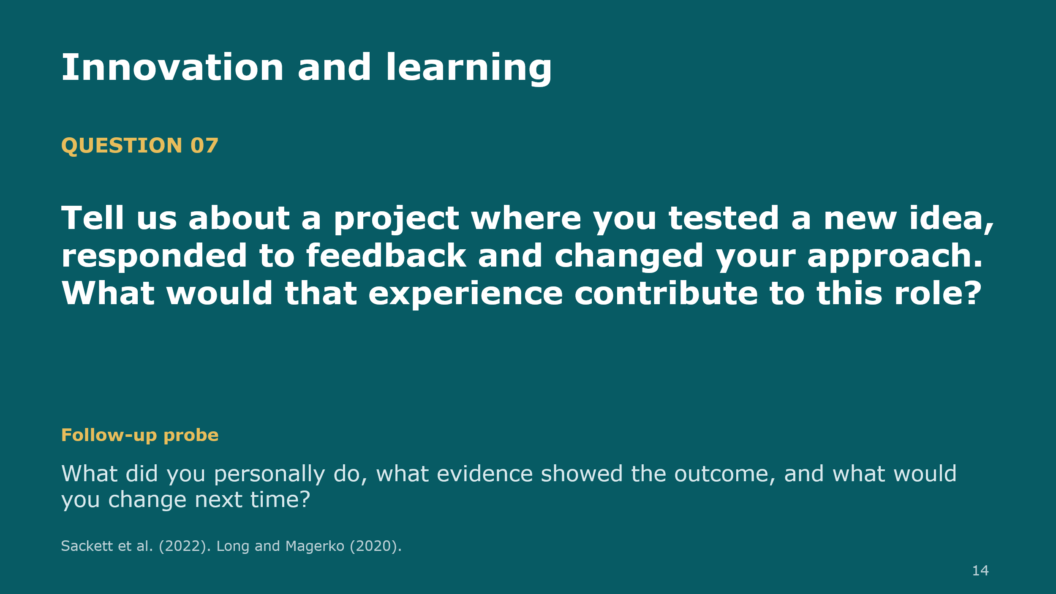
Spoken prompt: Tell us about a project where you tested a new idea, responded to feedback and changed your approach. What would that experience contribute to this role? What did you personally do?
Preparation guidance: Study, volunteering or employment examples are accepted. Evaluate personal contribution, demonstrated results and reflexive learning, which is congruent with principles of structured interviewing (Sackett et al., 2022). The candidate must relate learning to the critical engagement with AI (Long and Magerko, 2020). Nearby asking a single question and describing the next step. Competence, ethical judgement and collaboration should be incorporated into the appointment recommendation to promote responsible AI education throughout UWTSD.
References
Bender, E.M., Gebru, T., McMillan-Major, A. and Shmitchell, S. (2021) 'On the dangers of stochastic parrots: Can language models be too big?', Proceedings of FAccT '21, pp. 610–623. Available at: https://doi.org/10.1145/3442188.3445922 (Accessed: 5 October 2026).
International Labour Organization (ILO) (2025) Generative AI and jobs: A 2025 update. Geneva: ILO. Available at: https://www.ilo.org/publications/generative-ai-and-jobs-2025-update (Accessed: 5 October 2026).
Kasneci, E. et al. (2023) 'ChatGPT for good? On opportunities and challenges of large language models for education', Learning and Individual Differences, 103, 102274. Available at: https://doi.org/10.1016/j.lindif.2023.102274 (Accessed: 5 October 2026).
Liang, W., Yuksekgonul, M., Mao, Y., Wu, E. and Zou, J. (2023) 'GPT detectors are biased against non-native English writers', Patterns, 4(7), 100779. Available at: https://doi.org/10.1016/j.patter.2023.100779 (Accessed: 5 October 2026).
Long, D. and Magerko, B. (2020) 'What is AI literacy? Competencies and design considerations', Proceedings of CHI '20, pp. 1–16. Available at: https://doi.org/10.1145/3313831.3376727 (Accessed: 5 October 2026).
Ng, D.T.K., Leung, J.K.L., Chu, S.K.W. and Qiao, M.S. (2021) 'Conceptualizing AI literacy: An exploratory review', Computers and Education: Artificial Intelligence, 2, 100041. Available at: https://doi.org/10.1016/j.caeai.2021.100041 (Accessed: 5 October 2026).
Sackett, P.R., Zhang, C., Berry, C.M. and Lievens, F. (2022) 'Revisiting meta-analytic estimates of validity in personnel selection: Addressing systematic overcorrection for restriction of range', Journal of Applied Psychology, 107(11), pp. 2040–2068. Available at: https://doi.org/10.1037/apl0000994 (Accessed: 5 October 2026).
Stephenson, R. and Armstrong, C. (2026) Student Generative Artificial Intelligence Survey 2026. HEPI Report 199. Oxford: HEPI. Available at: https://www.hepi.ac.uk/reports/student-generative-ai-survey-2026/ (Accessed: 5 October 2026).
University of Wales Trinity Saint David (UWTSD) (2025) AI in Assessment. Updated May 2025. Available at: https://www.uwtsd.ac.uk/media/5728/download?attachment= (Accessed: 5 October 2026).

