
Master of Business Administration
Student Name: Resvy Ahmed
Student Number: 2504376
Module code: LCMB7026
Module Name: International Marketing: Principles and Practices
Lecturer: Tushara Balendran

Title: "An International Marketing Mix Analysis of Mercedes-Benz in Germany and the United Kingdom"

Table of Contents
SECTION 01 1
1. Introduction 1
2. Background Information of the Company 2
2.1 Company Identity and Heritage 2
2.2 Mission, Vision and Core Values 2
2.3 Geographic Presence: Home and Host Countries 3
2.4 Sales Performance and the Market Scale 3
3. The Macro Environment: Comparative PESTEL Analysis 3
4. Culture Orientation and Consumer Behaviour 7
5. Segmentation, Targeting, Positioning (STP) 9
5.1 Segmentation Strategy 9
5.2 Targeting Strategy 10
5.3 Positioning Strategy 10
5.4 Perceptual Map (Luxury vs Performance Positioning) 12
5.5 Similarities and Differences of STP 12
5.6 Comparative Analysis 13
6. International marketing Mix (7Ps) 14
6.1 Product Strategy (international marketing principles) 14
6.2 Pricing Strategy (Premium Strategy) 15
6.3 Place (Distribution Strategy) 16
6.4 Promotion Strategy 17
6.5 People 17
6.6 Process (Customer Complaint Handling) 18
6.7 Physical Evidence 18
6.8 Similarities and differences of 7Ps between these two services. 19
7. Directional Development Strategy 21
SECTION 02 23
1. Ethical Marketing Analysis (Based on 7Ps) 23
1.1 Examples of Ethical Marketing Practices 23
1.2 Types of Unethical Marketing Practices 24
2. Focused Marketing Mix Evaluation-STP 24
Recommendations 25
Recommendations for Germany 25
Recommendations for the United Kingdom 25
3. Gibbs Reflective Cycle 26
3.1 Description 27
3.2 Feelings 27
3.3 Evaluation 27
3.4 Analysis 27
3.5 Conclusion 27
3.6 Action Plan 28
Conclusion 29
References 30

SECTION 01

1. Introduction
Global marketing has evolved to be an important strategic role in an ever growing and interconnected globalised economy. It entails planning, designing and executing marketing activities across national boundaries taking into consideration the differences in economic conditions, regulatory systems and also the cultural setting. International marketing goes beyond market entry in the highly sophisticated markets like the worldwide automotive market to maintaining competitive advantage with a delicate equilibrium between strategic adaptation and standardisation. Multinational firms need to ensure their marketing mix matches with the local market but they retain a global brand (Hunt, 2023).
One of the most complicated and competitive international business industries is the premium automotive industry. It is highly responsive to strategy as it is characterised by quick technological development, strict environmental policies and changing tastes and preferences of consumers. In this background, Mercedes-Benz is a world-renowned innovator of high-end mobility, linked to excellence in engineering, innovation, and prestige. Being a part of the Mercedes-Benz group AG, the brand is present in more than 130 countries, which contributes to its being an appropriate case that should be analyzed in terms of international marketing strategies (Cioca et al., 2019).
The current report is a comparative study of the international marketing mix of Mercedes-Benz in United Kingdom and Germany. Germany is the home market of the brand that has a solid engineering culture but the United Kingdom is a polar opposite market posed by the economic environment after Brexit, service-sector economy, and consumerism in terms of brands. The report uses the analytical systems such as the PESTEL, the cultural dimensions of Hofstede and the STP model and the extended marketing mix (7Ps) with reference to the secondary academic, government, and industry data (Ani et al., 2025).
A reflective reflection of the research and the analytical process is also carried out with the help of Gibbs Reflective Cycle. Generally, the report will produce evidence-based information, as well as the strategic findings that will enable the brand to increase its competitive position in both markets.

2. Background Information of the Company

2.1 Company Identity and Heritage
Mercedes-Benz Group AG is a globally recognised vehicle manufacturer of luxury vehicles, headquartered in Stuttgart, Germany Its roots reach back to the invention of the automobile in 1886 by Carl Benz, and ever since that defining innovation, Mercedes-Benz has itself built a reputation for engineering excellence, technological innovation, safety leadership and premium design. The company operates as one of the core brands of the Mercedes-Benz Group along with subsidiary brands such as Mercedes-AMG, and Mercedes-Maybach. Today, Mercedes-Benz makes a full array of passenger cars, vans and electrified vehicles for different market segments all around the world (Mercedes-Benz Group, 2024).

2.2 Mission, Vision and Core Values
The mission of Mercedes-Benz is to provide the highest quality premium cars and commercial vehicles in the world with innovation, sustainability, and excellence in everything they do. This mission stresses the commitment to the superior quality of products, technological advancement, and customer satisfaction worldwide - central tenets for achieving its international marketing endeavours (PESTEL Analysis, 2025).
Core values that run through the fabric of the company are integrity, openness, respect, customer orientation, commitment to excellence and sustainability. These are values that guide the company's organisational culture and business practises, which affect internal stakeholder behaviours and external stakeholder perceptions in a similar way. As a global company and currently employing people of all backgrounds, Mercedes-Benz takes an active role promoting diversity and tolerance as a part of its corporate attitude (Mattina, 2025).

2.3 Geographic Presence: Home and Host Countries
As a company with German origins, Mercedes-Benz has Germany as its home market where it also has extensive production, research and development, and corporate facilities. Germany is the strategic heartland for innovation, engineering talent and industry partnerships, especially that of the wider ecosystem of European automotive industry (Tilly, 2017). In contrast, the United Kingdom is an important host market with a developed luxury market environment, a healthy premium car market and unique consumer preferences evolved by post-Brexit regulatory environments, urban mobility trends and advanced digital retail infrastructures (Market Research Future, 2026).

2.4 Sales Performance and the Market Scale
Globally, Mercedes-Benz remains one of the largest luxury automobile companies in terms of sales volumes. Recent corporate data show that in 2024, the Mercedes-Benz Group had about 1.98 million passenger car deliveries worldwide with about 641 800 in Europe and 213 456 in Germany affirming the continued relevance of Germany as a core market for the company despite the handling of competition and changes in demand patterns (Mercedes-Benz Group, 2024).

3. The Macro Environment: Comparative PESTEL Analysis
A good international marketing strategy is one that is based on a thorough knowledge of the macro-environmental pressures that influence the market environment. Such an analysis is based on the PESTEL framework, which is Political, Economic, Social, Cultural, Technological, Environmental, and Legal aspects. In the case of a global company like Mercedes-Benz, which has its operations both in Germany and the United Kingdom, there is a need to respond to different macro-environmental forces (Makos, 2024).

Table 1: Comparative PESTEL Analysis – Germany vs United Kingdom
Factor | Germany | United Kingdom | Comparative Implications
Political | Stable EU-aligned governance; strong industrial policy | Post-Brexit regulatory independence; trade complexities | UK faces higher import barriers and regulatory divergence
Economic | Strong manufacturing economy; stable GDP (~$4.5T) | Service-based economy; GDP (~$3.3T); currency volatility | UK pricing more volatile; Germany more stable demand
Social | Quality-focused, engineering-oriented consumers | Status-driven, brand-conscious consumers | Functional vs aspirational marketing approaches
Cultural | High uncertainty avoidance; long-term orientation | High individualism; indulgence | Rational vs lifestyle consumption behaviour
Technological | Global automotive R&D leader | Advanced EV adoption and digital ecosystem | Germany leads production; UK leads EV incentives
Environmental | Strict EU emission standards | Net-zero targets; strong EV incentives | UK more aggressive in consumer-level EV adoption
Legal | Harmonised EU regulations | Independent post-Brexit regulatory framework | Higher compliance complexity in UK

Political Factors
Germany has a stable political arena that has been supported by EU policies on the industries and which is accelerating industrial and automotive growth. Quite the contrary, UK post-Brexit gives rise to regulatory uncertainty and trade restrictions (Makos, 2024). The positive dimension of the situation in Germany is that the stability of policy will lead to take a positive stance on long-term investment whereas the negative dimension is that EU laws can make the flexibility harder. The favourable side of policy making in the UK is freedom, and on the unfavourable side is that the trade barriers contribute to operation costs.
Economic Factors
Germany has a stable and healthy economy which is approximately 4.5 trillion GDP and low inflation rate as compared to the European level. The GDP of approximately 3.3 trillion exposes UK to greater risks on inflation fluctuation as well as currency shocks. Also, the market of Germany and the UK differs in terms of automotive sales, though Germany has already strong domestic car sales (e.g., over 2.8 million new registrations per year), the UK market is facing another trend with the uneven demand (e.g., around 1.9 million new registrations, which are dependent on economic conditions and transition to EVMs). In Germany, the good GDP, favorable industrialization, and dependability in the demand are the positive factors whereas slower growth of new EV segments is the negative. The favourable factor in the UK is good buying power and surplus demand, and the unfavourable factor is inflation and fluctuating exchange rate when it comes to prices (European Automobile Manufacturers’ Association, 2024).
Social Factors
German consumers have functional, safety and engineering excellence as their priorities and this conforms to the rational buying behaviour. The emotional and symbolic consumption habits of the UK consumers have a greater impact in status, lifestyle and brand image (Makos, 2024).

Cultural Factors
According to Hofstede Cultural Dimensions, cultural differences introduce Germany as organized and risk-averse, whereas the UK is flexible and highly individualistic (Makos, 2024). These differences influence decision-making and brand perception.
Technological Factors
Mercedes-Benz is a heavy supplier when it comes to technology as Germany has some of the best automotive R&D and innovation in manufacturing in the world. The UK possesses a well-developed EV infrastructure and digital coverage to ensure that customer experience and the innovation of electric mobility are favoured. The favourable factor, in Germany, is a solid R&D ecosystem, whereas, the negative factor is a lower level of consumer adoption of new technology. The positive factor is fast EV-adoption and online interaction in the UK, and the negative factor is small production capacity at home.
Environmental Factors
With such stringent EU emission requirements, Germany compels manufacturers to be innovative in a sustainable way. The UK has ambitious net-zero targets and offers incentives to consumers to buy EVs.
Legal Factors
Germany works by the harmonised EU regulation and as such, there is uniformity in the markets. The independent regulatory landscape that will be present in the UK after Brexit brings in some extra compliance rules.
Similarities and Differences between Germany and the United Kingdom
Both nations are highly developed economies with high premium car needs, advancement in technology and growing interest in sustainability. Nevertheless, there are major differences. Germany provides a secure, manufacturing oriented condition in line with professionalism in engineering and strategic vision. Conversely, the UK market is more active and consumer oriented with greater individualism, brand recognition and open to innovation especially the electric mobility (European Automobile Manufacturers’ Association 2024).

4. Culture Orientation and Consumer Behaviour
Understanding cultural dynamics is vital in the field of international marketing, as consumer perceptions, values, and buying behaviour are deeply rooted to the societal norms. For a high-end brand like Mercedes-Benz, cultural sensitivity is especially important given that luxury consumption is frequently determined not only by utilitarian needs; it is determined by symbolic meanings as well.
Figure 1: Cultural Comparison – Germany vs United Kingdom (Hofstede Framework)
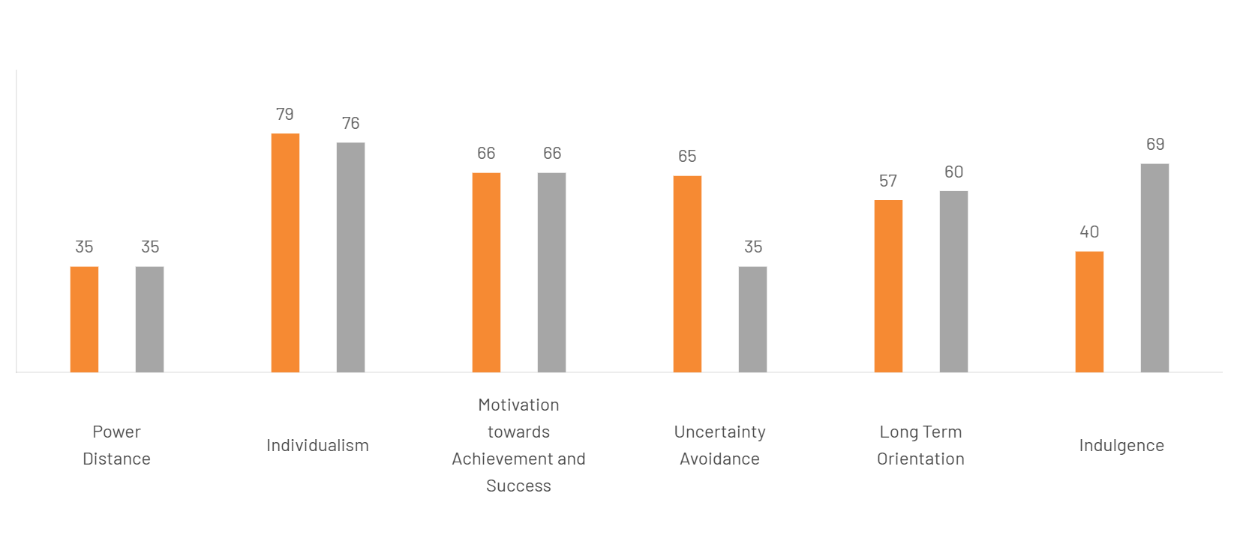
Source: The Culture Factor (2024) Country comparison tool: Germany vs United Kingdom. Available at: https://www.theculturefactor.com/country-comparison-tool?countries=germany%2Cunited+kingdom (Accessed: 20 April 2026).
Comparison of Germany and the United Kingdom (Hofstede Dimensions) based on culture.
A comparative cultural analysis according to Hofstede Cultural Dimensions shows considerable variations between Germany and United Kingdom that directly relate to consumer behaviour and marketing approaches.
The power distance in both countries is fairly low, suggesting that they prefer egalitarian forms and participative decisions. Nonetheless, the United Kingdom exhibits a more casual style of power than Germany, in which the organisational structures are more likely to be well defined (Hofstede, 2001).
United Kingdom is considerably higher than Germany in terms of individualism as there is more emphasis on individual autonomy, self-expression and individual success. Although Germany remains individualistic, it values more the structured institutions and the efficiency of a group.
In terms of achievement/success motivation (masculinity) the score of the two countries is the same. This means that the core cultural values in the two settings are competitiveness, performance and achievement, which contributes to high demands of quality and performance-based products (Minkov, 2010).
One of the key differences is in uncertainty avoidance. Germany portrays a greater level signifying a preference towards rules, planning and minimization of risks. The United Kingdom, in contrast, tolerates ambiguity and change and therefore has more flexibility in making decisions and openness to innovation.
As part of long-term orientation, Germany can be described as highly future oriented, where perseverance, sustainability and long-term planning are important. This is not the case in the United Kingdom though; the country has a more balanced orientation of both the short-term and long-term orientation.
Lastly, there is a great variance in indulgence. United Kingdom has been described as being highly indulgent with more focus on leisure, enjoyment and lifestyle. Germany, in turn, is more conservative, disciplined and restrained in its consumption.
Advantage and Disadvantage of the Hofstede Model
Hofstede model offers a methodic and universally recognised pattern of cross-cultural contrast that enables marketers to draw forecasts about the behaviour of consumers in different countries. It can be applied in designing international marketing strategies, particularly in segmentation and positioning, and provides quantifiable cultural facets, thus rendering comparisons readily noticeable and structured. Nevertheless, the model classifies culture and failed to consider differences at an individual or regional level. It also relies on historical information, and might not be quite representative of the current state of cultural relations within fast-changing societies. Moreover, it does not take into account the subcultures or multiculturalism among nations and can resort to stereotyping, thus lessening more contextual insight (Hofstede, 2001; Minkov, 2010).

5. Segmentation, Targeting, Positioning (STP)

5.1 Segmentation Strategy
Mercedes-Benz uses a multi-dimensional segmentation strategy, combining geographic, demographic, psychographic and behavioural variables to capture the intricacy of the luxury auto market (Philip Kotler et al., 2016).
- Geographic Segmentation:
In Germany, segmentation mirrors regional economic strength and industrial concentration and there is a higher demand in the more economically developed regions such as Bavaria and Baden-Württemberg. In the UK, demand is generally more concentrated in urban centres - London and the South East - where there is more income and more consumption based on lifestyle (OECD, 2023).
- Demographic Segmentation:
In both markets, the target brand is focused on high-income people such as professionals, executives, entrepreneurs, and business owners. There is however a rising market segment within the UK for younger affluent consumers who are drawn to entry level luxury models (Statista, 2024).
- Psychographic Segmentation:
German consumers are likely to be characterised as having a preference for functionality and reliability coupled with technical excellence, while in the UK, consumers are more heavily geared towards status, lifestyle and brand symbolism. This difference has an important effect on product preference and marketing communications (Hofstede, 2001).
- Behavioural Segmentation:
In Germany customers are often very brand loyal and value long-term value. In contrast, consumers in the UK are more sensitive to the brand image, promotional activities and innovation, especially in emerging areas such as electric vehicles (European Automobile Manufacturers’ Association, 2024).

5.2 Targeting Strategy
Mercedes-Benz pursues a differentiated targeting approach in which it operates in different segments that are made up of premium customers while preserving a consistent global brand identity (Philip Kotler et al., 2016).
- Germany:
The target market is primarily composed of established professionals, engineers and corporate clients that value performance, safety and engineering precision. Fleet and corporate sales are also important, indicating the country's strong industrial base (European Automobile Manufacturers’ Association, 2024).
- United Kingdom:
In addition to more classic high-income consumers, the brand targets aspirational, middle-upper class consumers, especially in metropolitan areas. Younger professionals and entrepreneurs are an important growth segment, particularly of compact luxury models and electric vehicles (Statista, 2024).

5.3 Positioning Strategy
Positioning is the process of how a brand is perceived in the mind of the consumer compared to their competitors. Mercedes-Benz has one world consistent positioning, focused around luxury, innovation and quality, but localised affecting its focus to what the local market expects (Al Ries et al., 2001).

Table 2: STP Comparison – Germany vs United Kingdom
Element | Germany | United Kingdom
Segmentation | Performance and function-oriented | Lifestyle and status-oriented
Targeting | High-income professionals, corporate clients | Affluent and aspirational consumers
Positioning | Engineering excellence and reliability | Luxury, prestige, and social status

- Germany:
The brand is set up as a signifier of engineering excellence and technological superiority. Marketing communications focus on aspects such as precision, safety and long-term reliability in accordance with the consumer expectation for functional value.
- United Kingdom:
In comparison, Mercedes-Benz is a prestigious and aspirational luxury brand. The emphasis is placed on elegance, status and higher living comfort, appealing consumers such desire for social recognition and aided to personal expression.

5.4 Perceptual Map (Luxury vs Performance Positioning)
Figure 2: Perceptual Map of Premium Automotive Brands (Germany vs UK)
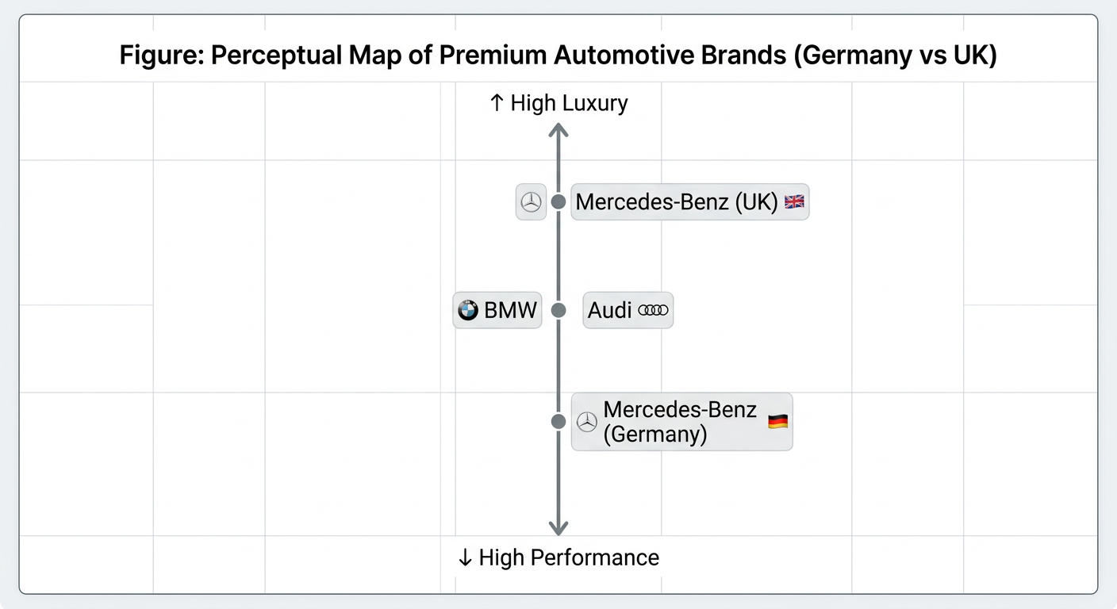
Source: Created by author
The perceptual map shows the difference in positioning of Mercedes-Benz among markets. It is more oriented towards performance and engineering excellence in Germany, but towards luxury and prestige orientation in the UK. Competition like BMW and Audi are at the intersection but of different position, which underlies the necessity of differentiated positioning strategies.

5.5 Similarities and Differences of STP
Germany and the United Kingdom are both highly oriented towards luxury and up-market consumer market segments, indicating the existence of a similar demand structure in the high-end automotive brands. The focus on brand quality, technological advancement and high performance in both markets is very high always, which further supports the international position of Mercedes-Benz, as a luxury maker. Moreover, the brand is characterized by a continuous international identity, so the basic positioning as luxury does not change in the two countries, but the modifications can be made in communication and product accentuating (Kotler et al., 2016).
Nonetheless, major variations arise in operationalization of segmentation, targeting and positioning strategies. The market of Germany is better supported by functional and engineering-based segmentation and it implies customer tendencies to support technical excellence, precision, and long-term value. The United Kingdom, conversely, emphasizes more on lifestyle-focused and aspirational parting, with symbolic value, status and emotional assigning a more predominant position in the purchasing action. Germany is more professionally oriented in terms of targeting, i.e., it is aimed at engineers, corporate clients and high-income professionals, whereas the UK market features wider range of aspirational middle-upper class customers, namely younger professionals and those who make purchases in cities. In a similar thread, positioning in these two markets is different: in Germany, Mercedes-Benz is more of a symbol of technical perfection and engineering stability, whereas in the UK it can be seen as a marker of prestige, social status, and self-expression (Hollensen, 2020).

5.6 Comparative Analysis
The comparative analysis of STP strategies shows that although Mercedes-Benz has a strong global brand identity, it makes a good adjustment to its segmentation and positioning to reflect the local market situation. This balance between standardisation and adaptation is very important for maintaining competitiveness in the international markets.
In Germany, the conformity between the core values of the brand and the expectations of consumers gives a natural competitive advantage. However, this may also reduce the opportunity to experience expansion to new markets if the brand continues to be too preoccupied by traditional consumers.
In the United Kingdom, the wider approach of strategy increases the scope on the market, but increases competition, price sensitivity especially in entry-level luxury. This requires constant innovation both with respect to the product and marketing communication.

6. International marketing Mix (7Ps)
The marketing mix or 7Ps framework is a crucial tool for converting strategic objectives into marketing tactics that can be implemented. For a premium automotive brand such as Mercedes-Benz, the 7Ps (Product, Price, Place, Promotion, People, Process, and Physical Evidence) will require to be adapted to local market conditions within the global brand consistency. This section shows a comparative analysis of the application of the 7Ps by Mercedes-Benz in two countries: Germany and United Kingdom, in which international marketing principles dealing with product and pricing are integrated (Kotler et al., 2016).

6.1 Product Strategy (international marketing principles)
The product strategy embraced by Mercedes-Benz has depth and width in order to suit a diverse consumer demand. The product line covers the number of trims and models in a product line and is known as depth of product. An example is that the C-Class is available in various trims and engine setups, interior and technology selections. Product width is associated with brand extension in various market segments which enables Mercedes-Benz to diversify its products without compromising good brand identity. Brand extension is where a brand name used in its existing categories or sub-segments is utilized to introduce new products in new categories or sub-segments (Aaker et al., 1996). As an example, Mercedes-AMG brand symbolizes high-performance sports cars, Mercedes-Maybach is an ultra-luxury car, and EQ is an electric mobility car.
Table 3: Product Adaptation: Germany vs United Kingdom
Product Factor | Germany | United Kingdom | Implication
Model Focus | Traditional combustion engines; performance-oriented | Increased electric vehicle adoption (EQ line) | UK demand influenced by government incentives and EV adoption trends
Design & Features | Engineering precision, safety, long-term reliability | Luxury enhancements, infotainment, comfort features | UK consumers prioritize status and lifestyle appeal
Packaging & Customisation | Standardised European specifications | Adjustments for local preferences (steering wheel orientation, units, trims) | Ensures regulatory compliance and market relevance
Branding Strategy | Corporate master brand with clear product hierarchy | Hybrid branding emphasising prestige and luxury | Supports aspirational positioning in UK

6.2 Pricing Strategy (Premium Strategy)
The reason behind premium pricing strategy is to show the high quality and exclusivity and the prestige of the brand. It focuses on price-inelastic consumers who focus on status, innovation, experience more than on cost, necessitating a high brand equity and differentiated positioning (Kotler et al., 2016). Germany is highly likely to be characterized by relatively steady demand that is due to engineering preference, unlike the United Kingdom where the demand will be affected by the status orientation and the trend of adopting EV. In the two markets, competitive intensity is high and this calls pricing strategy very critical by BMW, Audi, and Tesla. Germany has a better inflation stability than the UK, where inflation volatility could influence pricing decisions to be more impactful (European Central Bank, 2024; Bank of England, 2024). The economy of Germany is also very stable in terms of industries, contributing to higher purchasing power, and the UK is more vulnerable to external shocks like Brexit-related economic changes. Taxation disparities such as VAT and duties of imported goods also contribute to raising prices of vehicles in the UK. German consumers are more focused on the quality and engineering value, whereas UK consumers are more inclined to buy premium because of its status and prestige associated with higher costs (Hollensen, 2020).

6.3 Place (Distribution Strategy)
- Germany: Mercedes-Benz has the benefit of a strong domestic dealership network and a direct sales system. The company takes advantage of regional distribution hub staff and integrated supply chains, which maintains the availability of vehicles and after-sales service excellence.
Example: - United Kingdom: Distribution is more dependent on imports and third-party dealerships. Urban concentration of wealth makes metropolitan areas the main target with high-end showrooms placed strategically to give maximum visibility and experience to customers.
Figure 3: Dealership Representation Germany vs United Kingdom
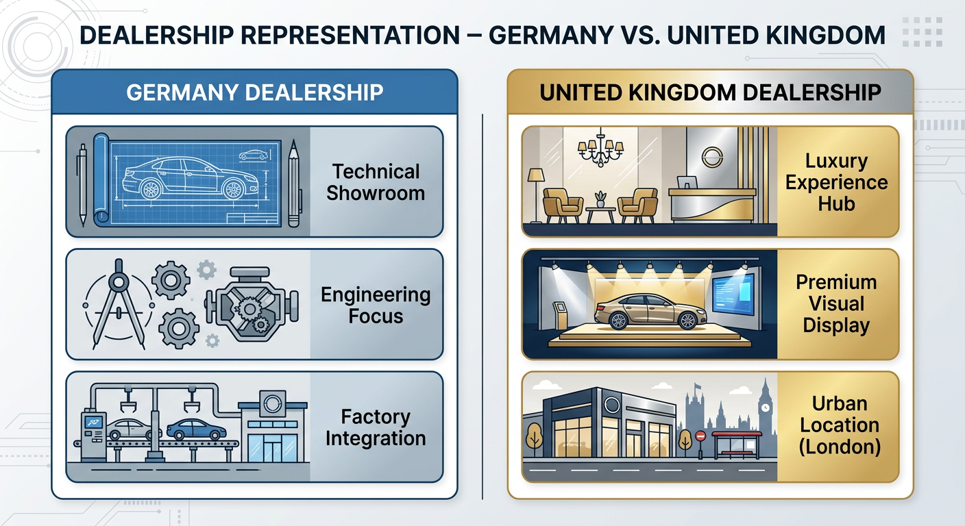
Source: Created by author
German dealerships pay much attention to technical accuracy and efficiency and have the legacy of engineering. On the contrary, UK dealerships are structured as experience centres, where the customer experience, atmosphere and brand image are the main subjects (Kotler et al., 2016).

6.4 Promotion Strategy
Integrated Marketing Communication (IMC) is the integration of all communication tools and channels that uniquely convey a consistent and coherent brand message to different markets (Fill et al., 2019).
Promotional strategies are adapted to the culture and psychology of consumers:
- Germany: Rational, performance-based advertising based on technical innovation, safety and reliability. Channels include publications in the industry, technical expo and digital campaigns that focus on specification.
- United Kingdom: Emotion-based marketing that focuses on luxury, prestige and lifestyle. Channels include lifestyle magazines, celebrity endorsements, experiential marketing, and digital marketing such as highlighting social status.

6.5 People
- Germany: Mercedes-Benz has around 170,000+ employees distributed around the world, with a substantial number of them located in Germany, as the headquarters and center of production. The employees are extremely competent, with engineering excellence and technical expertise as their priorities (Mercedes-Benz Group, 2024).
- United Kingdom: The UK employees comprise of almost 10,000+ employees with specialisation in sales, marketing and customer relationship management. Employees are developed to provide relationship based personalised service in line with luxury branding (Mercedes-Benz Group, 2024).

6.6 Process (Customer Complaint Handling)
The process of how customer complaints are handled is an important economic factor, it plays a significant role in preserving brand reputation and ensuring that the quality of service delivered to customers meets their expectations which is vital for Mercedes-Benz, as the company aims to deliver premium service experience (Hollensen, 2020).
- Germany: The complaint process is so structured, formalised and geared towards efficiency. Complaints can be lodged via authorised dealerships, customer service centres or digital platforms. Given Germany's working style which is highly methodical and process-oriented, the entire process focuses on technical accuracy, quick resolution as well as documentation.
- United Kingdom: The complaint handling process is now more customer-centric and relationship-driven, with tailored responses and dynamic resolution strategies. They use several channels like online portals, Call centres and social media. UK consumers expected a high level of service, and more emphasis was put on customer experience, empathy and service recovery.

6.7 Physical Evidence
Physical Evidence in International Marketing not only includes the physical spaces it needs to be digital presence as well and especially its official website as touch points for customers (Kotler et al., 2016).
Figure 4: Website Representation Germany vs United Kingdom
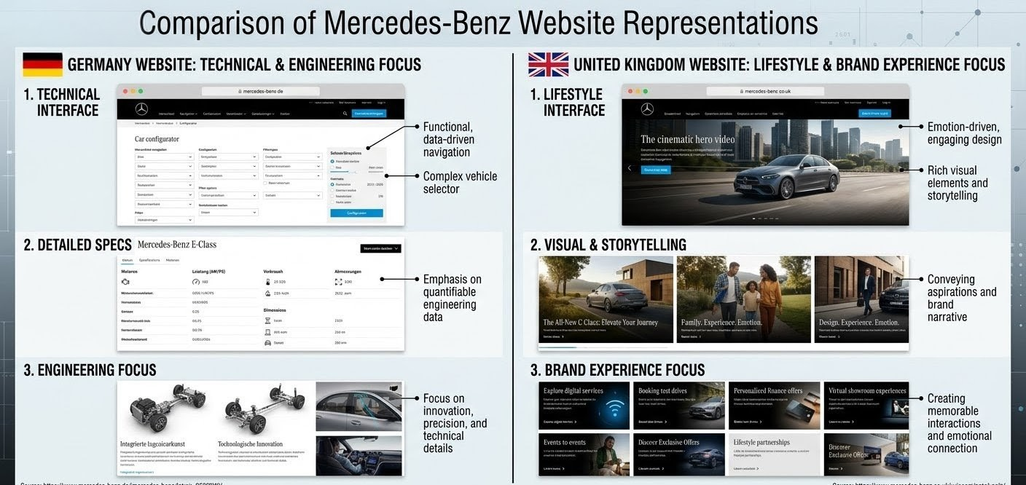
Source: Mercedes-Benz official websites – United Kingdom: [https://www.mercedes-benz.co.uk/] (https://www.mercedes-benz.co.uk/); Germany: [https://www.mercedes-benz.de/] (https://www.mercedes-benz.de/) (Accessed: 20 April 2026).
Typically, the German website is based on technical specifications, product details and engineering performance that supports rational decisions. The UK, on the other hand, has a far greater emphasis on visual appeal, narrative and lifestyle imagery which helps to enhance emotional appeal and reinforce its luxury positioning. While both remain consistent with their brands, they learn how to present differently that suits local consumers.

6.8 Similarities and differences of 7Ps between these two services.
Both countries (Germany and the United Kingdom) portray strong focus on quality of high-end products and constant innovation, which is indicative of the premium positioning of Mercedes-Benz in both countries. Brand identity is also very uniform, as luxury positioning is being sustained all over the world. Also, both markets are using integrated marketing communication (IMC) in digital and physical touchpoints, and brand message is coherent and cohesive. They also feature high rate of investment in the customer experience and quality of services, which increases customer satisfaction and long-term loyalty to the brands (Kotler et al., 2016), 2016; Fill et al., 2019).
Nevertheless, there are a number of key differences between the two markets concerning the 7Ps. In terms of its product, Germany pays so much attention to the performances and engineering excellence, and the United Kingdom is more concerned with luxury features and its lifestyle-oriented attributes. Dynamically, the German market is better off with the greater predictability and stability of the pricing structure whereas UK is highly prone to changes, owing to the currency exchange rates, taxation and inflation. In terms of place, Germany has a definite edge with the domestic production and strong-coordinated networks of distribution, where the UK uses much more imports and urban dealership systems. The way of promotion also varies greatly: Germany is more rational and technical in terms of its communication style, whereas the UK focuses on emotional and inspirational approach. Compared to the UK, Germany values technical expertise and engineering prowess more, as opposed to the UK, which emphasises more on the provision of services through relationships. The Germany dimension process is very well-organized and efficiency-focused as compared to the flexibility and customer-oriented dimension in the UK. Lastly, physical evidence varies according to its presentation style, where Germany favors functional and technical versus the UK that prefers experiential and more engaging in the presentation in line with a lifestyle branding approach (Hollensen, 2020).

7. Directional Development Strategy
The forward-looking goal of directional development of Mercedes-Benz in the United Kingdom is an adaptation to structural changes in the automotive market (especially to the electrification and digitalisation), as well as to changing consumer demands. To critically make out this strategy, it will be beneficial to combine Porters Generic strategies that explain the way companies gain an edge by cost leadership, differentiation, or focus strategies (Porter, 2008; Johnson et al., 2020).
Application of Porter’s Generic Strategy
In UK market, Mercedes-Benz majorly uses a differentiation approach. The brand does not focus on the price but focuses on higher quality, technological level, high luxury design, and brand prestige. This competitive positioning allows the company to sell on a premium price with a different identity under a highly competitive automotive industry (Porter, 2008).
Figure 5: Porter’s Generic Strategies Framework
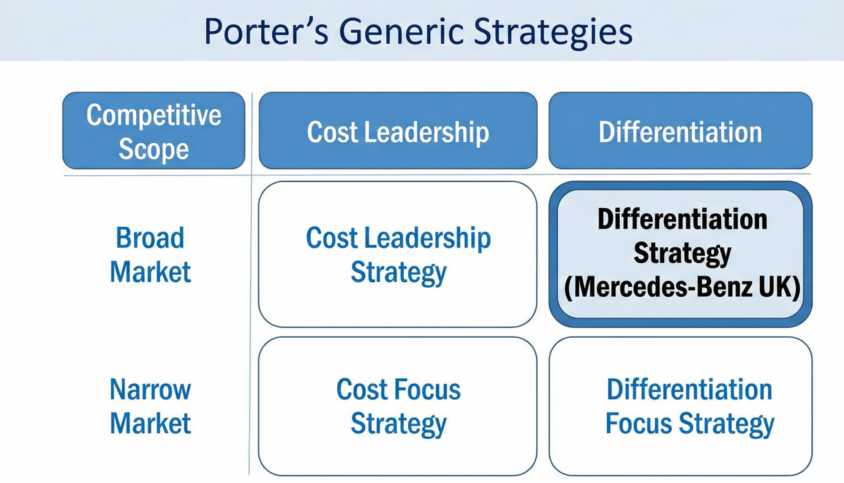

Source: Adapted from Porter (2008)

UK Market Strategic Directions.
One of the most important aspects of the differentiation strategy that Mercedes-Benz implements in the UK is its rapid switch to the electric mobility. The company has endured with its EQ sub brand, that manufactures high quality electric cars like the EQS and EQE and sells them with a mix of sustainability and luxury. This goes hand in hand with government policies in the United Kingdom encouraging zero-emission vehicles and is a reaction to the growing consumer environmental awareness. The incorporation of the sustainability and sustainability into the value proposition not only provides the company with better ethical positioning but also competitive differentiation as well (European Automobile Manufacturers’ Association, 2024).
Simultaneously, digital transformation is important in intensifying market presence. The digital penetration levels in UK consumers are high, and this aspect is encouraging that forced Mercedes-Benz to increase its online sales tools, virtual showrooms, and personalised digital services. The innovations make the customer journey more efficient and add to the image of the high-end brand by making the brand experience more convenient and technologically sophisticated (Chaffey and Ellis-Chadwick, 2019).
Moreover, the company is orienting on the premium experience differentiation. In UK, where consumer behaviour relies so much on the lifestyle and social status of the people, Mercedes-Benz invests on experiential marketing, luxury showrooms, and custom-made customer services. This strategy increases the emotional bond with the consumers and the brand loyalty.
Analysis
A differentiation strategy adopted will help Mercedes-Benz to remain high in terms of competition within the UK luxury automobile market. Nevertheless, such a method also has its difficulties. High pricing can reduce access especially in the time of economic insecurity and inflation. Also, due to the growing competition of the conventional competitors as well as new electric cars, the necessity of constant innovation is growing.
However, the company has developed a consistent and future focused development path due to the strategic orientation of luxury, sustainability, and digital innovation. Mercedes-Benz can maintain its competitive edge in the United Kingdom by concentrating its differentiation strategy with the developing market trends.

SECTION 02

1. Ethical Marketing Analysis (Based on 7Ps)
Ethical considerations are becoming an increasingly important factor in international marketing, especially for global brands operating in different regulatory and cultural contexts. For Mercedes-Benz, it is crucial that we maintain our ethical consistency throughout the country in both Germany and the United Kingdom, as this is essential to ensure long-term trust and reputation of the brand. This section is a critical evaluation of the ethical and unethical practices in the context of the marketing mix (7Ps).

1.1 Examples of Ethical Marketing Practices
- Sustainability and Environmental Responsibility (Products & Processes)
Mercedes-Benz has shown a fierce commitment to sustainability with the development of its EQ electric vehicle range as well as its investment in carbon neutral production processes. These initiatives demonstrate a sense of ethical responsibility as they address concern over climate change and are consistent with global environmental standards. In both Germany and the UK, the promotion of electric mobility is contributing towards carbon emissions-reduction, and helps achieve wider societal goals.
- Transparency in Safety and quality standards (Product & Promotion)
The company has high standards of safety and quality which they always communicate in their marketing. By giving accurate information about the performance of the vehicle, safety features and the technological capabilities of the car, Mercedes-Benz upholds principles of transparency and consumer protection. This can be found especially important in the German market (where consumers are especially discerning about value in reliability) and in the UK, where brand trust is an important factor in purchasing decisions.

1.2 Types of Unethical Marketing Practices
- Emissions Controversies (Product & Promotion)
One of the most notable ethical issues related to the automobile industry involving Mercedes-Benz is emissions reporting and diesels. There have been allegations of misleading emission data, and these have raised worries of lack of transparency and environmental responsibility. Such practices do not help build trust with consumers, and make a mockery of the sustainability claims, especially as markets are increasing in environmental conscious as in the UK.
- Price Discrimination and Market Inequality (Price)
Differences between the prices in Germany and the UK for some goods, caused by taxes and import duty as well as strategic pricing, could lead to a perception of unfairness in the eyes of consumers. While some disparities in price are absolutely structurally justified, large price differences with little or no justifiable value can bring up questions about ethics of fairness and accessibility.

2. Focused Marketing Mix Evaluation-STP
The combination of STP and marketing mix, this means that marketing strategies must be effective and ethical. Mercedes-Benz markets its products, prices, and promotion strategies with well-defined target segments for markets in both the domestic and international markets.
In Germany, the orientation is reflected in the focus on engineering quality and reliability, which is a direct reflection of the expectations of rational and performance-oriented consumers. The marketing mix supports this positioning by technical oriented promotion and product design.
In the UK as the marketing mix is more closely associated with aspiration and lifestyle orientated. Product features, pricing tactics and promotional campaigns are used to increase perceived prestige and social status. While this alignment is great when it comes to attracting their target consumers, it also raises ethical considerations about the perpetuation of materialistic values and the unequal nature of this type of tectonic scheme.

Recommendations

Recommendations for Germany
- Accelerate Electric Vehicle (EV) Leadership
Although Germany is a pioneer in automotive engineering, competition is still high for the move to electrification. Mercedes-Benz needs to continue to invest in its EQ product line and work on enhancing its battery efficiency, driving range, and charging infrastructure partners.
- Improve the Digital Customer Experience
German consumers, although traditionally rational people, are increasingly buying from digital platforms. The company should work on its digital ecosystem, which comprises online configurators, virtual showrooms, and AI-powered customer support systems.
- Broaden Target Segments
Mercedes-Benz's very strong links to engineering excellence may draw extensive criticism from younger consumers.
- Improve the Communication of Sustainability
While the company is doing much to invest in sustainable technologies, their communication to Germany will still be mostly technical.

Recommendations for the United Kingdom
- Refine Pricing Strategy to Cost Sensitivity
Due to import duties, taxation and fluctuation in currency prices is relatively high in UK for vehicles. Mercedes-Benz needs to adopt more flexible pricing strategies, such as offering leasing, subscription and promotional financing, to ensure accessibility while protecting its premium positioning.
- Expand the Market Penetration of Electric Vehicles
Given the UK's strong policy support for the adoption of EVs, the expansion of the company's electric vehicle portfolio should be a priority for the company.
- Enhance Lifestyle-Oriented Branding
UK consumers encourage and are very influenced by brand image and social status. It is suggested that Mercedes-Benz should further invest in emotionally-driven marketing campaigns and use digital media, influencers, and experiential marketing to strengthen its aspirational appeal.
- Improve Urban Distribution & Customer Experience
With a demand concentrated in metropolitan area, the company should increase its presence in major cities through Flagship showrooms and experience centres.

3. Gibbs Reflective Cycle
The process of Research and preparation of this report can be judged critically using Gibbs Reflective Cycle which is a structured way of reflective learning (Gibbs, 1988).
Figure 6: 6 Steps of Gibbs Reflective Cycle
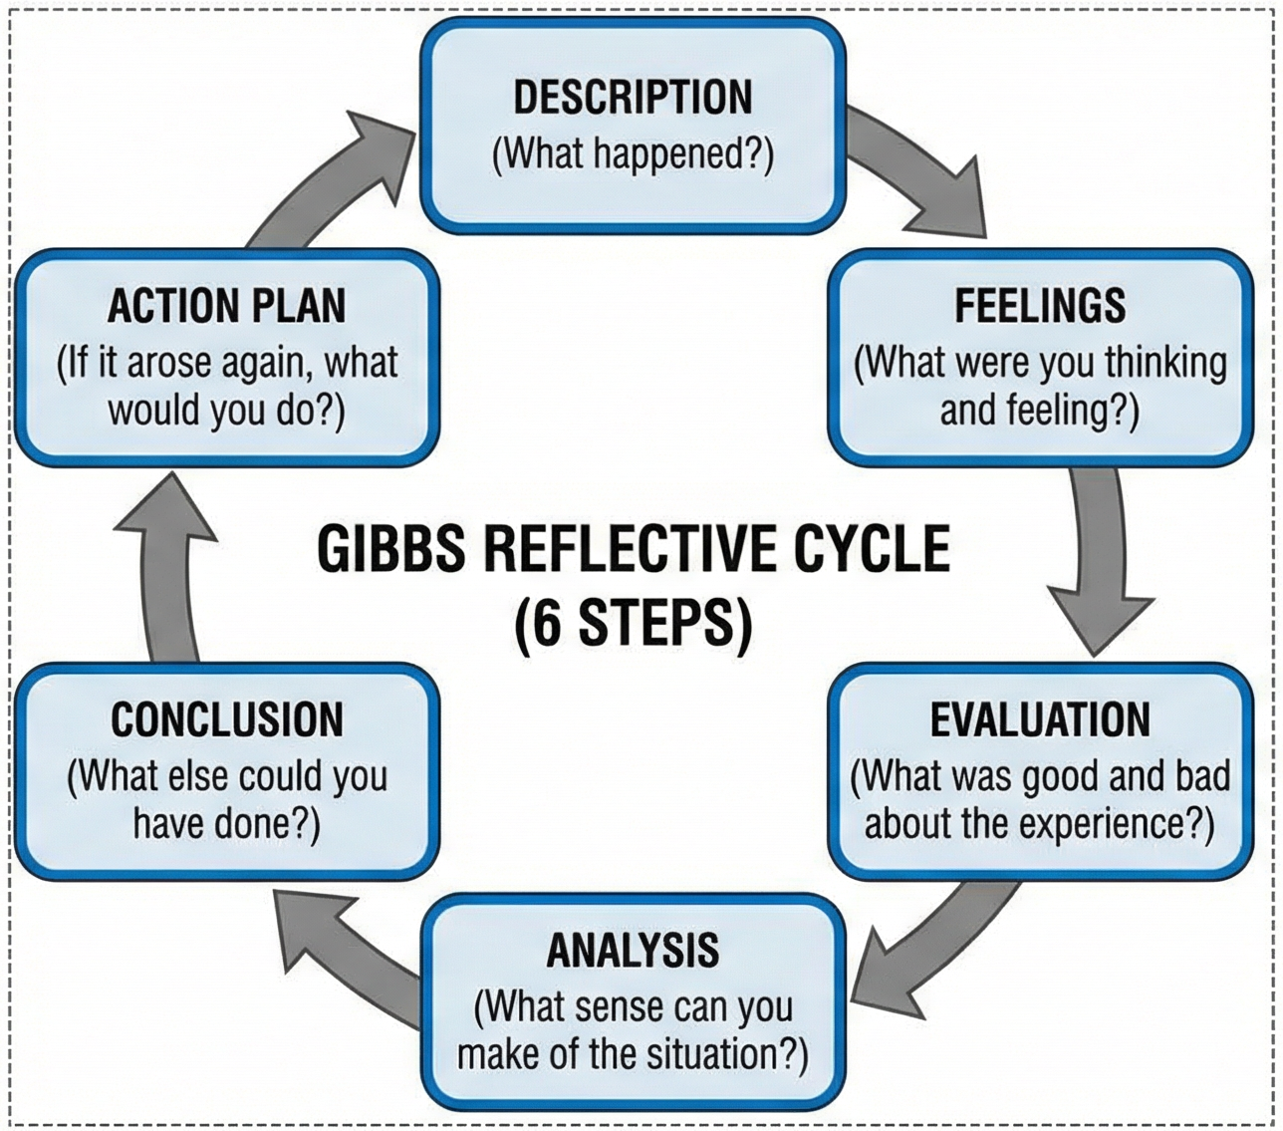
Source: Created by author

3.1 Description
The goal setting was the comparative analysis of the international marketing strategies of Mercedes-Benz in Germany and the United Kingdom. The process involved a substantial amount of secondary research, application of theoretical frameworks such as PESTEL, STP and the 7 Ps, and critical appraisal of market-specific strategies.

3.2 Feelings
At first the scope of the assignment seemed to be complex as there will be integration of multiple frameworks and analysis of two different markets. However, as the research progressed, a better understanding of the phenomena of international marketing was established, and therefore the readiness to apply the theoretical ideas increased.

3.3 Evaluation
A main advantage of the process was the inclusion of diverse and credible sources including academic literature and industry reports that contributed towards the depth of analysis. However, limitations were encountered in accessing up to date proprietary company data, which required the reliance on secondary interpretations.

3.4 Analysis
The findings of this analysis showed that international marketing is highly contextual and requires a balance to be achieved between global standardisation and local adaptation. The use of theoretical frameworks allowed for a systematic understanding of complex market dynamics and importance of culture and economy on marketing strategies.

3.5 Conclusion
The reflective process illustrated the importance of critical thinking, structured analysis and evidence-based reasoning in a postgraduate degree level research. It was also emphasised the need for adaption while working with incomplete and evolving data.

3.6 Action Plan
For future studies, the following are recommended:
- As much as possible, engage more deeply with secondary data
- Expand the range of academic sources to include some more recent studies
- Developing a better critical evaluating skills by comparing different theoretical perspectives

Conclusion
This report has brought out a holistic analysis of the international marketing strategy of Mercedes-Benz in Germany and the United Kingdom. Through the application of PESTEL, cultural analysis, STP and 7Ps framework, it is clear that although this brand has a strong global identity, its success relies on its adaptability to the local market conditions.
Germany has a stable and technical oriented market where the engineering excellence of the brand corresponds well with the expectations of the consumer. In contrast, the United Kingdom is a more dynamic environment with an aspirational consumption and changing regulatory environment, especially with regards to sustainability and electric mobility.
The analysis shows that there is a fine line of effective international marketing, between standardisation and localisation. Ethical aspects of marketing especially in terms of sustainability and pricing adds to the crucial importance of ethical marketing practices in building longevity of the trust factor for the brands.
Overall, the findings indicate that Mercedes-Benz is in a good position to maintain its global leadership as long as it keeps innovating and adapting its strategies to the evolving nature of the market.

References
Hunt, J. (2023) Essentials of global marketing: Strategies for a connected world, Uos. Available at: https://www.centuryinteractive.com/what-are-the-key-elements-of-global-marketing/ (Accessed: 15 April 2026).
Cioca, L.-I. et al. (2019) Sustainable development model for the automotive industry, MDPI. Available at: https://www.mdpi.com/2071-1050/11/22/6447 (Accessed: 15 April 2026).
Ani, H. et al. (2025) Mercedes-Benz Marketing Strategies: A comprehensive 2025 analysis: Brand vision, Brand Vision Insights. Available at: https://www.brandvm.com/post/mercedes-benzs-marketing-strategies (Accessed: 15 April 2026).
Mercedes-Benz Group, M.-B. Benz Patent Motor Car: The first automobile (1885–1886): Mercedes-Benz Group, Mercedes. Available at: https://group.mercedes-benz.com/company/tradition/company-history/1885-1886.html (Accessed: 15 April 2026).
PESTEL Analysis, P. (2025) What are Mission Vision & Core Values of Daimler Company?, PESTEL ANALYSIS. Available at: https://pestel-analysis.com/blogs/mission/mercedes-benz (Accessed: 15 April 2026).
Mattina, R. (2025) Company core values: 25 inspiring examples, Achievers. Available at: https://www.achievers.com/blog/company-core-value-examples/ (Accessed: 15 April 2026).
Tilly, R. (2017) ‘Cyclical trends and the market response: Long swings in urban development in Germany, 1850–1914’, German Industry and German Industrialisation, pp. 148–184. doi:10.4324/9781315223261-5.
Market Research Future, https://www. marketresearchfuture. com/ (2026) UK automotive industry market size, growth, trends, report 2035, Market Size, Growth, Trends, Report 2035. Available at: https://www.marketresearchfuture.com/reports/uk-automotive-industry-47036 (Accessed: 15 April 2026).
Makos, J. (2024) Pestel framework: The 6 factors of Pestel analysis, PESTLE Analysis. Available at: https://pestleanalysis.com/pestel-framework/ (Accessed: 16 April 2026).
European Automobile Manufacturers’ Association (ACEA) (2024) Automobile Industry Pocket Guide. Brussels: ACEA. Available at: https://www.acea.auto/publication/automobile-industry-pocket-guide/ (Accessed: 16 April 2026).
The Culture Factor (2024) Country comparison tool: Germany vs United Kingdom. Available at: https://www.theculturefactor.com/country-comparison-tool?countries=germany%2Cunited+kingdom (Accessed: 16 April 2026).
Geert Hofstede (2001) Culture’s Consequences: Comparing Values, Behaviors, Institutions and Organizations Across Nations. 2nd edn. Thousand Oaks, CA: Sage Publications.
Michael Minkov (2010) Cultural Differences in a Globalizing World. Bingley: Emerald Group Publishing.
Philip Kotler and Kevin Lane Keller (2016) Marketing Management. 15th edn. Harlow: Pearson Education.
OECD (2023) Regional Economic Outlook: Europe. Paris: OECD Publishing.
Al Ries and Jack Trout (2001) Positioning: The Battle for Your Mind. New York: McGraw-Hill.
Hollensen, S. (2020) Global Marketing. 8th edn. Harlow: Pearson Education.
Aaker, D.A. (1996) Building Strong Brands. New York: Free Press.
Bank of England (2024) Inflation Report 2024. London: Bank of England. Available at: https://www.bankofengland.co.uk (Accessed: 17 April 2026).
European Central Bank (2024) Annual Economic Report 2024. Frankfurt: ECB. Available at: https://www.ecb.europa.eu (Accessed: 17 April 2026).
Fill, C. and Turnbull, S. (2019) Marketing Communications: Discovery, Creation and Conversations. 8th edn. Harlow: Pearson.
Porter, M.E. (2008) Competitive Advantage: Creating and Sustaining Superior Performance. New York: Free Press.
Johnson, G., Scholes, K. and Whittington, R. (2020) Exploring Strategy. 12th edn. Harlow: Pearson Education.
Chaffey, D. and Ellis-Chadwick, F. (2019) Digital Marketing. 7th edn. Harlow: Pearson Education.
Gibbs, G. (1988) Learning by Doing: A Guide to Teaching and Learning Methods. Oxford: Oxford Polytechnic.
Amnesty International (2022) Powering change: Principles for businesses on human rights in electric vehicle battery supply chains. London: Amnesty International.
Armstrong, G., Kotler, P., Harker, M. and Brennan, R. (2020) Marketing: An introduction. 5th European edn. Harlow: Pearson.
Baines, P., Fill, C. and Rosengren, S. (2022) Marketing. 6th edn. Oxford: Oxford University Press.
BBC News (2024) UK car sales rise with surge in electric vehicle demand. Available at: https://www.bbc.com (Accessed: 17 April 2026).
Belz, F.-M. and Peattie, K. (2021) Sustainability marketing: A global perspective. 3rd edn. Chichester: Wiley.
Brassington, F. and Pettitt, S. (2019) Principles of marketing. 8th edn. Harlow: Pearson.
Hofstede, Geert. 1984, Culture`s Consequences, Sage Publications.
Mercedes-Benz Group AG (2023) Annual report 2023. Stuttgart: Mercedes-Benz Group AG.
Mercedes-Benz Group AG (2024) Sustainability report. Stuttgart: Mercedes-Benz Group AG.
United Nations Environment Programme (2023) Sustainable mobility and climate change. Nairobi: UNEP.
World Bank (2024) World development indicators: Germany and United Kingdom. Washington, DC: World Bank.

