

Word count: 2700
Module name
Title and number: Entrepreneurship BMIH5001
Tutor name: Neil Dyer
Contents
Introduction 3
Main Body 4
Business Concept Proposal and Justification 4
Competitive Analysis and Justification 9
Reflective Essay: Insights into Entrepreneurial and Managerial Potential 10
Action Plan 12
Conclusion 12
References 14
Appendix 16

Introduction
The hospitality industry is one of the most critical sectors of the world economy, offering a wide range of services such as lodging, food, and beverages, entertainment opportunities, events, travel and tourism, and other spheres (Morrison 2022). A participant in this broad and dynamic sector must be able to shape public industry trends, customer satisfaction, and management practices. This article aims to unveil a fresh and unique business concept for the hospitality industry: The concept will be the launch and promotion of a new brand called 'EcoLux Retreats.' Especially so given that there is increasing focus on both innovation and sustainability as value propositions, as noted by customers and the government. According to the idea proposed, a new series of hotels is to be designed and built for the organization and functioning of a concept of ‘Green luxury’, which means sustainable luxury and hospitality, the last word in contemporary concepts of green luxury hotel operation and guest satisfaction (Prakash et al., 2023). This is not just an expansion strategy but a kind of revolution focused on ensuring that the real needs of new and upcoming travelers are met as well as addressing the needs that are deemed most urgent in the market.
Innovation and sustainability have emerged as core competencies, not as additions, but as core aspects of the hospitality industry's strategic vision and delivery. The pursuits of these imperatives mean that for EcoLux Retreats, they do not just seek to go past the perceived concept of luxury and therefore have to offer experiences that are not only luxurious as well as unique but also sustainable in their ecological context as well as beneficial to society at large (Low, 2012). It also fits into the general trend regarding a growing demand by consumers for travel products that are more sustainable and searchable, meaning that consumers are increasingly willing to pay higher prices to purchase products that are produced more sustainably and can be searched online. The purpose of the business concept of the proposed business is to determine how EcoLux Retreats can build out sustainability themes into its operations, including construction or energy, reducing waste, sourcing local, and sustainable food, among other elements (Bharwani & Mathews, 2023). To this extent, EcoLux Retreats reaffirms not only its own emergency at the operational level but also the possibility of offering a new sustainable and luxury model for the sector. This approach sets a goal of making it possible for EcoLux Retreats to be not only a superior hotel standard but also a model of environmentally friendly business that has a vision for the future that other establishments are yet to emulate for the future of travel and hospitality.

Main Body

Business Concept Proposal and Justification

Value Propositions
EcoLux Retreats offers an unparalleled hospitality experience by seamlessly integrating luxury with sustainability, appealing to environmentally conscious travelers (Morrison, 2022). Our properties utilize advanced green technologies, including solar panels and geothermal heating, to minimize carbon footprints (Chan et al, 2016). The company’s target is to emphasize locally-sourced, organic cuisine to support local agriculture and reduce emissions (Kotler et al., 2017). Comprehensive waste management and water conservation systems, such as recycling programs and rainwater harvesting, are implemented to achieve zero waste (Enz, 2010). Partnerships with renewable energy providers and local environmental organizations enhance our sustainability credentials (Brotherton, 2008). Guests enjoy elegantly designed rooms, personalized services, and wellness programs, ensuring a luxurious yet eco-friendly stay (Walker, 2017). EcoLux Retreats sets new standards for luxury hospitality, meeting modern travelers' needs while contributing positively to environmental conservation (Pizam, 2010).

Customer Segments:
EcoLux Retreats targets tourists who are earth-conscious and insist on luxury travel while also being indifferent to the environmental effects of their destinations (Dolnicar & Grün, 2009). This segment consists of well-to-do persons, couples, and families who consider the aspect of preserving the environment in their travel decisions. We also serve corporations that are in search of green meeting locations for business conferences, team building, and events (Bohdanowicz, Zientara, & Novotna, 2011). Cavendish-Kane and Mcgraw (2007) argue that hotel guests not only expect quality services, but also strive for an exceptional experience and contribute to environmental conservation (Han, Hsu, & Sheu, 2010). By providing opportunities for health improvements, local food consumption, and participation in rural activities, we address the clients that are ready to invest money in a high-quality and eco-friendly vacation (Chen & Tung, 2014). EcoLux Retreats caters to the growing market in sustainable travel, and the company ranks among the cutting-edge eco-luxury players (Gössling, Hall, & Weaver, 2009).
Channels:
EcoLux Retreats utilizes a multi-channel approach to reach and engage our target audience. Our primary channels include our website and mobile app, offering seamless booking experiences, virtual tours, and personalized services (Buhalis & Law, 2008). This choice ensures direct engagement with customers, allowing for better control over the user experience and customer data (Kotler, Bowen, & Makens, 2014). Social media platforms are leveraged to build brand awareness, share sustainable travel content, and engage with environmentally conscious travelers (Hays, Page, & Buhalis, 2013). Partnering with online travel agencies (OTAs) like Booking.com and Expedia expands our reach, attracting a broader audience. Additionally, collaborations with eco-friendly influencers and travel bloggers help to enhance our brand’s credibility and visibility (Xiang & Gretzel, 2010). Participation in travel and hospitality industry events and conferences also boosts our industry presence and networking opportunities. This comprehensive approach ensures we effectively reach and engage our diverse customer segments.
Customer Relationships:
EcoLux Retreats focuses on building strong, personalized relationships with our guests to foster loyalty and enhance customer satisfaction. Personalized service is a cornerstone of our approach, utilizing data analytics to tailor experiences to individual preferences, ensuring each stay is unique and memorable (McIlroy & Barnett, 2000). This decision is driven by the growing expectation for customized experiences in the luxury market (Pine & Gilmore, 1999). Our loyalty program rewards repeat guests with exclusive benefits and offers, encouraging long-term relationships (Lemon & Verhoef, 2016).
Additionally, proactive engagement through social media and direct communication channels allows us to maintain a continuous dialogue with our customers, addressing feedback promptly and effectively (Hudson & Thal, 2013). We chose these strategies over more traditional, less interactive methods because they align with the preferences of our environmentally conscious target market, who value transparency and engagement with brands that reflect their values (Bhattacharya & Sen, 2003).
Revenue Streams:
EcoLux Retreats generates revenue through a diversified portfolio, designed to ensure stability and growth. Our primary revenue stream is premium room bookings, leveraging our unique eco-luxury positioning to attract high-paying guests (Chen & Peng, 2012). This choice reflects the willingness of our target market to pay more for sustainable, high-quality experiences (Dolnicar & Leisch, 2008).
Additional revenue is generated through on-site dining services, emphasizing farm-to-table cuisine that appeals to health-conscious and environmentally aware customers. We also offer wellness programs, including spa treatments, yoga classes, and eco-tours, which not only enhance guest experience but also add significant revenue (Heo, 2016).
Event hosting services, targeting corporate retreats, weddings, and special events, provide a substantial revenue stream, leveraging our unique settings and sustainability credentials (Getz, 2008). This diversification minimizes risk by spreading income sources across multiple streams rather than relying solely on room bookings, ensuring resilience against market fluctuations (Enz, 2010). This strategy is chosen over a single-focus approach to capitalize on varied market demands and ensure long-term financial sustainability.

Key Resources:
The cornerstone resources of EcoLux Retreats are its sustainable properties, a highly trained and dedicated staff, and advanced eco-friendly technologies. Our properties are strategically located in pristine natural settings, chosen to offer unique and immersive experiences that align with our eco-luxury value proposition (Buckley, 2010). These locations are critical as they provide the backdrop for the natural, serene environments our guests seek.
Our staff is meticulously trained not only in providing exceptional customer service but also in sustainable hospitality practices (Bohdanowicz, Zientara, & Novotna, 2011). This dual focus ensures that every interaction supports our commitment to sustainability while delivering a high level of service. The decision to invest in staff training stems from the understanding that well-informed employees are pivotal in executing our sustainable practices and enhancing guest satisfaction.
Advanced technology is another key resource, leveraged to minimize the environmental impact of our operations (Gössling, Hall, & Weaver, 2009). This includes energy management systems, water conservation technologies, and digital solutions that reduce waste, such as digital room keys. These technologies not only improve operational efficiency but also align with our sustainability goals. The choice to prioritize eco-friendly technology reflects the growing consumer demand for environmentally responsible travel options (Chen & Peng, 2012).
Key Activities:
The different processes in performing the key activities of EcoLux Retreats include focusing closely in managing properties, marketing, and guests, as well as efficiently delivering first-rate environmentally-friendly solutions. Some of our operations aim at ensuring optimal energy efficiency of the buildings, and the continual improvement of environmental management in tasks as diverse as wastage avoidance and water optimization (Buhalis & Law, 2008). Such actions are crucial for the delivery of the defined eco-luxury value proposition and for creating organic operational efficiency.
Marketing strategies reflect the focus on sustainability and eco-luxury, with the interest in environmentally-minded customers addressed via such elements as the brand’s pages in social networks, cooperation with influencers, and participation in events promoting sustainable tourism (Hays, Page, & Buhalis, 2013). The reason I have considered these particular marketing strategies is as follows: By adopting a competitive and effective market niche, it will be possible to differentiate ourselves in a crowded marketplace and attract the desired target audience.
From serving our guests, this is the core competency of our company or organization since it is the key operations we handle. This involves special focus to individual needs and wishes, overall health of the consumers that directly or indirectly relate to the tour, and the conduct of the tours that are inclined towards the aspects of sustainability (Heo, 2016). Another decision for-focused strategy is the provision of the excellent quality of the personalized services, which guarantees that individuals, whom are invited to become the guests, will receive the exceptional experiences; they will use the services again and recommend them to others enthusiastically.
EcoLux Retreats does this by integrating our strategic resources and processes with our sustainability and luxury values, thus providing an experience that exceeds the expectations of travelers today and defining new benchmarks in sustainable travel tomorrow.
Key Partnerships:
EcoLux Retreats is at the forefront of forging alliances that facilitate goals and objectives like increased sustainability and guest satisfaction. Stakeholders include local government and other related bodies as a way of checking sustainability regulations and obtaining legal permits (Bohdanowicz & Zientara, 2008). This decision, therefore, stems from the need to employ strategies that will enable us to gain genuine proof of the environmentally friendly services, products, and facilities that we offer to environmentally conscious travelers.
Partnerships with environmentally conscious suppliers aid in the development and acquisition of sustainable construction products, equipment, furniture, and services by managing a green supply chain (Legrand et al., 2012).We directly source our food products from local farmers, enabling our dining services to offer locally sourced organic food products. This decision not only meets the needs of the local economy but also aligns with the current trend of offering seasonal food options, a trend that consumers have widely embraced from farm to table (Browning et al., 2014).
The adoption of appropriate technology relationships and working with companies that focus on efficient energy use enable us to apply modern sustainable measures (Gössling et al., 2009). These collaborations are necessary so as to sustain the company’s operational functionality and address environmental concerns. Through such tie-ups, not only EcoLux Retreats underlines its commitment to sustainability, but the guest experience also gets the benefit of a more sustainable option.

Cost Structure
EcoLux Retreats' cost structure includes both fixed and variable costs. Fixed costs involve initial investments in land acquisition, sustainable construction, and green technologies (Buckley, 2010). These are chosen to align with our commitment to sustainability and long-term operational efficiency. Variable costs include staffing, utilities, and maintenance. Investments in energy-efficient systems and local sourcing reduce long-term variable costs by lowering utility expenses and transportation costs (Gössling et al., 2009). The decision to prioritize sustainability in our cost structure reflects the growing demand for eco-friendly travel and aims to ensure both environmental and financial sustainability.

Competitive Analysis and Justification
Force | Description | Justification
Threat of New Entrants | High initial investment in sustainable infrastructure and technology acts as a significant barrier. | Substantial capital, specialized knowledge, and strong supplier relationships deter new entrants, ensuring EcoLux Retreats maintains a competitive advantage in the eco-luxury market (Grant, 2016).
Bargaining Power of Suppliers | Specialized eco-friendly suppliers provide sustainable materials and local food. | Long-term contracts and partnerships with multiple suppliers mitigate the risk of supplier power, ensuring consistency and alignment with our sustainability goals (Porter, 2008).
Bargaining Power of Customers | Customers have high expectations in the luxury segment, increasing their bargaining power. | The unique combination of luxury and sustainability reduces price sensitivity, fostering strong customer loyalty and brand differentiation (Enz, 2010).
Threat of Substitutes | Traditional luxury hotels and other eco-friendly accommodations are potential substitutes. | Combining luxury and sustainability, EcoLux Retreats offers a unique value proposition appealing to eco-conscious travelers, mitigating the threat of substitutes (Dolnicar & Grün, 2009).
Industry Rivalry | The eco-luxury hospitality market is competitive, with established brands and new entrants. | Strategic focus on sustainability, continuous innovation, and strong marketing efforts provide a competitive edge, maintaining a distinctive market position (Kotler, Bowen, & Makens, 2014).

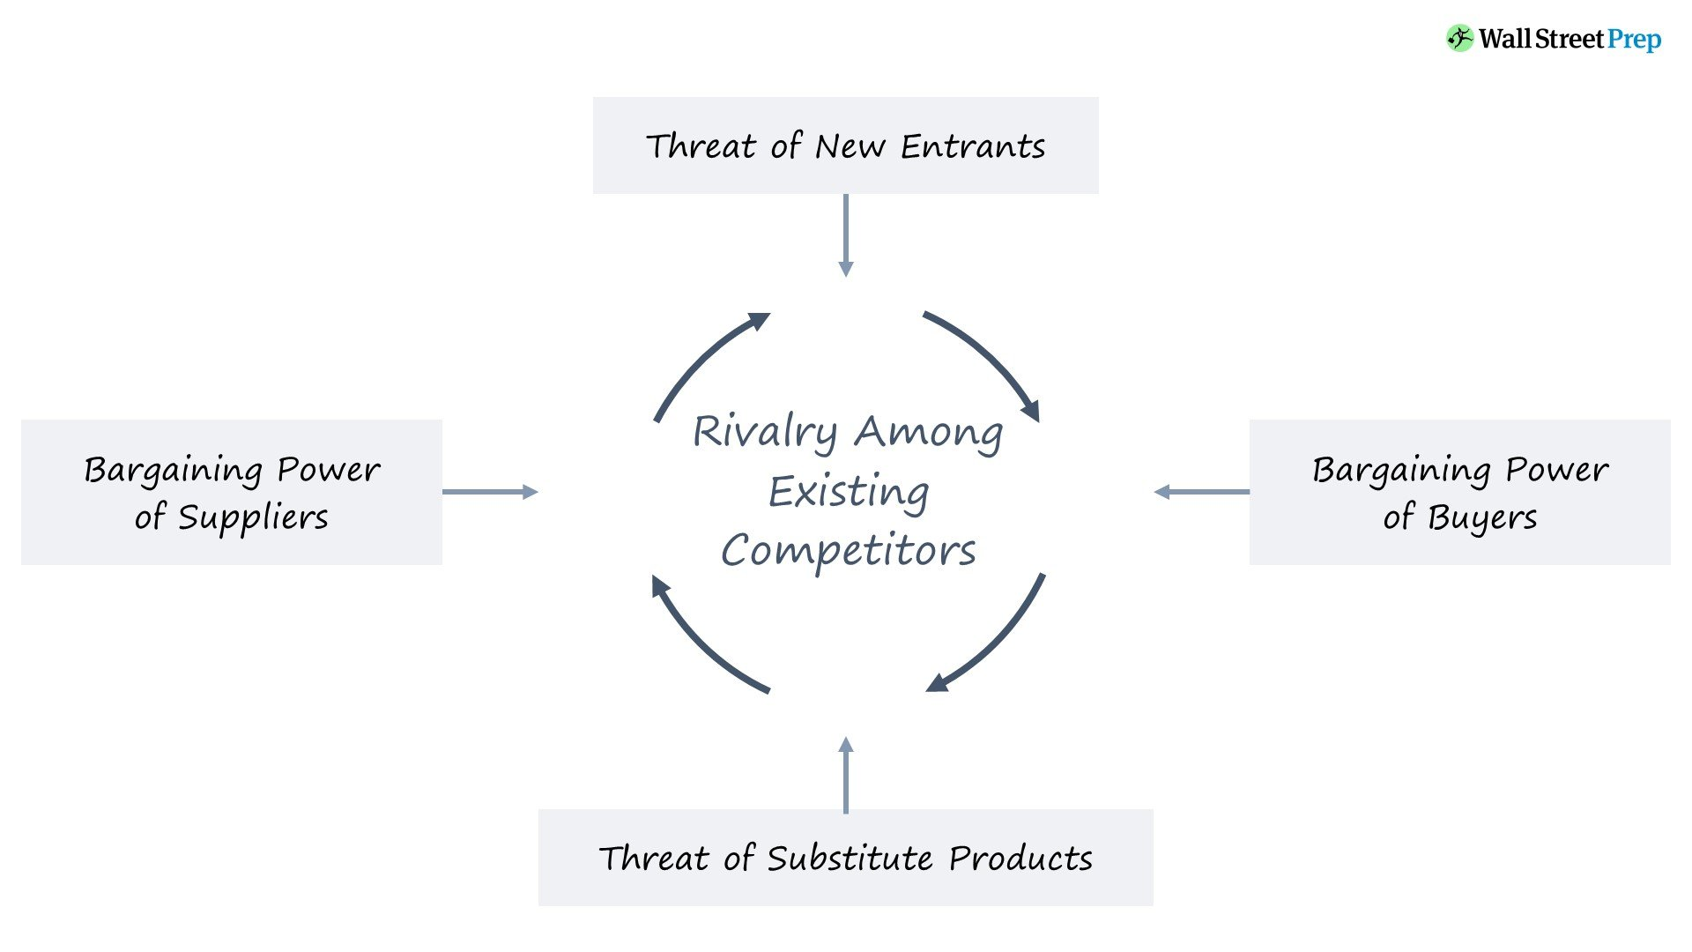
“<Porter's Five Forces model > (Source: wallstreetprep.com,2023)”
Reflective Essay: Insights into Entrepreneurial and Managerial Potential
Description
During a recent in-class exercise, I engaged with a series of questionnaires designed to unearth my entrepreneurial and managerial propensities. These tests aimed to measure various dimensions of my business acumen, including risk tolerance, leadership capabilities, innovation inclination, and decision-making styles. The results presented a multifaceted view of my potential as an entrepreneur and manager, highlighting strengths in creative problem-solving and strategic thinking while also pinpointing areas for improvement such as risk management and team leadership.
Feelings
At first, it was quite thrilling to discover the kind of strengths that I possess in entrepreneurship. What I learned about my aptitudes gave me a sense of fulfillment and focus in terms of career paths where I could apply my talents to innovative problem solving and strategic thinking. However, the first challenge was becoming aware of my weaknesses, particularly the instances in which I failed to assess risk appropriately and my shortcomings in leadership roles. It evoked feelings of frustration and a focused intention to tackle these gaps within patients' needs. Discerning these emotions, I came to understand that irritation and awkwardness, as well as spontaneity and confidence, are significant components of my developmental process.

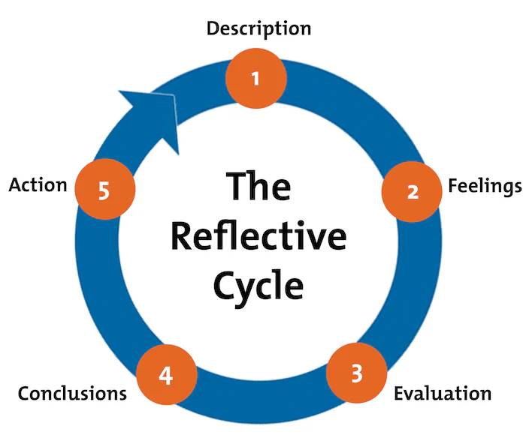
“<Gibbs' Reflective Cycle> (Source: mindtools.com,2024)”
Evaluation
These assessments revealed a rather intriguing paradox of strongly identified creative orientation, as well as aversive risk-taking and leadership profiles. This suggests that my strengths in identifying opportunities and envisioning long-term goals align more with the strength quadrant than the trouble quadrant. However, why does not one take more risks, and which leadership skills have to be further developed, not only with my potential but also with my visions? This contrast perhaps captures the need to adopt a more balanced approach to excellence in the dual dimensions of creating and managing new enterprises and ideas, creative risk-taking, and leadership.
Analysis
This will assist me in identifying my strengths and weaknesses when implementing the EO business framework, which emphasizes innovativeness, proactivity, and risk-taking, as I have learned from academic sources (Lumpkin et al, 2013). This is quite close to the EO, where they state that the ability to be innovative is of paramount importance in any form of entrepreneurship. On the same note, my overall low-risk-seeking attitude also poses a challenge to the EO's risk-taking, indicating that there may be a barrier to the creation of opportunities. The Leadership Trait Theory also helps in this case, as it implies that, although strategic visioning is a leadership strength, there is more to leadership, and that includes the ability to encourage or motivate people, which is something that I lack.

Action Plan
To address these insights, my action plan includes:
- Engaging in professional development workshops focused on risk management and leadership skills (Day et al, 2014).
- Seeking mentorship from experienced entrepreneurs to gain insights into effective risk-taking and team leadership (St-Jean, 2012).
- Participating in team-based projects to cultivate leadership and collaborative skills (Katzenbach et al, 2015).
- Regularly reviewing and adjusting my goals to ensure a balanced approach to innovation, risk-taking, and leadership (Gurd,2017).
This reflective journey has not only enhanced my self-awareness but also charted a path for my entrepreneurial and managerial growth, underlining the transformative power of introspection and targeted action.

Conclusion
EcoLux Retreats are a company that offers luxury experience with environmental responsibility and sustainability in mind for the modern clientele. It has redefined the standard of hospitality by incorporating green technologies and offering ‘organic food produced in Lanzarote’. Effective marketing strategies, sustainable customer relations, and maintaining healthy two-way business relationships guarantee customer satisfaction and a positive impact on the environment that firmly places EcoLux Retreats as an industry leader in the eco-luxury accommodation market.

References
- Bohdanowicz, P. and Zientara, P., 2008. Hotel companies' contribution to improving the quality of life of local communities and the well-being of their employees. Tourism and Hospitality Research, 8(2), pp.107-119.
- Buhalis, D. and Law, R., 2008. Progress in information technology and tourism management: 20 years on and 10 years after the Internet—The state of eTourism research. Tourism management, 29(4), pp.609-623.
- Bohdanowicz, P., Zientara, P. and Novotna, E., 2011. International hotel chains and environmental protection: An analysis of Hilton's we care! programme (Europe, 2006–2008). Journal of Sustainable Tourism, 19(7), pp.797-816.
- Browning, V., So, K.K.F. and Sparks, B., 2014. The influence of online reviews on consumers’ attributions of service quality and control for service standards in the hotel industry. Journal of Travel & Tourism Marketing, 31(7), pp.785-799.
- Buckley, R., 2010. Ecotourism: Principles and Practices. CABI.
- Buhalis, D. and Law, R., 2008. Progress in information technology and tourism management: 20 years on and 10 years after the internet—The state of eTourism research. Tourism Management, 29(4), pp.609-623.
- Chen, M.F. and Peng, N., 2012. Green hotel knowledge and tourists' staying behavior. Annals of Tourism Research, 39(4), pp.2211-2216.
- Day, D.V., Fleenor, J.W., Atwater, L.E., Sturm, R.E. and McKee, R.A., 2014. Advances in leader and leadership development: A review of 25 years of research and theory. The Leadership Quarterly, 25(1), pp.63-82.
- Dolnicar, S. and Grün, B., 2009. Environmentally friendly behavior: Can heterogeneity among individuals and contexts/environments be harvested for improved sustainable management? Environment and Behavior, 41(5), pp.693-714.
- Enz, C.A., 2010. Hospitality Strategic Management: Concepts and Cases. Wiley.
- Gössling, S., Hall, C.M. and Weaver, D., 2009. Sustainable tourism futures: Perspectives on systems, restructuring, and innovations. Routledge.
- Grant, R.M., 2016. Contemporary Strategy Analysis: Text and Cases Edition. Wiley.
- Gurd, B. and Helliar, C., 2017. Looking for leaders:‘Balancing’innovation, risk and management control systems. The British Accounting Review, 49(1), pp.91-102.
- Hays, S., Page, S.J. and Buhalis, D., 2013. Social media as a destination marketing tool: Its use by national tourism organizations. Current Issues in Tourism, 16(3), pp.211-239.
- Heo, C.Y., 2016. Sharing economy and prospects in tourism research. Annals of Tourism Research, 58, pp.166-170.
- Kotler, P., Bowen, J.T. and Makens, J.C., 2014. Marketing for Hospitality and Tourism. Pearson.
- Katzenbach, J.R. and Smith, D.K., 2015. The Wisdom of Teams: Creating the High-Performance Organization. Harvard Business Review Press.
- Legrand, W., Sloan, P. and Chen, J.S., 2012. Sustainability in the Hospitality Industry: Principles of Sustainable Operations. Routledge.
- Lumpkin, G.T., Moss, T.W., Gras, D.M., Kato, S. and Amezcua, A.S., 2013. Entrepreneurial processes in social contexts: how are they different, if at all?. Small Business Economics, 40, pp.761-783.
- Morrison, A.M., 2022. Hospitality and travel marketing. Routledge.
- Porter, M.E., 2008. Competitive Advantage: Creating and Sustaining Superior Performance. Free Press.
- Day, D.V., Fleenor, J.W., Atwater, L.E., Sturm, R.E. and McKee, R.A., 2014. Advances in leader and leadership development: A review of 25 years of research and theory. The Leadership Quarterly, 25(1), pp.63-82.

Appendix


