Critical Review

Name: Karol Schwarz
Student number: 1801245
Course: 3D Computer Animation
Module: Critical Review
Word count: 2298 (Excluding Bibliography)
Lecturer: Philip Organ
Introduction

This report will cover and review my study of the 3D Computer Animation course at the University of Wales Trinity Saint David, based in Swansea. The three-year long course will be covered and broken down in detail, covering aspects like my experience with animation before starting course, the first, second and third year of university, and the showreels showcasing my development in animation. The focus of this report will be on the skills I have acquired during the course, the skills I have acquired outside of the course and on how the pandemic has affected our study, transitioning to online classes. The report will be wrapped up with a conclusion, summarising my experience and providing reflection of my experience.

Experience Before University
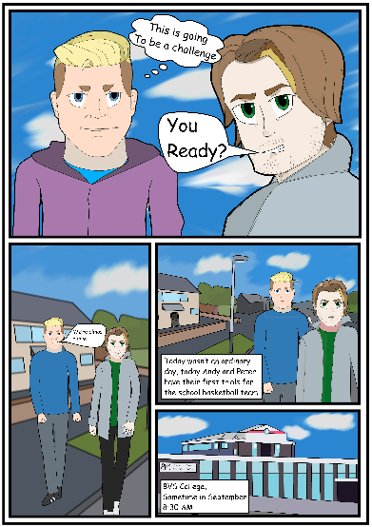
Before enrolling for a 3D Animation program of study, I was considering a vast number of different undergraduate courses. It was during Sixth form in Bishop Vaughan Catholic School when I decided I wanted to pursue an Animation course. During Year 13 I started to create digital art, working on Serif DrawPlus x6 which was available on the school’s computers. As my end of year art exam, I created a story driven comic book segment featuring two digital characters as well as different environments, during this production my art teacher suggested working on an animation, this planted a seed in my head and made me consider doing more research into the subject which eventually led me to apply for an animation course.

Experience with Digital Art

During my time in Sixth form my interest was in drawing and creating original characters, starting off with physical sketches and drawings, moving onto digital space with Serif DrawPlus, later transitioning onto Krita with my first pen tablet purchase. My first pen tablet was an outdated Wacom Bamboo tablet, with a small display and a 4:3 aspect ratio, which made it incredibly difficult to create art on 16:9 software and monitors. At this stage I had little to no experience with Photoshop, any 3D work or animation.

First Year of University

Throughout the first year of the course, we were introduced to eight different modules, split into two sets of four, for the first two terms. In the first term we studied ‘Ways of Thinking’, ‘Creative Practice 1’, ‘Visual Studies for Film and Digital Media’ and ‘3D Production Design and Animation’. Out of the listed modules, three of them were related to animation. During the second term we studied ‘Ways of Perceiving’, ‘Creative Practice 2’, ‘3D Organic Modelling’ and ‘3D Character and Effects Animation’.

Character and Environment Design

During the course of the first year, a new skill I picked up was using Photoshop, more specifically character and environment design on Photoshop. Having access to Adobe’s library on all computers and Wacom Cintiq’s in our classrooms allowed us to develop our skills on a daily, not only during class but in our free time as well. Wacom Cintiq’s were a big upgrade to my previous experience with pen tablets, the Cintiq had a large screen display which made drawing directly on the screen possible.
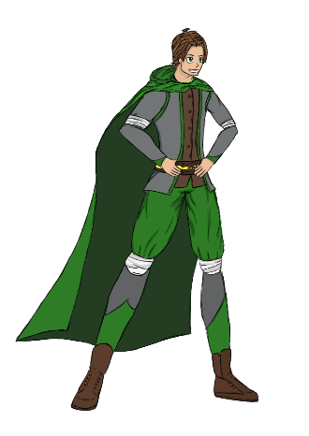
We learned about human proportions and anatomy throughout Visual Studies for Film and Media, the understanding of the human form is a crucial foundation when it comes to creating characters. Our tutor, Al Kang, gave us challenges to work on our drawing skills and to push ourselves, we would practice timed gestural drawing using “timed art model reference” videos that can be found on YouTube at New Masters Academy. Working on environmental drawings, Al Kang taught us about the importance of perspective, lighting, and shading. When drawing an environment, I keep the foreground sharper and darker (richer) in colour, and the background lighter in tone and less clear.
At the end of the module, we were tasked with creating a character and environment using the skills we developed throughout the term. Looking back at my character and environment, I recall being really pleased with the outcome, the fact that I learned that much in one term kept me motivated and dedicated to keep on improving.

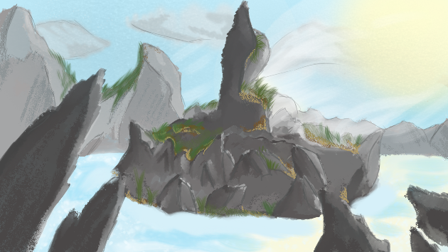
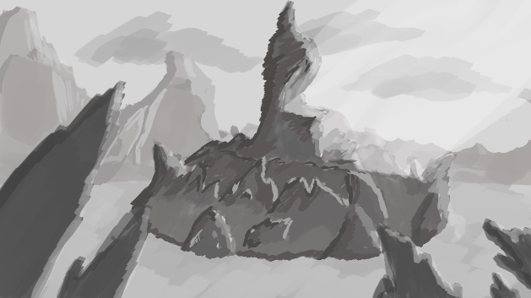

3D Work and Animation

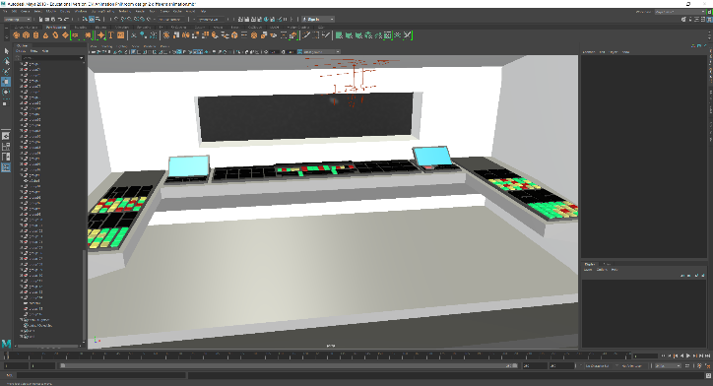
Before starting my first year of University, I had little to no experience with any 3D software apart from Blender. It’s also safe to say that my experience with Blender was limited at the time, I struggled using it and gave up on it rather quickly. My first real experience with 3D work started with Autodesk Maya during ‘3D Production Design and Animation’. Maya is a 3D modelling and animation program, that is used within the industry. Our tutor Phil Organ broke down the key aspects of Maya and introduced us to the program by covering all the basics. During the first few classes it was all about the layout and essential functions, after gaining a basic understanding of the software, Phil taught us how to create 3D meshes and modify them and how to use handy modelling tools such as the duplicate special. Within the first year of the course, we also learned basic rigging and animating, we used these skills to rig 3D characters in order to control them, and then used those character rigs to make an animation for our assignments.

We were also introduced to ZBrush during ‘3D Organic Modelling’ with Al, I took an immediate liking to the program due to the organic modelling aspect, it reminded me of clay sculpting. On the surface the program seemed like a much simpler approach to modelling than Maya, with all of its sculpting tools and brushes. Al taught us all of the basics of ZBrush during first year, such as the keyboard shortcuts, the essential tools such as symmetry, perspective and the difference between 2.5D and 3D modelling. At the end of the year, we were tasked with modelling an anatomically accurate human character. It felt like a lot of information to take in at the time, it was almost overwhelming during the first year, but it felt good to know that I was heading in the right direction and there was so much more to learn.

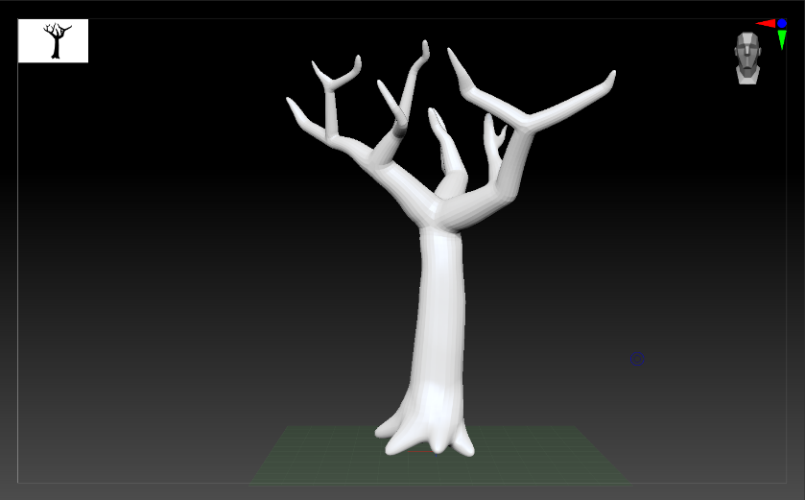

Second Year of University

Year one provided us with the foundations for animation and set us up for year two, we carried on learning more about the software we were introduced to, and we covered all the topics from first year but in greater detail. The new modules for this year were closely related to the previous ones, but with more of an emphasis on animation. It was in the latter part of second term when the University first shut down due to the pandemic, this affected me greatly since I was visiting family in Scotland at the time and was made to work from there without my usual and University setup.

Development

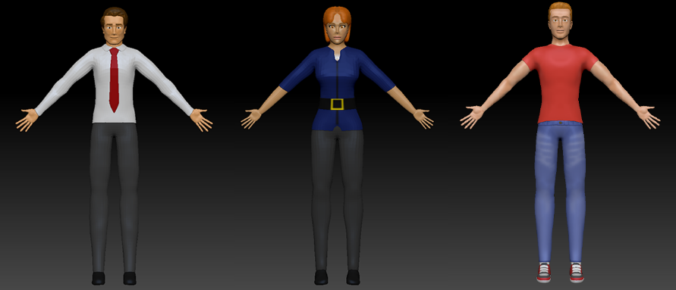
During second year we learned a lot about texturing in Maya, which mainly covered the hypershade and the different materials and properties, we were also introduced to UV Maps. This was tricky to understand and master at the time, especially with how awkwardly 3D models unwrap (mainly characters), an easier alternative to texturing was polypainting in ZBrush which was great for

characters. A big focus for me was learning about lighting in Maya in greater detail, in the first year while lighting a scene I was just eyeing it, while in the second we went into more detail about the different types and properties of lights, and the attribute editor which allows you to alter the behaviour of the light and fine tune it to suit your scene. The camera sequencer became a very useful tool we expanded upon in the second year, using different angles for effect and having the whole scene directed in Maya was convenient, at first the sequencer seemed confusing with the timeline and different tracks, but it didn’t take long to master it through trial and error. During this time, I also started learning Blender in my free time, due to its rise in popularity with its recent update it seemed like a viable option for modelling and even animating, considering that the program is free to use was another huge bonus. After having a basic understanding of Blender, I compared it to Maya and it stood its ground, ultimately I decided to stick with Maya due to my familiarity with it at this point. Its safe to say that second year was a step up and felt like more of a professional environment. In year two we started using Perforce and FTrack to manage our work within a server, in a similar way you would do in the industry. Perforce allowed us to transfer files between a group of people and different computers, which was more convenient than carrying a USB drive around or constantly sending work through email. FTrack is a web production tracking platform, it keeps track of progress and gives easy access to work and schedules between the students and tutor in this case.

Third Year of University

Having finished the second year of university online, we had a hope to return to the campus in person at the start of the third year, unfortunately this didn’t happen. Another major event was the course being moved from the art and design department to the applied computing department, which had us move from Dynevor to the SA1 building. This transition didn’t have a physical impact since classes remained online, but it has affected the modules. In general, the pandemic had a massive impact on our course as it has on the whole world.

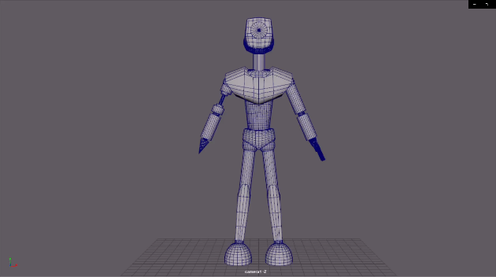
Besides the major changes to University, the third year gave us more freedom and time to focus on our assignments, using the skills we have learned in the first two years and our own time it was time to demonstrate what we got. During the summer break I used that time to stay sharp by keeping myself doing sketches, modelling in 3D and working on my weaknesses. It’s safe to say I have produced some of my best work in this year, my biggest improvement would be character rigging as I always struggled with it and now managed to complete a fully working character rig, another aspect I improved on was texturing, making my own texture in Photoshop and then adding them in Maya using the UV Editor.
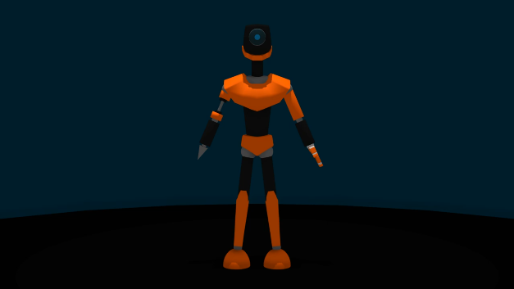

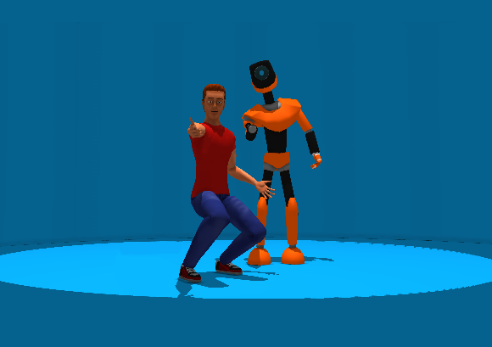

The Showreels

The showreels I worked on for the first part of Critical Review demonstrate my skills in 3D work and animation, the reels showcase my best work and have a purpose of demonstrating my abilities to potential employers. Most of the work in the two showreels comes from the latter part of second year and the third year of university, this is where my work has improved most and highlights my strengths as a 3D artist and animator.
Behind the showreels

The showreels showcase my 3D models and props, featuring two original modelled, rigged, and textured characters; CD-8 and Jack Spacey. The entirety of the ‘Best of’ showreel contains my work only, with no ‘free character rigs’ or other third-party assets. The showreel shows the development stages of creating a character and process of making an animation, featuring model sheets and character design as well as a 2D animatic followed by the final 3D animation. This shows my range of work and vast skills which can be a bonus with employability.

The longer showreel focuses on the animation, featuring original modelled characters as well as ‘free character rigs’. It is made clear which characters have been made by me, by showing a 360-degree view of the characters. The showreel features work from ‘3D Character and Creature Animation’, ‘3D Filmmaking’, ‘Advanced Character Animation’ and ‘Independent Project’. The showreel shows my and adaptability diversity in animation, through the wide range of emotion and different topics on animation. The animations are spread out and composited to give balance to the showreel, alternating from fast paced animation to slower and more relaxed animation, this was also synced with the music to flow smoothly.

Music

When compositing the showreels in Adobe Premiere Pro I started searching for royalty free music, I wanted the music to match the pace and style of the showreels and ended up doing some research and spending time listening to different artists and songs. I came across “Better Days” by Benjamin Tissot on his website www.bensound.com, I wanted to make sure I can use his music in the showreel as it was exactly what I was looking for, looking at the songs description on his website I found out I can use this music in my project as long as I credited his website. Being impressed with his music I took a deep dive on his site and found the song for the second showreel, “A New Beginning”.

Conclusion

Coming into this course I wanted to acquire the skillset to become an animator, while I had a lot of expectations, one thing I didn’t expect was the time to go by so fast. The University provided me with many great experiences and skills, being appointed as a class representative was something I took great pride in, it came with a lot of responsibility and a lot of meetings, but it was a good challenge. The part I like the most was talking to my classmates and getting our points across, being that person, someone can count on. In terms of my practical skills in the animation department, I could not be any more pleased, I learned about things I didn’t even know existed. I didn’t expect myself to be able to make an animation from start to finish by myself. This doesn’t mean that there still isn’t a lot to learn, the University provided me with the tools to be an animator and now it’s my time to use them and expand on them.

Bibliography

Williams, R., 2001. Richard Williams animation masterclass presents the animator's survival kit animated. [S.l.]: Faber.

Thomas, F. and Johnston, O., 1995. The illusion of life. New York: Hyperion.

New Masters Academy, 2021. Timed Art Model Reference for Figure Drawing and Figure Painting. [online] Youtube.com. Available at: <https://www.youtube.com/user/NewMastersAcademy> [Accessed 11 May 2021].

Tissot, B. n.d. Better Days. Bensound. [online]. Available at: <https://www.bensound.com/royalty-free-music/track/better-days> [Accessed 11 May 2021].

Tissot, B. n.d. A New Beginning. Bensound. [online]. Available at: <https://www.bensound.com/royalty-free-music/track/a-new-beginning> [Accessed 11 May 2021].

Elwyn, J., 2013. 6 Ways to Make Your Showreel or Demo Reel Stand Out. [online] The Beat. Available at: <https://www.premiumbeat.com/blog/demo-reel-showreel-tips/> [Accessed 11 May 2021].

Box, T. and Badruddin, B., 2018. 13 tips for creating the best animation showreel. [online] Digital Arts. Available at: <https://www.digitalartsonline.co.uk/features/motion-graphics/13-tips-for-creating-best-animation-showreel/> [Accessed 11 May 2021].

Amidi, A., 2018. 10 Tips For Making A Quality Animation Demo Reel. [online] Cartoon Brew. Available at: <https://www.cartoonbrew.com/educational/10-tips-for-making-a-quality-animation-demo-reel-165953.html> [Accessed 11 May 2021].

Its.ucsc.edu. n.d. Preparing Images for Web or Print. [online] Available at: <https://its.ucsc.edu/fitc/tutorials/webimages.html> [Accessed 11 May 2021].

Creativebloq.com. 2019. A designer's guide to printing a poster | Creative Bloq. [online] Available at: <https://www.creativebloq.com/print-design/how-to-print-a-poster-12121447> [Accessed 11 May 2021].

Minero, E., 2016. 4 Steps of Student Self-Assessment. [online] Edutopia. Available at: <https://www.edutopia.org/practice/mastering-self-assessment-deepening-independent-learning-through-arts> [Accessed 11 May 2021].

