
UNIVERSITY OF WALES
Trinity Saint David

Organisation’s quality systems and customer relationship management

Programme: BA (Hons) Leadership and Management Skills for the Workplace
Module: Understanding and Engaging in the Customer Experience Code: BMSW5103_LON

Module Lecturer´s Name: DR NANDISH PATEL
Student Name: Francisco Jose Gonzalez Castillo
Student Identity Number: 1917101
Word Count: 4199 words

Date: 19/08/2021

TABLE OF CONTENTS

1.- INTRODUCTION 3
2.- H10 HOTEL LONDON WATERLOO CONTEXT 4
3.- MODELS REVIEW 6
3.1.- CRM Models 6
3.1.1.- The IDIC model 6
3.1.2.- Payne’s five-process model 7
3.2.- Service quality 8
3.2.1.- SERVQUAL model 8
4.- JUSTIFICATION OF THE CHOSEN MODEL 9
5.- APPLICATION 11
5.1.- Strategy Development 11
5.2.- Value Creation 13
5.3.- Multi-Channel Integration 13
5.4.- Information Management 13
5.5.- Performance Assessment 14
6.- RECOMMENDATIONS 14
7.- CONCLUSION 15
8.- REFERENCES 16

1.- INTRODUCTION
This document will follow a line of study that will start by addressing the overall potential benefits that the implementation of CRM can bring to the customer experience and its impact on the organisation. Afterwards, it will be identified the main CRM problems experienced by the company and the advantages that could be gained by improving processes to deal with the difficulties identified. The following section will critically analyse IDIC model, Payne's Five Forces model and Gap Model of Service Quality (SERVQUAL), in order to evaluate their strengths/weaknesses and justify their application in solving the problems detected in H10 London Waterloo. Finally, the analytically selected models will be applied and recommendations will be proposed to improve the company's CRM system.
This report starts from the concept of Relationship Marketing (RM) to understand the implementation of Customer Relationship Management (CRM). RM is designed to identify, establish, maintain and finally terminate relationships when economic profitability has been achieved for all parties (customers and stakeholders) and the objectives of these relationships have been met (Egan, 2011). Within the breadth of this understanding of marketing, the part that deals with the implementation of the strategy is CRM.
The relationship between companies and their customers involves a dynamic component that implies the need for the organisation to be in continuous contact with the customer in order to obtain a flow of information that allows the company to understand and meet the expectations of customers at all times in order to be able to satisfy them and build customer loyalty (Project Management Institute, 2017). This dynamic relationship is based on the fact that customer behaviour is influenced by different social, cultural, economic, personal and psychological factors that can alter their purchase decision (Ali & Ramya, 2016) and their perception of the relationship with the company. Currently, factors such as Covid-19 have forced people to change their habits and the way they interact socially in a short space of time, this means that companies must adapt quickly to this new situation by offering value to the customer to maintain their level of commitment; for these reasons it is crucial to adapt the CRM strategy.
CRM is formed by different quality processes focused on understanding and identification of the profitable customers to satisfy them through the creation and delivery of value in aim of increasing the company's profits (Buttle, 2012). The constant development of technologies has allowed companies to use IT tools that, thanks to the support of those service quality processes, are able to manage the data obtained to identify customer needs and behaviours; this allows the possibility of creating a mutually beneficial relationship and commitment for both sides (Bergeron, 2002). It can be pointed out that CRM encompasses a set of processes, people and technologies that help to increase the company's profit.
According to Buttle (Buttle, 2012), the main advantages provided by customer relationship management in a company are:
- It increases customer loyalty because good customer service can improve customer experiences and meet their expectations (customer satisfaction & customer expectations).
- It helps to detect customers or segments of value for the company in order to retain the most profitable ones (customer acquisition & targeted customer retention) to increase the company's revenue.
- Develop value propositions more adapted to customers in order to obtain competitive advantages (customer value development).
- Respond to changes in customer behaviour at high speed.
- Reduce costs by increasing effectiveness in interacting with customers.

2.- H10 HOTEL LONDON WATERLOO CONTEXT
This report will analyse and evaluate the H10 London Waterloo hotel (177 rooms) from a quality process and customer experience point of view. It is a branch that opened in London in 2010 as part of the H10 hotel network (H10 hotels, 2020). The choice is justified because it is the company for which I have been working for the last 6 years in the kitchen department. It is a company that employed 69 people and generated a turnover of £7,875,232 in 2019 (Gov.uk, 2020). Being a medium-sized company and and having access to all departments, I will be able to obtain an insider's view of its customer relationship management.
The current situation is a critical point for the hospitality sector, and therefore for the H10 London Waterloo Hotel. External factors such as Covid-19 and Brexit have caused turnover to fall by 70% from pre-pandemic levels due to a drop in consumer spending in this industry, consequently the number of employees has fallen by 11%. (Office for National Statistics, 2021). With the easing of restrictions, the industry is starting to take off from a scenario of uncertainty and the redesign of its CRM strategy can play a key role in increasing profits.
Since the implementation of CRM strategies is based on people, processes and technologies, this report has focused on them to identify conflicting points in their application at H10 HLW:
- Lack of adaptation of the value proposition: before the pandemic, its proposition was focused on a quality and personalised service, centred on an executive type of customer. Nowadays, the restrictions that promote the remote working of the target market and the difficulties to travel internationally make necessary an adaptation of its value proposition to attract and identify a new market segment that allows maximising profits for the organisation. Currently their proposition does not add value to the customer, so customer loyalty has been reduced. In the hospitality industry, acquiring new customers is 5 times more expensive than retaining existing ones (Rahimi & Gunlu, 2016), but given the current circumstances such a measure could be considered to increase profits.
- The technology used is not adequate: internal communications between the different departments of the company are carried out through e-mails, calls and spreadsheets. This use of technology leads to a lack of understanding between employees, inefficiency in actions and a lack of knowledge about the live situation of any incident that may arise. The implementation of an IT tool that allows effective monitoring of incidents would increase the effectiveness and quality of customer service. An example of such problem is the communication between the housekeeping department and the front desk when assigning rooms that are clean and ready for use after check-out; the system used to communicate the availability of a room is a telephone call, so the front desk staff in charge of assigning them are completely unaware of which rooms are clean and available until they receive the call. This fact causes queues in the check-in procedure (lack of service quality).
- Lack of employee engagement/empowerment: CRM implementation involves changes in attitudes and processes, so employee satisfaction is crucial for the acceptance of such change. (Rahimi & Gunlu, 2016). Considering the human (face-to-face) nature of the hotel experience, correcting this issue is very important for customer satisfaction and the creation of a link between customers and the company.
- Lack of staff: The drop in revenue generated by the pandemic has led to a decrease in staffing levels, increasing the workload of existing staff and creating disruptions in the quality of service. For example, waiting times to respond to customers both by telephone and e-mail have increased as a result of this fact.

3.- MODELS REVIEW

3.1.- CRM Models
The following CRM models are taken from the recommended essential book "Customer Relationship Management" (Buttle, 2012).

3.1.1.- The IDIC model
This model approaches customer relationship management through four processes: identification, differentiation, interaction and customisation; its main objective is to gain customers' trust in order to be successful (Peppers, 2004).The key to understanding this model is the intrinsic emotional component that any type of relationship has when it seeks to generate commitment and reliability. Through the knowledge and individual integration of the customer in the company (previously offered by the modelling of past consumer behaviour), the value of each customer is differentiated and services and products can be adapted to their needs, meeting their expectations and generating trust and profitability for both parties. It is a continuous process that improves engagement through personalised knowledge to differentiate high-value customers, focusing more resources on them and increasing profits for the company (Peppers, 2004).
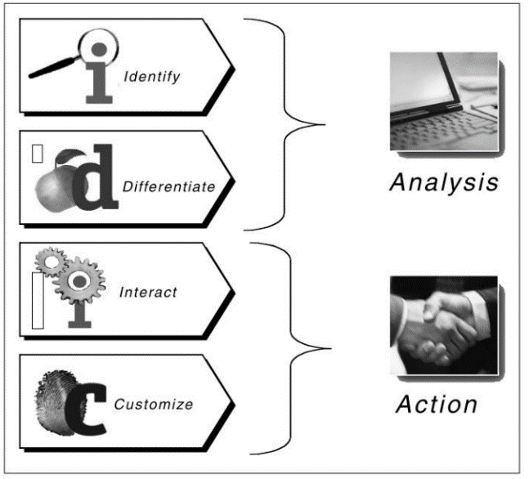
Figure 1.- IDIC model (Peppers, 2004)

This model bases its intervention on technology, as large databases and applications are needed to manage identification, differentiation, interaction and customisation. For this reason, it seems to be a very general model and focused on medium-large companies capable of mobilising large flows of customers. Although this model tends to justify its operation on the emotional component, its application tends to be similar to the management of large-scale data to identify the behaviour of individuals in order to apply mass marketing strategies, eliminating the human component of the relationship with the customer.
As it is a model based on continuity, it does not take into consideration the value lifecycle of customers and the possible benefit of ending the relationship when the customer is no longer valuable to the organisation; facing the problem of how to manage customer data that is no longer useful for the company and that occupies space in its database (which can cause scalability problems).

3.1.2.- Payne’s five-process model
Payne and Frow build their model based on the cross-functional and dynamic nature of CRM, pointing to the importance of creating an organisational strategy for successful implementation processes (Payne & Frow, 2006). The modelling we are concerned about links the design processes and the implementation areas shown in the figure below:
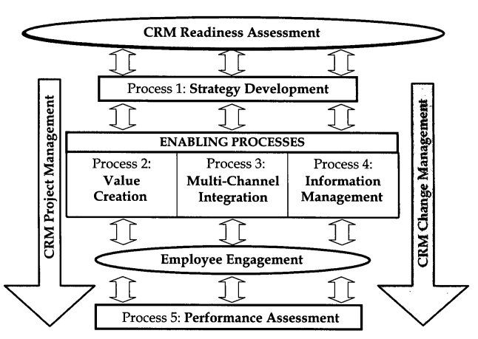
Figure 2.- Payne´s Model (Payne & Frow, 2006)
The processes are in charge of designing the CRM strategy, covering the company's strategy towards the consumer, the value proposition, the different touch points and their coherent coordination, the choice of tools to manage information effectively, the assessment of the objectives set and the identification of improvement parameters. (Payne & Frow, 2006).
The key elements of CRM implementation (CRM Readiness Assessment, CRM Change Management, CRM Project Management and Employee Engagement) are responsible for integrating and implementing CRM in a coordinated way, allowing a comprehensive overview of the process. These areas point to the importance of employee engagement, the connectivity of the different departments in the company and the professional development of employees, among others.
For the above reasons, it is a very complete model that integrates all the components of the company to develop quality customer relations, with clearly differentiated objectives that are the basis for the correct and successful implementation of CRM. Therefore, the background of this model is associated with synergy as a method of improving results. In contrast to the previous model, the importance of employee satisfaction, training and cultural background in the implementation of CRM is emphasised here. This is a key point, as employees with a high degree of satisfaction are more committed and identified with the company's proposal, achieving an increase in the quality of processes and customer service by increasing productivity, creativity and effectiveness. It should be noted that it is a model that is difficult to apply to medium to small companies because the large amount of resources needed to carry out the process would not be profitable.

3.2.- Service quality

3.2.1.- SERVQUAL model
Given the difficulty in measuring the fulfilment of a customer's needs or expectations in relation to a service, the authors of this model defined 5 gaps that influence the perception of quality of a service (Parasuraman, et al., 1985):
1.- Consumer expectations-management perceptions gap.
2.- Management perceptions- service quality specifications gap.
3.- Service quality specifications and the service delivery gap.
4.- Service delivery- external communication gap
5.- Expected service- perceived service gap

SERVQUAL provides 5 evaluation dimensions that allow to identify the status of service quality through surveys that weigh the expectations of a service against the perception of a service. If the weightings of expectations exceed perceptions, the quality of the service is not good. These 5 dimensions are (Parasuraman, et al., 1985):
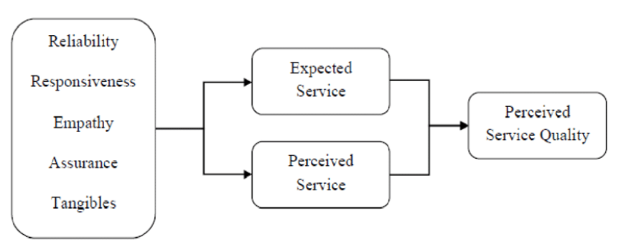
Figure 3.- Servqual (Parasuraman, et al., 1985)
Through the application of two surveys, one of them is asking about the general nature of the type of service (expectations) and the other one is specific to the service received (perception), SERVQUAL is aiming to evaluate the quality of the service in areas such as the fulfilment of the terms of service agreed with the customer, the effective and friendly resolution of incidents, the physical environment (people, equipment, means of communication and spaces), knowledge and professionalism in the delivery of the service, customer service and the predisposition of the employees (Parasuraman, et al., 1985).
The main criticisms of this model lie in its lack of consideration of economic, statistical and psychological aspects (Buttle, 1996); for example, the moods of the customer at the time of the assessment may be different and alter the results. It also seems clear that this model focuses on closely related dimensions within the service delivery process and does not take into account the results after the use of that service on customer satisfaction. For these reasons, this method can detect major failures, but would be less reliable for less pronounced errors in the delivery of quality service.

4.- JUSTIFICATION OF THE CHOSEN MODEL
In response to the problems identified at H10 in section 2 of this document, we will attempt to apply a model that works on those categories in which we can include these incidents, which are: the value proposition, the technologies used and the people involved in the processes. The application of the procedure shown by "Payne's five-process model" takes into account in its strategy the design of a clear value proposition that is distributed and known by the different levels of the company, so that, based on the importance that this model recognises in the integration of the different departments in the design of the value proposition, we can clearly see its justification. Another of the problems that this model takes up is the importance of the choice of technology and procedures in the success of CRM, so by applying process number 3 we will analyse the suitability of a change that, supported by technology, seeks to improve communication and the effectiveness of the processes that affect the quality of the service. The last two problems detected are related to the company's organisational culture and the lack of investment in employees. For its analysis, the model has an element of "employee commitment" that will allow us to work on proposing solutions to reverse this situation in the company. Authors such as Rahimi argue the importance of involving and motivating employees so that they actively contribute to the success of CRM implementation, making organisational culture a key pillar of its application (Rahimi & Gunlu, 2016). The lack of staff in the organisation becomes a clear challenge, as the lack of investment in this area, due to the drop in revenue associated with Covid-19, leads to a loss of quality in customer service. Currently, studies such as that collected by the Office for National Statistics suggest that we are beginning to see an increase in employee salaries in the hotel sector (Office for National Statistics, 2021), which means that companies must make an extra effort that is inversely proportional to their drop in revenue. The chosen model does not take into account these adverse economic factors affecting the implementation of CRM strategies and assumes that companies are able to make this investment.
With the application of this model, the aim is to make changes that solve the aforementioned problems, causing an increase in customer and employee satisfaction within the company, favouring their loyalty and lifetime value and seeking to increase profits in the organisation (Rahimi & Gunlu, 2016). People are reticent to changes, so one of the biggest challenges this implementation faces will be the adaptation of the organisational culture to a more effective model that will improve the quality of service.
The use of the "IDIC model" has been discarded because it focuses on customer knowledge relationships to make a continuous offering of new products or services, in the hotel industry the type of service offered is always the same. This model could be used in E-Retailers companies to increase their sales. On the other hand, this model neither takes into consideration the key role that employees play in human interactions with customers to improve service quality.

5.- APPLICATION
This document will apply Payne's five-process model through its 5 processes: Strategy Development, Value creation, Multi-Channel Integration, Information Management and Performance Assessment.

5.1.- Strategy Development
Since March 2019, with the beginning of the restrictions caused by Covid-19, the revenues of this company and the hotel industry in general have been greatly reduced. (Office for National Statistics, 2021) :
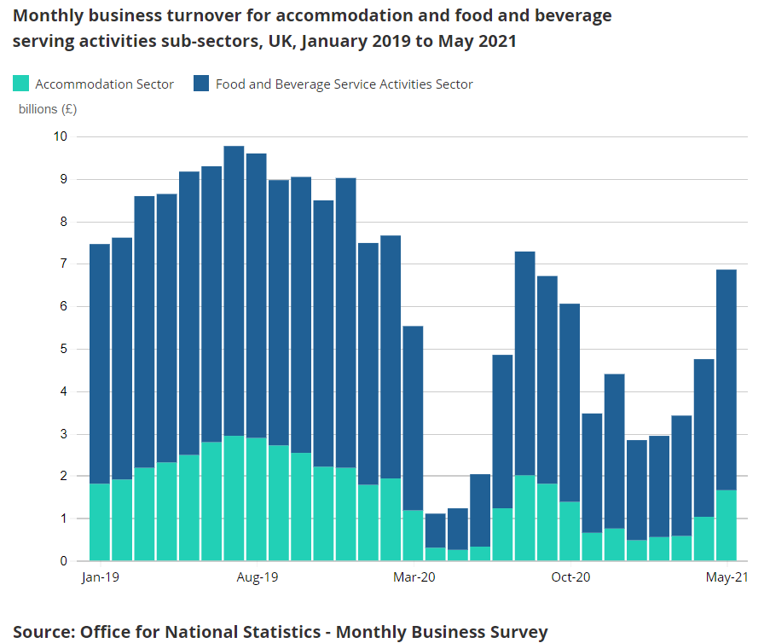
Figure 4.- Turnovers (Office for National Statistics, 2021)

The business segment in which H10 LWH used to work was the executive sector, accommodating this type of client and offering its meeting rooms as a meeting point for different companies. Nowadays, the restrictions that encourage remote working and the development of communication programmes such as "Microsoft Teams" or "Zoom" mean that this market segment has shrunk. The impact of these factors has led to a need to lower the price of the stay to increase occupancy, attracting a holiday customer located within the UK. As the market segment has changed, the previous strategy could be changed to a strategy based on offering leisure activities linked to the accommodation to increase the perception of service quality.
The identification of companies dedicated to leisure in London (aquatic parks, amusement parks, events, gastronomic experiences…) is a key point within the strategy. Agreements with these companies can be beneficial for both parties, attracting customers belonging to the identified segment. The selection of companies should be made on the basis of the data collected through customer needs surveys, and the quality of the customer experience should be monitored. This will help to better understand and identify valuable customers for the company. The proposed strategy for effective product development and identification of valuable customers is outlined below:
- Creation of customer profiling surveys
- Identifying valuable customers
- Developing partnerships with other companies based on customer preferences
- Experience quality control process
- Utilisation of the company's existing web-based platform ("H10 club") as a point of interaction with customers

Strategy Objectives | Benefits Produced
- CUSTOMER ADQUISITION  - CUSTOMER IDENTIFICATION  - CUSTOMER/EMPLOYEE SATISFACTION  - CUSTOMER LOYALTY  - CUSTOMER RETENTION  - IMPROVE SERVICE QUALITY  - ACQUIRE PARTNERSHIPS | - INCREASE REVENUE  - INCREASE PROFIT  - INCREASE EFFICIENCY  - REDUCE MARKETING COST

The main challenge facing the company is the process of changing from an executive-type hotel to a holiday hotel, which is why the strategy focuses on strengthening alliances with external leisure companies to obtain this flow of customers. After this key step, and through the technology described in section 5.3, valuable customers must be identified and retained.

5.2.- Value Creation
Through the outcomes provided by the strategy, the company will build a value proposition based on the quality of leisure experiences and personalisation of offers that create for the valuable customer a need of loyalty because the expectations demanded are met. In customer interactions, offers will describe the benefits that H10 brings to customers' holidays through its portfolio of partnerships with other leisure companies across London and the surrounding area. This will include promotions focused on attracting new customers through retained customers.
The objective of this proposal is continuous improvement through the interpretation of customer needs and the creation of a portfolio of leisure possibilities that allow the customer to plan their holiday from the H10 website (increasing the flow of data on the website will lead to a better identification of valuable customers and the steps to be taken to retain them).

5.3.- Multi-Channel Integration
One of the company's main problems currently lies in this process. It is essential to connect the different departments through a software tool for internal communication and incident management. This tool will allow to control the status of the different incidents and to monitor customer requirements in real time. Nowadays, internal communication via emails or telephone calls leads to a lack of effectiveness in the processes, which implies slowness and a loss of quality in the service. This tool should also allow the integration of data collected through the different touchpoints offered by the company.

5.4.- Information Management
From the point of view of data collection, it is important to use data management tools to connect all the platforms on which the company is present (Instagram, Facebook, Booking, Expedia and the company's own website) with the touch points for customers, classifying and transforming this flow of data into information. The main challenge of this process is the need to create a new department that is able to coordinate all the information and apply it to create knowledge that allows the identification and creation of personalised value for customers. The company does not currently have such a department.

5.5.- Performance Assessment
This evaluation is based on the creation of value for employees, customers and shareholders to measure the performance of the organisation and the incorporation of acquired knowledge (Payne & Frow, 2006). The three proposed control factors will be implemented in the different departments and will ensure the implementation of the CRM process. The major challenge facing the company in this process is the lack of employee engagement due to workload, lack of empowerment and poor economic conditions. In the recommendations section, some suggestions for improving this disengagement are outlined. The measurement of customer value creation will be done through the data management systems mentioned above.

6.- RECOMMENDATIONS
An adaptation of the value proposition is recommended. This recommendation is due to the restrictions caused by Covid-19 and the need to change the market segment in which the company operates. This value proposition should be focused on holiday-type customers. Making agreements with other leisure companies seems to be a key point in obtaining a new flow of data (allowing knowledge to be obtained) and the creation of value that meets the expectations of the new type of customer. Data management should be carried out through the implementation of new software that allows the integration of customer information and its rapid management.
From the point of view of internal processes that affect the quality of service, we recommend the implementation of an IT tool that allows communication between departments and the effective resolution of incidents in real time, providing value to the customer experience (Project Management Institute, 2017). This recommendation will reduce the number of dissatisfied customers and increase the perception of service quality thanks to the efficiency and rapid resolution of incidents. This process could also be supported by tools such as "Cultural Web" to reinforce cross-functionality and reduce costs.
In order to improve employee engagement, professional development is proposed in areas such as IT, data processing, marketing, customer service and collaboration skills. Motivation and employee training are key elements of a customer-centric CRM system. In the hotel industry where there are periods of high work demand, the commitment of employees who are working face-to-face with the customer are the basis for an optimal customer experience (Payne & Frow, 2006). The company should support the professional and personal development of employees.
Another recommendation that could help to dynamically improve the development of the customer value proposition would be the implementation of the service quality assessment model (SERVQUAL). Through the use of these surveys, an overview can be obtained in the areas of study mentioned in point 3.2.1. that allows for the identification of incidents in the perception of service quality.
Using these recommendations, it is intended to implement and integrate a new data and process management system that will enable the generation of knowledge in the organisation. This knowledge will be used to identify and retain profitable customers by creating and delivering value focused on these customers. At the same time these recommendations, combined with those aimed to improve the perception of the service offered by the company, are intended to increase customer loyalty and increase the organisation's revenue.

7.- CONCLUSION
This report shows the need for the company to put in place a CRM system to acquire, identify and retain profitable customers through value creation. The proposed new data and process management systems will enable the creation of knowledge and the integration of different departments in a more efficient and cost-effective way for the organisation. Currently H10 does not have a data management system that allows the creation of value for the new customer segment, producing a lack of coordination in customer knowledge and a lack of maximisation of potential benefits that could be obtained. On the other hand, this lack of CRM has meant that the company has not been able to adapt itself quickly to the pandemic situation, leading to a loss of service quality and a loss of customer value.
The organisation faces a major challenge with the implementation of Payne's model, as it involves major operational changes that require time and resources. Its main handicap lies in increasing employee engagement, requiring a strong investment in employee training and a change in organisational culture to support the implementation of the CRM strategy. On the other hand, it also requires an investment in data and incident management software and qualified personnel capable of converting this information into knowledge that would increase the company's profits.

8.- REFERENCES
Ali, S. M. & Ramya, N., 2016. Factors affecting consumer buying behavior. International Journal of Applied Research, 2(10), pp. 76-80.
Bergeron, B. P., 2002. Essentials of CRM a guide to customer relationship management. New York: Wiley.
Buttle, F., 1996. SERVQUAL: review, critique,research agenda. European Journal of Marketing, Volumen 30, pp. 8-32.
Buttle, F., 2012. Customer relationship management : concepts and technolgies. 2nd ed. London; New York: Routledge.
Cox, A., 2020. Data & Marketing Association. [Online]
Available at: https://dma.org.uk/article/adapting-customer-experience-in-a-post-covid-world
[Último acceso: 08 07 2021].
Egan, J., 2011. Relationship marketing : exploring relational strategies in marketing. fourth ed. Harlow, England: Pearson Education Limited.
Gov.uk, 2020. Gov.uk. [Online]
Available at: https://s3.eu-west-2.amazonaws.com/document-api-images-live.ch.gov.uk/docs/alHqIv1lfyHkc1_jv1nUCSWh-LchOSy_TH3GBear9Ic/application-pdf?X-Amz-Algorithm=AWS4-HMAC-SHA256&X-Amz-Credential=ASIAWRGBDBV3LL3UE5BI%2F20210704%2Feu-west-2%2Fs3%2Faws4_request&X-Amz-
[Último acceso: 07 07 2021].
H10 hotels, 2020. H10 hotels. [Online]
Available at: https://www.h10hotels.com/es/compania
[Último acceso: 07 07 2021].
Hollensen, S. & Opresnik, M. O., 2004. Fundamentals of Relationship Marketing. [En línea]
Available at: https://www.worldscientific.com/doi/epdf/10.1142/9781944659639_0001
[Último acceso: 23 07 2021].
Office for National Statistics, 2021. Coronavirus and its impact on UK hospitality: January 2020 to June 2021. [Online]
Available at: https://www.ons.gov.uk/businessindustryandtrade/business/activitysizeandlocation/articles/coronavirusanditsimpactonukhospitality/january2020tojune2021
[Último acceso: 22 07 2021].
Parasuraman, A. P., Zeithaml, V. A. & Berry, L. L., 1985. A Conceptual Model of Service Quality and its Implication for Future Research (SERVQUAL). Journal of Marketing, Volumen 49, pp. 41-50.
Payne, A. & Frow, P., 2006. Customer Relationship Management: from Strategy to Implementation. Journal of Marketing Management, Issue 22, pp. 135-168.
Peppers, D., 2004. Managing customer relationships a strategic framework. Hoboken, New Jersey: John Wiley & Sons.
Project Management Institute, 2017. An Event To Engage and Empower Yourself. PMI Today, Issue April, pp. 3-6.
Rahimi, R. & Gunlu, E., 2016. Implementing Customer Relationship Management (CRM) in hotel industry from organizational culture perspective. International Journal of Contemporary Hospitality Management, 28(1), pp. 89-112.

