Name: Tim Kirk
Student No. 1710839
Module: HPAR4004

The Skyscape of the Dulas Valley,
Powys, Wales.

At around 10.30pm on a Friday night in July 1969, a Mini ‘Traveller’ pulled up at a small caravan on Corris Caravan Park, near Machynlleth, Wales. The driver got out and opened the single (non-standard) rear door and out climbed a seven year-old boy wearing striped pyjamas and a dressing gown. As his two younger siblings were carried, still asleep, into the caravan, the boy ran across to a nearby tree and (looking up at the unworldly silhouettes of the giant fir trees on the tops of the valley walls surrounding him, picked out by the unreal brightness of the stars above) he urinated on it – a long tradition of all of eighteen months started by a beloved uncle – signalling the start of the summer holidays. As he ran back to the caravan, he stopped by the car and picked out his most prized possession – a lined A5 exercise book, the log of all the aircraft he had spotted flying through the valley in the past two summers. The thought of Phantoms, Hunters, Jet Provosts, and even the exotic F-111’s roaring through the valley at low level were his last that night.
An unworthy beginning to an archaeology essay and sure to be marked down for not addressing the question? Possibly, but fast-forward nearly fifty years and I am woken from my reverie by more aerial activity; same valley, different caravan and high above are the four contrails of a jet transport headed West – transatlantic – and probably military at that, because the trails are of a four-engined aircraft and the fact that civilian flight lanes are some seventy miles to the West, over Pembrokeshire. Another familiar sound, this time the low wop-wop-wop of broad, twin rotor-blades – unseen but, unusually for a Sunday, definitely military. Eventually, through a gap in the now-mature pine trees the ugly form of an Apache helicopter reveals itself, down in the valley almost at eye-level and therefore some 100 metres below the ridgelines. (Pers. Exp. 30.03.2019).
These strong memories and the emotions stirred by them can and do, in different forms, make up part of the complex relationship humans form with the skyscapes that surround them.
The line of the Dulas Valley between Corris and Machynlleth forms part of the Western leg of the RAF’s Low Flying Area 7 (LFA7) and have for at least the last fifty years (as evidenced by this writers’ experiences, described above) provided essential training for the pilots of the RAF.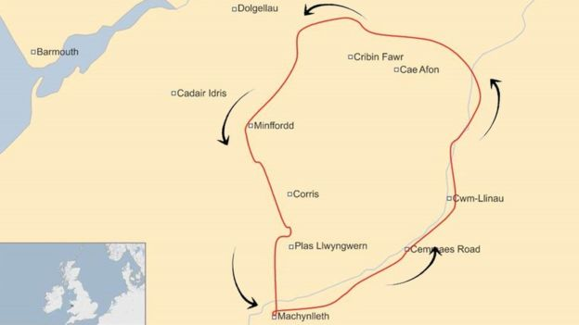 LFA7. (Source: bbc.co.uk)
Nowadays it is the fast jet Typhoons and F-15’s of various NATO and allied countries, supplemented by Tucano and Harvard II trainers from RAF Valley on Anglesea, and frequently by heavy transport aircraft such as Hercules and Atlas (and on rare occasions by the giant C-17 Globemaster) that break the peace of the valley.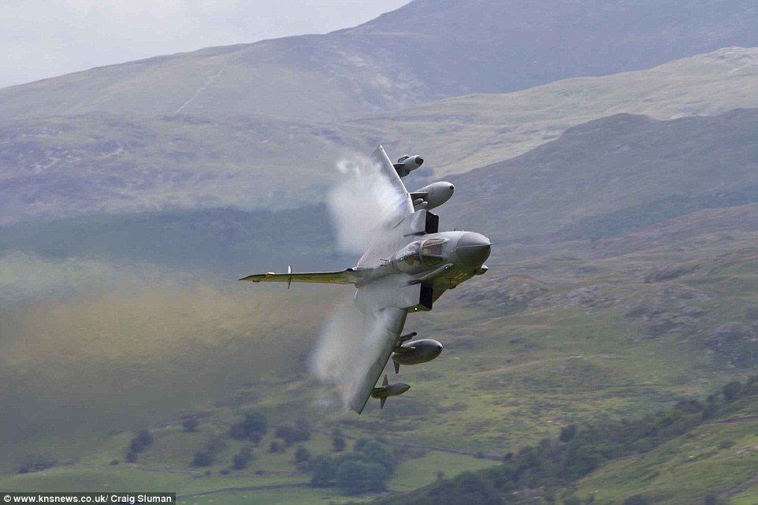
RAF Tornado entering the Mach Loop from the East. (Source: knsnews .co.uk)

The night skies are not so bright nowadays; health and safety requirements led, in the 1990’s, to sodium lighting being placed around the caravan site.
Much of this part of the mid-Wales economy relies on three industries – livestock farming, forestry and tourism.
The livestock industry (predominantly sheep, but with some dairy cattle) does not mix well with the sudden loud and repetitive noise of military aviation and increasingly there are demands for night flying to be banned (which is rather disingenuous because, from this writers’ experience, fast-jet night-flying is very rare and even turbo-prop transport sorties are unusual). Rather, this would seem to be a political action allied to 21st century ‘NIMBYism’ (BBC News, 2018).
The Forestry Commission (predecessor to Natural Resources Wales) began to plant the otherwise unproductive hillsides in the area with Pine trees (largely Douglas Fir, but with some plantations of Larch) after the First World War and after three thinnings over the last fifty years these are now mature, some being as much as two metres in diameter and over thirty metres tall (Natural Resources Wales (no date)). Current policy is to clear-fell these areas and allow natural re-growth of a mixed-woodland – a much better balance for natural fauna to re-populate the area, but devastating to the immediate beauty of the area.
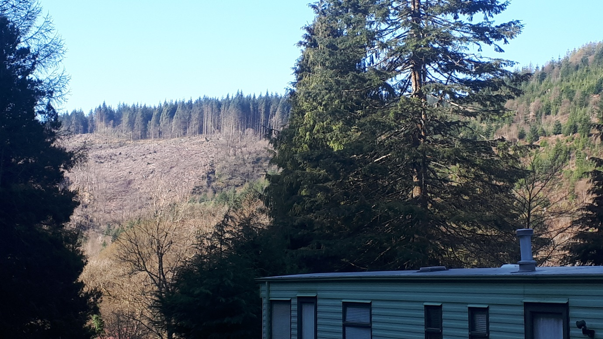
Clear-felling in the Dulas Valley, Winter 2018 (Source: Author)

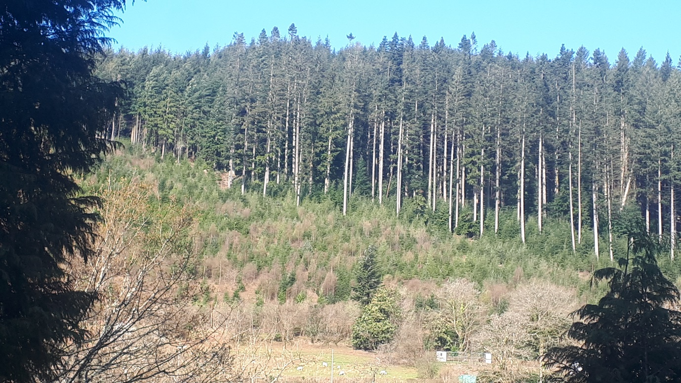
Natural re-growth (after around ten years) alongside original planting (Spring 2019). (Source: Author)

But it is tourism that is the major industry today. Situated just to the North are the slate Quarries of Corris and Aberllefeni – part of the Snowdonia National Park bid to have the slate industry of North-West Wales inscribed as a World Heritage Site (Gwyn, 2018). Running through the forests are tracks and paths for walkers, cyclists and horses, many with splendid vistas of the surrounding skyscape, in line with Natural Resources Wales’ policy of a ‘Multi-Purpose Forestry’ landscape (Farmer and Earwood, 2001). Running through the valley is the Corris Railway – now a ‘heritage railway’, but which used to link the quarries and villages of the valley to Machynlleth, some ten kilometres downstream.
More broadly, and in archaeological terms, the valley is the site of the main Roman road from Wroxeter to Bangor and just over the skyline, on the summit of Tarrenhendre is the site of the wartime crash of three Mk.V Spitfires, lost – ironically – on a low-flying exercise from RAF Llanbedr on 27th March 1942 (NPRN 286655) (coflein n.d.).
With the advent of the internet and ‘social media’ it is no longer necessary for small boys to carry penny exercise books for their plane-spotting activities; just look up You-tube and there are hundreds of sites dedicated to the local training activities of the Western worlds’ air forces.
However, after all the noise and disturbance has gone, it is still the natural effects of skies and landscapes that bring peace to the end of the day.
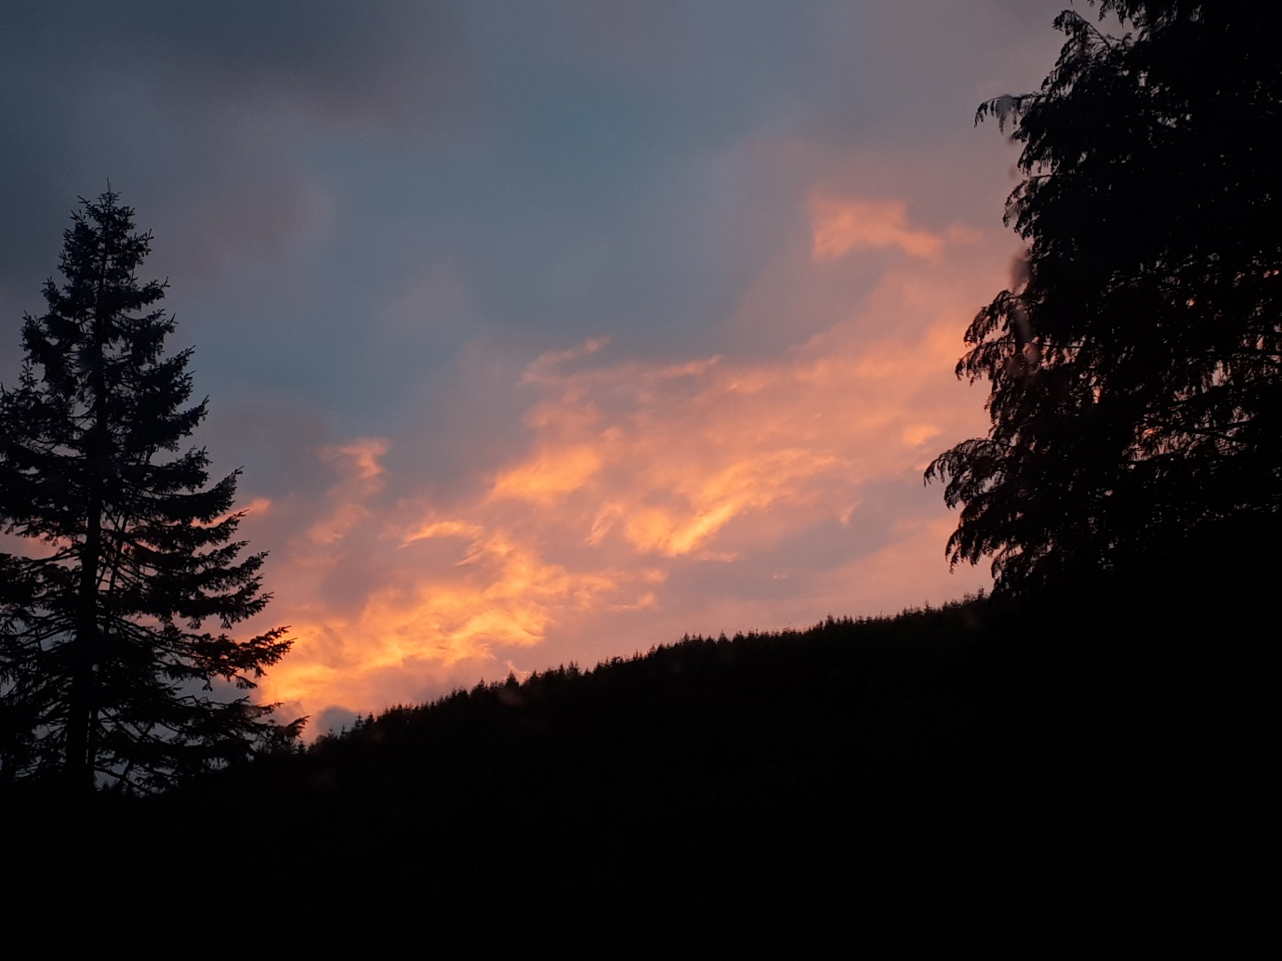
Sunset, 21st October, 2018. (Source: Author)

Bibliography

BBC News (no author), (2018). Complaints Spark Probe Into Machynlleth Low-Fly Jets. Available at: https://www.bbc.co.uk/news/uk-wales-45084885. (Last Accessed: 15.04.2019).
Coflein (no author), 2019. Available at: https://www.coflein.co.uk . Last accessed: 10.04.19.
Farmer, R. and Earwood, C. (2001). ‘Heritage Management in Multi-purpose Forestry’ in Forestry and British Timber, Dec. 2001. Available at: https://www.search.proquest.com/docview/223795578 (last accessed: 10.04.2019).
Gwyn, D. (2018). ‘The Talyllyn Railway – World Heritage Site? In Talyllyn News, 259:8. Sept. 2018 Tywyn: Talyllyn Railway Preservation Society.
Natural Resources Wales, (no author). (no date). Available at: https://www.naturalresourceswales.co.uk/days-out/places-to-visit/mid-wales/tan-y-coed. Last accessed:15.04.2019.

