Values, Beliefs and Attitudes
By Nicola Bennett Student: (1905849)

Fairness
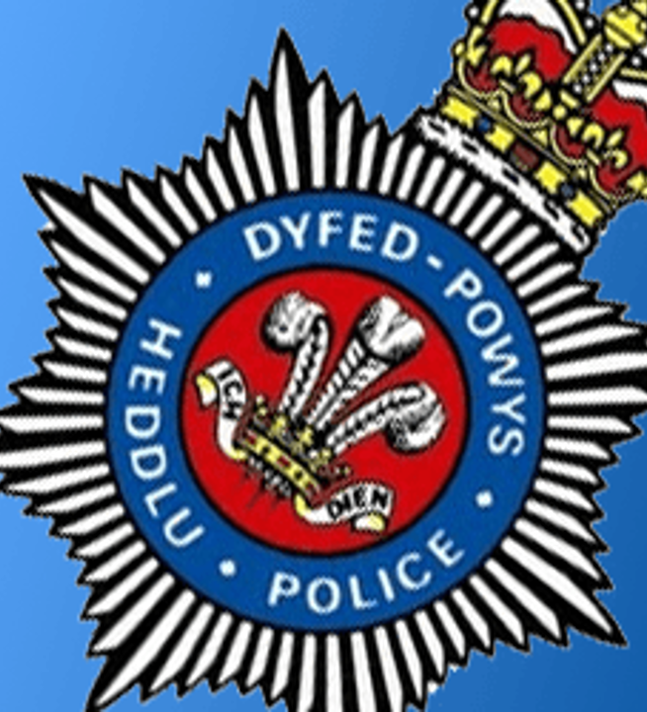
Introduction

Researching newspaper articles, journalists’ opinions and looking into Dyfed Powys Police Force’ policies, will give an insight to what people think of them and how the police should behave.
Defining fairness and Identifying their Values, Beliefs and attitudes in a critical form will demonstrate what qualities their profession can bring to communities if used in the correct way.
Using Robert Dilts, (1996) and Richard Barrett’s Model (1998) helps demonstrate positive and negative approaches. These will show how police officers may react to situations that occur every-day.

Values, Belief and Attitudes
Dyfed Powys Police have a wide range of staff in their force, their values state that they are accountable, fair, selfless and they demonstrate openness, leadership and respect. At the core of all that they do, they use integrity, objectivity and honesty within their role.
Their belief or “their vision”, they work together to provide a first-class service that is visible and accessible, their mission is to safeguard their communities together (Dyfed Powys Police, 2020).

Fairness
Fairness is defined as being impartial and demonstrating treatment or behaviour without favouritism or discrimination. According to Fabian Society (2012),
“Fairness and equality are essential ingredients for a successful society”
(Fabian Society, 2012).
Dyfed-Powys (2020), claim to believe in this particular policy …..‘Aims in fairness‘- to improve employment relations and promote fairness at work through which problems or concerns can be investigated and resolved in an efficient, constructive and a fair manner (Dyfed-Powys Police, 2020).
This policy must be applied consistently to all staff irrespective of:
- Age/Disability
- Sex/Gender
- Race, Religion, Beliefs
- Language.
But are possible attributes in every Police officer toward the public.
According to the National Academies Press (2004), Police have legitimacy in the eyes of the community, which is one of the important outputs of policing.
If the community trust local officers and feel they are fair and give equal services in their roles, the community will become abideable and will trust and invest in their officers further.
Robert Dilts (1996) Model
It will become more likely that civilians will cooperate with incidents quickly and commit less crimes.
Using Robert Dilts (1996) Model shows levels of consciousness in what is expected of them at work.
Officers have a purpose in their role whilst representing the civil authority, they need to maintain the law and show fairness and equality whilst serving and protecting citizens, they will have a sense of being the best in their roles because their values and beliefs mean so much to them and their families.
They will have many capabilities and developed certain skills from training. What officers deal with daily and who they say it to, could cause detrimental reactions if an officer’s behaviour isn’t fair or subjective.
Using initiative and positive acts would be beneficial, if these are used in the right way for the right reasons, then results will be shown in the community and trust will be gained.
A pleasant report from South Wales Police Chief Constable Matt Jukes (2020) states that as civil restrictions have changed the demand for the service.
“We have seen tremendous resilience and dedication to keeping South Wales safe with lives being saved every day. There has been remarkable acts of heroism and bravery, such as on off duty PCSO rescued a girl from the sea, officers coming to the aid of a bus driver who had suffered a heart attack in and two police officers wading into the sea during the early hours to save a vulnerable man”(Jukes, 2020, Keeping South Wales Safe).
The community Officers have also continued to carry out proactive work, tackling knife crime and serious violence. These achievements leave an enormous and hugely appreciated legacy in our communities. (Jukes, 2020)
However, Dyfed Powys Police (2020) have had their fair share of bad press and negative media thrown their way.

Richard Barrett’s (1998) Model
Critical Analysis
Every person operates from one of the levels of consciousness, Police officers are no different, how fast a person grows and how far they get depends on their ability to meet their needs.
The Spectator Magazine, (2013) states There is a rise in Police corruption and reluctance from police chiefs to stop it (The Spectator, 2013).
It is said that Chief constables blame lack of resources for not being able to pursue inquiries into claims of malpractice and misconduct, but what could be a greater priority than ensuring that their own officers are not breaking the law.
These same police chiefs seem to find endless funds to chase people who say unpleasant things on social media and prosecute journalists, but it is evident they are prosecuting the wrong people.
There are more officers that we know of not using their values and beliefs to the best of their abilities, so journalists are looking for stories that that the police are throwing to them.
The Guardian has learned that officers in England and Wales have had many complaints, one area being investigated, a series of high-profile cases that have been caught on camera, that several officers are using their power inappropriately against the BAME community (Dodd, 2012).

Conclusion
Reflecting on all the information, I believe each act of fairness comes from that individual and the influences behind them. With correct training and policies provided and values shown, being fair is finding a situation where they may need to stand in front of their procedures to achieve fairness in any given situation.
I believe they are accountable for their choices, for Power, their authority or that they are genuinely there to help and protect.
Officers have shown they are subjective and open enough to reach out to the community, but it is possible the communities are rebelling.
Regardless of good or bad people there should be a show of respect and positive service to their communities, by getting involved and making themselves known and genuinely helping, this may improve employment and civilian relations.
Newspapers, social media and journalists have a tendency to report negative interactions with the Police force. These interactions are high-lighted more predominantly due to its confrontational nature. Positive interactions are less publicised as this should reflect the standard of policing, which should be the norm and therefore does not warrant wide-spread media attention.
As Barrett’s Model (1998) shows there can be some judgmental, selfish and greedy officers within the force, new or vulnerable officers may be influenced to follow that lead, but officers shown in the Dilts Model (1996) prove they can be capable of fairness and show the right behaviours.
If most officers help build fair relationships with their communities, it will inspire younger generations. Officers will demonstrate the right attitude, young men and women will have a positive belief in the police and it could make their values reality.

References

Barrett, R. (1996) 7 Levels Model. Available at: https://myctt.valuescentre.com/mapping-values/barrett-model/organisational-consciousness (Accessed on: 10 November 2020).
Darbyshire, N. (2015) ‘The Shocking Truth About Police Corruption in Britain’ The Spectator Magazine, Issue (7) Available at: https://www.spectator.co.uk/article/the-shocking-truth-about-police-corruption-in-britain (Accessed: 12 November 2020).
De Lannoy, S. (2014) Fairness at Work Policy. Available at: https://www.dyfed-powys.police.uk/media/1137/fairness-at-work-policy-v1.pdf (Accessed: 10 November 2020).
Discovery in Action (2018) Logical levels of change, Robert Dilts. Available at: https://www.discoveryinaction.com.au/wp-content/uploads/2011/06/DIA-Models-Logical-Levels-of-Change-Dilts.pdf#:~:text=Robert%20Dilts%20is%20an%20organisational%20psychologist%20who%20has,what%20promotes%20or%20limits%20our%20effectiveness%20as%20leaders. (Accessed: 13 November 2020).
Dodd, V. (2020) ‘Police and Crime Correspondent’ The Guardian (UK Edition), 09 July, Available at: https://www.theguardian.com/uk-news/2020/jul/09/police-in-england-and-wales-face-inquiry-into-possible-racial-bias (Accessed: 13 November 2020).
Dyfed -Powys Police (2020) Apprenticeships. Available at: https://www.dyfed-powys.police.uk/en/join-us/apprenticeships/ (Accessed: 7 November 2020).
Dyfed-Powys Police (2020) Your Area. Available at: https://www.police.uk/pu/your-area/dyfed-powys-police/tenby-rural/ (Accessed: 5 November 2020).
Entzminger, B. (2013) How to Use Power. Available at: https://bdentzy.com/how-to-use-power-quote/ (Accessed: 10 November 2020).
Fabian Society (2012 The future of the left since 1884 Available at:https://fabians.org.uk/fairness-and-equality-are-essential-ingredients-for-a-successful-society/ (Accessed: 12 November 2020).
Jukes, M. (2020) ‘Keeping South Wales Safe’ South Wales Police. Available at: https://www.south-wales.police.uk/en/newsroom/chief-constable-writes-to-teamswp-to-thank-them-for-their-efforts/ (Accessed: 13 November 2020).
Police Academy Review (1984) Lunchtime Movie Review Child of the 80s, Available at: https://www.moviehousememories.com/police-academy-1984/ (Accessed: 5 November 2020).
Skills you Need (2011-2020) Helping You Develop Life Skills. Available at: https://www.skillsyouneed.com/lead/logical-levels.html (Accessed: 12 November 2020).

