

Student name: | Sheikh Polas Ahmed | Student ID number: | 2418845
Programme: | MBA
Module: | Finance for Business Managers
Module code: | BMMB7005D | Contribution to Overall Module Assessment (%): | 100%
Lecturer: | Marie Pitson | Internal Verifier: | Badir Miftah
Assignment Title: | Part 1: Whitbread PLC ORD  Part 2: Jordons PLC | Word count (or equivalent): | 5000 words
Submission deadline: | 21th July 2025 | Return date of provisional marks & written feedback: | 14th August 2025

Contents
Part 01 3
Introduction 3
Financial Data Extraction 4
Financial Ratio Calculations 5
Limitations of the Ratio Analysis 18
Recommendations to Improve Whitbread PLC’s Financial Management 18
Part 02 21
Business Report: Investment Appraisal for Jordons Plc 21
Financing the Proposed Investment Programme 31
References 35
Appendix 36
Financial Statement 36
Ratio Calculations 38

Part 01

Introduction
This report provides a comprehensive analysis of Whitbread PLC's financial performance for the years 2023 and 2024. The company is listed on the London Stock Exchange and is part of the FTSE 100 Index. The financial data for this analysis has been extracted from Whitbread's annual reports for 2023 and 2024 (Whitbread Annual Report, 2025). The analysis focuses on several key financial ratios that help assess the company’s overall financial health. First, profitability ratios will be examined to understand how well the company generates profit from its revenue and assets. Key ratios such as gross profit margin, operating profit margin, and return on equity will be discussed. These ratios help assess the efficiency and effectiveness of the company in creating value for its shareholders. Next, the liquidity ratios will be analysed, including the current ratio and quick ratio, to evaluate Whitbread’s ability to meet its short-term obligations. These ratios are important for understanding whether the company has enough liquid assets to cover its current liabilities. The gearing ratios will also be assessed to understand the company’s use of debt in its capital structure. Ratios including debt to equity and equity ratio will be reviewed to evaluate the level of financial risk the company faces due to its reliance on debt financing. Also, efficiency ratios will be analysed to understand how well the company uses its assets to generate revenue. Ratios like asset turnover, inventory turnover, and receivables turnover will highlight the company’s operational efficiency. Finally, investor ratios, including earnings per share (EPS), will be discussed to understand the returns the company is providing to its shareholders. Based on these analyses, recommendations will be made to improve the company’s financial management and ensure long-term success.

Financial Data Extraction
The following data has been extracted from the Consolidated Income Statement and Consolidated Balance Sheet:
Figure 1: Extracted Financial Data Source: (Whitbread, 2024)
The financial data from Whitbread PLC's annual report for 2023 and 2024 shows positive growth in several key areas. Revenue increased from £2,625.2 million in 2023 to £2,959.9 million in 2024, indicating a rise in sales (Whitbread, 2024). Operating profit also grew from £413.4 million to £561.1 million, suggesting better efficiency. Net profit for the year rose from £278.8 million to £312.1 million, showing stronger overall profitability. Basic earnings per share increased from 138.4 pence to 161 pence, benefiting shareholders. However, total current assets decreased from £1,328.3 million to £837.2 million, mainly due to a drop in cash and cash equivalents. Total current liabilities rose slightly, from £845.6 million to £870.4 million, while total equity fell from £4,111.4 million to £3,519.4 million. The share price also increased from £3,075.0 to £3,303.0, reflecting positive market sentiment (Investing.com, 2025). Gross Profit is not explicitly stated in the income statement. For the purpose of this analysis, Operating Profit before tax will be used as a proxy for evaluating operational efficiency and profitability before interest and tax (Whitbread, 2024). If a more detailed breakdown had been available, a true Gross Profit calculation would have been preferred. These data will be used to calculate the financial ratios, which will offer insights into the company's performance across various financial metrics.

Financial Ratio Calculations
Below are the calculated financial ratios for the past two years.
- Profitability Ratio: Profitability ratios measure a company's ability to generate profits relative to its revenue, assets, or equity (Hayes, 2025). These ratios indicate how efficiently the company is operating and how well it can turn sales into profits, showing the overall financial health of the business.
Operating Profit Margin
This ratio shows the percentage of revenue that remains after paying for variable costs like wages and raw materials but before paying interest or tax (Hayes, 2025). It indicates how efficiently the company is operating.
Operating Profit Margin = $\frac{Operating Profit before tax}{Revenue}×100$

Particulars | 2024 | 2023
Operating Profit Margin | $\frac{561.1}{2959.9}×100$ = 18.96% | $\frac{413.4}{2625.2}×100$ = 15.75%

Interpretation: The Operating Profit Margin improved from 15.75% in 2023 to 18.96% in 2024, showing that the company became more efficient in generating profit from its core operations. This is a positive sign of enhanced operational management.
Operating Profit Margin Increase:
- Improved Operational Efficiency: Whitbread could have improved its cost management or increased its revenue, leading to higher profits from core operations.
- Cost Reduction: The company may have successfully reduced operating expenses, such as production or administrative costs, which boosted the operating profit margin.
Net Profit Margin
Net Profit Margin is a financial ratio used to calculate the percentage of profit a company produces from its total revenue (Palasciano, 2025).
Net Profit Margin = $\frac{Net Profit }{Revenue}×100$
Particulars | 2024 | 2023
Net Profit Margin | $\frac{312.1}{2959.9}×100$ = 10.54% | $\frac{278.8}{2625.2}×100$ = 10.62%

Interpretation: The Net Profit Margin decreased slightly from 10.62% in 2023 to 10.54% in 2024. Although the decrease is minimal, it indicates a slight decline in the company's ability to convert revenue into profit after accounting for all expenses, including taxes and interest.
Net Profit Margin Increase:
- Improved Cost Control: The Net Profit Margin could have increased due to a reduction in operating or non-operating costs, improving profitability.
- Revenue Growth: An increase in net profit could be driven by higher sales, which would boost the margin.
Return on Asset (ROA)
This ratio indicates the effectiveness of asset utilization that results in profit in the company. When ROA is larger, it indicates that the device is efficient in using its assets (Maverick, 2021).
Return on Asset (ROA) = $\frac{Operating Profit Before Tax}{Total Assets}×100$
Particulars | 2024 | 2023
Return on Asset (ROA) | $\frac{561.1}{9521.3}×100$ = 5.89% | $\frac{413.4}{9942.8}×100$ = 4.16%

Interpretation: The ROA increased from 4.16% in 2023 to 5.89% in 2024, meaning the company is utilizing its assets more effectively to generate profit. This improvement suggests better asset management and greater efficiency in turning assets into earnings.
Return on Asset (ROA) Increase:
- Better Asset Utilization: When ROA is higher there may be a sign that the assets are utilized more efficiently to generate profits (Hargrave, 2025). This might have been the resultant effect of improved management of the assets they have or rather the utilization of assets which yield higher returns.
- Higher Net Profit: In the case where the net profit grew very well and the assets were maintained or at a slower growth rate, ROA would improve and demonstrate good profitability per asset.
Return on Equity (ROE)
This ratio measures the return generated on shareholders’ equity. It shows how well the company is using its investors' capital to generate profits (Maverick, 2021).
Return on Equity (ROE) = $\frac{Net Profit}{Total Equity}×100$

Particulars | 2024 | 2023
Return on Equity (ROE) | $\frac{312.1}{3519.4}×100$ = 8.87% | $\frac{278.8}{4111.4}×100$ = 4.16%

Interpretation: The ROE rose from 6.78% in 2023 to 8.87% in 2024, indicating a higher return for shareholders. This suggests that the company is using its equity capital more effectively to generate profits, which is a positive outcome for investors.
Return on Equity (ROE) Increase:
- Higher Net Profit: The increase in ROE suggests that Whitbread earned more profit from its shareholders' equity, possibly due to higher revenues or better cost control (CFI Team, 2024).
- Decreased Equity: If equity remained stable or decreased while profits grew, the ROE would increase, as the same amount of equity generates more return.
Return on Capital Employed (ROCE)
This ratio measures the profitability of the company relative to the capital employed in the business (Mcclure, 2021). It helps assess how efficiently the company is using its capital to generate profit.
Return on Capital Employed (ROCE) = $\frac{Operating Profit before tax}{Total Assets-Current Liabilities}×100$
Particulars | 2024 | 2023
Return on Capital Employed (ROCE) | $\frac{312.1}{9521.3-870.4 }×100$ = 6.49% | $\frac{413.4}{9942.8-845.6 }×100$ = 4.54%

Interpretation: The ROCE increased from 4.54% in 2023 to 6.49% in 2024, indicating that the company is generating more profit from its capital. This improvement shows more efficient use of capital employed, which leads to higher profitability for the business (Mcclure, 2021).
- Liquidity Ratio: Liquidity ratios measure a company's ability to meet its short-term financial obligations using its most liquid assets (CFI, 2020). They are important because they help assess whether a company has enough cash or assets that can quickly be converted into cash to cover its immediate debts.
Current Ratio
The Current Ratio measures a company's ability to pay off its short-term liabilities with its short-term assets. It indicates whether the company has enough assets including cash, receivables, and inventory to cover its current debts that are due within a year (CFI, 2020).
Current Ratio= $\frac{Current Assets}{Current Liabilities}$

Particulars | 2024 | 2023
Current Ratio | $\frac{837.2}{870.4 }$ = 0.96:1 | $\frac{1328.3}{845.6 }$ = 1.57:1
Interpretation: The Current Ratio decreased significantly from 1.57 in 2023 to 0.96 in 2024. This indicates a decline in the company’s ability to cover its short-term liabilities with its short-term assets. A current ratio below 1 suggests that the company might face challenges in meeting its short-term obligations without relying on inventory or other less liquid assets.
Current Ratio Decrease:
- Increased Current Liabilities: Whitbread may have increased its short-term liabilities, causing the Current Ratio to drop from 1.57 in 2023 to 0.96 in 2024.
- Reduced Current Assets: A decrease in short-term assets, such as cash or receivables, may also have caused the drop in the ratio, suggesting tighter liquidity (BBC, 2025).
Possible Reasons:
Improved Operating Profit: An increase in ROCE could be due to higher operating profit, meaning Whitbread is generating more profit from its available capital (Maverick, 2022). This could result from cost reductions, improved sales, or better overall efficiency.
More Efficient Capital Utilization: ROCE might improve if Whitbread became more efficient in utilizing its assets or if it made investments that provided higher returns on capital. This would show that the company is effectively deploying its resources to generate profit (Maverick, 2022).
Quick Ratio
Quick ratio is a stricter metric of liquidity as compared to the current ratio. It does not include inventory in the current assets consideration; it narrows down to what the business can utilize to settle its short term obligations and measure using only those assets that are most liquid such as cash, accounts receivables, and marketable securities (CFI, 2020).
Quick Ratio= $\frac{Current Assets-Inventories}{Current Liabilities}$
Particulars | 2024 | 2023
Quick Ratio | $\frac{837.2-21.2}{870.4 }$ = 0.94:1 | $\frac{1328.3-21.7}{845.6 }$ = 1.55:1

Interpretation: Quick Ratio as well fell down to 0.94 in 2024 as compared to 1.55 in 2023. Quick ratio is still a more restrictive measure of liquidity and it does not include inventory as current assets. When the ratio is below 1 it indicates that the business might not be able to cater to its short-term liabilities using either cash or receivables as liquid assets.
Quick Ratio Decrease:
- Lower Liquid Assets: The fall of the Quick Ratio in 2024 to 0.94 compared to 1.55 in the previous year means that the company will have less cash or receivables to work with and it would be more difficult to pay short- term liability without using inventory.
- Increase in Current Liabilities: An increase in short-term debts or payables could have also lowered the quick ratio, reducing liquidity.
- Gearing Ratios: Gearing Ratio indicates what percentage of the capital of one firm is financed with a debt (Boyte-White, 2025). It gives us an idea of the extent to which capital structure of the company is financed using borrowed funds.
Debt to Equity Ratio
The Debt-to-Equity Ratio measures the proportion of debt used to finance the company relative to shareholders' equity (Fernando, 2025). A higher ratio indicates more financial leverage and greater reliance on debt.
Debt to equity ratio = $\frac{Total Debt}{Total Equity}$
Particulars | 2024 | 2023
Debt to Equity Ratio | $\frac{994.9}{3519.40 }$ = 0.28 | $\frac{993.4}{4111.4}$ = 0.24

Interpretation: The Debt-to-Equity Ratio increased from 0.24 in 2023 to 0.28 in 2024, meaning that the company has slightly increased its reliance on debt financing relative to equity. While the ratio is still relatively low, the increase indicates higher financial risk as the company uses more debt to fund its operations.
Debt-to-Equity Ratio Increase:
- More Debt Financing: Whitbread may have taken on more debt in 2024, increasing its reliance on borrowed funds. (CFI, 2025)
- Stable Equity: The equity remained relatively stable, which made the increase in debt more noticeable.
Gearing Ratio
The Gearing Ratio shows the proportion of a company's capital that is financed by debt (Kenton, 2024). It provides insight into how much of the company’s capital structure is dependent on borrowed funds.
Gearing ratio = $\frac{Total Debt}{Total Debt + Total Equity}$
Particulars | 2024 | 2023
Gearing Ratio | $\frac{994.9}{994.9+ 3519.40 }$ = 0.28 | $\frac{993.4}{993.4+4111.4}$ = 0.24

Interpretation: The Gearing Ratio increased from 0.19 in 2023 to 0.22 in 2024, reflecting a rise in the company's financial leverage. This suggests that the company is becoming more reliant on debt to fund its activities.

Gearing Ratio Increase:
- Higher Debt Levels: The company could have raised more debt, which caused the gearing ratio to increase (Allianz, 2024).
- Lower Equity Growth: If equity growth was slower than debt growth, the ratio would rise, increasing financial risk (Allianz, 2024).
- Efficiency Ratio: Efficiency ratios show how well a company uses its assets and resources to generate revenue (CFI, 2022). These ratios help assess how effectively the company manages inventory, receivables, payables, and fixed assets.
Inventory Turnover
It measures the average number of days inventory is held before being sold.
Inventory Turnover =$\frac{Cost of Goods Sold}{Inventory}$
Particulars | 2024 | 2023
Inventory Turnover | $\frac{2959.9- 561.1}{ 21.2}$ = 113.151 | $\frac{2625.2-413.4}{21.7}$ = 101.926

Interpretation: The increase in Inventory Turnover Days from 101.93 days in 2023 to 113.15 days in 2024 suggests that it is taking the company longer to sell its inventory in 2024.
Inventory Turnover Days Increase:
- Slower Sales or Demand: Reduced demand leading to longer inventory holding periods (Melanie, 2018).
- Overproduction or Overstocking: Producing or purchasing more inventory than needed, causing delays in sales.
Receivables Turnover (Days)
The accounts receivables turnover ratio measures how efficiently a company collects payment from its customers (CFI Team, 2025).
Receivables Turnover (Days)=$\frac{Trade and Other Receivables}{Revene}$*365
Particulars | 2024 | 2023
Receivables Turnover (Days) | $\frac{119.3}{ 2959.9}*365$ = 15 days | $\frac{141.8}{2625.2}$ * 365= 20 days

Interpretation: The decrease in Receivables Turnover Days from 20 days in 2023 to 15 days in 2024 shows that Whitbread has been able to collect its receivables more quickly in 2024.
Receivables Turnover Days Decrease:
- Improved Collection Efficiency: Better credit control or invoicing practices resulting in quicker payments (Hanley, 2025).
- Changes in Customer Payment Terms: Shortened payment periods or discounts for early payments encouraging faster collection (Hanley, 2025).
Payables Turnover (Days)
The Payables Turnover ratio measures the average time it takes for a company to pay its suppliers (CFI, 2022).
Receivables Turnover (Days)=$\frac{Trade and Other Payables}{Cost of Goods Sold}$*365

Particulars | 2024 | 2023
Payables Turnover (Days) | $\frac{670.5}{ 2398.8}*365$ = 102 days | $\frac{676.7}{2211.8}$ * 365= 112 days

Interpretation: The slight decrease in Payables Turnover Days from 0.31 days in 2023 to 0.28 days in 2024 indicates that Whitbread is paying its suppliers a little faster in 2024.
Payables Turnover (Days) Decrease:
- Improved Supplier Relations: Whitbread may be paying suppliers faster to secure better terms or discounts (Madigan, 2022).
- Better Cash Flow Management: The company might have improved its cash management, allowing it to pay off debts quicker.
Asset Turnover
The Asset Turnover ratio measures how effectively the company is using its total assets to generate sales (Forage, 2023).
Asset Turnover =$\frac{Revenue}{Total Assets}$
Particulars | 2024 | 2023
Asset Turnover | $\frac{2959.9}{ 9521}$= 0.31 | $\frac{2625.2}{9942.8}$ = 0.26

Interpretation: The increase in Asset Turnover from 0.26 times in 2023 to 0.31 times in 2024 suggests that Whitbread is using its assets more efficiently to generate revenue.
Fixed Asset Turnover
The Fixed Asset Turnover ratio measures how effectively the company is using its fixed assets (like property, plant, and equipment) to generate sales (CFI Team, 2025).
Fixed Asset Turnover =$\frac{Revenue}{Total Non-current Assets}$
Particulars | 2024 | 2023
Fixed Asset Turnover | $\frac{2959.9}{ 8629.7}$= 0.34 | $\frac{2625.2}{8611.3}$ = 0.30

Interpretation: The increase in Fixed Asset Turnover from 0.30 times in 2023 to 0.34 times in 2024 indicates that Whitbread is utilizing its fixed assets more effectively to generate revenue.
Asset Turnover and Fixed Asset Turnover Increase:
- Better Use of Assets: Whitbread has become more efficient in using its assets to generate revenue (Indeed Editorial Team, 2025).
- Investment in High-Return Assets: The company may have invested in more productive assets, boosting efficiency.
- Solvency Ratio: Solvency Ratio is a financial ratio that measures a company’s ability to meet its long-term debt obligations (Hayes, 2024).
Interest Coverage Ratio
The Interest Coverage Ratio measures a company's ability to meet its interest payments on debt with its operating income (Allianz Trade, 2024).
Interest Coverage Ratio =$\frac{EBIT}{Interest Expense}$
Particulars | 2024 | 2023
Interest Coverage Ratio | $\frac{561.1}{179.3}$= 3.13 | $\frac{413.4}{166.9}$ = 2.48

Interpretation: The Interest Coverage Ratio increased from 2.48 in 2023 to 3.13 in 2024, suggesting that Whitbread is in a better position to cover its interest expenses with its operating income.
Interest Coverage Ratio Increase:
- Improved Operating Profit: The increase in the Interest Coverage Ratio from 2.47 in 2023 to 3.13 in 2024 could be due to a rise in Whitbread's operating profit (Groww, 2015). This indicates the company has become more efficient in generating income from its core business operations, enabling it to cover its interest payments more easily.
- Decreased Interest Expenses: Another reason could be that Whitbread reduced its interest expenses, either through refinancing at a lower interest rate or paying off debt, which would improve the company's ability to cover its interest payments (Groww, 2015).
Debt-to-Asset Ratio
The Debt-to-Asset Ratio measures the proportion of a company’s total assets that are financed through debt (Peterdy, 2024).
Debt to asset ratio = $\frac{Total Debt}{Total Assets}$
Particulars | 2024 | 2023
Debt-to-Asset Ratio | $\frac{561.1}{9521.3}$= 0.104 | $\frac{413.4}{9942.8}$ = 0.099

Interpretation: The Debt-to-Asset Ratio increased slightly from 0.099 in 2023 to 0.104 in 2024, indicating that Whitbread is using slightly more debt to finance its assets.
Debt-to-Asset Ratio Stability:
- Consistent Debt Levels: The Debt-to-Asset Ratio remained unchanged at 0.10 in both 2023 and 2024. This suggests that the company has maintained a consistent level of debt in relation to its total assets, keeping its financial risk stable (One, 2023).
- Increase in Total Assets: Another reason for this stability could be an increase in the company’s total assets, which would keep the debt-to-asset ratio relatively unchanged even if the amount of debt remained constant (One, 2023).
- Investor Ratio: Investor Ratios are financial metrics used to evaluate the performance of a company from the perspective of an investor.
Earnings Per Share (EPS) -Basic
Earnings Per Share (EPS) is a financial metric that shows a company’s profit allocated to each outstanding share of common stock (SAXO, 2025).
Earnings Per Share (EPS) -Basic = $\frac{Net Profit}{Shares Outstanding}$
Particulars | 2024 | 2023
EPS- Basic | 161 pence | 138.4 pence
***Directly quoted from the annual report.
Interpretation: The Basic EPS increased from 138.4 pence in 2023 to 161 pence in 2024, indicating that Whitbread PLC is generating higher profits per share for its shareholders.
Reasons for Increase in Earnings Per Share (EPS):
- Higher Profitability: The increase in EPS is primarily due to higher profits generated by Whitbread PLC, which could be attributed to increased revenue, cost reductions, or improved operational efficiency (Nirmal Bang, 2022).
- Reduction in Outstanding Shares: The increase in EPS may also result from a reduction in the number of outstanding shares due to stock buybacks or share repurchases, which would allocate more profit per share (Nirmal Bang, 2022).
Earnings Per Share (EPS) -Diluted
Diluted EPS accounts for all potential dilution that could occur if securities or convertible instruments including options, warrants, or convertible bonds were exercised (Gartner, 2024).
Earnings Per Share (EPS) -Diluted = $\frac{Net Profit}{Shares Outstanding+Dilutive Securities}$
Particulars | 2024 | 2023
EPS-Diluted | 159.9 pence | 137.5 pence
***Directly quoted from the annual report.
Interpretation: The Diluted EPS also increased from 137.5 pence in 2023 to 159.9 pence in 2024, reflecting an improvement in earnings available to each share, even after considering the potential dilution of shares.
Price to Earnings (P/E) Ratio
The Price to Earnings (P/E) ratio measures the market price of a company’s stock relative to its earnings per share (Amure, 2024).
Price to Earnings (P/E) Ratio = $\frac{Market Price Per Share}{Earnings Per Share}$
Particulars | 2024 | 2023
Price to Earnings (P/E) Ratio | $\frac{159.9}{3303}$=20.67 | $\frac{137.5}{3075}$= 22.36

Interpretation: The P/E Ratio decreased from 22.36 in 2023 to 20.66 in 2024, suggesting that the market is valuing Whitbread PLC at a lower multiple of its earnings.
Reasons for Decrease in Price to Earnings (P/E) Ratio:
- Stock Price Decrease Relative to Earnings: The decrease in P/E could indicate that the stock price has decreased, making the stock more attractively priced in relation to its earnings (Eric Estevez, 2019). This could reflect a decrease in investor optimism or broader market conditions.
- Increased Earnings Stability: The lower P/E ratio could also suggest that the market views the earnings of Whitbread as more stable and less speculative, which leads to a lower premium being placed on the stock despite improved profitability (Eric Estevez, 2019).

Limitations of the Ratio Analysis
- Lack of Context: While Whitbread’s ratios show trends in profitability, liquidity, and efficiency, they need to be compared with industry averages or competitor data to understand if the company is performing well or not (CFI, 2023).
- Accounting Differences: Whitbread’s ratios could be affected by different accounting methods such as how depreciation is calculated or how inventory is valued, which may not be consistent with competitors, making direct comparisons difficult (BBC, 2022).
- Ignores Non-Financial Factors: The ratios, like ROCE or P/E ratio, focus only on numbers, ignoring important factors such as management decisions, market competition, or consumer trends, which can significantly impact performance (CFI, 2023).
- Historical Data: Whitbread’s ratios are based on past financial data (2023 and 2024), which may not accurately reflect current market conditions or future challenges the company might face, such as changes in consumer behaviour or global economic shifts.
- Too Simplistic: Ratios like current ratio or inventory turnover are useful but don’t tell the whole story (BBC, 2022). For example, a decreasing current ratio might raise concerns, but it doesn’t explain if the company is investing in long-term growth or simply facing temporary cash flow issues.

Recommendations to Improve Whitbread PLC’s Financial Management
- Improve Liquidity Management:
  - Increase Current and Quick Ratios: The Current Ratio and Quick Ratio have decreased in 2024, indicating potential liquidity concerns (Salamah, 2023). Whitbread should focus on improving its ability to meet short-term obligations. This could be done by reducing current liabilities, increasing liquid assets (like cash), or improving inventory management.
  - Recommendation: Whitbread could work on reducing short-term debt and improving cash flow management, for example, by extending payment terms with suppliers or reducing inventory levels.
- Optimize Inventory Management:
  - Decrease Inventory Turnover Days: The Inventory Turnover Days increased from 101.93 days to 113.15 days. This suggests slower inventory movement, which can lead to higher holding costs.
  - Recommendation: Whitbread should improve its inventory management by adopting just-in-time inventory systems, better demand forecasting, and stock optimization to reduce holding costs and improve cash flow (Maverick, 2024).
- Reduce Debt Levels:
  - Lower Debt-to-Equity and Gearing Ratios: Both the Debt-to-Equity Ratio and Gearing Ratio have slightly increased, suggesting that Whitbread is becoming more reliant on debt financing (Investopedia, 2021). While the current levels are manageable, continued reliance on debt could increase financial risk.
  - Recommendation: Whitbread should consider reducing its reliance on debt by increasing equity through issuing shares or retaining more profits (Salamah, 2023). Reducing debt could help the company manage interest expenses and decrease financial risk.
- Enhance Profitability:
  - Maintain High Profit Margins: While profitability ratios, such as the Gross Profit Margin and Operating Profit Margin, have improved, Whitbread should continue efforts to improve cost management and increase revenues to maintain these margins (Eades, 2025).
  - Recommendation: The company should focus on driving revenue growth through expanding market share, improving product offerings, and controlling costs (Eades, 2025). Investments in technology or automation could also help in improving operational efficiency.
- Leverage Assets More Efficiently:
  - Improve Asset and Fixed Asset Turnover: The company’s Asset Turnover and Fixed Asset Turnover have improved, but there is still potential for further improvement.
  - Recommendation: Whitbread should continue to focus on utilizing its assets more effectively to generate revenue. Investments in high-return assets, reducing excess idle assets, and enhancing capital allocation strategies could further increase asset efficiency.
- Maintain Strong Interest Coverage:
  - Focus on Reducing Debt Financing: The Interest Coverage Ratio has improved, but Whitbread should continue to focus on maintaining this ratio by managing interest expenses and maintaining strong earnings before interest and tax (EBIT).
  - Recommendation: Whitbread could explore ways to refinance existing debt to reduce interest payments or focus on growing EBIT through enhanced profitability, which will help maintain its ability to meet interest obligations (Salamah, 2023).
- Monitor Market Valuation:
  - Control the P/E Ratio: The P/E Ratio has decreased, which might indicate the stock is being valued more reasonably by the market (Bajaj Finserv, 2023). However, it could also suggest a more cautious investor sentiment.
  - Recommendation: Whitbread should focus on increasing investor confidence by delivering strong financial performance, improving future growth prospects, and maintaining a consistent dividend policy to help boost its market valuation.

Part 02

Business Report: Investment Appraisal for Jordons Plc
  - Investment Appraisal and Recommendation
The Net Present Value (NPV) technique is employed to evaluate the financial attractiveness of each investment option (Singhal, 2024). This method discounts future cash flows to their present value, providing a direct measure of the value added to the firm by undertaking a project. A positive NPV indicates that the project is expected to generate returns in excess of the cost of capital, thereby increasing shareholder wealth. The analysis incorporates a corporation tax rate of 25% and capital allowances of 20% on a straight-line basis. The cost of capital is assumed to be 6%.
NPV= $-Initial Investment+ ∑\frac{After-tax Cashflow+Tax Shield}{{(1+r)}^{t}}$
Option A: Expand Retail Outlet$​$
Jordons Plc is considering three alternative investment options for expanding its business. The first option is to expand its flourishing retail outlet to include all products. This involves an initial investment of £600,000, with expected cash flows of £200,000, £300,000, £400,000, and £500,000 over the next four years. After accounting for the capital allowances of £120,000 per year (20% on a straight-line basis) and a 25% corporation tax rate, the after-tax cash flows are adjusted for each year, and the present value of these cash flows is calculated using a 6% discount rate.
Year | Cash Flow (£'000) | Capital Allowance (£'000) | Taxable Profit (CF - CA) (£'000) | Tax (25%) (£'000) | After-Tax Cash Flow (CF - Tax) (£'000) | Discount Factor (6%) | Present Value (£'000)
0 | -600 |  |  |  |  |  | -600
1 | 200 | 120 | 80 | 20 | 180 | 0.943396226 | 169.8113208
2 | 300 | 120 | 180 | 45 | 255 | 0.88999644 | 226.9490922
3 | 400 | 120 | 280 | 70 | 330 | 0.839619283 | 277.0743634
4 | 500 | 120 | 380 | 95 | 405 | 0.792093663 | 320.7979336
 |  |  |  |  |  | NPV | 394.63271

Interpretation: The NPV for Option A (Expand Retail Outlet) is £394,632.71, meaning the project will generate a positive return after covering the initial investment of £600,000. This shows that the expansion is financially viable, adding value to the business. However, compared to the other options, it provides a smaller return. This suggests that while the retail expansion is profitable, it offers less growth potential than other alternatives like internet sales or producing curtains (Reinartz, Wiegand and Imschloss, 2020). Overall, the project is a good investment but may not be the best option for significant growth.
Option B: Develop Internet Sales
The second option is to develop into internet sales, which would require a larger initial investment of £1,000,000. The expected cash flows for this option are £400,000, £450,000, £650,000, and £980,000 over the next four years. Similar to Option A, capital allowances and tax effects are applied.
Year | Cash Flow (£'000) | Capital Allowance (£'000) | Taxable Profit (CF - CA) (£'000) | Tax (25%) (£'000) | After-Tax Cash Flow (CF - Tax) (£'000) | Discount Factor (6%) | Present Value (£'000)
0 | -1000 |  |  |  |  |  | -1000
1 | 400 | 200 | 200 | 50 | 350 | 0.943396226 | 330.1886792
2 | 450 | 200 | 250 | 62.5 | 387.5 | 0.88999644 | 344.8736205
3 | 650 | 200 | 450 | 112.5 | 537.5 | 0.839619283 | 451.2953646
4 | 980 | 200 | 780 | 195 | 785 | 0.792093663 | 621.7935256
 |  |  |  |  |  | NPV | 748.15119
Interpretation: The NPV for Option B (Develop Internet Sales) is £748.15, meaning the project will generate a significant return after covering the initial investment of £1,000,000. This shows that moving into internet sales is a highly profitable option, providing substantial value to the business. Compared to Option A, it offers a much higher return, indicating more growth potential. This makes it a strong investment choice. The positive NPV suggests that the internet sales expansion will bring in more profit and is likely a better option than expanding the retail outlet.
Option C: Produce Curtains and Roman Blinds
The third option is to produce curtains and Roman blinds, which involves the largest initial investment of £1,600,000. The expected cash flows for this project are £400,000, £700,000, £850,000, and £1,100,000 over four years. After accounting for capital allowances and tax implications, the NPV for this option is calculated.
Year | Cash Flow (£'000) | Capital Allowance (£'000) | Taxable Profit (CF - CA) (£'000) | Tax (25%) (£'000) | After-Tax Cash Flow (CF - Tax) (£'000) | Discount Factor (6%) | Present Value (£'000)
0 | -1600 |  |  |  |  |  | -1600
1 | 400 | 320 | 80 | 20 | 380 | 0.943396226 | 358.490566
2 | 700 | 320 | 380 | 95 | 605 | 0.88999644 | 538.4478462
3 | 850 | 320 | 530 | 132.5 | 717.5 | 0.839619283 | 602.4268356
4 | 1100 | 320 | 780 | 195 | 905 | 0.792093663 | 716.8447652
 |  |  |  |  |  | NPV | 616.2100131

Interpretation: The NPV for Option C (Produce Curtains and Roman Blinds) is £616,210.01, meaning the project will generate a positive return after covering the initial investment of £1,600,000. This indicates that expanding into the production of curtains and Roman blinds is a profitable option, contributing substantial value to the business. While the NPV is lower than the internet sales option (Option B), it still suggests that the investment will be beneficial and generate a solid return. The positive NPV implies that the project will recover the initial investment and yield additional profits, making it a viable, though less lucrative, alternative compared to the other options.
Recommendation
A summary of the NPV for each option is as follows:
Option A (Expand Retail Outlet) | £394,620
Option B (Develop Internet Sales) | £ 748.15
Option C (Produce Curtains and Roman Blinds) | £616.2

Based on the Net Present Value (NPV) criterion, Option B (Develop into internet sales) is the most financially attractive project as it yields the highest positive NPV of £747,250. This indicates that undertaking Option B would add the most value to Jordons Plc and, consequently, maximize shareholder wealth (Fernando, 2024). Therefore, it is recommended that Jordons Plc invests in Option B.
  - Approximate Internal Rate of Return (IRR) for Option B
The Internal Rate of Return (IRR) is defined as the discount rate at which the Net Present Value (NPV) of a project becomes zero. It represents the effective annual rate of return that the project is expected to generate. In the case of Option B, IRR will be estimated through interpolation. At 6% rate of discount we know that the NPV is one of 748.15. Higher discount rate will be applied in order to reduce the NPV value as near as possible to zero and, thus, define the IRR. The calculations will be performed by varying the discount rates and noticing the variation in NPV till a number very close to zero is reached. The method used to compute an approximate Internal Rate of Return (IRR) of Option B (Develop Internet Sales) was the interpolation method. This procedure is based on the calculation of the NPV at two levels of the discount rate in order to determine the IRR. Here NPV was first calculated on a 10 per cent discount by which the NPV will be 578,427.02, and then NPV was calculated using 15 per cent discount by which the NPV will be 399,594.76. The discount rate corresponding to which the NPV equals zero is called the IRR, and with the help of these two rates, it is possible to approximate the value of the IRR using the interpolation method (Dai et al., 2022). The process involves finding a rate that brings the NPV closer to zero, based on the values calculated at the two different discount rates. This approach allows for a more precise estimate of the IRR, which represents the annual rate of return the project is expected to generate.
NPV at 10% Discount Rate for Option B:
 | Discount Rate | 10%
Year | After-Tax Cash Flow (CF - Tax) (£'000) | Discount Factor (10%) | Present Value (£'000)
0 | 0 | 0 | -1000
1 | 350 | 0.909090909 | 318.1818182
2 | 387.5 | 0.826446281 | 320.2479339
3 | 537.5 | 0.751314801 | 403.8317055
4 | 785 | 0.683013455 | 536.1655625
 |  | NPV | 578.42702

NPV at 15% Discount Rate for Option B:
 | Discount Rate | 15%
Year | After-Tax Cash Flow (CF - Tax) (£'000) | Discount Factor (15%) | Present Value (£'000)
0 | 0 | 0 | -1000
1 | 350 | 0.869565217 | 304.3478261
2 | 387.5 | 0.756143667 | 293.0056711
3 | 537.5 | 0.657516232 | 353.4149749
4 | 785 | 0.571753246 | 448.8262978
 |  | NPV | 399.5947699

Interpolation Method:
IRR= $Lower Rate+ \frac{NPV at Lower Rate}{NPV at Lower Rate-NPV at Higher Rate} ×(Higher Rate-Lower Rate)$
$$=10\%+ \frac{578.42702}{578.42702-399.5947699} ×(15\%-10\%)$$
$$=26.17\%$$
Approximate IRR for Option B = $26.17\%$
This high IRR means that Option B will provide a huge payoff, which is quite beyond the cost of capital of 6% at the company.
  - Interpretation of Results for Management
Theoretical Arguments for Net Present Value (NPV)
The Net Present Value (NPV) method is considered the most reliable technique for investment appraisal for several key reasons:
- Maximization of Shareholder Wealth: The primary goal of any company is to maximize shareholder wealth. NPV directly aligns with this objective (Le, 2021). A positive NPV indicates that the project will generate returns higher than the cost of capital, thus increasing the firm's overall value and, consequently, the wealth of its owners.
- Incorporation of Time Value of Money: NPV accounts for the time value of money, which reflects that a pound today is worth more than a pound in the future due to its earning potential (Le, 2021). By discounting future cash flows back to their present value using the firm’s cost of capital, NPV ensures that cash flows received earlier are more highly valued than those received later, reflecting their true economic worth.
- Consideration of All Relevant Cash Flows: Unlike some other methods, such as the payback period, which might ignore cash flows after a certain point, NPV includes all incremental cash flows throughout the project’s entire life, providing a complete picture of the project’s profitability.
- Clear and Unambiguous Decision Rule: The NPV decision rule is straightforward: accept all projects with a positive NPV and reject those with a negative NPV. For mutually exclusive projects, the project with the highest positive NPV should be chosen. This simple rule minimizes ambiguity in investment decisions (Le, 2021).
- Consistent Reinvestment Assumption: NPV assumes that intermediate cash flows are reinvested at the company’s cost of capital, which is generally more realistic than assuming they are reinvested at the project’s internal rate of return (IRR), especially for projects with very high IRRs.
- Additivity Principle: The NPVs of independent projects are additive. This means that if multiple independent projects are undertaken, the total NPV for the firm is simply the sum of the individual project NPVs, which is helpful in capital budgeting when evaluating multiple projects.
Continued Popularity of Non-Discounting Methods
Despite NPV being the superior method, non-discounting methods like the Payback Period and Accounting Rate of Return (ARR) are still popular for several reasons, primarily due to their simplicity and ease of understanding (Open Stax, 2025).
Payback Period:
- Simplicity and Intuition: The payback period is easy to calculate and answers a basic question: "How quickly will I recover my investment?" This simplicity makes it accessible to managers who may not have a strong financial background (Kagan, 2025).
- Focus on Liquidity: Businesses facing liquidity constraints or operating in volatile markets may prioritize a quick recovery of initial investment, which is directly addressed by the payback period.
- Risk Proxy: A shorter payback period is often viewed as less risky, as the firm is exposed to the investment for a shorter time, making this method useful in uncertain economic conditions (Kagan, 2025).
Accounting Rate of Return (ARR):
- Familiarity with Accounting Metrics: ARR is based on accounting profits, which are readily available and familiar to managers accustomed to traditional accounting measures (Corporate Finance Institute, 2018). It can be easily integrated with existing financial systems.
- Comparability: ARR allows for easy comparison with other accounting performance targets or industry averages, making it useful for benchmarking.
- Ease of Calculation: Like the payback period, ARR is simple to calculate and requires data typically already compiled for financial reporting.
However, both methods have significant limitations: they ignore the time value of money, and the payback period overlooks cash flows after the payback is achieved (Open Stax, 2025). ARR uses accounting profits rather than actual cash flows, which can be manipulated by accounting policies.
Other Factors to Consider Before an Investment Decision
While NPV and IRR are crucial for evaluating a project’s financial viability, several other factors should be considered before making an investment decision. Before making an investment decision, several other factors must be considered along with the NPV:
- Risk and Uncertainty: Every investment carries some level of risk. Sensitivity analysis, scenario analysis, and other risk management tools can be used to assess how changes in assumptions (e.g., changes in cash flow or discount rates) impact the NPV (Meng and Ainur Kaiyrbayeva, 2024). This helps decision-makers understand the potential variability in returns.
- Strategic Alignment: An investment should align with the company’s long-term goals and strategy. Even if a project has a positive NPV, it may not be the best choice if it does not support the company’s overall direction or if it diverts resources from more critical initiatives (Vaidya, 2022).
- Market and Competitive Environment: The investment should be evaluated in the context of the external market conditions. Factors such as competition, market demand, regulatory changes, and technological advancements can significantly impact the success of a project (Meng and Ainur Kaiyrbayeva, 2024).
- Liquidity and Funding: The company must ensure that it has enough liquidity to fund the project. Financing options, whether through debt, equity, or internal funds, need to be considered, and the cost of capital should reflect the chosen financing method.
- Environmental and Social Impact: Increasingly, businesses are considering the environmental, social, and governance (ESG) impacts of their investments. Projects that contribute to sustainability or have a positive social impact may enhance the company’s reputation and align with broader corporate responsibility goals (Meng and Ainur Kaiyrbayeva, 2024).
  - Optimal Investment Policy with Limited Funds
Jordons Plc faces a capital constraint of £2,000,000, and projects are divisible. In such a scenario, the Profitability Index (PI) is the most appropriate tool to rank projects and determine the optimal investment policy, as it maximizes the NPV per unit of capital invested.
The Profitability Index (PI) is calculated as:
PI = $\frac{PV of Future Cashflows}{Initial Investment}$ = $\frac{NPV+Initial Investment}{Initial Investment}$
Calculation of Profitability Index for Each Option
Option A (Expand Retail Outlet):
- Initial Investment: £600,000
- NPV: £394,620
PI = $\frac{£994,620}{£600,000}$ =1.6577
Option B (Develop Internet Sales):
- Initial Investment: £1,000,000
- NPV: £748.150
PI = $\frac{£1,748,151.19}{£1,000,000}$ =1.75
Option C (Produce Curtains and Roman Blinds):
- Initial Investment: £1,600,000
- NPV: £616.21
PI = $\frac{£2,216,210.01}{£1,600,000}$ =1.36

Option A (Expand Retail Outlet) | 1.66
Option B (Develop Internet Sales) | 1.75
Option C (Produce Curtains and Roman Blinds) | 1.36
With a limited capital budget of £2,000,000 and the assumption that projects are divisible, Jordons Plc should invest in projects in descending order of their Profitability Index until the capital budget is exhausted.
- Invest in Option B:
  - Investment: £1,000,000
  - Remaining Capital:
  - £2,000,000−£1,000,000=£1,000,000
  - NPV from Option B: £747,250
- Invest in Option A:
  - Investment: £600,000
  - Remaining Capital:
  - £1,000,000−£600,000=£400,000
  - NPV from Option A: £394,620
- Invest in a fraction of Option C:
  - Remaining Capital: £400,000
  - Total Investment for Option C: £1,600,000
  - Fraction of Option C to undertake: £400,000/£1,600,000​=0.25 (or 25%)
  - NPV from 25% of Option C: 0.25×£615,870=£153,967.50
The total NPV generated from this optimal investment policy will be the sum of the NPVs from the chosen projects:
Total NPV = NPV (Option B) + NPV (Option A) + NPV (25% of Option C) Total NPV = £747,250+£394,620+£153,967.50
Total NPV = £1,295,837.50
This policy ensures that Jordons Plc maximizes the value generated from its limited capital budget by prioritizing projects that offer the highest return per unit of investment.

Financing the Proposed Investment Programme
Jordons Plc’s proposed investment programme, which requires £2 million (£1,000,000 for Option B + £600,000 for Option A + £400,000 for 25% of Option C), needs careful consideration of financing sources. The company has several internal and external funding options, each with pros and cons.
Internal Sources of Finance
Retained Earnings
Retained earnings are profits that are reinvested in the business instead of being paid out as dividends (CFI Team, 2022).
Advantages:
- Cost-Effective: No flotation costs or fees involved.
- No Ownership Dilution: Shareholders retain full control.
- Flexibility: No fixed repayment or interest obligations.
- Positive Signal: Indicates strong financial health to investors.
Disadvantages:
- Opportunity Cost: Shareholders miss immediate dividends.
- Limited Availability: Dependent on the company’s profitability.
- Potential for Suboptimal Investment: Funds may be used inefficiently, just to avoid leaving them unused.
Sale of Assets
Selling non-core or underutilized assets can provide quick funds (CFI Team, 2022).
Advantages:
- Immediate Cash: Quick access to funds.
- Efficiency: Reduces costs like maintenance and insurance.
- Streamlined Operations: Removes unnecessary assets.
Disadvantages:
- One-Off Source: This is not a sustainable funding method.
- Loss of Future Potential: Some assets may become valuable later.
- Sign of Financial Trouble: Frequent asset sales may raise concerns.
- Valuation Challenges: Assets might be sold at a discount.
External Sources of Finance
Equity Finance (Issuing New Shares)
Issuing new shares allows the company to raise capital by selling ownership stakes (CFI Team, 2022).
Advantages:
- No Repayment Obligation: No need to repay or pay fixed dividends.
- Improved Gearing: Reduces financial risk by increasing equity.
- Long-Term Capital: Equity provides permanent funding.
Disadvantages:
- Dilution of Ownership: Existing shareholders lose control.
- High Flotation Costs: Significant costs in issuing new shares.
- No Tax Shield: Dividends are paid from after-tax profits.
- Market Sensitivity: Share prices depend on market conditions.
Debt Finance (Loans, Bonds, Debentures)
Debt involves borrowing money from banks or issuing bonds.
Advantages:
- Tax Deductibility: Interest payments are tax-deductible.
- No Ownership Dilution: Debt holders don’t gain control.
- Lower Cost: Debt is usually cheaper than equity.
- Financial Leverage: Can increase returns if the project generates higher returns than the cost of debt.
Disadvantages:
- Fixed Repayment: Debt must be repaid regardless of company performance.
- Increased Financial Risk: More debt increases financial risk.
- Covenants and Collateral: Lenders may impose restrictions and require collateral.
Venture Capital/Private Equity
Venture capital firms provide funds to high-growth companies in exchange for equity (CFI Team, 2022).
Advantages:
- Significant Capital: Provides funding for high-risk projects.
- Expertise and Networks: Provides valuable strategic guidance.
- No Fixed Payments: Like equity, no interest or repayment schedules.
Disadvantages:
- Loss of Control: Venture capitalists demand substantial equity.
- High Cost: Expected returns are often high due to risk.
- Demanding Investors: They seek high returns and a clear exit strategy.
Financing Recommendation
For Jordons Plc’s £1.4 million investment programme, a balanced approach combining internal and external financing is advisable.
Start with Retained Earnings: If available, retained earnings should be used as they are cost-effective and don’t dilute ownership.
Debt and Equity Mix: If retained earnings are insufficient, a mix of debt and equity financing is recommended:
- Debt: A term loan or issuing private placement bonds could provide a significant portion of the required funds. Interest payments are tax-deductible, making debt attractive (CFI Team, 2022).
- Equity: A rights issue or private placement could raise additional equity. While it dilutes ownership, it reduces financial risk and strengthens the balance sheet.
Other Sources for Specific Needs:
- Leasing: If specific new assets are needed, leasing could be an option to preserve capital.
- Government Grants: Jordons Plc should explore any available grants, especially for expansion projects in line with regional or innovation initiatives (CFI Team, 2022).

References
Kindly open the attached PDF to view the reference list.

Appendix

Financial Statement
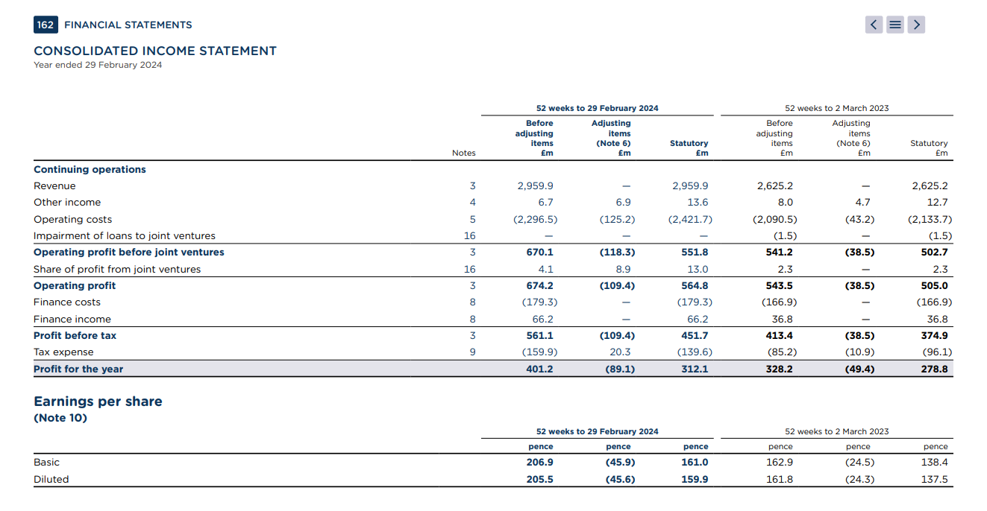
Figure 2: Consolidated Income Statement
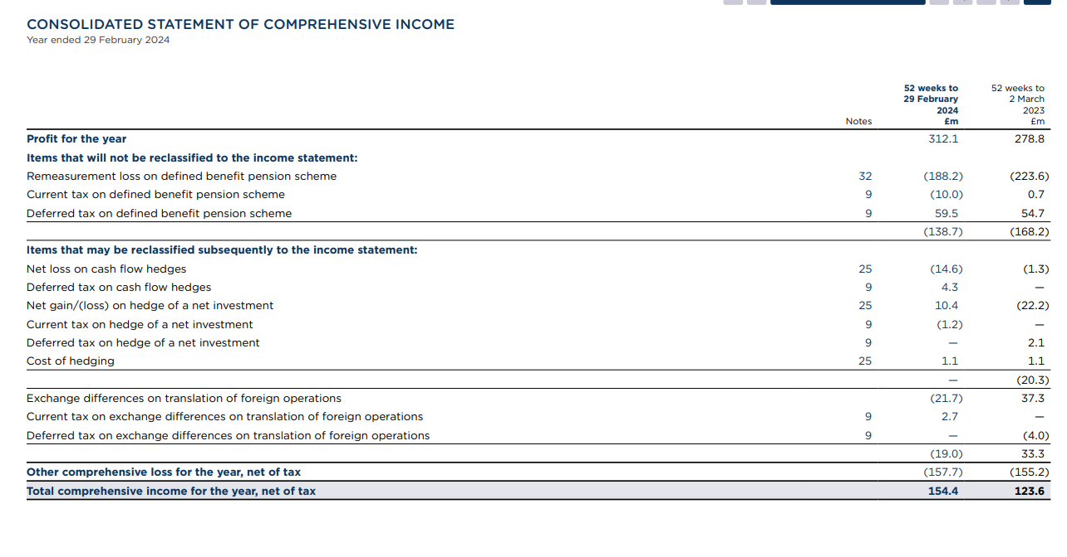
Figure 3: Consolidated Statement of Comprehensive Income
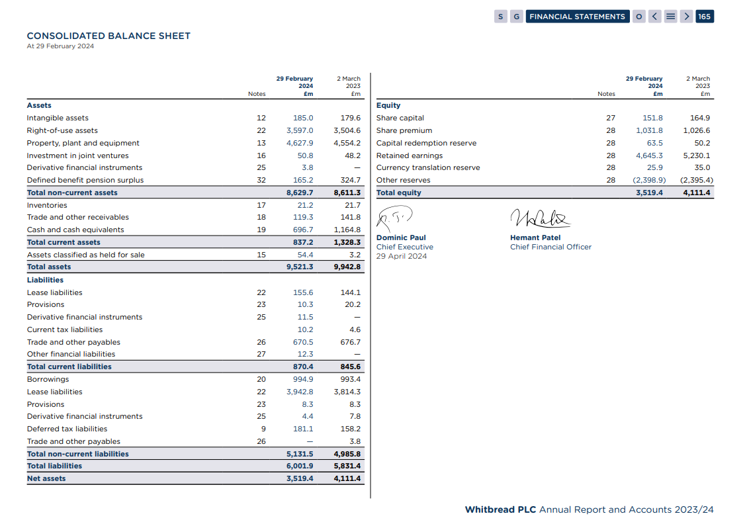
Figure 4: Consolidated Balance Sheet
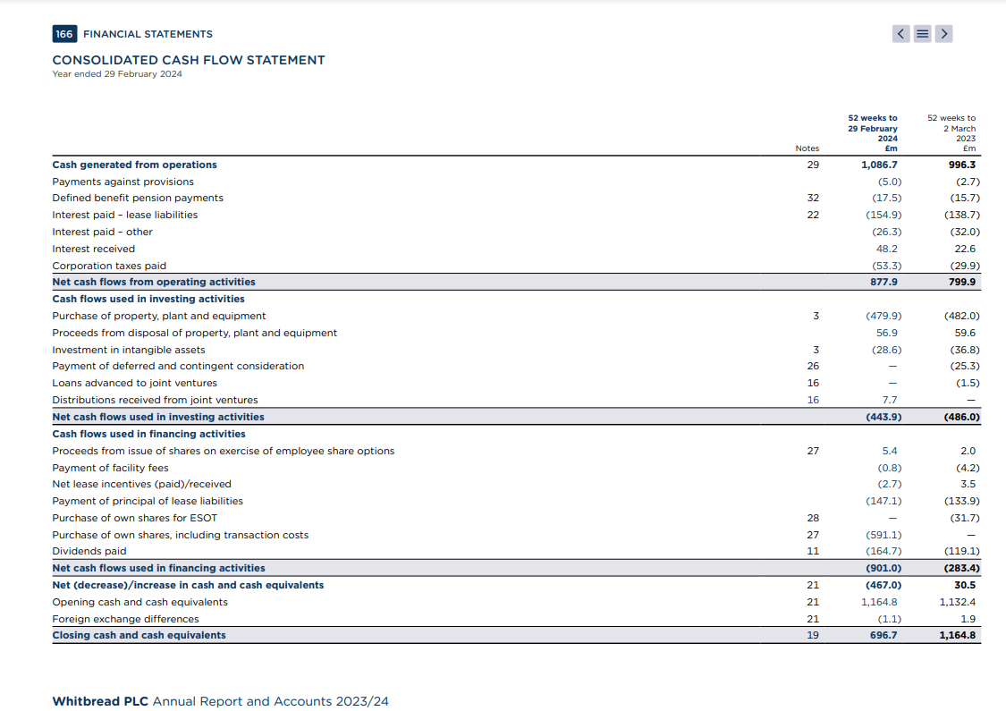
Figure 5: Consolidated Cashflow Statement

Ratio Calculations
Profitability Ratios
 | 2024 | 2023
Gross Profit Margin
Operating Profit Margin | 18.96% | 15.75%
Net Profit Margin | 10.54% | 10.62%
Return on Asset (ROA) | 5.89% | 4.16%
Return on Equity (ROE) | 8.87% | 6.78%
Return on Capital Employed (ROCE) | 6.49% | 4.54%
Liquidity Ratios
 | 2024 | 2023
Current Ratio | 0.96186 | 1.57084
Quick Ratio | 0.9375 | 1.54518
Gearing Ratios
 | 2024 | 2023
Debt to Equity Ratio | 0.28269 | 0.24162
Gearing Ratio | 0.22039 | 0.1946
Efficiency Ratios
 | 2024 | 2023
Inventory Turnover (Days) | 113.151 | 101.926 | Days
Receivables Turnover (Days) | 14.7115 | 19.7155 | Days
Payables Turnover (Days) | 102.023 | 111.672 | Days
Asset Turnover | 0.31087 | 0.26403 | Times
Fixed Asset Turnover | 0.34299 | 0.30486 | Times
Solvency Ratios
 | 2024 | 2023
Interest Coverage Ratio | 3.12939 | 2.47693
Debt-to-asset Ratio | 0.10449 | 0.09991
Investment Ratios
 | 2024 | 2023
Earnings Per Share (EPS) -Basic | 161 | 138.4
Earnings Per Share (EPS) - Diluted | 159.9 | 137.5
Price per Earnings ratio (P/E) | 20.6567 | 22.3636

