

Digital Skills and Research Methods
Term 2

Irina Merlan
1818268
07.01.2020

Table of content:
- Introduction………………………………………………………………………………..….….page 3
- Background………………………………………………………………………………………..page 3
- Aims and Objectives………………………………………………………………………..…page 5
- Methodology….………………………………………………………………………………..…page 5
- Results………………………………………………………………………………………………..page 6
- Conclusion…………………………………………………………………………….….………..page 11
- References……………………………………………………………………..…………....…....page 12
- Appendices ……………………………………………………………………………...………..page 13

Introduction
The main purpose of this assignment is to analyse what is the impact of the V.L.E. (virtual learning environment) on the learning experience of the students from the University of Wales Trinity Saint David London Campus. I started to explain a little about the background of the topic which contains literature review. After that I identified what are the aims and objectives of my research. I manage to do that by doing a research in which I have collected and analysed primary and secondary data. The primary data was collected with the help of a questionnaire which was applied to 30 samples which were students randomly picked from the campus of the university. After that, I have analysed this primary data with the help of different statistical tools and techniques.
Background
In the 21st century, the E-learning has ended up noticeable as part of this wave of technology and digitization which has reached and affected positively and negatively different corner of the world (Barrington& Barrington, 2014). Either if we speak about the business sector or any other sector we can’t think how this would function with technology. The education sector has embraced as well this wave and improved the learning environment for the students. One of these improvements stands for Virtual Learning Environment which gives the students the opportunity to easily access a bigger amount of academic materials which are basic for the learning experience.
One of these examples of V.L.E. is the Moodle digital platform which delivers to the students different learning materials which are basic for diverse courses or provide to them a various amount of ideas, activities and interactions on different subjects. (Guasch et al. 2010)
According to Beek (2018) "Digital learning can greatly improve the way educational services are delivered. More schools should embrace this innovation.".
According to Bateman (2018), virtual learning environments come with a lot of benefits for both students and teachers. If we analyse the benefits provided for students, V.L.E. gives them the opportunity to learn in an advanced way by using methods which helps them to gain new skills and abilities without the need or travelling or to arrange meetings with their colleagues which attend the same courses. V.L.E. brings to huge advantages for the teachers as well. They can prepare virtual lessons or practical courses for students giving them the opportunity learn despite of the distance. Via a V.L.E a mixed learning approach can moreover offer to students more assistance and help in order to keep them engaged into a course, investing time more in working on tasks which are more practical for learning all the theories behind what the teachers are doing though a virtual learning environment.
Nearly all higher education institutions adopt VLE and the Virtual Learning Environment is created and edited by the teachers and other individuals which usually design and plan the learning materials which are used by the students on the platforms such as Moodle (Xu, Park and Baek, 2011).
Figure 1.Moodle registration map
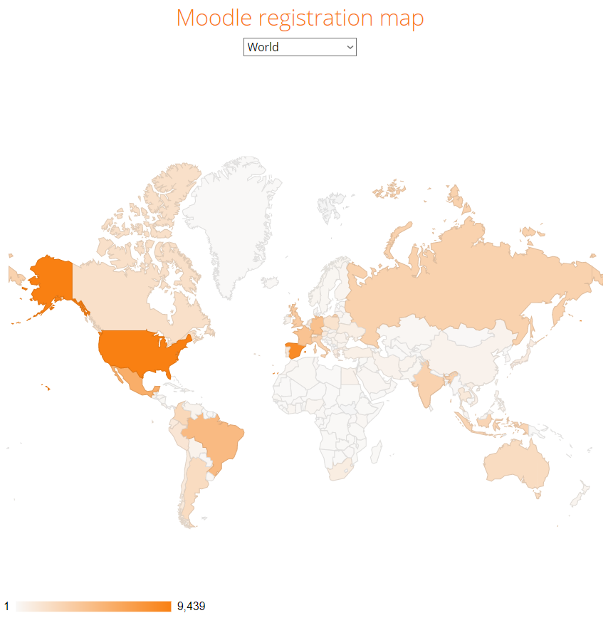
According to the statistics about the moodle which are available at https://stats.moodle.org, they are 104,000 sites with 20,000,000 courses and 175,000,000 users and 841,000,000 enrolments with 370,000,000 forum posts and 180,000,000 resources with 1,821,000,000 quiz questions over 230 countries. In Figure 2, United Kingdom is on place 7/10 on top 10 from 230 countries by registration.
Figure 2.Top 10 from 230 countries by registrations
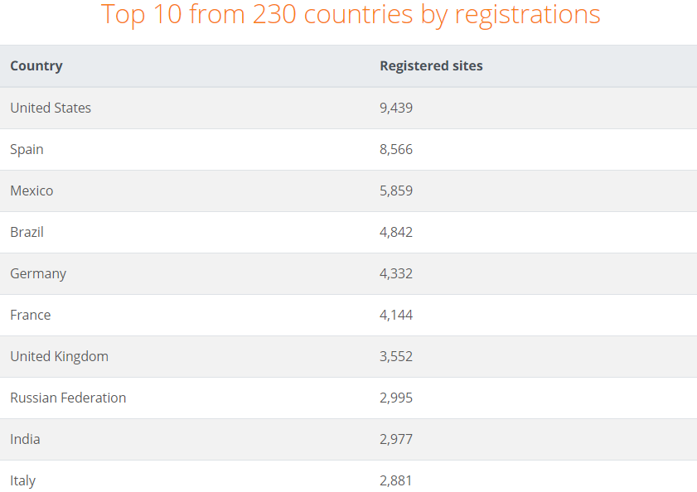
Aims and objectives
The main aim of this research is to analyse what are the impacts of the V.L.E. (virtual learning environment) on the learning experience of the students from the University of Wales Trinity Saint David London Campus. Along with this, the main objective is to identify all the positive and negative influences by using the Moodle in the academic virtual learning environment. Another objective is to evaluate which are the techniques that can be used in order to develop the technology skills along with employability. Other objectives are to research the usefulness of the platform for the students who are using the Moodle and to identify what is the frequency of using this academic platform for the academic purposes.
Methodology
The essential part of my research is methodology. According to Kumar(2019), the main elements of the research methodology are research approaches, research philosophy, statistical approaches and data collection. I was doing this research in which I have collected and analysed primary and secondary data. The primary data which contains essential information is usually collected directly from the field. That implies collecting the information from direct interaction with respondents which in my case was the personal interview.
According to Flick (2015), the primary data sources are more solid and accurate sources as there is a low chance of data manipulation and secondary data can be changed, redesigned, adjusted or updated which can lead in manipulation of the original information and results. I collected secondary data from books, auxiliary materials, online researches, articles, diaries, statistics and many more.
The primary data collection tool is represented by a questionnaire which contains 10 questions which are different types of questions related to the gender, age group, satisfactory level and so on. After that, I have analysed the primary data with the help of different statistical tools and techniques. In order to extract the results I have analysed the data quantitatively (Sreejesh, 2016).
The population is represented by the students who are learning at the University of Wales Trinity Saint David. The geographical area in which I have carried out my primary research is in London Campus, U.K. Because the populations which is studied has huge proportions, the method which I have used to collect my data is personal interview which was applied to 30 samples which were students randomly picked from the campus of the university to take part of this study. I choose to protect the identity of the students and therefore I did not ask them any personal information because I wanted to analyse the participants of the survey as a combined form of a sample, not to identify them as individuals cause them any difficulties and issues in their replies for my questionnaire.

Results
After I have analyzed the primary data I concluded to these results. Analyzing the 30 samples, I have 20 respondents which are male and 10 are female. The male gender represents 33% of the whole percentage and 67% are female. That means we have in our campus more females students which are using the Moodle rather than male students.
Graphic 1.Gender proportions of the respondents

The group age of the respondents is analyzed bellow in the graphic 2.
Graphic 2. Age group of the respondents

The results above show the mixture of the age of the respondents as their age group may vary from 18 to 51 or more. The most common age group is the 29-40 age range represented by 17/30 so more than half of the respondents and the next age group is 18-28 age range represented by 8/30 so most of the users of the Moodle are young individuals.
How often the respondents access Moodle to study?
Graphic 3.The frequency of respondents of accessing the Moodle per week

Graphic 3 represents the frequency per week of respondents of accessing the Moodle to study and from the bar chart represented above we can see that most respondents 10/30 which represent 33% are accesing the Moodle to study 2 times per week and 3/30 respondents are accesing the Moodle daily to study. From this analysis, we can see clearly that the most frequency of access is 2 times per week and it might be because we are coming only 2 times a week at school and the lower frequency is 3/30 respondents are accessing the Moodle daily which to study which means the among of students which are using the Moodle platform for V.L.E. is quite frequent.
From where did they normally access the Moodle?
From the Graphic 4 which is represented bellow we can see that 40% of the students are accessing the Moodle from the University Campus which means either on computer labs, on their laptops or phones but in the Campus Area and 40% of the students are accessing the Moodle from Off University Campus(e.g. at home). Only 20% of the students are accessing the platform between on and off campus which means they don’t find it easy to access it if it’s not form home or university campus.

Graphic 4.Percentage of location accessing the Moodle

From the Graphic 5 represented bellow it is clear that the amount of students who are accessing the Moodle from Off University Campus and from the University Campus is equally divided into 12/30 and 12/30 respondents.
Graphic 5.Location of access of Moodle

Did the students experience any technical problems in accessing the Moodle?
Graphic 6.Percentage of meeting technical problems in accessing the Moodle
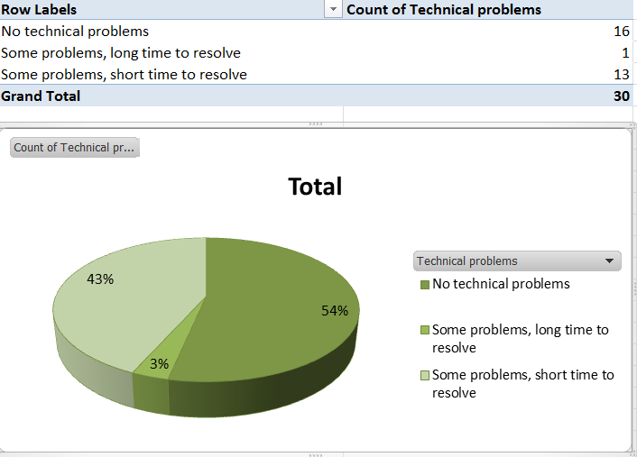
According to Graphic 6 which analyzes the percentage of the respondents who had technical problems in accessing the Moodle it can be clearly seen that only 1/30 respondents which represents 3% of the students had problems which took a long time to resolve but most of them (54%) didn’t have any technical problems or they had some problems but it took a short time to resolve and to access the Moodle(43%).
That means the platform is easy to use and mostly with no technical issues for a long period of time which means that the students didn’t waste time in using this type of V.L.E in academic purposes.
How satisfied are the respondents about the Moodle?
As we can see in the Gaphic bellow 53% of the students are satisfied about the Moodle and 30% are very satisfied which means 83% of the students finds this V.L.E. platform a good tool and they are happy to use it in order to study. Only 5/30 respondents were not sure or the level of satisfaction of the Moodle was low and no records have been for Very unsatisfied.

Graphic 8.Level of satisfaction for the Moodle
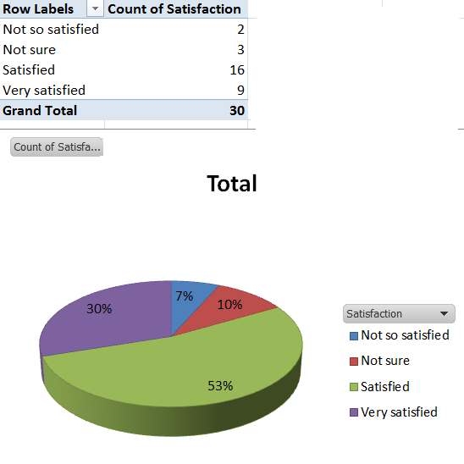
Did the staff from the university helped the rspondents to navigate in the Moodle?
Graphic9. Percentage of the students who were helped by the staff in accessing the Moodle
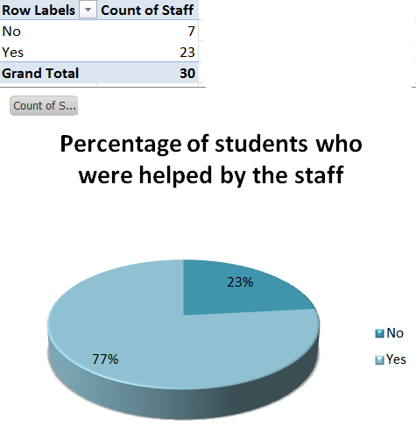
As we can see in the Graphic 9 which represents the percentage of the students who were helped by the staff we can observe that 23/30 which represents 77% of the students were helped by the staff. That means that most of the time, the staff was happy to offer their time and help to the students in order to help them to access the Moodle.
Conclusions
This main purpose of the research has been touched and we can clearly see that the using of V.L.E brings mostly advantages among both students and teachers for academic life. The effectiveness of using the Moodle is highly rated among the students of University of Wales Trinity Saint David in the London Campus. Mostly of them are young females within the group of 18-40 who are using the Moodle mostly 2 times a week either from the campus or from home and didn’t had any difficulties in accessing the platform. The level of satisfaction of students for using the Moodle is raised as well.

References
- Barrington, R. and Barrington, R. (2014). Moodle Gradebook. Birmingham: Packt Publishing.
- Sreejh, S. (2016). MIXED METHOD RESEARCH DESIGN. [Place of publication not identified]: SPRINGER.
- Damnjanovic. V, Jednak. S, &Mijatovic. I, (2015) Factors affecting the effectiveness and use of Moodle: students' perception, Interactive Learning Environments, 23:4, 496-514,
- Barker, J. and Gossman, P., 2013. The learning impact of a virtual learning environment: students’ views. Teacher Education Advancement Network Journal (TEAN), 5(2), pp.19-38.
- Choi, B. and Baek, Y., 2011. Exploring factors of media characteristic influencing flow in learning through virtual worlds. Computers & Education, 57(4), pp.2382-2394.
- Flick, U., 2015. Introducing research methodology: A beginner's guide to doing a research project. Sage.
- Kumar, R., 2019. Research methodology: A step-by-step guide for beginners. Sage Publications Limited.
- Xu, Y., Park, H. and Baek, Y., 2011. A new approach toward digital storytelling: An activity focused on writing self-efficacy in a virtual learning environment. Journal of educational technology & society, 14(4), pp.181-191.
- Lukman, R. and Krajnc, M., 2012. Exploring non-traditional learning methods in virtual and real-world environments. Journal of Educational Technology & Society, 15(1), pp.237-247.
- Power, C., Petrie, H., Sakharov, V. and Swallow, D., 2010, July. Virtual learning environments: another barrier to blended and e-learning. In International Conference on Computers for Handicapped Persons (pp. 519-526). Springer, Berlin, Heidelberg.

Appendices


