Module: Marketing Management
Module code: LCMB7024
Lecturer: Taonga Kaonga Sobere-Snithers
Student Name: Crista Grigore
Student Id:2118246
Assignment Title: Assessment component 2: Marketing Strategies Portfolio

Table of Contents
Element 2: Segmentation, Targeting, Differentiation, and Positioning (STDP) Analysis for Apple Inc 4
1.1 Segmentation 4
1.1.1 Geographic 4
1.1.2 Demographic 4
1.1.3 Psychographic 4
1.1.4 Behavioural 4
1.2 Targeting and persona 5
1.2.1 Primary target profile 5
1.3 Purchase drivers 6
1.4 Market size and rationale 6
1.5 Differentiation 6
1.5.1 Value proposition 6
1.5.2 USP 7
1.5.3 Competitor gap analysis 7
1.6 Positioning 7
1.6.1 Positioning statement 7
1.6.2 Messaging pillars 7
1.6.3 Proof points 8
Element 3: Marketing mix (7Ps) 8
2.1 Product 8
2.2 Price 8
2.3 Place 9
2.4 Promotion 9
2.5 People 9
2.6 Process 10
2.7 Physical evidence 10
Element 4: Reflection 11
3.1 Skills and knowledge gained 11
3.2 Poster preparation and presentation reflection 11
3.3 Future improvements and professional development plan 12
References 13
Appendices 17
Appendix 1 – Element 1 – Poster Presentation 17

Element 2: Segmentation, Targeting, Differentiation, and Positioning (STDP) Analysis for Apple Inc

1.1 Segmentation

1.1.1 Geographic
The brand will target the high-income and middle-income markets which have a high level of roof-top solar adoption and favourable policy. Its main markets are North America, Western Europe, Australia and selected cities in Asia Pacific (Tian et al., 2022). The quickest adoption is demonstrated by urban and suburban homeowners whose grid is unstable or are charged high retail electricity rates (Wood Mackenzie, 2024). The regional installers and utility programs influence the speed of roll-out and revenue models (IEA, 2023).

1.1.2 Demographic
The main target consumers are aged 30-65 years and they are homeowners. Homes with a household income that is above the median and with those that have mortgage or ownership status. The early adopters are biased towards the professionals, the technology workers and the educational level of higher learning (Wang, 2024). The next generation of households with older and empty nests is conscious of backup power and comfort (Deloitte, 2023). Younger families prioritize in their purchasing behaviour in terms of savings and sustainability (Grand View Research, 2025).

1.1.3 Psychographic
High-tech products offer premium reliability, convenience, and status to their intended users. They cherish smooth systems and well-refined user experience. Purchases are driven by environmental issues and desire to be independent of utilities (Deloitte, 2025). Complex installs make risk aversion a factor that drives the demand of white glove services. Purchase intent is determined by brand trust and privacy guarantees (Saeli et al., 2025). Analytics and Warranty extension subscription is more popular among homeowners with greater lifetime value (Gupta, Misra and Yadav, 2021).

1.1.4 Behavioural
Purchase drivers involve the increasing electricity prices, experience of outage, and ownership of solar. The customers prefer ready-made solutions to the do-it-yourself ones (Grand View Research, 2025). With the existence of evident ROI in terms of bill savings or grid services, subscription acceptance attains an increase. Repeat purchases or upsell would be through software functionalities, capacity add-ons and enrolment of VPP. High intent leads are converted into in-store demos and installer recommendations (Carrera, 2025). Sensitivity to the price is present but fades away among the purchasers who also appreciate the brand experience and financing opportunities (McKinsey and Company, 2025).
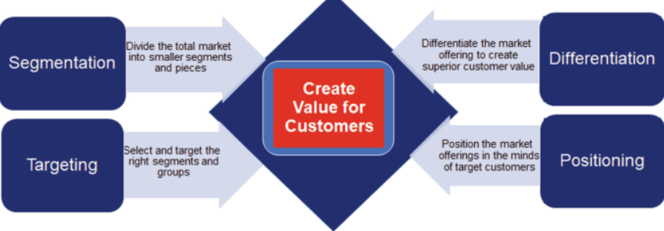
Figure 1: STDP Analysis
Source: (Wheeler, 2022)

1.2 Targeting and persona

1.2.1 Primary target profile
Attribute | Details
Persona | Urban Eco Tech Owner
Age | 35 to 55
Income | Upper middle to high
Home status | Owns detached or semi-detached house
Tech profile | iPhone user, HomeKit enabled, uses paid digital services
Motivations | Lower bills, backup power, sustainability, status
Pain points | Difficult installs, weak UX, privacy concerns, high cost
Purchase drivers | Brand trust, live demo, installer advice, finance options
Buying behaviour | Prefers integrated systems, accepts subscriptions
Preferred channels | Apple Stores, website, certified installers
After sales habits | Expects quick support and software updates
Lifetime value indicators | Subscriptions, upgrades, referrals

Detailed explanation
Urban Eco Tech Owner is a homeowner aged 35-55 and with a higher income and good exposure to digital ecosystem. They like combined technology that can be installed in everyday lives in a single application. Their primary objectives consist of smaller bills, better up backup power and less emission. They are hesitant in situations where installations appear complicated or cases where privacy is not evident. The retail outlet and installer recommendation of Apple have effects. Cost barriers are solved through financing. Once they have made a purchase, they want quick service and dependable updates. They tend to embrace add-ons and subscriptions and this enhances retention and long-term value.

1.3 Purchase drivers
The need to have the lower bill, trustworthy backup, environmental effects and smooth control of the devices. The tendency to using branded ecosystem and easy installation. Ready to fund hardware at predetermined monthly expense. Final decision depends on the installer endorsement and live demonstration (Grand View Research, 2025).

1.4 Market size and rationale
The residential battery market is very robust with an estimated tens of billions with high CAGR till the year 2030 (Reuters, 2025). The market of smart homes and energy is developed in tandem, allowing Apple to cross-sell its installed base. The premium of the Apple brand and the presence of the company in the retail market lower the price of acquiring customers compared to entry (MarketsandMarkets, 2024). The segment will provide hardware margins and subscription ARPU by analytics and energy services (Mordor Intelligence, 2026).

1.5 Differentiation

1.5.1 Value proposition
Apple Smart Energy Hub is a connection between high-quality equipment and software that is easy to use. It provides real-time energy analytics, HomeKit, automatic load shifting and grid participation. The product will be based on intuitive UX, safe data management, and AppleCare. The package also includes approved installation and optional energy management subscription.

1.5.2 USP
The USP of Apple is that it has integrated systems among the devices, retail channels that can be trusted and huge ecosystem in terms of services. The Hub is Apple designed and single-touch based with Home application. Apple wallets to fund and relationships with existing payment facilitates conversion. The product has household-expanding modulatory capacities.

1.5.3 Competitor gap analysis
Tesla, Sonnen and LG are major incumbents who dwell on battery specifications and VPP features. They have varying UX and brand presence in retail is different in terms of retail. Tesla is a leader in terms of capacity density and VPP scale (Tesla, 2025). Sonnen puts stress on community VPPs (Sonnen, 2025). LG is interested in engineering and installer networks (LG Energy Solution, 2025). Apple bridges discrepancies in refined user experience, store demonstrations, cross-sell ecosystem, and exclusive customer service solutions. This makes the process less cumbersome to the mainstream customer who appreciates convenience and reliability.

1.6 Positioning

1.6.1 Positioning statement
Apple Smart Energy Hub, which is a homeowner’s product that is able to provide a simple, secure and efficient home energy, consists of an integrated battery and solar management system with an Apple design, a smooth Home app, and an AppleCare service. It provides guaranteed bills, blackout coverage, and low set-up pressure (IEA, 2023).

1.6.2 Messaging pillars
Simplicity: Apple UX is one app set that was certified as installers of white glove delivery.
Reliability: Redundancy and failover that has proven hardware.
Sustainability: Recycled products, supplier renewables, life-cycle take-back.
Value. Both hardware and subscription plans with apparent ROI through bill savings and VPP revenue.

1.6.3 Proof points
Pilot testing and installer partner deployments and utility pilot deployments. Regional based tariff energy saving modelling. Battery specifications compared with the mainstream products. Apple greener reports on recycled materials and renewables used by the suppliers. Retail demo measures of conversion uplift (Wood Mackenzie, 2024; MarketsandMarkets, 2024).

Element 3: Marketing mix (7Ps)

2.1 Product
The Apple Smart Energy Hub is an energy platform that is home-based and modular. It combines a small inverter, a modular battery pack, which can be expanded, and a control module, which is connected to the Apple Home app. The hardware is Apple designed and has interior enclosures of a sealed enclosures that can be installed in a garage or indoors. The modules are built to connect to one another easily to upgrade the field (Chen et al., 2024). Software updates are features that are added without access to hardware. The product is interoperable with a one-touch Home app set up course and Matter support of third-party devices. The Hub has the inbuilt solar yield, consumption and savings analytics. Add-ons that users have options include additional battery modules, EV charger integration, and two levels of analytics and grid services. The device can be locally controlled, and encrypted data processing can be used to ensure privacy (Tian et al., 2022). Security and quality are in accordance with the known energy storage standards. Apple retailing experience encourages practical demonstrations and the booking of pre-sales location evaluation. This product plan lowers the perceived risk among mainstream buyers, and helps sustain revenues in software and service (Apple Developer, 2026).

2.2 Price
The pricing is a combination of a higher initial price and subscription. Base hardware is of a premium that is above mainstream home batteries. Tiered packages match capacity and services. Funding partners will provide low monthly payments through Apple Pay instalments. The subscription plans are based on the principles of an energy storage as service, under which customers purchase a monthly subscription fee in exchange of analytics, maintenance, optional ownership models, run by third parties (Wang, 2024). This will reduce the initial cost of entry amongst practical families. There are transparent calculators of ROI determined on the basis of tariff data and on local incentives. The pricing strategy is based on the overall cost of ownership rather than only initial price to support the premium positioning and more lifetime value based on the service ARPU (Roots Analysis, 2026).

2.3 Place
Distribution is via Apple Stores, Apple.com as well as certified installer networks. In the Apple Stores, there are demos and pre-installation surveys. The online store also promotes distant location reviews and finance deals. Site works and warranty activation are done by certified installers. Collaboration with utilities and solar installer allows the bundling of offers. This multi-channel channel helps minimize the acquisition expenses and allows Apple to claim the retail story (Saeli et al., 2025). In-store appointments and retail demos generate an increased conversion rate in comparison with pure online listings. The certification of installers provides the same quality of installations and brand experience across markets (Harvard Business Review, 2011).

2.4 Promotion
Use of coordinated PR, retail activities, as well as targeted digital campaigns are used by Launch. PR emphasizes safety, privacy and sustainability qualifications. Apple Stores organize demonstration workshops and training of builders. Influencer strategy is based on reputable technology reviewers and thought leaders in the energy industry (Carrera, 2025). Paid search focuses on high tariff and outage areas on homeowners. Cross-sell campaigns are directed to current users of Apple Services and devices and offer them personalised deals. Co-branded rebates and pilot case studies are a partnership with utilities to demonstrate value. Regional Payback calculators, installer testimonials and short installation videos are used as content marketing. Face-to-face experience and workshops in the community facilitate the adoption of the less technical consumers. This is a combined strategy that employs earned, owned, and paid media to reduce the decision-making process (Have Ignition, 2024).

2.5 People
People strategy is based on the trained Apple retail personnel and certified installers. Apple retail teams are given product and energy basic training to have successful demos. The installer programmes qualify electricians and solar companies to fulfil the standards of safety and warranty (Chen et al., 2024). An elite level of AppleCare is offered to energy products which includes remote diagnostics and priority field service. Training focuses on the aspect of safety, user onboarding, and privacy practices. Mutually, installer networks are provided with lead referrals using the Apple platform. This framework safeguards brand pledge and aids installations scaling and keeping trust with the customers (Clean Energy Council, 2025).

2.6 Process
The flow charts include pre-sale survey, installation and after-sales support. Customers make an online booking either online or in stores. Certified installers do the site prep and system commissioning on a checklist (Richardson, 2024). The Home application takes you through the process of onboarding through a step wizard and safety and connectivity checks. The updates of firmwares and services are carried out via the secure channels of Apple. Remote diagnostics will minimise truck rolls and resolutions. Easy response and replacement support service level agreements are good pricing to retain and retention. The onboarding of devices and complex apps are associated with UX to minimize the friction during the setup (Nielsen Norman Group, 2025).

2.7 Physical evidence
Packaging is made of recyclable materials and has minimized inserts to be recycled. Retail demos offer a modular simulated failure, an application walkthrough, and simulated failure situations. Safety certifications and Warranty are also found in their marketing and packaging to create trust (Richardson, 2024). Apple provides long-form capacity and performance guarantee and a definite warranty on cells and system components. The Hub has recognised safety marks of any market, as well as UL and IEC compliances of energy storage systems. On the product page, demo performance metrics and independent lab results are represented. Installation certificates, serial numbers and test reports are stored in post-sale customer portals. Strict certification and an elegant retail image reduce perceived risk among mainstream homeowners and contributes to premium brand positioning (UL/standards guidance, 2025).
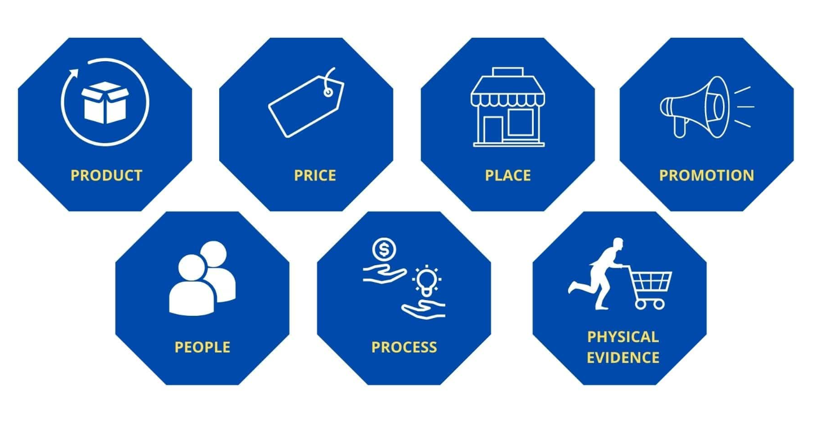
Figure 2: Marketing Mix 7Ps
Source: (Greene, 2024)
The major scholarly and practitioner assistance
Capital-intensive home technology markets are better adopted using product modularity and service bundling. Onboarding of users and UX of apps decrease the churn of connected devices. Certified service partners Omnichannel retail and certified service partners expand conversion and secure brand equity. Service storage of energy provides alternative revenue and price reduction. Clear warranties and safety certification makes the purchase less frictional and hastens approvals. In essence, the 7Ps coexist to provide a high-value, low friction, service-based home energy product, which takes advantage of the retail and ecosystem capabilities of Apple (NNG, 2025; Have Ignition, 2024; Infovision, 2025).

Element 4: Reflection

3.1 Skills and knowledge gained
I associated strategic frameworks with a realistic product brief. I compared and contrasted market segments based on the existing information and justified arguments with references. I created an elaborate persona and charted purchase drivers to monetisation pathways. I developed a 7P marketing mix that fits retail, subscriptions of software and certified installer services. I practiced to write concisely the academic work and discipline in citation. I enhanced visual presentation on the poster slide. I charted out stakeholder issues and made evidence summaries on each claim. I established pilot trial and monitoring success indicators. I applied meta reflection in order to transform feedback into tangible edits (Yadav and Bhatia, 2024).

3.2 Poster preparation and presentation reflection
Compression of messages was imposed by poster work. I made headlines concise and I relied on the use of diagrams. There were clear risk responses and lines of revenue in the investor pitch. The live rehearsals revealed the lapses in pilot evidence and installer expenses. Assumptions on tariffs and local incentives were tested by way of the audience questions. I rearranged content to pre-empt on investment and retail distribution benefits. The product benefits were realized by using demo scenarios to make products tangible to the non-technical stakeholders. Flow was enhanced and filler language was eliminated through timing practice. Evidence, flow, and slide sequencing edits were directed by post rehearsal reflection (Sherwood, 2024).

3.3 Future improvements and professional development plan
To begin with, two small pilot deployments should be run using certified installers to collect performance and user information. Second, prepares model regional tariffs and briefs of produce market specific ROI. Third, full-time energy economics and regulatory policy short courses. Fourth, attend investor pitch workshops and simulated panels to tighten delivery. Fifth, create a set of installer tools to normalise commissioning and handover. I will keep an eye on KPIs and generate monthly reports to the stakeholders. These measures enhance the empirical evidence, make operations more prepared, and the portfolio more assessable. Evidence-based practice, critical analysis, and applicability by the professionals will be graded and recorded in an annex, and their transparency reports to the stakeholders.

References
Apple (2024) Environmental Progress Report 2024. Apple. Available at: https://www.apple.com/environment/pdf/Apple_Environmental_Progress_Report_2024.pdf (Accessed: 26 February 2026).
Apple Developer, 2026. Developing apps and accessories for the home. Apple Developer. Available at: https://developer.apple.com/apple-home/ (Accessed: 26 February 2026).
BloombergNEF (2025) Global Energy Storage Growth Upheld by New Markets. BloombergNEF. Available at: https://about.bnef.com/insights/clean-energy/global-energy-storage-growth-upheld-by-new-markets/ (Accessed: 26 February 2026).
Carrera, D. R. S. (2025). The 7Ps of Marketing: Keys to Business Success in a Changing Environment. Diginomics, 4, 193-193. https://diginomics.ar/index.php/digi/article/download/193/218 (Accessed: 26 February 2026)
Chen, Z., Xu, Y., and Zhang, G. (2024). Analyzing market plans for enhanced energy hub efficiency: strategies for integrating multiple energy sources and collaboration. Energy Sources, Part A: Recovery, Utilization, and Environmental Effects, 46(1), 10994-11017. https://www.tandfonline.com/doi/abs/10.1080/15567036.2024.2387239 (Accessed: 26 February 2026)
Clean Energy Council (2025) Industry programs. Clean Energy Council. Available at: https://cleanenergycouncil.org.au/industry-programs (Accessed: 26 February 2026).
Deloitte (2023) Smart home trends. Deloitte Insights. Available at: https://www.deloitte.com/us/en/insights/industry/telecommunications/connectivity-mobile-trends-survey/2023/smart-home-industry-adoption-trend.html (Accessed: 26 February 2026).
Deloitte (2025) For home tech, think 'smarter' and harder (no date). https://action.deloitte.com/insight/3545/for-home-tech-think-smarter-and-harder (Accessed: 26 February 2026)
Grand View Research (2025) Battery Energy Storage Systems Market Size Report, 2033. Grand View Research. Available at: https://www.grandviewresearch.com/industry-analysis/battery-energy-storage-systems-market (Accessed: 26 February 2026).
Grand View Research (2025) Residential Battery Market Size | Industry Report, 2033. Grand View Research. Available at: https://www.grandviewresearch.com/industry-analysis/residential-battery-market-report (Accessed: 26 February 2026).
Gupta, S., Misra, M. and Yadav, J. (2021) 'Connected Homes: Inclusion of IoT in Indian households,' SSRN Electronic Journal [Preprint]. https://doi.org/10.2139/ssrn.3874398 (Accessed: 26 February 2026)
Have Ignition (2024) Go-to-market strategy for smart home devices. Have Ignition. Available at: https://www.haveignition.com/industry-guides/go-to-market-strategy-for-smart-home-devices (Accessed: 26 February 2026).
IEA (2023) Energy storage. International Energy Agency. Available at: https://www.iea.org/energy-system/electricity/grid-scale-storage (Accessed: 26 February 2026).
Infovision (2025) Experiential retail trends: How immersive store experiences are redefining store shopping. Infovision. Available at: https://www.infovision.com/blog/experiential-retail-trends-how-immersive-store-experiences-are-redefining-store-shopping/ (Accessed: 26 February 2026).
Johnson, R. (2011) What I learned building the Apple Store. Harvard Business Review, 21 November 2011. Available at: https://hbr.org/2011/11/what-i-learned-building-the-ap (Accessed: 26 February 2026).
LG Energy Solution (2025) Home Battery. LGESS. Available at: https://www.lgessbattery.com/m/us/home-battery/intro.lg (Accessed: 26 February 2026).
MarketsandMarkets (2024) Smart Home Market Size, Share & Growth, 2032. MarketsandMarkets. Available at: https://www.marketsandmarkets.com/Market-Reports/smart-homes-and-assisted-living-advanced-technologie-and-global-market-121.html (Accessed: 26 February 2026).
McKinsey & Company (2025) Evaluating the revenue potential of energy storage technologies. McKinsey. Available at: https://www.mckinsey.com/industries/electric-power-and-natural-gas/our-insights/evaluating-the-revenue-potential-of-energy-storage-technologies (Accessed: 26 February 2026).
Mordor Intelligence (2026) Battery Energy Storage System (BESS) market. Mordor Intelligence. Available at: https://www.mordorintelligence.com/industry-reports/battery-energy-storage-system-market (Accessed: 26 February 2026).
Nielsen Norman Group (2025) Onboarding and Connecting Smart Devices: 5 Guidelines. NNGroup. Available at: https://www.nngroup.com/articles/smart-device-onboarding/ (Accessed: 26 February 2026).
Nielsen Norman Group (2025) Smart-Device Apps: 7 Best Practices. NNGroup. Available at: https://www.nngroup.com/articles/smart-device-best-practices/ (Accessed: 26 February 2026).
Reuters (2025) China's power reforms, global data centre buildout usher in battery boom. Reuters. Available at: https://www.reuters.com/sustainability/climate-energy/chinas-power-reforms-global-data-centre-buildout-usher-battery-boom-2025-12-21/ (Accessed: 26 February 2026).
Richardson, N. (2024). The Marketing Mix. In Sustainable Marketing Planning (pp. 79-136). Routledge. https://www.taylorfrancis.com/chapters/edit/10.4324/9781003434214-5/marketing-mix-neil-richardson (Accessed: 26 February 2026)
Roots Analysis (2026) Energy Storage As A Service Market Industry Report 2040. Roots Analysis. Available at: https://www.rootsanalysis.com/energy-storage-as-a-service-market (Accessed: 26 February 2026).
Saeli, R., Rahmani, B., and Annabestani, A. A. (2025). Strategic Analysis of the Position of Apple inc. https://gps.gu.ac.ir/article_232012_60f8a383a06240446a724d385afc1911.pdf?lang=en (Accessed: 26 February 2026)
Sonnen (2025) sonnenBatterie. sonnen. Available at: https://sonnengroup.com/sonnenbatterie/ (Accessed: 26 February 2026).
Tesla (2025) Powerwall – Home Battery Storage. Tesla. Available at: https://www.tesla.com/powerwall (Accessed: 26 February 2026).
Tian, W., Wang, M., and Wang, Q. (2022). The core competentness of Apple Inc. In 2022 7th International Conference on Financial Innovation and Economic Development (ICFIED 2022) (pp. 718-725). Atlantis Press. https://www.atlantis-press.com/article/125971602.pdf (Accessed: 26 February 2026)
UL standards guidance (2025) UL certifications for battery systems. SunLith Energy. Available at: https://sunlithenergy.com/ul-certifications-for-battery-systems/ (Accessed: 26 February 2026).
Wang, F. (2024). Analysis of Home Furnishing Marketing Based on Internet of Things in the Intelligent Environment. International Journal of Ambient Computing and Intelligence (IJACI), 15(1), 1-16. https://www.igi-global.com/viewtitle.aspx?titleid=348964 (Accessed: 26 February 2026)
Wood Mackenzie (2024) Europe residential energy storage outlook 2024. Wood Mackenzie. Available at: https://www.woodmac.com/reports/power-markets-europe-residential-energy-storage-outlook-2024-150283658 (Accessed: 26 February 2026).

Appendices

Appendix 1 – Element 1 – Poster Presentation


