
University of Wales Trinity Saint David Birmingham

Professional development within Health and social care (LCHS4009)
Birmingham

Submitted by
Name of the student: Azra Munirali Habib
Student ID:2507358

Lecturer: Wafa Nasir

Contents
Curriculum Vitae 3
Personal Statement 9
Personal SWOT Analysis 11
Personal Development Plan Template 12
Reflection Using Gibbs’ Reflective Cycle 14

Curriculum Vitae
Azra. Munirali. Habib.
Address:- 38 Dymoke street, Birmingham, B120TA.
E-mail:- azra22munir@yahoo.com.
Phone number: - On Request.

I am a Compassionate, Motivated and Trustworthy Health and social care student currently completing a level 4 Diploma in health and social care. I am passionate about delivering high-quality person-centred care that promotes dignity, respect, and independence, while ensuring Patients feel Safe, valued, and supported.
My studies have provided me with strong understanding of safeguard, Infection prevention and control, health and safety, quality and diversity, confidentiality, Communication and Professional Practice. I have developed confidence in supporting Individual with the wide range of Physical, emotional, and social needs.

I am committed to upholding the NHS constitution and its care values by putting patients first, treating everyone with kindness and respect, working jointly with colleagues and continually striving to improve the quality that I will provide. I am eager to begin my career as a Healthcare Support Worker within the NHS, Where I can contribute Positively to patient care while continuing to learn and develop Professionally.

CORE SKILLS: -
-Personal centred care,
-Compassionate Patient Support,
-Excellent Verbal and Written communication,
-Active listening,
-Building positive relationships with Patients and Families.
-Safeguarding adults and children infection Prevention and Control.
-Health and safety awareness,
-Equality. Diversity, and Inclusion.
-Confidentiality.

EDUCATION:
Dispensary assistant course:2016
Level 2 NVQ counter assistance: 2017.
Level 4 Diploma in Health and social care, started September 2025, expected completion September 2026

-Key modules covered in Health and social care:
-Problem solving skills.
-Communication skills and critical thinking.
-Team working.
-Self-awareness.
Work experience.
2012-2020 worked in a pharmacy as counter assistant. My main role in this position involved speaking with patients in person and on the telephone. collecting prescriptions and giving advice on over-the-counter medicines, other duties included stock checking and stock rotation.
Voluntary experience.
Supported local community wellbeing events.
Assisted older adults during social activities.
Helped in organise charity fundraising activities.
Encouraged Participation and independence.
Hobbies and personal Interests.
I enjoy reading about healthcare developments, Volunteering within my local community, maintaining a healthy lifestyle through regular exercise, swimming, playing badminton and cycling, developing my communication skills and participating in professional development courses to enhance my knowledge of Health and social care practice.
References:
Academic reference:
Course tutor: Wafa. Nasir.
Level 4 Health and social care programme.
Character Reference:
Raza. Virji. {Pharmacist.]
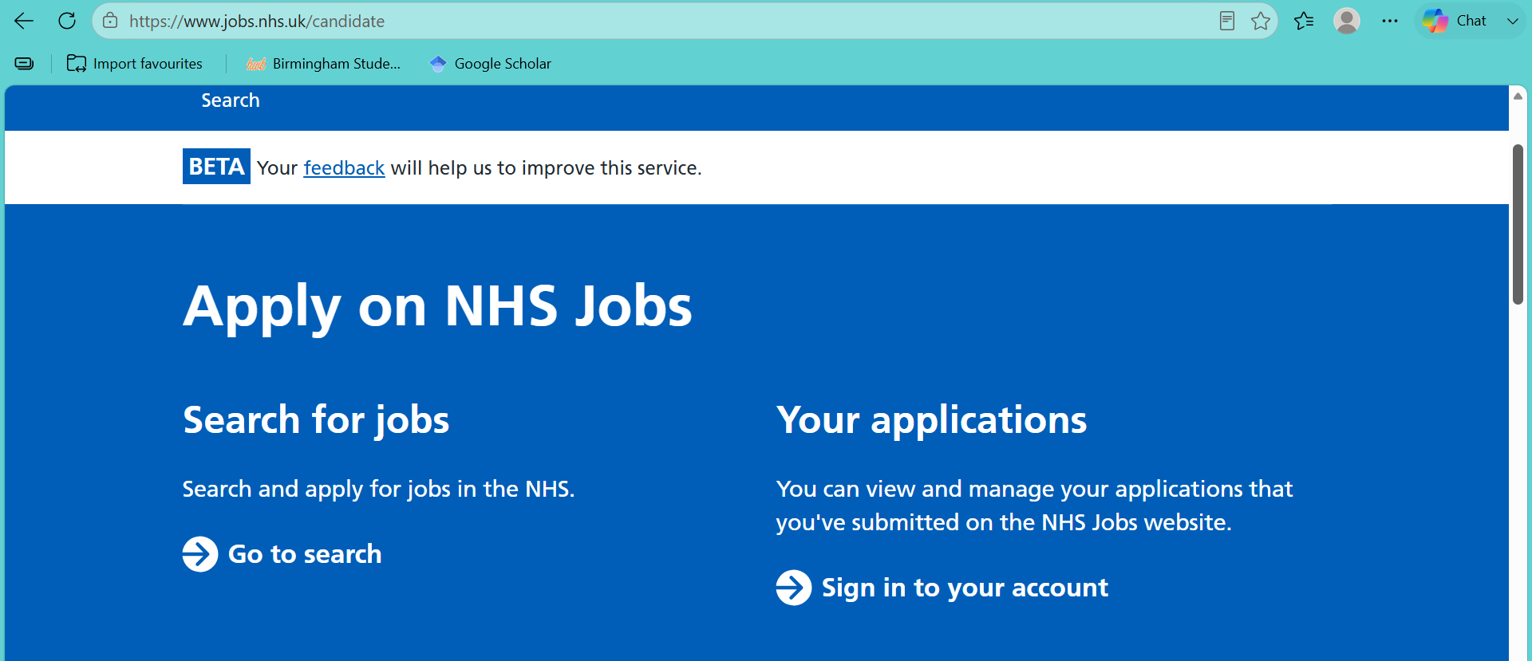

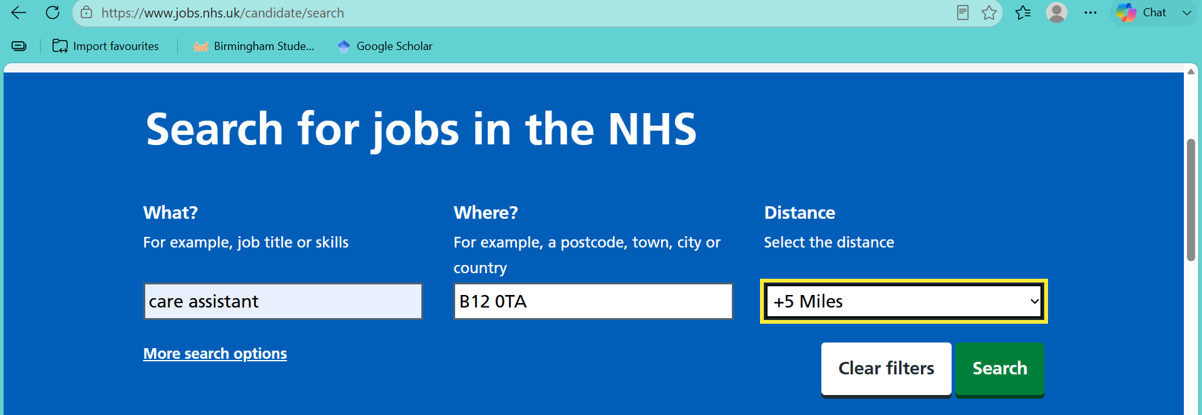

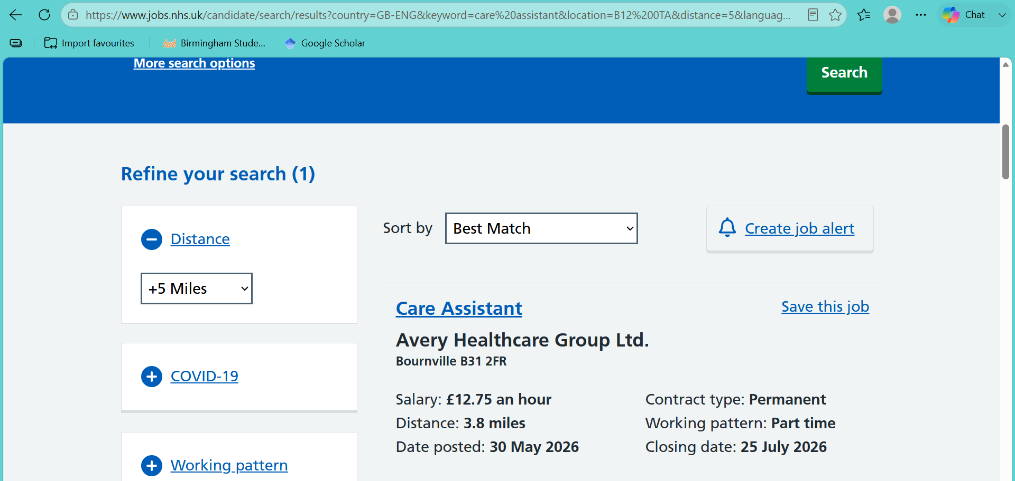

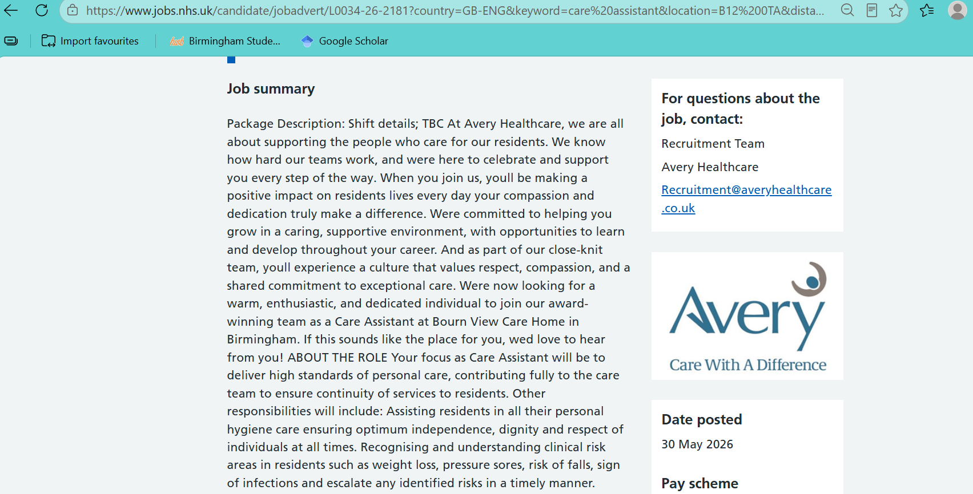

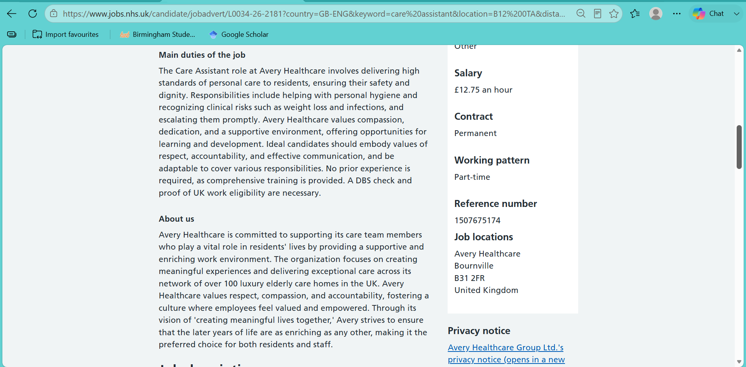
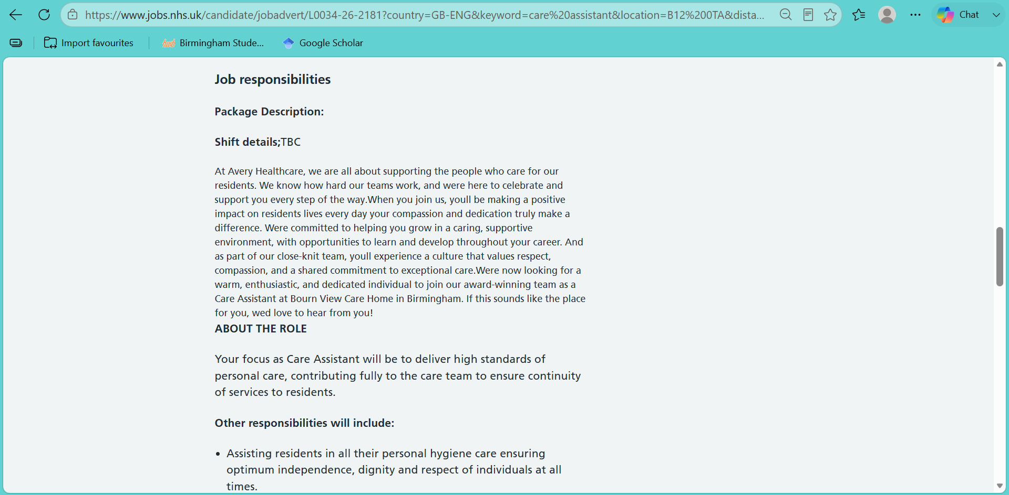
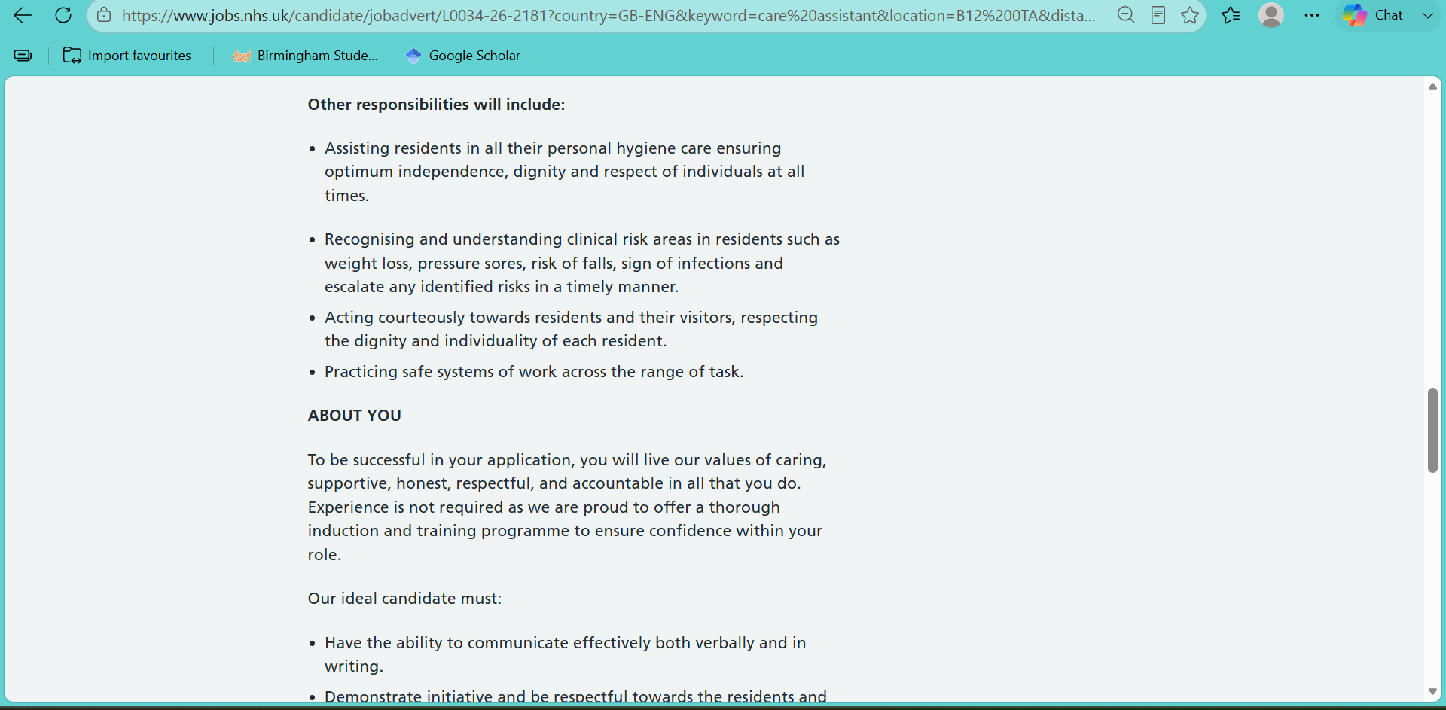
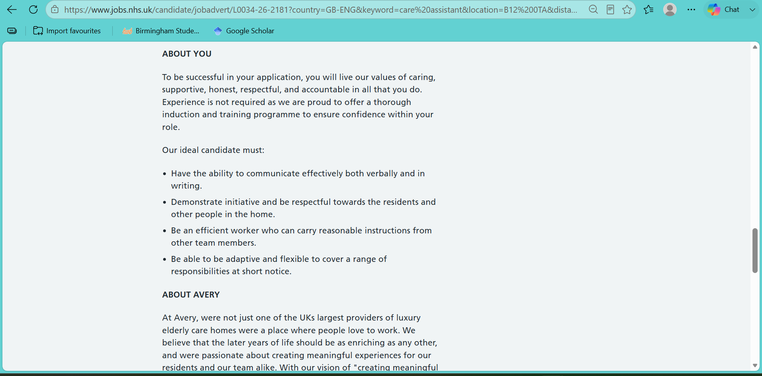
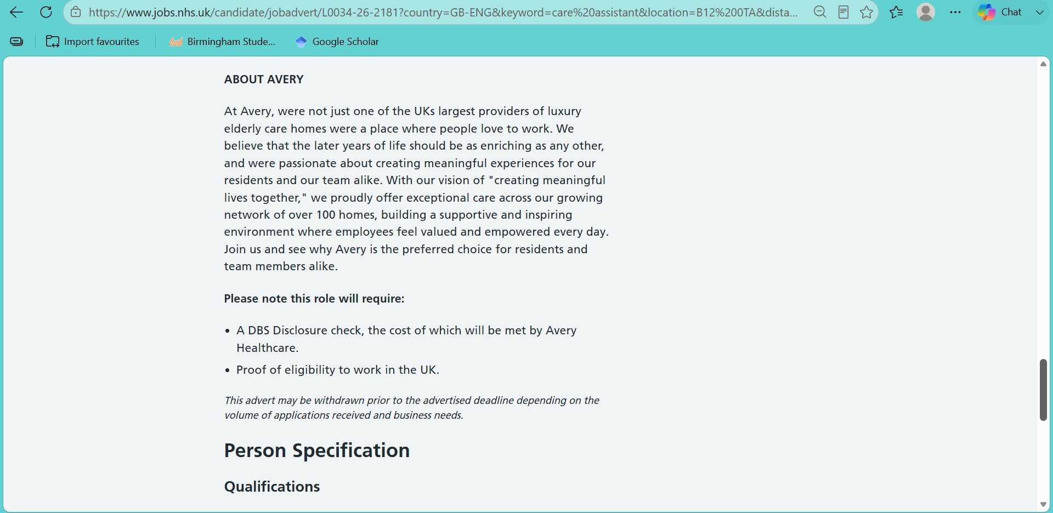

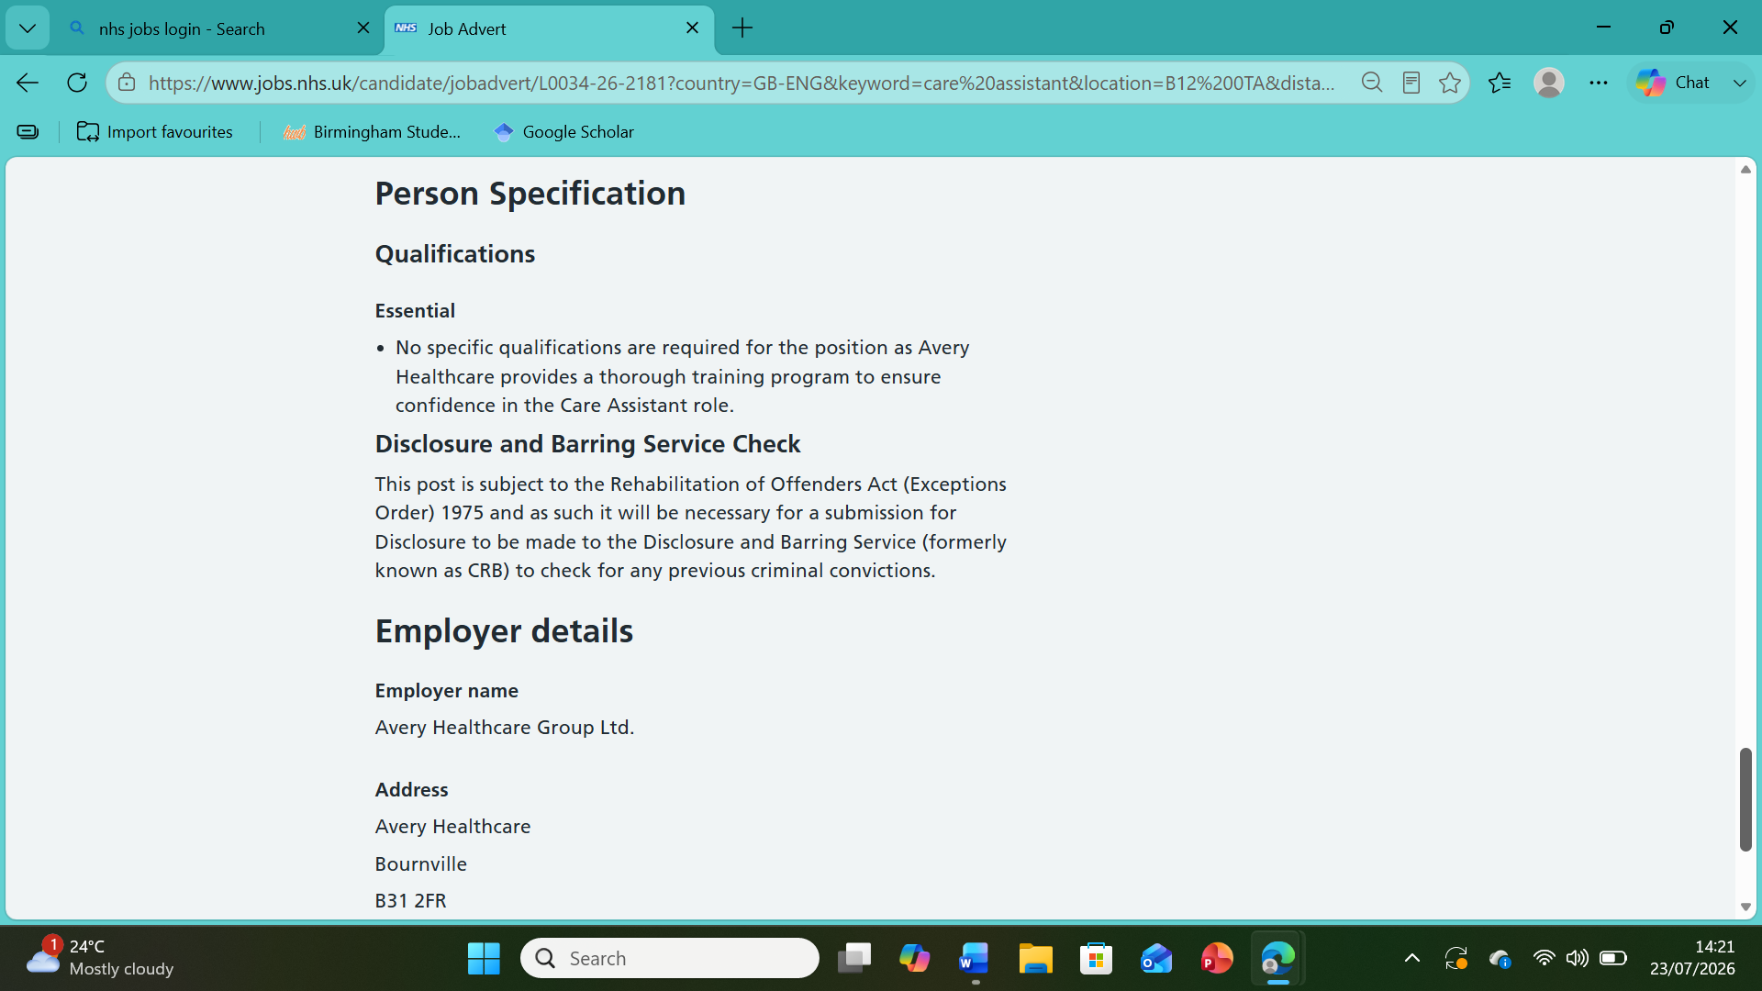

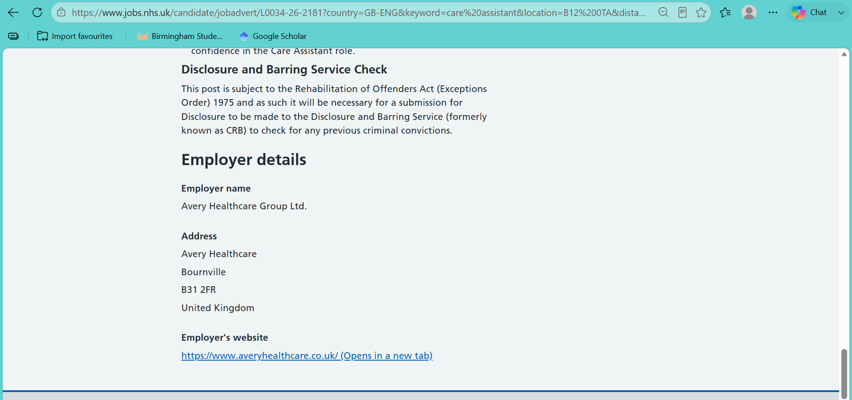

Personal Statement
I am a compassionate, caring, and dedicated person who genuinely enjoys helping others. Supporting people to live comfortable, independent, and meaningful lives is something I find both rewarding and fulfilling. My long-term goal is to build a successful career in health and social care, where I can make a real difference by providing high-quality, person-centred support to those who need it most.
I am excited to apply for the Care Assistant position with Avery Healthcare because I admire your commitment to creating a warm, welcoming environment where residents are treated with dignity, kindness, and respect. These are values I strongly believe in, and I would be proud to be part of a team that places compassion and quality of care at the heart of everything it does.
I am nearly completing a Level 4 qualification in Health and Social Care, which has given me a strong understanding of the knowledge and responsibilities required to provide safe and effective care. During my studies, I developed a solid understanding of person-centred care, safeguarding, infection prevention and control, health and safety, equality and diversity, effective communication, confidentiality, mental health awareness, and the importance of promoting independence and wellbeing. This qualification has prepared me to work professionally while following policies, procedures, and relevant legislation to ensure the highest standards of care.
Alongside my studies, my experience of caring for others has helped me develop the practical skills and personal qualities needed for a Care Assistant role. I understand how important it is to support people with personal care in a way that protects their dignity and respects their individual preferences. I appreciate the need to assist with mobility, encourage good nutrition and hydration, monitor any changes in a person's health or wellbeing, maintain accurate records, and communicate clearly with residents, their families, and colleagues.
One of the things I value most about working in care is getting to know each person as an individual. Everyone has their own life story, preferences, and routines, and I believe good care should always reflect that. I always aim to treat people with patience, kindness, and respect, helping them maintain as much independence as possible while ensuring they feel safe, valued, and listened to.
I believe my personal qualities make me well suited to this role. I am patient, reliable, approachable, and empathetic, with strong communication and listening skills. I enjoy working with people from different backgrounds and understand the importance of building trusting relationships. I work well as part of a team, but I am equally confident working independently and taking responsibility for my duties. I stay calm under pressure, adapt well to changing situations, and am always willing to learn and improve through training and practical experience.
I would be proud to join Avery Healthcare because I can bring both the knowledge, I have gained through my Level 4 Health and Social Care qualification and a genuine passion for caring for others. I am committed to providing compassionate, person-centred care that supports residents' physical, emotional, and social wellbeing while always respecting their dignity and individuality.
Thanking you in advance for your kind consideration to my application. I would welcome the opportunity to contribute to your team, continue developing my skills, and build a long-term career with Avery Healthcare while making a positive difference in the lives of your residents every day.

Personal SWOT Analysis
Strengths | Weaknesses
Compassionate and caring towards clients.  Good communication and listening skills  Reliable, patient, and trustworthy  Able to work well in a team  Strong understanding of safeguarding and confidentiality | Time management can be challenging during busy shifts  Limited experience with certain medical procedures  Can become emotionally affected by difficult situations
Opportunities | Threats
Attend training courses to improve skills (e.g., dementia care, first aid, medication administration)  Progress to Senior Care Assistant or Nursing roles  Gain professional qualifications in health and social care | Stress and burnout due to demanding work  Exposure to infectious illnesses  Staff shortages leading to increased workload  Risk of workplace injuries from lifting or moving clients

Personal Development Plan Template
Goals | List the actions to complete to achieve the goal | Support/resources needed | Target date | Review date
Improve confidence in managing challenging situations | Attend relevant training, shadow experienced colleagues, and ask for regular feedback from my supervisor. | Support from my supervisor, training courses, and guidance from experienced colleagues. | October 2026 | January 2027
Improve time management | Prioritise tasks at the start of each shift, use a daily checklist, and review my workload regularly. | Support from my supervisor, shift planner, and feedback from colleagues. | September 2026 | December 2026
Develop my knowledge of dementia care | Complete dementia awareness training, review the NICE guideline on dementia (NICE, 2018), read workplace policies, and apply this knowledge in practice. | Access to dementia awareness training, the NICE Guideline NG97, workplace policies, and support from senior staff. | November 2026 | February 2027
Continue developing my communication skills | Attend communication training, practise active listening, and seek regular feedback from colleagues and service users where appropriate, in line with the Care Certificate Standards (Skills for Care, 2025). | Communication training, supervision meetings, and feedback from colleagues. | December 2026 | March 2027

References
National Institute for Health and Care Excellence (NICE) (2018) Dementia: assessment, management and support for people living with dementia and their carers (NG97). Available at: https://www.nice.org.uk/guidance/ng97 (Accessed: 20 July 2026).
Skills for Care (2025) Care Certificate Standards. Available at: https://www.skillsforcare.org.uk/Developing-your-workforce/Care-Certificate/Care-Certificate-standards.aspx (Accessed: 20 July 2026).

Reflection Using Gibbs’ Reflective Cycle
Gibbs’ Reflective Cycle (1988) is a reflective model that encourages individuals to evaluate their experiences and identify ways to improve future practice. This reflection uses Gibbs’ model to evaluate my Component 1 presentation, considering my thoughts and feelings, my lecturer’s verbal feedback, and the lessons I will take into future presentations.
I delivered a PowerPoint presentation. After the presentation, my lecturer told me that I performed well overall, kept within the time limit, and became more confident as the presentation progressed. She also commented that although I felt nervous at the beginning, this was not noticeable to the audience. However, she advised me to include more information when explaining each slide, as this would demonstrate a deeper understanding of the topic.
Before presenting, I felt anxious because I wanted to perform well and was worried that my nerves would affect my delivery. As I started speaking, I focused on the content instead of my anxiety, and I gradually became more confident. I was surprised when my lecturer said that my nervousness was not obvious. According to Cottrell (2019), feeling nervous before presentations is common, but preparation and practice can improve confidence, which reflects my own experience.
Overall, I believe the presentation was successful. I managed my time effectively, spoke confidently as the presentation progressed, and explained the information instead of reading directly from the slides. My lecturer's positive feedback confirmed that these were strengths. However, I also recognise that I could have developed my explanations further. Although I expanded on my slides, I did not always provide enough detail or examples to fully demonstrate my knowledge. Race (2019) explains that constructive feedback helps students recognise both their strengths and the areas that require further development. Receiving balanced feedback helped me understand exactly what I need to improve.
Reflecting on this experience has helped me understand that confidence develops through practice and experience rather than appearing immediately. Moon (2004) suggests that reflection encourages deeper learning by helping individuals think critically about their experiences. Looking back, I can see that my preparation enabled me to recover from my initial nerves and present confidently. My lecturer's feedback also showed me that effective presentations involve more than simply explaining the points on a slide. Hargie (2021) highlights that effective communication depends on conveying information clearly and ensuring understanding. Reflecting on my presentation, I recognise that adding more detail and relevant examples would have strengthened my delivery and demonstrated a greater depth of knowledge.
This reflection has helped me identify both my strengths and my weaknesses. I was pleased that I stayed within the time limit, communicated clearly, and became more confident as I continued speaking. At the same time, I understand that I need to provide more detailed explanations during presentations. Gibbs (1988) suggests that reflecting on experiences allows individuals to learn from them, and this process has helped me recognise practical ways to improve my presentation skills.
For future presentations, I will practise more to improve my confidence at the beginning of the presentation and reduce my anxiety. I will also prepare additional speaking notes for each PowerPoint slide so that I can explain my points in greater depth without relying on the slides. Finally, I will continue to seek and apply feedback from lecturers because it provides clear guidance on how to improve future performance. Continuous reflection and professional development are important within health and social care. Skills for Care (2023) highlights the importance of developing knowledge, skills, and behaviours to provide effective and person-centred care. I will use this experience to continue improving my communication and presentation skills, which are essential for my future career.
References
Cottrell, S. (2019) The Study Skills Handbook. 5th edn. London: Red Globe Press.
Gibbs, G. (1988) Learning by Doing: A Guide to Teaching and Learning Methods. Oxford: Oxford Polytechnic.
Hargie, O. (2021) Skilled Interpersonal Communication: Research, Theory and Practice. 7th edn. London: Routledge.
Moon, J.A. (2004) A Handbook of Reflective and Experiential Learning: Theory and Practice. London: RoutledgeFalmer.
Race, P. (2019) The Lecturer's Toolkit: A Practical Guide to Assessment, Learning and Teaching. 5th edn. London: Routledge.
Skills for Care (2023) The Care Certificate. Available at: https://www.skillsforcare.org.uk/Developing-your-workforce/Care-Certificate/Care-Certificate.aspx (Accessed: 23 July 2026).

