Assignment 2

  - Menu Engineering (Practical Task)

Student name: Lavinia-Maria Curtean
Student ID: 2232073
Lecturer’s name: Jaliya De Silva
The Module Name: Food and Beverage Operations
Word count: 480

Contents
Assignment 2 1
Part 1: Restaurant concept 1
Restaurant Concept: 1
Target Audience: 1
Reasoning behind the Menu Choices: 1
Part 2: Menu design 1
References 1

Part 1: Restaurant concept

"Harvest & Hearth: Farm-to-Table Dining Experience"

Harvest & Hearth is an innovative farm-to-table restaurant concept that will be introduced to the Hotel Trinity Chain. The aim of this concept is to provide guests with a unique dining experience that celebrates the freshest seasonal ingredients sourced directly from local farms and producers. The restaurant will combine the rustic charm of a farmhouse with a contemporary and inviting ambiance, creating a warm and welcoming atmosphere for guests to enjoy.

Target Audience:
The target audience for Harvest & Hearth will be both hotel guests and local residents who appreciate high-quality, sustainable dining experiences (Davis, 2018). This concept aims to appeal to individuals who are conscious of their food choices and value the connection between farm and plate.

Reasoning behind the Menu Choices:
The menu at Harvest & Hearth will feature a diverse selection of dishes inspired by the seasonality and abundance of the local region. The emphasis will be on showcasing the natural flavours of the ingredients through simple and creative preparations. Here are the key considerations behind the menu choices:

1. Seasonal Ingredients: The menu will change regularly to align with the seasons, ensuring that only the freshest and most flavourful ingredients are used (Firth, 2022) This approach guarantees that guests can experience the best produce each season has to offer while supporting local farmers and reducing the carbon footprint associated with long-distance transportation.

2. Local Sourcing: A strong focus will be placed on partnering with local farmers, ranchers, and artisans to obtain the highest quality ingredients (Johnston, 2012). This not only supports the local economy but also ensures that the ingredients are ethically and sustainably produced.

3. Menu Variety: The menu will cater to a range of dietary preferences and restrictions, including vegetarian, vegan, and gluten-free options (Motarjemi & Lelieveld, 2014). By offering a variety of choices, Harvest & Hearth aims to accommodate the diverse needs of its guests and provide inclusive dining experiences for all.

4. Culinary Innovation: The menu will showcase innovative and creative culinary techniques that enhance the natural flavours of the ingredients (Zutshi, 2019). Chefs will experiment with unique flavour combinations and cooking methods to elevate traditional dishes and surprise guests with new taste sensations.

5. Artisanal Beverages: In addition to the food menu, Harvest & Hearth will offer a thoughtfully curated selection of local and craft beverages. This will include locally brewed beers, small-batch wines, and specialty cocktails made with locally sourced spirits and fresh ingredients.
The overarching goal of the menu choices at Harvest & Hearth is to create a dining experience that not only tantalizes the taste buds but also promotes sustainable practices and supports the local community. By showcasing the best of the region's seasonal produce and emphasizing the importance of responsible sourcing, this restaurant concept will provide guests with a memorable and meaningful dining experience that celebrates the essence of farm-to-table cuisine.

Part 2: Menu design
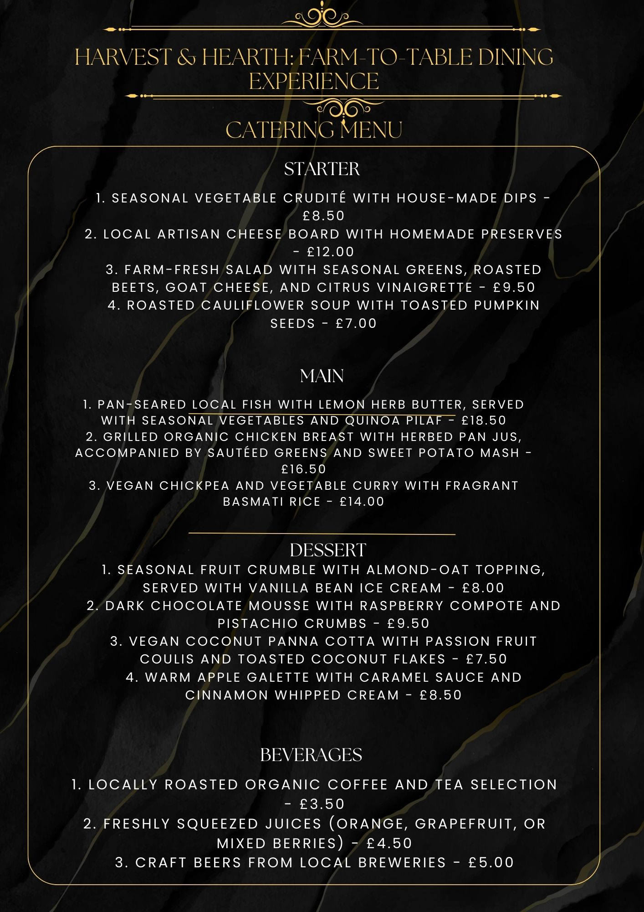

References
Davis, B. (2018) Food and Beverage Management. 6th edn. London: Routledge.
Firth, G. (2022) Service Operations Management. New York, USA: Willford Press.
Johnston, R. (2012) Service operations management : improving service delivery. 4th edn. England: Pearson.
Johnston, R. et al. (2021) Service Operations Management: Improving Service Delivery. Harlow, England: Pearson.
Motarjemi, Y. and Lelieveld, H. (2014) Food safety management : a practical guide for the food industry. Amsterdam: Academic Press.
Zutshi, A. (2019) ‘How to develop well-informed and assured teams to embed food safety compliance in the UK catering and Hospitality Industry’, Perspectives in Public Health, 139(6), pp. 294–295. doi:10.1177/1757913919872783

