Student Name: xxxxxxxxxxxx Student number: xxxxxxxxx
Programme of Study: Photography In The Arts (BA) Module: ADAD5003
Word Count: 2777

Tutor’s Name: Paul Duerinckx

Question 5: From the Lens-Based Image Making research strand lectures, choose a theme, movement, or selection of artists that relate to your practice or interests, and construct a 2,500-word essay. Critically assess primary themes, key writers, and relevant practitioners.

In this essay I will be looking at femininity in society through art and text under the theory that gender is a performative and a result of the norms in a patriarchal society. Many artists and writers have explored femininity and gender and how the world around us deeply ingrains and determines our relationship with these things. First of all, how do we deconstruct terms such as femininity and masculinity? These terms cover “traits, appearances, interests, and behaviors that have traditionally been considered relatively more typical of women and men” (kachel, Steffens and Niedlich, 2016). Many have the view that both masculinity and femininity are innate and natural, a woman is feminine and a man is masculine and some people view these things as characteristics that naturally occur with each sex and if one was to go against the traits typical of their sex then it may result in judgement from others. Judith Butler talks of how these expectations of gendered performance come to be, in her book Gender Trouble she states “We are actually in the presence of three contingent dimensions of significant corporeality: anatomical sex, gender identity, and gender performance (Gender Trouble, p.175)”. What Butler is essentially saying is that the way in which one performs their gender is separate to anatomical sex, it goes against the theory that the two automatically go hand in and are purely instinctual. Butler describes being a woman as “a term in process, a becoming, a constructing that cannot rightfully be said to originate or end … it is open to intervention and resignification” (Butler, p.43, 1990). Many women choose to express their femininity in alternative ways as a form of

self-expression and sort of a rebellion against the gender norms and performativity, something I will go into later on in this essay.

First, to better understand femininity and the role it plays it’s vital to consider the role of the patriarchal society. The dictionary defines patriarchy as “…a society controlled by men in which they use their power to their own advantage” (dictionary, 2020). Some may argue that in this day and age the patriarchy no longer exists, that we live in an equal society, however, this is not that case. What happens is that there is a change in the way the patriarchy presents itself and it isn’t always obvious at first glance. Sally Hines writes references femininst theortist Sylvia Walby’s analysis of the patriarchy and how there are key characteristics that reinforce it “women have less formal power and representation in government (…) women are more misrepresented in media and popular culture” (Hines, p.16, 2018), these are just two points Walby makes. The beauty standards the mass media projects and how women are expected to be “feminine” reinforces the lack of power and this idea that women’s main worry should be how she looks, her weight, her age, and everything about her outward appearance which belittles achievements and anything else she might want in the world. This is especially prominent when you look at the difference between men and women who are celebrities, how often does a man’s weight gain make the news? How often is a man’s weightloss praised? Even when a woman is successful she’s still required to be constantly making sure she looks her best otherwise she’s simply let herself go. “We choose most times to describe a woman as something to do with the way she looks” (Hariharan, 2017), this process of positive word association with appearance starts at such a young age, countless times I remember growing up and hearing “your hair looks so pretty like that”, “what a pretty dress” and I’ve been told I look tired or ill on a day where I decide I do

not want to wear makeup. I heard my brother being praised for doing well in sports, for being active and bold, but these same characteristics were bot praised in myself or my sister.
Women often fear becoming old, losing their youth as they have been made to associate youth with beauty and beauty with their importance and purpose ,“we should understand that beauty standards are one of the ugliest tricks of the patriarchy!” (Hariharan, 2017)”. Where does femininity as a performance come in to this? If women are taught from a young age to always be conscious of her appearance then often it can hold a great significance in her life, teaching women that other pursuits are less worthy of time and the pursuit of unattainable eternal beauty and youth is of the upmost for if she doesn’t have beauty then she simply does not have value in the world.

It’s a fruitless chase, how can a woman be content about her appearance when the ideal body is constantly changing, when new unattainable standards are constantly out of reach. “What was considered an ideal body in 1960 is now defined as ‘full figure’” (bordo, p.57, 1993). These unrealistic standards take a toll, many women develop eating disorders and body dysmorphia as a result of chasing after what can never be reached, “our culture is so obsessed with keeping our bodies slim, tight and young that when 500 people were asked what they feared most in the world, 190 replied, “Getting fat”” (Bordo p.140, 1993). This just shows the lengths women often go to to remain slim, and as someone in recovery from an eating disorder it’s hard to describe the fear that simply gaining weight brings on, and it’s sad that something natural can ruin lives. Many feminist artists make art in protest to the constant pressure on women to be a certain way; slim, hairless, unaged, always-made-up, in clothes that hug her figure but they can’t be too tight or revealing because then she’s promiscuous and is asking to be sexualised OR if she dresses too conservatively then she’s a

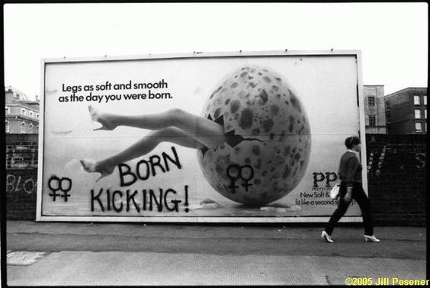
prude and must be hiding her body out of shame. How about we teach men to respect women in whatever they wear, do men have to worry that they’re going to be harassed because their trousers are fitted as opposed to baggy?
Figure 1

Feminist artist and playwright Jill Posener captures feminists graffiti in reaction to the misogyny and ridiculous beauty standards on advertisements from the 80s. “Legs as soft and smooth as the day you were born”, this quote from the ad perfectly captures the unrealistic standards placed on women and also how women are often infantilised instead of seen as equal to their adult male counterparts. In reaction the graffiti “born kicking” shows the rebellion and aggression to the beauty standards, women are strong and powerful.
Stereotypical “femininity” would depict a woman as timid, shy, quiet, but this image perfectly captures how anger isn’t only for the men!

Trying to deconstruct and analyse how one perceives and experiences gender is no easy task. Most people have assumptions on how femininity and masculinity presents themselves and

the stereotypical traits that goes along with them. However, gender identity and these expressions don’t go hand in hand, for example, a biological male can identify as cisgender (with his sex) but have what are considered “feminine” characteristic such as a soft voice, gentle presence, being in touch with emotions and expressing them, taking pride and spending time on physical appearance, these traits do not mean that the man is any less a man than a man who displays stereotypical masculine traits. However, societal norms will often lead to others judging a man with what are considered stereotypical feminine traits as weak, unmanly and a failure simply for not adhering to what is considered “manly”. It’s easy to see why the reinforcement of people to stick to these labels is easy to see, gender- nonconforming individuals are often harassed for their rebellion against gender norms. It's also typical for people to make assumptions about individual’s sexualities if they display non- conforming gender traits and this may also lead to harassment. “The statement ‘It’s a girl’, or ‘It’s a boy’, inscribes gender onto the child’s body” (Hines, p.69, 2018). When women are taught that having “masculine features” is unbecoming in women why is this so significant and what does it mean for a woman as she grows up? Well, first it’s easier if you look at what are considered masculine features. Features that are often associated with masculinity are as follows; aggression, dominance, confidence, strong in both body and mind, purpose-driven, independent, focused on own needs, decisive, unemotional (can keep emotions internal).
When a woman is confident she is often told to dial it down because it’s arrogant, when a man is confident it’s seen as attractive. When a man is career orientated he’s seen as driven, when a woman focuses on her career instead of a family she’s asked when she wants kids and how the clock is ticking against her favour. When a man is single he’s a bachelor, when a woman is single she’s often told to find a suitable partner before she looks go. When a man is dominant he’s seen as powerful, when a woman is dominant she can be seen as a control-

freak. To put it simply, “The connotations of being described as a typically feminine woman encompass assumptions about, amongst other things, vulnerability, physical strength, intelligence, and sexual availability (…) yet feminine behaviour is a ‘task’ of imitation (Holland, p.35, 2004).

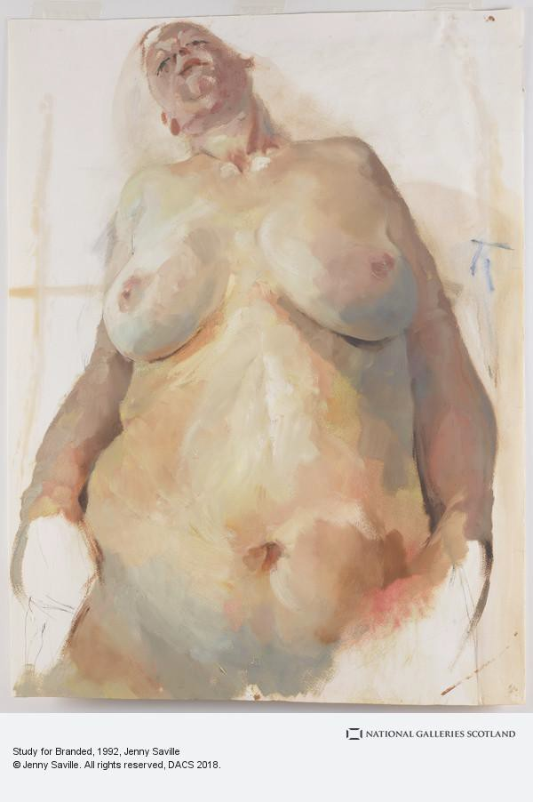
Figure 2

One such artist who challenges the portrayal of femininity within her work is Jenny Saville. Saville portrays women in their rawest, realest form, evoking reaction simply because the women she portrays aren’t what society deems as pretty and feminine. Jenny, in an interview with the independent stated “What is beauty? Beauty is usually the male image of the female body” (Jenny in the independent, Davies, 2011). She goes on to say how in her paintings her “women are beautiful in their individuality” (Davies, 2011). Jenny paints her figures

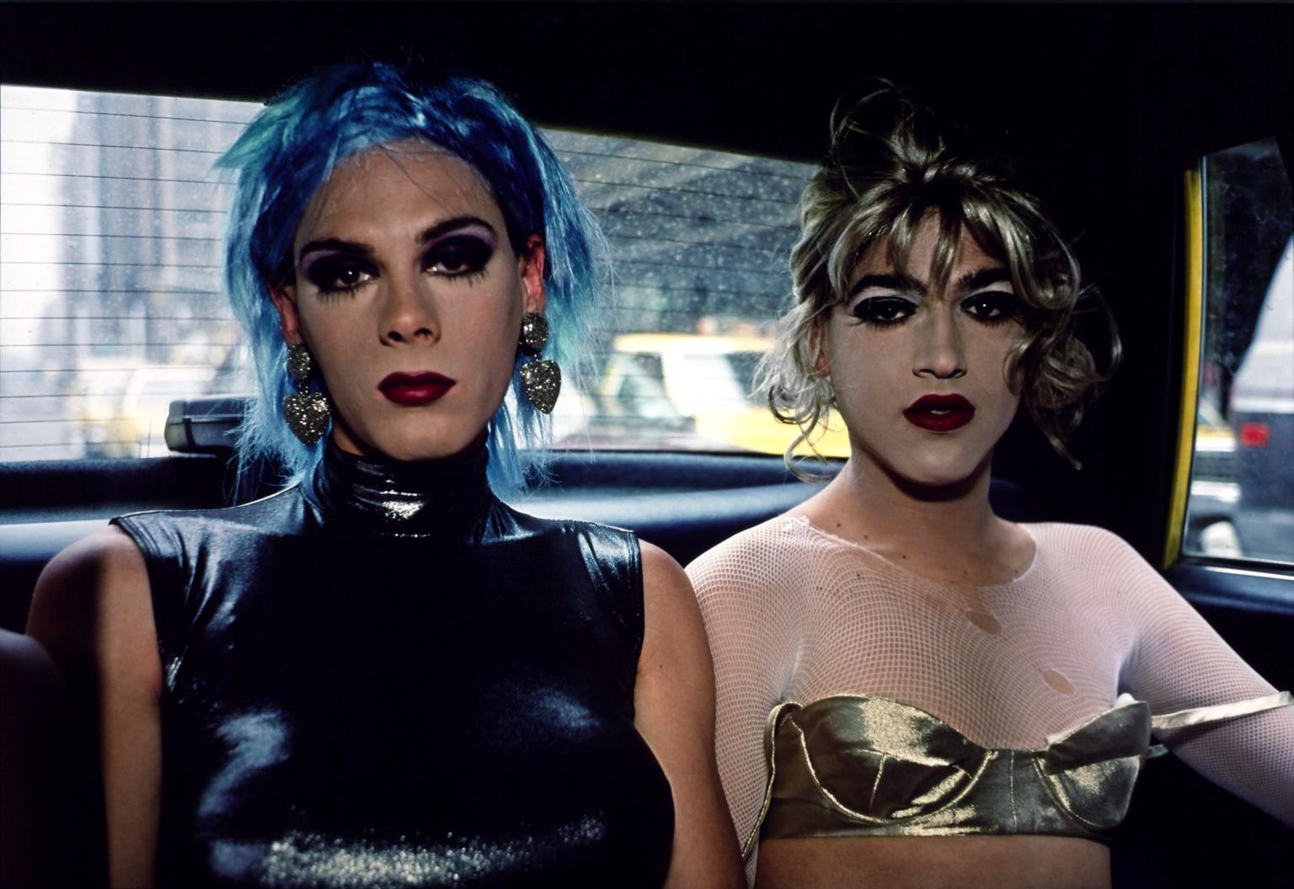
realistically and often uses models who would be considered not to fit the beauty standards of the 21st century because she wants what’s real and brutally honest.
Figure 3

One can even look at the extremes of feminine performance and look at drag queen. Drag queens are in a way caricatures of what women are brought up to imitate. Drag in general has come under some fire for being anti-feminist as it filters women down to their outwards appearance and attributing that to be the sole strife for the female population, “you’ve got those that argue drag is just a parody of femininity, mocking women, both characteristics and the aesthetic” (Segalov, 2015). However, drag queen do this as a form of self-expression, ciswomen and transwomen don’t have that luxury and are instead at the mercy of the patriarchal society “these queens can hang up their heels at the end of the night, an opportunity not afforded to women day to day” (Segalov, 2015). There’s also the argument that men portraying women simply reinforces stereotypes that serves the ideology of the patriarchy. However if we look at it like this “seeing drag as a performance that reinforces the

gender binary assumes that aspects of drag performance may mirror normative assumptions associated with gender. Seeing drag as a performance that “reinforces the gender binary suggests that drag reinforces the notion that being male and female are defined and based on strict classifications of sex and gender” (Dougherty, p.20-21,2017). Personally I don’t think drag queens are considering the gender stereotypes they may be reinforcing but rather playing with and performing gender in a way that rebels against these norms, and when if you consider the fact that there has to be these norms in order for someone to dress up as the “opposite” gender and perform in the first place, otherwise it would simply be a man wearing a dress and makeup, we give these things prescribed gender purposes and attach gender to them, why should a dress be considered “feminine’? Anyone can wear one!
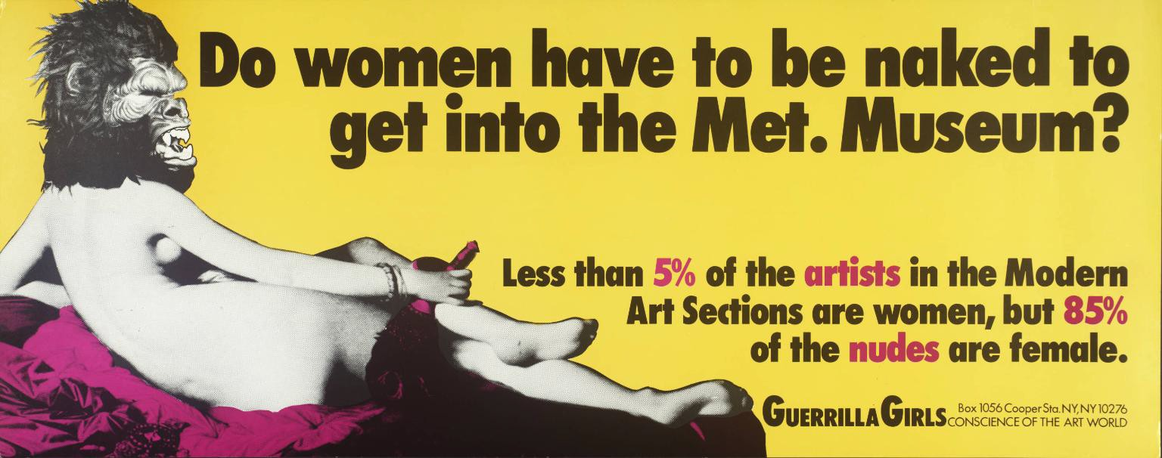
Figure 4

The Guerrilla Girls tackle issues about inequality and the representation of women in the art world and how the art world is very much sexist and misogynistic towards women. We can see this in art history, straight away it’s a lot easier to list significant historical art figures who are cisgender, white males. As The guerrilla girl’s state in this piece, although women were often the muse and feature in works women artists historically have been features less in writing and in museums. Nudes throughout art history have often featured women in a way that adheres to the male gaze, the women are smooth skinned, have long flowing hair,

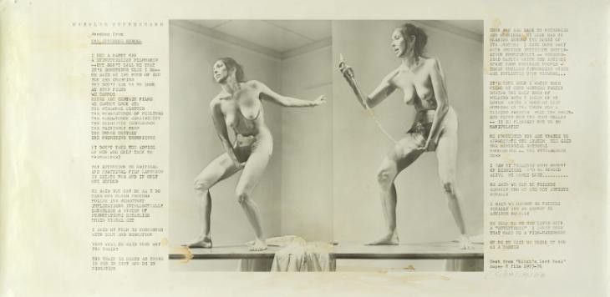
appear almost naïve with wide eyes and despite being nude there’s often an innocence and coquettishness that pierces the onlooker. Like Jenny Saville, many other female artists have depicted the naked female form in a way that does not comply with male gaze but instead is honest and personal, art which is not for a man’s pleasure but for a woman’s liberation.
Figure 5

Carolee Schneemann was a feminist performance artist who reclaims the nude female body “Schneemann believed her nudity subverted not catered to, an intrusive male gaze” (Solly, 2019). She wanted to comfort society’s discomfort with a powerful woman nude, a woman who isn’t coy or playful but confident and sometimes even aggressive and bold. Schneemann was also known as a pioneering artist in the second wave feminist movement. Schneemann’s work’s interest me as she explores “’The paradox of being both the artist and object at once”’ (Doyle, 2002). Many other female photographers use self-portraiture to tackle this paradox, such as Cindy Sherman, Nan Goldin, Francesco Woodman, Hannah Wilke etc. Most of my work involves self-portraiture, when I photography myself I am conscious of the image I am putting out and often want to challenge the male gaze. I have posed nude to some degree, but as Schneemann states I did so in a way that does not adhere to the male gaze, my

femininity, my masculinity and everything about me is conveyed through the lens in a way that suits my values. I have performed in a more feminine way as a way to depict the struggle of performing and comply to gender norms.
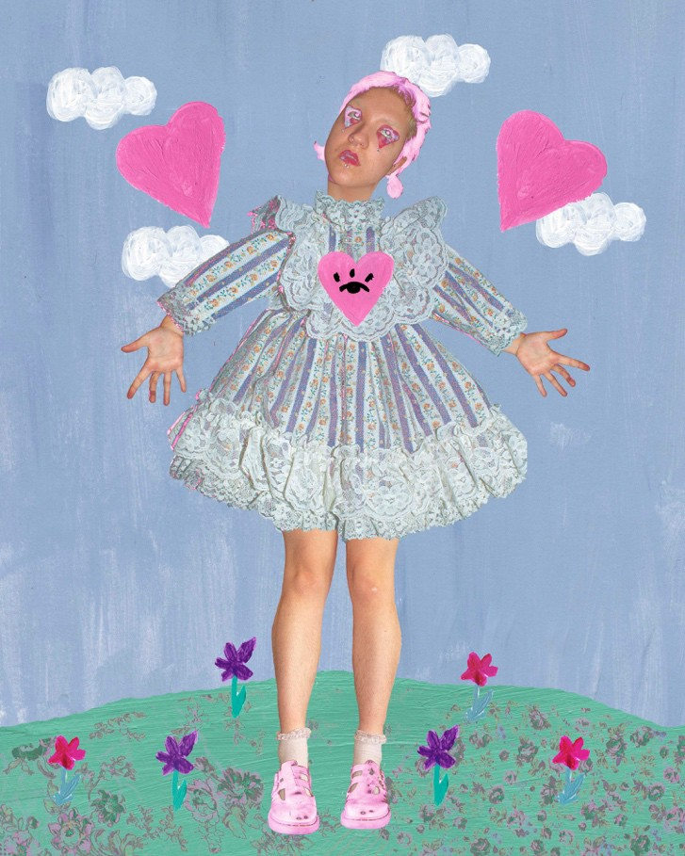
Figure 6

The above figure is a montage a created called Doll Parts (2020), this mixed media piece is a reaction to how I see femininity, almost like a stiff, rigid burden which I feel is sort of alien to me being born female. It’s quite an obvious metaphor for how many women feel chasing unattainable beauty almost trying I become like living dolls. Although I feel like my work may vary in terms of aesthetics and methods I’m always focused on the themes of self, identity, gender performance and fluidity.

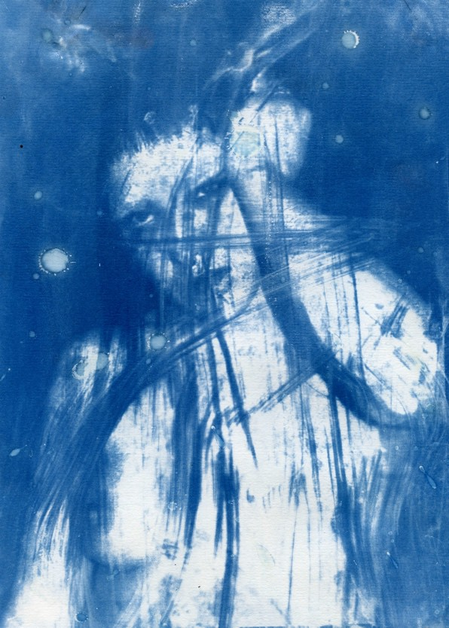
Figure 7

Similarly in this image from my body of work titled Flesh (2020) I challenge the male gaze and the historical “nude” with heavy markings to the image as if my representing the frustration within my body and anger at how the world may view it, anger at never being content with how it looks. Similarly to how Schneemann uses art to express her discontent with how the world views women I want my work to challenge the stereotypes of femininity and my practice is driven by a sort of anger which in itself is considered a “masculine” emotion.

As John Berger states in Ways of Seeing the presence of a man is difference to that of a woman. Berger states that a man’s presence is “dependent upon the promise of power which he embodies (…) if it is small he is found to have little presence” (Berger, p.45, 1972). However, in contrast a woman’s presence “expresses her own attitude to herself (…) Her presence is manifest in her gestures, voice, opinions, expressions, clothes, chosen surroundings, taste- indeed there is nothing she can do which does not contribute to her

presence” (Berger, p.46, 1972). So, in essence Berger is saying that a woman is aware that she is constantly being watched and in a way has to constantly perform or her “presence” will be less so. She must always be thinking about her image and, more importantly, how that image will appear to others as how other’s perceive her is what society has taught her gives her the most value in the world. A woman is “continually accompanied by her own image of herself” (Berger, p.46, 1972), it’s this awareness that makes me want to explore femininity and how we often subconsciously perform gender traits and norms because it is so deeply ingrained in our minds, even if we wish to rebel and actively try to challenge these.

Bibliography.

Berger, J. (1972) Ways of Seeing. British Broadcasting Association and Penguin Books

Bordo, S. (1993) Unbearable Weight: Feminism, Western Culture and the Body. University of California Press.

Butler, J. (1990) Gender Trouble: Feminism and the Subversion of Identity. Routledge

Davies, H. (2011) Interview: This is Jenny, and This Is Her Plan: Men Paint Female Beauty in Stereotypes; Jenny Saville Paints It The Way It Is. And Charles Saatchi Is Paying Her To Keep Doing It. Available at: https://www.independent.co.uk/life-style/interview-this-is-jenny-and- this-is-her-plan-men-paint-female-beauty-in-stereotypes-jenny-saville-paints-it-the-way-it-is- and-charles-saatchi-is-paying-her-to-keep-doing-it-1426296.html (Accessed 13 December 2020)

Dictionary, O. (2020) Available at: https://dictionary.cambridge.org/dictionary/english/patriarchy (Accessed 10 December 2020)

Dougherty, C. (2017) Drag Performance and Femininity: Redefining Drag Culture through Identity Performance of Transgender Women Drag Queens, Available at: https://cornerstone.lib.mnsu.edu/cgi/viewcontent.cgi?article=1728&context=etds

(Accessed 5th December 2020).

Hariharan, N. (2017) Beauty Standards- The Ugliest Trick Of Patriarchy, Available at: https://feminisminindia.com/2017/05/10/beauty-standards-ugliest-trick/ (Accessed 11
December 2020)

Hines, S., (2018) Is Gender Fluid?: A Primer for the 21st Century. Thames and Hudson Holland, S. (2004) Alternative Femininities: Body, Age and Identity. Berg.
Niedlich, C., Kachel, S., Steffens, M.C., (2016) Traditional Masculinity and Femininity: Validation of a New Scaled Assessing Gender Roles. Avaliable at: https://www.frontiersin.org/articles/10.3389/fpsyg.2016.00956/full (Accessed 28 November 2020)

Segalov, M. (2015) Are Drag Queens Doing Enough For Feminism? Available at: https://www.dazeddigital.com/artsandculture/article/27232/1/are-drag-queens-doing- enough-for-feminism ( Accessed 29 November 2020)

Solly, M. (2019) Carolee Schneemann Pioneered the Way Women’s Bodies Were Seen Available at: https://www.smithsonianmag.com/smart-news/feminist-performance-artist- carolee-schneemann-dies-79-180971680/ (Accessed 13 December 2020)

Figures

Fig. 1: Posener, J. Born Kicking, 1993 (Graffiti On a Billboard in London) Available at: https://robtownsendgm.wordpress.com/2016/08/22/research-the-grammar-of-the- ad/f00655bd4cbb09ea8e5153b0a99f172c/ (Accessed 27 November 2020

Fig. 2: Saville, J. Study for Branded, 1992 (oil on paper), Purchased (Henry and Sula Walton Fund) Available at: https://www.nationalgalleries.org/art-and-artists/159502/study-branded (Accessed 2 December 2020)

Fig. 3: Goldin, N. Misty and Jimmy Paulette In a Taxi, NYC, 1991 (photography dye destruction print on paper mounted board), Tate. Available at: https://www.tate.org.uk/art/artworks/goldin-misty-and-jimmy-paulette-in-a-taxi-nyc-p78046 (Accessed 13 December 2020)

Fig. 4: Guerrilla Girls, Do Women Have To Be Naked To Get Into the Met. Museum?, 1989 (Screenprint on paper), Tate. Available at: https://www.tate.org.uk/art/artworks/guerrilla- girls-do-women-have-to-be-naked-to-get-into-the-met-museum-p78793 (Accessed 13
December 2020)

Fig. 5: Schneemann, C. Interior Scroll, 1972 (Beet juice, urine and coffee on screenprint on paper) Tate. Available at: https://www.tate.org.uk/art/artworks/schneemann-interior-scroll- p13282 (Accessed 14 December)

Fig. 6: Jones, D. Doll Parts, 2020 (mixed media montage) Fig. 7: Jones, D. Flesh, 2020 (cyanotype on paper).

xxxxxxx: This is an exemplary essay written in an engaged way and from a personal viewpoint.

Your feedback details for each assessment component, is as below:

Engagement with Literature Skills (weighted at 30% of the total mark)
Show your engagement with relevant and credible literature. Use discussion, critique and referencing to demonstrate your awareness of suitable theories and concepts. Apply your referencing skills clearly and consistently.

Excellent use of artist research and contextualising writing provides a thorough exploration of the subject area. Choices, both historical and contemporary, provide an excellent framework upon which you have neatly arrayed your ideas.

Knowledge and Understanding Skills (weighted at 20% of the total mark)
Manage and organise your research information into the given framework. Show your knowledge and understanding of the principles and theories of your topic. Use analysis, discussion, and bibliographic referencing to show your knowledge of relevant research and scholarship.

An excellent example of research-driven writing that demonstrates a thorough understanding of a wide range of ideas related to your theme. You have successfully integrated your own practice into the essay by exploring the links that exist between theory and practice both in chosen examples/artists and your own work.

Cognitive and Intellectual Skills (weighted at 20% of the total mark)
create links and relationships to theories and practices that apply to your chosen keywords; critically evaluate and analyse the relevant theoretical and practice-based discourses; conclude by outlining and justifying the research question (or questions) that have come from your exploration.
A notable use of linked theoretical ideas has allowed you to both demonstrate diverse areas of practice and the relationships these have with each other around the theme of gender and identity. You demonstrate a thorough understanding of the concerns with this kind of practice and the discourse that surrounds it.

Practical Application Skills (weighted at 20% of the total mark)
Assimilate and apply the required rules and criteria of the given format to your text. Organise information into a coherent framework which identifies a range of concepts and theories and discusses their merits and limitations. Consistently apply referencing conventions to suit the required format.
Excellent writing that demonstrates a notable ability to formulate your own perspectives while providing plentiful contextual support, that is perfectly integrated with your own writing. This is very well-argued although you would benefit from writing your own question title. This would further contextualise the essay.

Transferable Skills for Life and Professional Practice (weighted at 10% of the total mark)
Present your text professionally, applying attention to the conventions of English language and grammar. Communicate your ideas in a coherent and consistent style with due consideration to the reader/audience. Apply your writing knowledge showing a command of writing structures, such as sentence structure, paragraphing, and appropriate and explicit use of visuals to enhance communication.
Superlative writing to a high academic standard. Extreme care and attention to detail means that there is little that interrupts the flow. This is a little on the long side (though, in no way, 'reads' too long) but there is no obvious need for editing. You would benefit from using paragraphs more to break up extended passages.

Very good use of visuals though you might benefit from using visuals more in the earlier part of the essay, perhaps to illustrate some of the arguments that have led to the necessity for the gender identity-based art that you show later (although, to some extent, you do it in detournement form)

This is great indicator of what is to come. An excellent essay.

To access additional Study Skills support: Email: studyskillsdistance@uwtsd.ac.uk (email for appointment) Telephone: +44(0)1570 424947 Skype: student.support.tsd
You can Click here for details on the current HARVARD version of the UWTSD Referencing Handbook https://www.uwtsd.ac.uk/library/infoskills/referencing-handbooks/ link to open resource.

