Module Code- BMSK4001

Prepared By:
Sanzina Rahman
Student Number (ID): 1812578
Group 3

MODULE Name:
Academic and Employability Skills

Prepared for:
Lloyd Beharry

Assignment Task:
Produce a reflective paper of 2,000 words, explaining how the learning in the module has helped you develop both your academic and employability skills. Reflect also on skills gaps and suggest ways you might improve on these gaps.

Table of Content

- Abstract Page 2
- Introduction Page 2
i. Academic skills
ii. Employability skills

- Gibbs Reflective cycle Page 3
- Description Page 4
- Feeling
- Time management Page 6
- Pareto’s 80-20 rules Page 7
- Eisenhower Chart Page 8
- Text Page 9
- Evaluation and Analysis Page 10
- Action Plan Page 11

- Conclusion Page 11

- References Page 12

Abstract:
I will be writing a report here reflecting on my last semester learning about academic and employability skills. At first I will explain the description following by my feelings about the module. I will evaluate and analyse my understanding and performance. And lastly I will try to put together an action plan for myself which will eventually help me to improve my academic and employability skills together.

Introduction:
In today’s world to be successful a combination of academic and employability skills are essential. Both of them work side by side in the way to achieve success.
Academic skills:
Academic skills are those which help anyone to become more effective at developing communication, interpersonal, and time management skill. In this stage we learn about the academic knowledge which can be use in our everyday life. For example: A degree in economics can make anyone qualified to apply for a job but to get the job we need to show the employer the connection between the degree and the skills. When we can establish a connection between our academic knowledge and our skills like: time management, decision making, or problem solving then the employer can feel the connection with us through our skills rather that our degree.
Employability skills:
On the other hand employability skills are transferrable skills. They are job readiness or foundational skills. These skills can be shaped depending on the requirements to solve any problems. Employability skills always gives anyone advantage over academic skills. This is a soft workplace skill that help employee to use their knowledge to research, think critically and also in decision making. Employability skill can help me to improve myself in three stages:
- Prepare- this stage helps to prepare for the job with skills like: attitude, communication skill and team work.
- Search: This is applying stage with skills like: CV writing, Formal writing, Interview.
- Secure- Maintaining the job with skills like: self-development, networking, performance review.
Here I am going to reflect on my learned skills I have acquired in this module and evaluate my achievement with one method of reflection. This will be done by using Gibbs Reflective model.

Gibbs reflective Cycle:
Gibbs cycle encourage to think systematically about any specific experiences. This cycle help to reflect on the event asking about the experience, feelings. For example how/what did you feel before/ during/after? Overall share the experience. After discussion of feeling comes evaluation. Evaluate the whole situation negative and positives way. Then comes the analysis of the learning and lacking’s. At last make a personal development plan to improve the performance and overcome the lacking’s.

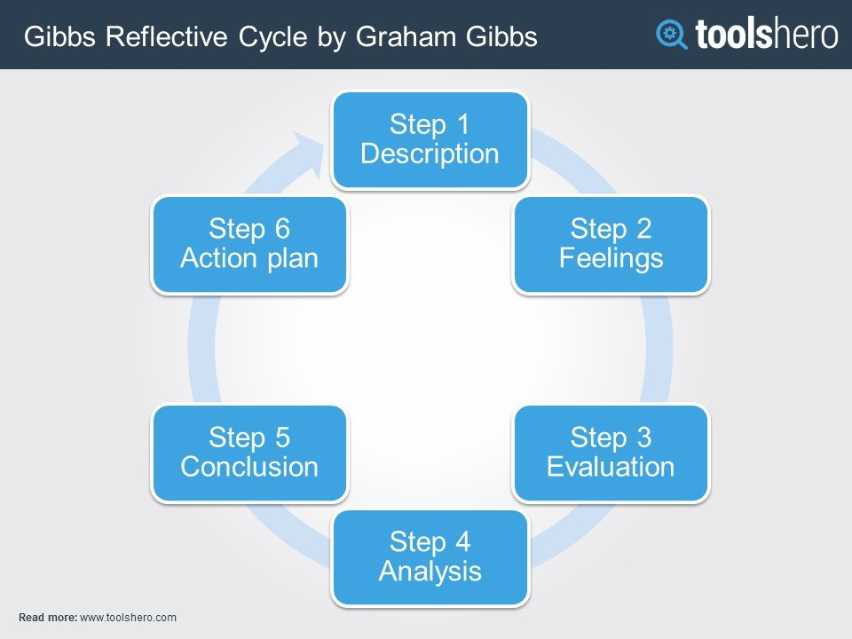

- Description:
I came to do this course for my personal development. I started this module to improve my academic and employability skills. When I started this course I found myself confused. I thought I knew about these skills before. Then slowly I realised that knowing about something and doing that work practically is very different thing. For example, memorizing the instruction book of how to fly a plane and actually flying a plan in real life are two very different things. My situation was like this. I had a degree which helped me to arrange a job but the lacking of practical knowledge made it harder for me to progress in my workplace. But after this module now I know how to combine both of my academic and employability knowledge to achieve my expected progress in the workplace.

- Feelings:
At the beginning of this course I felt lost and frustrated. From this module I got to know that our each and every move can define us as a person of character or otherwise as well. I never thought that my communication, leadership, team work ability can affect my performance and the whole teams as well. I felt overwhelmed with all these information. When I was asked to write this report I was little confused. Then I started to write and I realised that I knew exactly what I should or shouldn’t do in my workplace now. I realised that in the back of my head I have already drawn a plan of my “to do” improvement list. I learned all of these from this module. This is now helping me immensely in my everyday life.
The skills that we learned from here are:
- Employability skills:
Employability skills are a combination of transferable skill along with technical understanding subject attributes and overall knowledge.
There are several kinds of employability skills like;
- Communication Skill –
This is the ability to explain you clearly to the other person with all the necessary information available.
From here I learnt about the importance of communication skill, verbal, non-verbal or in physical way. As I work in a care home; clear communication between the staff is very important to carry on a smooth service in the organization. For example we as a care worker have a responsibility to manage the dietary chart and medical chart of our resident. If there is any miscommunication between staff then it could affect our residents.
- Inter personal skills –
Human being is a social creature. We can’t survive alone. Inter personal skills helps us to be socialite with other people. As a care home worker it is an essential skill for me to be socialite with my colleagues. In this way I can gather more knowledge and experience from them which can help me to become more confident and effective team player.
- Personal skills-
Personal skills are your personal attributes or character. This is something you are born with or achieve it with continuous practice. In my profession sympathy and empathy is very important. Nobody except you to feel the pain of other’s but at least can sympathise with the person who is in pain. This is how I should practice sympathy. Putting me in other’s shoe is the way for me to practice empathy.

- Academic skills:
With all these employability skill I also learn couple of academic skills from this course. There are few academic skills which helped me to improve myself in my work place. For example;

- Research ability-
To be resourceful you need to do research. From this course I learned about this skill. This is the ability to organize, evaluate, investigate and analyse. In 21st century everything is changing in a blink of an eye. It is essential to keep yourself up do date all the time. Research and note taking skills are those which helped me to search for the proper resources to improve my knowledge. As a care home worker I applied it in my workplace. For example if any resident is feeling unwell, I need to search for the best option and support to provide for him immediately. In other case recently we had got complain about our food service. To improve our food service I had to research about the nutrition and medical fact of our resident. Then make a clear decision about the changes we need to make into our system.
- Formal writing:
This learning helped me a lot in my everyday life. In my job I have to write formal letter every day to the food supplier, Medicine supplier, different cleaning company, GP practice and also the pharmacy. To do so it is necessary to have knowledge about the formal language. This model helped me to improve my formal writing skills as well as my academic skills, which are essential to maintain the professional etiquette, credibility, and accuracy.

- Time management-
I learned time management skill from this course. Time management is organising, planning and distributing task depending on their priorities.
Time management helps us to prioritise our most urgent work than the non-urgent work. Good time management help to work smarter not harder. It helps us to get more work done in less time.
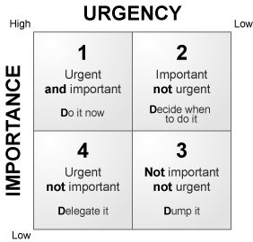
In my work place I have to do several tasks like distributing work, make food menu, fixing doctor’s appointment and many more for the residents. I feel this time management skill helped me a lot in my everyday work. Now before I start my day, I make a clear picture of my work schedule and decide which one task is most important, difficult, and time consuming. I tend to do that job done at first cause this way I become stress free for the rest of my day. For example making menu chart for the resident or work schedule for the worker is the biggest stressful work I have to do in a daily basis. After this course now I start my day with this difficult one. Then I can move myself on to the second stage of the model. Prioritising is now always in my mind which helps me to complete more tasks in less time.
- Pareto’s 80-20 rules:
Pareto’s principle suggests that 20 percent of your activities will account for 80 percent of your result.
It’s like eat the biggest frog first. For example, now every morning I decide which task I should do first. Then, I target to complete that task first. After that I move to the second most important task. In this way I try to finish all the task priority wise.
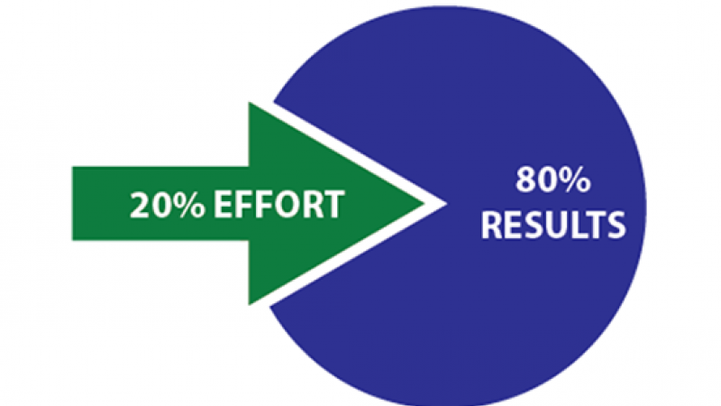
Source: https://helix.northwestern.edu/blog/2012/11/paretos-law-dummies

- Eisenhower Method:
There is another way we can organize our task that is Eisenhower’s method. In here we organize our entire task based on their importance or urgency- non-urgency. Eisenhower Matrix is a time management tool which can help to categorize and prioritize the tasks in hand.
“What is important is seldom urgent and what is urgent is seldom important.”- Dwight D. Eisenhower.

Eisenhower chart:
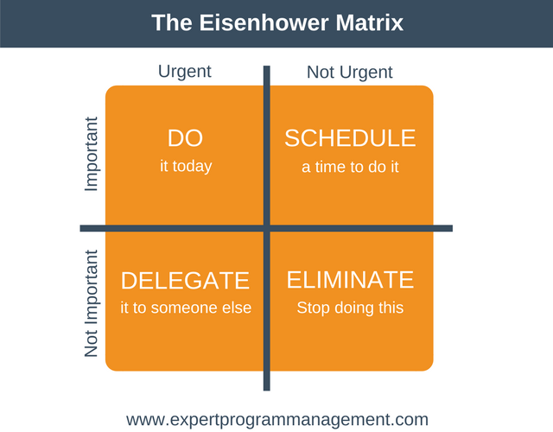
Source: https://expertprogrammanagement.com/2017/07/the-eisenhower-matrix/
From the chart we can see that Eisenhower segment task in four categories:
- Urgent and important- do immediately.
- Important but not urgent- schedule for later.
- Urgent but not important- delegate if possible.
- Neither important nor urgent- leave it if possible.
From this model my learning regarding time management helped me to understanding the concept of time and work distribution depending on their priority.

- Text –
From this module I also gained the ability to do referencing, paraphrasing and summarising. What is referencing mean?
Referencing skill: This is a basis for academic writing. Referencing is very important because it adds to the shared knowledge of all involved in an academic area. Referencing improve the quality of any writing. It shows the depth of the writer’s research.
Reason of referencing is:
- To avoid plagiarism
- To lend credibility/ evidence of your argument
For example, to write this reflective report I used two secondary text books along with other resources to explain my understandings. I apply my learning of paraphrasing to summarise a particular topic. And I also applied the referencing skill taught in this model to make my report authentic and to avoid any kind of plagiarism. Books I have used here to support my work are:
- Eat the frog - which helped me to learn about time management.
- 7 habits of highly effective people. From here I learned how to work effectively.
This skill is going to help me in my workplace as well. In the time of making the yearly report regarding the care home performance and resident I can use my ability of paraphrasing and summarising. Also in case of putting any previous theory in the report, now I know how to give reference for the sake of credibility.

- Analysis:
I am going to explain my learning and skills gaps here in the form of SWOT analysis;

Strength | Opportunity
This module helped me to identify my strength:  Team work  Time management  Researching skills. | Produce opportunity by networking/ socialising.
Weakness | Threats
Lack of prioritising ability affected my performance. | Lack of clear communication or instruction can become a threat for me.

Source: Albert Humphrey (1960s and 1970s)

- Evaluation:
Here I am going to evaluate my learning in this module. Before starting this course I ask myself what I am going to learn from here and how it is going to help me in my workplace. I learned two important element of success from this course, academic and employability skills. Without these, success cannot be obtained. From the learning of this course I have planned a personal development plan to improve my performance. I am going to explain it down below with an action plan. For my self-development I have follow my action plan strictly. I need to set up my target than try to achieve the target. I need to regularly review my own progress and try to overcome my lacking’s cautiously.

Action plan:

Academic
Skills | How to achieve them | Time frame
Time management | I have to practice prioritizing my daily activities to achieve maximum output in minimum time. | 3 months
IT knowledge | I have to practise my IT knowledge more to make it more polish. | 2 months

Employability
Skills | How to achieve them | Time frame
Accept Diversity | Respect everyone despite of the difference of culture, language, experience. | 6 months
Practicing VARK | I have to practice all elements of VARK rather than depending on only visual. For example listing to news regarding any changes in care law or reading any NHS news latter. | 2 months

- Conclusion:
I decided to do this course for my academic and personal development. I have a job which I am doing for last 4 years. But not been able to climb up to higher position yet. This module gave me idea of self-development through practicing academic and employability skills. This module helped me to see through my personal and professional lacking. When I finish this course and leave from here I wish to overcome my lacking within the planned time period and hoping to convert them as my strength.
Reference:

- Covey,S.(1989). The 7 Habits of Highly Effective People. USA.
- Dweck,C.(2006). Mind Set: The New Psychology of Success. New York: Ballantine Books.
- Dye, V. (2011) ‘Reflection, Reflection, Reflection. I’m thinking all the time, why do I need a theory or model of reflection?’, in McGregor, D. and Cartwright, L. (ed.) Developing Reflective Practice: A guide for beginning teachers. Maidenhead: McGraw-Hill Education (pp. 217-234). https://my.cumbria.ac.uk/media/MyCumbria/Documents/ReflectiveCycleGibbs.pdf
- Expert Program Management. (n.d.). Expert Program Management. [online] Available at: https://expertprogrammanagement.com/2017/07/the-eisenhower-matrix/ [Accessed 18 Aug. 2019]. https://expertprogrammanagement.com/2017/07/the-eisenhower-matrix/
- Felipe, V. (2013). Using Academic Skills in the Workplace | Braathe Enterprises Virtual Blog Project. [online] Braatheenterprises.com. Available at: http://www.braatheenterprises.com/virtualproject/college/using-academic-skills-in-the-workplace/ [Accessed 18 Aug. 2019]. http://www.braatheenterprises.com/virtualproject/college/using-academic-skills-in-the-workplace/
- Gibbs, G. (1988).’ Learning By Doing’, Oxford: FEU.
- Humphrey, A. (1960s and 1970s). SWOT Analysis. Professionalacademy.com. (n.d.). Marketing Theories - SWOT Analysis. [online] Available at: https://www.professionalacademy.com/blogs-and-advice/marketing-theories---swot-analysis [Accessed 18 Aug. 2019].
- My.cumbria.ac.uk. (2016). Academic Services & Retention Team. [online] Available at: https://my.cumbria.ac.uk/media/MyCumbria/Documents/ReflectiveCycleGibbs.pdf [Accessed 18 Aug. 2019].https://my.cumbria.ac.uk/media/MyCumbria/Documents/ReflectiveCycleGibbs.pdf
- Mindtools.com. (n.d.). Gibbs' Reflective Cycle: Helping People Learn From Experience. [online] Available at: https://www.mindtools.com/pages/article/reflective-cycle.htm [Accessed 19 Aug. 2019]. https://www.mindtools.com/pages/article/reflective-cycle.htm

- Mulder, P. (2018). Gibbs Reflective Cycle by Graham Gibbs. Retrieved [insert date] from ToolsHero: https://www.toolshero.com/management/gibbs-reflective-cycle-graham-gibbs/.
- Staff, C. (2017). Developing Academic Skills That Transfer to the Workplace. [online] Collegeforamerica.org. Available at: https://collegeforamerica.org/developing-academic-skills-workplace/ [Accessed 18 Aug. 2019]. https://collegeforamerica.org/developing-academic-skills-workplace/
- Schmitz, T. (2016). The Three Types of Soft Skills | The Conover Company. [online] The Conover Company. Available at: https://www.conovercompany.com/the-three-types-of-soft-skills/ [Accessed 18 Aug. 2019]. https://www.conovercompany.com/the-three-types-of-soft-skills/
- Tracy,B. (2008). Eat that Frog. 2nd ed.USA.

