Module BMPF7008 Work based learning project
Contents:
Project Proposal Form 2
Project Report 6
Introduction 6
Literature Review 6-9
Methodology 9
Sampling 10
Methods 10-11
Findings:
Survey Data Break down 12
Discussion 19
Limitations:
Sampling 21
Methods 22
Ethics and Insider Researcher Bias 22
Conclusion 23
Bibliography 24
Appendix 27

Project Proposal
Project Title: ‘Investigating experiences of female vocal change at adolescence for altos, sopranos and mezzo soprano as adults, and the lasting effects this had on their performance confidence.’
Context

Research surrounding female voice change at adolescence is growing (Blatt, 1983; Gackle, 1991; Sweet, 2015) to add to existing research that focus’ on male adolescent voice change (Hughes, 1997; Ashley, 2013, Williams & Harrison, 2016). As a vocal coach, many of my adult female students often relate their lack of confidence in power and range, to a ‘change’ in the voice they experienced during adolescence. This study aims to identify any recalled symptoms of vocal change at adolescence for different voice groups (soprano, mezzo & alto) and whether these have continued into adulthood, and affected performance confidence.

Justification

I hope to research whether separate voice groups perceive the pubertal voice change differently, and whether this has had any long term impact on voice ability and confidence. The existing research into female voice change is based on adolescent participants who are currently facing these symptoms (Blatt, 1983, Sweet, 2015). There is a lack of research of adult’s recalled experiences during this phase and the impact on the adult voice, after voice change.

Intended Impact

Research on female choral singers changing voices has shown that sharing knowledge on the voice with singers contributes positively to female adolescents and their attitude towards their voice (Howard et al, 2018). Research like this in an amateur environment could continue to assist performance institutions and private tutors when dealing with voice change for different voice groups in females. Through this, a suitable outline of vocal symptoms and how to manage these for different voice groups could be put together.

In addition, if this research can help to pinpoint whether voice change is a contributing factor to adults with a loss of confidence in singing, the correct support from tutors could help to increase confidence and promote a stronger identity in vocalists post voice change (Good-Perkins, 2020).

Outlined Intention

I will conduct a literature review into female voice change during adolescence and the perceived vocal symptoms. I hope to gather 15 adult amateur female vocalists from my local area, private tutoring lessons and local amateur theatre groups by using stratified sampling (Teddlie & Yu, 2007). These participants will self-identify into each voice group (soprano, mezzo and alto), ideally having 5 in each group. A cover letter and consent form will be sent to participants who volunteer for this project by approximately end of April. A 20-question survey will be sent out online which will be a mix of qualitative closed and open questions about any recalled vocal change, symptoms and their experience with any vocal changes. The questions will use multiple choice, single choice and open text boxes when necessary. The remaining questions will target participants’ experiences with adult performance confidence and whether there is any correlation. One focus group for each of the vocal groups (alto, mezzo, and soprano) will be conducted for further detail, which will be recorded and transcribed.
I will amalgamate all the results into a report, analyse and discuss these findings, alongside my presentation, by July.

The Ethics and Insider Research

Due to the qualitative nature of this project, ‘insider’ researcher issues may occur such as bias, influencing data from participants (Breen, 2007). As participants are from my local area, there could be a loss of objectivity (Delyser, 2001). Using qualitative questions, the answers might promote detail from participants. Due to this research being work-based, understanding this project aims to give a voice to all participants (Reed & Proctor, 1995), the focus groups may also encounter bias and ethical issues. Participants may feel they are overly sharing, but all participants must have a say. As a researcher I must remain unbiased and just observe in the focus groups. It is likely sensitive topics will be spoken about relating to performance experiences and confidence, and a de-brief email will be given after these focus groups to help manage any potential traumatic experiences recalled. I will include a note within this email to say if any further issues need to be addressed, they should contact me. All participants will have an identifier for anonymity.

Personal Learning Outcomes

- Experience in conducting research to better any future research projects into female voice change, and improve the process.
- Use findings to set a basis for further research into voice change in adolescents and adults, to improve my private tutoring lessons.

References

Anderson, C (2010) Presenting and Evaluating Qualitative Research, American Journal of Pharmaceutical Education, 74 (8) Article 141

Andrew T. J, Vincent Ng, & Louis T (2021). A Review of Key Likert Scale Development Advances: 1995–2019. Frontiers in Psychology, p.12

Ashley, M (2013) Broken voices or a broken curriculum? The impact of research on UK school choral practice with boys, British Journal of Music Education, Vol.30, pp.331-327

Blatt, M (1983) Training Children during the phases of Voice Mutation, Annals of Ontology, Rhinology & Laryngology, Vol 92 (5)

Breen, L (2007) The researcher ‘in the middle’: Negotiating the insider/outsider dichotomy, Centre for Social Research , Edith Cowan University, The Australian Community Psychologist, Volume 19, No.1

DeLyser, D. (2001). “Do you really live here?” Thoughts on insider research. The
Geographical Review, pp.441-453.

Gackle, L (1991) The Adolescent Female Voice: Characteristics of Change and Stages of Development, The Choral Journal , Vol. 31, No. 8 , pp. 17-25

Good-Perkins, E (2020) Rethinking Vocal Education as a Means to Encourage Positive Identity Development in Adolescents, Humane Music Education for the Common Good, Indiana University Press.
https://iupress.org/9780253046918/humane-music-education-forthe-common-good/

Howard, D, Welch, G, Himonides, E & Owens, M (2018). The Developing Female Chorister Voice: Case-Study Evidence of Musical Development. Journal of Voice. 33.

Hughes, A (1997) Changes in the male voice in puberty, Archives of Disease in Childhood, 77: pp.445-447

Reed, J & Proctor, S (1995) Practitioner Research in Health Care: The Inside Story, London: Chapman and Hall.

Sweet, B (2015) The Adolescent Female Changing Voice : A Phenomenological Investigation, Journal of Research in Music Education, Vol.63 (1) pp. 70-88

Teddlie, C & Yu, F (2007) Mixed Methods Sampling : A Typology With Examples, Journal of Mixed Methods Research, SAGE Publications

University of Wales Trinity Saint David (2022) Research Ethics & Integrity Code of Practise, Web address : https://www.uwtsd.ac.uk/media/uwtsd-website/content-assets/documents/research/REICoP-July-2022.pdf

Williams, J & Harrison, S (2016) Boys’ singing voice change in adolescence, Oxford Handbook of Singing, Oxford Handbooks Online, Oxford University Press.

Project Report
'A focus on Alto female voice change and the potential lasting effects on adult performance confidence’.
Introduction
Female voice change is a more recently documented phase of mutation undergone during puberty. This is as common as male voice change, but not quite so severe (Blatt, 1983). Researchers such as Sweet (2015) and Gackle (1991) have been building up the research around female voice change and the symptoms that are experienced during this time, and the reasons why this change occurs.
In my local area, as a vocal teacher, there is a demand for vocal lessons primarily from female adults. Many of the topics covered in lessons are usually linked to performance confidence, and a lack of it with certain aspects of a singer’s voice. In discussion it seemed as though the confidence was linked to a change in the voice during puberty previously.
The project aims are as follows:
- To discover whether altos experience adolescent voice change more severely than their vocal counterparts (Soprano & Mezzo Soprano)
- To outline whether a particular symptom is prominent during this change
- And to see if this has a knock on effect on adult performance anxiety.
My literature review will be focused on outlining the basis of which symptoms are experienced during voice change, existing research on the alto voice, and research on performance confidence.

Literature Review: Existing Research on female voice change.
Existing research around vocal change outlines the physiological and physical changes in the voice at adolescence for female singers, and the symptoms that are linked to this (Gackle, 1991). There are many researchers and pedagogues that have looked at male voice change during puberty (McKenzie 1956, Swanson 1977, Cooksey 2000) however only more recently have pedagogues such as Sweet (2015) been looking into the similarities and differences of female voice change during puberty. Researchers such as Duffy (1970) proposed that voice mutation related strongly to the onset of menstruation in adolescent females, however vocal mutation symptoms lasted longer than the initial onset of menstruation. Abitol et al (1999) found that in females, the impact of oestrogen and progesterone during the pubertal period produces the characteristics of a female voice, whilst testosterone and androgens released at puberty are responsible for the male vocal characteristics. Both of these particular research showing evidence, that like males, females also experience changes to their voices during adolescence.

Symptoms
The physical attributes of female vocal change are outlined by Gackle (1991), showing that during puberty female vocal folds grow by 3-4mm in length. Although this isn’t as drastic as the male counterparts growing in length by nearly an entire centimetre, there is still a noticeable change. Weiss (1950) had already compared the direction of growth in vocal folds for both male and female, and that although both male and female larynx grows anterior to posterior, the male larynx grows substantially more in this direction. The female larynx grows largely in height resulting in a softer and lighter sound. This was supported by Toole (2003) who stated the effects of this lengthening of the vocal folds and larynx lead to many changes of the characteristics of the female voice. These were; a lower in speaking voice, a slight increase in range and the evidence of initial formation of registers in the voice.
Female vocalists experience a similar range of vocal symptoms during the voice change just as their male counterparts do (Gackle 1991, Toole 2003, Willis and Kenny 2008). These symptoms are uncertainty of pitch, huskiness, inconsistent range, cracking and discomfort when singing and breaks in the voice (Gackle 1991, 2006, and 2011). Sweet (2015) supported Gackle, stating that the most common characteristics associated to adolescent female vocal change was huskiness, unpredictable vocals and lack of strength and range. These symptoms affect female vocalists and their choice of repertoire, performance confidence, vocal technique and rehearsal/warm up strategies (Gackle, 2014) by limiting different aspects of their voice depending on how they experienced the voice mutational phase.
A study by Yarnell (2006) examined the experiences of adolescents undergoing voice change and found that hoarseness, vocal breaks, and pitch instability were the most frequently reported symptoms. The study highlighted the potential impact of these symptoms on emotional well-being and social interactions. Monks (2003) investigated the effects of voice change on adolescents' participation in choral singing. The study revealed that individuals who received supportive guidance from vocal coaches and peers exhibited higher levels of confidence and continued participation in choral activities despite the challenges posed by voice change.
The literature shows that there are numerous vocal symptoms that can occur during voice change, listed above. Through this research I hope to pinpoint the most common symptom of female voice change during the voice mutation phase.
Altos
Alto female singers are lower female singers, and possess a unique vocal range that adds depth, richness, and character to choral and solo performances (Einarsdóttir, 2022). However, the relationship between vocal range and performance confidence among alto singers remains a subject of interest. Several studies have explored the relationship between vocal range and performance confidence among female singers, offering insights into the experiences of alto vocalists.
In a study conducted by Einarsdóttir (2022) alto singers were interviewed about their vocal perception and challenges. The findings highlighted the importance of supportive environments, recognition of their unique vocal qualities, and access to repertoire suited to their range in enhancing performance confidence among alto vocalists. This research placed alto voice in the forefront, and outlined the components that make up alto’s identity in singing, such as ‘self-learning’ alto choral lines and having an ‘introverted nature’ compared to potentially arrogant sopranos. Rolvsjord & Halstead (2013) reported findings from a study they conducted that alto participants recalled childhood experiences where they were ‘teased’ for having a low alto voice, and lacked singing abilities because of this.
Some of the literature relating to alto voices is outdated, and there is a gap in the research for more recent research on alto voices. For example, there was a documented discussion in 1882 of how singing masters knew little about the alto voice, and that increasing the attention to it might encourage altos to step forward (Novello, 1882).
This part of my literature review outlined research about alto range and performance confidence, but I struggled to uncover any substantial evidence about what alto singers experience during the voice mutation phase and whether this differed from sopranos or mezzos.

Performance Confidence
Several studies have examined the links between female voice change and performance confidence among adolescent girls. Parker (2016) explored the experiences of girls undergoing voice change in choral singing. They found that girls who received supportive and empathetic guidance from teachers and peers exhibited higher levels of performance confidence compared to those who lacked such support.
Barefield (2012) outlined the importance of how negative experiences can cause anxiety in young singers with knock on effects leading to a lack of performance confidence. He stated that critical evaluation at a young age from voice instructors could cause worry about intonation problems, and therefore increase panic about pitching notes, and decrease confidence.
Gackle (2006) briefly mentions how in one study adolescent females switched to a lower pitch in singing due to symptoms of voice change, to be more confident in their abilities. Gackle (1991, 2006) noted a decrease in range as a symptom of voice change in adolescent females, and that this led to adolescent female switching to a lower vocal part and labelling themselves “alto” to be more confident. However, adult voice does not emerge until the early to mid-twenties (Gackle, 2014) and therefore it is not ideal to prematurely label adolescent females into vocal parts.
Wright (2005) outlined the link between negative self-image in adolescents and voice change, with its possible mental repercussions affecting confidence. Through his investigations he came to the conclusion, “Research confirms the increased incidence of negative self-image and low self-esteem, which at times places adolescents at risk for depression.” (Wright, 2005, p. 223). From the research I have found, I am expecting to find a high correlation between negative experience during voice change at adolescence, and a lack of performance confidence.

Methodology
For this research project I used mixed methods. Using mixed methods helps the researcher to approach topics with multiple ways of interpreting data, seeing and hearing the world, multiple ways to make sense of the world, and multiple viewpoints on what is valuable (Greene, 2008). This stance on how we interpret reality aligns with my paradigm-views, and experience can be interpreted in multiple ways. Using a pragmatic approach, the combination of quantitative and qualitative methods, and allows a more holistic picture of participants data and experience being part of who they are (Morgan, 2007).
Due to the nature of the research project, to investigate participants’ life experiences and perceptions in regards to adolescent voice change I understood that participant’s answers potentially could be long descriptive data. This type of data allows large amounts of descriptive data to be stored, on the account of the participants’ experiences of the situation in question. In this instance, I looked for individual experiences of a period of time in female singer’s lives, and whether they believed these experiences shaped their vocal perception or impacted their performance confidence.

Sampling
I chose to define my sample by requesting that all participants were singers who had been regularly singing since the age of 10 years. I chose this age because this coincides with when Gackle’s (2011) outline of the age of menstruation within her research, and identifying this as the age that voice mutation is likely to start. I was looking for 15 responses, and this was achieved within one month of the questionnaire going live. I was looking for a split of 5 Altos, 5 Mezzo Sopranos and 5 Sopranos – however this was not the response I received. My sample ended up being 7 Sopranos, 5 Mezzos and 3 Altos. These participants self-identified into the categories Alto, Soprano and Mezzo.
Methods
SmartSurvey, which is an online questionnaire generator, allowed me to create a mix of questions. Some of the questions allowed students to type their own answers in a text box (qualitative), some were multiple choice and some were singular choice (yes or no) questions (quantitative). This mix of different types of questions helped to gain data that could be broken down and stored in graph or numerical format (quantitative), and some helped to gain expressive and descriptive data from participants to give their own insight (qualitative). For this project I approached the study with a mixed-method approach. Initially I wanted to use two methods of study, a survey and a focus group, but unfortunately no participants came forward for the focus group within the allotted time for the project.
The survey was put onto Facebook and Instagram, and was advertised as a questionnaire open to female singers who had been singing since the age of approximately ten years of age. This was shared to a local amateur theatrics society called Maldon and District Dramatics Society. The survey went out on the 21st of April 2023 and was live via the Smart Survey website for one month exactly.
The questionnaire had 15 questions and a final text box to add any comments (Table 1). The SmartSurvey website allowed complete anonymity with the answers given, the only answer that was not anonymous, was the final question asking for email addresses to be given only if participants were happy to be a part of the focus group. All participants had to pass through a consent window to be able to take part in the quiz, this consent window outlined the study and the right to withdraw, anonymity and that the focus group was not a mandatory part of this study (Appendix.1)
The questions that I chose for this survey were influenced by my literature review. For example, question 5 and 8 related to Gackle (2006) and Sweet (2015) reporting the most common symptoms, which are used in the table below (see table 2 in Appendix).
(Table 1)
1 | What vocal group are you? (Drop down choice)
2 | At what age did you start singing? (Open answer)
3 | What voice group did you lean towards in adolescence? (11-17yrs) (drop down choice)
4 | Did you experience any change in your voice during adolescence? (this could be gradual or sudden) (drop down choice with added text box for elaboration)
5 | Please tick any symptoms you experienced in any degree during adolescence or voice change ( multiple pre-set choice of answers – tick as many as applicable)
6 | Did you find singing during adolescence challenging or difficult? (drop down choice)
7 | Did you have a vocal coach/singing teacher/music teacher during this time? ( drop down choice)
7a | If you answered no to the previous question, if a singing teacher/coach had been available to you, would you have sought support? (non-compulsory)
8 | Which vocal symptom/difficulty did you find the most prominent? (please specify other if not in the list) (multiple choice pre-set answers)
9 | Did any vocal experiences during adolescence change how you perceive your vocal ability in adulthood? ( drop down choice)
10 | Please rate your confidence levels in your vocal ability currently (drop down choice)
11 | Have you had vocal lessons or training in adulthood? (drop down choice)
12 | Did you ever address any changes that occurred during adolescence in adult lessons or training? (please elaborate as to why for either answer) ( drop down choice with added text box)
13 | Do you still experience any of the issues/symptoms you struggled with at adolescence vocally as an adult now? (please elaborate as to why for either answer)
14 | Please rate whether you think more information about the voice at adolescence would have helped your performance /confidence today? (drop down choice with additional text box)
15 | Did you suffer from any voice-related health problems during adolescence or now as an adult? (drop down choice)

Project Findings
Below is an overview of the results from the survey. Some of this data will be collated into tables, and some of the data relevant to the literature review will be discussed.
Sopranos | Mezzos | Altos
7 | 5 | 3
Q1 - What vocal group are you?

Q2 - At what age did you start singing?

This means the average age when participants began singing regularly was 9 years of age.

Q3 - What voice group did you lean towards in adolescence? (11-17yrs)
All the participants who identified as altos in adulthood, also identified as altos at adolescence, whilst those that identified as mezzos, actually leaned towards soprano at adolescence. Overall the answers showed that a higher percentage of participants leaned towards being soprano at adolescence. This is supported by the literature, Toole (2003) outlining that the lengthening of the vocal folds during puberty did relate to a slight increase in range.

Q4 - Did you experience any change in your voice during adolescence? (This could be gradual or sudden)
From this study 60% of the participants reported experiencing a change in their voice during adolescence. Of this percentage there was a range in what participants outlined as a change. P10 reported just flatness of pitch, whereas P12 experienced a sudden and drastic change of hoarseness, loss of pitch and power, and breathe control difficulties. P1 reported a wider range, but this was coupled with loss of power and some dry throat and difficulty pitching at times. Gackle (1991) reported these symptoms the participants mentioned within the research (flatness of pitch, loss of power, hoarseness), so these results keep in line with the current literature surrounding voice mutation symptoms.
Q5- Please tick any symptoms you experienced in any degree during adolescence or voice change
This question had multiple choices of symptoms during adolescent voice change with the ranking of; definitely, somewhat, little and none. The most reported symptom, in any degree, was a change in overall pitch. The least reported symptom, in any degree, was pain when singing. However the most reported symptom under the degree ‘definitely’ was joint between a break in the voice and a change in overall pitch. Again, these findings on vocal symptoms are supported by research by Yarnell (2006), Sweet (2015) and Gackle (1991). Further breakdown of these percentages below:
(Table 2)
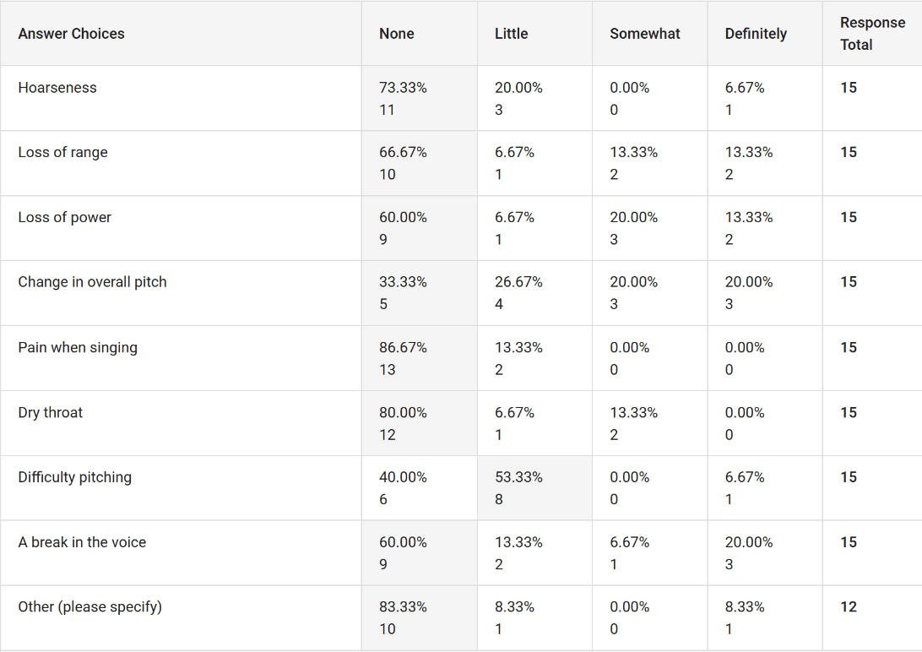
Q6 - Did you find singing during adolescence challenging or difficult?
80% of participants reported no difficulty with singing during adolescence. The 20% who reported they did experience difficulty during adolescence were all soprano at adolescence, and two who now identify as mezzo. The difficulties they elaborated on covered mental issues with loss of confidence and pressure from their voice teacher, and the physical loss of range creating problems when singing. This is supported by Parker (2016) who discovered that girls who didn’t receive support from voice teachers during the voice mutation phase, lacked confidence in their performance.

Q7 - Did you have a vocal coach/singing teacher/music teacher during this time?

Out of the 2 participants that reported having neither of these guides during adolescence, one was soprano (P12 who also reported a sudden voice change) and one was alto (P5 who reported no change until adulthood). The two participants that had no guidance had very different experiences of adolescent voice change. These results showed no correlation with the rest of the data that a vocal coach or music teacher changed their perception of adolescent voice change.

Q8 - Which vocal symptom/difficulty did you find the most prominent? (Please specify other if not in the list)
When asked which vocal symptom participants found most noticeable during adolescent voice change, 33.33% reported a break in the voice. 20% reported a difficulty in pitching notes, and 6.67% reported a loss of power. Another non-listed symptom that was reported was lack of breath control (6.67%). Another symptom that was most frequently experienced, although only under the ‘little’ category, was difficulty pitching (53.33%). These results are supports by Gackle (1991) and her outline of symptoms experienced during this time.
Q9 - Did any vocal experiences during adolescence change how you perceive your vocal ability in adulthood?
10 out 15 participant (66.67%) reported that the experiences they had during adolescence changed their perception on their adult voices. These responses were nearly all elaborated on in the text box, and the responses that were shared shed a negative impact on their adult perceptions of their voice, and their performance confidence. Some of the responses are as below:
“Comparisons to others in the same theatre group. Definitely made me a lot more conscious of trying to sing better than another. Which is ridiculous!! Definite loss of confidence.” – P14
“That impact has been dragged on for a very long time, making me insecure about my abilities and my voice in general. It took the praise of a sound technician on my very specific personal sound (he was jealous) to start the way I perceive my instrument. I was already in my 30s by then.” – P9
“I desperately wanted to be mezzo, but had it in my head and heart that only ‘special’ people get to be mezzos and that the majority of people are sopranos. So even though I had a strong lower range and wasn’t comfortable in higher tessituras, I went against my teacher’s advice as auditioned for College as a soprano. Because I was really a high mezzo and picked my rep carefully, they let me in as a soprano. By the Christmas of my first year PG I had lost the top fifth or so of my voice. I went back to my old teacher who fixed it, and I finally accepted that I was indeed a mezzo. Everything improved from then.” – P8
P4 and P9 both commented on comparison of their own voices with peers and tutors abilities, and that this negatively impacted the perception of their own voice.
It seemed that overall the participants that did report a negative impact experienced during voice change, and the results were from all voice groups. Neither Alto, Mezzo nor Soprano stood out as having more negative insight on their voices than their counterparts. These were unexpected results, as I had assumed altos would have been more negative on their view of this mutation voice phase. It was also unexpected that such a high percentage would have negative experiences.

Q10 - Please rate your confidence levels in your vocal ability currently
For this question the answers were separated into a scale to depict overall confidence with singing abilities. This varied from ‘not confident at all’ to ‘very confident with no concerns’. The table below shows that the most common answer, was ‘confident but with some concerns’. The participants that reported not being confident with their singing abilities were a split between voice groups as per below:
Nearly all the ‘Confident’, and both ‘Very Confident’ answers were sopranos and mezzo sopranos.

(Table 3)
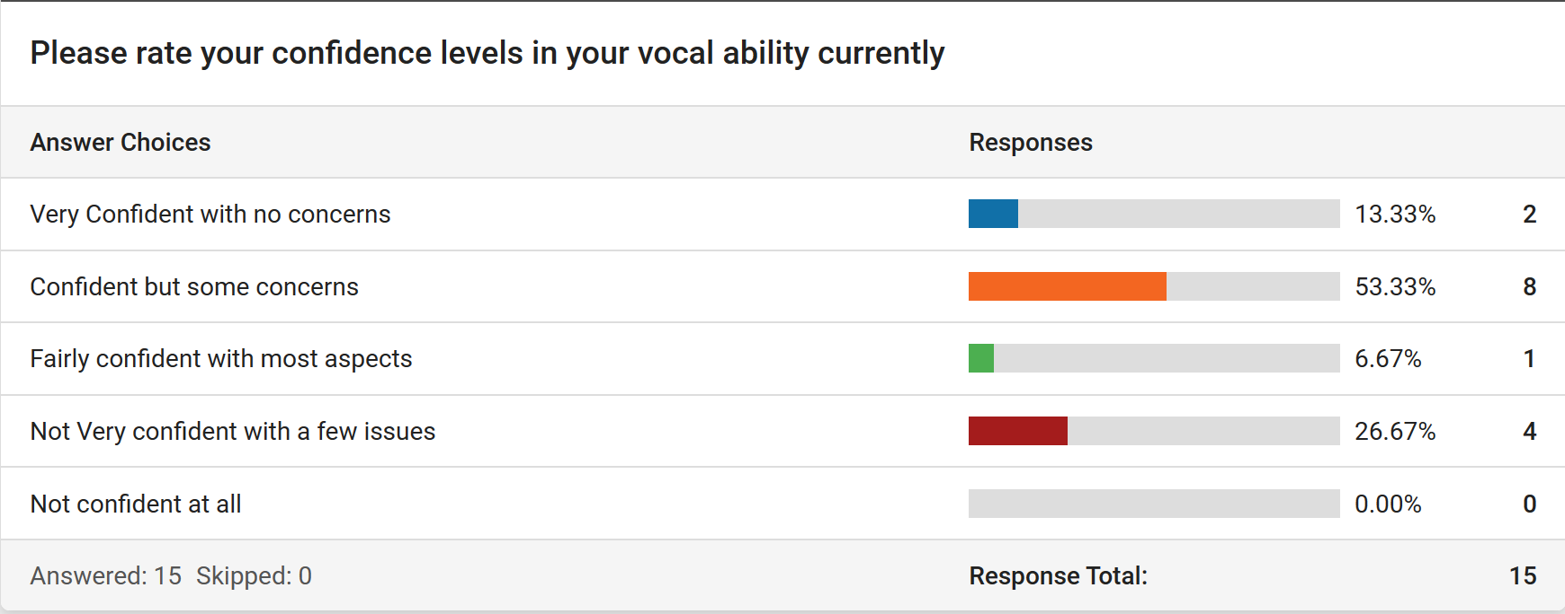

Q11 - Have you had vocal lessons or training in adulthood?

Extensive Vocal Training | Basic Training | No Training at all
60% | 20% | 20%
All of the answers that stated they received extensive vocal training were soprano and mezzo soprano.

Q12 - Did you ever address any changes that occurred during adolescence in adult lessons or training?
Out of 15 responses, 9 participants chose to elaborate on this with the text box available. 5 participants reported that the reason was due to their vocal coaches being traditional and not having any knowledge about female voice change at adolescents, and therefore they felt they couldn’t bring it up. The 5 responses were all either soprano or mezzo soprano.

Q13 - Do you still experience any of the issues/symptoms you struggled with at adolescence vocally as an adult now?
9 participants responded and elaborated on their experiences during adolescence and the issues they faced as adults. There was a large array of responses, and during coding I categorised these by looking for keywords such as symptoms, negative experiences, and confidence issues.
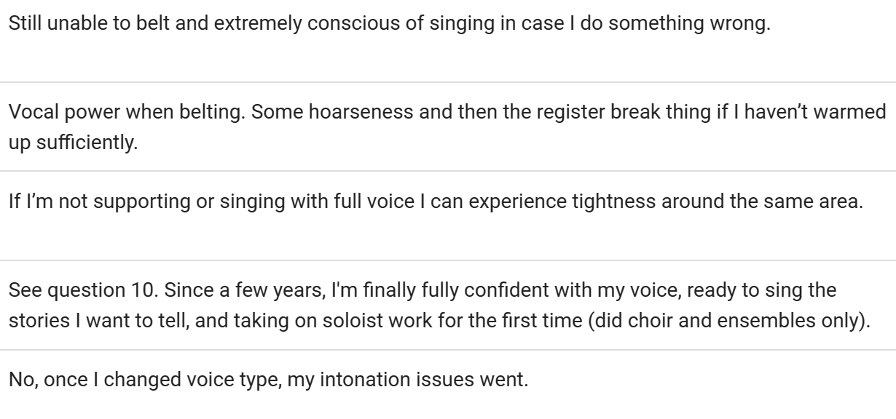
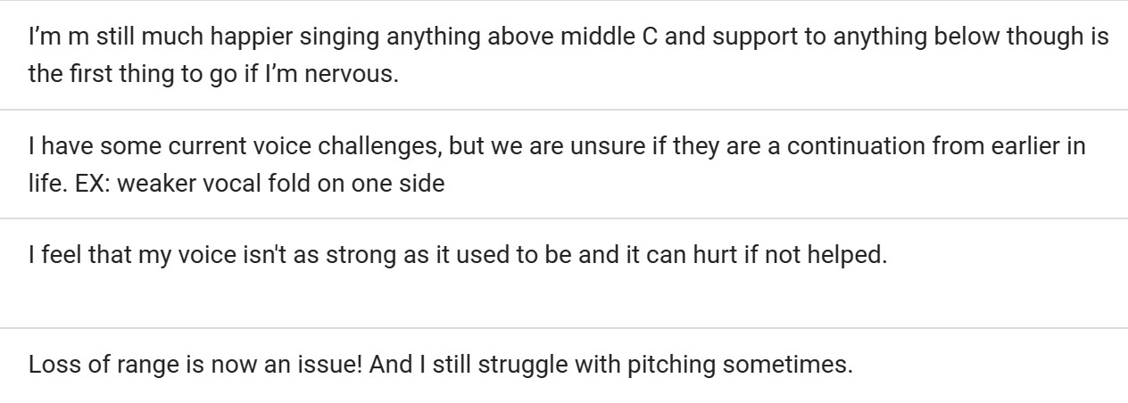
Q14 - Please rate whether you think more information about the voice at adolescence would have helped your performance /confidence today?
For this question 14 out of 15 participants reported that they felt more information at the time about female voice change would have either been ‘very useful’ or ‘somewhat useful’.

Q15 - Did you suffer from any voice-related health problems during adolescence or now as an adult?
Only one participants reported any voice-related health problems during adolescence, and didn’t report this being a problem as an adult after pregnancy. Research shows those with vocal health issues or voice miss-use, would have needed a longer training programme at any age to combat these problems, this including the voice mutational phase during adolescence (Cleveland, 1995).

Discussion
To find links and themes throughout this project I used thematic analysis, which is used to identify, analyse, and report patterns or themes within a dataset or text. It involves systematically coding and categorizing data to identify recurring ideas, concepts, or patterns, which are then organized into meaningful themes (Braun & Clarke, 2006). This means that the studies were read multiple times in full to identify common themes in relation to the aim of this review (Braun & Clarke, 2006). Thematic analysis allows us to observe the participants narrative of a life situation, and provides purely qualitative and detailed account of data (Vaismoradi et al, 2013). The focus of this study was on the alto voice group, and whether they experienced a more severe vocal change to their higher vocal counterparts.
Common Symptoms of Voice Change
The most common symptom was the recurring report from participants of ‘voice breaks’ during adolescent female voice change. This was seen as a negative part of the participant’s experience, alongside ‘difficulty pitching’, although this was experienced only ‘a little’ on the answer scale by most participants. These findings match patterns found in existing research such as Sweet (2018) who outlined that due to sudden growth during puberty in the laryngeal muscles, female adolescents can struggle with transitioning between registers, and also effect adolescent’s abilities to pitch. Bonnie Blu Williams (1996) also identified in her study comparing pre-pubertal and pubertal females, that pubertal females would experience symptoms like breathiness, pitching issues and voice breaks more so than pre-pubertal.
The symptom of ‘voice breaks’ and ‘change in pitch’ didn’t seem to follow a pattern at all, and occurred in a handful of participants of all voice groups. Both symptoms occurred most highly in sopranos, however there was already an unbalanced level of Sopranos compared to the other two voice groups. Therefore, this data does not prove that more altos experienced the common symptoms of voice change than sopranos and mezzos, and further research would be needed.
Negative Experience
Existing research shows that many female adolescents have a negative view of voice change, due to feeling self-conscious about the unpredictability of their voice. This self-awareness can hinder their willingness to perform and may lead to a decrease in self-confidence (Johnson and Smith, 2017). In total, 10 participants reported a negative experience during this time. A range of answers were given, and were highly descriptive. I identified themes such as ‘comparing to others’ and ‘lack of support’. Research does outline the importance of inclusion and support during these years for singers, Good-Perkins (2020) spoke about the issues of the silenced singer, and how a vocal coach can be the catalyst to push singing experiences to a positive or negative outcome. Vocal coaches should be open to the students’ perception of what is good and bad, rather than dictating. This dictation could lead to students feeling inadequate about their voices because they don’t fit into a bracket.
The results throughout this study were not consistent, as when asked whether participants found the voice mutation phase difficult, 80% reported they didn’t find it difficult at all. However later on, the above responses to whether the voice mutation phase changed their perception of their voice, all 10 who responded yes elaborated in a negative view.
When looking at coding qualitative data for ‘negative experience’ it is important to mention that the coding was based off of my perception of what this might look like.
Performance Confidence
The period of adolescence is often filled with feelings of inadequacy, insecurity, and an over-riding need for peer acceptance. (Wright 2005). As a performer and now a vocal coach, I have experienced multiple levels of performance confidence issues through adolescents and adulthood.
I found only six participants reported confidence issues. These were a mix of Sopranos, Mezzos and Altos. Only one of these participants reported a negative experience of voice change at adolescents. However, later in the study when participants were asked whether they experienced any of the symptoms and issues in their voice currently, 10 participants elaborated on different aspects of their voice. This included symptoms such as tightness, hoarseness, and breaks in the voice, lack of range and loss of power. These symptoms are similar or the same as the symptoms at adolescent voice change reported by Gackle (2006). Many of the responses mentioned the comparison to others at adolescence, and the lack of understanding and knowledge on the part of their music teacher or vocal coach at the time, resulting in a loss of confidence and even giving up on singing altogether.

Limitations
Sampling
I used random sampling to acquire 15 participant. Initially I wanted 30, but realised the amount of data for a 15-question survey would be vast and the analysis would be very time consuming. I outlined my requirement criteria (female / a regular singer since puberty) to attract participants that would be relevant to this study. However, this sample would been subject to bias due to where I advertised this project. The local theatre societies that I advertised in already knew me as an individual and therefore these participants were not a truthful and honest representation of the local demographic. This in itself was another limitation of my study. I wanted this study to reflect singers within my local area, as this was where I experienced a lack of support of adolescent female voice change. However this would have created very specific qualitative results that could not be generalised to all individuals that would fall into the criteria I set out (female/regular singer since puberty). By advertising to local theatre groups via social media, I did in fact create a bias towards this type of individual, and did not include all female singers from a variety of walks of life, such as those who no longer sang or did not attend theatre society. I also did not expand this research to all genres of singers (opera, pop, CCM), and this was purely narrowed down to amateur musical theatre singers.
A limitation of my sampling method was that I also expected participants to self-identify which vocal group they were in. By publicising the advert and the initial question of the study being ‘Which Vocal Group are you?’ I was leaving vocal identification open to the participants’ interpretation. Although most singers think they are aware of their range and which vocal group they prefer to sing in, this was not supported evidence to show which voice group participants actually should be assigned to.
One way to improve the quality of my sample, to ensure that the data is more valid, would have been to have used purposive sampling and screened my sample for their vocal ability to identify voice group (Teddlie & Fen, 2007). Rather than leaving the participants to self-identify their vocal group, by screening them and testing their range, I could have placed them into vocal groups depending on where they could sing comfortably. This would make the data collection a more lengthy progress as I would have to meet each participant in person to test their range, but it would make the results more accurate for each vocal group.

Methods
I had wanted to conduct a 15 question survey and follow this with a focus group for each voice type to help to elaborate on the experiences that participants had with vocal change. However, I left a part of the survey for those to leave their email if they wanted to be considered for the focus group, and no participants responded when asked to participate in focus groups. In review, I had made this part non-mandatory with the idea that if the focus groups were mandatory, I would struggle to find any participants for the survey and the entirety of the study. The focus groups had the option to be online via Zoom, a video/audio platform, as research has shown this is a more comfortable setting than face to face discussion (Thunberg & Arnell, 2021). However no participants came forward for the focus group in any platform. This meant that although I wanted two research methods, I would only use the one.
Although I received enough data to conduct this study, and the data was a mix of qualitative and quantitative data, my findings were inconclusive to my hypothesis, due to the fact it was incorrect for the balance between alto, mezzos and sopranos for my participants. I could not determine the aims for this study.
Additionally, after the survey questions were completed and once I began to analyse the answers, it became apparent that some of these participants had extensive vocal training during adolescence and some did not. The study was aimed at any vocalist who had been singing since pre-teen ages (10yrs approximately), and was open to the public via social media, and local theatre groups. In hindsight, I should have been more specific with my sampling and made sure that there were not as many variables for participants. I wanted this study to be a true representation of the local demographic, and I did not want to make sampling too specific in fear that this would not represent the demographic fairly.

Ethics and Insider Researcher Bias
For this research project, I was aware that I was dealing with potentially emotional and sensitive information from each participant’s adolescence. My research question actively asked for participant’s to recall this voice mutation phase, and whether this was a negative experience. Due to this, I tried to keep all participants as anonymous as possible, and for this reason I will not be sharing the entirety of all the participants’ individual survey answers, as these had some personal email addresses on them.
As this survey was aimed at my local demographic, it was highly likely I would know some of the participants, as I advertised through theatre groups that were local to me. Due to this, I was aware that I would be subject to insider researcher bias. Being an insider researcher has positive repercussions to the research, such as greater understanding of participants and a natural relationship with participants (Bonner & Tolhurst, 2002). However it also comes with some negatives that can impact the study, such as a loss of objectivity and creating assumptions based on researcher’s prior knowledge (Delyser, 2001). This sort of bias would prevent me from having an objective stance on the data, and might create bias within the results that would have made this study an incomplete example of the demographic (Kanuha, 2000). Being an insider researcher, and having a level of prior knowledge of participants, can create issues with ethical codes (Gerrish, 1997) and this can affect anonymity for the participants. This was something I was highly aware of when conducting my survey. Equally the participants may also insight bias to the data they present because of their connection with me (Delyser, 2001) and they may assume I already know the answer.
Another way I had planned to prevent insider research bias, was to use multiple data collection methods. This can overcome any missed information via shared understanding of incomplete sentences, and vague comments (DeLyser, 2001). However, the second method of collecting data, which was the focus groups, never materialised.

Conclusion
The research question that was proposed in this study was looking specifically for negative experience during adolescence in regards to voice change for altos, and any long term performance confidence issues. Although we can see from existing research such as Gackle (2011) that choral singing at adolescence can be a positive influence on young females’ lives, it is apparent not all adolescent girls feel this way about the mutational voice phase.
However, this research set out to show that Altos potentially experienced a much harsher voice change, with more prominent symptoms that lead to a lack of confidence in adult performing. The literature I looked at had no reference to whether altos did experience voice change any differently to their voice counterparts, and I felt compelled to look into this further. The results did not support this, as a range of participants from different voice groups experienced the common symptoms such as voice breaks (Sweet, 2015) and a lack of performance confidence. This survey showed that not just Altos experienced negative voice change, and that rather it was a handful of participants in each voice group that found the experience negative.
We can take from this research, that the most common vocal symptoms during this time such as voice breaks and difficulty pitching, matches existing research (Gackle, 1991 & Sweet, 2015). This survey also indicated not enough education was available for adolescent females to explore for themselves. Participants also suggested vocal coaches were not equipped with enough supporting information either.
The practical next steps that I have concluded from this survey, is that further research could be executed, looking into specific samples of voice groups during adolescent voice change, and potentially pre-screen these participants to help identify voice groups. I will also look into whether there are any other contributing factors that occur during adolescence that could change the overall experience for singers experiencing voice mutation.
From this survey, however, it is clear more education should be at hand for all singers at adolescence. Applications such as relevant curricular in schools for music classes for adolescents going through puberty, could help female singers to regain some of their confidence through adolescence, regardless of which voice group they identify with. For the adult community, more support could be offered through group vocal sessions and choral groups, to assist with persistent voice symptoms and reassurance for performance confidence.

Bibliography
Aronson, A. E., & Bless, D. M. (2009). Clinical voice disorders. Thieme Medical Publishers.
Barefield, R (2012) : Identifying and Assisting Singers with Chronic Anxiety Issues, Music Educators Journal, Vol. 98, No. 3, pp. 60-63
Blatt, M (1983) Training Children during the phases of Voice Mutation, Annals of Ontology, Rhinology & Laryngology, Vol 92, Ed (5)
Bonner, A., & Tolhurst, G. (2002). Insider outsider perspectives of participant observation. Nurse Researcher, Vol. 9 Ed (4), pp. 7-19.
Braun V & Clarke V (2006) Using thematic analysis in psychology. Qual. Res. Psych. Vol 3 pp. 77–101
Cooksey, J (1999) Working With Adolescent Voices, St Louis: MO, Concordia Publishing
Cooksey, J. (2000) Voice transformation in male adolescents. In L. Thurman & G. Welch (Eds.), Body mind and Voice – Foundations of Voice Education, Iowa City, IA: The Voice Care Network. pp. 718–738
Cleveland, T (1995) Voice Care – The Team Approach, Journal of Voice, pp. 56-57
DeLyser, D. (2001). “Do you really live here?” Thoughts on insider research. The
Geographical Review, pp. 441-453.
Duffy, RJ (1970) Fundamental frequency characteristics of adolescent females. Lang Speech. Vol 13, pp.14-24
Einarsdóttir, S (2022) ‘I Certainly Couldn’t Be a Soloist and I Really Struggle with Auditions’, International Review of the Aesthetics and Sociology of Music, Croatian Musicological Society, Vol 53, pp.139-160
Gackle, L (1991) The Adolescent Female Voice: Characteristics of Change and Stages of Development, The Choral Journal, Vol 8, pp.17-25
Gackle, L. (2000). Understanding voice transformation in female adolescents. In L. Thurman & G. Welch (Eds.), Body mind and voice: Foundations of voice education (Rev. Ed.). Iowa City, IA: National Center for Voice and Speech. pp. 739–744
Gackle, L. (2006). Finding Ophelia’s voice: The female voice during adolescence. The Choral Journal, 47(5), pp. 28–37.
Gackle, L. (2011). Finding Ophelia’s voice, opening Ophelia’s heart: Nurturing the adolescent female voice. Dayton, OH: Heritage Music Press.
Gackle (2014) Adolescent Girls’ Singing Development, The Oxford Handbook of Singing.
Gerrish, K. (1997). Being a ‘marginal native’: Dilemmas of the participant observer. Nurse Researcher, Vol. 5 Ed. (1), pp.25-34.
Greene, J. C. (2008). Is mixed methods social inquiry a distinctive methodology? Journal of Mixed Methods Research, 2(1), pp. 7-22.
Good-Perkins, E (2020) Rethinking Vocal Education as a Means to Encourage Positive Identity Development in Adolescents, Humane Music Education for the Common Good, Indiana University Press. https://iupress.org/9780253046918/humane-music-education-forthe-common-good/
Kanuha, V. K. (2000). “Being” native versus “going native”: Conducting social work research as an insider. Social Work, Vol. 45, pp. 439-447.
Mckenzie, D (1956) Training the Boys Changing Voice, London, Bradford and Dickens, Drayton House
McMillan, J., & Schumacher, S. (2006). Research in Education. (6th Ed.) Boston: Pearson Education.
Morgan, D. L. (2007). Paradigms lost and pragmatism regained: Methodological implications of combining qualitative and quantitative methods. Journal of Mixed Methods Research, 1(1), pp. 48-76
Monks, S. (2003). “Adolescent singers and perceptions of vocal identity.” British Journal of Music Education Vol. 20, Ed (3) pp. 243–56
Novello & Ewer (1882) Scarcity of Alto Voices, The Musical Times and Singing Class Circular, Vol.23, No.468, p.100
Oates, J., & Stathopoulos, E. T. (2004). A preliminary investigation into the singing formant frequencies of female pre- and post-mutational voices. Journal of Voice, 18(1), pp. 46-55
O’Toole, P. (1998). “A missing chapter from choral methods books: How choirs neglect girls.” Choral Journal 39 (5): pp. 9–32.
Parker, E (2016) A Grounded Theory of Adolescent High School Women’s Choir Singers’ Process of Social Identity Development, Journal of Research in Music Education, Vol, 65, Sage Journals, pp.391-507
Phillips, K. (1996) Teaching Kids to Sing. New York: Schirmer Books.
Swanson, F. (1961) The proper care and feeding of changing voices. Music Educators Journal, Vol. 48, pp. 63–67.
Swanson, F.J (1977) The Male Singing Voices ages 8 to 18, Cedar Rapids, IA, Igram Press
Sweet, B (2018) Voice Change and Singing Experiences of Adolescent Females, Journal of Research in Music Education , July 2018, Vol. 66, No. 2, pp.133-149
Teddlie, C. (2005). Methodological issues related to causal studies of leadership: A mixed methods perspective from the USA. Educational Management Administration & Leadership, Vol. 33, Ed (2), pp. 211-217
Teddlie, C., & Stringfield, S. (1993). Schools make a difference: Lessons learned from a 10-year study of school effects. New York: Teachers College Press.
Teddlie, C., & Tashakkori, A. (2003). Major issues and controversies in the use of mixed methods in the social and behavioural sciences. Handbook of mixed methods in social & behavioural research, Thousand Oaks, CA: Sage pp.3-50
Teddlie, C & Fen, Y (2007) Mixed Methods Sampling: A Typology with Examples, Journal of Mixed Methods of Research, Sage Publications, Vol 1
Thunberg, S & Arnell, L (2021) Pioneering the use of technologies in qualitative research – A research review of the use of digital interviews, International Journal of Social Research Methodology, Vol. 25, Ed. 6, pp. 757-768
Toole, G. H. (2003). “The female singing voice from childhood through adolescence.” Dissertation Abstracts International 64, Vol. 6
ROLVSJORD, R., & HALSTEAD, J. (2013). A Woman’s Voice: The Politics of Gender Identity in Music Therapy and Everyday Life, The Arts in Psychotherapy. http://www.sciencedirect.com/science/article/pii/S0197455613001184
Vaismoradi M, Salsali M, Mark P. (2011) Patient safety: nursing students’ perspectives and the role of nursing education to provide safe care. Int. Nurse. Vol 58, pp. 434–442
Vaismoradi, M, Turunen, H, and Bondas, T (2013) Content analysis and thematic analysis: Implications for conducting a qualitative descriptive study, Nursing and Health Sciences (2013), 15, 398–405
Welch, G. F., & Howard, D. M. (2001). Singing and vocal development. In The Science and Psychology of Music Performance, Oxford University Press. pp. 197-216
Weiss, D. (1950). "The pubertal change of the human voice." Folia Phoniatrica, Vol. 2 Ed (3), pp. 126-159
Willis, E. & Kenny, D. (2008) Effect of voice change on singing pitch accuracy in young male singers. Journal of Interdisciplinary Music Studies, 2, pp.111–119.
Williams, B. B. (1996). “An investigation of selected female singing—and speaking—voice characteristics through comparison of a group of pre-menarcheal girls to a group of post-menarcheal girls.” Journal of Singing Vol 52, Ed (3): pp. 33–40.
Wingate, J. M., & Siegel, G. M. (2019). Teaching Adolescent Singers During Voice Change: A Survey of Choral Directors. Journal of Research in Music Education, Vol. 67, Ed (4), pp. 378-397.
Wright, E. J. (2005). “Trapped in negative self-focus: The implications of emerging self-focused emotion regulation and increased depression risk following pubertal onset in females.” Proquest Dissertations and Theses. PhD dissertation. Iowa: The University of Iowa. Section 0096, Part 0622, pp. 223
Yarnell, S. (2006). “Vocal and aural perceptions of young singers aged ten to twenty-one.” Journal of Singing Vol. 63, Ed (1), pp. 81–85

Appendix
Table 1
1 | What vocal group are you? (Drop down choice)
2 | At what age did you start singing? (Open answer)
3 | What voice group did you lean towards in adolescence? (11-17yrs) (drop down choice)
4 | Did you experience any change in your voice during adolescence? (this could be gradual or sudden) (drop down choice with added text box for elaboration)
5 | Please tick any symptoms you experienced in any degree during adolescence or voice change ( multiple pre-set choice of answers – tick as many as applicable)
6 | Did you find singing during adolescence challenging or difficult? (drop down choice)
7 | Did you have a vocal coach/singing teacher/music teacher during this time? ( drop down choice)
7a | If you answered no to the previous question, if a singing teacher/coach had been available to you, would you have sought support? (non-compulsory)
8 | Which vocal symptom/difficulty did you find the most prominent? (please specify other if not in the list) (multiple choice pre-set answers)
9 | Did any vocal experiences during adolescence change how you perceive your vocal ability in adulthood? ( drop down choice)
10 | Please rate your confidence levels in your vocal ability currently (drop down choice)
11 | Have you had vocal lessons or training in adulthood? (drop down choice)
12 | Did you ever address any changes that occurred during adolescence in adult lessons or training? (please elaborate as to why for either answer) ( drop down choice with added text box)
13 | Do you still experience any of the issues/symptoms you struggled with at adolescence vocally as an adult now? (please elaborate as to why for either answer)
14 | Please rate whether you think more information about the voice at adolescence would have helped your performance /confidence today? (drop down choice with additional text box)
15 | Did you suffer from any voice-related health problems during adolescence or now as an adult? (drop down choice)

Table 2
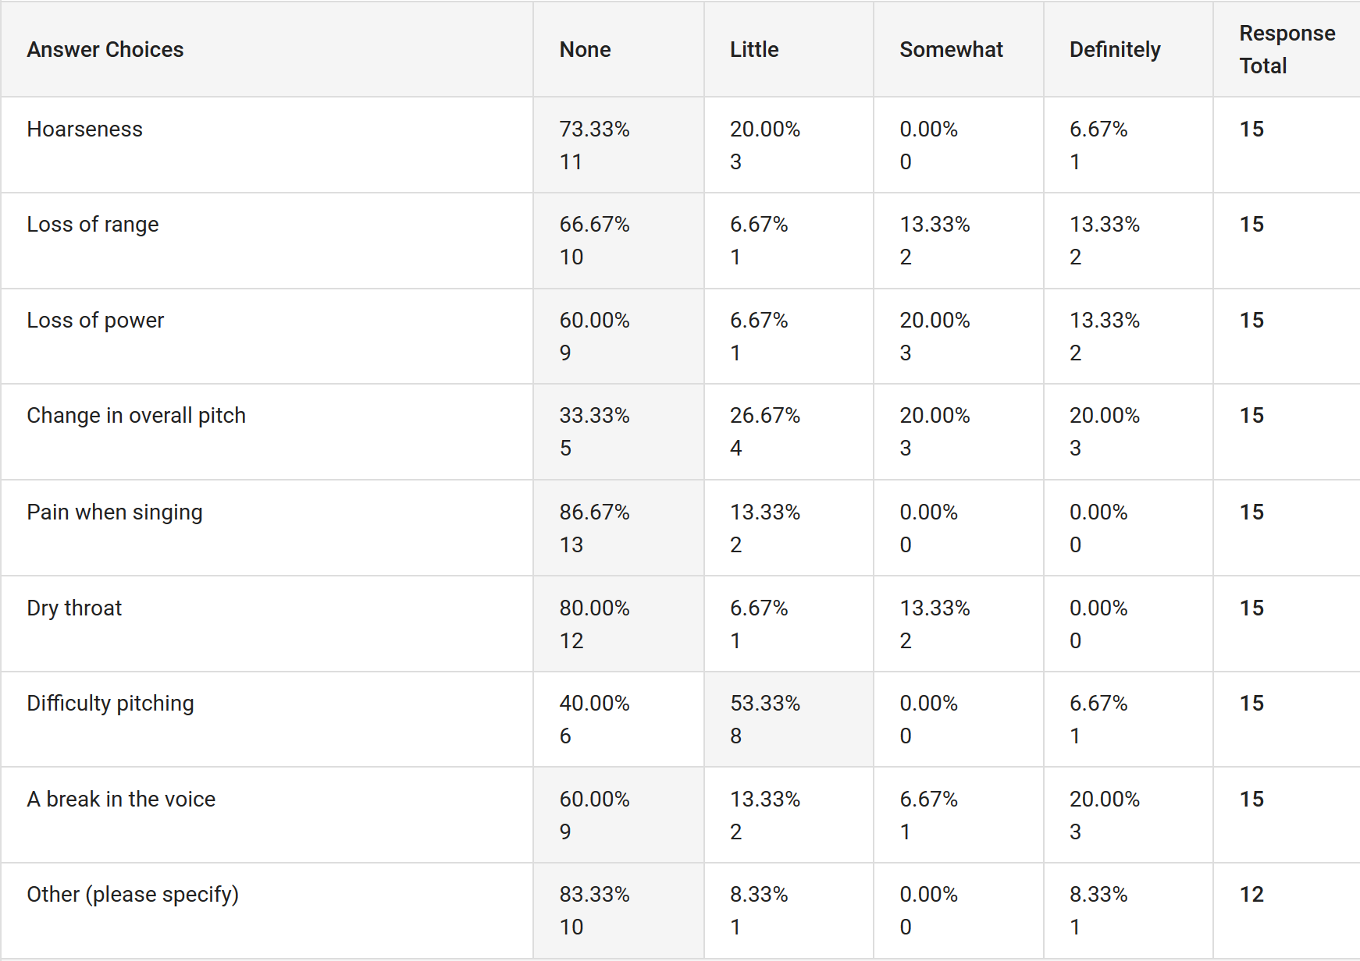
Table 3
Consent Form
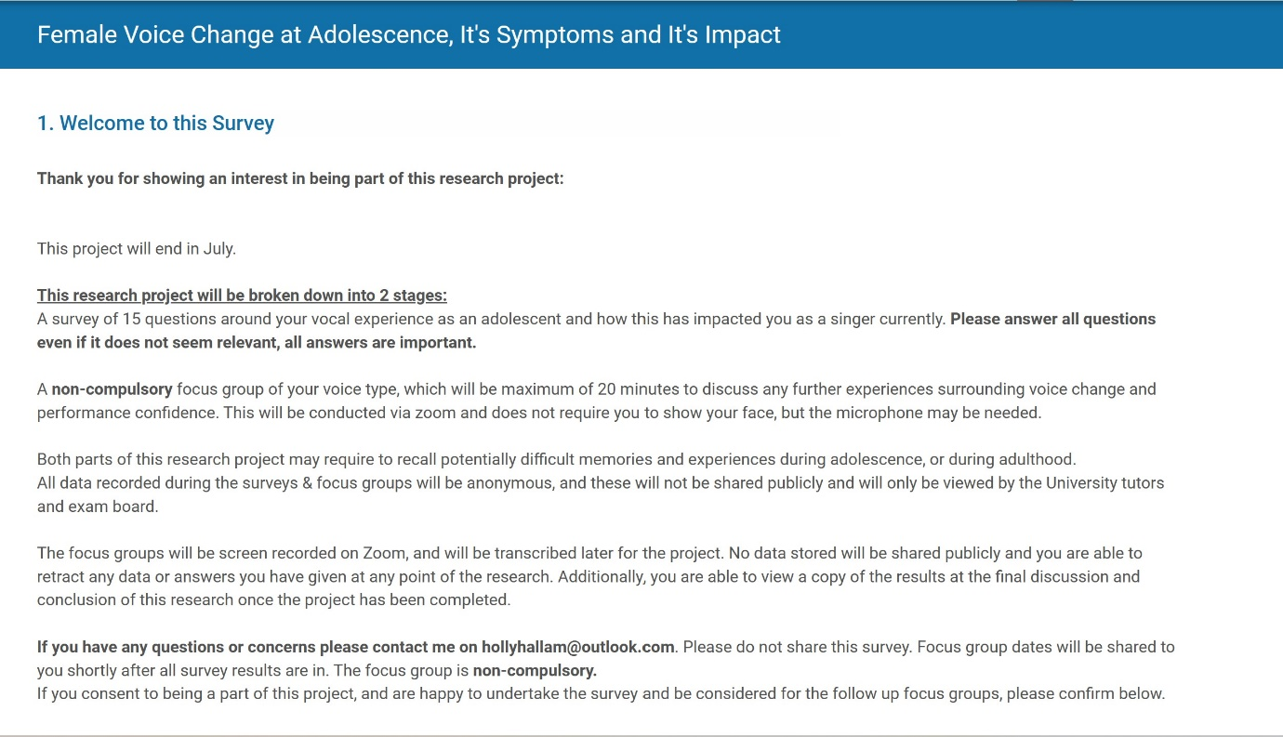
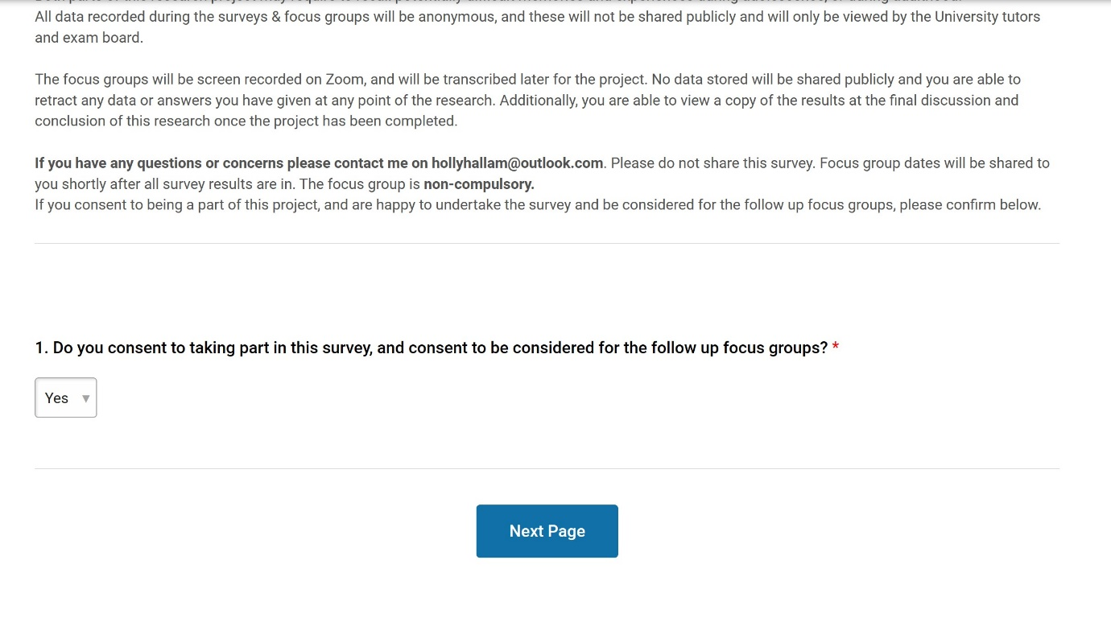

Permission Letter


