Siwan Thomas
1702379
Surface Pattern Design
M4X01559 C
Gwenllian Beynon
1302

Theme

- Does a place depend on human existence to exist?
- Yi Fuan Tuan (1977:161) – ‘place is whatever stable object catches our attention’
- Places only exist due to human involvement/experiences.
- Loses definition
- Does globalised development ruin what makes a place a place?
- Mike Crang ‘While modern technology creates material affluence it endangers the affective aspects of place’ 1998 p.103

Ways of Perceiving – John Berger

- Dealing the perception of how people see things
- Able to change this by questioning and challenging the viewers
- ‘we only see what we look at. To look is an act of choice’ Ways of Seeing 1972 p.8

Floor Plan of the Imagined Exhibition
THE RELATIONSHIP BETWEEN PEOPLE AND PLACES
Bedwyr Williams

- TYRRAU MAWR 2016
- Created a digital projection of a fictional mega city in Cadair Idris.
- Is this place considered more of a place now due to human experience?
- Globalisation’s impact on natural places.
Location

- Turbine Hall, Tate Modern – Frances Morris ‘a hugely significant space; awe inspiring in its scale’ Tate.
- Taking it out of context and placing it amongst the Preseli Mountains, like Bedwyr Williams
- Prada Marfa – pop architectural land art project – dealing with the idea of consumerism/globalisation
- People unknowingly leaving their mark = grass.
Richard Long

- BOYHOOD LINE 2015
- Creating marks / lines by walking across landscapes.
- Marking the fact that he has been there.
- Exploring the idea that everyone does this subconsciously.
- ‘to walk in a straight line is the easiest thing a human being can do to put his mark on a place’ = is it more of a place now before human involvement?
Ways of Perceiving – The Relationship between People and Places

The imagined exhibition will explore the theme of the relationship between people and places. Does a human’s presence make a place exist? In order to fully explore this theme, past ideas from key thinkers such as John Berger, Doreen Massey and Yi- Fun Tuan will be used and manipulated into contemporary ideas that will make the imaginary exhibition relevant to now. Additionally, including contemporary and conceptual artists such as Bedwyr Williams and Richard Long will challenge the audience with how they perceive the idea of place within the concepts of art, design and socio geography. Geography has the ability to communicate with different disciplines and artists to open up the conversation between natural and human sciences in regard to places.

Place is no longer defined as a geographical location or region, instead it is now ‘reinterpreted as an experimental and social phenomenon’ Norton (274:2000). Contemporarily, ‘the concept of place informs studies of the sense of belonging to’ Norton (274:2000). Stating that places are reliant on human experiences and involvement to exist. Many geographers such as Edward Relph and Yi- Fun Tuan argue ‘that people do not live in a framework of geometric relationships but a world of meaning’ Hubbard et al (5:2004) Indicating that place is an empirical idea, which has a reality dependent on human life, without human experience places would lose definition. Yi- Fun Tuan’s work focused on people’s emotional attachment to places, saying ‘Place is whatever stable objects catches our attention’ Tuan (161: 1977), implying that places do rely on human experience to exist.

Additionally, as well as effecting places spiritually and spiritually, people have a materialistic effect on places too. Globalisation is also an example of human involvement on places, it ‘is central to discussions of the contemporary political and economic worlds’ Norton (4:2000), making it a relevant topic today. According to Oxford Dictionary, globalisation is ‘the process of development of international influence on an international scale’. Development and intrusion on this rate could destroy what makes a place a place, the sense of the place. By Investigating into cultural geography and socio geography, it’s clear that cultural geography ‘is concerned with making sense of people and the places that they occupy’ Norton (3:2000). Whereas globalisation is a threat to due to the fact that the “modern world involves the erosion of place specificity through global for us and a consequent impoverishment of human variety and experience” Crang (100: 1998). The imagined exhibition will explore these themes.

The imagined exhibition will deal with the perception of how people see things. John Berger states in his book Ways of Seeing that ‘the way we see things is affected by what we know or what we believe in (8:1972). By including influential and contextual artwork by Bedwyr Williams and Richard Long in the exhibition, not only will the audience question their existing knowledge, but they will also gain a new understanding of the undertaking theme. This will ensure that the viewers will change the way they see things through changing the way they think and for them not to ‘only see what we look at’ Berger (8:1972).

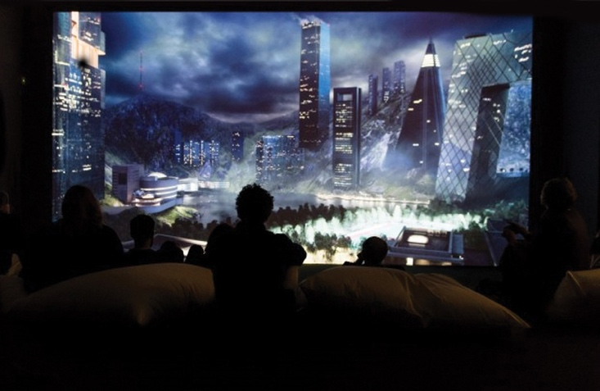
One of the artworks included in the imagined exhibition is Bedwyr Williams’s Tyrrau Mawr (2016). It is a digital projection that ‘imagines a futuristic city set in the mountainsides of Cadair Idris’ (North Wales), Deacon (2016). The Wales Online article quotes Williams as he states the idea for the piece came when he ‘thought about what would happen if you moved a million people into a city where there’s no tradition, in a place like Wales that is obsessed with tradition’. The artwork is a critique of the mega ‘cities in China and the Middle East that just pop up so quickly’ Deacon (2016). It can be argued that it is a social and environmental experiment by Williams to envision what effects modern urban development may have on a place like Cadair Idris. It is described as a ‘rugged summits, glacial lakes and a mossy wooded gorge cover over 450 hectares of breathing taking landscape’ with no human population by the website Visit Mid Wales (2017). With this knowledge it is clear this work addresses the theme of human’s effects on a place through globalisation. ‘While modern technology creates material affluence it endangers the affective aspects of places’ Crang (104: 1998). Within the developed and globalised world cities and spaces like this ‘may well destroy a sense of place’ Crang (106: 1998), This highlights the importance of including Bedwyr Williams in the exhibition as Tyrrau Mawr is a look into the future.
Figure 1 -Bedwyr Williams: Tyrrau Mawr (2016). Photographed by Polly Thomas.

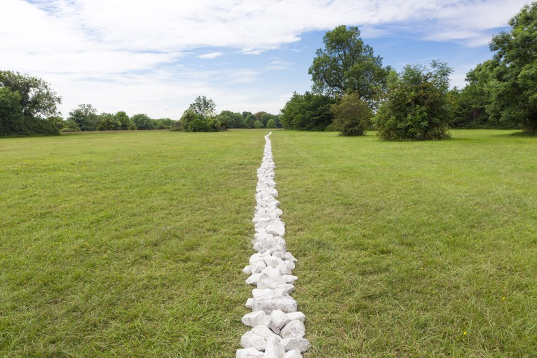
A Boyhood Line (2015) is also included in the imagined exhibition. It is land art made by the artist Richard Long. He makes art by walking in landscapes, making lines and marks to mark the fact he has been there. Moorhouse (7:2002) states ‘to walk a line is the easiest thing a human being can do to put his mark on a place’. This is an example of physical interventions that people have with the landscape, represented by a straight man-made line. According to the website Arnolfini, the Boyhood Line was made from white limestone centred on a footpath. The path had been formed after people were ‘instinctively following the same path and establishing an unplanned path through the grass’ (2015). This implies that everyday people unknowingly and subconsciously put their mark on the place. Knowing this, the floor of the exhibition will be made out of grass to portray the marks human’s make unknowingly on places. It is a human presence, ‘shared in the sense that the meaning of place can be communicated to others’ Norton (274:2000).

Figure 2 - Richard Long: A Boyhood Line (2015). Photographed by Max McClure

These artworks will be showcased in an exhibition that will be held at the Tate Modern. Lonely Planet (2017) describes the location as an ‘outstanding modern and contemporary art gallery’. Having said this, due to the large size of the building, the exhibition will be taking place in Turbine Hall. According to the Tate (2018) website, Frances Morris, director at the Tate Modern describes the Turbine Hall as ‘a hugely significant space; awe inspiring in its scale’. This will prove to be the ideal location for an imagined exhibition with a balance of aesthetically pleasing and conceptual artwork. Figure 4 shows the floor plan of the imagined exhibition which also includes the artworks of Jamie North and Marianne Kemp. These pieces are included in the exhibition to directly contrast the natural elements of places and the man-made effects of globalisation.

Figure 3 – Turbine Hall Floor Plan

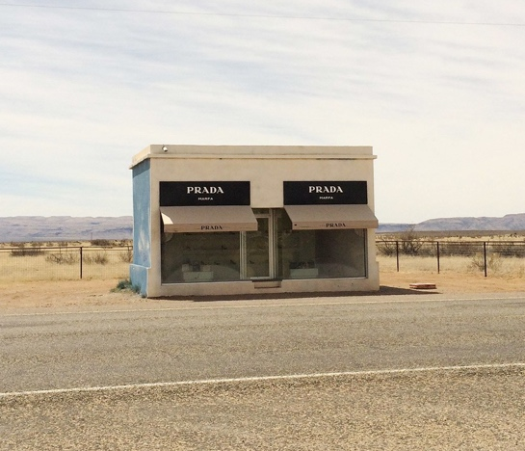
In order to continue exploring the theme of the relationship between places and people, the exhibition will be placed in the middle of the Preseli Mountains. This is to emphasis the contrast between the manmade involvement and the natural elements of the place. The idea was inspired by the pop art installation, Prada Marfa. By taking the Tate Modern out of context and locating it in an unfamiliar place, it will make the audience rethink what they already know. Contrasting the contexts will change the way people think and see changes to their own habitats, by making a link between what they visually can see and what they mentally can imagine. Going against John Berger argument that ‘we never look at just one thing; we are always looking at the relation between things and ourselves’ (8:1972). An article by Thessaly La Force (2014) quotes the artists Elmgreen & Dragset that made Prada Marfa expressing ‘as artists we are only here in order to trigger a debate, to provide platforms for other people’s interpretations’.
Figure 5 - Prada Marfa. 2014. Photographed by Thessaly La Force

Reference List

Arnolfini. (2015) Richard Long offsite commission: Boyhood Line. Available at: https://www.arnolfini.org.uk/whatson/richard-long-offsite-commission/view. Accessed on 5TH May 2018.
Berger, J. (1972) Ways of Seeing. Penguin Book Ltd
Crang, M. (1998) Cultural Geography. London: Routledge.
Deacon, T. (2016) A futuristic version of a Welsh city could win a prestigious £40,000 art prize. Wales Online [Online].
Available at: https://www.walesonline.co.uk/whats-on/arts-culture-news/futuristic-version-welsh-city-could-12136475. Accessed on 5th May 2018.
Hubbard, P., Kitchin, R., Valentine, G. (2004) Key thinkers on space and place.
La Force, T. (2014). Prada Marfa. [Figure 3- Online] Available at: https://www.vogue.com/article/prada-marfa-visit-texas-elmgreen-dragset-art-vandalism Accessed on 14th April 2018.
La Force, T. (2014) The Evolution of Prada Marfa from Sculpture to Pop Culture Landmark. Vogue [Online]
Available at: https://www.vogue.com/article/prada-marfa-visit-texas-elmgreen-dragset-art-vandalism. Accessed on: 14th April 2018.
Random Acts (2017) Welsh landscapes get a dystopian makeover in this futuristic short. Available at: https://www.youtube.com/watch?v=-k7HyR5K5bQ. Accessed on 14th April 2018.
Moorhouse, P. (2002) Richard Long: Walking the Line. London: Thames & Hudson
McClure, M. (2015) A Boyhood Line. [Online- Figure 2] Available at: https://www.arnolfini.org.uk/whatson/richard-long-offsite-commission/view Accessed on 4th May 2018.
Norton, W. (2000) Cultural Geography: themes, concepts, analyses. Oxford: Oxford University Press
Tate. (2017) Turbine Hall.
Available at: http://www.tate.org.uk/visit/tate-modern/turbine-hall. Accessed on 26th April 2018.
Thomas, P. (2016) Tyrrau Mawr. [Photograph – Figure 1] Cardiff: National Museum Cardiff
Tuan, Y. (1977) Space and Place: The Perspective of Experience. University of Minnesota
Wheeler, T. (2017) Lonely Planet.
Available at: https://www.lonelyplanet.com/england/london/attractions/tate-modern/a/poi-sig/370395/358914. Accessed on 28th April 2018.
Visit Mid Wales (2017) Cadair Idris (NRW) Accessed on 4th May 2018.
Available at:

http://www.visitmidwales.co.uk/Dolgellau-Cadair-Idris-(NRW)/details/?dms=3&venue=1012055 .

Bibliography

Hiss, T (1991) The Experience of Place. New York: Vintage Books
Maitland, G (1951) The Art of Colour and Design. McGraw- Hill

