Data Warehousing & Data Mining:
Data Mining

MODULE | Data Warehousing & Data Mining (ACCA6026)
STUDENT NAME | Pedro Gaetjens Molongua
STUDENT NUMBER | 2327143
LECTURER | Dr. Rajeev Nath

This photo by Unknown Author is licensed under CC BY-SA-NC license

INDEX
Purpose and Practice of Data Mining 7
Dataset Description and Exploration 7
Data Dictionary 7
Exploratory Data Analysis & Quality Assessment 9
Class Distribution Analysis 9
10
Customer Profile & Engagement Insights 11
Data Pre-processing and Post-processing 13
Data Quality and Type Verification 13
Feature Selection and Normalisation Assessment 13
Attribute Encoding 16
Class Distribution and Balancing 16
Model Post-processing and Interpretation 16
Sample Runs and Analysis Methods 17
Supervised Classification Analysis 17
Algorithmic Evaluation & Model Selection 18
J48 Decision Tree Analysis 18
Random Forest Ensemble Analysis (Selected Model) 20
Naïve Bayes Probabilistic Analysis 22
23
Unsupervised Customer Segmentation 24
25
27
Behavioural Synthesis & Strategic Profiles 29
Methodological Limitations & Future Improvements 29
Business Recommendations 29
Reflective Commentary 30
Model Performance Assessment 30
Strengths and Limitations 30
Future Improvements 31
REFERENCES 31
FIGURES
Figure 1: Weka Preprocess visualization showing the balanced class distribution of Target_Churn (True = 526 / 52.6%, False = 474 / 47.4%). 7
Figure 2: Weka scatter plot showing the class-conditional distribution of Satisfaction_Score (Y-axis) grouped by Target_Churn (X-axis), illustrating significant overlap between churned (True) and retained (False) customer profiles. 9
Figure 3: Weka Preprocess panel demonstrating the removal of the Customer_ID feature using the unsupervised Remove filter, leaving 14 active attributes across 1,000 customer instances 12
Figure 4: Weka 3.9.6 J48 Decision Tree execution output and confusion matrix. 16
Figure 5: Weka 3.9.6 Random Forest execution output and confusion matrix. 18
Figure 6: Weka 3.9.6 Naïve Bayes execution output and confusion matrix. 20
Figure 7: Weka SimpleKMeans parameter configuration ($k=3$, seed = 10, Euclidean distance). 22
Figure 8: Weka 3.9.6 SimpleKMeans output log ($13$ active attributes, Target_Churn ignored). 24
TABLES
Table 1: Online Retail Customer Churn Data Dictionary and Attribute Summary 6
Table 2: Comparative Performance Summary of Supervised Classifiers (10-Fold Cross-Validation) 14
Table 3: Comparative Confusion Matrix Breakdown and Operational Impact 15
Table 4: Empirical SimpleKMeans Final Cluster Centroids and Profiles ($k=3$) 25

Purpose and Practice of Data Mining
Data mining is the process of extracting meaningful patterns, relationships, and predictive insights from large datasets to support decision-making. In retail and e-commerce settings, it helps organisations turn routine customer records into actionable intelligence for marketing, customer retention and strategic planning. Chen et al. [1] explain that business intelligence and analytics (BI&A) is a core business practice for analysing structured transactional data, with BI&A 1.0 specifically relying on relational databases, data warehousing, statistical analysis, clustering, classification and predictive modelling. This makes data mining highly suitable for customer analytics because it supports the discovery of hidden behaviour patterns in sales, spending and engagement data.
In customer-focused business context, data mining is especially valuable for churn prediction. Kiguchi et al. [2] define customer churn as the percentage of customers who stop using a product or service within a given period, while retention refers to maintaining customer relationships over time. In retail, predicting churn allows businesses to identify customers at risk of leaving and to intervene early with targeted offers, personalised communication and improved service delivery. This directly reduces revenue loss and lowers the steep corporate costs associated with acquiring new customers.
Data mining also supports customer segmentation, where unsupervised techniques group consumers with similar behaviour or spending characteristics [1]. These segments help managers understand distinct customer profiles and design tailored marketing strategies for each group. Together, clustering and classification enable businesses to move from passive descriptive reporting to proactive decision support, serving as a practical business tool for maximising customer value, loyalty and long-term profitability.

Dataset Description and Exploration
The dataset utilised for this study is the Online Retail Customer Churn Dataset, sourced from Kaggle repository [3].

Data Dictionary
ATTRIBUTE NAME | DATA TYPE | MISSING VALUES | SUMMARY STATISTICS / CATEGORIES
Customer_ID | Numeric | 0 (0%) | Minimum: 1  Maximum: 1,000  Mean: 500.5  StdDev: 288.8
Age | Numeric | 0 (0%) | Minimum: 18  Maximum: 69  Mean: 43.267  StdDev: 15.242
Gender | Nominal | 0 (0%) | Other: 324 (32.4%)  Male: 334 (33.4%)  Female: 342 (34.2%)
Annual_Income | Numeric | 0 (0%) | Minimum: 20.01  Maximum: 199.73  Mean: 111.963  StdDev: 52.844
Total_Spend | Numeric | 0 (0%) | Minimum: 108.94  Maximum: 9,999.64  Mean: 5,080.793  StdDev: 2,862.123
Years_as_Customer | Numeric | 0 (0%) | Minimum: 1  Maximum: 19  Mean: 9.727  StdDev: 5.536
Num_of_Purchases | Numeric | 0 (0%) | Minimum: 1  Maximum: 99  Mean: 49.456  StdDev: 28.544
Average_Transaction_Amount | Numeric | 0 (0%) | Minimum: 10.46  Maximum: 499.57  Mean: 266.877  StdDev: 145.873
Num_of_Returns | Numeric | 0 (0%) | Minimum: 0  Maximum: 9  Mean: 4.612  StdDev: 2.897
Num_of_Support_Contacts | Numeric | 0 (0%) | Minimum: 0  Maximum: 4  Mean: 1.934  StdDev: 1.403
Satisfaction_Score | Numeric | 0 (0%) | Minimum: 1  Maximum: 5  Mean: 2.974  StdDev: 1.392
Last_Purchase_Days_Ago | Numeric | 0 (0%) | Minimum: 1  Maximum: 364  Mean: 182.89  StdDev: 104.391
Email_Opt_In | Nominal | 0 (0%) | True: 529 (52.9%)  False: 471 (47.1%)
Promotion_Response | Nominal | 0 (0%) | Responded: 338 (33.8%)  Ignored: 301 (30.1%)  Unsubscribed: 361 (36.1%)
Target_Churn | Nominal | 0 (0%) | True: 526 (52.6%)  False: 474 (47.4%)
Table 1: Online Retail Customer Churn Data Dictionary and Attribute Summary

Exploratory Data Analysis & Quality Assessment
The data contains 1,000 customer records described by 15 attributes, including demographic, transactional, behavioural and customer engagement variables. No missing values were identified, resulting in 100% data completeness. Consequently, no missing-value imputation was required during the data pre-processing stage, allowing the analysis to proceed using the original observations without introducing estimation bias.

Class Distribution Analysis
The target variable, Target_Churn, is also well balanced with 526 customers (52.6%) classified as churned and 474 customers (47.4%) retained. This balanced class distribution is advantageous for supervised classification because algorithms are less likely to become biased towards a dominant class, allowing performance metrics such as accuracy, precision, recall and Area Under the ROC Curve (AUC) to provide a more reliable evaluation of predictive performance (Figure 1).

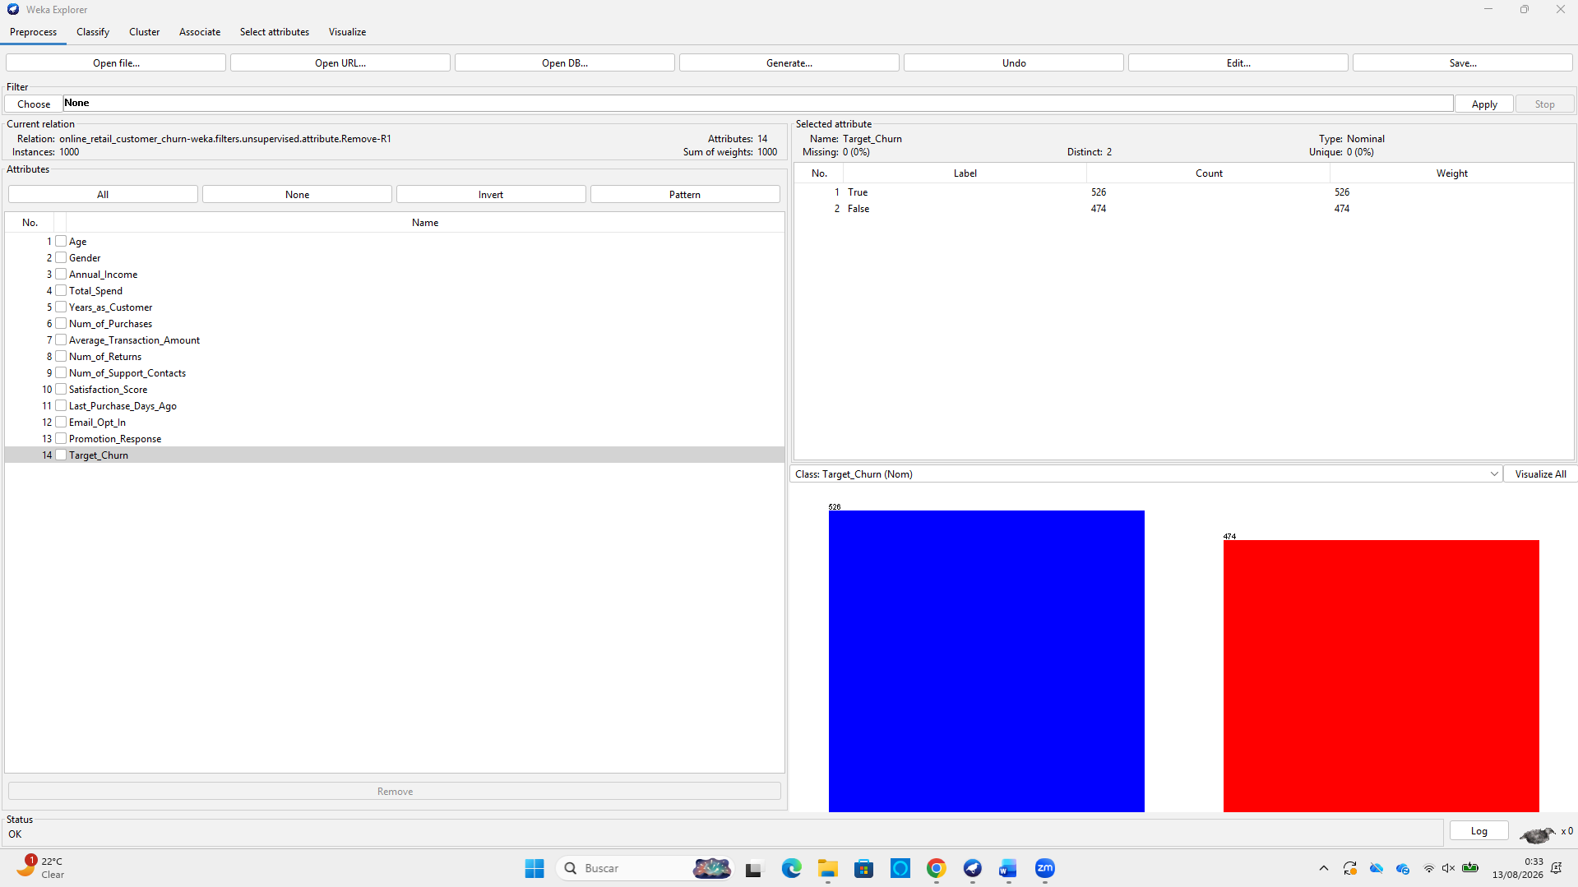
Figure 1: Weka Preprocess visualization showing the balanced class distribution of Target_Churn (True = 526 / 52.6%, False = 474 / 47.4%).

Customer Profile & Engagement Insights
Descriptive statics further indicate the customers have an average tenure of 9.73 years, make approximately 49 purchases and spend an average of £5,080.79 over their lifetime. Customer engagement appears moderate, with a mean Satisfaction Score of 2.97 out of 5 and an average of 1.93 customer support contacts per customer.

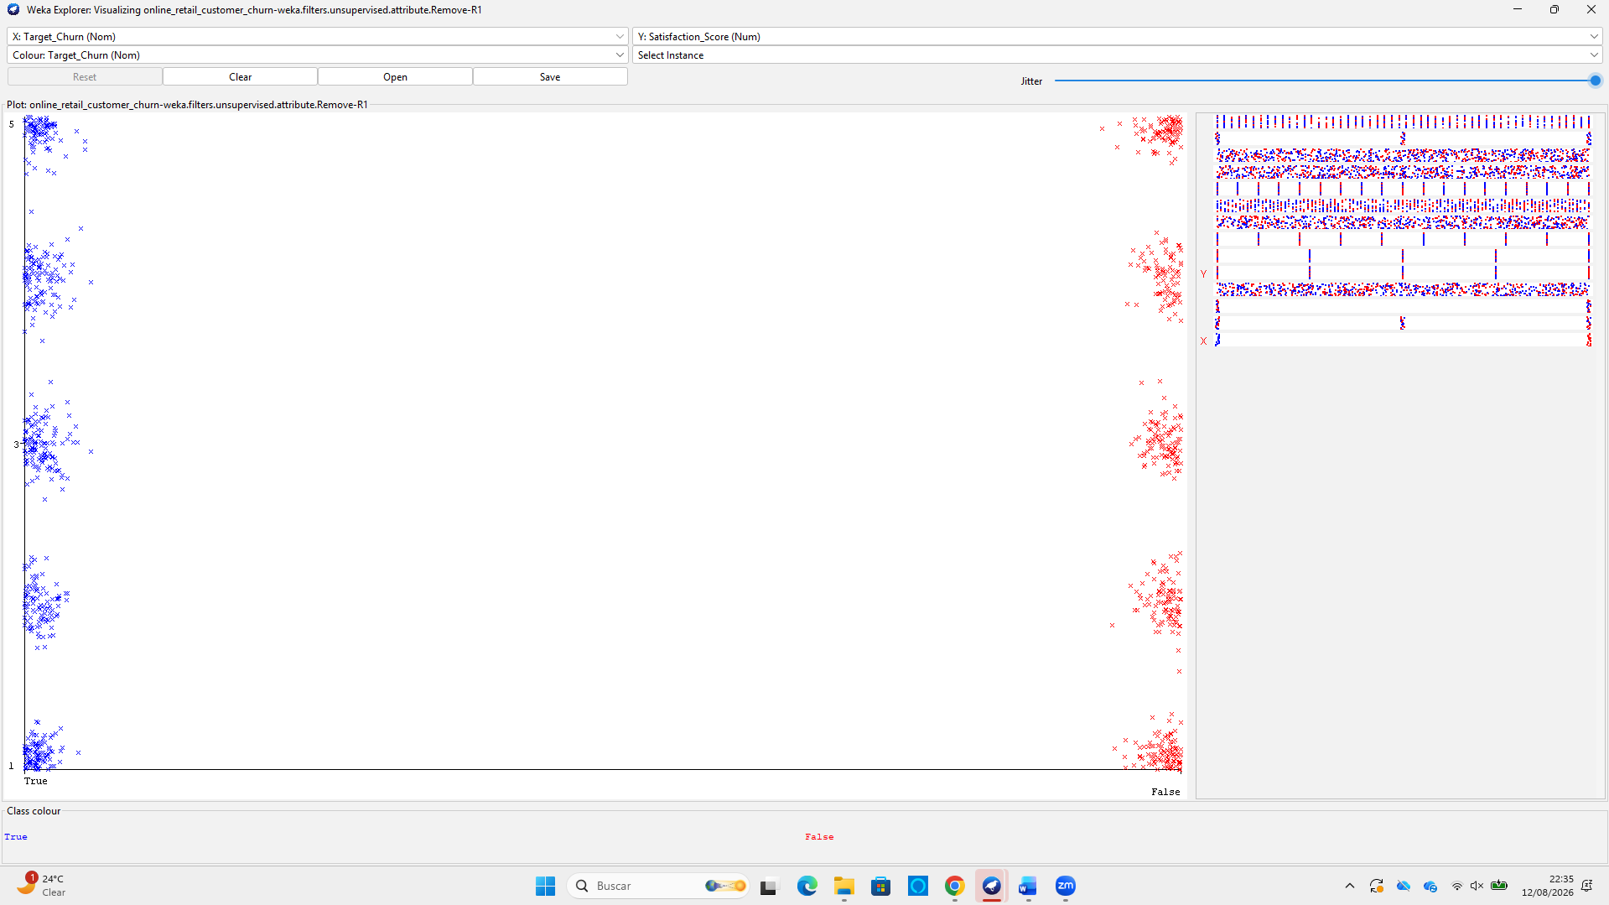
Figure 2: Weka scatter plot showing the class-conditional distribution of Satisfaction_Score (Y-axis) grouped by Target_Churn (X-axis), illustrating significant overlap between churned (True) and retained (False) customer profiles.
As illustrated in Figure 1, a detailed examination of the Satisfaction_Score distribution across Target_Curn classes demonstrates near-identical score distribution between churned (True) and retained (False) customers across all satisfaction levels (1 to 5). This visual evidence highlights that individual customer satisfaction ratings lack distinct linear decision boundaries when evaluated in isolation, providing early exploratory justification for why single-variable thresholding fails and why robust multi-dimensional classification models are required.
Meanwhile, categorical attributes such as Gender, Email_Opt_In and Promotion_Response exhibit relatively balanced distributions across their customer population without significant demographic bias. Overall, these characteristics indicate that the dataset is well suited for both classification techniques to predict customer churn and clustering techniques to identify meaningful customer segments.

Data Pre-processing and Post-processing
Data pre-processing and post-processing are fundamental stages of the CRISP-DM data mining lifecycle. Plotnikova et al. [4] emphasise that systematic data preparation improves data quality, reduces computational complexity, and provides a robust foundation for model development and interpretation.

Data Quality and Type Verification
As established during the exploratory data analysis in Section 1.2, an initial audit confirmed 100% data completeness across all 1,000 instances and 15 attributes. Consequently, no missing-value imputation techniques (such as mean substitution or $k$-nearest neighbour estimation) were required, preserving the natural integrity of the original observations.
Furthermore, prior to model construction, all attributes were inspected within Weka to ensure that numerical variables were correctly recognised as numeric and categorical variables were stored as nominal attributes. This verification ensured that classification algorithms interpreted each feature correctly without requiring manual data type conversion.

Feature Selection and Normalisation Assessment
Pre-processing primarily focused on feature selection by identifying and removing non-predictive attributes. The attribute Customer_ID serves purely as an internal database primary key, assigning a unique sequential identifier (1 to 1,000) to each customer record. Because every customer possesses a unique identifier, the attribute contains no generalisable predictive information regarding customer churn or purchasing behaviour. Retaining unique key identifiers during model training can introduce noise, cause decision tree models to overfit on spurious primary keys and distort distance calculations in distance-based clustering algorithms.
Using Weka’s Remove unsupervised attribute filter (weka.filters.unsupervised.attribute.Remove), Customer_ID was permanently removed from the operational dataset (Figure 3).
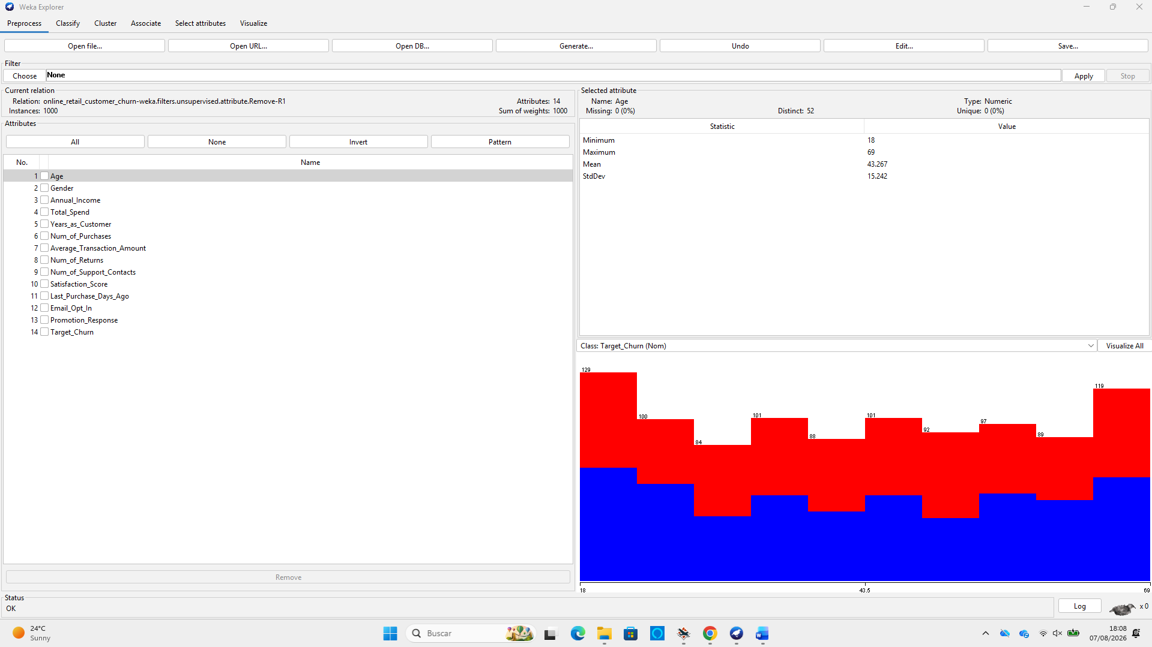
Figure 3: Weka Preprocess panel demonstrating the removal of the Customer_ID feature using the unsupervised Remove filter, leaving 14 active attributes across 1,000 customer instances
Following feature selection, the dataset contained fourteen active attributes comprising ten numeric predictor variables (Age, Annual_Income, Total_Spend, Years_as_Customer, Num_of_Purchases, Average_Transaction_Amount, Num_of_Returns, Num_of_Support_Contacts, Satisfaction_Score and Last_Purchase_Days_Ago), three nominal predictor variables (Gender, Email_Opt_In and Promotion_Response) and one nominal target variable (Target_Churn).
Feature scaling techniques such as normalisation or standardisation were intentionally omitted prior to classification. The primary algorithms selected for this study (J48 Decision Tree, Random Forest and Naïve Bayes) are either non-parametric, scale-invariant or rely on probability distributions, rendering scaling unnecessary while preserving the original units for business interpretability. However, for subsequent unsupervised distance-based clustering experiments (such as SimpleKMeans), numerical behavioural variables (e.g., Total_Spend and Annual_Income) are standardised prior to clustering to prevent high-magnitude attributes from disproportionately dominating Euclidean distance calculations over smaller-scale attributes like Satisfaction_Score.

Attribute Encoding
The categorical attributes Gender, Email_Opt_In and Promotion_Response were retained in their original nominal format. Because Weka natively supports nominal predictors within algorithms such as J48, Random Forest and Naïve Bayes, no manual one-hot encoding or label encoding transformations were required prior to model training.

Class Distribution and Balancing
Target_Churn, exhibits a near-even class distribution, with 526 customers (52.6%) classified as churned and 474 customers (47.4%) retained. Because the class balance is naturally well-distributed, no oversampling, undersampling or Synthetic Minority Over-sampling Technique (SMOTE) algorithms were applied [5]. Maintaining the natural class distribution allowed the classification models to be trained and evaluated without introducing synthetic observations or losing genuine training instances.

Model Post-processing and Interpretation
Following model generation in Weka, a structured post-processing methodology was established to translate raw algorithmic outputs into actionable insights. The performance of each classifier was evaluated using standard evaluation metrics extracted from 10-fold cross-validation, including confusion matrices, classification accuracy, Precision, Recall, $F_{1}$-score and Area Under the ROC Curve (AUC). The results were subsequently summarised using comparative tables and visualisations to facilitate algorithm comparison, identify the best-performing predictive model and support business recommendations presented later in the report.

Sample Runs and Analysis Methods

Supervised Classification Analysis
To operationalise predictive analytics for churn management [1], three classification algorithms were evaluated in Weka 3.9.6 using the dataset [3]: J48 Decision Tree, Random Forest (100 trees) and Naïve Bayes. Following established data mining methodologies [2], [4], model training and evaluation were conducted via 10-fold cross-validation across 1,000 instances, utilising 13 predictor attributes and 1 nominal target variable (Target_Churn) to provide a reliable estimate of generalisation performance. Predictive efficacy was evaluated across Accuracy, Precision, Recall, $F_{1}$-score, Kappa ($κ$) and Area Under the ROC Curve (AUC) [6].
EVALUATION METRIC | J48 DECISION TREE | RANDOM FOREST (100 TREES) | NAÏVE BAYES | SELECTED CLASSIFIER
Accuracy | 50.3% (503) | 51.3% (513) | 48.8% (488) | Random Forest
Kappa ($κ$) | 0.0065 | 0.0134 | -0.0455 | Random Forest
Precision (Churn = True) | 0.527 | 0.531 | 0.510 | Random Forest
Recall (Churn = True) | 0.546 | 0.629 | 0.677 | Naïve Bayes
$F_{1}$-Score (Churn = True) | 0.536 | 0.576 | 0.582 | Naïve Bayes
Area Under ROC (AUC) | 0.494 | 0.505 | 0.463 | Random Forest
Table 2: Comparative Performance Summary of Supervised Classifiers (10-Fold Cross-Validation)
CLASSIFIER | TRUE POSITIVES (TP) | FALSE POSITIVES (FP) | FALSE NEGATIVES (FN) | TRUE NEGATIVES (TN) | OPERATIONAL FOCUS
J48 Tree | 287 | 258 | 239 | 216 | Over-branching on continuous features [7]
Random Forest | 331 | 292 | 195 | 182 | Lowest FN count (captures +44 churners vs J48) [8]
Naïve Bayes | 356 | 342 | 170 | 132 | High FP count (72.2% False Positive Rate) [9], [10]
Table 3: Comparative Confusion Matrix Breakdown and Operational Impact

Algorithmic Evaluation & Model Selection

J48 Decision Tree Analysis
J48 created a hyper-complex tree (285 nodes, 148 leaf nodes) due to unbinned continuous variables like Total_Spend. C4.5 split criteria constructed arbitrary boundaries around local variance [7]. This structural complexity is consistent with overfitting, leading to weak cross-validation performance (Accuracy = 50.3%, AUC = 0.494).

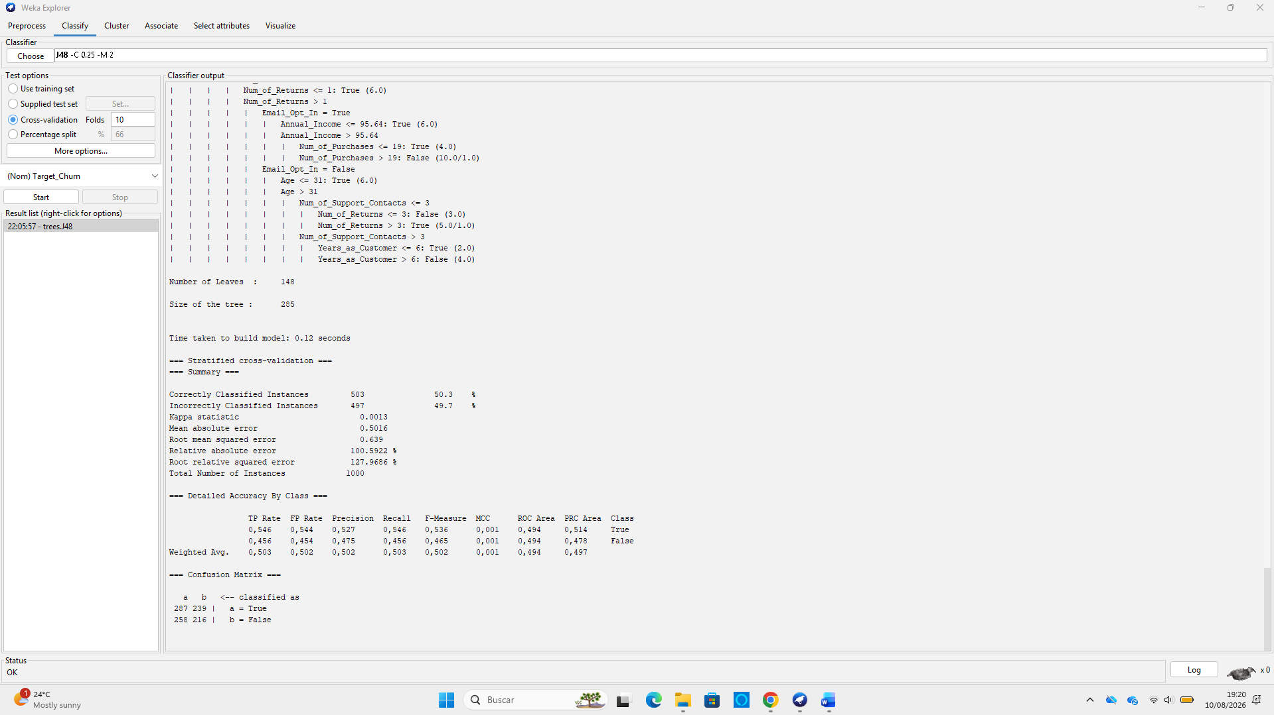
Figure 4: Weka 3.9.6 J48 Decision Tree execution output and confusion matrix.

Random Forest Ensemble Analysis (Selected Model)
Is the most appropriate of the three evaluated classifiers because it achieved the highest Accuracy (51.3%), Precision (0.531), AUC (0.505) and Kappa ($κ=0.0134$), while substantially reducing False Negatives to 195 [8]. However, its AUC of 0.505 and Kappa of 0.0134 indicate that the model provides only marginal predictive value above chance and should not be considered a strong standalone churn predictor.

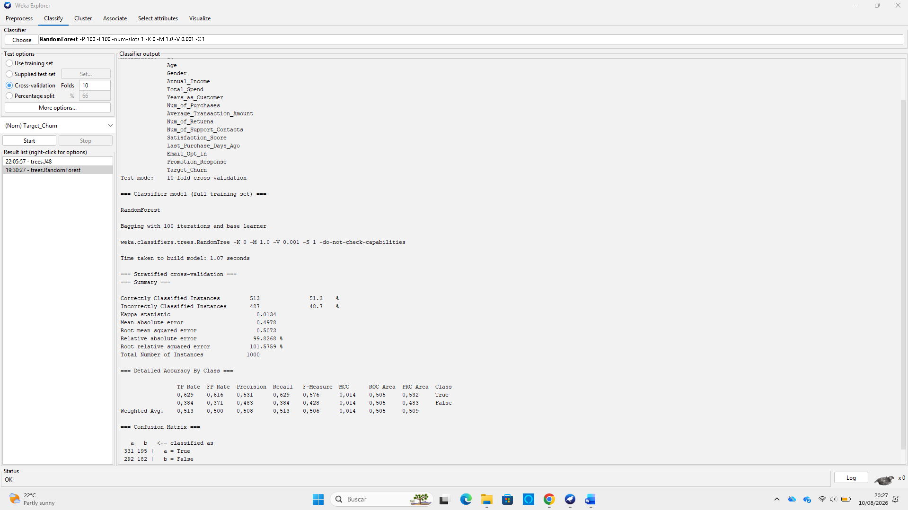
Figure 5: Weka 3.9.6 Random Forest execution output and confusion matrix.

Naïve Bayes Probabilistic Analysis
Naïve Bayes produced the lowest reliability (Accuracy = 48.8%, AUC = 0.463), displaying strong positive class bias (698 positive predictions). The relatively weak performance may reflect the conditional-independence assumption of Naïve Bayes, which can become problematic when predictor variables contain substantial dependencies [9]. This generated 342 False Positives (FPR = 72.2%), which would lead to misallocated retention expenditure [10].

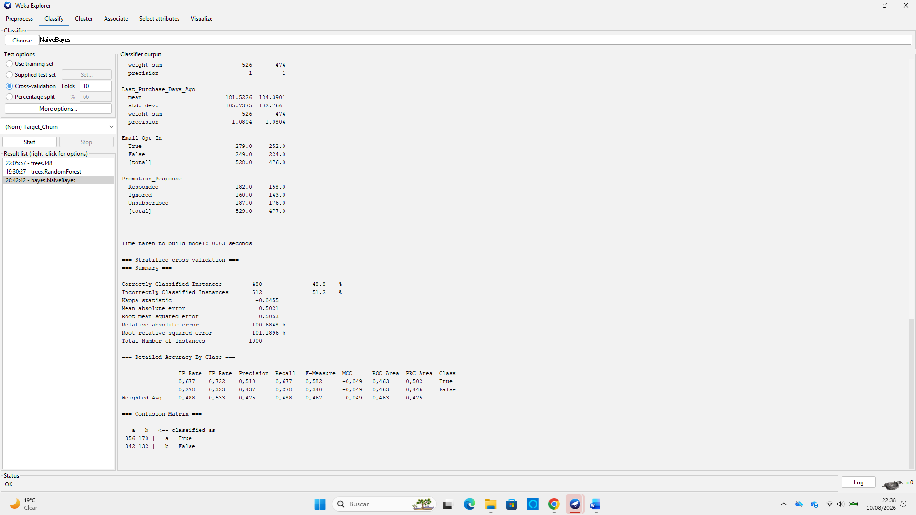
Figure 6: Weka 3.9.6 Naïve Bayes execution output and confusion matrix.

Unsupervised Customer Segmentation
To address Task (b), Weka’s SimpleKMeans algorithm was deployed ($k=3$, seed = 10, Euclidean distance). To prevent class label leakage, Target_Churn was explicitly excluded using Weka’s attribute ignore function, leaving 13 active attributes.

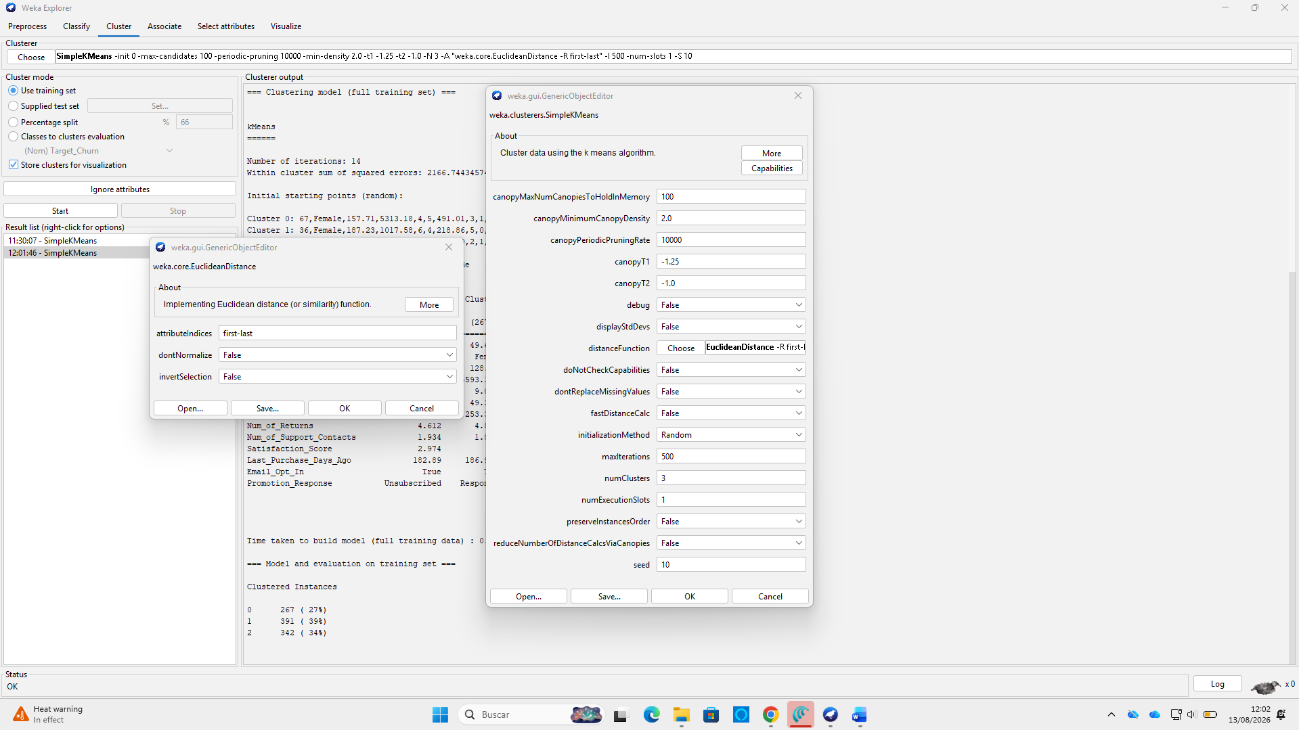
Figure 7: Weka SimpleKMeans parameter configuration ($k=3$, seed = 10, Euclidean distance).
The algorithm converged in 14 iterations with a Within-Cluster Sum of Squared Errors (SSSE) of 2,166.74. Excluding Target_Churn produced an SSSE of 2,166.74, compared with 2,493.17 when the target attribute was included. This demonstrates that the final clustering configuration generated a different and more internally compact partition of the dataset; however, SSSE should be interpreted alongside the resulting cluster profiles rather than as a standalone measure of segmentation quality [11].

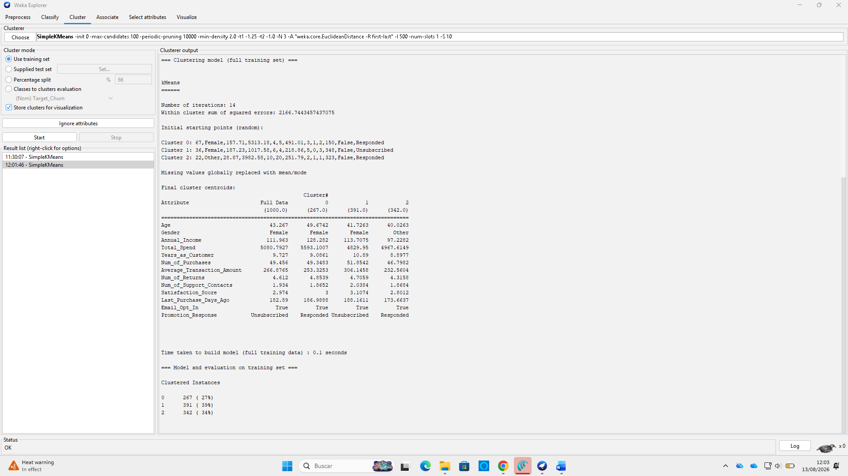
Figure 8: Weka 3.9.6 SimpleKMeans output log ($13$ active attributes, Target_Churn ignored).

ATTRIBUTE / FEATURE | FULL DATA ($N=1000$) | CLUSTER 0: PREMIUM SPENDERS | CLUSTER 1: LOYAL CHAMPIONS | CLUSTER 2: DEAL SEEKERS
Size ($N$) / Proportion | 1,000 (100%) | 267 (26.7%) | 391 (39.1%) | 342 (34.2%)
Age / Income (£k) | 43.27 / £111.96k | 49.67 / £128.28k | 41.73 / £113.71k | 40.03 / £97.23k
Total Spend (£) / Tenure | £5,080.79 / 9.73 yrs | £5,593.10 / 9.09 yrs | £4,829.95 / 10.89 yrs | £4,967.61 / 8.90 yrs
Purchases / Avg Order (£) | 49.46 / £266.88 | 49.35 / £253.33 | 51.85 / £306.15 | 46.80 / £232.56
Satisfaction (1–5) | 2.97 | 3.00 | 3.11 | 2.80
Promotion Response | Unsubscribed | Responded | Unsubscribed | Responded
Target Churn Status | Ignored | Ignored | Ignored | Ignored
Table 4: Empirical SimpleKMeans Final Cluster Centroids and Profiles ($k=3$)

Behavioural Synthesis & Strategic Profiles
- Cluster 0: High-Income Premium Spenders (26.7%, $N=267$): Interpreted as an affluent cohort (Age 49.7, Income £128.28k, Spend £5,593.10) responsive to marketing (Responded). Action: VIP loyalty perks and early access launches.
- Cluster 1: Loyal Organic Champions (39.1%, $N=391$): Interpreted as long-tenured accounts (10.89 years) with high order value (£306.15) who opt out of promotional emails (Unsubscribed). Action: Focus on operational service rather than intrusive email campaigns.
- Cluster 2: Price-Sensitive Deal Seekers (34.2%, $N=342$): Interpreted as a price-sensitive cohort (Income £97.23k, Order £232.56, Satisfaction 2.80) actively engaging with promotions (Responded). Action: Targeted discount bundles and satisfaction recovery.

Methodological Limitations & Future Improvements
- Scale Sensitivity: SimpleKMeans uses unstandardised Euclidean distance; consequently, higher-range variables (Total_Spend) exert greater influence on distance calculations than bounded metrics (Satisfaction_Score). Future work should evaluate Z-score feature standardisation.
- Advanced Architecture & Feature Selection: The near-random classification performance ($\text{AUC}≈0.50$) highlights the need for correlation-based feature selection (FCBF) [12], advanced machine learning frameworks [13] and gradient-boosted decision tree architectures (such as XGBoost) [14].

Business Recommendations
Based on the empirical findings, retail managers and e-commerce decision-makers should adopt structured, risk-aware approach to customer churn management:
- Deploy a Tired, Low-Cost Retention Workflow: Although Random Forest achieved the highest overall performance (AUC = 0.505, Accuracy = 51.3%), its elevated False Positive Count (292 instances) means 29.2% of loyal customers were misclassified as churn risks. Offering high-value financial incentives to this group would severely erode profit margins. As demonstrated by Mydyti et al. [10], integrating predictive analytics into automated customer service workflows optimise operational spending while driving evidence-based decisions. E-commerce managers should deploy Random Forest solely as an initial screening tool, triggering low-cost retention actions, such as automated satisfaction surveys or re-engagement emails, rather than immediate price discounts.
- Enrich Data Capture Beyond Static Transaction Totals: The near-random predictive capacity across all models indicates that static demographic and aggregated historical metrics (Annual_Income, Total_Spend, Satisfaction_Score) lack sufficient predictive signal. In line with findings by Gangadharan et al. [13], e-commerce platforms must expand data collection pipelines beyond static profiles to capture both implicit and explicit user interaction data (including real-time web session frequency, cart abandonment rates and clickstream activity) to build precise user preference models.
- Incorporate Automated Pre-processing Pipelines: Data engineering teams must mandate pre-processing discretisation prior to model training. As established by Chandrasekar et al. [7], converting unbinned continuous predictors into entropy-based nominal bins removes arbitrary numerical split boundaries, preventing single-tree over-branching and improving operational model transparency for business stakeholders.

Reflective Commentary

Model Performance Assessment
Overall predictive performance across the three classifiers was low, bounded between 48.8% (Naïve Bayes) and 51.3% (Random Forest). The models struggled to establish clear decision boundaries due to substantial overlapping feature distributions between churned and retained customer profiles.

Strengths and Limitations
Strengths: Utilizing a stratified 10-fold cross-validation framework ensured unbiased sampling and robust performance estimates. The evaluation clearly illustrated ensemble theory: Random Forest successfully mitigated the extreme variance and over-branching (285 nodes) of default J48 through bagging and subspace sampling [8].
Limitations: Default J48 overfit continuous numerical noise [7]. Naïve Bayes performed worst (AUC = 0.463, $κ$ = -0.0455) due to its strict attribute independence assumption and overlapping Gaussian density estimations across continuous features [9]. Evaluating strictly on accuracy without cost-sensitive weighting masked critical trade-offs between false alarms and missed churners [6].

Future Improvements
Correlation-Based Feature Selection: Apply filter-based algorithms such as Fast Correlation-Based Feature Selection (FCBF) prior to training. As demonstrated by Gopika [12], removing redundant and highly correlated attributes significantly reduces dimensionality, noise and multicollinearity.
Advanced Boosting Architectures: Shift from standard bagging to Gradient-Boosted Decision Trees (GBDT). As shown by Zhang and Jung [14], gradient boosting sequentially minimises loss functions and captures complex non-linear feature interactions far better than individual trees or basic random forests.
Supervised Discretisation: Pre-process continuous attributes using Fayyad-Irani entropy binning to improve decision tree readability and stability [7].

REFERENCES
[1] H. Chen, R. H. L. Chiang and V. C. Storey, "Business Intelligence and Analytics: from Big Data to Big Impact," MIS Quarterly, vol. 36, (4), pp. 1165–1188, 2012. Available: https://research.ebsco.com/plink/8d406895-de29-39f1-849b-66e851417284. DOI: 10.2307/41703503.
[2] M. Kiguchi, W. Saeed and I. Medi, "Churn prediction in digital game-based learning using data mining techniques: Logistic regression, decision tree, and random forest," Applied Soft Computing, vol. 118, pp. 108491, 2022. Available: https://www-sciencedirect-com.uwtsd.idm.oclc.org/science/article/pii/S1568494622000436. DOI: 10.1016/j.asoc.2022.108491.
[3] Hassane Skikri. (07/08). Online Retail Customer Churn Dataset. Available: https://www.kaggle.com/datasets/hassaneskikri/online-retail-customer-churn-dataset?resource=download.
[4] V. Plotnikova, M. Dumas and F. P. Milani, "Applying the CRISP-DM data mining process in the financial services industry: Elicitation of adaptation requirements," Data Knowl. Eng., vol. 139, pp. 102013, 2022. Available: https://www-sciencedirect-com.uwtsd.idm.oclc.org/science/article/pii/S0169023X22000258. DOI: 10.1016/j.datak.2022.102013.
[5] N. V. Chawla et al, "SMOTE: synthetic minority over-sampling technique," Journal of Artificial Intelligence Research, vol. 16, pp. 321–357, 2002. .
[6] K. M. Sujon et al, "Accuracy, precision, recall, f1-score, or MCC? empirical evidence from advanced statistics, ML, and XAI for evaluating business predictive models," Journal of Big Data, vol. 12, (1), pp. 268, 2025. Available: https://libkey.io/10.1186/s40537-025-01313-4. DOI: 10.1186/s40537-025-01313-4.
[7] P. Chandrasekar et al, "Improving the prediction accuracy of decision tree mining with data preprocessing," in 2017 IEEE 41st Annual Computer Software and Applications Conference (COMPSAC), 2017, . DOI: 10.1109/COMPSAC.2017.146.
[8] Gérard Biau and Erwan Scornet, "A random forest guided tour," TEST, vol. 25, (2), pp. 197–227, 2016. . DOI: 10.1007/s11749-016-0481-7.
[9] G. I. Webb, E. Keogh and R. Miikkulainen, "Naïve Bayes." Encyclopedia of Machine Learning, vol. 15, (1), pp. 713–714, 2010. .
[10] H. Mydyti, A. Kadriu and Mirjana Pejic Bach, "Using Data Mining to Improve Decision-Making: Case Study of A Recommendation System Development," Organizacija, vol. 56, (2), 2023. Available: https://www.proquest.com/scholarly-journals/using-data-mining-improve-decision-making-case/docview/2820106133/se-2?accountid=130472 https://libkey.io/libraries/1422/openurl?ctx_ver=Z39.88-2004&ctx_enc=info:ofi/enc:UTF-8&rfr_id=info:sid/ProQuest&rft_val_fmt=journal&rft.genre=article&rft.jtitle=Organizacija&rft.atitle=Using+Data+Mining+to+Improve+Decision-Making%253A+Case+Study+of+A+Recommendation+System+Development&rft.au=Mydyti%252C+Hyrmet%253BKadriu%252C+Arbana%253BMirjana+Pejic+Bach.&rft.aulast=Mydyti&rft.aufirst=Hyrmet&rft.date=2023-01-01&rft.volume=56&rft.issue=2&rft.spage=138&rft.isbn=&rft.btitle=&rft.title=Organizacija&rft.issn=13185454&rft_id=info:doi/10.2478%252Forga-2023-0010 https://doi.org/10.2478/orga-2023-0010. DOI: 10.2478/orga-2023-0010.
[11] K. Katahira, "Evaluating the predictive performance of subtyping: A criterion for cluster mean-based prediction," Statistics in Medicine, vol. 42, (7), pp. 1045–1065, 2023. Available: https://doi-org.uwtsd.idm.oclc.org/10.1002/sim.9656. DOI: 10.1002/sim.9656.
[12] N. Gopika and A. M. Kowshalaya M.E., "Correlation based feature selection algorithm for machine learning," in 2018 3rd International Conference on Communication and Electronics Systems (ICCES), 2018, . DOI: 10.1109/CESYS.2018.8723980.
[13] K. Gangadharan et al, "From Data to Decisions: The Power of Machine Learning in Business Recommendations," IEEE Access, vol. 13, pp. 17354–17397, 2025. . DOI: 10.1109/ACCESS.2025.3532697.
[14] Z. Zhang and C. Jung, "GBDT-MO: Gradient-Boosted Decision Trees for Multiple Outputs," IEEE Transactions on Neural Networks and Learning Systems, vol. 32, (7), pp. 3156–3167, 2021. . DOI: 10.1109/TNNLS.2020.3009776.

