Student number / Rhif myfyiwr

Table of Contents / Tabl Cynnwys

Task 1 – Written summary / Tasg 1 - Crynodeb Ysgrifenedig 2
Task 2 – Mind map / Tasg 2 – Map meddwl 4
Task 3 – Presentation / Tasg 3 - Cyflwyniad 6
Task 4 – Reflection / Tasg 4 - Myfyrdod 7
Reference list / Rhestr Cyfeirnodi 8

Task 1 – Written summary / Tasg 1 - Crynodeb Ysgrifenedig
Preparing for higher education is a crucial step for students seeking to pursue their academic and career goals. This process requires careful planning and preparation to ensure success in the university or college environment. First, a student should focus on how to study effectively. For this student has to understand how to create an ideal study environment and how to overcome procrastination and perfectionism, which are often significant barriers to effective studying (Pauk and Owens, 2013). Additionally, a study plan is necessary to guide them throughout their academic journey.

Figure 1: Preparing for higher education.
Secondly, essential digital skills are required for the preparation. It is important that students learn how to use digital tools effectively as this is a crucial skill in today's digital age (Ahmadi and Reza, 2018). Students must demonstrate proficiency in using digital tools to conduct research, create presentations, and collaborate with other students and instructors.
The third thing that students need to consider is producing authentic work. Throughout their academic journey, students will be required to produce various types of assessments. It is important to exhibit integrity in academics by acknowledging and properly citing the sources from which one's research and ideas are derived (Khoo and Kang, 2022). Academic honesty is critical in maintaining academic integrity, and students must familiarize themselves with the rules of citation and referencing.
Then students should focus on understanding the assessment. Students will be required to produce different types of assessments, including written, oral, visual, or a combination of these. They will need to improve rigor (TNN, 2021). Understanding the requirements of each assessment and how to approach them is critical to achieving academic success. Students must also learn how to manage their time effectively to complete their assignments within the given timeframe.
In short, preparing for higher education is a multifaceted process that requires careful planning and preparation where students must learn how to study effectively, demonstrate proficiency in digital skills, produce authentic work, and understand assessment requirements.

Task 2 – Mind map / Tasg 2 – Map meddwl

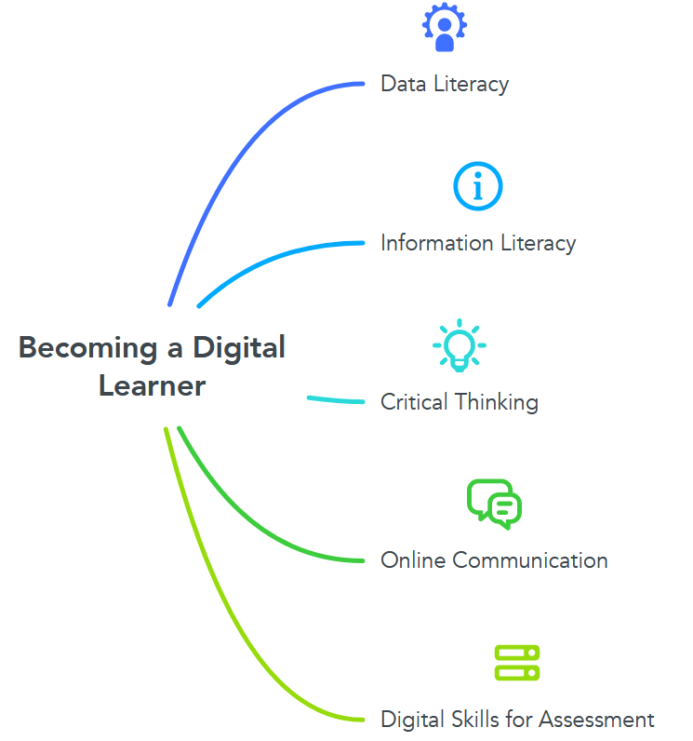
Figure 2: Mind Map for a Digital Learner (Self-made)
The mind map in Figure 2 for Becoming a Digital Learner has five main branches.
The first branch is "Data Literacy," which includes understanding how to work with data in digital formats, such as spreadsheets and databases. it is imperative for students to acquire the skills of gathering, evaluating, and comprehending data in order to arrive at informed decisions and tackle problems efficiently (Gage and McDaniel, 2012).
The second branch "Information Literacy" presents finding and evaluating credible sources of information using digital tools and resources, as well as understanding copyright and plagiarism is an essential skill for research, academic writing, and professional development (Wilkes et al., 2015).
The third branch focuses on "Critical Thinking," which involves analyzing and evaluating information and ideas to form opinions and make decisions. This skill is crucial for success in higher education and professional life. Students must develop their critical thinking skills to analyze and evaluate arguments, make informed decisions, and solve problems effectively (Karbalaei, 2012).
The fourth branch is "Online Communication," which includes understanding and using various digital communication tools effectively, such as email, social media, and online collaboration tools. This skill is essential for success in the modern workplace, where virtual communication and collaboration are becoming increasingly common (O’Dowd, 2021).
The fifth branch is "Digital Skills for Assessment," which is an important aspect of higher education. Students must learn how to use digital tools to produce high-quality written and visual assessments, including presentations, reports, and videos. This skill is essential for success in higher education and the workplace, as digital literacy is becoming increasingly important (Khan et al., 2022).

Task 3 – Presentation / Tasg 3 - Cyflwyniad
Please follow this link to view my presentation:
https://youtu.be/HNmvnoOZG3g
And here is my presentation Script:
Hello, everyone! My name is Abul and I am a digital learner. Being a digital learner means that I am constantly adapting and learning new technologies and methods of communication. As a digital learner, I have developed strong analytical and problem-solving skills. Besides, my sense of place is my virtual environment. By being immersed in this virtual environment, I have gained a deep understanding of technology and how it can be utilized to solve problems (O’Dowd, R, 2021). Next, as a digital learner, I value collaboration, honesty, and transparency. These values help me to work effectively with others, share ideas and knowledge openly, and build trust within teams (Walumbwa et al., 2011). I also value diversity and respect for others' perspectives and opinions. Lastly, as a digital learner, I believe in continuous learning and improvement. I believe that by being open-minded and willing to learn, I can develop new skills and knowledge that will benefit both myself and my team (Marshall et al., 2021). I also believe in the power of teamwork and the importance of building strong relationships with team members.

Task 4 – Reflection / Tasg 4 - Myfyrdod
As a digital learner, I had many experiences while starting university and getting to grips with online learning and resources. As well as I remember what I have gone through while writing my first assignments. Starting university was a huge transition for me, and the shift to online learning only made it more challenging. At first, I found it difficult to navigate the various platforms and resources, but with time and practice, I became more comfortable with them. However, the process of writing my first assignments was still daunting, and I struggled with time management and organizing my thoughts.
Till now of my learning, I have come to appreciate the importance of adaptability and resilience. However, by taking the time to familiarize myself with the various online resources and platforms, I have been able to navigate the challenges of remote learning more effectively. As I began writing my first assignments, I realized that the skills required for academic writing are distinct from those of other forms of writing (Irvin, 2010). I found myself struggling with time management and organization, and I often felt uncertain about how to approach the task at hand. However, by seeking support from resources such as the university writing center, I was able to gain a better understanding of academic writing conventions and improve my skills. Moving forward, I plan to continue to improve my time management skill, seeking support from resources such as the university writing center, and as expected from a learner reaching out to peers and professors for feedback and guidance (Lee, 2018). I recognize that there will be many challenges ahead, but I am committed to continuing to develop my skills as a learner and taking advantage of the resources available to me.

Reference list / Rhestr Cyfeirnodi
Ahmadi, D., and Reza, M., (2018), ‘The use of technology in English language learning: A literature review’, International Journal of Research in English Education, 3(2), pp. 115-125.

Gage, N. A., and McDaniel, S., (2012), ‘Creating smarter classrooms: Data-based decision making for effective classroom management’, Beyond Behavior, 22(1), pp. 48-55.

Irvin, L. L., (2010), ‘What is academic writing’, Writing spaces: Readings on writing, 1, pp. 3-17.

Karbalaei, A., (2012), ‘Critical thinking and academic achievement’, Íkala, revista de lenguaje y cultura, 17(2), 121-128.

Khan, N., Sarwar, A., Chen, T. B., and Khan, S., (2022), ‘Connecting Digital Literacy in Higher Education to the 21st Century Workforce’, Knowledge Management & E-Learning, 14(1), pp. 46-61.

Khoo, E., and Kang, S., (2022), ‘Proactive learner empowerment: towards a transformative academic integrity approach for English language learners’, International Journal for Educational Integrity, 18(1), pp. 1-24.

Lee, J. (2018), ‘Feedback on feedback: Guiding student interpreter performance’, Translation & Interpreting, The, 10(1), pp. 152-170.

Marshall, T., Keville, S., Cain, A., and Adler, J. R., (2021), ‘On being open-minded, wholehearted, and responsible: A review and synthesis exploring factors enabling practitioner development in reflective practice’, Reflective Practice, 22(6), 860-876.

O’Dowd, R, (2021), ‘Virtual exchange: moving forward into the next decade’, Computer Assisted Language Learning, 34(3), pp. 209-224.

Pauk, W., and Owens, R. J., (2013), How to study in college. Cengage Learning.

TNN, (2021), Preparation 2.0: The new paradigms of Higher Education - Times of India, The Times of India. Available at: https://timesofindia.indiatimes.com/education/news/preparation-2-0-the-new-paradigms-of-higher-education/articleshow/88271444.cms (Accessed: March 9, 2023).
Walumbwa, F. O., Christensen, A. L., and Hailey, F., (2011), ‘Authentic leadership and the knowledge economy: Sustaining motivation and trust among knowledge workers’, Organizational dynamics, 40(2), 110-118.

Wilkes, J., Godwin, J., and Gurney, L. J., (2015), ‘Developing information literacy and academic writing skills through the collaborative design of an assessment task for first year engineering students’, Australian Academic & Research Libraries, 46(3), pp. 164-175.

