New Energy Solutions - Solar Energy Storage

By
Florin-Ciprian Bucur
Dissertation project submitted to the University of Wales,
Trinity Saint David

Degree of Master of Science
November 2022

Supervised by Prof. Andrew Thorne
Executive summary
In the following project, a commercial solar model that might be implemented in industrial buildings was built. Additionally, this project also contains discussions related to solar energy, including its benefits, storage methods, and potential application areas. Moreover, the following project has also examined solar energy's potential used in recharging electric vehicles and the role that solar cells can play in this process. Talking about the solar energy potential, the annual temperature average in the UK falls around between 15 and 20 degrees Celsius. Hence UK has great potential for solar energy. During the winter months of December and January, solar panels produce an amount of energy that is typically between 40 and 60 percent lower than what it is during the summer months of July and August. Consequently, energy can be stored during summer and can be used in winter. Most people feel that now, the United Kingdom has the best weather in Europe for harnessing wind energy. By the midpoint of 2022, the United Kingdom will have 11,198 wind turbines, with a combined generation capacity from over 25.5 GW. Wind turbines can also be installed in the homes but the installation of wind turbines in UK requires planning permission. On the other hand, station of hydroelectric power in the UK were responsible for 1.87 gigawatts (GW) of installed electrical generating capacity. When the three renewable energy sources were compared, wind energy was the leading electricity source in UK resulting in 17.1 percent of the overall generation of electricity, solar energy came on second with 10.4 percent while hydro power contributed 3.9 percent. For the storage of energy, different mediums have been evaluated that include chemical, latent as well as sensible storage systems. While talking about using solar panels for charging electric vehicles, it was concluded that the user will need eight 250-watt solar panels to charge their electric vehicle (EV) completely using solar power.
Table of Contents
Chapter 1 8
1.1 Introduction: 8
1.2 Generation of wind energy: 10
1.3 Generation of hydroelectric energy: 12
1.4 Generation of solar energy: 14
1.5 Solar cells in electric cars: 17
Chapter 2 18
2.0 Literature review 18
2.1 Renewable energy resources and energy demands: 18
2.2 Comparison of energy production between solar, wind and hydro power: 18
2.3 Impact of solar and wind energy on climate change: 20
2.4 Using solar energy to charge electric cars: 22
2.5 Solar energy storage methods: 25
Chapter 3 28
Discussion and calculation 28
PART: 01 28
Avoid Utility Discrete Curtailment Through Analog Curtailment 36
Monitor & Alarm on Inverter Internal Temperature 37
Monitor Max Current Load From Tracker Actuators 37
Track Average Current Per String to Detect Blown DC Fuses 37
Detect Losses from Soiling or Shading 38
Challenges include: 39
PART: 02 40
Orientation of Roof 40
Solar panel With Advanced Technology 45
Solar Inverters 46
PART: 03 50
Solar Battery Bank 50
PART: 04 61
Cost Estimation 69
Savings 72
Conclusion 73
Chapter 4 74
Recommendations and future works 74
References: 76

List of Figures
Figure 1: Energy production through wind. (Source: wind.energy.gov) 9
Figure 2: Generation of hydroelectric energy. (Source: Energy.gov) 10
Figure 3: Process of converting solar energy into electrical energy using solar cell. (source: britannica.com) 12
Figure 4: Concentrated solar power plant. (Source: Britannica.com) 13
Figure 5 Solar Panels in an Industry for production of electricity 24
Figure 6 Seasonal Variations in Sun's Intensity 26
Figure 7 Power Curves for Summer and Winter 26
Figure 8 Load Estimation 27
Figure 9 Rough calculation 27
Figure 10 Energy Consumption 28
Figure 11 Panel Requirement 29
Figure 12 Panel Specifications 29
Figure 13 Panel Individual Capacity 30
Figure 14 Solar air conditioning system installed on the rooftop of a building 34
Figure 15 Solar Energy Heating Building for ventilation 35
Figure 16 Three Major Types of solar panels 37
Figure 17 Solar panel Efficiency Ratings 38
Figure 18Basic operating principle of a Solar Cell 39
Figure 19 Half Cut Panel Technology 39
Figure 20 Perc Panel technology 40
Figure 21 Bifacial Panel technology 40
Figure 22Micro Inverters 41
Figure 23 String Inverters 41
Figure 24 Panel Requirement 42
Figure 25 Panel Capacity 42
Figure 26 Battery Types 43
Figure 27 Battery Capacity 44
Figure 28 Laod Estimation & Sizing of PV 45
Figure 29 Ev Specifications 48
Figure 30 Private Charging Options 49
Figure 31 Public Charging Options 50
Figure 32Ev Specifications 50
Figure 33 Ev's Supply and Demand for Electricity in Evening 51
Figure 34 fast Chargers Comparison Worldwide 51
Figure 35 Future's charging Infrastructure 52
Figure 36 On Grid Solar System 56
Figure 37 Hybrid Solar System 56
Figure 38 Off Grid Solar System 57

List of tables
Table 1Appliances Power Consumption per Day 28
Table 2 Comparison between Panel Types 36

Chapter 1

1.1 Introduction:
In the following project the researcher, deal with the comparison of different resources of producing renewable energy such as wind, sun as well as hydro power to develop new energy solutions. This project will also include different scenarios in which maximum output of solar, wind and hydro power can be obtained. The main focus of our project will be solar energy, how solar energy can be stored and where can this energy be utilized. Another aspect of this paper will be to analyze the use of solar energy in electric vehicles and how solar cells can be used for charging electric vehicles.
Environmental and ecological concerns that are having an effect on our day-to-day lives have been generated by the excessive production and usage of fossil energy resources (FER) (Stern, 2007). The continued consumption of fossil fuels may accelerate the rate at which climate change is taking place, which may have disastrous repercussions. To maintain a temperature rise below 2 °C, the Climate Change Intergovernmental Panel (IPCC) suggested in its 2007 report that greenhouse gas concentrations in the atmosphere be maintained at or around 450 ppm (Solomon, 2007). Problems on a global scale with the environment are going to have a significant influence on consumption patterns of energy all across the world over the course of the next few decades. Any potential future efforts to cut carbon emissions will almost certainly have an effect on the breakdown of overall energy-related carbon emissions into their component energy sources. This is a very real possibility (Bi, 2004). In some of the world's poorest countries, pollution of the air is rapidly becoming one of the most pressing environmental issues. In this regard, clean and renewable resources, also known as RCER, are increasingly desirable for the development of sustainable energy sources and the reduction of environmental pollution in these countries (Esen, 2006).
The present power systems in many countries are not sustainable due to the increasing demand for energy that has been brought on by population growth and economic growth, as well as the short- and long-term unpredictability that is tied to the availability of sources. It is necessary to simultaneously create a new energy structure that features consumption rationing in addition to great efficiency. To facilitate the transition toward a more sustainable structure for our energy system, it is imperative that a greater emphasis on the utilization of clean and renewable energies sources to be placed (Kubota, 2013).
It is possible that using renewable energy on a massive scale could be one of the now doable answers to the difficulties that FER has brought. Even while the use of renewable energy sources is not even close to reaching their full potential on a worldwide basis, RER have expanded at a rapid rate in the most recent decade or two, especially in terms of solar and wind power (Jaber, 2012). The rapid expansion of the use of RER may be attributable to the many advantages they offer, including the following: (1) lowering emissions of carbon dioxide and other greenhouse gases and enhancing environmental quality; (2) facilitating the attainment of energy independence in a number of nations that do not have sufficient reserves of fossil fuels; (3) expanding the range of resources available for the generation of energy and enhancing the organizational structure of the currently available energy systems; (4) making a contribution to the achievement of sustainable development; (5) fostering the growth of local labor
According to the findings presented in Renewables 2012: Global Status Report, the amount of electricity generated by hydropower increased by 4% to 1000 gigawatts (GW), while the amount of electricity generated by other renewable sources collectively increased by nearly 17% to approximately 560 GW (Jaber, 2012). On a global scale, hydropower as well as solar photovoltaics (PV) each contributed almost one-third of the additional capacity of renewable power sources that were installed in 2013. Wind power came in a close second with 2,9%. For the very first time, more solar photovoltaic capacity was built all over the world than wind power capacity. At the close of 2013, it was estimated that renewables accounted for 26.4% of the total power generating capacity of the world. The contribution of geothermal power (GP) is, alas, somewhat insignificant.

1.2 Generation of wind energy:
One of the technologies for renewable energy that is growing at a rate that is considered to be the most rapid is wind energy. Utilization is expanding in every region of the world, and one of the reasons for this is that prices have been going down. The most recent data that was released by IRENA indicates that the global installed capacity for wind generating has increased by a factor of about 75 per cent over the course of the past two decades, skyrocketing from 7.5 gigawatts (GW) in 1997 to about 564 GW by the end of 2018. This rise was seen both on land and in offshore locations. Between 2009 and 2013, the quantity of power generated by wind-powered sources increased by more than double, and in 2016, wind energy contributed for 16% of the total renewable energy that was utilized to generate electricity. Although high wind speeds can be found in a variety of locations around the globe, the most productive areas for generating electricity from the wind are frequently rural ones. The potential for wind energy generated offshore is enormous (Arshad, 2019).
Over a century and a half ago, the first wind turbines were built. Soon after the electric generator was developed in the 1830s, attempts were made by engineers to convert the power of the wind into electrical energy. Wind power was originally generated in the United Kingdom in 1887, although it is generally agreed that modern wind power was first developed in Denmark. Horizontal-axis wind turbines were erected in Denmark in 1891, and a 22.8-meter wind turbine began operating there in 1897 (Musgrove, 2009).
Utilizing the energy that is produced whenever air is made to move in a certain direction might result in the production of electricity from wind (Roberts, 2007). Electricity can be generated from wind power by employing wind turbines as well as other technologies that transform wind energy into forms that can be utilized. When wind blows through a turbine, it first makes contact with the blades, which in turn causes the shaft to rotate, which in turn causes the turbine that is linked to the blades to revolve.
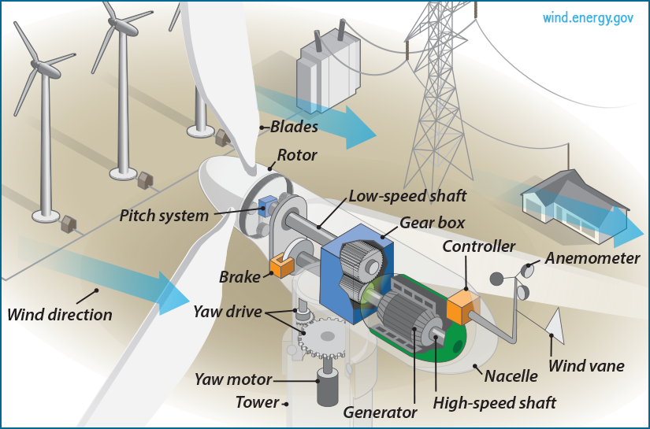
Figure 1: Energy production through wind. (Source: Energy Efficiency & Renewable Energy, 2021)
Through the coupling of electromagnetic as well as kinetic energy, electricity is produced by spinning a shaft attached to a generator, which is moved by the input of kinetic energy. Both the size of the turbine and the length of its rotor blades affect how much energy can be harvested from the wind. Results show that the output is related to the wind speed cubed and the rotor's size. As per the certain theoretical calculations, the potential for wind power increases by a factor of eight when wind speed doubles.

1.3 Generation of hydroelectric energy:
In order to produce electricity, hydroelectric power plants use the kinetic energy of moving water, as that which would be found in a waterfall.
Water is stored in a reservoir, released at a controlled rate through a gate or valve, and directed downwards to a turbine or generator at most hydroelectric power facilities. Water accumulates potential energy just before it is discharged over the top of a dam or begins to descend down a slope. As water travels downhill, the energy stored in its potential state is transformed into kinetic energy. It is possible to generate energy by using the water to move the blades of a turbine, and this electricity is then sent to the consumers of the power plant (Fang, 2008).
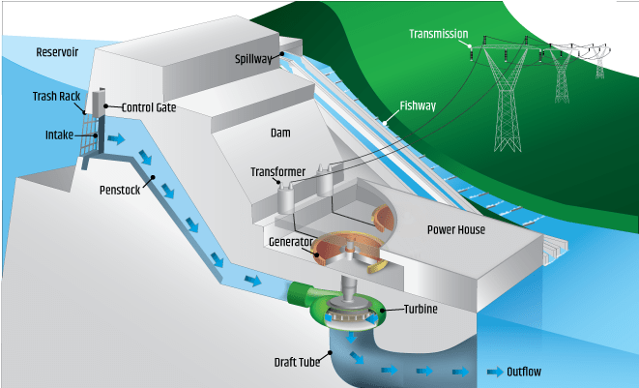
Figure 2: Generation of hydroelectric energy. (Source:Generation of hydroelectric energy, 2021)
There are three distinct varieties of hydroelectric power plants, but the impoundment facility is by far the most typical one (Egré, 2002). A dam is utilized in an impoundment facility in order to regulate the flow of water that is held back in a pool or reservoir. When there is a demand for extra energy, water is let loose from the dam. After the water has been let loose, gravity takes over and the water begins to flow down through a turbine. The generator gets its electricity from the spinning blades of the turbine.
A diversion facility is an example of a different kind of hydroelectric power plant. This kind of plant is distinctive in that it does not make use of a barrier. In its place, it makes use of a network of canals to direct the flow of river water toward the generators that power the turbines.
The third variety of power plant that can be built is referred to as a pumped-storage facility. This facility is responsible for storing the energy that is produced from renewable energy sources like solar, wind, as well as nuclear power in order to utilize it at a later time. Pumps are used in the plant to move water from one reservoir located at a lower elevation to another reservoir located at a higher level. This allows the plant to retain energy. The pool is placed at a lower elevation. When there is a significant increase in the demand for energy, the water that is stored in the higher pool is emptied out. A turbine is turned to produce additional electricity as this water rushes back down to the lower reservoir from the upper reservoir.

1.4 Generation of solar energy:
Directly converting sunlight into power is made possible by solar cells. This sort of cell generates electrical potential when light strikes the junction of a metal and a semiconductor (like silicon), or the junction of two semiconductors. Under typical conditions, a single solar cell may yield no more than two watts of power. By linking together several cells, as in solar-panel arrays, however, solar power plants and big residential systems can produce hundreds or even thousands of kilowatts of electricity. This is achieved by joining a vast number of the individual cells that make up the tissue. Because the solar radiation intensity is rather modest to begin with, enormous and pricey arrays of photovoltaic cells are required to generate even moderate quantities of energy. The bulk of today's solar cells only have an energy efficiency of about 15 to 20 percent, making them rather inefficient (Chu, 2011).

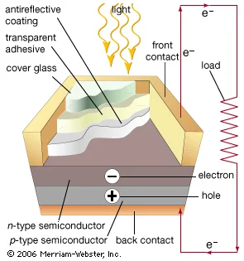
Figure 3: Process of converting solar energy into electrical energy using solar cell. (Source: Ashok, 2019)
In low-power applications, such as calculators and watches, for example, small photovoltaic cells that can be powered by either natural or artificial light have proven to be quite useful. These cells generate electricity when exposed to light. Larger units have been utilized to supply power for water pumps & communications systems in remote places, as well as for weather satellites and communications satellites. Traditional panels made of crystalline silicon and emerging technologies that make use of thin-film solar cells, such as building-integrated photovoltaics, are both examples of technologies that can be installed on the rooftops of homes and businesses to either supplement or replace the conventional source of electric supply (Jelle, 2012).
Concentrated solar power plants utilize focusing, or concentrating, collectors to focus sunlight gathered from a large area onto a smaller blackened receiver. As a result, the light's intensity is significantly increased, which in turn produces high temperatures.
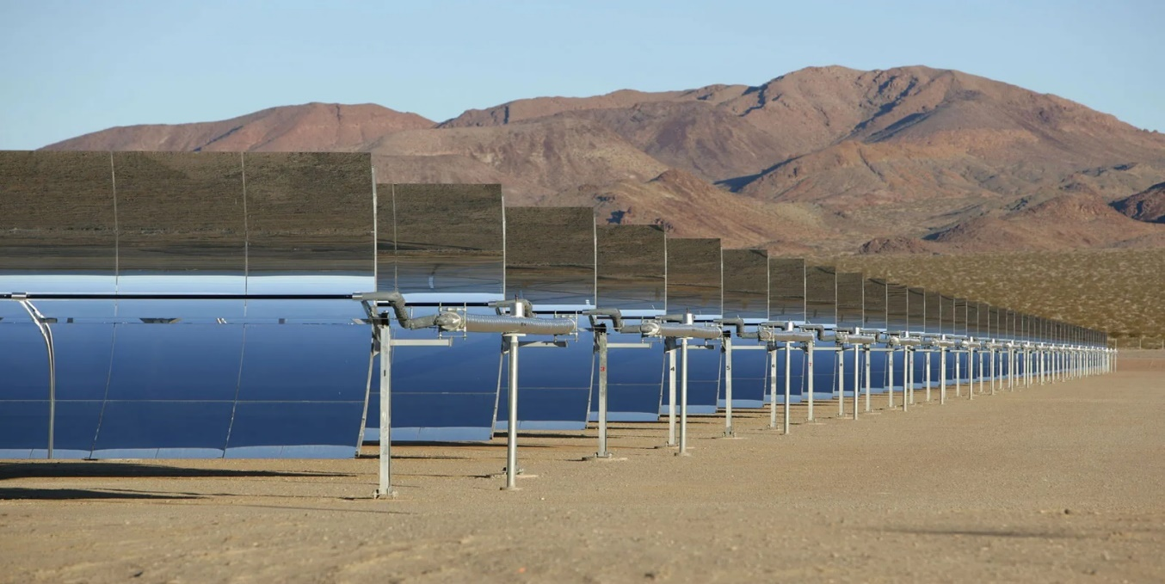
Figure 4: Concentrated solar power plant. (Source: Ashok, 2019)
A target can be heated to temperatures of approximately 2,000 °C (3,600 °F) by concentrating a significant amount of sunlight using arrays of mirrors or lenses that are perfectly aligned with one another (Zhang, 2013). After that, the heat can be put to use in the functioning of a boiler, which can then be used to produce steam to be utilized in a steam turbine electric power plant. This steam can then be used to generate electricity. The movable mirrors can be placed in such a way as to focus enormous volumes of solar energy onto the blacked pipes through which water is pumped, and as a result, the pipes are heated in order to generate steam in a manner that is direct.
The United Kingdom has set a goal for the year 2025 of meeting 15% of its total energy consumption through the use of renewable sources (Mathews, 2015). In order to accomplish this goal, the amount of power that can be generated from renewable resources is fast expanding. Wind power is now the most widely used form of renewable energy in the UK; however, the solar resource is enormous, and use of solar energy is growing throughout the country. Because it is so simple to integrate photovoltaic cells into building materials, solar photovoltaic systems are frequently used in both commercial and residential structures. As a result, these systems provide the most suitable source of decentralized renewable energy production in metropolitan areas. The Feed-in-Tariffs scheme (FITs) is a government initiative to enhance energy output from renewable energy sources, and small-scale solar PV power is eligible for the system. Solar photovoltaic panels use the sun's irradiance to create electricity through a process known as photogeneration, which involves the creation of charge carriers in a semiconducting material like silicon.

1.5 Solar cells in electric cars:
Solar cells are also widely used in solar cars these days. A solar car is a solar-powered vehicle designed to go on roads open to the public or racetracks. Solar cars are electric cars that generate their own power using photovoltaic cells that are housed within the vehicle itself. Solar vehicles often have a rechargeable battery that serves to help manage and store the energy that is harvested from the vehicle's solar cells as well as to collect the kinetic energy that is produced when the vehicle is slowed down. Some solar cars have the capability of supplementing the power of sunshine that is used to charge their battery with the power of external power sources that can be plugged into the automobile (Tie, 2013). Solar vehicles cannot function without a solar array that is equipped with photovoltaic cells (also known as PV cells), which turn sunlight into power. PV cells, on the other hand, immediately convert sunlight into electric current, in contrast to solar thermal energy, which transforms solar energy into heat. When photons from light impact photovoltaic cells, they excite the electrons inside the cells, which then allow the electrons to flow and produce an electric current. Silicon and alloys of indium, gallium, and nitrogen are some examples of the semiconductor materials that are used to construct PV cells. Crystalline silicon, which has an efficiency rate of 15-25%, is the material that is employed the most (Surek, 2005).

Chapter 2

2.0 Literature review

2.1 Renewable energy resources and energy demands:
Resch et al. (2008) found that the theoretical and technical potentials of RER are vast when compared to the current levels of energy use and, hence, RER deployment. More than three hundred thousand times the world's current main energy consumption might potentially be met with the help of RER. They also highlighted that taking into account technical limits, the potential is still 16 times bigger than the needs that are now being met, although RER covers approximately just 13.1% of the market at the moment (Resch, 2008).
In addition to the background material supplied by Haas et al. (2011), the authors of another study that looked at the promotion and adoption of renewable energy sources in the European electricity market in 2010 also included some fresh details. They found that the design needs of various RES-E support schemes was more important than the more commonly discussed issue of feed-in tariffs versus quota systems based on tradable green certificates.

2.2 Comparison of energy production between solar, wind and hydro power:
Evan et al. (2009) evaluated the non-combustion-based renewable electricity production technologies by comparing them to a variety of sustainability factors and making use of data found in the published research. It was determined that there was a large variation between the technologies in terms of power cost, greenhouse gas emissions, and efficiency of electricity generation. This was traced back to differences in the technology pathways open, as well as the dependence of each source of renewable energy on certain locations. The qualitative analysis of the societal implications was based on the quantitative analysis of the primary individual impacts that were presented in the research. Wind power was discovered to be the most sustainable form of energy, followed by hydropower, photovoltaics, and geothermal energy in that order.
The feasibility of sustainable energy and heat producing technologies was studied by Dombi et al. (2014). Using a seven-factor sustainability assessment framework, researchers looked into ten distinct types of energy generation technology. Using a randomized choice experiment, these qualities were ranked. According to the results, concentrated solar power (CSP), hydroelectric power, and wind power plants were all acceptable strategies for generating electrical power.
Studies on sustainable power in Mexico was analyzed by Alemán43-Nava et al. (2014). Findings show that hydropower has the highest installed capacity among renewable energy sources inside the country (11.603 MW), while Mexico ranks fourth in the world in terms of its wind power capacity (958 MW).

2.3 Impact of solar and wind energy on climate change:

There has been some working done in the past to try to estimate the ways in which climate change may impact solar energy. Using two different climate change models and a single emissions scenario, the estimation described by Crook et al. (2014) investigates worldwide changes in PV as well as concentrated solar power (CSP) outputs. They come to the conclusion that CSP is more susceptible to the effects of climate change than PV, and they predict that overall solar power will increase by a few percent from 2010 to 2080 in Europe and China, remain relatively unchanged in Algeria and Australia, and decrease by a few percent in the United States of America and Saudi Arabia.
Gueymard et al. (2011) studied the uncertainty in long term solar irradiance datasets in the United States. They focus on the seasonal components of the solar resource in an effort to provide a deeper understanding of the solar resource for specific applications. According to the findings of Pan et al. (2004), which makes use of a regional climate change model, the seasonal-mean daily global irradiance in the United States may drop by as much as 20% by the end of the 2040s.
Recent research conducted by Vine (2012) examines the overall resilience of California's power sector to the effects of climate change. Work of a similar nature has been done in relation to wind energy. For example, Pryor et al. (2010) examines the processes by which wind energy can engage with climate change, with a particular focus on Northern Europe. They come to the conclusion that in the near term (up to the 2050's), climate change will have little effect in comparison to natural variability. The wind resource in the UK is characterized by Sinden (2007), who looks at recent patterns in wind speed observations. However, the researcher does not cover climate change. There is a limited amount of published research that is accessible in relation to the solar resource in the UK and the effect that climate change will have on this resource.

2.4 Using solar energy to charge electric cars:
In the past, it has been investigated that the possibility of recharging electric vehicles with energy derived from the sun and the wind. Jacobson et al. (2014) based their notion on the concept of acquiring diverse sources of energy primarily through predicting, which is dependent on both the passage of time and the weather in a particular place. They indicated that predicting the weather conditions of the future will give them an idea of how much energy to generate and store so that it may be used in the car in the future. However, a forecast that is based on the current climate conditions is almost never accurate or precise. As a result, there is a possibility that there will be insufficient energy or none at all to power the vehicle. The construction of a design that could hypothetically indicate how solar energy may be easily captured, stored, and utilized is not something that has been completely researched on and is also not considered more realistic to run.
In recent years, authors have disseminated their understanding and views on the topic of how electric automobiles can be charged through the utilization of grid electricity that was created from conventional sources of energy such as irradiance from the sun. According to the findings of the study that was carried out by Kelly-Detwiler (2013), the amount of power that is available for residential usage and other activities is reduced as more electric vehicles use the grid as a source of power supply. Because of this, there is an imbalance in the distribution of power, which results in a weak power factor and unstable power net. The use of electric automobiles will be encouraged more, and this will provide a greener environment. Despite the implementation of stricter rules, utilizing solar energy with an endless power supply will serve as a superior choice due to the aforementioned benefits.
Zhang et al. (2015) have also presented that how to use the optimal daylight hours charging strategy to charge electric cars. This is because solar irradiance is at its peak during the day. Their findings focus on how to take advantage of this peak solar irradiance. They made an effort to devise a strategy for how to fully optimize the energy that was falling on the surface of the earth at peak hours. But they did not explain how the extra energy would be shared or how energy would be collected during periods of little or no solar irradiance, despite the fact that it was an environmentally benign approach to the capturing of energy that used PV cells. On the other side, the work that we do lots of attempts to explain how solar energy may be harnessed from PV cells in order to charge electric cars from parking lots, thereby offering space for extra energy storage during peak periods as well as energy reuse during periods of low demand.
Bhatti et al. (2016) have previously studied on the topic of solar cells being integrated into electric vehicles in order to supply solar energy. They argued that in order to make use of the energy produced by the intergraded PV cells, the capacity of the battery must be lower than what is considered to be optimal. Although it is a sustainable strategy, but the amount of solar energy that can be captured by the PV setup of the vehicle is restricted due to the saturation point of the vehicle's battery. Because the vehicle is in motion the majority of the time, optimizing the energy collection will require a more sophisticated and high-tech system to be built into the vehicle, which will make it more expensive to run. On the other hand, charging a vehicle with solar panels installed in a parking lot is a less complicated and more cost-effective option, and it also offers greater ease and convenience.
Kramer et al. (2008) have also studied on plug-in hybrid electric vehicles. According to them, it appears that these automobiles use (consume) both gasoline and electricity at rates that are dependent on the amount of distance travelled as well as the topography of the route. These automobiles not only contribute to an increase in environmental pollution but also have a high price tag due to the fact that they have two engines. In addition, due to the fact that their engine designs are built on a blended strategy, the inefficiency of the vehicle when it comes to travelling longer distances is increased if even one of the engines malfunctions. The charging of electric cars with solar power is not only better for the environment but also more reliable.

2.5 Solar energy storage methods:
In order to find a good medium between rising energy demand and supply, Colbertaldos et al. (2019) highlight the importance of hydrogen as the key medium for storing renewable energy. The state of California's electricity grid has relied heavily on solar energy as its principal source of energy production. To lessen the negative effects of electricity's sporadic availability, fuel-cell technology has been developed, is a technology that electrolytically obtains hydrogen from this clean resource. In the case, each and every kilowatt-hour of electricity came from renewable, alternative sources. In addition, various different strategies for hydrogen storage capacity were brought up for debate.
Saeedmanesh et al. (2018) discuss the significance of deriving the majority of one's energy needs from non-exhaustible resources, particularly the sun. The objective of this project is to meet the need for energy, construct a grid that produces no emissions, and provide all of the different parts of the economy with environmentally friendly forms of energy as well as chemicals and fertilizers that produce no emissions.
The researchers Gutiérrez-Martin et al. (2021) explain and use for a solar panels-hydrogen technology system a new approach that compares two configurations. These configurations are a battery aided electrolysis and a direct coupling. They minimize the amount of energy that is wasted, and as a result, they cut costs by employing a more compact electrolyze that is caused by the battery. The system that makes use of hydrogen technology is demonstrated to be both self-sufficient and environmentally friendly.
In order to make a building more energy efficient, Boulmrharj et al. (2020) plan to install a system that uses renewable energy and electrolyzes water. The system includes a proton-exchange membrane fuel cell, also known as a PEMFC, a hydrogen electrolyzed, and a photovoltaic system. Together, these components are responsible for supplying the building with thermal electricity and energy. Experimentation, simulation, and modelling are the three methods that they utilize to improve the system's overall performance.
Two different energy management systems for a solar battery system are put to the test by Liu et al. (2020). There are multiple possibilities for the placement of buildings in metropolitan areas that use renewable energy. An investigation was conducted into the proposed technological index of demand, storage, grid, and energy supply. The findings provide evidence of economic benefits and technologically optimized economies.
Sattler et al. (2020) create a variety of designs with the intention of implementing them on the rooftop gardens. The output of energy, appropriate plant selections, and structural design considerations were the factors that were assumed to be tested by the prototypes. The following is the conclusion: In order to aid in the production of clean energy in urban dwellings, options can be taken for the integrated integration of PV as well as green plant areas on the same surface, which can be applied to both new and existing buildings. This is feasible so long as the proposed solutions are of the lightweight building variety that do not burden the extra population for the building's resistant structure.
Using seasonal storage can drastically cut down on the need for solar collectors to be utilized for heating, as stated by Braun et al. (1981). This is especially true in cold climates where DHW loads are considerably smaller than space heating loads. According to Hooper (1995), a solar heating system with a 100% solar portion for UK households with seasonal storage would need just 25% of the solar collector needed for the same system type with short-term storage. This is in comparison to a system that has short-term storage. Because solar collectors are typically quite pricey, there is unquestionably room for improvement in the creation of storage systems that are more cost-effective in order to capture higher solar fractions for the aforementioned heating jobs.
According to the findings of Sillman (1981), systems with seasonal storage, system performance grows linearly with storage capacity up to the point where it can store all of the heat produced in the summer. This point is referred to as the point of unconstrained operation. He came to the conclusion that the point of unrestricted activity was where the economic potential was maximized. He also investigated the possibility that solar space heating systems that are outfitted with seasonal storage and provide nearly one hundred percent of the space heating could have a cost per unit of heat supplied that is comparable to or lower than the cost of solar space heating systems that are outfitted with diurnal storage and provide only fifty percent of the space heating.

Chapter 3

Discussion and calculation

PART: 01
It was observed that industrial uses of solar thermal are growing at an astounding rate. Alternatives can be found using solar thermal energy for power generation, chemical processing, and space heating. It has use in the food industry as well as in the non-metal, textile, construction, chemical, and commercial sectors (Muneer, Maubleu and Asif, 2006). Conversely, solar electricity is widely used in the telecommunications, agricultural, water desalination, and construction sectors to power electrical appliances including lights, pumps, motors, fans, refrigerators, and water heaters (Kalogirou, 2003). Increasing the system's efficiency can be achieved by using solar energy in a wide range of contexts, which necessitates adjusting energy ratios, boosting energy stability, expanding energy sustainability, and decreasing the amount of energy converted (Sharma, Chen, and Vu Lan, 2009). This project's objective is to investigate the usage of solar energy systems in manufacturing and to determine which manufacturing processes are most suitable for solar energy integration. (Hoffmann, 2006). These mentioned steps must be incorporated.
- Site Location, Available Area & Energy Consumption for Solar Power Plant
- Finalizing the System Sizing
- Site Planning, Site Layout, (Electrical & Mechanical) Shading Analysis etc
- Solar Panels Orientation
- Selection of Solar Panels & Inverters (DC to AC Ratio 1) Structures
- Cables Sizing & String Sizing & Electrical Components sizing
- Losses Estimation & Energy Yield
- Economical Evaluation (Payback Period)
Design of the PV solar system in an industry should adhere to the following overarching principles such as under the assumption of power supply meeting the load, the system's economics will be optimal. Software and hardware design are two distinct phases in the development of a photovoltaic power producing system (Yang et al., 2020). The best computation of square angle, prediction of system performance, and cost-effective analysis are all included in the software design process, as well as an examination of the load and an estimate of the load's energy usage, calculation of radiant energy of solar cell surface matrix, calculation of photovoltaic cell components, and battery capacity, and optimization complement between them, and the best estimation of square angle (Wu et al., 2011). The hardware design process involves several different steps, such as load selection and design, solar cell and battery selection and design, array component and support design, inverter selection and design, control system measurement system design, and array component and support design (Muneer, Asif and Kubie, 2003).
Photovoltaic system design relies on having a thorough understanding of a wide range of information and doing the required economic analysis (Barker and Power, 1979). Mainly, it consists of the following procedures such as at first is to inspect the site where the photovoltaic system will be installed in order to gather data such location, weather, the current situation, the expected load, the user's needs, and so on; the second is to calculate and design the software; and the third is to design the hardware (Parida, Iniyan and Goic, 2011). After the software has been built, the needs of performance and a relatively good economy must be taken into account; the fourth step is to install and connect the system; the fifth step is to monitor, evaluate, and optimize the operation of the system (Kusch-Brandt, 2019). Industrialization of a solar power system to generate electricity:
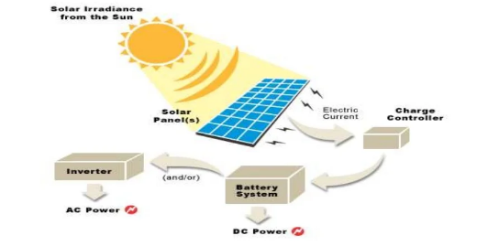
Figure 5 Solar Panels in an Industry for production of electricity, (Source: Newkirk, 2014)
Four hours of daily sunlight is ideal for solar panels. It usually takes between five and eight hours for a panel to fully charge a dead battery. It is important to note that a battery's current condition plays a significant role in determining how long a charge takes to complete. If a battery is completely dead, it only takes between five and eight hours for a solar panel to recharge the cells. When it's gloomy and rainy, a solar photovoltaic system will always generate electricity (Kusch-Brandt, 2019). While the best performance is achieved with direct sunlight, solar panels installed upon our building’s roof can still function with indirect sunlight. Even on foggy days, solar panels can provide electricity (Choudhury, Andersen and Rekstad, 1988). Depending on the panels' quality and efficiency, they may produce less electricity. While our solar panels will still produce some electricity at night, it will be far less than during the day. Since moonlight is simply sunlight that has been reflected by the moon, solar cells can theoretically function when exposed to moonlight (Möllenkamp, Beikircher and Häberle, 2020).
For a 12-volt battery to be fully charged by most solar panels, it takes around four hours of sunlight. More efficient panels might require just two hours of sunshine, although less efficient ones might need some six hours or more.
When the weather is severe, solar panels operate at peak efficiency. Due to the combination of colder weather and comparable sunlight, spring is the ideal time to launch the solar project and stock up on energy before turning on the air conditioner during the summer. In the winter, photovoltaic arrays generate around half as much energy as they do in the summer. Since the solar panels receive less sunshine in the winter, they create less energy. Even while they continue to function during the winter, their output is maximized in the summer when there is more sunshine. The sun's intensity varies with the seasons, requiring a different charging schedule for solar panels at different times of the year.
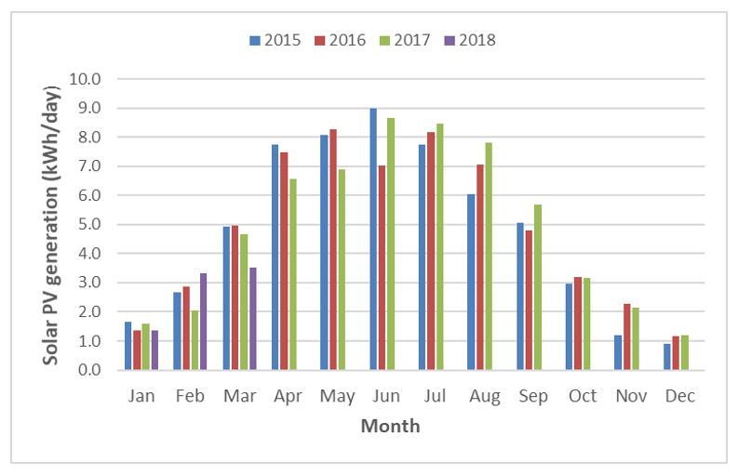
Figure 6 Seasonal Variations in Sun's Intensity Source: (Burnett, Barbour, and Harrison, 2014)
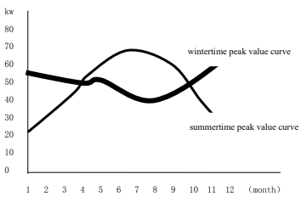
Figure 7 Power Curves for Summer and Winter Source: Rosemarie, (2013)
The panel is attached to the roof of 15m by 50m long located in a South-East.

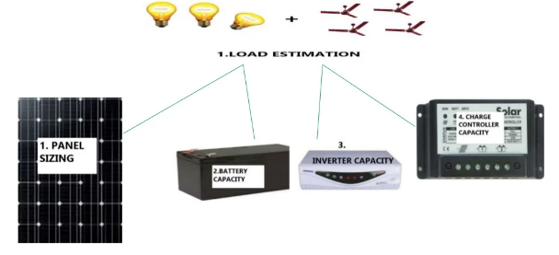
Figure 8 Load Estimation Source: (Electrical Technology, 2013)
If it is only estimated that the lamps and fans in a single industrial room, The rough estimation:
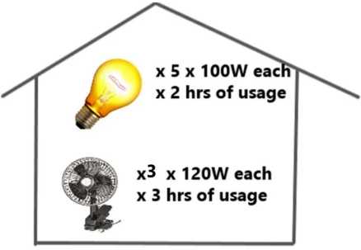
Figure 9 Rough calculation Source: Menezes et al., (2014)
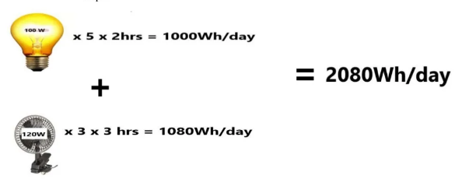
Figure 10 Energy Consumption Menezes et al., (2014)

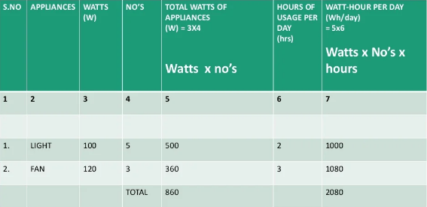

Table 1 Appliances Power Consumption per Day Source: Menezes et al (2014)
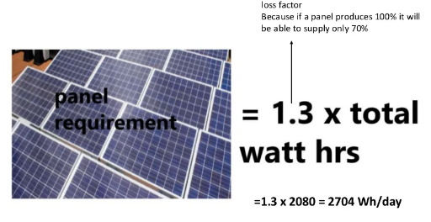

Figure 11 Panel Requirement Menezes et al., (2014)
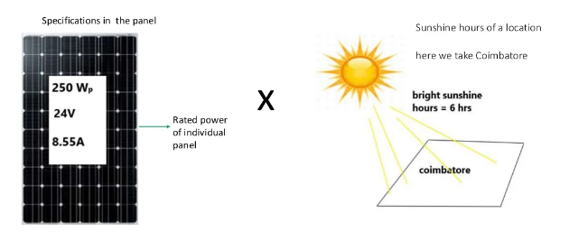
Figure 12 Panel Specifications
Individual Panel Capacity = Rated power × Sunshine hours
= 250 × 6
= 1500Wh/day
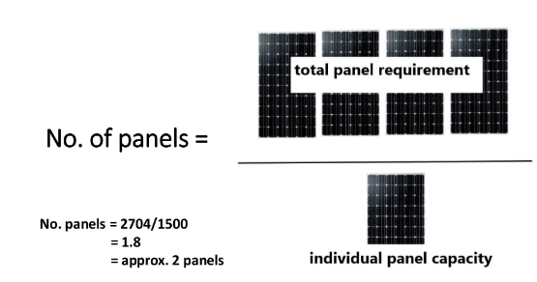
Figure 13 Panel Individual Capacity
- Losses in a solar power system can be caused by a number of different things, including: the orientation of the panels (tilt angle, azimuth angle), the quality of the panels, inverters, and cables, and the weather.
- The Impact of Solar Radiation and Shadows
- Keeping Things Warm and Toasty (Soiling or Dust)
- Environmental conditions loss covers a wide spectrum of module failures caused by changes in irradiance and surface temperature. Two important ones are shade mismatch across modules, where completely modules are impeded by partial shading modules within the same string, as cell temperature degradation whereby higher working temperature can contribute to reduced panel performance.
- The power output of a solar cell is mostly affected by optical losses since they reduce the short-circuit current. Light that enters a solar cell but does not produce an electron-hole pair due to reflection or lack of absorption is considered optical loss.
- First-day degradation describes the decline in performance of a solar cell after it has been installed and exposed to sunlight for the first time. A loss of 0.5% to 1.5% may result from this. It's important to note that LID affects just certain sorts of modules.
- We can sort out all losses by:

Avoid Utility Discrete Curtailment Through Analog Curtailment
Congestion here on distribution network is a common cause of site outages. With insufficient demand, the utility may unlock your site's recloser. The utility believes it has only two choices if it experiences congestion. We don’t turn off the site or risk losing users. Actually, there is a third choice, provided you have the levers to pull. It is in your best advantage to provide some juice, of course. Our industrial site can continue operating with a decreased output with the help of the utility when active power curtailment is set up in the control system. The only thing that we need is the utility's set point or the parameter used in their hedging logic.

Monitor & Alarm on Inverter Internal Temperature
An inverter may also fail to operate at all if its internal temperature rises above a safe threshold. This is a critical failure that will knock an inverter offline entirely and reduce output to unusable levels. The excellent thing is that it can be prevented altogether with even a minimal system of monitoring.

Monitor Max Current Load From Tracker Actuators
Make use of a tracking system to estimate the daily maximum current load for each tracker actuator. The data will clearly highlight the onset of issues by tracking the normalised, maximum daily current of each tracker over time.
In the event of binding or turning resistance, the tracker carrying the most current will be the one to give out. Soft downtime is likely to occur if the same item is drawing the most current every day, or if one tracker's max current is much higher than the others.

Track Average Current Per String to Detect Blown DC Fuses
Blown DC fuses were another common, if less spectacular, "soft downtime" concern at PV plants. If the DC fuse in the combiner box blows, power will be cut off to that section or the whole box.
Since DC fuses are so small, they can be difficult to spot if they blow.

Detect Losses from Soiling or Shading
Soiling is a similar but entirely preventable problem. In our industrial site, particle layers on your modules might reduce energy production when farmers plough their fields or when trees discharge pollen with a vengeance.
Control and monitoring systems should be able to identify the onset of diminished energy output. Our SCADA system ought to be able to show you how real-time string data corresponds to daily average output by calculating averaged current per string and normalizing the data.
The better renewable feed-in tariff in New South Wales (NSW) is offered by Globird Energy and Origin, at 20 cents per kWh (c/kWh) for consumers on a single rate plan. As of January 22, 2015, the solar feed-in tariff has been in effect. Compensation levels for solar plants up to 10MW were paid under the scheme for a term of 25 years. That has been well-established in many fields recently.
As of April 1, 2022, applicable tariffs have been increased by 7.5 percent, reflecting the increase in the RPI over that time period. The feed-in tariff is therefore realized in numerous sectors.
A Feed-in-Tariff (FiT) is a legislative instrument that provides long term contracts for RE providers, often depending just on cost of production of each technology, in order to encourage investment in renewable energy.
As the capital as well as installation costs, operational costs, and grid interconnection and maintenance costs associated with installing a RE system all fall on the owner as well as the grid utility, it is widely agreed that the establishment of these kind of schemes is vital for the promotion of RET development.
The goal of FiT schemes is to speed up the development of RET technology so that it can reach grid parity. The establishment of prospective targets is aided by having a well-defined end point and a timeline for reaching that end point; this allows regulators to keep tabs on the program's progress as it is put into action and enforced.
It is crucial that such a framework be adaptable so that issues can be identified and resolved without derailing the overall strategy.

Challenges include:
- Financial restraints
- Electricity infrastructure and regulations
- Risks and rewards involved with renewable energy investments.
- Possible and actual examples of market failure caused by funding for new ideas

PART: 02

Orientation of Roof
- Positioning of the solar panels such that they face between due south and due west is optimal. If we set up our panels here, they will get the most sunshine possible.
- Surface mounted panel or pole installed panels might well be our best option if our roof is not oriented correctly.
- A solar panel's optimal power output depends in part on its orientation. The angle of some solar panels, like the one seen above, may be adjusted to follow the Sun throughout the day.
- In the Northern Hemisphere, where the sun rises with in east but sets inside the west, the southern side of a home receives the greatest sunshine. A garden that faces south can so benefit from the sun's rays.
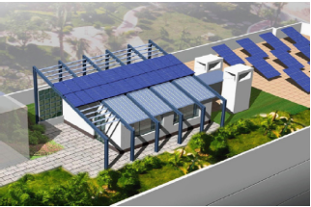
Figure 14 Solar air conditioning system installed on the rooftop of a building Source: (Morsali, Akbarian and Hamed Zar Gari, 2021)
- Solar panels, also known as photovoltaics, can convert solar radiation into usable electricity, which may then be utilised to power buildings (Li et al., 2017). These panel can be utilized to extend the electrical grid to outlying areas or to enhance an existing grid.
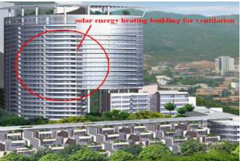
Figure 15 Solar Energy Heating Building for ventilation Source: (FEMP, 2016)
- Today, solar thermal and photovoltaic conversion systems are commonplace. The International Energy Agency (IEA) has projected that by 2050, solar array installation will provide approximately 45 percent of the world's energy requirements. Increasing the system's efficiency can be achieved by using solar energy in a wide range of contexts, which necessitates adjusting energy ratios, boosting energy stability, expanding energy sustainability, and decreasing the amount of energy converted (Balaras et al., 2007). The purpose of our project is to examine the use of solar energy systems in manufacturing and to identify those manufacturing processes that are most suited for solar energy integration (Voivontas et al., 1999).

Table 2 Comparison between Panel Types
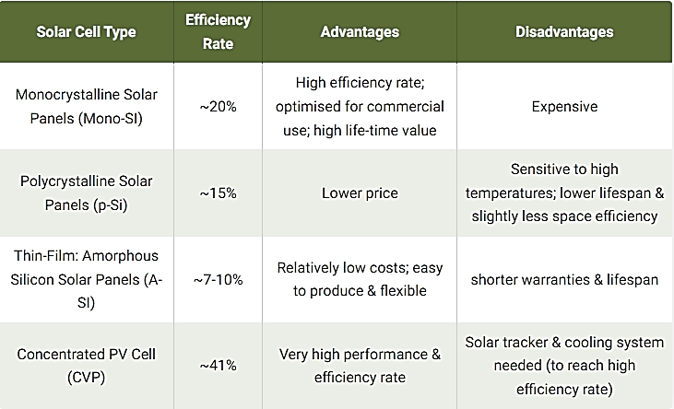
- Mostly used panels are Monocrystalline, Polycrystalline and Thin Films.
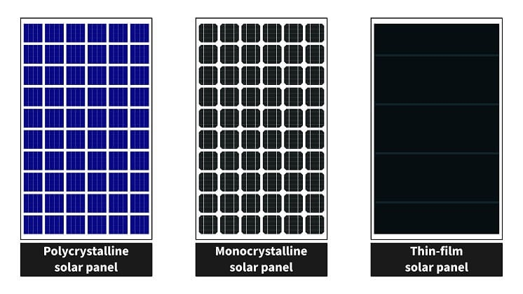
Figure 16 Three Major Types of solar panels Source: Howell, (2019)
- Among solar panel types, monocrystalline panels are widely regarded as the most efficient. Because of this, they are frequently used in residential and commercial buildings for larger energy systems. SunPower Maxeon is popular across a wide range of sectors. It provides solar panels that are very efficient and produce a high amount of energy. As one of the most powerful residential solar panels in this buying guide, SunPower's 415-watt model stands out.
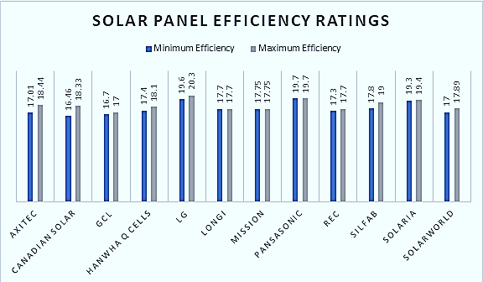
Figure 17 Solar panel Efficiency Ratings Source: Newkirk, (2014)
- Rankings are a great way to gauge a solar panel's usefulness and effectiveness. Current efficiency ratings for panels are generally between 15% and 20%, with LG Solar, Panasonic, and Solaria holding the highest rates. Whereas the overall panel efficiency was 15% five years ago, the market now anticipates scores closer to 18%-20%+. Efficiency ratings are projected to rise even further as cell technology develops.
- PV cells in a solar panel convert sunlight into usable energy. An electrical current is generated when these charges move in response to the cell's own internal electrical field.
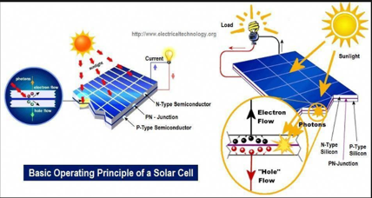
Figure 18Basic operating principle of a Solar Cell Source: (Apogeeweb, 2017)

Solar panel With Advanced Technology
Half Cut Technology
- It is more efficient and has less of an impact from shadows.
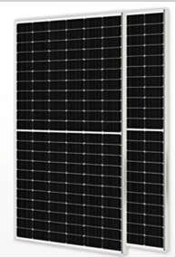
Figure 19 Half Cut Panel Technology Source: (Solar Reviews, 2021)
- Perc Technology
- In order to increase efficiency, a later has been added to the panel's rear.
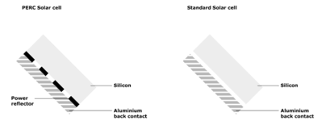
Figure 20 Perc Panel technology Source: (Dambhare, Butey and Moharil, 2021)
Bifacial Panel Technology
- The solar panels can now take in light from behind as well as in front of them.
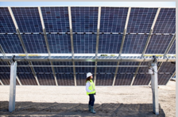
Figure 21 Bifacial Panel technology Source: (Mesbahi, 2021)

Solar Inverters
Micro Inverters
- Micro inverters are far more compact, and they are installed at the rear of each solar panel. Each panel has its own in-built inverter that changes the DC electricity into AC just where it's generated. Individually, the micro inverter’s function.

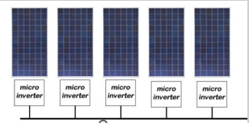
Figure 22Micro Inverters Source: (Solar Reviews, 2022)
Solar Inverters
String Inverters
- All the energy produced by our solar panels is sent to a single inverter in a string inverter. The use of these inverters is widespread.

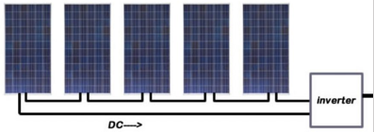
Figure 23 String Inverters Source: (Solar Reviews, 2022)
Electrical Wiring, LV Panel & Switchgear
- Input/Output Cables (DC) (for Strings to Inverter)
- A/C Cords (for Inverter to LV Panel)
- Disconnecting devices (for Termination of Inverters in LV Panel via Breakers, Disconnects)
Panel Requirement/Cost
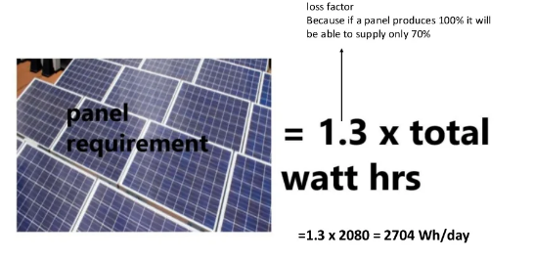
Figure 24 Panel Requirement

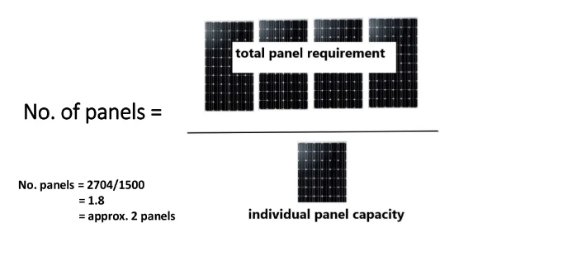
Figure 25 Panel Capacity
- The average solar panel, depending upon brand and size, now costs between $2 and $4 to produce.
- The Monocrystalline Photovoltaic System is the clear winner for us. Due to their superior efficiency, they take up considerably less room than competing designs. This type of solar cell has the longest expected lifespan, according to its manufacturers; in fact, most of them come with a 25-year guarantee. The panels are more resilient to high temperatures. The maximum efficiency levels are achieved by monocrystalline solar panels, often between 15 and 20%. They are particularly efficient in terms of space use due to their high efficiency rate, which means they generate more electricity per square foot. When the temperature is high, monocrystalline solar panels perform better than other types.

PART: 03

Solar Battery Bank
- Lead Acid Battery (Flat Plate Battery, Tubular Battery)
- Dry Battery (Gel, Li Ion Battery)

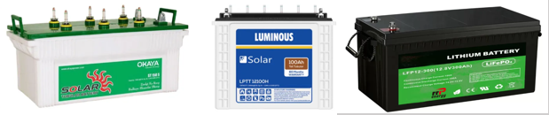
Figure 26 Battery Types Source: (J, 2019)
Total Battey Capacity (Ah-ampere hours)
The capacity of the battery is expressed in terms of current for a particular voltage.
= $\frac{Total watt hours per day used by appliances ×Days of Autonomy (DA)}{(0.85 ×Depth of Discharge \left(DOD\right) ×Nominal Battery Voltage}$
Thumb Rule: The battery voltage must match the panel voltage.

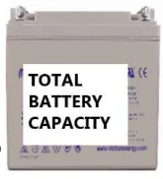
Figure 27 Battery Capacity
= $\frac{Total Wh/day × DA}{Battery Voltage ×0.85 ×DoD}$
= $\frac{2080 ×3 }{0.6 ×0.85 ×24}$
= 509.8Ah
No of Batteries = total battery capacity (Ah) / individual battery capacity (Ah)
= 509.8 / 150
= 3.4

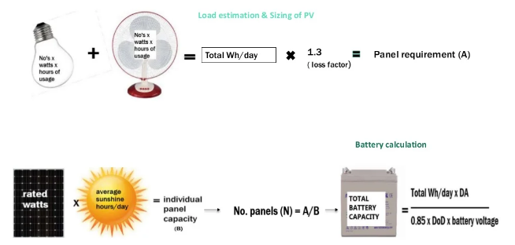
Figure 28 Load Estimation & Sizing of PV Source: (Chel, Tiwari and Chandra, 2009)
Lead acid, lithium ion, nickel cadmium and flow batteries are the four most common types of solar batteries. Lead acid batteries are the most common type, and they are inexpensive and dependable, but they need to be serviced on a regular basis. Additionally, May, Davidson and Monahov, (2018) notes that batteries are recognised as one of the most important and effective solutions for network stabilisation, and a variety of battery chemistries are available. The technology of lead batteries is described in depth, along with how they might be better adapted for energy storage applications. Lead batteries have long cycle and calendar lives, and they have been developed to have significantly longer cycle lives than they did 20 years ago in situations where they are not routinely recharged. Li-ion batteries have a greater energy density and specific energy; however, this is less important for stationary applications.

Lead Acid Batteries
When it comes to solar batteries, lead acid technology has shown itself time and time again. Energy storage via these deep-cycle batteries dates back to the 1800s. Because of how trustworthy they are, they have managed to stay in business.
How lead acid battery’s function:
The simplest form of a lead acid battery comprises four components:
- A negatively charged plate of lead and antimony metal
- A positively charged plate of lead dioxide-based metal.
- An acidic solution of sulfuric acid and water
- The negative plate is known as the anode, the positive plate is known as the cathode, and the water/acid solution is known as the electrolyte.

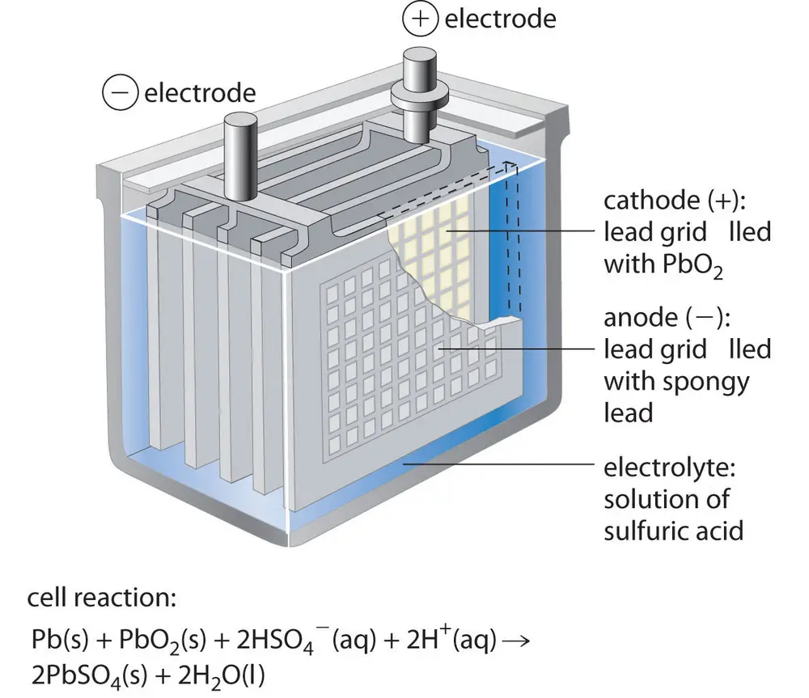
Components of lead batterie Source: (Libre Chemistry, 2019)
A lead-acid battery is priced at $0.17/Wh. Lead-acid batteries are a significant environmental issue due to their toxicity. When properly maintained and handled, however, these dangers can be substantially reduced.
Furthermore, there are various recycling facilities that can reuse the lead battery components. Batteries can significantly reduce the risks of environmental pollution if they are discarded correctly. These batteries are inexpensive, user-friendly, and based on a well-established technology. Short cycle life, low specific energy and power, short cycle life, and extensive maintenance are among the disadvantages.
Lithium-Ion Batteries
As far as energy storage goes, lithium-ion batteries are really the cutting edge. As the market for EVs grew, battery makers saw the advantages of lithium ion as a storage medium for the power needed to run them. Almost overnight, they were adopted as one of the most popular solar battery banks.
The graphic below gives a schematic and organised overview of the interface between a LIB storage system and the electric grid, emphasising key components, keywords, and considerations for the study and debate of this review: A typical LIB storage system comprises a battery (battery cells assembled into modules and optional pack configurations), a thermal concept or Thermal Management System (TMS) (which can be further subdivided into Battery-TMS (B-TMS) and System-TMS (S-TMS)), and an Energy Management System (EMS) control. Depending on the application, the power electronics system may consist of a single or several voltage inverter units (DC/AC link) and sometimes a transformer coupling element for integration to higher grid voltage levels. The application side defines the attainable profit (alternatively, value production through increased reliability or savings due to a reduction in the customer's electricity cost) via storage system integration and has a significant impact on the installation and operation requirements for storage units. Appropriate sizing of the storage system (batteries and power electronics) is another prerequisite for system optimization. For revenue maximisation, it is necessary to consider not only attainable revenues, but also initial investment costs and potential replacement costs.
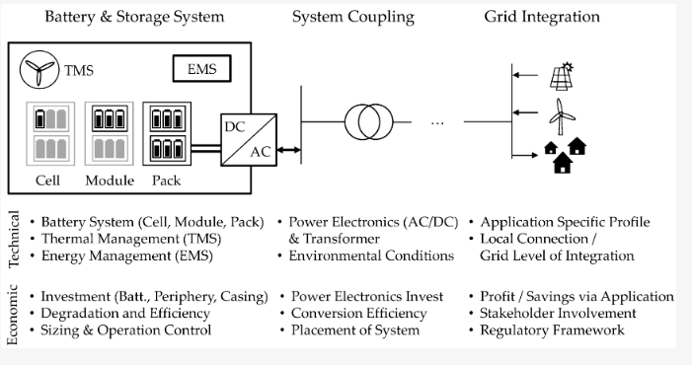
Formalized schematic drawing of a battery storage system Source: Hesse et al., (2017)
Nickel Cadmium Batteries
Ni-Cd batteries, or nickel cadmium batteries, are not as popular as other types of batteries like lead acid or lithium ion. Although Ni-Cd batteries have been around since the late 1800s, it was not until the 1980s that they received a significant upgrade that allowed them to store far more energy. They are highly regarded in the aviation sector and are divided into nickel metal hydride (NiMh) battery and nickel-cadmium (NiCd) battery.

Nickel metal hydride
The NiMH battery is a secondary battery/rechargeable battery with reversible reactions. In a nickel metal hydride battery, the negative electrode is metal hydride, the positive electrode is nickel oxyhydroxide [NiO (OH)], and the electrolyte is potassium hydroxide [KOH]. The anode is composed of metal hydride, which is an alloy of zinc, vanadium, chromium, and titanium. NiMh batteries have the following capacities: cell voltage 1.2 V, energy density 140-300 Wh/l, self-discharge rate 30%/month, specific energy 60-120 Wh/kg, charge/discharge efficiency 66%, specific power 250-1000 W/kg, and cycle durability 500-1000 cycles.
These batteries are commonly used in consumer devices and utility/telecom backup. The average cost of a NiMh battery is $0.99/Wh. The primary advantages of NiMh batteries are their long cycle life, high energy density, and established technology. However, the downsides are that they have a limited long-term cost-cutting potential and are more expensive than lead-acid batteries.
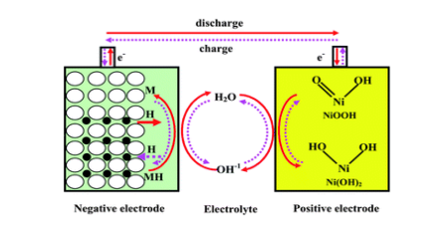
Schematic view of Ni-MH battery Source: (Salkuti, 2021)

Nickel-cadmium
According to Salkuti, (2021) NiCd is a rechargeable battery having a positive electrode of nickel hydroxide [Ni (OH)2] and a negative electrode of cadmium [Cd]. The electrolyte is a solution of alkaline potassium hydroxide [KOH]. The reaction is reversible since it is a rechargeable battery. Depending on the construction, the batteries have a temperature range of -40oC to 70oC and a high self-discharge rate of up to 20% each month. The batteries have a relatively low cycle life of 2000-2500 cycles and an energy density of 50-70 Wh/kg. A schematic depiction of a Ni-Cd battery is shown below:
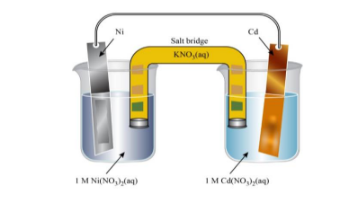
Schematic diagram of Ni-Cd battery Source: (Salkuti, 2021)
NiCd batteries have a specific energy range of 40–60 Wh/kg, an energy density range of 50–150 Wh/l, a specific power range of 150 W/kg, a charge/discharge efficiency range of 70–90%, a self-discharge rate of 10%/month, a cycle durability range of 2000 cycles, and a nominal cell voltage of 1.2 V. Ni-Cd batteries are employed in backup systems for utilities and telecommunications, as well as in consumer electronics [35]. Ni-Cd batteries are priced at $1.50 per watt-hour. Ni-Cd batteries contain extremely hazardous heavy metals that can harm the environment (the soil), but there are recycling centres that can properly dispose of and recycle these batteries.
Flow Batteries
As a new form of energy storage, flow batteries are on the rise. A water-based electrolyte fluid is contained within the battery and circulates between two tanks. The chemical changes that take place during charging make it possible to store the energy for later use. The demand for these types of batteries is on the rise recently. In comparison to smaller batteries, their higher price reflects their greater size.
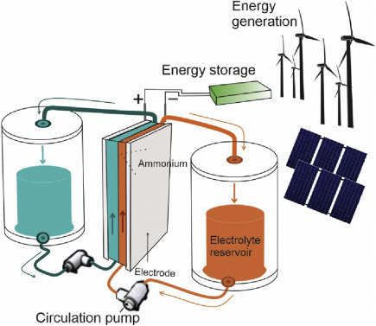
The schematic view of flow batteries. Source: Dincer and Erdemir, (2021)

According to Salkuti, (2021) flow batteries are divided into:
Vanadium redox battery (VRB)- The vanadium RFB is an electrochemical energy storage device that converts chemical energy to electrical energy and vice versa, allowing chemical energy to be stored and utilised when the conversion to electric energy is necessary. A configuration of vanadium RFB with a cell stack and two electrolyte tanks. (Arribas et al., 2016)
Zinc bromine battery (ZnBr)- ZnBr batteries are utilised for backup power, minor load levelling, and peak shaving in transmission and distribution systems. The advantages of ZnBr batteries include high energy and power densities, scalability for large applications, and largely independent energy and power scaling, while the disadvantages include safety hazards (corrosive and poisonous components), high maintenance costs, and an early stage of development.
Sodium-sulfur battery- Sodium (Na) possesses a high specific capacity and a formidable negative potential. Na salts are abundant, cheap, and innocuous in nature. Positive electrode of rechargeable sodium-sulfur battery is molten sulphur, negative electrode is molten sodium, and electrolyte is solid beta alumina ceramic.
At temperatures between 300 and 350 degrees Celsius, both sodium and sulphur are liquids, and solid Na+ electrolytes have a high conductivity. During discharge, sodium emits electrons throughout the circuit, and Na+ ions flow across the electrolyte, combining with sulphur to form sodium polysulphides. Throughout the charge, the process is reversible because the sodium polysulphide breaks down and Na+ ions flow back through the electrolyte. Around maintaining the liquid condition of the electrolyte, the battery's operating temperature is normally set to 300 degrees Celsius. Sodium-sulfur batteries have an energy density ranging from 150 to 240 W/kg, a power density ranging from 150 to 230 W/kg, and a cycle life ranging from 5000 to 6000 cycles.
Lithium-ion batteries are the preferred type of battery due to their high energy density and long lifespan in the industrial sector. The memory effect, in which a battery "remembers" its former capacity after being subjected to repeated partial discharge/charge cycles, is not present in Li-ion batteries. This is a benefit over the same effects of Ni-Cd and Ni-MH. Moreover, the self-discharge rate of Li-ion batteries is very low, hovering between 1.5% and 2% per month. Its benefits include the fact that lithium-ion batteries hardly ever need to be serviced. And unlike lead acid batteries, they are able to store more energy in the same amount of area. Most manufacturers of lithium-ion batteries provide a warranty of at least ten years, and the batteries themselves have such a longer life cycle. Because of their greater depth of discharge, lithium-ion batteries may release more of their stored energy before needing to be recharged, contributing to their longer lifespan.

PART: 04
- The United Kingdom has pledged to achieve carbon neutrality by the year 2050. The transportation industry is presently the greatest emitter in the United Kingdom, with road transportation accounting for 91% of all transportation emissions.
- It is projected that a conventional battery electric vehicle in the UK today, powered by the country's clean electricity mix, produces only one-third of the greenhouse gases of a comparable gasoline vehicle over its lifetime. Improvements in grid decarbonization, battery technology, manufacturing, including end-of-life processing could increase emissions savings even more, to 76% by 2030 and 81% by 2050.
- More than a quarter of all new automobiles sold in December 2021 were battery electric vehicles, according to industry statistics. We predict that by 2030, up to ten million automobiles and trucks, or around a quarter of the total, will need to have zero emissions from the tailpipe. In order to achieve carbon reduction goals, other scenarios project even higher rates of adoption. The Climate Change Committee (CCC) predicts, for instance, that by 2030, between 27 and 37% of the world's automobile and van fleet would be battery electric.
- Almost half (52%) of all U.S. transportation emissions come from passenger cars and taxis; another 16% come from vans as well as other lightweight goods vehicles. 18 This article focuses on private as well as fleet vehicles with a maximum gross vehicle weight of 3.5 tonnes. Additionally, they are applicable to electric motorcycles and mopeds, which could also use the same charging infrastructure as EV vehicles and trucks.
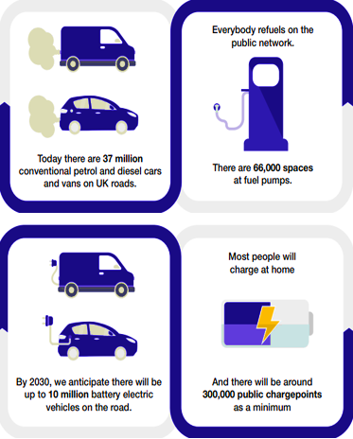
Figure 29 Ev Specifications
ChargePoint are found in a variety of public and private settings around the country
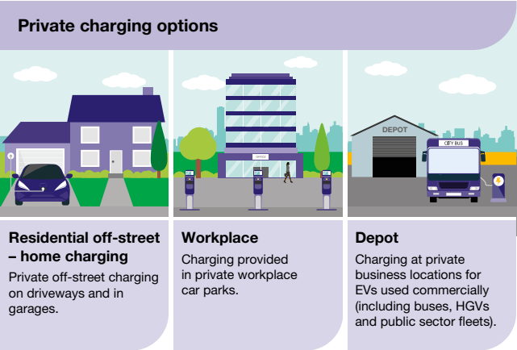
Figure 30 Private Charging Options Source: (EFRE, 2019)
Charging can take place in a variety of public and private levels, allowing for adaptable responses to users' varying requirements. Nearly all EV owners charge their vehicles at night while they sleep. Even if the popularity of EVs grows, this will remain true. Currently, about 70% of English homes who own a car have the option of private, off-street parking (Nandi and De, 2007). Ninety percent of existing EV drivers use it often or occasionally.
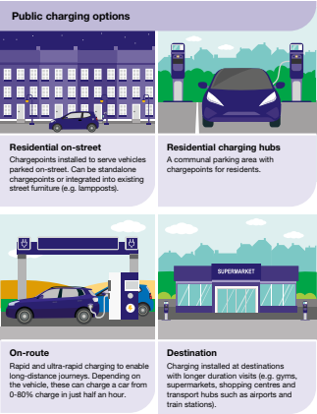
Figure 31 Public Charging Options
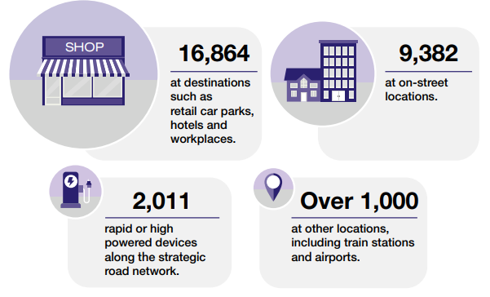
Figure 32Ev Specifications
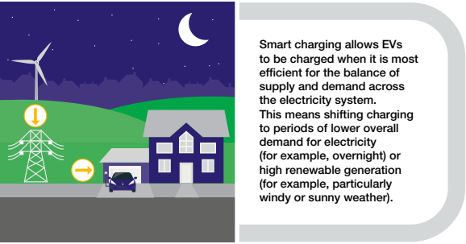
Figure 33 Ev's Supply and Demand for Electricity in Evening
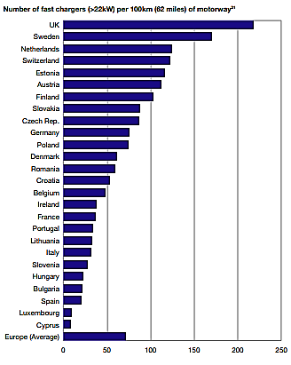
Figure 34 Fast Chargers Comparison Worldwide Source: (Funke et al., 2019)
We have a clear vision for the country’s future charging infrastructure.
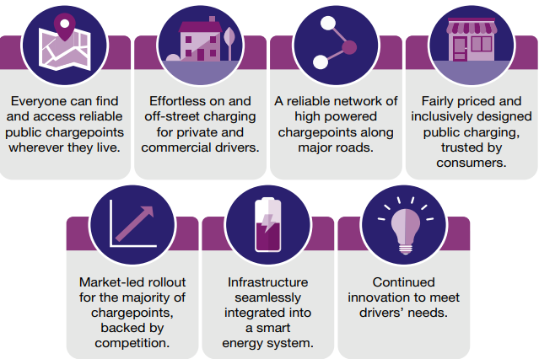
Figure 35 Future's charging Infrastructure Source: (Funke et al., 2019)
Both the charging infrastructures and electric automobiles will continue innovation in the next years. Those who drive electric vehicles (EVs) and society at large will both benefit from the regulatory framework that will allow for the introduction of novel solutions (Nicholas and Lutsey, 2020). In order to provide consumers with more affordable options, the automotive industry, energy providers, and charging infrastructure providers will collaborate to create attractive bundles. An increasingly sophisticated energy system will benefit EV drivers by lowering prices for all energy consumers through better demand management (Fathabadi, 2017). Using smart charging, both families and businesses may cut costs. There will be a wide variety of smart charging rates available to people who charge at home or at the office. When energy costs are reduced, they can charge their car without incurring any additional costs. With the use of car-to-grid technology, they will be able to profit from their vehicle batteries by selling excess energy back to the grid. Those who rely on low-voltage, on-street public charging may soon be able to schedule charging sessions in advance. Enterprises operating vehicle fleets will utilise smart, programmable charging and vehicle-to-grid technologies to schedule and charge vehicles at a depot or local base. Quick nodes will benefit from better energy management and lower peak costs because to battery storage. It will be easy and affordable for chargepoint operators and installers to connect new charge points to the grid.
Less than 800,000 battery electric vehicles (BEVs) were sold in the US during the first quarter of 2017, representing less than 1% of all vehicles. But recent expansion has been robust because of growing public acceptability, better technology, and encouraging legislation. According to McKinsey, there could be between 10 and 11 million BEVs driving throughout the United States by the year 2030.
Present-day all-electric BEVs can go over 250 kilometers on a single battery charge (Xie, 2016). On the other hand, contemporary vehicles from illustrious manufacturers like Musk and Mercedes can travel up to 600 miles on a single charge. A hybrid electric vehicle (HEV) is a car that combines a motors, battery, fuel tank, and internal combustion engine. Typically, vehicles have a capacity of 40 kWh, however the highest-capacity models can hold 100 kWh. Your car's range is directly proportional to the size of its battery.

COST OF THE OVERALL PROCESS
Rough calculation.
There are four basic processes to designing a solar photovoltaic system:
- The estimation of PV arrays, loads and storage batteries
Following assumptions were made during the rough calculations:
- Six hours of daily use of two compact fluorescent lights (CFLs; 18 watts each); two ceiling fans (60 watts each);
- Total load to PV panel system = No. of units × equipment rating = 2 × 18 + 2 × 60 = 156 watts
- Total watt-hours rating = Total load (watts) × Operating hours = 156 × 6 = 936 watt-hours
- Power output of a PV panel = Peak rating × operating factor = 40 × 0.75 = 30 watt
The power used at the end use is less (due to lower combined efficiency of the system):
- Actual output of a panel × combined efficiency = 30 × 0.81 = 24.3 watts (VA) = 24.3 watts
Energy produced by one 40 Wp panel in a day:
- Power output × 8 hours/day (peak equivalent) = 24.3 × 8 = 194.4 watts-hour
Number of solar panels required to satisfy given estimated daily load:
- Total watt-hour rating / (Daily energy produced by a panel)
936/194.4 = 4.81 = 5 (Approx.)
Inverter size is to be calculated as:
- Total connected load to PV panel system = 156 watts
- Inverter are available with rating of 100, 200, 500 VA, etc.
- Therefore, the choice of the inverter should be 200 VA.

Cost Estimation
Cost of arrays:
= No. of PV modules × Cost/Module
= 5 × 8000 (for a 40 Wp panel @ Rs.200/Wp) = Rs.40000
Cost of batteries:
= No. of Batteries × Cost/Module
=1 × 7500= Rs.7500
Cost of Inverter:
= No. of inverters × Cost/Inverter
= 1 × 5000 = 1 × 5000
= Rs.5000 Total cost of system
= A + B + C = 40000 + 7500 + 5000
= Rs.52500 [Additional cost of wiring may be taken as 5% of total system cost]
Some Assumptions:
- As much as 90% efficiency is achieved during the inverter's transformation of DC to AC power.
- 12 volts is the standard operating voltage for batteries.
- There are eight hours of daylight every day.
- 6 hours of daily PV panel use for lights and fan.
- The maximum power rating for a PV panel is 40 Wp (where Wp stands for "watt-peak"), which indicates the panel's maximum possible power output.
On Grid Solar System
The only time solar power is used is during times of reduced electricity consumption due to net metering, and it is not used at all if the grid goes down.
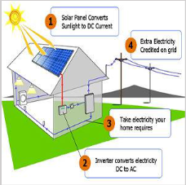
Figure 36 On Grid Solar System Source: (Sols Energy, 2021)
Hybrid Solar System
- The Solar Power System is Linked to the Grid. You may use it with Net Metering, too, to save money on your monthly electricity payment. When the power is out, solar energy can still be used.
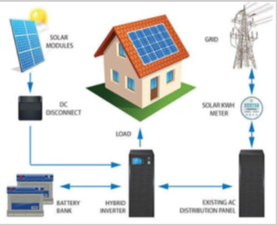
Figure 37 Hybrid Solar System Source: (Alktranee and Bencs, 2020)
OFF Grid Solar System
- Added in place Unfortunately, access to grid is currently unavailable. Ineligible for Net Metering. Linked to a Power Supply Unit for Emergency Use.
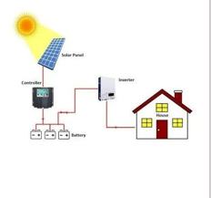
Figure 38 Off Grid Solar System Source: (Brinkhaus, Jarosch and Kapischke, 2011)

Savings
- If we connect our panel to the power grid, we won't need to invest in a costly battery backup system that will store any energy you generate in excess. To be "off-grid" means that we are not tied onto the local utility grid in any way. The fact that can provide all of our own energy needs makes this an attractive option. In some rural places, installing an off-grid solar system can be more cost-effective than running new electricity lines. Efficiency, emission reductions, combined heating and power, use of sustainable power, and more effective use and materials recycling are just a few of the many options for lowering industrial greenhouse gas emissions.
- Costs and carbon emissions can be lowered by reducing energy consumption and business travel. Thirdly, 35% of firms are motivated to act just on climate because they must comply to current and/or forthcoming regulation.

Conclusion

Photovoltaic (PV) systems are acknowledged as sustainable and long-lasting energy sources. Tawalbeh et al. (2020) remark that even though photovoltaic (PV) systems generate little pollution during operation, the possible environmental repercussions of their manufacture and disposal must not be neglected. Important environmental problems include the production of hazardous chemicals, the pollution of water resources, and the release of air pollutants during the manufacturing process, as well as the impact of PV installations on land utilisation. Solar energy, one of the renewable energy sources, is a clean form of electrical power generation with zero greenhouse gas (GHG) emissions. Solar irradiation contains a high amount of energy every minute, making it an excellent opportunity for gathering renewable energy. Material science and engineering breakthroughs would make the capture and distribution of solar energy to end users more efficient. The widespread deployment of solar energy infrastructure, along with efficient use, has the potential to increase energy supply while reducing dependency on fossil fuels. However, solar energy's contribution to energy consumption is still negligible, and it confronts several economic and environmental obstacles.
According to Lee, Trcka, and Hensen (2013) the industrial sector was one of the top energy consumers in 2009, accounting for 24% of total energy consumption in Europe and 32% of total energy consumption in the United States. Compared to other building types with equivalent total floor area, the roof-to-floor ratio of industrial halls, which are predominantly single-story structures, remained relatively high. In most cases, energy-generating components such as photovoltaic (PV) systems may be installed on relatively broad rooftop surfaces that serve no special purpose without necessitating considerable adjustments to the building's architecture. Moreover, because most industrial halls are situated in open areas, the performance of PV systems is not hindered by shadowing from surrounding structures.
However, the high initial capital investment cost, which is unlikely to be recouped by power cost reductions, hinders the widespread adoption of PV systems in industrial halls. It becomes a paradox because mass adoption is believed to be a key factor in reducing the price of PV systems. Government policies offer a variety of economic incentives to offset the high initial cost to encourage wider deployment of PV systems in the idea that more adoption will reduce future deployment costs. The most common incentive is a feed-in tariff. The feed-in tariff, which is governed by many systems, is the premium rate at which utilities have agreed to purchase back electricity from grid-connected, local renewable energy sources.
The following project illustrates a rectangular structure with a low-pitched gable roof that spans 15 m width 50 m depth 6-8 m height (6 m on the long sides; 8 m at the ridge) and is excellent for PV installation. The capital investment for grid-connected PV systems is anticipated to be £3000/kWP, including the cost of PV modules (assuming the typical monocrystalline type with a rated efficiency of 14%) and the cost of balance-of-system components, which is roughly consistent with current statistics.
Monocrystalline PV cells are produced from high-purity silicon, giving the panels a uniform hue and a uniform look. They are considerably more expensive to manufacture than polycrystalline cells but are more efficient (15-20%). Polycrystalline cells are made from raw silicon that has been shaped in square molds and cut into wafers, giving the panels a distinctive look with the squares visible on the surface. Their efficiency (about 14 to 17 percent) and cost are marginally lower. Mounting devices with a 15-degree inclination are used to put solar panels on flat rooftops. However, if the roof slope is already 5 degrees, panels can be installed directly on the roof. Slope selection is a compromise between boosting productivity, enhancing water runoff, and reducing wind loads.
In the diagram below, eight monocrystalline solar panels are linked in series to create a string with a capacity of 3080 kWP. When conditions are good during the day, solar panels may convert solar energy into electricity by absorbing sunlight (direct current)
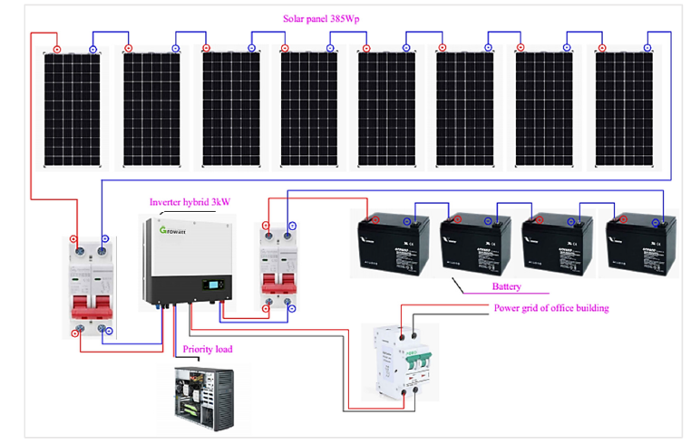

Case study connection schematic for a grid-connected solar power system with battery storage.
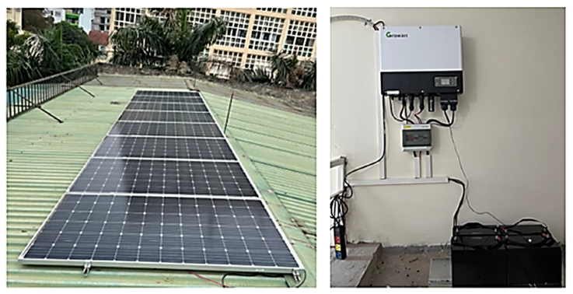
The grid-connected rooftop solar power system's energy generation performance is assessed by comparing simulation and experiment data. The generated electricity of the 3 kWP solar power system is simulated using the PVSYST solar power system specialist software, as illustrated in Figure above. The annual quantity of power produced by the solar array is around 3679 kWh per year, or 306.5 kWh each month. The months of May to September have the maximum solar power output, whereas December, January, and February have the lowest solar power generation.
Financial feasibility metrics such as the internal rate of return (IRR), net present value (NPV), and benefit-cost ratio can be used to evaluate the financial viability of solar power facilities that are grid-connected (B–C). This research provides an examination of the financial effectiveness of grid-connected rooftop solar power systems with and without storage to suggest investment alternatives for commercial buildings in South-West Wales. The undertaking investment cost is proportional to the real price of solar power in the UK market. The cost of inverters and batteries makes a significant difference in the total investment cost of grid-tied solar power systems with and without storage. In addition, the purchase of four 100 Ah batteries for £870 has increased the initial price for a solar power system with storage. As a result, the investment cost difference between 3 kW grid-tied solar power systems with and without storage is roughly £3650p kW.
Implementing innovative technologies such as hybrid power systems and/or floating PV systems can provide high PV performance with reduced land use, according to the study. PV energy systems have a far smaller impact on air quality and climate change than conventional power generation systems. Nevertheless, attempts to limit the environmental impact of hazardous substances used in PV production must be implemented. Due to the variety of old materials and the need for many processing steps, recycling these materials is a challenging operation.

Chapter 4

Recommendations and future works
This section provides a comparison summary of the most important renewable energy technologies currently available for use in residential and commercial buildings in the UK. The emphasis is placed on renewable energy supply as well as energy storage as a means of assisting in the formulation of priorities for the direction of future development. Solar energy has long been the most popular form of renewable energy source in the UK. This is due to the fact that solar energy is widely available and has a relatively cheap cost that is, for the most part, unaffected by the size of the installation. When there is a limitation on the amount of space available for solar energy installation, a wind turbine can be utilized to supplement the solar energy or reduce reliance on a single source of energy. When compared to solar energy, wind energy is typically more difficult to access and implement, despite the fact that it has the advantage of being more readily available on cloudy days and nights. However, because to its relatively expensive cost, the use of wind energy for home uses is restricted to a certain extent.
It is important to keep in mind that the weather has a role in determining the viability of various approaches to reducing energy consumption. For instance, in buildings where heating is the primary energy demand, better levels of insulation and airtightness typically result in greater savings. When it comes to constructions that rely primarily on cooling, the considerations are less effective, and the insulation may, in fact, make the natural cooling effect more difficult to achieve over extended periods of lower ambient temperature.
Smart controls, power lighting, as well as energy-efficient appliances, amongst other things, are all factors that contribute to energy savings by minimizing the amount of energy that is consumed by buildings. Lighting and home appliances that are more energy-efficient can help minimize the cooling strain on HVAC systems. If people behave in a manner that is reasonably energy-efficient, the establishment of a net-zero building may be made easier using intelligent controls.
If it is planned and set up correctly, energy storage can be used to improve process performance while simultaneously cutting resource costs and minimizing the negative effects on the surrounding environment. The production of energy, its storage, and its distribution are the three primary aspects that make up energy storage. On the other hand, adding energy storage systems and the associated energy conversion equipment to residential buildings not only increases the level of complexity of these structures but also results in an increase in the amount of money spent on both the initial investment and the operation and maintenance of these systems.
According to this analysis, the most significant environmental impact is the development of hazardous compounds during the manufacture of PV systems. Heavy metals, chemical solvents, and acids were discovered to be the key components that emerged throughout the separation, extraction, purification, manufacturing, and cleaning operations of various types of solar cells. It is noteworthy to note that the land usage of PV systems differs from normal power cycles in that vast scales are used. The land, on the other hand, may be securely repaired and used for residential or industrial uses.
It is obvious that there are certain gaps in materials research. Additional research is undoubtedly necessary to enhance and innovate in the production of materials for solar cells. During the production process, this will be reflected positively in energy usage, efficiency, and carbon dioxide emissions. Self-cleaning materials are currently being researched, which would cut water use. It is also advised to recycle PV waste to decrease environmental impacts and maintain raw material supply.
In recent years, there has been an increase in interest in PV future difficulties and opportunities, with most of the research focusing on lowering costs, improving efficacy, and improving the technical design of present systems. However, it is critical to consider the environmental effect and long-term viability of solar PV systems. The latest developments in PV sustainability have been researched in several aspects such as sustainability in PV system design; use of recyclable and biodegradable polymeric materials frameless roofing design minimise or decrease the rare elements and recycling PV system trash They investigated two possibilities for the end of PV life: recycling and landfilling. The research emphasised the significance of the recycling process, which includes the recovery of raw materials, a reduction in energy consumption, and a reduction in emissions of items that would be damaging to the environment if dumped in landfills.

References:
- Alemán-Nava, G.S., Casiano-Flores, V.H., Cárdenas-Chávez, D.L., Díaz-Chavez, R., Scarlat, N., Mahlknecht, J., Dallemand, J.F. and Parra, R., 2014. Renewable energy research progress in Mexico: A review. Renewable and Sustainable Energy Reviews, 32, pp.140-153.
- Andrić, I., Koc, M. and Al-Ghamdi, S.G., 2019. A review of climate change implications for built environment: Impacts, mitigation measures and associated challenges in developed and developing countries. Journal of Cleaner Production, 211, pp.83-102.
- Arshad, M. and O’Kelly, B., 2019. Global status of wind power generation: theory, practice, and challenges. International Journal of Green Energy, 16(14), pp.1073-1090.
- Balaras, C.A., Grossman, G., Henning, H.-M., Infante Ferreira, C.A., Podesser, E., Wang, L. and Wiemken, E. (2007). Solar air conditioning in Europe—an overview. Renewable and Sustainable Energy Reviews, [online] 11(2), pp.299–314. doi: 10.1016/j.rser.2005.02.003.
- Bales, C., Gantenbein, P., Jaenig, D. and Weber, R., 2007. Laboratory prototypes of thermo-chemical and sorption storage units. Report B3 of Subtask B. Paris: International Energy Agency, Solar Heating and Cooling Programme.
- Barker, A.S. and Power, H.J. (1979). Photovoltaic solar cell array used for supplemental power generation. Solar Energy, 23(5), pp.427–434. doi:10.1016/0038-092x (79)90151-8.
- Bashetty, S. and Ozcelik, S., 2021. Review on Dynamics of Offshore Floating Wind Turbine Platforms. Energies, 14(19), p.6026.
- Bhatti, A.R., Salam, Z., Aziz, M.J.B.A. and Yee, K.P., 2016. A critical review of electric vehicle charging using solar photovoltaic. International Journal of Energy Research, 40(4), pp.439-461.
- Bi, Y., Guo, T., Zhang, L. and Chen, L., 2004. Solar and ground source heat-pump system. Applied Energy, 78(2), pp.231-245.
- Boulmrharj, S., Khaidar, M., Bakhouya, M., Ouladsine, R., Siniti, M. and Zine-dine, K., 2020. Performance assessment of a hybrid system with hydrogen storage and fuel cell for cogeneration in buildings. Sustainability, 12(12), p.4832.
- Braun, J.E., Klein, S.A. and Mitchell, J.W., 1981. Seasonal storage of energy in solar heating. Solar Energy, 26(5), pp.403-411.
- Choudhury, C., Andersen, S.L. and Rekstad, J. (1988). A solar air heater for low temperature applications. Solar Energy, 40(4), pp.335–343. doi:10.1016/0038-092x (88)90006-0.
- Chu, Y. and Meisen, P., 2011. Review and comparison of different solar energy technologies. Global Energy Network Institute (GENI), San Diego, CA, 1, pp.1-52.
- Colbertaldo, P., Agustin, S.B., Campanari, S. and Brouwer, J., 2019. Impact of hydrogen energy storage on California electric power system: Towards 100% renewable electricity. International Journal of Hydrogen Energy, 44(19), pp.9558-9576.
- Crook, J.A., Jones, L.A., Forster, P.M. and Crook, R., 2011. Climate change impacts on future photovoltaic and concentrated solar power energy output. Energy & Environmental Science, 4(9), pp.3101-3109.
- Dombi, M., Kuti, I. and Balogh, P., 2014. Sustainability assessment of renewable power and heat generation technologies. Energy Policy, 67, pp.264-271.
- Egré, D. and Milewski, J.C., 2002. The diversity of hydropower projects. Energy policy, 30(14), pp.1225-1230.
- Energy, 32(1), pp.118-140.Morales Pedraza, J., 2020. The Current Situation and Perspectives on the Use of Hydropower for Electricity Generation. In Electrical Energy Generation in Europe (pp. 93-167). Springer, Cham.
- Esen, H., Inalli, M. and Esen, M., 2006. Technoeconomic appraisal of a ground source heat pump system for a heating season in eastern Turkey. Energy Conversion and Management, 47(9-10), pp.1281-1297.
- Evans, A., Strezov, V. and Evans, T.J., 2009. Assessment of sustainability indicators for renewable energy technologies. Renewable and sustainable energy reviews, 13(5), pp.1082-1088.
- Fang, H., Chen, L., Dlakavu, N. and Shen, Z., 2008. Basic modeling and simulation tool for analysis of hydraulic transients in hydroelectric power plants. IEEE Transactions on energy conversion, 23(3), pp.834-841.
- Fathabadi, H. (2017). Novel grid-connected solar/wind powered electric vehicle charging station with vehicle-to-grid technology. Energy, 132, pp.1–11. doi: 10.1016/j.energy.2017.04.161.
- Greaves, D., Jin, S., Wong, P., White, D.J., Jeffrey, H., Scott, B. and Wigg, R., 2022. UK perspective research landscape for offshore renewable energy and its role in delivering net zero. Progress in Energy.
- Gueymard, C.A. and Wilcox, S.M., 2011. Assessment of spatial and temporal variability in the US solar resource from radiometric measurements and predictions from models using ground-based or satellite data. Solar Energy, 85(5), pp.1068-1084.
- Gupta, A.K., 2018. “Today ' s Need & Importance Role of Solar based Automobile System,” vol. 5, no. 5, pp. 26–30.
- Gutiérrez-Martín, F., Amodio, L. and Pagano, M., 2021. Hydrogen production by water electrolysis and off-grid solar PV. International Journal of Hydrogen Energy, 46(57), pp.29038-29048.
- Guzzella, L. and Sciarretta, A., 2007. Vehicle propulsion systems (Vol. 1). Springer-Verlag Berlin Heidelberg.
- Haas, R., Panzer, C., Resch, G., Ragwitz, M., Reece, G. and Held, A., 2011. A historical review of promotion strategies for electricity from renewable energy sources in EU countries. Renewable and sustainable energy reviews, 15(2), pp.1003-1034.
- Hadorn, J.C., 2008. Advanced storage concepts for active solar energy—IEA SHC Task 32 2003-2007. proceeding of Eurosun, Lisbon, Portugal.
- Hoffmann, W. (2006). PV solar electricity industry: Market growth and perspective. Solar Energy Materials and Solar Cells, 90(18-19), pp.3285–3311. doi: 10.1016/j.solmat.2005.09.022.
- Hooper, F.C., 1955. Possibility of complete solar heating of Canadian buildings. Eng. J. (NY);(United States), 38(11).
- Jaber, S.A., 2012. Renewables 2012 Global Status report. REN21 Renewable Energy Policy Network/Worldwatch.
- Jacobson, M.Z. and Delucchi, M.A., 2011. Providing all global energy with wind, water, and solar power, Part I: Technologies, energy resources, quantities and areas of infrastructure, and materials. Energy policy, 39(3), pp.1154-1169.
- Jelle, B.P., Breivik, C. and Røkenes, H.D., 2012. Building integrated photovoltaic products: A state-of-the-art review and future research opportunities. Solar Energy Materials and Solar Cells, 100, pp.69-96.
- Kalogirou, S. (2003). The potential of solar industrial process heat applications. Applied Energy, 76(4), pp.337–361. doi:10.1016/s0306-2619(02)00176-9.‌
- Kelly-Detwiler, P., 2013. Electric Cars and the Power Grid: How Are They Coming Together?
- Khan, K.A., Kabir, M.A., Mamun, M., Hossain, M.A. and Alim, S., 2020. An observation of solar photovoltaic electricity across the globe. IJARIIE, 6(4), pp.1487-504.
- Kramer, B., Chakraborty, S. and Kroposki, B., 2008, November. A review of plug-in vehicles and vehicle-to-grid capability. In 2008 34th annual conference of IEEE industrial electronics (pp. 2278-2283). IEEE.
- Kubota, H., Hondo, H., Hienuki, S. and Kaieda, H., 2013. Determining barriers to developing geothermal power generation in Japan: Societal acceptance by stakeholders involved in hot springs. Energy Policy, 61, pp.1079-1087.
- Kusch-Brandt (2019). Urban Renewable Energy on the Upswing: A Spotlight on Renewable Energy in Cities in REN21’s ‘Renewables 2019 Global Status Report’. Resources, 8(3), p.139. doi:10.3390/resources8030139.
- Kusch-Brandt (2019). Urban Renewable Energy on the Upswing: A Spotlight on Renewable Energy in Cities in REN21’s ‘Renewables 2019 Global Status Report’. Resources, 8(3), p.139. doi:10.3390/resources8030139.
- Lee, B., Trcka, M. and Hensen, J.L.M. (2013). Rooftop photovoltaic (PV) systems: a cost–benefit analysis study of industrial halls. International Journal of Low-Carbon Technologies, 9(4), pp.319–326.
- Li, J.M., Zhang, J.Q., Li, Q. and Guo, Z.D. (2017). Thermal Aging Effects on Fire Performance of the Cross-Linked Polyethylene Insulated Cable. Materials Science Forum, 898, pp.2399–2404. doi: 10.4028/www.scientific.net/msf.898.2399.
- Liu, J., Wang, M., Peng, J., Chen, X., Cao, S. and Yang, H., 2020. Techno-economic design optimization of hybrid renewable energy applications for high-rise residential buildings. Energy Conversion and Management, 213, p.112868.
- Liu, Q., 2014. Electric car with solar and wind energy may change the environment and economy: A tool for utilizing the renewable energy resource. Earth's Future, 2(1), pp.7-13.
- MacKay, D.J., 2013. Solar energy in the context of energy use, energy transportation and energy storage. Philosophical Transactions of the Royal Society A: Mathematical, Physical and Engineering Sciences, 371(1996), p.20110431.
- Mathews, J. and Ardiyanto, A., 2015. Estimation of Greenhouse Gas Emissions for Palm Oil Biodiesel Production: A Review and Case Study within the Council Directives 2009/28/EC of the European Parliament. Health, 6, pp.25-41.
- Möllenkamp, J., Beikircher, T. and Häberle, A. (2020). Recalibration of SPN1 pyranometers against pyrheliometer and its relevance for the evaluation of concentrating solar process heat plants. Solar Energy, 197, pp.344–358. doi: 10.1016/j.solener.2019.12.055.
- Mondol, J.D., Yohanis, Y.G. and Norton, B., 2007. The impact of array inclination and orientation on the performance of a grid-connected photovoltaic system. Renewable
- Muneer, T., Asif, M. and Kubie, J. (2003). Generation and transmission prospects for solar electricity: UK and global markets. Energy Conversion and Management, 44(1), pp.35–52. doi:10.1016/s0196-8904(02)00043-2.
- Muneer, T., Maubleu, S. and Asif, M. (2006). Prospects of solar water heating for textile industry in Pakistan. Renewable and Sustainable Energy Reviews, 10(1), pp.1–23. doi: 10.1016/j.rser.2004.07.003.
- Musgrove, P., 2009. Wind power. Cambridge Books.
- Nandi, P. and De, R. (2007). Production of sweetmeat utilising solar thermal energy: economic and thermal analysis of a case study. Journal of Cleaner Production, 15(4), pp.373–377. doi: 10.1016/j.jclepro.2005.11.006.
- Nicholas, M. and Lutsey, N. (2020). Quantifying the electric vehicle charging infrastructure gap in the United Kingdom. [online] Available at: https://theicct.org/sites/default/files/publications/UK-charging-gap-082020.pdf [Accessed 2 Apr. 2021].
- Pan, Z., Segal, M., Arritt, R.W. and Takle, E.S., 2004. On the potential change in solar radiation over the US due to increases of atmospheric greenhouse gases. Renewable Energy, 29(11), pp.1923-1928.
- Parida, B., Iniyan, S. and Goic, R. (2011). A review of solar photovoltaic technologies. Renewable and Sustainable Energy Reviews, 15(3), pp.1625–1636. doi: 10.1016/j.rser.2010.11.032.
- Paska, J., Surma, T., Terlikowski, P. and Zagrajek, K., 2020. Electricity generation from renewable energy sources in Poland as a part of commitment to the polish and EU energy policy. Energies, 13(16), p.4261.
- Pryor, S.C. and Barthelmie, R.J., 2010. Climate change impacts on wind energy: A review. Renewable and sustainable energy reviews, 14(1), pp.430-437.
- Purohit, I., Sundaray, S. and Motiwala, S., 2018. Familiarization with Energy Storage Technologies and Their Relevance for Renewable Energy (RE) Based Power Generation. In Low Carbon Energy Supply (pp. 273-326). Springer, Singapore.
- Resch, G., Held, A., Faber, T., Panzer, C., Toro, F. and Haas, R., 2008. Potentials and prospects for renewable energies at global scale. Energy policy, 36(11), pp.4048-4056.
- Roberts, B.W., Shepard, D.H., Caldeira, K., Cannon, M.E., Eccles, D.G., Grenier, A.J. and Freidin, J.F., 2007. Harnessing high-altitude wind power. IEEE Transactions on Energy Conversion, 22(1), pp.136-144.
- Rosen, M.A. and Dincer, I., 2003. Exergy methods for assessing and comparing thermal storage systems. International Journal of Energy Research, 27(4), pp.415-430.
- Saeedmanesh, A., Mac Kinnon, M.A. and Brouwer, J., 2018. Hydrogen is essential for sustainability. Current Opinion in Electrochemistry, 12, pp.166-181.
- Sattler, S., Zluwa, I. and Österreicher, D., 2020. The “PV rooftop garden”: providing recreational green roofs and renewable energy as a multifunctional system within one surface area. Applied Sciences, 10(5), p.1791.
- Sedaghat, A., Mostafaeipour, A., Rezaei, M., Jahangiri, M. and Mehrabi, A., 2020. A new semi-empirical wind turbine capacity factor for maximizing annual electricity and hydrogen production. International Journal of Hydrogen Energy, 45(32), pp.15888-15903.
- Sharma, A., Chen, C.R. and Vu Lan, N. (2009). Solar-energy drying systems: A review. Renewable and Sustainable Energy Reviews, 13(6-7), pp.1185–1210. doi: 10.1016/j.rser.2008.08.015.
- Sillman, S., 1981. Performance and economics of annual storage solar heating systems. Solar Energy, 27(6), pp.513-528.
- Sinden, G., 2007. Characteristics of the UK wind resource: Long-term patterns and relationship to electricity demand. Energy policy, 35(1), pp.112-127.
- Solar, P., 2000. Gmbh, I. Survey of Thermal Storage for Parabolic Trough Power Plants Period of Performance: Survey of Thermal Storage for Parabolic Trough Power Plants Period of Performance.
- Solomon, S., Qin, D., Manning, M., Chen, Z., Marquis, M., Averyt, K., Tignor, M. and Miller, H., 2007. IPCC fourth assessment report (AR4). Climate change, 374.
- Stern, N. and Stern, N.H., 2007. The economics of climate change: the Stern review. cambridge University press.
- Surek, T., 2005. Crystal growth and materials research in photovoltaics: progress and challenges. Journal of Crystal growth, 275(1-2), pp.292-304.
- Tawalbeh, M., Al-Othman, A., Kafiah, F., Abdelsalam, E., Almomani, F. and Alkasrawi, M. (2020). Environmental impacts of solar photovoltaic systems: A critical review of recent progress and future outlook. Science of The Total Environment, 759(14), p.143528.
- Tie, S.F. and Tan, C.W., 2013. A review of energy sources and energy management system in electric vehicles. Renewable and sustainable energy reviews, 20, pp.82-102.
- Vine, E., 2012. Adaptation of California’s electricity sector to climate change. Climatic Change, 111(1), pp.75-99.
- Voivontas, D., Yannopoulos, K., Rados, K., Zervos, A. and Assimacopoulos, D. (1999). Market potential of renewable energy powered desalination systems in Greece. Desalination, 121(2), pp.159–172. doi:10.1016/s0011-9164(99)00017-x.
- Wilson, G.A. and Dyke, S.L., 2016. Pre-and post-installation community perceptions of wind farm projects: the case of Roskrow Barton (Cornwall, UK). Land use policy, 52, pp.287-296.
- Wu, Z., Zhou, S., An, L., Shen, G. and Shi, H. (2011). Theoretical Foundation for Energy Structure Adjustment. Modern Applied Science, 5(1). doi:10.5539/mas.v5n1p133.
- Xie, G. (2016). Bright and Low Driving Voltage Top-Emitting Organic Light Emitting Diodes on Silicon. Nanomedicine & Nanotechnology Open Access, 1(1). doi:10.23880/nnoa-16000105.
- Yang, Z., Wang, Y., Xing, L., Yin, B. and Tao, J. (2020). Relay Protection Simulation and Testing of Online Setting Value Modification Based on RTDS. IEEE Access, 8, pp.4693–4699. doi:10.1109/access.2019.2963228.
- Zhang, H.L., Baeyens, J., Degrève, J. and Cacères, G., 2013. Concentrated solar power plants: Review and design methodology. Renewable and sustainable energy reviews, 22, pp.466-481.
- Zhang, W., Ge, W., Huang, M. and Jiang, J., 2015. Optimal day-time charging strategies for electric vehicles considering photovoltaic power system and distribution grid constraints. Mathematical Problems in Engineering, 2015.

‌

‌

Figures references
Alktranee, M. and Bencs, P. (2020). Overview of the hybrid solar system. Analecta Technica Szegedinensia, 14(1), pp.100–108.
Apogeeweb (2017). Working principle and Development of Solar Cell. [online] www.apogeeweb.net. Available at: https://www.apogeeweb.net/article/27.html.
Arribas, B.N., Melício, R., Teixeira, J.C., and Mendes, V.M.F. (2016). Vanadium Redox Flow Battery Storage System Linked to the Electric Grid. Renewable Energy and Power Quality Journal, pp.1025–1036.
Ashok, S. (2019). solar energy | Description, Uses, & Facts. In: Encyclopædia Britannica. [online] Available at: https://www.britannica.com/science/solar-energy.
Brinkhaus, M., Jarosch, D. and Kapischke, J. (2011). All year power supply with off-grid photovoltaic system and clean seasonal power storage. Solar Energy, 85(10), pp.2488–2496.
Burnett, D., Barbour, E. and Harrison, G.P. (2014). The UK solar energy resource and the impact of climate change. Renewable Energy, 71, pp.333–343.
Chel, A., Tiwari, G.N. and Chandra, A. (2009). Sizing and cost estimation methodology for stand-alone residential PV power system. International Journal of Agile Systems and Management, 4(1/2), p.21
Dambhare, M.V., Butey, B. and Moharil, S.V. (2021). Solar photovoltaic technology: A review of different types of solar cells and their future trends. Journal of Physics: Conference Series, 1913(1), p.012053
Dincer, I. and Erdemir, D. (2021). Fundamentals and Concepts. Heat Storage Systems for Buildings, pp.1–35
EFRE (2019). Alternative Fuels Data Center: Developing Infrastructure to Charge Plug-In Electric Vehicles. [online] Energy.gov. Available at: https://afdc.energy.gov/fuels/electricity_infrastructure.html.
Electrical Technology (2013). How Many Solar Panels, Batteries & Inverter Do I Need for Home? [online] ELECTRICAL TECHNOLOGY. Available at: https://www.electricaltechnology.org/2013/05/a-complete-note-on-solar-panel.html.
Energy Efficiency & Renewable Energy (2021). The Inside of a Wind Turbine. [online] Energy.gov. Available at: https://www.energy.gov/eere/inside-wind-turbine.
Energy, S. (2021). Solar PV Systems Explained: On Grid v. Off Grid v. Hybrid Solar Rooftop Systems. [online] SOLS Energy. Available at: https://www.solsenergy.com/blog/solar-pv-systems-explained-on-grid-v-off-grid-v-hybrid-solar-rooftop-systems/ [Accessed 20 Oct. 2022].
FEMP (2016). Solar Ventilation Air Preheating | WBDG - Whole Building Design Guide. [online] Wbdg.org. Available at: https://www.wbdg.org/resources/solar-ventilation-air-preheating.
Funke, S.Á., Sprei, F., Gnann, T. and Plötz, P. (2019). How much charging infrastructure do electric vehicles need? A review of the evidence and international comparison. Transportation Research Part D: Transport and Environment, 77, pp.224–242
Hesse, H., Schimpe, M., Kucevic, D. and Jossen, A. (2017). Lithium-Ion Battery Storage for the Grid—A Review of Stationary Battery Storage System Design Tailored for Applications in Modern Power Grids. Energies, 10(12), p.210
Howell, B. (2019). Types of Solar Panels: Which Is Best for You? [online] The Eco Experts. Available at: https://www.theecoexperts.co.uk/solar-panels/solar-panels-types.
J, K. (2019). Solar Battery Chemistry Comparison Chart | Best for Off-Grid? [online] Modern Survival Blog. Available at: https://modernsurvivalblog.com/alternative-energy/solar-battery-comparison-chart/ [Accessed 20 Oct. 2022].
Libre Chemestry (2019). Joshua Halpern and Scott Johnson. [online] Chemistry 2000. Available at: https://chem.libretexts.org/Courses/Prince_Georges_Community_College/CHEM_2000%3A_Chemistry_for_Engineers_(Sinex)/UnitA_Thermo_and_Electrochemistry/Chapter_17%3A_Electrochemistry/Chapter_17.5%3A_Commercial_Galvanic_Cells.
Martin Newkirk (2014). CLEAN ENERGY REVIEWS. [online] CLEAN ENERGY REVIEWS. Available at: https://www.cleanenergyreviews.info/blog/2014/5/4/how-solar-works.
May, G.J., Davidson, A. and Monahov, B. (2018). Lead batteries for utility energy storage: A review. Journal of Energy Storage, [online] 15, pp.145–157
Menezes, A.C., Cripps, A., Buswell, R.A., Wright, J. and Bouchlaghem, D. (2014). Estimating the energy consumption and power demand of small power equipment in office buildings. Energy and Buildings, [online] 75, pp.199–209.
Mesbahi, M. (2021). Solar Energy Efficiency: Dominant Bifacial Solar Panel Technologies. [online] Wevolver. Available at: https://www.wevolver.com/article/solar-energy-efficiency-dominant-bifacial-solar-panel-technologies.
Morsali, S., Akbarian, S. and Hamed Zar Gari, Z. (2021). Simulation of the roof shapes and building orientation on the energy performance of the buildings. Journal of Building Pathology and Rehabilitation, 6(1). doi:10.1007/s41024-021-00132-3.
Salkuti, S.R. (2021). Electrochemical batteries for smart grid applications. International Journal of Electrical and Computer Engineering (IJECE), 11(3). pp1849-1856.
Sánchez-Díez, E., Ventosa, E., Guarnieri, M., Trovò, A., Flox, C., Marcilla, R., Soavi, F., Mazur, P., Aranzabe, E. and Ferret, R. (2021). Redox flow batteries: Status and perspective towards sustainable stationary energy storage. Journal of Power Sources, pp481
Solar Reviews (2021). What is half-cut solar cell technology? [online] Solar Reviews. Available at: https://www.solarreviews.com/blog/half-cut-solar-cell-technology-explained.
Solar Reviews (2022). Pros and cons of string inverters vs microinverters. [online] Solar Reviews. Available at: https://www.solarreviews.com/blog/pros-and-cons-of-string-inverter-vs-microinverter.

