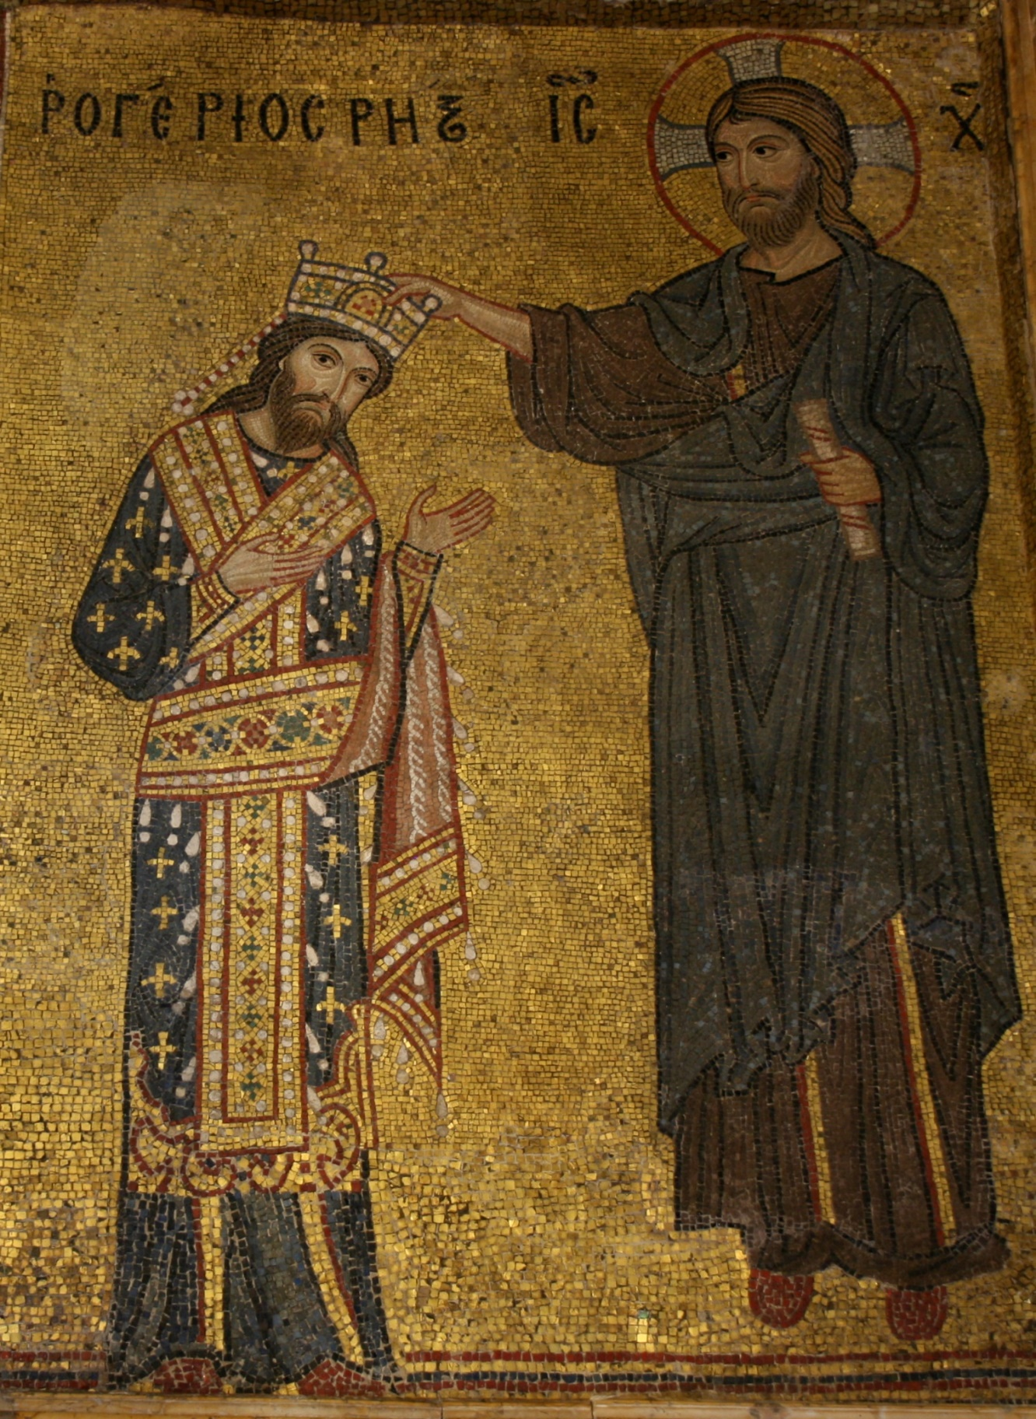

Detail from the mosaic with Roger II receiving the crown from Christ, Martorana, Palermo
Mosaic with Roger II receiving the crown from Christ, Martorana, Palermo – Commentary
The chosen image shows the mosaic panel depicting the coronation of King Roger II, found in the Church of Santa Maria dell'Ammiraglio, in Palermo the capital of Sicily. The church displays the multicultural society of Sicily in the 12th century, combining Norman, Byzantine and Arabic style. Most of the mosaics are believed to have been created by Byzantine craftsmen, thus influencing the appearance of Roger II and Jesus Christ who are shown in a typically Byzantine style. The feature of Christ and the overwhelming religious connotations of the mosaic emphasise the arguable Norman piety and religious focus. The text at the top of the mosaic is particularly interesting to those exploring the Norman’s conquest of Sicily, as it is not in Latin as would be expected but instead in Greek. This Norman consciousness to create a shared ‘identity’ that articulates their religious devotion, would have helped to legitimise their rule in Sicily and provide justification for having conquered it. Looking at the lasting Norman legacy in Sicily, not only through surviving literature but through architecture including mosaics, shows the emerging concept of Norman identity or ‘Normanitas’.
Many of the mosaic’s key features provide historians with vital information about Sicily following the Norman conquest and the events that followed. Firstly, the colour blue is heavily featured, and to a contemporary audience the main connotation would be that of heavenly and divine grace, as the Virgin Mary is often shown wearing blue cloth. There is also the suggestion that the colour blue signifies a state of servitude, something that would further compliment the emerging Norman identity. Furthermore, the use of gold in the glass mosaic tiles emphasises the wealth of the Normans and Sicily, and is additionally used frequently in the developing Romanesque architecture of the period. To both a contemporary and modern audience, the connotations of the colours are striking and add to the historical focus upon visual culture and in the information that can be inferred from it. In addition to the choice of colour being a reflection of the religious identity of the Normans, Roger II’s piety is also stressed by the pose he is depicted in. By leaning towards Christ and having his palms reaching outwards, it can be deciphered that Roger would have wished to show his coronation as a divinely sanctioned event, and continues the legacy of the Normans similarly to his father Roger I who is featured in the chronicle written by Geoffrey Malaterra. It can be assumed from the mosaic that the country of Sicily was multicultural and that the Normans would have been well assimilated into society; ‘During Roger II’s reign, Sicily was home to a plurality of ethnic groups and had a very differentiated social structure’. Through which it can be seen that modern historians make use of a multitude of sources in order to create an accurate image of the Normans from both visual and textual material. The clothing of both Roger II and Jesus Christ are Byzantine in style and are similar to the mosaic of William II and Virgin Mary in Monreale Cathedral. The text at the top of the mosaic is particularly significant for showing Norman assimilation, as the text is in Greek and directly translates into the Latin for ‘Rogerios Rex’. The use of both languages, unites the eastern church of Byzantium with the western church of Rome, and further proves the Norman adaptation following invasion. The text contributes to the visual information provided and gives names to the figures depicted, much like other mosaics and even the Bayeux Tapestry.
Surviving Norman mosaics contribute to the study of visual culture, as they are known to have been used to portray a particular image pertaining to their desired identity. It is known that the mosaic panels in Martorana are portable, and could therefore be moved to more suitable locations for specific viewing audiences. Having the ability to move mosaic panels showing the coronation of Roger II means that it is not a fixed piece of propaganda to support the Norman rule of Sicily and can subsequently be moved where needed. There are academics who debate the mosaics of Sicily and whether they had been imported from Constantinople, but Distefano states that ‘it would be more logical to consider the presence of specialised workshops within the island, perhaps set up as part of the Norman-Swabian worksites, rather than opt from imports from Constantinople’. Perhaps a step to continue further in this argument would be to consider surviving source material from Sicily to confirm the manufacture of the mosaics in Sicily, although the lack of mention of this in Distefano’s work does leave doubt surrounding the availability of supporting evidence. If the mosaics had been created in Constantinople then their function as portable pieces could support this, but ultimately it seems unlikely for the Normans to have imported artwork for their churches when using Sicilian craftsmen shows not only a peaceful state, but assimilation unlike previous conquests by Normans.
The choice to show Roger II being crowned by Jesus Christ, contributes further to the understanding of the Noman’s having a religiously centred identity both in Normandy and conquered Sicily. Graham Loud mentions in his article The Kingdom of Sicily and the Kingdom of England, 1066-1266, that Roger II is not heavily mentioned in the work of Orderic Vitalis, and his feature of Roger often concerns his acts of religious defiance. Therefore proving that the deliberate feature of Roger’s divine coronation in the permanence of a golden mosaic within church architecture, proves the Norman desire for a positive religious reputation. Not only is Christ depicted as a floating figure in the mosaic, but is also named by the Greek initials further showing the importance of the divine figure to the image. A lot of Norman sources show verisimilitude through events in battle and in conquest, and to a certain extent the portrayal of Roger II being crowned by Jesus could be seen in this light, although those who have doubts surrounding their divine favour may see through the intent of the mosaic. Having also been crowned on the 25th of December in Palermo, Roger aligns himself with other great leaders such as William the Conqueror and Charlemagne. The religious connotations of Christmas Day also emphasise the religious focus of the Normans, through which their claim of being divinely favoured by Jesus Christ seems all the more wholesome. Norman sources such as the Sicilian mosaics support the claim to have divine favour from God, in that they legitimise the actions of the conquering forces in addition to their papal backing. Again alluding to the importance of visual culture, it would be clear to the contemporary viewing audience in the church that King Roger II has been crowned by Christ, a figure present in the Abrahamic religions although only fundamental to Christianity.
Overall, it can therefore be seen that the depiction of Roger II of Sicily’s coronation by Jesus Christ in the mosaic of the Church of Santa Maria dell'Ammiraglio in Palermo, provides historians with visual material that contributes to the information provided in textual material like Orderic Vitalis. There are academic debates surrounding the mosaics in Sicily, and their usefulness to historians is reliant upon supporting additional sources. Some of the main features of the mosaic provide key information surrounding the situation in Sicily following the Norman conquest, the choice of colour and design give in impression of a multicultural society with the mosaic clearly having been made by Byzantine craftsmen. The inclusion of Christ in the mosaic emphasises the pious identity of the Normans in Sicily and the importance that religion plays to their forming ‘identity’. The Sicilian mosaic proves to be a useful to those looking at the Sicily following the Norman invasion, and the formation of ‘Normanitas’ through visual material in addition to written material.
Word Count: 1306

Bibliography
Distefano, Glampaolo, "Liturgical Furnishings And Icons In The Church Of Santa Maria Dell'ammiraglio In Palermon In The Middle-Ages", Imago Temporis. Medium Aevum, 5 (2011), 149-162
Loud, G. A., "The Kingdom Of Sicily And The Kingdom Of England, 1066-1266", History, 88 (2003), 540-567 <https://doi.org/10.1111/1468-229X.00279.>
Malaterra, Goffredo, and Kenneth Baxter Wolf, The Deeds Of Count Roger Of Calabria And Sicily And Of His Brother Duke Robert Guiscard (Ann Arbor: University of Michigan Press, 2005)
"Meaning Of Colors In Christian Art", Medieval-Life-And-Times.Info, 2018 <http://www.medieval-life-and-times.info/medieval-art/meaning-of-colors-in-christian-art.htm> [Accessed 9 November 2018]
"Roger II | Facts & Biography", Encyclopedia Britannica, 2018 <https://www.britannica.com/biography/Roger-II> [Accessed 9 November 2018]

"Meaning Of Colors In Christian Art", Medieval-Life-And-Times.Info, 2018 <http://www.medieval-life-and-times.info/medieval-art/meaning-of-colors-in-christian-art.htm> [Accessed 9 November 2018].
Goffredo Malaterra and Kenneth Baxter Wolf, The Deeds Of Count Roger Of Calabria And Sicily And Of His Brother Duke Robert Guiscard (Ann Arbor: University of Michigan Press, 2005).
Glampaolo Distefano, "Liturgical Furnishings And Icons In The Church Of Santa Maria Dell'ammiraglio In Palermon In The Middle-Ages", Imago Temporis. Medium Aevum, 5 (2011).
Mosaic of William II and the Virgin Mary in Monreale Cathedral, Palermo.
Glampaolo Distefano, "Liturgical Furnishings And Icons In The Church Of Santa Maria Dell'ammiraglio In Palermon In The Middle-Ages", Imago Temporis. Medium Aevum, 5 (2011), p159.
Graham A. Loud, "The Kingdom Of Sicily And The Kingdom Of England, 1066-1266", History, 88.292 (2003), 540-567 <https://doi.org/10.1111/1468-229X.00279.>.
"Roger II | Facts & Biography", Encyclopedia Britannica, 2018 <https://www.britannica.com/biography/Roger-II> [Accessed 9 November 2018].

