  Component One:  What are the key skills required when working in the housekeeping team? 750 words (+/- 10%)  Contribution to Overall Module Assessment: 25% | Student No: | 2118661
 | Module Title: | Operating hotel facilities
 | Module Code: | BMIH4006
 | Lecturer: | Muhammad Casamo
Introduction
Housekeeping is the department in a hotel that ensures a safe, comfortable and, most importantly, clean environment. This department also manages all the laundry, including sheets, uniforms and tablecloths. The housekeeping team follows proper cleaning protocols and schedules to maintain the quality of work and thus makes the hotel reputable.
Housekeeping department Skills
The housekeeping department must possess skills such as communication to understand the guest's needs and provide solutions. An adequately cleaned and fresh environment is the heart of any hotel, and a housekeeper must be very good at cleaning. Managing multiple things at a time requires organisational skills by which a housekeeper can keep a record of all the cleaning supplies (Nimri et al.,2020). A housekeeper must manage time to perform all the cleaning and organising of rooms correctly and within time efficiently. Discipline and trustworthiness are other vital skills required to be an excellent housekeeper to keep valuable items of guests safe. Housekeepers must be patient and polite and pay attention to details if any complaints come from guests regarding cleaning and other factors. Adhering to the cleaning standards of the hotel without compromising the quality of work and the ability to take the lead of work makes a good housekeeper. Taking responsibility for work and ensuring all areas are well cleaned and maintained, thus showing excellent performance, are some of the qualities of the housekeeping department. Housekeepers must be flexible and able to take feedback constructively without getting defensive and improve performance for customer satisfaction. It is also the house staff's responsibility to notify other departments if the equipment in the room does not function accurately and declutter items from rooms like trash and stock new items (Singh and Amandeep, 2017). House staff should be able to work in teams towards a common target without having clashes and efficiently take decisions at times.

Personal reflection
Being a housekeeper for quite some time, this job was very hectic. As a housekeeper, I was required to perform various tasks simultaneously without compromising quality was challenging. In addition, a housekeeper is expected to have a calm and composed attitude even after hours of tiring work. Furthermore, house staff has to coordinate with other departments to notify them about maintenance and assist the guest regarding their concerns and issues. Working as a house staff has made me realise that it is a tough job, and I now have so much respect for them.
Applying knowledge in the industry
From this knowledge, it can be stated that hotels can only work with housekeeping staff. The housekeeping department is the foundation of any hotel, ensuring an appropriately clean and safe environment is provided to the guest upon their arrival and throughout their stay. Housekeepers must have professional attitudes and appearances and are required to work in teams. This department not only maintains hygiene inside rooms but is also responsible for cleaning public areas of hotels, such as swimming pools, parking, and lobbies, and ensuring trash is disposed of correctly and timely. Being attentive towards details of rooms and other areas to keep them in proper order and doing all the necessary stockings are also the housekeeping department's duties (Çelebi, D 2015).
Industry examples

The resident Covent Garden Hotel has more than a thousand positive reviews, and nearly all of them mentioned the outstanding performance of the housekeeping department and have a total rating in terms of cleanliness which represents the department's efficiency. Another hotel in London has more than six thousand reviews, and guests have mentioned the professional behaviour of the housekeeping department and spotlessly clean rooms and even public areas. The Montcalm Royal London House have many loyal customers because the housekeeping staff is very cooperative and ensures guest satisfaction as their top priority, thus providing a very comfortable and clean environment (Haynes, N., 2016).
Importance in the hospitality industry
Every hotel worldwide intends to provide guests with attractive, comfortable, clean and pleasant surroundings. Among all these factors, cleanliness is a solid position in making customers comfortable. When hotels pay attention to even the most minor details that can satisfy guests, it shows how concerned the housekeeping department is with customers. Around 97% of the people travelling around the world and staying in hotels mentioned that a clean and safe environment is the top concern (Đurašević and Kavarić, 2016). Considering hotels around the UK, the primary concern of housekeeping staff is to provide excellent services to ensure guests have pleasant and hospitable experiences.
Hence, housekeeping plays a significant role in the hospitality industry and improves the hotel's overall reputation.
Conclusion
It can be concluded that the housekeeping department is the hotel's foundation. The housekeeping department performs various significant roles, such as cleaning, which makes a reputation. This department not only maintains hygiene inside rooms but is also responsible for cleaning public areas of hotels, such as swimming pools, parking, and lobbies, and ensuring trash is disposed of correctly and timely.

Word Count | 807

Component Two:
Contribution to Overall Module Assessment: 25%
In this scenario – You have just been promoted to the team leader for a floor within the hotel. A guest complained that on their arrival, their room had not been properly cleaned. Create an action plan and answer the following questions.

Problem | Why did it happen? | What are you going to do? | How will you prevent this from happening in the future? | What measures would you introduce to improve team effectiveness?
The room was not cleaned upon arrival. | It happened due to misinformation and a lack of communication from the front desk to the cleaning department. | I would apologise for this mistake and ask them to wait to quickly correct the mistake while also giving them compliments to pacify them (Awan et al., 2021). | I would ensure that proper communication and interaction are happening among the departments in order to ensure good services. | In order to improve effectiveness, I would ensure that there is communication with each other.
There was bad staff attitude towards the customers. | It happened due to being unable to keep a personal and work-life balance. Hence, also the emotion came out with the lack of good service towards the customers. | I would apologise to the customers and ask them to forgive the employee due the mistake made. Hence, at these times, mainly, the customers are asked to wait in the waiting area, where they are served other items not charged to them (Dolnicar et al., 2019). | I would ensure that there is a good staff attitude with seeing and keeping an eye on all employees. | The employees will be supervised by the managers and team leaders to ensure a good attitude while also making them practice good attitude and respect. Also, this will be ensured by monitoring employees.
There is a lack of communication between departments. | This is done due to a lack of seeing and deliberating with each other about cleaning (Knezevic Cvelbar et al., 2021). | I would ask them to wait for some time as the room is being cleaned (Penninga and Chibili, 2019). | I would call for a meeting and ask who has done it and ensure a proper explanation from them. | This will be effective in the long run by determining effective communication with meetings, training and proper day planning.
The guest is being rude about the room and other services with amenities. | The guest is rude due to his attitude; however, there will be a missing room to clean (Dolnicar et al., 2019). | I would ask them to politely wait or, if they are ruder, ensure them with complimentary items (Awan et al., 2021). | I would, as a team leader, ask the customers to be polite. Hence, if customers are asked politely, they also become soft and handle with dedication and not rudeness and agitation (Knezevic Cvelbar et al., 2021). | Staff managers and supervisors will talk to customers to maintain the decorum of the hotel (Dolnicar et al., 2019).
The room was not up to the customer's standards. | This happened due to the worker was doing her work alone, and mistakes happen by mistakes (Lundberg and Karlsson, 2011). | I would be sorry for this mistake and ask them to wait in order to do the work until it is up to the customer's standards. However, if a customer is still not satisfied, hence I, as a team leader, will give those complimentary drinks or food (Awan et al., 2021). | I would, as a team leader would, ensure that the room is checked to see if it is properly sufficient for the customer's needs (Penninga and Chibili, 2019). | Hence, in the future, this mistake will be ensured with the help of checking and ensuring that work is proper so there is no complaint about other problems as well.

Component Three:
Contribution to Overall Module Assessment: 50%
Your task is to create and prepare a presentation following the detailed scenario provided below.

As the floor housekeeping manager and given the recent guest complaints, you need to put together a basic training presentation for your colleagues within the housekeeping team to get the best out of them, ensure that brand standard is being achieved and that Health and Safety procedures are also being followed.

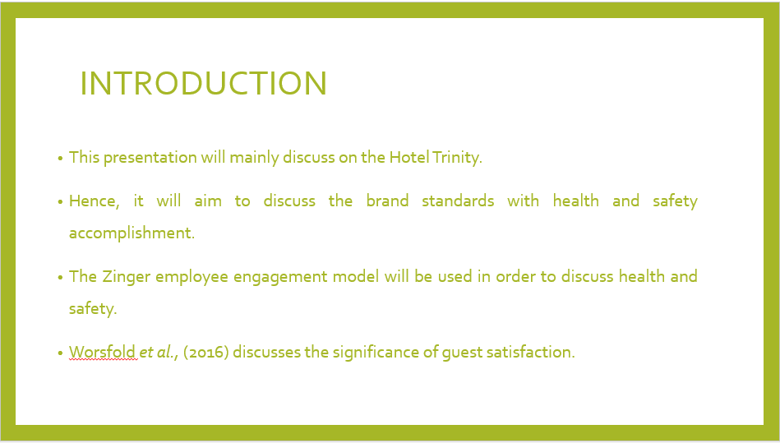

Training Notes: The hotel discussed here is Hotel Trinity, where basically being a floor housekeeping manager, the recent guest complaints need to be put together within the housekeeping team in order to ensure that Health and Safety procedures are achieved and brand standards are being maintained. Hence, the main objective of the presentation is to ensure that achieving brand standards and maintaining health and safety in the hotel. Hence, it will aim to discuss the brand standards with health and safety accomplishments. Hence, Worsfold et al. (2016) discuss the significance of guest satisfaction. Hence, it is the physical aspects of hotels, which the main area in service provision.

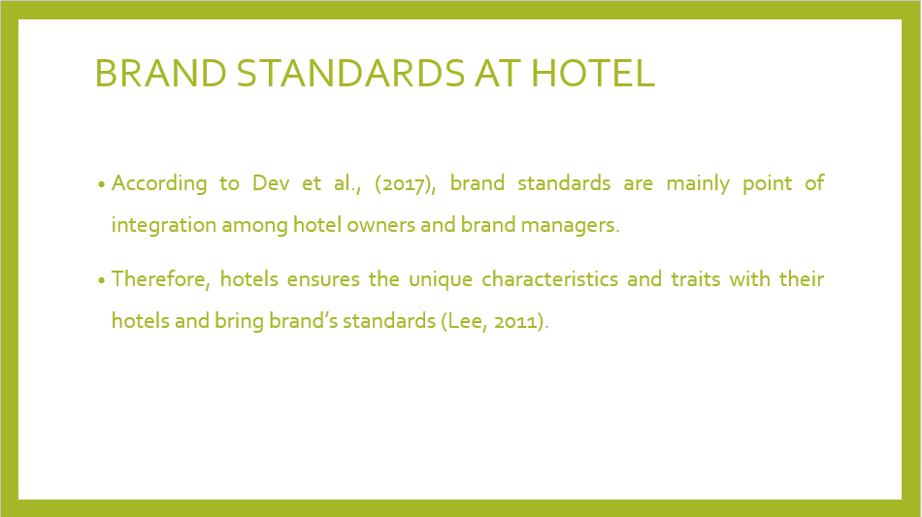

Training Notes: The hotel's housekeeping staff is mainly considered an asset, which helps in maintaining cleaning standards across the hotel. Therefore, the hotel housekeeping staff mainly provides beauty to the hotel (Otis, 2016). Henceforth, in this slide, the light is shed on the role of housekeeping, which is mainly responsible for making the customer happy. Without staff, the outcomes and results of the hotel are not possible.

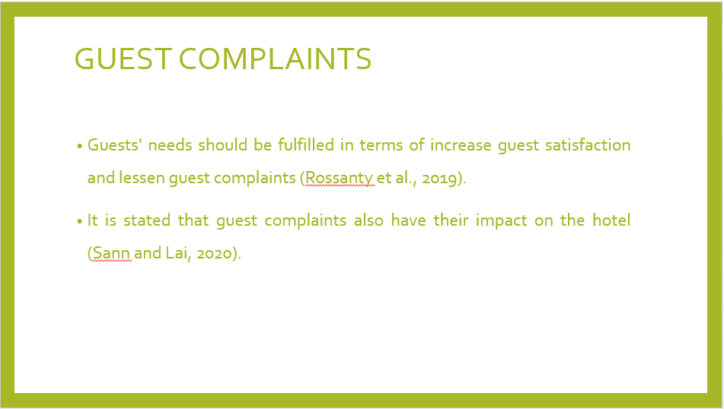

Training Notes: According to Dev et al. (2017), brand standards are mainly a point of integration among hotel owners and brand managers. Therefore, it is said that maintaining consistent standards is needed and required systemwide. Hence, in regard to this, many amenities and facilities are provided by the hotel in regard to first-time visits and repeat business. Further, goods and services given by the hotel are the main consideration in the hotels (Jordá‐Albiñana et al., 2009). Hotels seek ways to differentiate themselves through. Therefore, hotels ensure the unique characteristics and traits of their hotels and bring the brand's standards (Lee, 2011).

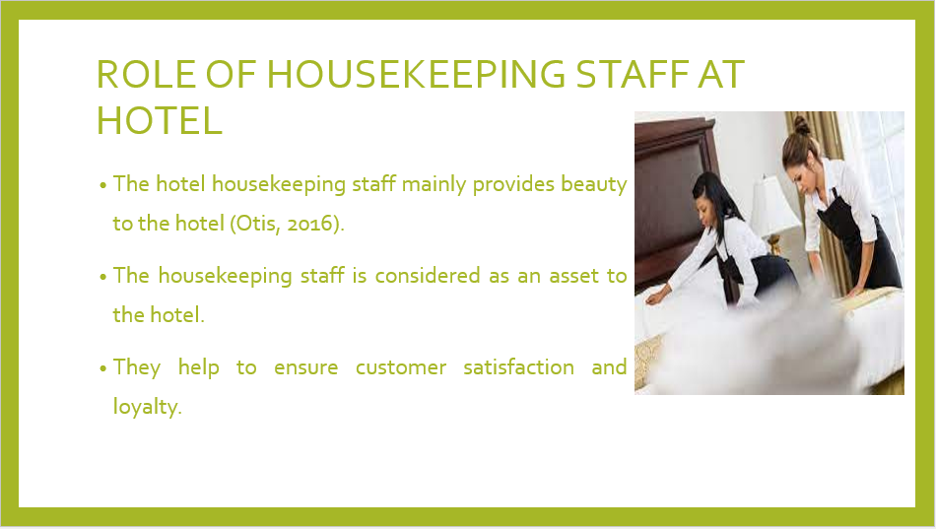

Training Notes: It is stated that guest complaints also have an impact on the hotel. Hence, guest complaints are mainly related to cleanliness, room, sleep quality, and location. Also, service and value are also seen by the guest (Sann and Lai, 2020). Hence, in the hotel, guest satisfaction is mainly seen as guest complaints that should not be there in regard to maintaining guest loyalty. It is essential to ensure that addressing guest complaints is needed to be done. Hence, guests' needs should be fulfilled in terms of increasing guest satisfaction and lessening guest complaints (Rossanty et al., 2019).

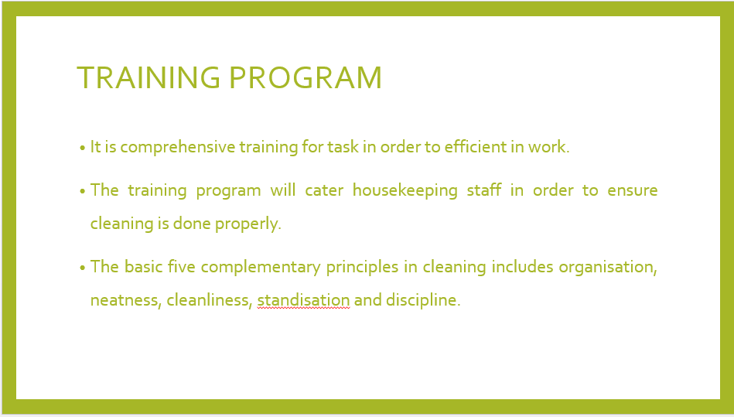

Training Notes: Housekeeping is not just about cleanliness. However, it also sees neat work is done, orderly cleanliness is maintained, halls and floors are cleaned, trip hazards are seen, and waste materials are removed with other fire hazards from work areas. Also, the basic five complementary principles include organisation, neatness, cleanliness, standardisation and discipline. Further, there are six stages of cleaning in a proper cleaning practice. Housekeeping is mainly considered as cleaning for the hotel. However, it helps to keep a maintained situation in order to encourage a feeling of safety, comfort, and enjoyment. Hence, the training will be given in-depth in order to provide them with full information. Hence, it will help them to boost and promote customer satisfaction in a pleasant atmosphere. Further, the training program will cater to housekeeping staff in order to ensure cleaning is done properly. It is comprehensive training for tasks in order to be efficient in work (Alcalde-González et al., 2023).

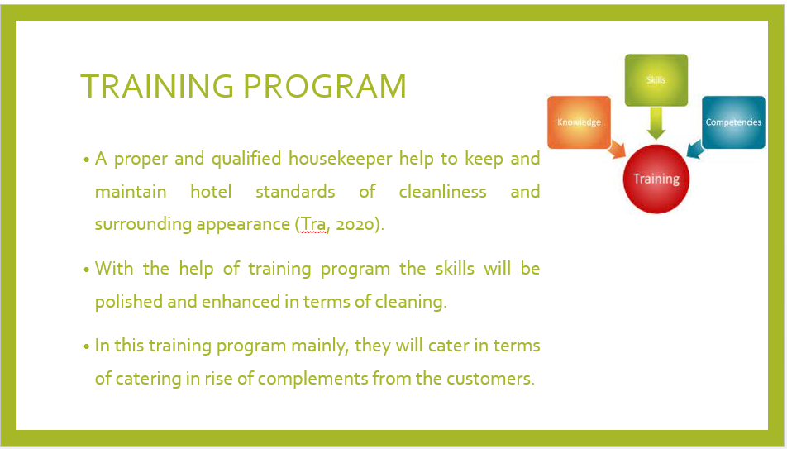

Training Notes: Housekeeping staff is considered as an assistant to the hotel. Hence, in this training program mainly, they will cater in terms of catering in the rise of compliments from the customers. Therefore, with the help of a training program, the skills will be polished and enhanced in terms of cleaning. For housekeeping, there is a training program working, which will mainly focus on the implementation and accommodations of learning skills from the program. It is also stated that in the hotel industry, the housekeeping department plays a significant role in terms of accommodation institutions. Hence, a proper and qualified housekeeper help to keep and maintain hotel standards of cleanliness and surrounding appearance (Tra, 2020).

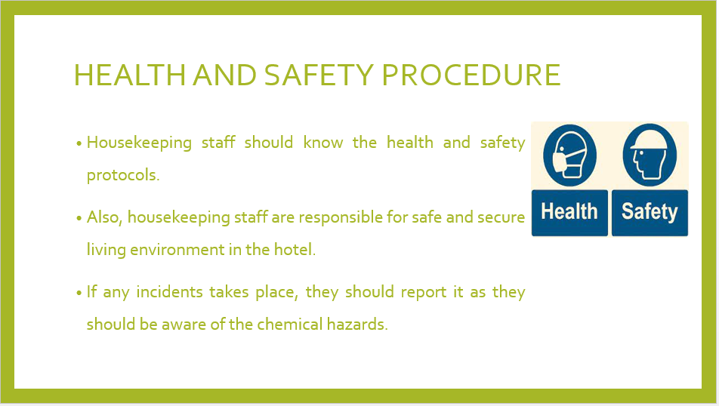

Training Notes: Health and safety procedures are needed in the hotel staff in order to maintain a safe environment for all people. In this slide, mainly health and safety procedures are highlighted in terms of housekeeping staff, which are responsible in terms of omitting hazards of the hotel. By shedding light on this slide, a safe and secure living environment is needed.

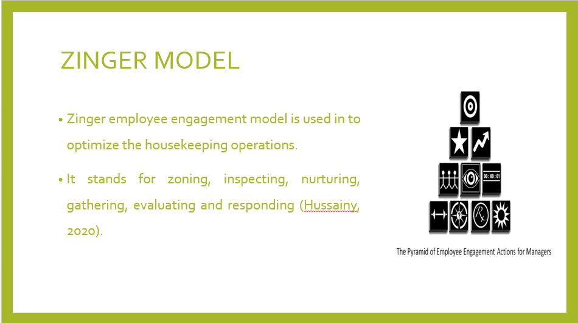

Training Notes: This model is mainly defined as focused connections and links in order to achieve better results as it mainly sees strategy and organisation, recognising employees' finite energy as a key factor in order to attain happiness or not. Therefore, he uses employees' strengths and plays with them according to their needs (Sadhale, 2020).
Hence, in this presentation, the Zinger employee engagement model is used to optimise housekeeping operations. Hence, it stands for zoning, inspecting, nurturing, gathering, evaluating and responding, as each is focused on streamlining housekeeping processes and procedures in terms of cleaning practices (Hussainy, 2020).

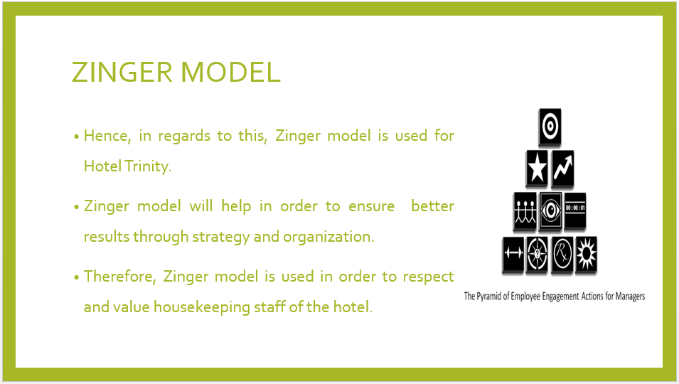

Training Notes: For Hotel Trinity, the Zinger model will be used in order to ensure that engaged employees, mainly housekeeping staff, in regards to main voices being heard and respected in terms of valuing the employee and using employees' strengths in order to work accordingly.

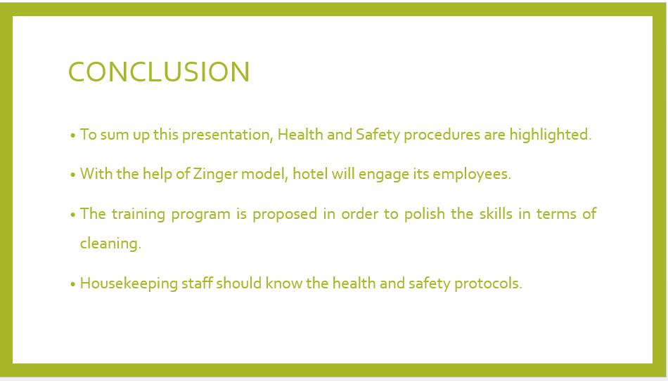

Training Notes: To sum up this presentation, mainly hotel trinity was highlighted in regard to planning a training program for the housekeeping staff. With the help of the Zinger model engagement model, Health and Safety procedures with cleaning practices were told to the staff.

References

Alcalde-González, V., Mozo, A.G. and Bustos, A.V., 2021. No clean rooms, no hotel business: Subversion tactics in Las Kellys’ struggle for dignity in hotel housekeeping. Annals of Tourism Research, 91, p.103315.
Awan, M.I., Shamim, A. and Ahn, J., 2021. Implementing 'cleanliness is half of the faith in re-designing tourists and experiences and salvaging the hotel industry in Malaysia during the COVID-19 pandemic. Journal of Islamic Marketing, 12(3), pp.543-557.
Çelebi, D., 2015. Qualitative analysis on the factors affecting housekeeping employees job satisfaction in the hospitality industry: A study in 5-star Izmir hotels (Master's thesis, Sosyal Bilimler Enstitüsü).
Dev, C.S., Hamilton, R. and Rust, R., 2017. Hotel brand standards: How to pick the right amenities for your property.
Dolnicar, S., Knezevic Cvelbar, L. and Grün, B., 2019. A sharing-based approach to enticing tourists to behave more environmentally friendly. Journal of Travel Research, 58(2), pp.241-252.
Đurašević, S. and Kavarić, A., 2016. Theory and practice: Essential balance in the education of staff in the hotel industry. Turističko poslovanje, (17), pp.35-45.
Haynes, N., 2016. The evolution of competitor data collection in the hotel industry and its application to revenue management and pricing. Journal of Revenue and Pricing Management, 15, pp.258-263.
Hussainy, S.S., 2020. Review on motivational theories & models: Its application for employees' retention in organisations. International Journal of Business and Applied Social Science, 6(1), pp.40-46.
Knezevic Cvelbar, L., Grün, B. and Dolnicar, S., 2021. “To clean or not to clean?” Reducing daily routine hotel room cleaning by letting tourists answer this question for themselves. Journal of Travel Research, 60(1), pp.220-229.
Lee, T.J., 2011. Role of hotel design in enhancing destination branding. Annals of Tourism Research, 38(2), pp.708-711.
Lundberg, H. and Karlsson, J.C., 2011. Under the clean surface: working as a hotel attendant. Work, employment and Society, 25(1), pp.141-148.
Nimri, R., Kensbock, S., Bailey, J., Jennings, G. and Patiar, A., 2020. Realising dignity in housekeeping work: Evidence of five-star hotels. Journal of Human Resources in Hospitality & Tourism, 19(3), pp.368-387.
Otis, E.M., 2016. Bridgework: Globalisation, gender, and service labour at a luxury hotel. Gender & Society, 30(6), pp.912-934.
Penninga, S. and Chibili, M.N., 2019. The rooms department. In Modern Hotel Operations Management (pp. 118-163). Routledge.
Rossanty, Y., Nasution, M.D.T.P. and Irawan, I., 2019. Communication and Customer Relations Strategy in Improving Hotel Guests’ Satisfaction in Samosir Tourism Area, North Sumatra, Indonesia. International Journal of Management (IJM), 10(6).
Sadhale, M., 2021. The Changing Role of Housekeeping Department in Hotels Post COVID-19 Pandemic. Eureka Publications.
Sann, R. and Lai, P.C., 2020. Understanding homophily of service failure within the hotel guest cycle: Applying NLP-aspect-based sentiment analysis to the hospitality industry. International Journal of Hospitality Management, 91, p.102678.
Singh, D. and Amandeep, M., 2017. Motives For Selecting Housekeeping Department As A Career-A Study Of Selected Hotels Of North India. Merit Research Journal of Business and Management, 5(7).
Tra, T., 2020. Action plan for training new Housekeeping Employee: case: Hotel Indigo Helsinki.
Worsfold, K., Fisher, R., McPhail, R., Francis, M. and Thomas, A., 2016. Satisfaction, value and intention to return in hotels. International Journal of Contemporary Hospitality Management.

