MODULE: MANAGEMENT ECONOMICS (LCBB5008)
Name and ID of the Student: Ivan Hristov Stoyanov (2111872)
Name of the University: University Of Wales Trinity Saint David
Table of Contents
Business description 2
Demand and market equilibrium 3
Price of Substitutes 4
Price of complements 5
Consumer Income 6
Consumer Taste and Preferences 9
Consumer expectation of price 10
Demographics 11
Elasticity of demand 13
Substitute effect 14
Necessary vs luxury 15
Consumer income proportion 16
Pricing strategy 16
References 18

Business description
This report aims to demonstrate the microeconomic notion of demand, equilibrium and elasticity. In the study of economics, these concepts create the base of the entire subject. If the situation of a company or industry is considered, then understanding how the market for the product operates calls for knowledge gaining on the mentioned subject matter (Besanko and Braeutigam 2020). For the analysis of businesses through lenses of demand, equilibrium and elasticity, this paper has chosen the company Apple Inc, the largest consumer electronic gadgets production company globally. Also, as the company has a diversified product range, it will be more feasible if any particular product range is taken under consideration for the analysis formation, then that will depict better results (Podolny and Hansen 2020).
Generated from California, USA, Apple Inc is identified as a technology company that has inflicted its market dominance with its products on a global level. Apple experienced net sales of $394.33 billion during the year 2022, all over the world (Laricchia 2023).
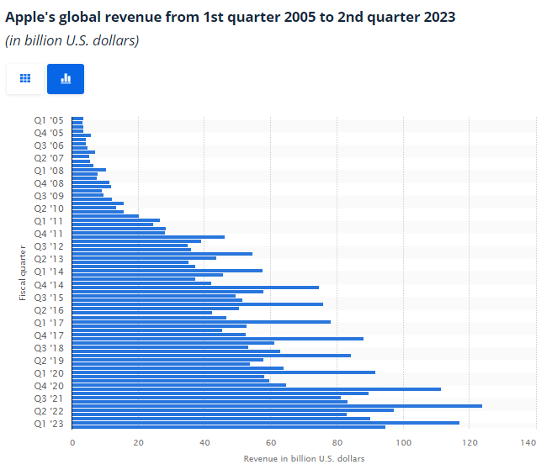
Source: (Laricchia 2023)
The company emerged to sell personal computers initially. Later on, Apple extended its product domain to iOS, iPhone, iMac, iPod and iPad (MA, Sehrawat and PK 2019). In other words, for consumer electronic gadgets Apple created a completely new ecosystem with the highest efficiency as well as with extremely efficient security features. In the advanced years, Apple opened its independent retail stores and acquired numerous small companies for organizational portfolio expansion. Currently, Apple has created a statement in the market with its iPhones and there is a huge demand for the same witnessed (Krishnan and Krishnan 2022). The reason behind choosing this product range is that Apple is an ‘essential’ luxury brand where the product ranges are high priced but give value for money (Moslehpour et al. 2019). iPhone is the product range that is comparatively the most affordable for being a necessary product type. Hence, this product range will be most feasible to demonstrate the market situation of demand, equilibrium and elasticity.

Demand and market equilibrium
Demand is the concept that is considered the root of economics. The desirability of every product by the consumers at a determined level of price and quantity is known as the demand for that product. When the price of the product changes, its quantity demanded changes and when other factors like substitute product pricing, consumer income, taste and preference, expectation of future price and demographics get altered, then the overall demand for the product changes (Cowen, Tabarrok and Tabarrok 2021).
On the other hand, equilibrium refers to the situation of a market when the demand and supply of a product equate with each other. As the following diagram depicts, the demand curve shows the total requirement of people for the iPhone and the supply curve denotes the productivity and capability of the company to make it available in the market (Kreps 2019). The conjunction point of these 2 curves is the equilibrium because the demand is completely getting satisfied by the supply.
Quantity
Price
Supply
Demand
Q0
P0
Figure 1: Demand-Supply equilibrium
In this section, the influence of each factor will be described to identify if the demand increases or decreases due to those forces when the product under consideration is the iPhone.

Price of Substitutes
If the market for consumer handsets is to be considered then it can be said that Apple has a strong threat in its iPhone product range from the handsets produced by other companies like Samsung, Sony, Google, Redmi and many more (Sun and Fah 2020). The pressure of substitutes is more because all of the companies produce consumer smartphones with the Android ecosystem but charge lesser prices than iPhones. Although the Apple operating system is extremely attractive, still as here the factor under consideration is the price of the substitutes, the impact on iPhone demand is more. If the present market domain for consumer handsets is to be considered, then it can be identified that the price of smartphones that are substitutes for iPhone is not much less. Also, financial experts are suggesting that as per their forecast in future these prices are less likely to go down (Sinka et al. 2021). Now then, for those handsets which have a price range similar to iPhone, demand will be consistent towards Apple or even increase by a slight amount. People will prefer iPhones when they are willing to spend a higher price because Apple has the best reputation in the market in terms of producing handsets. On the other hand, smartphones that have a price range significantly lesser than iPhones will still be demanded by customers. Hence, even if their price increases, the demand for iPhones will remain the same because people will be less likely to shift to Apple as the vast price gap exists.

Price of complements
Multiple complementary products of the iPhone are essential for people planning to buy the same. Some of these products are, the charging adapter and phone cases. Usually, the recent versions of the product require the consumers to buy a charging adapter separately which makes it a necessary complementary product (Apple 2023). On the other hand, as a huge amount is spent on buying an iPhone every individual seeks to purchase a cover to guarantee the safety of the handset. Market research and product ideas signified that both of these complimentary items have a significant price attached to them. As the entire world is going through an intensity of inflationary pressure, it is assumed that the price of mobile accessories is also increasing which makes the complimentary items more expensive (Mukherjee and Ouattara 2021). As these are necessary items, the total package of an iPhone and the complimentary products will be costing a higher price now. This might decrease the demand for iPhones as people will want to wait for a decrease in any of the products so that the product bundle becomes less expensive.
Quantity
Price
Supply
Demand 1
Q1
P1
Figure 2: Decrease in the Demand
Demand
P0
Q0

Consumer Income
Consumer income is the most significant factor that can clearly state if the demand for an iPhone will increase or decrease. In the study of economics, it is strongly suggested that the more a consumer starts to earn, the more they shift towards products that are expensive and high quality (Mankiw 2021). That means the demand will increase for a luxury but necessary item like an iPhone. As the cost of living is increasing due to inflationary pressure, the wage and income of the consumers are also increasing. This signifies a higher purchasing power for them when it is assumed that the increasing purchasing power is more intense than the increase in the cost of living. In such a situation, the demand for the iPhone will surely increase.
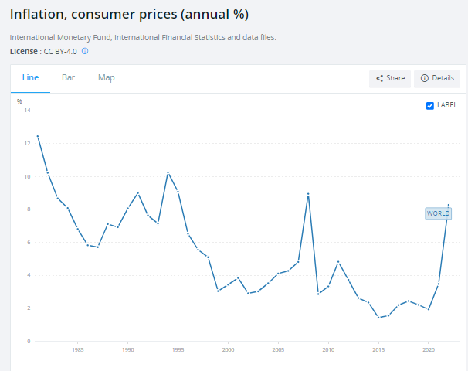
Source: (data.worldbank.org 2023)

Quantity
Price
Supply
Demand
Q0
P0
Figure 3: Increase in demand
Demand 1
P1
Q1
However, another perception also needs to be considered here. Several market reports suggest that the purchasing power parity of people has decreased (Stewart 2023). This signifies their affordability has declined despite an income rise because of the inflationary pressure. This is known as a reduction in the consumers' real income. If that is the case, then the demand for iPhones will surely decrease or it can stay at its previous levels as no new demand will be generated despite the income increase of the consumers.
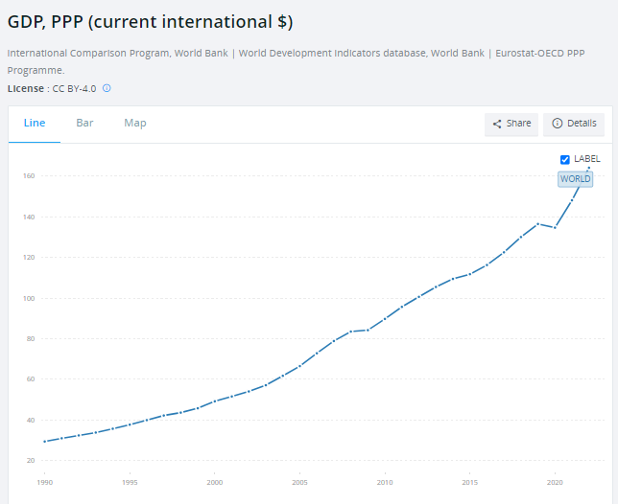
Source: (data.worldbank.org 2023)
Quantity
Price
Supply
Demand 1
Q1
P1
Figure 4: Decrease in the Demand
Demand
P0
Q0

Consumer Taste and Preferences
Consumer taste and preferences are known as their specific choices of a product or a brand. Apple with their extremely good marketing strategy as well as brand equity has created the position of trustworthiness among the consumers (De Guzman et al. 2022). At present, most people try to buy an iPhone and those who are unable to do the same mainly have the reason for non-affordability. That means, a consumer’s preference can be noticed in favour of the iPhone. Although there are exceptions, the proportion is significantly low. It can also be identified that the taste and preference of the consumers regarding choosing their handsets have created a loyal consumer base for iPhone and kept the demand steady so far. Security can be identified as one of the main issues in smartphone industry because personal data breach and hacking have created a challenge for cyber security (Srivastava et al. 2019). Positively, Apple with its operating system provides the best cyber security to its consumers. As a result, to have stress-free smartphone usage and a secure cyber life, the taste and preference of consumers regarding their choice of handset is tilting more towards iPhone. This is increasing the demand for the product.
Quantity
Price
Supply
Demand
Q0
P0
Figure 5: Increase in demand
Demand 1
P1
Q1

Consumer expectation of price
As iPhones are expensive, the decision of buying one is highly dependent on the future expectation of price (Hadi 2021). Recently, the prices of the last released iPhone models decreased to significantly low levels. However, as of now it has again increased and marketing reports regarding smartphones are also suggesting that it is less likely that the price will decrease in the future. On the other hand, the latest model of the iPhone 15 is set to launch shortly. Hence, one group of people are expecting that when the new model will be entering the market, the price of the existing models will decrease. That is why they are saving up for buying the product in the coming days. However, another group believes that to draw the demand more towards the newly launched products Apple will increase the existing iPhone models’ prices. That means they are expecting a higher price range in the future. This is influencing them to buy the product at present and the demand is rising.
Quantity
Price
Supply
Demand
Q0
P0
Figure 6: Increase and decrease in demand
Demand 1
P1
Q1
Demand 2
Q2
P2

Demographics
The number of consumers will increase when more people are employed. If the demographic trend of the world is seen as the below diagram shows, then it will be found that there was a steep decrease in employment during 2020 as an impact of the COVID-19 pandemic (Montenovo et al. 2022). However, this statistic has picked up its pace and the employment proportion has reached almost the pre-pandemic levels. This means more people are getting jobs and gaining a significant amount of purchasing power. This implies an expansion in the consumer base for the iPhone due to an increase in the number of buyers. This incident has the potential to increase the demand for iPhones further shortly.
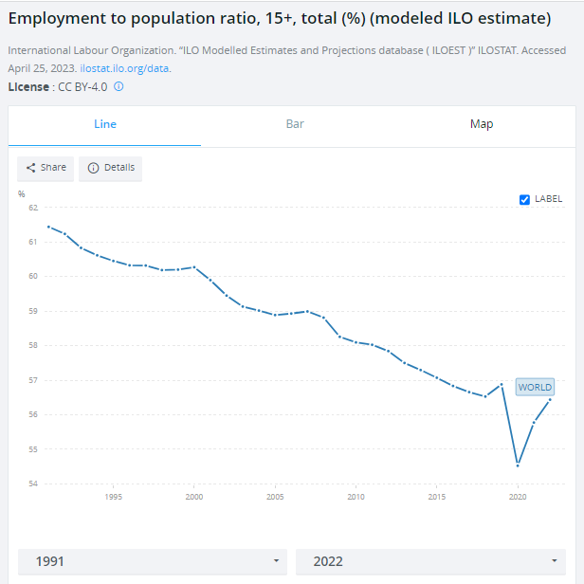
Source: (data.worldbank.org 2023)
Quantity
Price
Supply
Demand
Q0
P0
Figure 7: Increase in demand
Demand 1
P1
Q1

Elasticity of demand
Elasticity in the most straightforward words is identified as the percentage proportion of change in the quantity demanded of a product when either the price or income of the consumer or the price of related goods change. Here, this paper will work with only price elasticity of demand which is the responsiveness of change in the quantity demanded as per the percentage proportion when there is a percentage change in the price of the product (Nicholson and Snyder 2021). From this conception, it can be said that the demand for any product can be either inelastic or elastic. When it is observed that the price change creates a more than proportional alteration in the quantity demanded, then it is known as an elastic commodity. On the other hand, when the change in price does alter the quantity demanded by a lesser proportion, then the demand is known to be inelastic (Brewer 2021). That means for products that are identified as elastic commodities the producers are skittish about increasing the price as they know it will decrease the quantity demanded by a huge proportion which will ultimately result in a revenue loss for the company. Whereas, for inelastic products, there is no such restriction or fear. There are mainly 4 factors that can influence the price elasticity of demand. These factors are the availability of substitute products, segregation of the commodity as a luxury or a necessity item, the proportion of income that gets invested in the product purchasing and time elapse calculated from the price change (Petri 2021).

Substitute effect
As per the demand elasticity concept, when there is an availability of a massive number of substitute products, the substitution effect is stronger. That means for a slight price hike, the consumers can shift to the substitute commodities. This makes the product an elastic one. From this argument, the iPhone can be identified as an elastic commodity. If the iPhone models become expensive further, the consumers will switch to Samsung or Google or any other company products. Critically analysing a crucial aspect can be identified which is the quality superiority of iPhones (Sun et al. 2021). Consumers are always focused on their value for money and the iPhone has been providing the same for decades. That means, despite the price increase, there will be a significant proportion of consumers who will prefer not to switch to substitute commodities. However, this also needs identification, this notion does not change the fact that iPhone is an elastic commodity. The only difference is that the intensity of elasticity might be less when the value for money of the product is considered. That means, although some people will decide to focus on purchasing iPhones due to their quality, there will be a significant proportion of the consumer base who will shift to substitute commodities and make the net demand lower and turn the commodity into an elastic one because the switching proportion is usually higher than the staying proportion.
Quantity
Price
Elastic Demand
Q0
Figure 8: Elastic demand of iPhone
P0

Necessary vs luxury
When the segregation of the iPhone into either the luxury or necessary genre is considered, then that creates a situation of confusion. If the price segment of iPhones is to be taken under consideration, then the commodity will be listed as a luxury product. However, if the product domain and its usage are considered, then iPhones are necessary consumer goods. Therefore, they are labelled as necessary expensive items. Now then, the elasticity of demand concept states that, for luxury items, demand is highly elastic because a slight decrease in the price will influence more people to purchase the product just like the iPhone (Rumapea, Tumbuan and Tielung 2022). On the other hand, the demand for necessary products is usually inelastic because as those are required for the basic livelihood, price alteration does not matter much for the demand to alter. After specifying the demand elasticity for both commodities types, it can be said that the iPhone has more similarities to being listed as a luxury item because people do not need it to survive on this planet. Consequently, this makes the product highly elastic and the producers as well as the company will be benefited from a demand increase if they even decrease the price by a slight amount.

Consumer income proportion
Usually, a handset does not cover much of the proportion of consumer income. However, this is not the same in the case of the iPhone. Due to the price range of this product, low and middle-class people spend a significant portion of their income to purchase this product (Bhorat et al. 2023). When spending on a commodity account for a higher proportion of the income, the demand naturally becomes elastic because a slight change in the price will help the consumers to relocate their budget on spending. If the demographic of this world is considered then researchers numerous times have strongly emphasised that the world population consisted of more middle-class people and the proportion of high-class people with high affordability is significantly low (Kotkin 2023). Hence, if the total consumer base is considered, it will be said that on average, a higher proportion of the income is spent when a consumer wants to buy an iPhone. This indicates the demand to be more elastic. Hence according to this factor also iPhone is an elastic commodity.

Pricing strategy
Based on the analysis done so far this paper argues that Apple presently follows value-based pricing (Nagle, Muller and Gruyaert 2023). Although to gain a high proportion of the market share Apple has been alleged to follow the minimum advertised price, but as throughout the years the company has successfully kept the expense of the iPhone product range at a significantly high level, the notion of value-based pricing goes better with their strategy of setting the final price (Sarkar, Omair and Kim 2020). Consumers prefer the iPhone despite the high price solely because of the quality and value for money it presents. When deciding to spend nearly $1000, a consumer will most likely choose an iPhone than a Samsung Galaxy flip model. Hence, value-based pricing is assumed to be working well for iPhones. Alongside, this report also suggests that the company should continue to follow this pricing strategy only. Critically, if Apple decides to take up a competitive pricing strategy for its iPhone product range, then there might generate a notion that the quality of the product is lacking for which the manufacturing cost might be lower and the company is successful in decreasing the final price. Also, taking up cost plus pricing will decrease the expense of the iPhones resulting in the same notion. This can create adverse effects such as a fear of quality assurance and people might tend to demand less of the product. Therefore, it will be better for Apple to keep using value-based pricing for their iPhone product range.

References
Apple (2023) Power adapters for iPhone, Apple Support. Available at: https://support.apple.com/en-in/guide/iphone/iph8c1e31583/ios (Accessed: 17 July 2023).
Besanko, D. and Braeutigam, R., 2020. Microeconomics. John Wiley & Sons.
Bhorat, H., Kimani, M.E., Lappeman, J. and Egan, P., 2023. Characterisation, definition, and measurement issues of the middle class in sub-Saharan Africa. Development Southern Africa, 40(1), pp.39-56.
Brewer, D., 2021. Household responses to winter heating costs: The remarkably inelastic demand for space heating. Working paper.
Cowen, T., Tabarrok, A. and Tabarrok, A., 2021. Modern principles: microeconomics (p. 474). New York: Worth Publishers.
data.worldbank.org (2023) Employment to population ratio, 15+, total (%) (modeled ILO estimate), World Bank Open Data. Available at: https://data.worldbank.org/indicator/SL.EMP.TOTL.SP.ZS (Accessed: 17 July 2023).
data.worldbank.org (2023) GDP, PPP (current international $), World Bank Open Data. Available at: https://data.worldbank.org/indicator/NY.GDP.MKTP.PP.CD (Accessed: 17 July 2023).
data.worldbank.org (2023) Inflation, consumer prices (annual %), World Bank Open Data. Available at: https://data.worldbank.org/indicator/FP.CPI.TOTL.ZG (Accessed: 17 July 2023).
De Guzman, M., Tabaquin, K.L., Dimaunahan, P.J. and Dimaculangan, E., 2022. Impact of Apple’s Brand Equity Towards Purchase Intentions of Gen Z Thomasians on Secondhand Apple Products. International Journal of Social and Management Studies, 3(5), pp.116-124.
Hadi, A.S., 2021. The influence of product attribute, promotion mix, distribution channel, and price toward repurchase intention on iPhone. Asian Management and Business Review, pp.95-104.
Kotkin, J., 2023. The coming of neo-feudalism: A warning to the global middle class. Encounter Books.
Kreps, D.M., 2019. Microeconomics for managers. Princeton University Press.
Krishnan, L.R.K. and Krishnan, D., 2022. Employment Practices at Apple; Social and Legal Issues Disrupting India's Industrial Relations Landscape. Journal of the International Academy for Case Studies, 28(4).
MA, S., Sehrawat, A. and PK, S.K., 2019. iPhone as a proxy indicator of adaptive narcissism: An empirical investigation. Psychology & Marketing, 36(10), pp.895-904.
Mankiw, N.G., 2021. Principles of Microeconomics 9e. Cengage Learning Asia Pte Limited.
Montenovo, L., Jiang, X., Lozano-Rojas, F., Schmutte, I., Simon, K., Weinberg, B.A. and Wing, C., 2022. Determinants of disparities in early COVID-19 job losses. Demography, 59(3), pp.827-855.
Moslehpour, M., Chau, K.Y., Dadvari, A., Do, B.R. and Seitz, V., 2019. What killed HTC and kept Apple alive? Brand sustainability comparison of two Asian countries. Sustainability, 11(24), p.6973.
Mukherjee, K. and Ouattara, B., 2021. Climate and monetary policy: do temperature shocks lead to inflationary pressures?. Climatic change, 167(3-4), p.32.
Nagle, T.T., Müller, G. and Gruyaert, E., 2023. The strategy and tactics of pricing: A guide to growing more profitably. Taylor & Francis.
Nicholson, W. and Snyder, C.M., 2021. Intermediate microeconomics and its application. Cengage Learning.
Petri, F., 2021. Microeconomics for the critical mind: mainstream and heterodox analyses. Springer Nature.
Podolny, J.M. and Hansen, M.T., 2020. How Apple is organized for innovation. Harvard Business Review, 98(6), pp.86-95.
Rumapea, A.E., Tumbuan, W.A. and Tielung, M., 2022. The influence of brand luxury, brand awareness, and perceived quality on purchase intention of Iphone in Manado. Jurnal EMBA: Jurnal Riset Ekonomi, Manajemen, Bisnis dan Akuntansi, 10(3), pp.215-224.
Sarkar, B., Omair, M. and Kim, N., 2020. A cooperative advertising collaboration policy in supply chain management under uncertain conditions. Applied Soft Computing, 88, p.105948.
Sinka, M.E., Zilli, D., Li, Y., Kiskin, I., Msaky, D., Kihonda, J., Mkandawile, G., Kaindoa, E., Killeen, G., Zanga, J. and Metelo, E., 2021. HumBug–an acoustic mosquito monitoring tool for use on budget smartphones. Methods in Ecology and Evolution, 12(10), pp.1848-1859.
Srivastava, S.R., Dube, S., Shrivastaya, G. and Sharma, K., 2019. Smartphone triggered security challenges—Issues, case studies and prevention. Cyber Security in Parallel and Distributed Computing: Concepts, Techniques, Applications and Case Studies, pp.187-206.
Stewart, C., 2023. Re-evaluating whether absolute or relative purchasing power parity is being tested when using price indices.
Sun, G., Li, J., Cheng, Z., D'Alessandro, S. and Johnson, L., 2021. Consumer personality factors and iPhone consumption in China. Journal of Consumer Behaviour, 20(4), pp.862-870.
Sun, L. and Fah, C.T., 2020. Xiaomi-transforming the competitive smartphone market to become a major player. Eurasian journal of social sciences, 8(3), pp.96-110.

