

BA (Hons) Leadership and Management Skills for the Workplace
Module: Developing Relationships and Workplace Achievements

Module code: BMSW 5102-A1
Student: Rupia Hussain-ID: 2010133
Lecturer: Rexon Nting

Assignment 2-Title: 2500-word academic report, employing academic models, methods, and theories to develop a plan to meet identified personal development needs and expectations of individual employees in your chosen organisation.

Table of Contents

1. Introduction 2
a. What is employee development?
b. Is employee development important?
2. Introduction to the company context 3
2.1 What is 560 Degree Feedback?

3. Professional Development Plan (PDP) 4
4. Evaluating the Development Plan and Tasks 5
5. Company SWOT analyses 7
6. The 70:20:10 Model for Learning and Development 8
7. Motivation and Performance Impacts 8
8. Appraisal plan 9
9. Recommendation 10
10. Conclusions ……………………………………………………………………………………………………………………………..11
11. Reference…………………………………………………………………………………………………………………………………12

Introduction

The purpose of this report is to determine how employee development can change and empower an organisation's credibility and sustainability. Critically evaluate the methods and tools that can be used to train employees’ developments which can reflect on the business positively.
  - What is employee development?

The employee growth process of bettering workers’ existing competencies and skills but also, developing new ones to support the business goals and objectives [11] (Valamis, 2021). It is not just developing employees but also, organisational development and management strategies.
A well-trained workforce is quick and efficient to the task at hand and performs at a higher level. By developing employees company gets better outcome and boost employee motivation.
  - Is employee development important?

Organisational development allows continually to improve by making strategic choices for the company and employees learning new skills. Employees who take part in staff training activities are more likely to produce quality work with less or reduce effort and team members. Spur a positive performance that enhances a company's reputation among customers and other stakeholders. Referring to their predictions for 2019, Bersin by Deloitte, a leading research and advisory services firm specialising in enterprise learning, talent management, talent acquisition, and strategic HR solutions said, “Organisations with high-impact learning delivered profit growth three times greater than their competitors, ”Investing time and money on developing and expanding the knowledge of existing employees increases the future potential for an organisation and secures them a place as a strong competitor within an industry” [10] (Speet, n.d.).

Introduction to the company context

The owners of the new business have suffered unduly from their previous business an Indian food takeaway. There were two main reasons for their excessive loss. 1st: untrained staff, who only obtained experience through working in traditional restaurants and take-way. The attitude towards change and updating skills were very negative. The working culture was masculine and traditional, with no diversity or new-age views. There was a huge communication gap with the biggest stakeholders the customers. Due to little or no English-speaking language staff.
2nd: The unprecedented Covid-19 pandemic. The government restrictions and working from home put enormous strain. Most of the staff were venerable due to their age and health conditions and as a consequence unable to work. Cost of materials hike and shortage of necessary goods, put exceedingly pressure to run the business. Finally, the owners had to close the business. After a long break, the owners took profound steps to evaluate the whole experience by gathering 540 Degree feedback data. Came back with a new business idea for fast food: burgers, peri peri along with Indian traditional popular dishes.

2.1 What is 560 Degree Feedback?

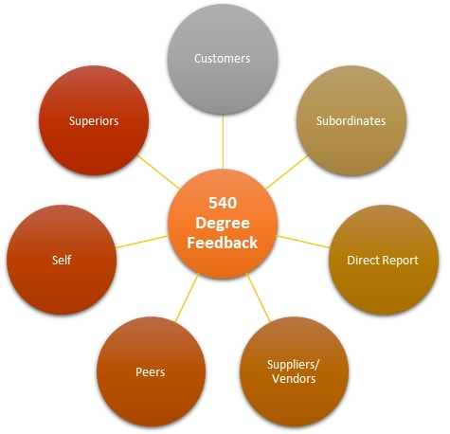[4] (Hollywoodsassafras.com, n.d.).

560 feedback appraisal plan is a multi-rating evaluation of observation from peers, managers, customers, suppliers, colleagues, supervisors, and self-awareness. Helps critically assess problems. Crucial customer point of view, necessary to find out the competitive market conditions and demand. 540-degree feedback can help orient adequate training methods to strengthen business and its employee’s satisfaction leading to greater revenue. Using traditional feedback may not highlight all problem areas.

Professional Development Plan (PDP)

The company must use smart goal strategies to avoid such mistakes repeating in the new venture. Promoting a team with SMART goals can stabilise and sustain the business. Setting Specified, Measurable Achievable Realistic and Timely goals can keep an organisation one step ahead. It is essential to inspect and evaluate all the areas that need development including staff training and development. To find out the employee training needs, create Employee professional development plan.
Development Objectives | Priority | Activities to be undertaken | Resources | Target Start Date | Target End Date | Evaluation
1. Knowledge of all products of the company | Immediately | Read information about the company and menu | Talk to senior staff, menus, and websites. Practising taking orders | Immediately. | Until perfected | ongoing training as menu products may change
2. Record keeping temperatures, food dates, and storage methods. | Important | Read instructions in the manual folder and talk to seniors. | Buying clear dating stickers, thermometer | from the start | 4 weeks | After the target date check, all is done properly, if necessary, will review the resources
3. Maintaining all official paper works, mails, bills, vat, communicating with boss and third parties. | Can be delayed until complete other crucial goals | Opening letters, reading, replying, informing the boss, getting authorisation. Carrying out officials’ chores | Admin skills, organising and communicating skills. Large dairy, folders, office Mobile | As soon as it can be accommodated by the manager | 2-3 months | Every 6 months check records if this is done correctly and if any changes need to be made.
4. Communicating and understanding customers when taking orders | Priority | Speaking to customers with confidence, knowing what to say, practising writing fast and correctly | Short language course. Computer.  May have digitalised order-taking systems | As soon as a resource can be available | 3 months | Observe and see how they deal with complicated customers. Review what can be improved.
5. Obtaining food handling and food safety certificates | with immediate effect | Research for the necessary course. Reading. | Money, time, online/ practical | As soon as the resource and employee timetable. | 6 months | If not achieved within the time frame, maybe try a different training provider

Evaluating the Development Plan and Tasks

1. Knowledge of all products of the company- It is paramount that all employees are aware of all the products the company provides and sells. Regardless of who’s cooking, it is essential they shopfront staff know what goes in a particular dish to inform customers if asked when taking orders, especially customers with food allergies. Training can be given on the job, saving time and money. Can be feasible by shadowing a senior member or having a mentor, the goal can be achieved in a short interval.
2. Record keeping, temperatures, food dates, and storage methods- it is critical to maintaining these records accurately daily. The health inspectors can visit unannounced. Expire date labels can be bought pre-printed with name, and date headings with sticky backs. Located in the shopfront, kitchen and basement there are 7 freezers and 6 fridges to keep records of. The temperature is to be recorded at the opening and closing times. It takes a lot more time with manual, to make it more efficient and acceptable to the person responsible for these tasks, change to a digital thermometer, which is quicker and more accurate., saving time to do other tasks. With a digital checker, cooked food temperature can be checked easily to determine if it's ready to put away and create suitable methods to store. With these resources, the routine will run smoothly and lower waste. Easily adaptable to any employee to practise and maintain consistency.

3. Maintaining all official paper works, mails, emails, bills, value-added tax (VAT), payslips, communicating with boss and third parties- In the old company, the owners were responsible for all administration jobs. Which wasn’t very efficient and lacked in maintaining deadlines for bills and corresponding. Now with the new more organised business structure. It is imperative to have someone loyal and competent to carry out these confidential tasks. As an HR assistant, I have been trained on the job by one of the bosses, who works in a large accounting firm. It is very difficult for me to get hold of him, which causes delays in responding to important letters and third parties’ queries. To resolve this matter, I have created a chat group with both bosses using a mobile digital platform called WhatsApp. Now three of us get notified at once and get a quick response from the relevant person.

4. Communicating and understanding customers when taking orders- The customer’s first contact is the employee who undertakes this role. It is crucial to be fluent in English and have a good manner of communication, along with writing and reading skills. Unfortunately for most of the employees, English is a second language and there is a significant need for training and development in these areas. Providing a crash course will help employees be confident and boost their ability to deal with complex situations and customers. A computerised ordering system would speed up order accuracy and help staff give quality and faster service, freeing them to attend to more customers than taking orders by hand. These processes will cost and take time but investing in digitalised systems and training employees, in the long run, is highly beneficial and sustainable for the company.

5. Obtaining food handling and food safety certificates- I was not aware that by law every person who’s working in the food handling business should have a valid Food Hygiene certificate. I have obtained mine with a 2-day intensive course, which I resourced myself. Along with Health and Safety, Food Safety and First Aid certificates. Fortunately, many feasible, low-cost short online courses are accessible to all, on any electronic device.

Company SWOT analyses

To scrutinize the company’s strengths and weaknesses, a tool called SWOT matrix by Albert. S. Humphrey. Swot analyses can be used to find the areas that need to be dealt and also, with Swot outcomes a company can effectively organise and sort the issues in order of urgency.
STRENGTH | WEAKNESS | OPPORTUNITY | THREATS
- New Unique combination.  - Familiar with the area and its people.  - Newly decorated welcoming vibrant settings.  - Fewer people to manage | - Lack of skills and experience.  - Untrained employees.  - New team.  - Reduced staff.  - Reduced budget.  - New soft wears.  - Lacking in organising.  - Still using manual order-taking methods.  - Environmental waste control | - Possibility of catching the market.  - Expanding business. Second chance.  - Creating a brand. To build a close neat loyal team.  - Open to ideas and opportunities to integrate variety. | - Competitions. Debts.  - Unknown members.  - Increasing costs.  - Need of staff training.  - Costly equipment and maintenance.  - Maintaining rules and regulations.
(Diagram: Author)

Reviewing the analyses of the swot many areas need tackling to develop and stabilise the new business. One of the ways the company recently started to improve on sustainability and help the environment is by reducing plastic packaging and recycling used oil. Before, oils were poured into the drain now the problem has become into opportunity. Many companies pay and collect used oils. This is a great for the environment and organisations. The collection used to be monthly, after the review the parties agreed it will be more cost-effective every 3 months.

The 70:20:10 Model for Learning and Development

The 70:20:10 learning and development model suggests a proportional breakdown of how people learn effectively. It is based on a survey conducted in 1996 asking two hundred executives to self-report how they believed they learned. Michael Lombardo and Robert Exchanger expressed their rationale behind the 70:20:10 model this way in The Career Architect Development Planner [12] (Wikipedia Contributors, 2019).
The survey established that 70% of learning and development takes place on the job with experiences, 20% from good and bad feedback from colleagues and surroundings, 10% from courses and readings.
Reviewing the above analyses of Swot and PDP it is agreeable that the majority of this employee development can be achieved in the workplace by practically doing the job, with help from colleagues and management, which is more cost-effective for the company and its employees. Working together promotes team bonding and loyalty. Once the PDP objectives have been addressed many of the swot weaknesses and threats can be eliminated or changed to strengths.

Motivation and Performance Impacts

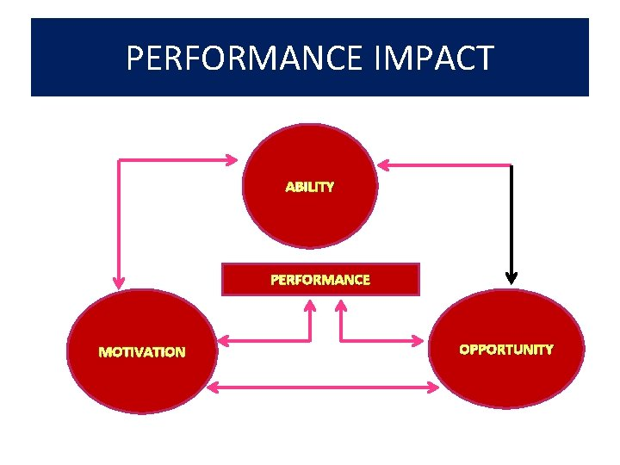 The ‘AMO’ formula by Boxall and Purcell, 2003.

The formula demonstrates that motivation is key to influencing employees to perform well. To perform well employees, have to be confident and doubtless in their ability. When employees are assured of their ability it impacts the perforce positively [2] (Armstrong, 2017).

Having a multicultural workforce plays a significant role in employees’ motivation and performance. According to Author Kassem who wrote a quote by G. Hofstede, 2004 “'The collective programming of the mind which distinguishes the members of one organization from another” in his book (Organizational culture and achieving business excellence: emerging research and opportunities) Individuals values, beliefs, assumptions and attitudes that influences behaviour within an organization [8] (Rassel Kassem, Ajmal and Igi Global, 2019, chap 1). Having diverse and multicultural workforce boost motivation and increases the ability to learn from each other. Encourage high outcomes, and productibility, improve morals, enhance skills and expands problem-solving expertise. When employees are treated with respect and valued, given the necessary attention to their needs people work better and can be an asset to the company.

Appraisal plan

Performance management is a process for establishing a shared understanding of what is to be achieved and how it is to be achieved and an approach to managing and developing people that improve the individual, team and organizational performance [1] (Armstrong, 2009).

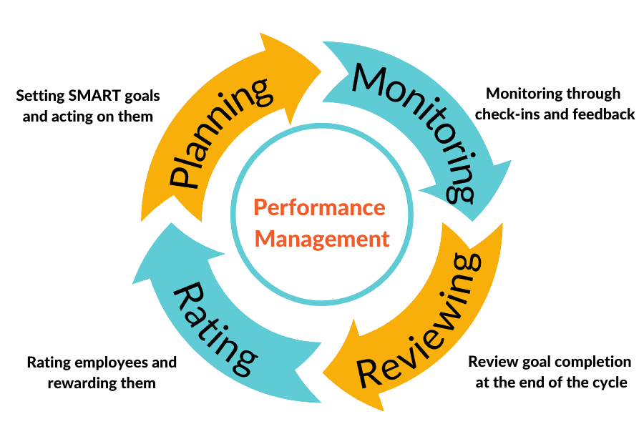 [3] (Image: Engagedly, 2022)

It is necessary to have an appraisal plan to manage employee performance, training and development. When the training is in motion it is crucial to monitor the progress if it is working for the employee. Reviewing and apprising the effort with reward or recognition will boost learning ability and confidence. Depending on the task, an appraisal should be planned with effectiveness. Reflecting on every 3 monthly reviews (4. Communicating and understanding customers when taking orders faster) it was an hour long, set at the end of the shift. Most of the conversation was about what was learned and required more time to complete. Points to be noted: shorter appointment, earlier in the day, focus on what is left to be developed, that way review can be planned to give enough time, change to 6 months review. It will be more focused and to the point. A positive attitude and appraisal plan combined with rewards, promotion, and training can inspire employees to achieve desired organizational goals.

Recommendation

To maintain the standard and values of the business it is imperative to hire the right employee with the necessary and adequate skills. The hired employee may have academic qualifications but may not have the relevant experience. Offer training from the start, which will create a positive emotional attachment for the company and offer a resource to enhance skills. Necessary to monitor the tasks closely and work on one project at a time. Critically thinking about learning from the owner’s previous mistakes, to avoid the same situation using the McKinsey 7s model which is based on organizational change. The model aims to depict change leaders manage organizational changes by interacting with the following seven key elements: Structure, Strategy, System, Shared values, Skill, Style, and Staff [6] (Malik, 2022). Also, use the 360 Degree Feedback, reviews and rating from peers and managers. The shared values emphasize a strong culture of all working together to achieve the ultimate results of a common goal which is the objectives of the business.

Conclusions.

Training and development of employees are vital for any organisation. Investing in training potential employees benefits both the organisation and the individual. It will motivate the employee to perform beyond expectation and greater job satisfaction. Training programs solve gaps in employee skills. Training can eliminate weaknesses in employees and encourage an individual to become more competent and who needs less supervision to complete tasks. Also allows employees to grow and attracts qualified candidates who see an opportunity to advance their skills while working in the company [5] (Indeed, n.d). Professional growth for employees gives credibility to the organization to achieve goals and prosper further. Increase employee retentions, which stable company infrastructure gives great strength to sustainability.
The Vilfredo Pareto Analysis of 80/20. The Pareto principle states that for many outcomes, roughly 80% of consequences come from 20% [13] (Wikipedia Contributors, 2019). If you have the “Know How”. Well-equipped employees, organisations can achieve 80% of production and projects with 20% of human power. Continuing professional development can create job satisfaction, loyal staff and long-lasting business.

Reference
[1] Armstrong, M. (2009). Armstrong’s handbook of performance management : an evidence-based guide to delivering high performance. 4th ed. London: Kogan Page.
[2] Armstrong, M. (2017). Armstrong’s handbook of performance management : an evidence-based guide to delivering high performance. London: Kogan Page.
[3] Engagedly. (2022). The 4 Stages of a Performance Management Cycle. [online] Available at: https://engagedly.com/the-4-stages-of-a-performance-management-cycle/ [Accessed 4 Aug. 2022]. (Engagedly, 2022)
[4] Hollywoodsassafras.com. (n.d.). What is a 540 degree feedback? – HollywoodSassafras.com. [online] Available at: https://hollywoodsassafras.com/popular-tips/what-is-a-540-degree-feedback/ [Accessed 3 Sep. 2022].
[5] www.indeed.com. (n.d.). How to Implement an Effective Employee Training and Development Program. [online] Available at: https://uk.indeed.com/hire/c/info/how-to-create-an-effective-employee-training-and-development-program?gclid=Cj0KCQjwio6XBhCMARIsAC0u9aFpS19Ou9w00ErxTKZlndw7RC_-WF7pk_0OzWv70aov6QPDF6ni1XUaAt9-EALw_wcB&hl=en&aceid=&co=GB [Accessed 4 Aug. 2022].
[6] Malik, P. (2022). The McKinsey 7-S Model Framework, Explained (2022) - Whatfix. [online] The Whatfix Blog | Drive Digital Adoption. Available at: https://whatfix.com/blog/mckinsey-7s-model/ [Accessed 7 Aug. 2022].
[7] Mullins, Laurie, and Jacqueline E. McLean. Mullins: Organisational Behaviour in the Workplace, Pearson Education, Limited, 2019. ProQuest Ebook Central, http://ebookcentral.proquest.com/lib/trinity/detail.action?docID=5830196.
Created from trinity on [Accessed 26 Jul. 2022]
[8] Rassel Kassem, Ajmal, M.M. and Igi Global (2019). Organizational culture and achieving business excellence : emerging research and opportunities. Hershey, Pennsylvania (701 E. Chocolate Avenue, Hershey, Pennsylvania, 17033, Usa): Igi Global, p.chapter 1.
[9] Skills For Justice. (2017). Five reasons why staff development in the workplace is important. [online] Available at: https://skillsforjustice.org.uk/news-insights/five-reasons-why-staff-development-in-the-workplace-is-important#:~:text=An%20ongoing%20training%20and%20development [Accessed 30 Aug. 2022].
[10] Speet, M. (n.d.). The Importance of Training and Development in the Workplace. [online] www.certusgraduate.com. Available at: https://www.certusgraduate.com/blog/2019/10/the-importance-of-training-and-development-in-the-workplace?source=google.com [Accessed 30 Aug. 2022].
[11] Valamis (2021). What is Employee Development? It’s Benefits and Importance. [online] Valamis. Available at: https://www.valamis.com/hub/employee-development [Accessed 3 Sep. 2022].
[12] Wikipedia Contributors (2019a). 70/20/10 Model (Learning and Development). [online] Wikipedia. Available at: https://en.wikipedia.org/wiki/70/20/10_Model_(Learning_and_Development) [Accessed 30 Aug. 2022].
[13] Wikipedia Contributors (2019b). Pareto principle. [online] Wikipedia. Available at: https://en.wikipedia.org/wiki/Pareto_principle [Accessed 31 Aug. 2022].

