  Generating Business data and analysis  Data Analysis and Report | BMSP4004 Dr Roisin Mullins  Alexander Apps (1806320)  Date of Submission 9.1.19

-Introduction-

Analysis? Definition “the separating of any material or abstract entity into its constituent elements”, (Dictionary.com, 2012). What for? For the necessary purpose of understanding its elemental essences; for which a greater understanding of any subject can be gathered to improve our understanding for example of our social cohesion, political systems, sciences, producing the management styles that would affect a business in a positive manner and needed sustainability in any business sector just to name a few examples of this cognisant progression. A powerful tool with many applications and a fundamental necessity to any business that wants to understand itself. What would analysing a business or a business’s gateways and gatekeepers provide, weakness, strengths, thrusts from the opposition and how we can keep a sustained growth for said business. But how many of us know how to generate the necessary data to keep growth in the black what databases are needed for growth and analysis of said business what databases do we need and have, to analyse this social science how do we do it and why? A data base is but a small intelligence gathering option. Highly necessary for growth. Flat-form and Relationships databases are a well-used whetstone for sharpening progress in this business world. Very different but very crucial. But what is essential to these styles of analysis, for example a conference centre what sense of analysis would entail the selection of a particular place over another what analysed factors are necessary for that selection, would it relate to the wellbeing of a future generation, what role should an administrator approach when designing a database and how is it maintained and implemented. Such understanding is the wonderment of our instinctual and intellectual curiosity and piqued by the unmasking of the undiscovered essence of scrutiny alchemised to science.

-Well Being of Generations Wales Act 2015-

“This Act is about improving the social, economic, environmental and cultural well-being of Wales.” (Gov.Wales, 2016). In 2015 the Welsh Government instituted “The Well Being of Generations Act”. Predictably designed to improve the long term thinking of public sector institutions, and to provide a better working commitment with local communities and how said communities interact with each other. Which inevitably will prevent any sense of problems of communication and will hopefully generate a cohesive direction for community and businesses (IBID). Essential this means that all Public Sector bodies, will commit to a prejudicial application of sustainability, forming a better thriving and less wasteful paradigm than before. Which will greatly benefit Welsh Communities for the long term. Therefore, the public sector will analyse all of their future decision making, stressing the need for a conveyance of clemency. Which will be directly proportional to the potential damaging factors that bad decisions could have on the lives of Welsh subjects, well in to their own future and hopefully will not lead to any sense of corrosive malfeasance and myopic nepotism, which would not only affect sustainability but affects communities with a devastating and unavoidable permanency. The “Well Being of Generations Act”, expects groups and communities to “work together better, involve people reflecting the diversity of our communities, look to the long term as well as focusing on now and take action to try and stop problems getting worse - or even stop them happening in the first place.” So far, this Act has a statutory commissioner, who is entitled to be a custodian for the interests of the newer generations and will coordinate public sector institutions linked to this Act aggregating the goals of the its implacable good will. Which attenuates a trajectory for the social economic and environmental and cultural good will of the electorate to maximise and fulfil its potential through the establishment of Public Service Boards. “Sustainability is defined as a requirement of our generation to manage the resource base such that the average quality of life that we ensure ourselves can potentially be shared by all future generations. ... Development is sustainable if it involves a non-decreasing average quality of life.” (Asheim, 1994). The 21st century definition (sustainabilitydegrees, 2018) exceeds this ideal. Sustainability today has to consider and environmental model for a business to maintain the planet and the human race and not squander vital resources necessary for future generations to enjoy. In essence, sustainability, is a precipitous equilibrium, that can easily be struck in to an easy oblivion simply through political, social or business sector negligence or inattention, so in 2000 the “Earth Charter” (Earthcharter, 2016) defined it again as “founded on respect for nature, universal human rights, economic justice, and a culture of peace.”

-A Sustainable Conference Centre-

Swansea Beach why choose this venue. How does it relate to the Wellbeing of Generations Act? Generating a virtual zero water and carbon footprint it would rely chiefly on the organisers imagination on how to orchestrate the event giving them great freedom to plan the event. With just a simple counsel fee an organiser could benefit greatly from advertising locally within in the Swansea community. Bringing a cohesive force of local businesses foods for example to set up nearby. Helping to “enable local people to improve unloved space(s)” (futuregenerations, 2019), it may become a very well-loved space due to its availability and the cheapness of its fee. By utilising this space which has nearby parking and restaurants an event being business or social – perhaps a Wedding – could be easily planned and acted on by just a few simple phone calls and fees. In an extreme sense the guests may not need chairs. This would be completely up to the organiser; the sky is the limit and if a larger budget was there then marquis and food facilities could be brought in. But the low cost of the beach and its splendid natural setting would be its best-selling factor as well as bringing a community together and breathing new life in to a possibly overlooked place.

-What is a Database?-

“A usually large collection of data organized especially for rapid search and retrieval (as by a computer)” (merriam-webster, 2018). Essential for all businesses today in the Database we trust. Categorising all aspects of the internal workings in any business is crucial without this sense of analysis, everyone would be lost without this paradigm. The database is what all longsighted businesses need. The database is completely capable of giving clarity to all aspects and elements of business and provides the necessary posture for a sustainable and mercantilely progressive sense of progress. No businesses need databases and would be lost without them. Businesses use them and would never neglect them in any sense. They require constant maintenance and updates and when creating them the administrator must have all the requirements met for the said business and will need to be reflected within its construction. Tricky but necessary and completely needed all businesses need them and could not exist without databases they are essential for sustainability.

-Role Database Administrator –

The responsibilities of a Database Administrator are multi-fold. They must make sure that all data is accurate and kept up to date, that so sense of loss has occurred, and that said data hasn’t been corrupted in any sense and can be accessed in an essentially easy way (dsp, 2018). This will mean constantly updating necessary software making sure it is maintained, make sure that the alchemising of data uploading, and downloading is always available. There will need to be a backup for the data. Needs to be secure, have proper authenticity be tuned and have the ability to manage any encountered problems, a record of its ambient performance should be kept for improvement. The End user and the database designer have a raw symbiosis they are both interlinked and need each other.

-Planning & Analysis of a Database-

Unfortunately, the needed software has nowadays become expediently obsolete not being able to keep up with the hardware of computer systems and the necessary complexity of new databases means that without a good computer system there will be no database (w3schools, 2018). Due to the complex level of code needed to portray an accurate database the need is exceeding the demand and maintaining the database can become problematic. But for design and analysis of data an administrator must consider, the identification of the directions and goals and purpose of the data requirements, find the amore and odium of the “information systems” and decide on bottom up or top down approach and make sure that the current IT departments could offer unseen advantages for the planner for the analysis to become more stream lined, such as “by linking and cross-analysing existing database information” (dobney, 2017).

-Database Design-

All databases have an ephemeral cycle and are always subject to change, meaning that constant updates are needed, due to every other system in the company being linked to in an intrinsic sense to this sense of analysis. They will require constant development for the new database cycle. Linking and Cross linking said data is the best course for the immediate life of this system. It will need “extraction” and “cleaning”, to maintain its own sustainability, an essence not just reserved for business. Live data bases are necessary for the world of today and require complex algorithms for its lifespan. Pictured below is a visual representation of database design.
(dobney, 2017)
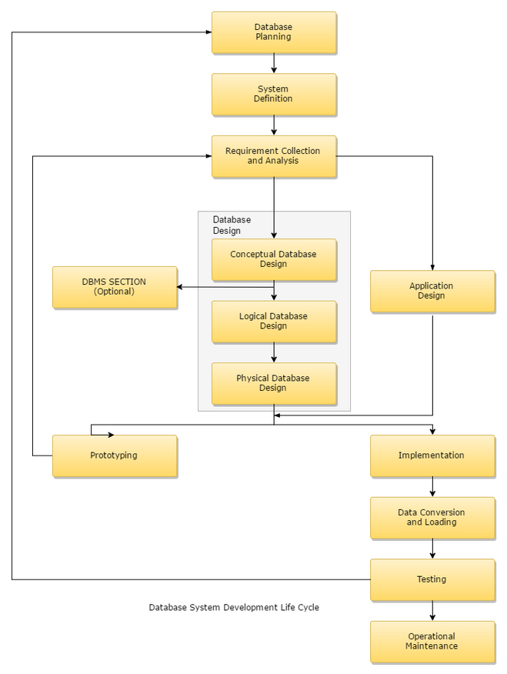

-Maintenance-

Looking for corrupting influences or slow signs of their development. There may be a specific section of the analysed data that has tricky coding or difficult algorithms that require highly qualified people to maintain and develop more suitable ones. Sometimes doubles of certain records could be maintained in the same database and would present a problem for the user and administrator, and being aware of any axiomatic anomalies from developing, which is why they require constant updating. The desired result of this is to keep a fluid operation within the analysis’s direction making sure that data and database programs are up to date. If this sense is not implemented the forum of analysis the database will become unresponsive and exist in a state of disrepair. This could not be allowed due to the essential nature of the database (wisegeek, 2019).

-Implementation-

The Implementation is a concerned process that uses the definition of the data as the source for the implementation. It is concerned with scope, schedule, design, training and review of the newly created system (chegg, 2019). This can be the trickiest part of the operation to ensure a good system all characters of the business and employees have to be considered and refracted through the lighted beacon of sustainability. Is it “one to many”, what ERD is used and how all this is considered and implemented by a conscientious administrator? (An Example of the Implementation process is shown below)
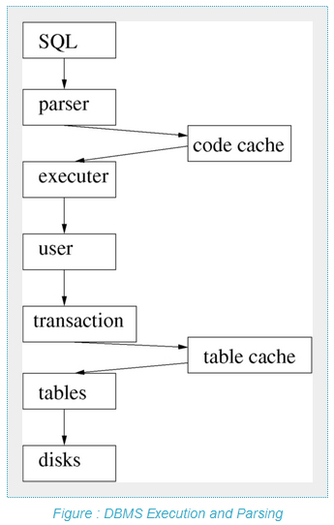

-Compare the Conference venue database and Prosumer data file-

The relationship database and the prosumer have the same intention. Both have the essences of analysis as the primary driving factor. Where the prosumer data base is rudimentary but effective if looking quickly for a specific identity, it lacks the more complex methodology of the Conference venue database. The Prosumer is a simple flat file what you see you get. The Conference Venue is a relationship database and can attain a much more complex analysis and understanding of a business record, client or trend that the simple flat form sense of analysis. Within the Relationship database a Primary Key will link the different data to each other forming a relationship, and will posses a one to many, one to one or many to many. Entities are usually a focus for more than a single piece of information which are usually conceptual. It also contains a term used as an attribute something that cannot be broken down any further in to elemental pieces. Then a Primary key will used to specifically designate records within said database. Then we have the Foreign key a table which draws its data from the same place as another tables Primary key. The design of a relationship database is set with specific rules such as names, all column entries must be of the same kind, multiple values are not allowed in a cell all of this makes it easier for the end user to participate in its formulated analysis when looking for a fact. Also known as an Entity-Relationship Diagram, (ERD) it has become an essential tool for business since its inception in the 1980’s and has revolutionised business analysis (Techopedia, 2019). Marking an extreme transition for the better, this type of data base is now a crucial development for business analysis in all senses and will not be overtaken any time soon, comparing it to the flat-form is unjustified one is a Datsun one a Ferrari, one does the job while one greatly influences decision making and speeds up the process of deep analysis if correctly implemented. Examples of the different structures of the flat form vs. the relationship database are shown within the Appendix.

-Bibliography-
Asheim, G. B. (1994). "Sustainability," The World Bank.
chegg. (2019). Database Implementation. Retrieved from chegg: https://www.chegg.com/homework-help/definitions/database-implementation-3
Dictionary.com. (2012). Analysis. Retrieved from Dictionary.com: https://www.dictionary.com/browse/analysis
dobney. (n.d.). Database analysis to Big Data analysis. Retrieved from dobney: http://www.dobney.com/Intelligence/database.htm
dsp. (2018). The Key Responsibilities of a Database Administrator. Retrieved from dsp: https://www.dsp.co.uk/the-key-responsibilities-of-a-database-administrator/
Earthcharter. (2016). The Earth Charter. Retrieved from Earthcharter: http://earthcharter.org/discover/the-earth-charter/
futuregenerations. (2019). A Wales Of Cohesive Communities. Retrieved from futuregenerations: https://futuregenerations.wales/aotp/community/
Gov.Wales. (2016, August 6). Well-being of Future Generations (Wales) Act 2015. Retrieved from Welsh Government: https://gov.wales/topics/people-and-communities/people/future-generations-act/?lang=en
merriam-webster. (2018). Definitions for database. Retrieved from merriam-webster: https://www.merriam-webster.com/dictionary/database
sustainabilitydegrees. (2018). What is Sustainability? Retrieved from sustainabilitydegrees: https://www.sustainabilitydegrees.com/what-is-sustainability/
Techopedia. (2019). Entity-Relationship Diagram. Retrieved from Techopedia: https://www.techopedia.com/definition/1200/entity-relationship-diagram-erd
w3schools. (2018). Planning, Design and Administration. Retrieved from w3schools: https://www.w3schools.in/dbms/planning-design-administration/
wisegeek. (2019). What is Database Maintenance? Retrieved from wisegeek: https://www.wisegeek.com/what-is-database-maintenance.htm

-Appendix-

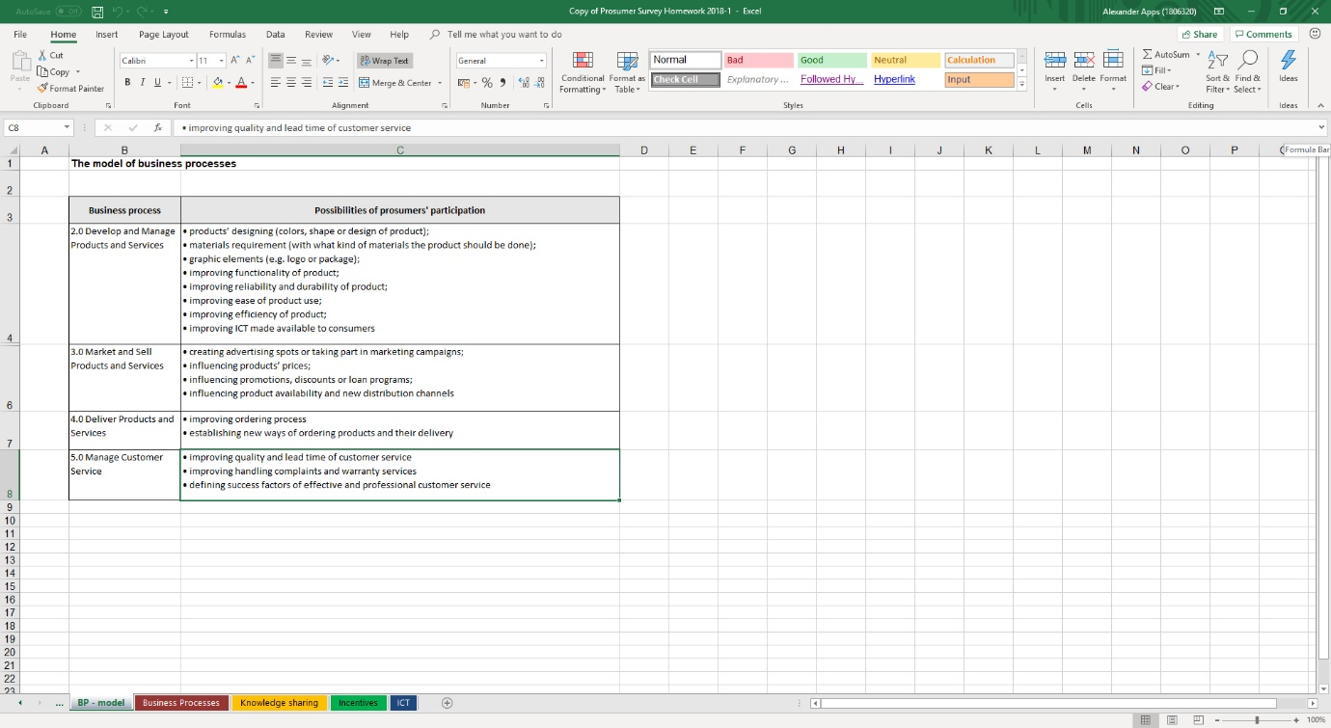
Flat-form

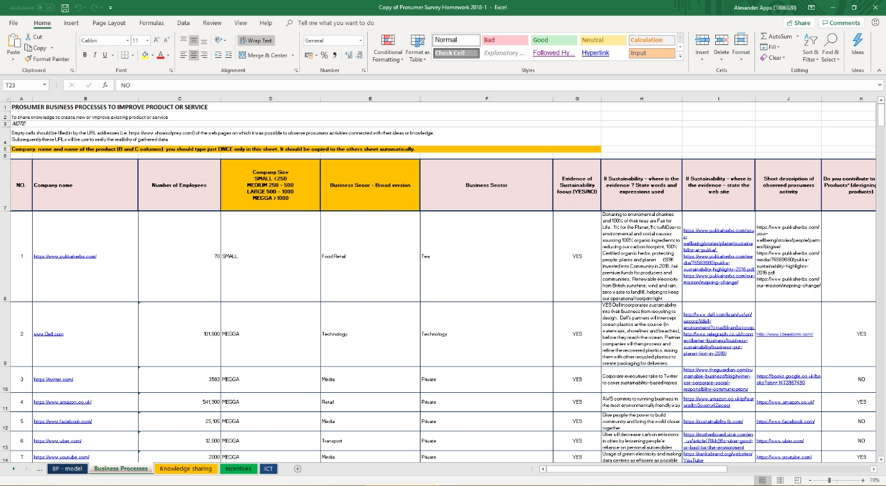
Relationship Database or Entity-Relationship Diagram Has a much more detailed understanding of business analysis than the flat-form. Even though the flat-form does have rudimentary uses.
ERD
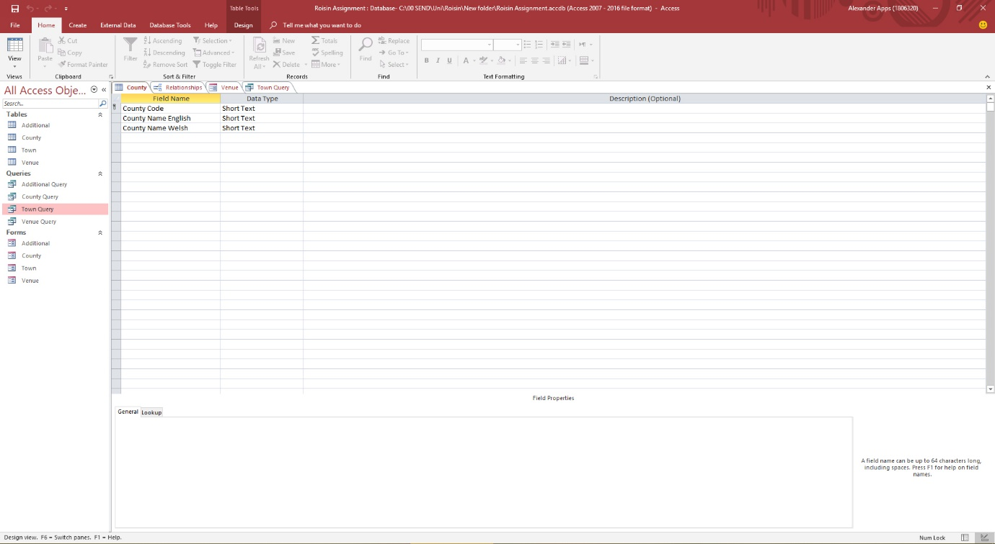

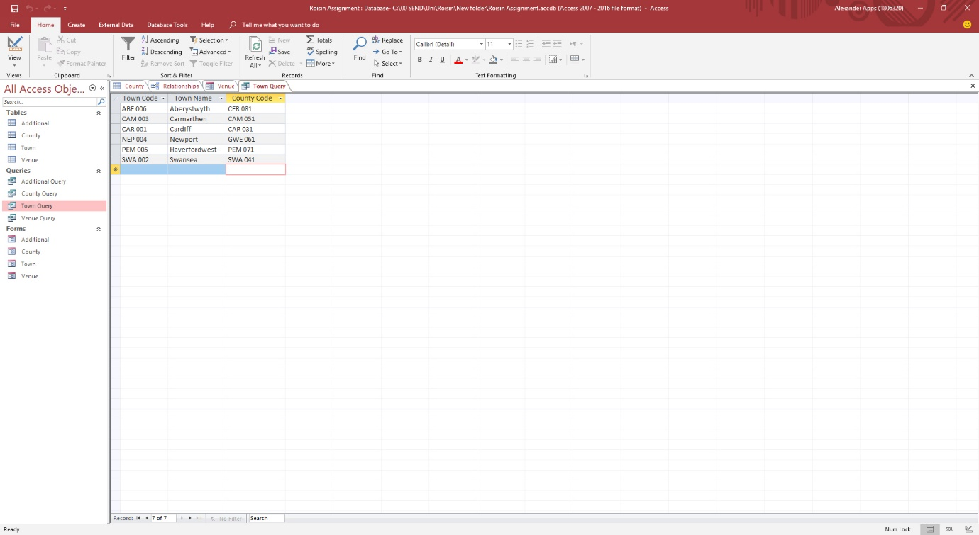

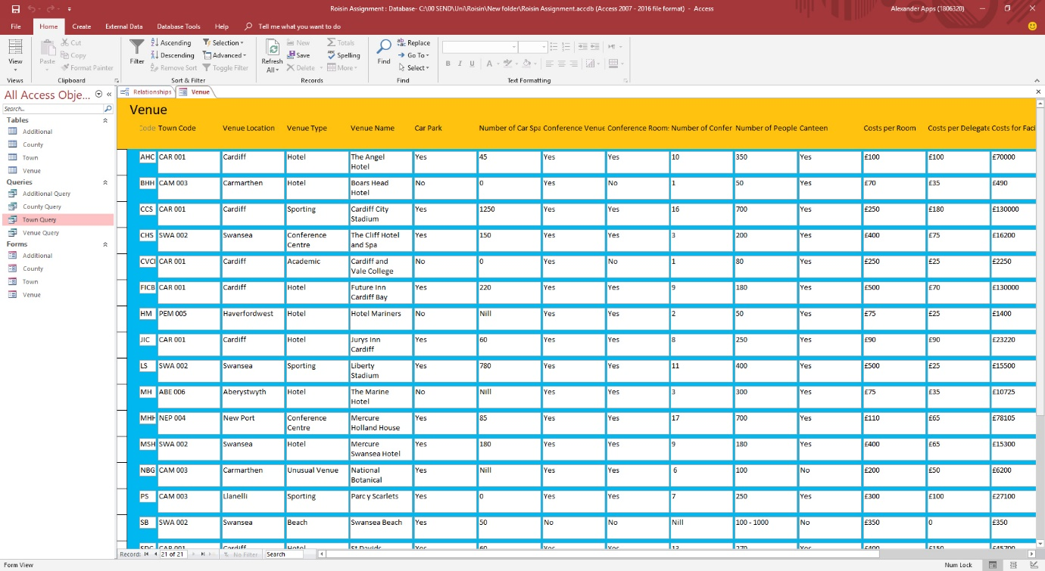

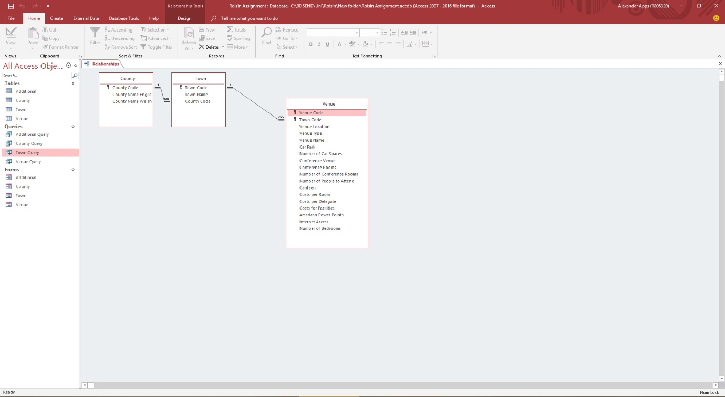
Here the Primary Keys are shown and the sense of relationships.

