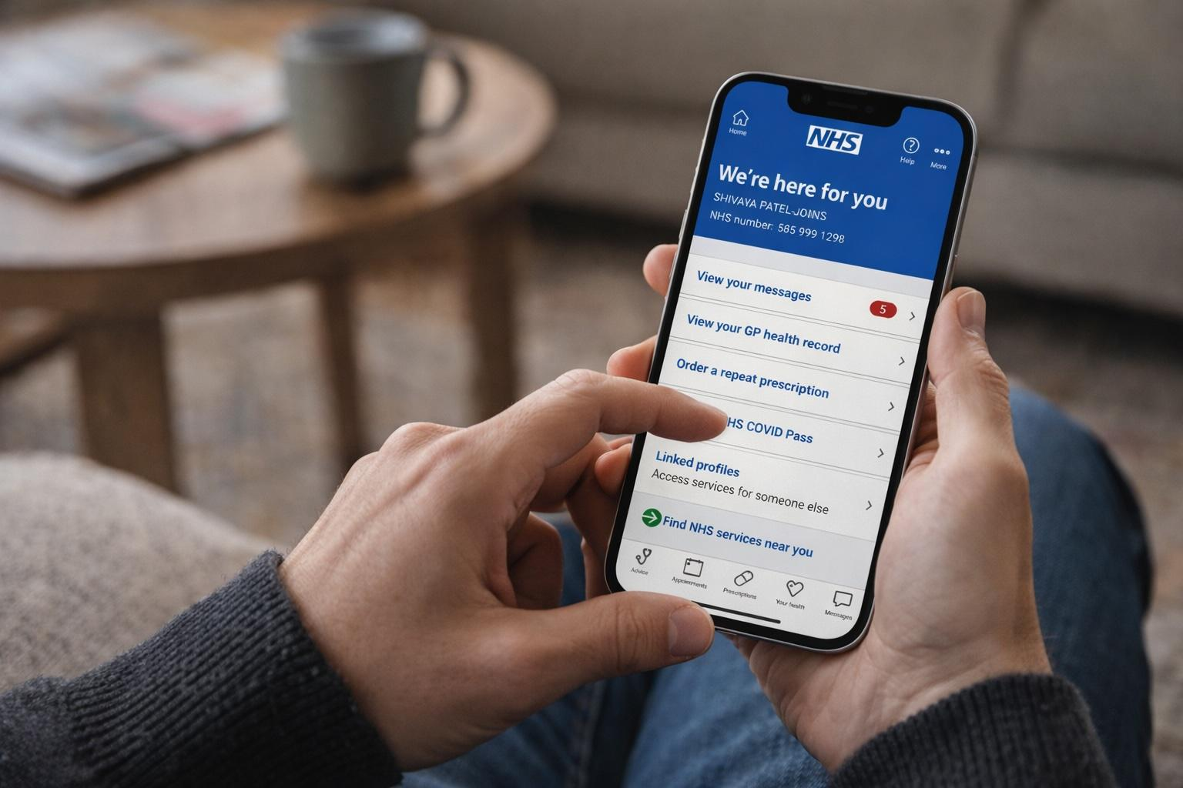  (Distilled Post Editorial Team, 2026)  Component 1: Written Report  Digital Transformation in the Health and Care Professions  Module Code: BMHP6026 | Gazala Haroon  Student ID: 2411422  Lecturer: Tomy Adattu Chacko

Contents
Introduction 2
Digital Innovation and Implementation 3
Impact on the Workforce 3
Impact on Service Delivery 4
Impact on Patients and Service Users 6
Impact on Communities 7
Conclusion 8
Reference List 10

Introduction
Digital technology is changing how health services are accessed and delivered in the UK. The NHS App, launched nationally in England in 2019, is an important example of this transformation. It provides a secure digital route for patients to manage their healthcare, including booking appointments, ordering repeat prescriptions and accessing health records (Reidy et al., 2025). This reflects the wider move towards mobile health applications and digitally integrated healthcare.
The NHS App has become increasingly important because it aims to give patients greater control while making access to NHS services more convenient. Its large-scale adoption demonstrates its relevance: by December 2025, more than 40 million accounts had been registered, although only around 13.2 million unique users logged in during that month (NHS England, 2026d).

Figure 1: NHS App registration and active use, December 2025.
Source: NHS England (2026d).
As shown in Figure 1, the substantial difference between registered accounts and monthly active users indicates that registration alone is not a reliable measure of active engagement with digital healthcare. Furthermore, research shows that NHS App uptake varies between population groups, raising concerns about digital exclusion and unequal access (KC et al., 2023). Therefore, while the NHS App offers significant opportunities, its success depends on accessibility and effective implementation. This report critically evaluates its positive and negative impacts on the healthcare workforce, service delivery, patients and service users, and communities, with particular attention to efficiency, patient experience and health inequalities.

Digital Innovation and Implementation
The NHS App is a digital platform that connects patients with NHS services in England. It allows users to access health records and test results, order repeat prescriptions, manage appointments and receive messages from NHS services through a smartphone, tablet or web browser (NHS, 2026a). The technology uses NHS login to verify a person's identity and connects with existing NHS digital systems.
The NHS App was launched nationally in 2019, but its importance increased during the COVID-19 pandemic when healthcare services needed more remote and digital methods of communication and access (NHS Digital, 2023). Its development has continued beyond the pandemic. NHS England (2025a) expects GP practices to provide core NHS App functions, including appointment management, prescriptions, online consultations, messaging and access to patient records. In addition, by April 2025, NHS App services were available through 87% of hospitals in England (Department of Health and Social Care, 2025a).
However, implementation should not be judged only by national availability. Reidy et al. (2025) found that implementation was influenced by differences between local organisations, existing technologies and working practices. Therefore, although the NHS App demonstrates significant progress towards integrated digital healthcare, its effectiveness depends on successful integration with local services, staff engagement and patients' ability to use digital technology.

Impact on the Workforce
The NHS App has changed the work of both clinical and administrative staff by moving some routine activities towards patient self-service. Patients can manage appointments, order repeat prescriptions and access information digitally, which may reduce telephone calls and repetitive administrative work. NHS England (2023) argues that digital innovation can improve productivity and release staff time, although these benefits depend on technology being properly integrated into everyday working practices.
However, digitalisation does not simply remove workload; it can redistribute it. Staff may need to manage online requests, respond to digital messages and support patients using digital services. Blease et al. (2024) found concerns among GPs that patient online record access could increase the time spent responding to patient questions and lengthen consultations. Therefore, although digital access may improve convenience, it may also create additional demands on staff and shift rather than simply reduce workload.
The NHS App also changes the competencies and responsibilities expected of staff. Professionals need digital literacy, knowledge of information governance and confidence in supporting patients with technology. The NHS Long Term Workforce Plan recognises that technological change requires staff to develop new skills and work in different ways, supported by digital training and leadership programmes (NHS England, 2023). This investment is important because inadequate training may reduce confidence and contribute to resistance.
Staff acceptance is therefore critical. Reidy et al. (2025) found that implementation of the NHS App was shaped by local organisational circumstances and existing working practices, suggesting that national introduction alone cannot guarantee successful adoption. Consequently, the App can support workforce efficiency, but its benefits depend on training, staff engagement, appropriate workload planning and effective integration with existing systems. Without these conditions, digital transformation may shift rather than reduce pressure on NHS staff.

Impact on Service Delivery
The NHS App has changed service delivery by allowing patients to complete routine healthcare activities without always contacting services directly. Patients can manage appointments, order prescriptions, receive messages and access information digitally. NHS England (2026a) states that increasing patient self-service can reduce administrative work and unnecessary enquiries. This can improve workflow because staff can spend more time supporting patients with complex needs. However, digital access improves the process of accessing care rather than increasing the number of healthcare professionals or available appointments. Therefore, technology alone cannot resolve wider capacity pressures.
There is evidence of measurable service benefits. The Department of Health and Social Care (2025a) reported that NHS App expansion was associated with around 1.5 million fewer missed hospital appointments and an estimated 5.7 million staff hours saved from July 2024. Nevertheless, NHS England (2025b) later explained that these benefits were estimates based on assumptions and evidence of varying quality. Consequently, the figures indicate potential efficiency gains but should not be interpreted as definite proof that the App itself caused all reported savings.
Digital communication may also reduce costs. The Department of Health and Social Care (2025b) estimated that expanding App-based communication could replace at least 50 million letters and save approximately £200 million over three years.
Table 1: Reported service-delivery benefits associated with NHS App expansion
Service-delivery measure | Reported impact
Missed hospital appointments | Around 1.5 million fewer
Staff time | Around 5.7 million hours saved
Letters | At least 50 million potentially replaced
Estimated financial saving | Around £200 million over three years
Sources: Department of Health and Social Care (2025a; 2025b); NHS England (2025b).
Furthermore, patients can view estimated hospital waiting times through the App, potentially improving transparency and reducing uncertainty (NHS England, 2026b). However, waiting-time information depends on data supplied by individual trusts and may be incomplete or delayed. Therefore, improved information does not necessarily mean shorter waiting times.
Implementation also varies between organisations. Reidy et al. (2025) found that the NHS App had to operate alongside different local technologies, organisational priorities and workflows. This suggests that successful digital service delivery depends on effective integration rather than simply providing the technology. Overall, the NHS App can improve efficiency, access, communication and workflow, but its impact remains dependent on reliable systems, accurate data, organisational capacity and continued alternative access for patients who cannot use digital services.

Impact on Patients and Service Users
The NHS App can improve the patient experience by giving people greater convenience, choice and control over their healthcare. Patients can access health records and test results, order repeat prescriptions and manage appointments without always telephoning or visiting a GP practice (NHS, 2026a). This may be particularly useful for people managing long-term conditions or balancing healthcare with work and caring responsibilities. Reidy et al. (2025) found that the App's development increased opportunities for patients to interact digitally with NHS services. However, convenience should not automatically be interpreted as improved quality of care because patients may still experience difficulties accessing the clinical services they need.
Access to personal health information can also strengthen patient autonomy. Research suggests that patient access to electronic health records can support greater involvement, empowerment and engagement in healthcare (Alomar et al., 2024). However, increased access can also have disadvantages, as patients may face usability barriers or have difficulty interpreting health information without professional support. Therefore, digital access is most beneficial when patients can still obtain professional advice.
A major limitation is digital inequality. Although NHS App use has increased considerably, uptake is not equal across society. KC et al. (2023) found inequalities in NHS App adoption associated with factors including age, ethnicity, deprivation and health status. Similarly, Ofcom (2025) reported continuing differences in digital access and confidence across UK population groups. These findings challenge the assumption that making a service available online automatically makes healthcare more accessible. Patients without suitable devices, reliable internet access or adequate digital literacy may experience greater difficulty, particularly if traditional routes are reduced.
Privacy and safety are also important. The NHS App uses NHS login and identity verification to protect confidential health information (NHS England, 2025d). Strong security can increase trust, but complex authentication may itself become an accessibility barrier for some users. Furthermore, the National Data Guardian (2025) stresses that public confidence in how health information is accessed and used remains essential to digital healthcare.
Overall, the NHS App can increase autonomy, convenience and access, but its benefits are uneven. A digital-first approach is therefore more equitable when telephone, face-to-face and supported access remain available. Otherwise, a technology intended to increase patient choice could unintentionally reduce choice for people who are digitally excluded.

Impact on Communities
The NHS App can benefit communities by reducing the importance of location when accessing some healthcare services. People can order prescriptions, manage appointments and obtain health information from home, which may particularly help people with mobility difficulties, caring responsibilities or limited access to transport. NHS England (2024) emphasises that digital healthcare should be designed inclusively and should complement rather than replace non-digital services, as barriers relating to access, skills and accessibility may worsen existing health inequalities.
The App can also support families and carers through family and carer access, sometimes called proxy access. With appropriate permission, a trusted person can manage appointments, prescriptions and some health information for another person (NHS, 2026b). This may support people with long-term conditions or limited digital ability. However, access requires appropriate consent and safeguarding checks, showing that convenience must be balanced against privacy and individual autonomy.
A more significant limitation is digital exclusion. Socioeconomic disadvantage, disability, language barriers and lack of suitable technology can reduce people's ability to benefit from digital healthcare. NHS England's Core20PLUS5 framework identifies deprived communities, ethnic minority groups, people with learning disabilities and other socially excluded populations as groups that may experience healthcare inequalities (NHS England, 2025c). Therefore, expanding the NHS App without adequate support could unintentionally widen existing inequalities rather than reduce them.
Nevertheless, digital technology may also support public health and co-production by giving communities easier access to information and allowing patients to participate more actively in managing their health. The development of proxy services further shows how digital systems can be designed around patients and carers rather than professionals alone (NHS England, 2026c). However, meaningful co-production requires communities to influence how services are designed, not simply use a finished product.
Overall, the NHS App can improve community access and family involvement, but its wider value depends on inclusive design, digital support and maintaining non-digital alternatives. Without these safeguards, digital transformation may benefit already-connected communities more than those with the greatest healthcare needs.

Conclusion
The NHS App represents an important digital transformation in health and social care because it has changed how patients access information and interact with NHS services. Overall, the evidence shows that its impact is valuable but not equally positive in every area. For the workforce, the App can reduce some routine administrative tasks and support more efficient working, but it also creates new responsibilities and requires appropriate digital skills, training and staff acceptance. For service delivery, digital appointments, prescriptions, records and communication can improve convenience, workflow and efficiency; however, these improvements depend on effective integration with local systems and do not directly solve wider problems such as staff shortages or limited healthcare capacity.
For patients and service users, the App can strengthen autonomy by providing easier access to health information and services. Nevertheless, privacy concerns, digital literacy and difficulties using technology may limit these benefits. At community level, remote access and family or carer involvement can reduce geographical and practical barriers, while digital exclusion may disadvantage people experiencing socioeconomic inequalities.
Therefore, the NHS App should not be viewed as a replacement for traditional healthcare access. Its effectiveness depends on combining digital innovation with human support, staff development, secure information management and non-digital alternatives. A balanced and inclusive approach is most likely to ensure that digital transformation improves healthcare without widening existing inequalities.

Reference List

Alomar, D., Almashmoum, M., Eleftheriou, I., Whelan, P. and Ainsworth, J. (2024) ‘The impact of patient access to electronic health records on health care engagement: systematic review’, Journal of Medical Internet Research, 26, e56473. doi: 10.2196/56473. Available at: https://doi.org/10.2196/56473
Blease, C.R., Kharko, A., Dong, Z., Jones, R.B., Davidge, G., Hagglund, M., Turner, A., DesRoches, C. and McMillan, B. (2024) ‘Experiences and opinions of general practitioners with patient online record access: an online survey in England’, BMJ Open, 14(1), e078158. doi: 10.1136/bmjopen-2023-078158. Available at: https://doi.org/10.1136/bmjopen-2023-078158
Department of Health and Social Care (2025a) Major NHS App expansion cuts waiting times. London: Department of Health and Social Care. Available at: https://www.gov.uk/government/news/major-nhs-app-expansion-cuts-waiting-times (Accessed: 25 September 2026).
Department of Health and Social Care (2025b) Patients to receive reminders and test results via the NHS App. London: Department of Health and Social Care. Available at: https://www.gov.uk/government/news/patients-to-receive-reminders-and-test-results-via-the-nhs-app (Accessed: 27 September 2026).
Distilled Post Editorial Team (2026) ‘NHS App waiting time overhaul aims to rebuild patient trust after widespread confusion’. Distilled Post. Available at: https://www.distilledpost.com/post/nhs-app-waiting-time-overhaul-aims-to-rebuild-patient-trust-after-widespread-confusion (Accessed: 30 September 2026).
KC, S., Tewolde, S., Laverty, A.A., Costelloe, C., Papoutsi, C., Reidy, C., Gudgin, B., Shenton, C., Majeed, A., Powell, J. and Greaves, F. (2023) ‘Uptake and adoption of the NHS App in England: an observational study’, British Journal of General Practice, 73(737), pp. e932–e940. doi: 10.3399/BJGP.2022.0150. Available at: https://doi.org/10.3399/BJGP.2022.0150.
National Data Guardian (2025) National Data Guardian 2024–2025 report. London: National Data Guardian. Available at: https://www.gov.uk/government/publications/national-data-guardian-2024-2025-report (Accessed: 28 September 2026).
NHS (2026a) NHS App. Available at: https://www.nhs.uk/nhs-app/ (Accessed: 26 September 2026).
NHS (2026b) Using family and carer access – NHS App help. Available at: https://www.nhs.uk/nhs-app/help/profile/family-and-carer-access/ (Accessed: 30 September 2026).
NHS Digital (2023) The NHS App after the pandemic. Leeds: NHS Digital. Available at: https://digital.nhs.uk/blog/transformation-blog/2023/the-nhs-app-after-the-pandemic (Accessed: 25 September 2026).
NHS England (2023) NHS Long Term Workforce Plan. London: NHS England. Available at: https://www.england.nhs.uk/publication/nhs-long-term-workforce-plan/ (Accessed: 27 September 2026).
NHS England (2024) Inclusive digital healthcare: a framework for NHS action on digital inclusion. London: NHS England. Available at:
https://www.england.nhs.uk/long-read/inclusive-digital-healthcare-a-framework-for-nhs-action-on-digital-inclusion/
(Accessed: 30 September 2026).
NHS England (2025a) 2025/26 priorities and operational planning guidance. London: NHS England. Available at: https://www.england.nhs.uk/long-read/2025-26-priorities-and-operational-planning-guidance/ (Accessed: 26 September 2026).
NHS England (2025b) NHS App Benefits Estimates – Supplementary Information – June 2025. London: NHS England. Available at: https://digital.nhs.uk/supplementary-information/2025/nhs-app-benefits-estimates-supplementary-information---june-2025 (Accessed: 28 September 2026).
NHS England (2025c) Core20PLUS5 (adults): an approach to reducing healthcare inequalities. London: NHS England. Available at: https://www.england.nhs.uk/about/equality/equality-hub/national-healthcare-inequalities-improvement-programme/core20plus5/ (Accessed: 29 September 2026).
NHS England (2025d) NHS login. London: NHS England. Available at: https://digital.nhs.uk/services/nhs-login (Accessed: 25 September 2026).
NHS England (2026a) NHS App roadmap. London: NHS England. Available at: https://digital.nhs.uk/services/nhs-app/roadmap (Accessed: 30 September 2026).
NHS England (2026b) Waiting times in the NHS App. London: NHS England. Available at: https://digital.nhs.uk/services/nhs-app/nhs-app-features/waiting-times-in-the-nhs-app (Accessed: 27 September 2026).
NHS England (2026c) National proxy service. London: NHS England. Available at: https://digital.nhs.uk/services/national-proxy-service (Accessed: 28 September 2026).
NHS England (2026d) NHS App Management Information – December 2025. London: NHS England. Available at: https://digital.nhs.uk/data-and-information/publications/statistical/nhs-app-statistics/december-2025 (Accessed: 30 September 2026).
Ofcom (2025) Adults’ media use and attitudes report 2025. London: Ofcom. Available at: https://www.ofcom.org.uk/media-use-and-attitudes/media-habits-adults/adults-media-use-and-attitudes (Accessed: 26 September 2026).
Reidy, C., Papoutsi, C., KC, S., Gudgin, B., Laverty, A.A., Greaves, F. and Powell, J. (2025) ‘Qualitative evaluation of the implementation and national roll-out of the NHS App in England’, BMC Medicine, 23, article 20. doi: 10.1186/s12916-024-03842-w. Available at: https://doi.org/10.1186/s12916-024-03842-w

