The impact of the new Alex building on the grade ll listed 19th century former library building in Swansea, Alexandra Road

5/27/2022

Student name: Steffan Pryce-Griffiths Student ID number: 1902720
Programme: Construction Management
Module: Building Conservation Asset and Facilities Management
Module code: ACBA 6006
Assignment Title: Analysis of built assets – A case study approach

Table of contents
Table of contents 0
Table of figures 4
1. Introduction 5
2. Understanding the Significance of the School of Arts building 5
2.1 High Evidential value 5
2.2 High historical value 6
2.3 Positive Aesthetic value 9
2.4 Medium communal value 12
3. Identifying the changes to the grade ll former library building 13
4. Assessing the impact of the proposals 14
4.1 Alex building & refurbishment affect the evidential value of the School of Arts Building? 14
4.2 Alex building & refurbishment affect the aesthetic or design qualities of the School of Arts Building? 14
4.3 Alex building & refurbishment affects the communal value of the School of Arts building? Would they make it easier for people to access and appreciate the building or site? 14
4.4 Are there any other risks or benefits? 14
4.5 Alex building effect on the Outstanding Universal Value of Alexandra Road 16
5 Philosophies and processes involved in retrofitting both the former library & Alex building 17
5.1 Building pathology approach under BS 7913 2013 18
5.2 Stages 18
5.3 Understanding moisture on the building and its effects. 19
5.4 Thermography for traditional building – improving energy efficiency 20
5.4 Consideration required when doing alternations 20
5.4.1 Understanding the Building: Differences between old and new buildings 21
6. Asset management approaches & challenges faced between a traditional and modern construction. 23
6.1 Strategic and operational management in historic asset management 23
24
6.2 Maintenance Guidance 24
6.2.1 listed buildings routine maintenance 25
6.2.2 Why is maintenance important? 25
6.3 Asset management on a historic building (School of Arts) compared to Modern construction (Alex building) 26
6.3.1 Honest repair 26
6.3.2 Energy consumption 26
6.3.3 Building management system 27
7. Conclusion 28
Reference list 29

Table of figures

Figure 1-3. School of Arts building from 1893,1900 to 1925 4
Figure 4. Photo captured from the original reading room on the Dr Who episodes starring David Tennant. 6
Figure 5-6. Working Men’s Club and Institute 7
Figure 7-8. Glynn Vivian 8
Figure 9-10. Police station 9
Figure 11. Excessing cleaning to brickwork 13
Figure 12. Stages of IHBC which can be used as a retrofit process for Traditional Buildings 15
Figure 13. Conservation process 17
Figure 14-15. Deterioration from damp in the School of Arts building 19
Figure 16. ISO 55000 Asset management 21
Figure 17. Strategic to operational management 22
Figure 18. Example on how energy consumption could be spread over a building. 25

Tables
Table 1. Changes to materials and finishes 11
Table 2. Summary Heritage Impact Statements 0

Introduction

This report is assessing the impact of the “£6 million Refurbishment & Extension to Grade II Listed 19th Century Former Library Building” (Powell Dobson Architects Ltd, n.d.). A listed building application will have to be filled to have consent on the demolition of the 1936 two-storey extension on Pleasant Street. The former caretaker’s house on Alexandra Road, former kitchen / toilet space to the north faced courtyard. For a steel frame extension coffered cast in-situ reinforced concrete slabs. The University of Wales Trinity Saint David owns and has desires to return the “building to its original glory in a modern context, creating a new educational environment” (Turner, 2015). Mentioned a UWTSD spokesman in a 2015 article on the new Alex building. This proposed development has potentially listed objectives, one being a more energy-efficient listed building. The construction of a glazed glass foyer could provide the building with a more radiant use than the non-draft lobby of the past. It will provide a greater capacity for the University to use for either a high technology infrastructure for students, more area to accommodate students at the University to “further improve the student experience and safeguard the long-term future of the building for the people of Swansea” (Turner, 2015). Improvements to the “environmental systems and controls installed within the refurbished” (Turner, 2015) the former library to deliver a more economically and sustainable future for future users of both buildings. This report aims to redeem if the proposed changes will have any significance to the grade II listed building by not impacting the fabric or historic character of the building.

Understanding the Significance of the School of Arts building
This grade II building was designed by “Henry Holtom of Dewsbury in the Italian classical style and opened in 1887” (Turner, 2015) by Prime minister William Gladstone. (Wales online). A prime example of Victorian architecture cost £20,000 to construct. The former Swansea library’s historic character is still in tack with minimal alternations to the building except to the North facing courtyard with the new Alex building. Assessing the significance following with Cawd’s conservation principles, it is considered that the School of Arts building has high and positive heritage values within a highly valued conservation area of Alexandra Road.

  - High Evidential value
Exterior
- Monumental and symmetrical classical design with red brick facings with pale freestone dressings.
- End bays with slate pavilion roofs (centre roof destroyed in Second War)
- Tripartite arched windows the centre tower.
- Main den tilled cornice with solid parapets and plain frieze.
- Banded quoins to the upper floor
- Swagged and fluted oculi to inner bays over pedimented and key blocked studio windows.
- Arched and key blocked ground floor windows with linked impost bands and panelled aprons.
- Segmental key blocked basement windows behind area railings
- T-frame glazing
- Panelled pilasters and carved tympanum.
- Main arched and pilastered doorcase has foliage carving to spandrels and key block sliding double doors.
- Doorcase with guilloche surround, inscribed over door under glazed lunette, flying platform to steps, 6-panel doors.
- Grandeur of the building’s original façade.
(CADW, 1987)
Interior
- Interior of entrance hall has paired doorways up steps, arched coffered ceiling to the vestibule, elaborate timber pedimented doorcases with lunettes over, arched and pilastered treatment to lateral corridors.
- Aisled, circular rear Reading classical detailing.
- Cast iron columns with rich acanthus capitals and radiating timber bookcases with guilloche ironwork balconies support entablature.
(CADW, 1987)
  - 2.2 High historical value
- As mentioned, the former central library was opened by prime minister William Gladstone in 1887. This building was the first flagship followed by the demolition of the slums area in the late 1870s. Figure 1 is an image of the building in 1900.
- The building was known to be a “favourite haunt for Dylan Thomas” (Thomas, 2018). Dylan Thomas is acknowledged as one of the most important Welsh poets of the 20th century.
- In 1962 Peter Sellers spent many years in the building as an English lecturer for Swansea University. Peter Sellers also starred in the ‘Only Two Can Play’ movie in 1960 and scenes were filmed in the building.
- The library was transferred to the city's civic centre in 2007 and the building has been used in television programmes.
- Doctor who episodes silence in the Library and Forest of the dead was broadcasted on Saturday 31 May/Saturday 7 June 2008.
- It was also used for scenes in the Sherlock tv series starring Benedict Cumberbatch and Martin Freeman.
- Swansea Council established a new seafront city centre civic centre in 2007 which led to the old Swansea Met University which is now the University of Wales Trinity Saint David buying the Victorian building.
The YouTube link to the Dr Who episodes reveals the original reading room of the listed building in it. (27) The Doctor Meets The Vashta Nerada | Silence In the Library | Doctor who - YouTube
(BBC, 2014)
Figure 1-3. School of Arts building from 1893,1900 to 1925
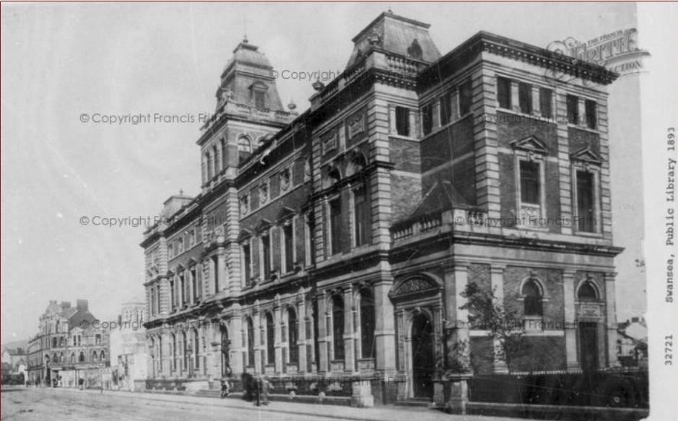
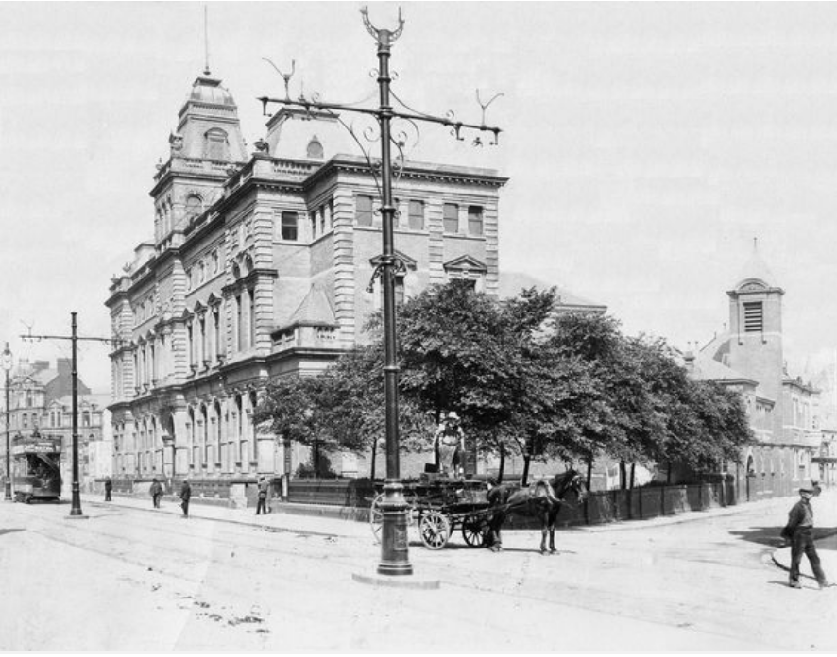

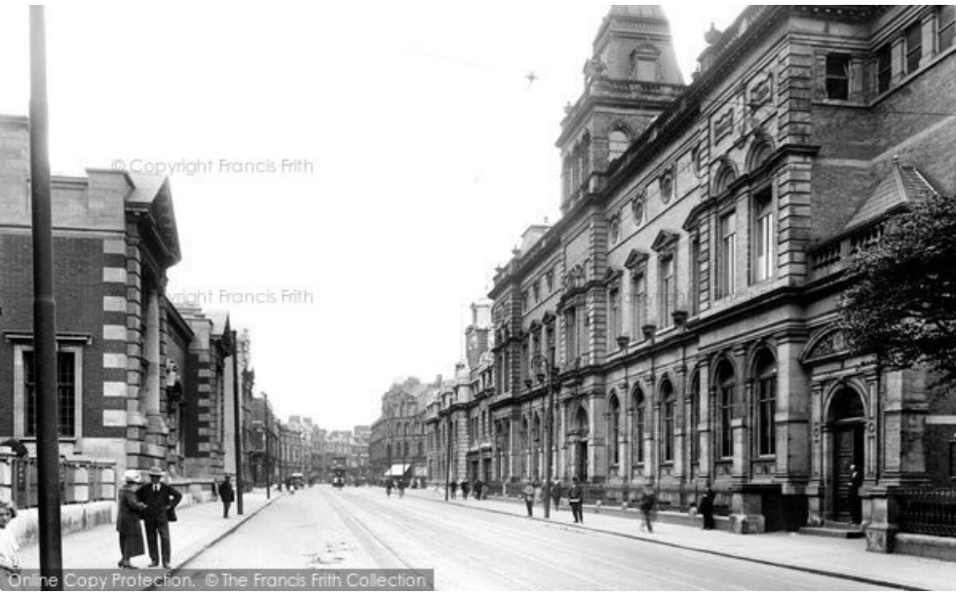
(The Francis Frith Collection)

Figure 4. Photo captured from the original reading room on the Dr Who episodes starring David Tennant.
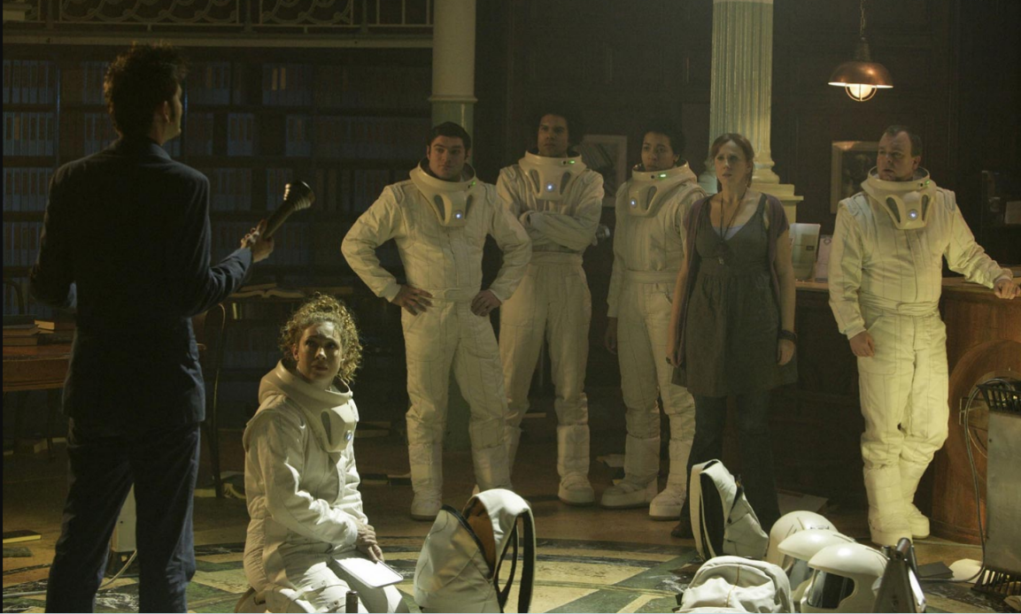

  - 2.3 Positive Aesthetic value
The School of Arts building is built up in a conservation area on Alexandra Road with grade ll listed buildings surrounding it. The street was renamed in October 1881, following a “visit of the Princess of Wales and Princess Alexandra to Swansea (CITY AND COUNTY OF SWANSEA, 1986)”. From 1885 to the First World War several “very fine public buildings were erected on both sides of Alexandra Road”. The availability of big publicly owned sites and discarded old premises in the town centre location led to the construction of the “Working Mens Club and Institute (1885), the Central Library (1887), the BBC Building (1899), the Glynn Vivian Art Gallery (1909/11) and the Central Police Station )1913)). Theses building bring aesthetic value to Swansea and to the people living in Swansea. Buildings designed in “a rich classical and baroque revival style were just part of the impressive curve of buildings”. World War ll “destruction and post-war reconstruction, road construction in particular”, much of the original character of the area is gone leaving”. Therefore, it is vitally important these buildings are kept and preserved for the history of Swansea from surviving the war.

Figure 5-6. Working Men’s Club and Institute
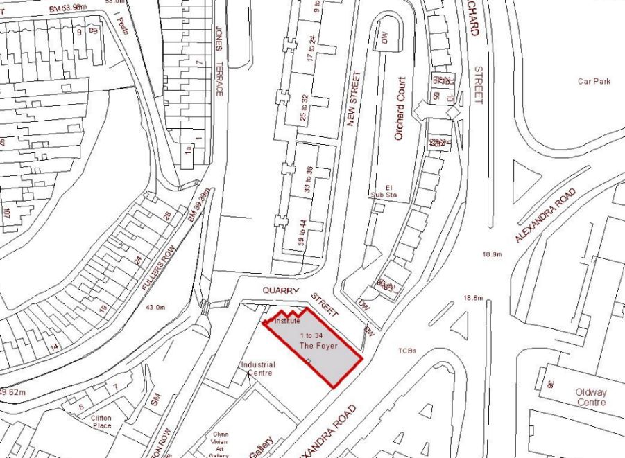
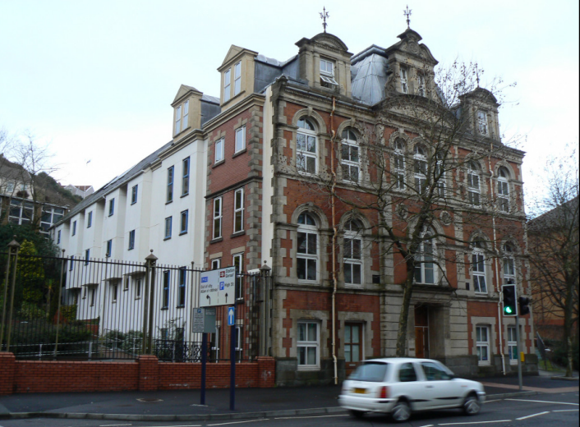

Figure 7-8. Glynn Vivian
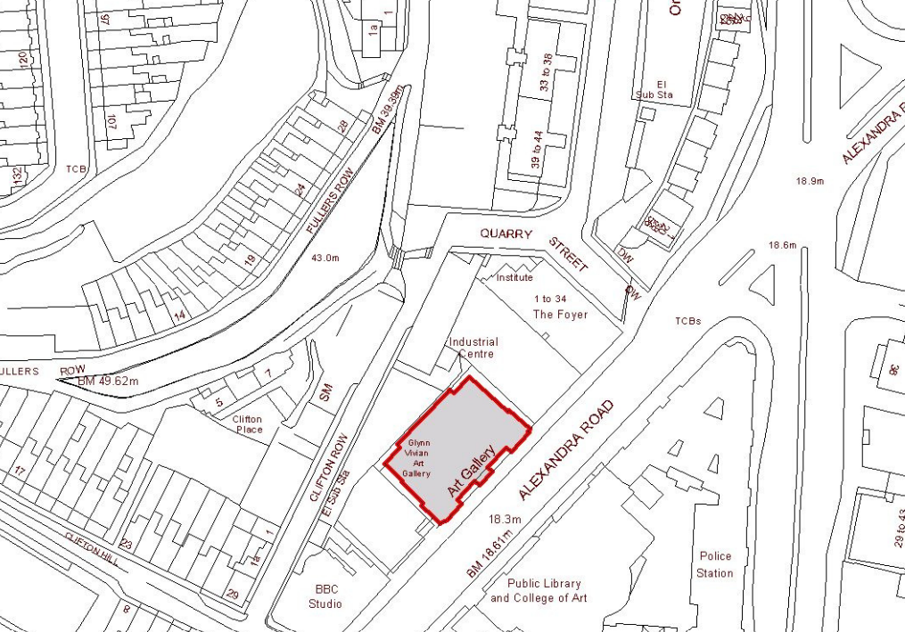
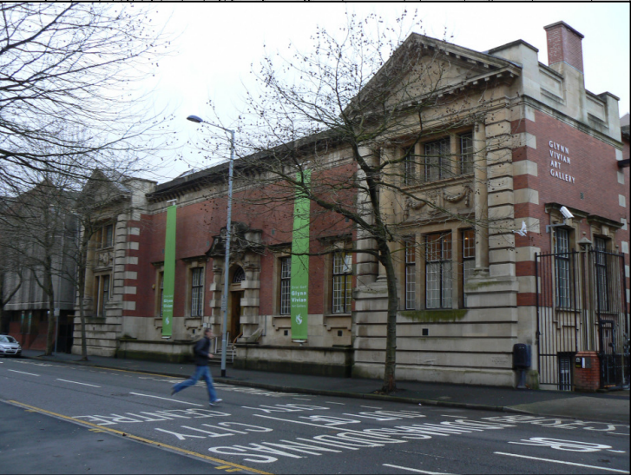
Figure 9-10. Police station
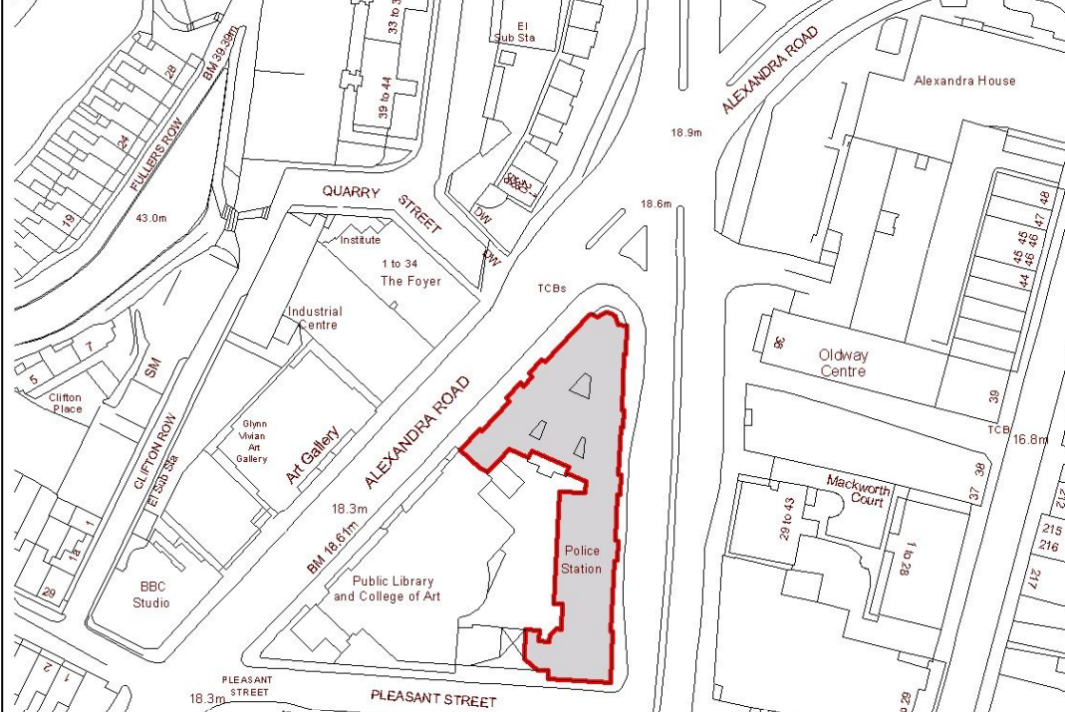
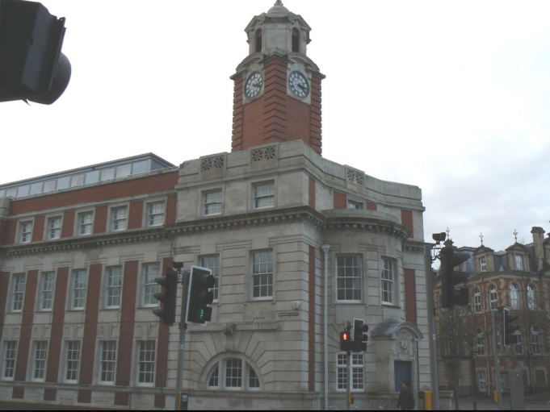

2.4 Medium communal value
Alexandra road has a conservation area appraisal from the City and County of Swansea. It has an architectural ensemble of historic assets. Not just from the listed buildings which have been mentioned. However, the area has a “historic group of public buildings on both sides of Alexandra Road and the 19th Century terrace houses” (CITY AND COUNTY OF SWANSEA, 1986) along the Gore Terrace, Clifton Hill, and Pleasant Street. Which has great significance to the people of Swansea. The buildings on this road have survived two world wars however their significance is shown with the damages of the war still on some of the buildings.

Identifying the changes to the grade ll former library building

This section will be assessing the change of the new glazed atrium with an extension to the side of the building. The main feature of the Alex building is the “impressive double façade achieved with AluK’s curtain walling solution” (ALUK), which provides a further 657m² to the original building. The curtain wall system forms the “internal wall, and structurally bonded glazed toughened laminated glass skin forming the outer wall, with an interstitial space between them” (ALUK). This state-of-the-art extension provides a new entrance, workshops, teaching spaces and design studios which were unachievable in just the School of Arts building.
Below are descriptions of the proposed changes and extension additions to the library building from the consented planning applications on the City and County Swansea website.

Table 1. Changes to materials and finishes
Location | Description of changes - materials and finishes
External walls | Structural glass on spider brackets to Alexandra Road. PPC aluminium framed glass curtain wall above slate plinth to Pleasant St. Metal panels to lift shaft. Restoration of existing.
Roof | Flat 'green' roof to new extension. Refurbishment of existing
Chimney | English bond brickwork, stainless steel flue.
Windows | Existing windows to be refurbishes, some replaced like for like.
External doors | Glass doors to new main entrance. PPC aluminium framed doors and roller shutter doors to extension. New wood door in original style to rear. Redecorate existing.
Ceilings | Structural concrete soffit with steel frame on show in new extension. Repair and redecorate existing.  vin new extension. Repair and redecorate existing.
Internal | Plastered blockwork to new extension. Redecorate existing. The original circular reading room has been restored and made available as a public venue.
Floors | Vinyl tiles/sheet to new extension, Retain existing.
Internal doors | Glass and wood to new extension. Redecorate/ upgrade to FDs existing.
Rainwater goods | Cast iron.
Boundary treatments | Existing railing in front of 1880's building to be refurbished.

(CADW, 1987)
Table 2. Summary Heritage Impact Statements indicates the proposed changes with beneficial and harmful impact with the proposed solution in dealing with each issue. On pages 28-29.

Assessing the impact of the proposals

  - 4.1 Alex building & refurbishment affect the evidential value of the School of Arts Building?
The two-storey extension which was constructed in 1936 on Pleasant Street had to be demolition however this was shown on the north faced courtyard instead of the front of the building. The physical attachment of the curtain walling required to cut into one of Brown Yorkshire sandstone decorative dressings and a section of the English bond on the red brick of the building. This allowed the curtain wall system to sit flush on the red brick. It is suggested that the evidential value of the historic assets is minimal as the Alex building is “transparent as possible to express the original scale and features of the historic fabric behind” (Broad, 2015).

  - 4.2 Alex building & refurbishment affect the aesthetic or design qualities of the School of Arts Building?
The new Alex building is set back from the older School of Arts building which reduces the visual impact of viewing it down Alexandra Street. Alex’s building is lower in height and transparent with the glass glazing system. This allows people to understand the time frame of construction between the new Alex building to the old School of Arts building. The Alex building is a lightweight appearance which doesn’t affect the aesthetic quality of the School of Arts building.

  - 4.3 Alex building & refurbishment affects the communal value of the School of Arts building? Would they make it easier for people to access and appreciate the building or site?
The new Alex building presents a simpler foyer for future users to identify compared to school of Arts building which has hard to recognises. The original circular reading room has been unavailable to the public before. However, during the refurbishment of the school of Arts building the reading room was “restored and made available as a public venue” (Broad, 2015) for the community to use.

  - 4.4 Are there any other risks or benefits?
High Risks- Junctions damaged between joining the old and new buildings together. Damaged to the coarsening and a section of the English bond on the red brick to attach the curtain walling system. Potentially waterproofing weakness between both buildings if not sealed correctly with mastic and fault on brickwork. Cleaning historic brickwork should only be “justified in certain circumstances, but in many cases will do more harm than good” (alimcclary, 2017) There are risks in “damaging the brickwork and can remove a building’s sense of history” (alimcclary, 2017). This is shown in figure 11 of the damaged brickwork from cleaning on the Old School of Arts building. Modern construction methods or materials used on the historic School of Arts building could affect the fabric of the building. Damp problems could occur from waterproofing and insulating differently which could trap water and causes dampness. Accessibility for maintenance could be an issue, can
High Rewards- The extension of the Alex building provides possible climate control with the façade facing south. This offers “long exposition to the sun for solar energy and keep the building warm during the winter” (Broad, 2015). Noise pollution is minimised, and ventilation is helped with a “series of louvers at the bottom of the façade” which was important for congested road traffic outside. The building is economically more sustainable used with “reduced energy consumption and creates an inspiring place to learn” for students.

Figure 11. Excessing cleaning to brickwork
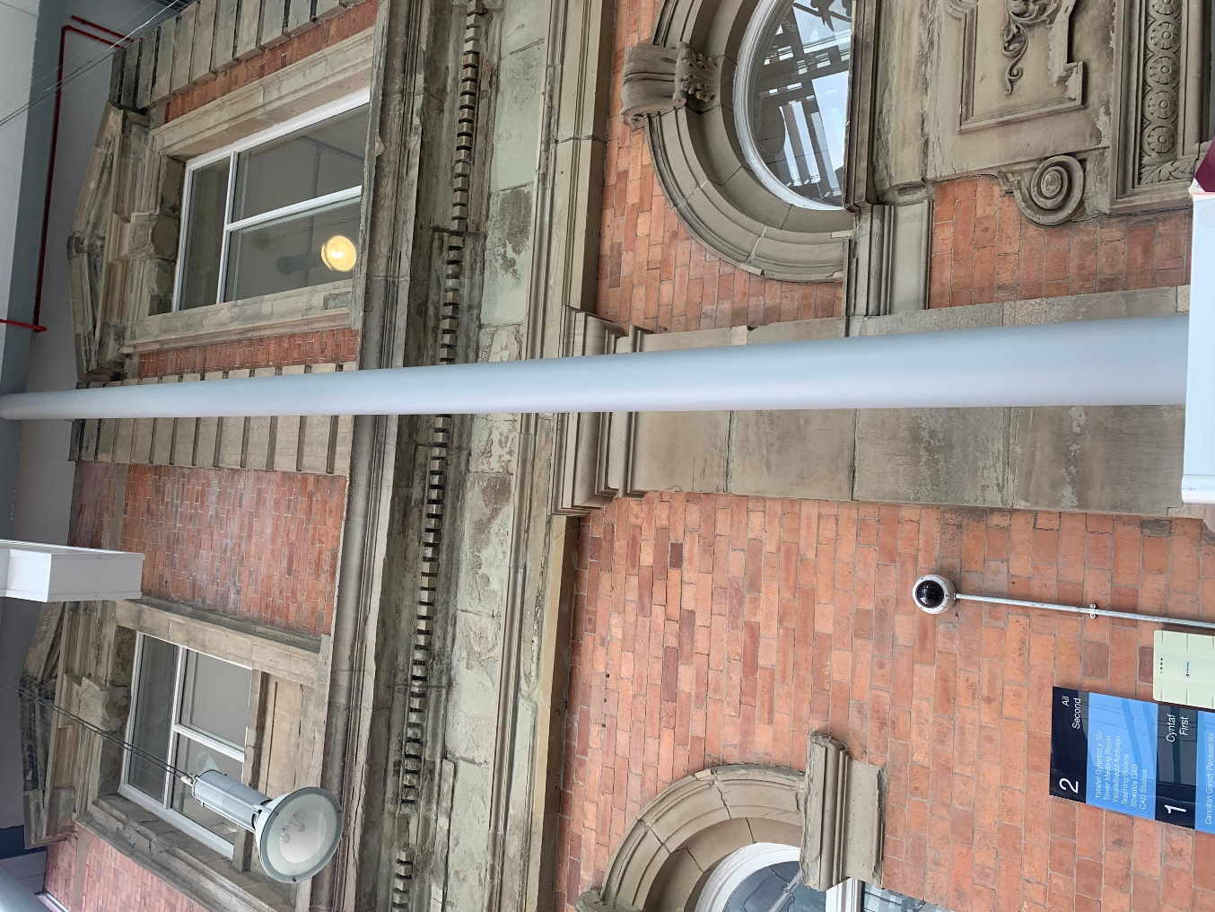

  - 4.5 Alex building effect on the Outstanding Universal Value of Alexandra Road
Simpler working cottages and the former Swansea Ragged school which was founded in 1847 on Orchard Street. The visual impact of these buildings has been affected by the new Alex building. Visual impact from the front of the site is quite high. However, the visually impact decreases reduces along Alexandra Road attributable to the setting back of the Alex building and lower height.

5 Philosophies and processes involved in retrofitting both the former library & Alex building

Older buildings such as the Swansea former library should be treated carefully when retrofitting with modern technology to prevent any damage occurring to the structure or being counterproductive. This section aims to assess the philosophies and retrofitting process involved for Alex building on the former library building.
To successfully retrofit the former Swansea library before any changes are made, we must consider the following principles…
- detailed examination of existing needs for repair and conservation.
- assessment of the thermal characteristics and performance of the building envelope, for which expertise in thermal imaging is a crucial advance on theoretical U-values.
- analysis of heating and electrical systems.
- understanding of moisture effects and humidity.
- assured competences in the requisite disciplines.
(THE BUILDING CONSERVATION DIRECTORY, 2017)

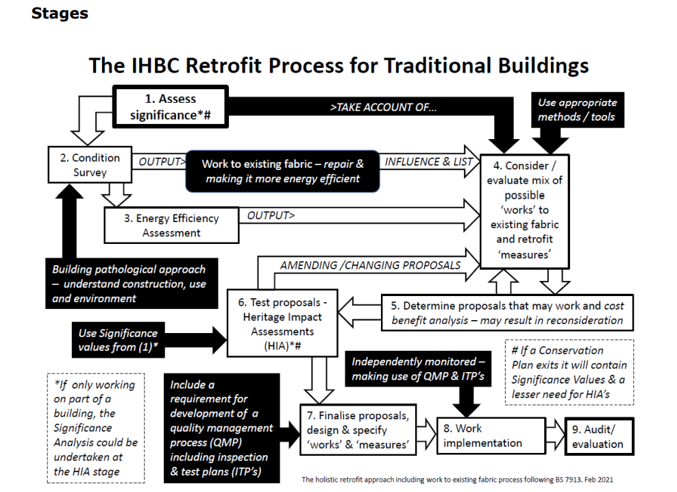
Figure 12. Stages of IHBC which can be used as a retrofit process for Traditional Buildings
  - (IHBC)
  - 5.1 Building pathology approach under BS 7913 2013
It is important to understand the pathology of historic buildings to implement the “appropriate remedial measures can ensure historic buildings of any age can remain in good condition and fully usable” (BSI Standard Publication, 2013). The BS 7913 2013 provides a pathology method to understand how the components of the building interact and how the space is used. This is significant within ventilating a building, “where chimney flues, sub floor vents and cupolas contribute to a passively managed environment”. Disturbances to these elements should be notified to prevent consequences, “remedial actions should identify innovative solutions if the original elements or systems cannot be reintegrated”.

  - 5.2 Stages
Understanding the building, the setting of the building is important, what environment the building sits in, ground levels, drainage, and wind exposure. How much moisture and temperature stress are on the building? Does the building sit within an area prone to flooding and the ground conditions of the site? The building is in Swansea which is prone to 4 times more rain than London
It’s important to understand if any alterations or additions have occurred since it was first constructed. Any information on changes to the material used along with the consequences of both construction and maintenance due to the changes.
As mentioned before in the report. The heritage significance of the building is imperative to appreciate the different types of heritage assets of the building. To prevent alternations from having a major impact on the heritage of the building.
Building services and equipment, energy used for lighting, ventilating, cooling, and heating the building through equipment and appliance needed for the building use.
How do the occupants use the building? The amount of energy will vary on what the room is used for in the University. The levels of comfort expected, technical services and equipment required to know how much energy is used.
(RICS, Investigation of Moisture and its Effects in Traditional Buildings)

Figure 13. Conservation process
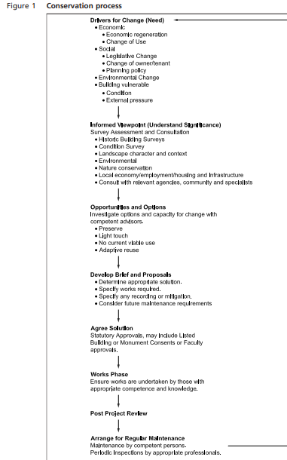

  - 5.3 Understanding moisture on the building and its effects.
A survey must deliver the best practice in investigating moisture related issues within the former Swansea library due to it being a traditional building. The investigation should consider listing specific elements of the building at “each stage of the diagnostic investigation and repair process” (RICS). Traditional building is referred to as being constructed of solid walls from permeable materials such as “brick, stone, earth, timber, and lime-based mortars, plasters and renders” (RICS). Which allows moisture to absorb. However, they “readily allow it to evaporate when conditions become drier”. Contrasting, modern construction depends on “impermeable barriers to prevent moisture from entering the fabric”. A competent surveyor will be fully aware of the “existing regulations, standards and guidelines that will be apply to traditional buildings”. This will allow them to understand to apply these documents for the diagnosis of moisture.
(RICS, Investigation of Moisture and its Effects in Traditional Buildings)

  - 5.4 Thermography for traditional building – improving energy efficiency
Thermography is a visual method to demonstrate heat energy. The infrared camera captures and displays a map of the surface temperature variations emitted by all the objects. The thermal pattern uses “different colours or shades of grey, depending on palette selected” (Institute of Historic Building Conservation, 2017). The heat energy emitted from the surface object will be illustrated through the thermal pattern. To assess the fabric of new and existing in buildings, thermography is useful in retrofitting energy-efficiency interventions. By determining between high emissivity such as bricks and plasters compared to low emissivity materials such as glass and metals. The thermography can determine “under the skin of a building without having to take the building apart”. This gives the “ability to see invisible heat energy provides valuable data for assessing thermal performance”
Improving the energy efficiency in a historic building will help “lower carbon emissions and fuel bills and often increase comfort” (Historic England, 2018). The adaptations to the building must comply with legal requirements, broadly to achieve a sustainable environment. It’s important to find the “right balance between benefit and harm” which is not easy when retrofitting an old building. The consequences of getting retrofitting or energy efficiency measures wrong encompasses: “harm to heritage values and significance, harm to human health and building fabric, and failure to achieve the predicted savings” or decreases in environmental impact.
(Historic England)
(Institute of Historic Building Conservation, 2017)

  - 5.4 Consideration required when doing alternations
Alternations should only take play if there is no suitable alternative option without damaging the impact on the significance of the historic building. The historic building which has been “altered in the past and is being reinstated to its original form, elements of the historic building” (BSI Standard Publication, 2013) might have been lost during and the replacement must be justified. The following factors should be considered...
- whether there is evidence of the original design.
- The quality of the alterations relative to the significance of the original design,
- The magnitude of the impact of alternations on significance.
- Retaining alterations as evidence of the historic building’s history.
- Whether reinstatement would make the historic building more fit for purpose.
- Archaeological interest/evidential value of a historic building’s development that might be lost.
(BSI Standard Publication, 2013)

  - 5.4.1 Understanding the Building: Differences between old and new buildings
It was important for the designer and contractors to understand the difference between the old to the new building when refurbishing the School of Arts building with the additions of the Alex building. To recognise how a traditional building allows moisture to be present which is not construction failure though how moisture movement is how the system works in a traditional build compared to modern construction which prevents. moisture entering the fabric.
Figure 14-15. Deterioration from damp in the School of Arts building
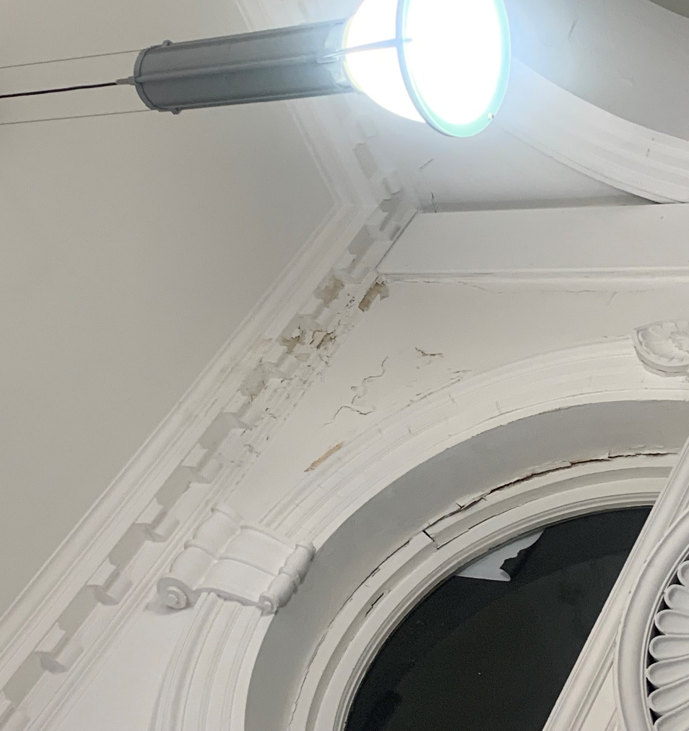
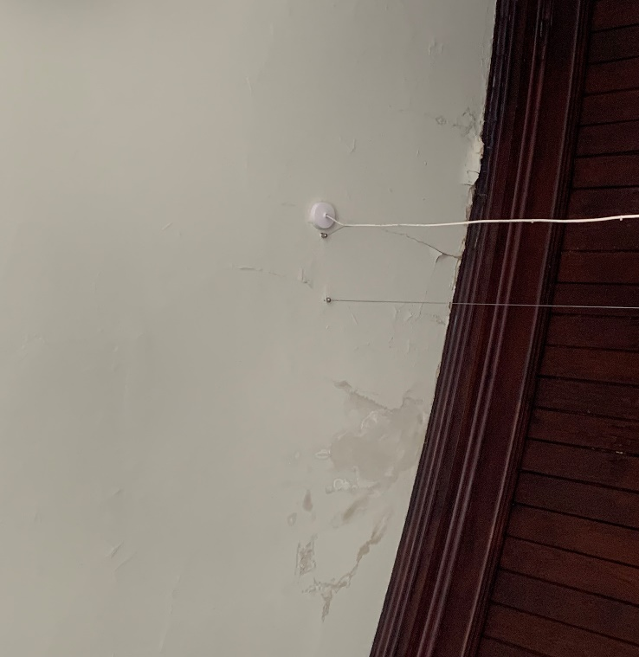

Asset management approaches & challenges faced between a traditional and modern construction.

ISO 55000 is an international standard for asset management. Which will have scopes and guidance on how to care for a building. Asset management is the need for any repair or proposed works required on a building. In this section, we will be comparing and evaluating the different asset management approaches and challenges between the historic building of the School of Arts building to the new Alex building. These inspections are “carried out at regular intervals, coupled with prompt action to pre-empt or remedy problems, are the basis of effective maintenance” (Historic England, 2013). The maintenance aim is to limit deterioration by being “cost-effective, the time and money spent on routine care, regular surveys and minor repairs protect the value of the building”. Efficient maintenance benefits the health and safety of building users and the public.
(Historic England, 2013)
Figure 16. ISO 55000 Asset management
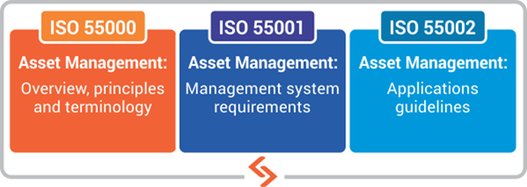

  - 6.1 Strategic and operational management in historic asset management
Following BS 7913 2013, asset management for a historic building can be split into two management approaches this being strategic management and day-to-day operational management. Strategic management involves the overall pathway to the “management operation, setting the vision, defining the mission statement, establishing values, goals and targets, planning strategy, delegating responsibilities” (BSI Standard Publication, 2013). Three simple questions help us determine this…
- Where are we now? - Is the School of Arts building economically sustainable to meet government plans?
- Where do we want to be? - Achieving sustainable objectives for both buildings?
- How do we get there? - What are the positives and negatives of the adaptations, will any heritage values be affected on the School of Arts building?
The day-to-day operational management comprises the “effective organization and coordination of services and resources to deliver the vision and strategy, liaising” (BSI Standard Publication, 2013) with the input of e.g., the general public or contractor. An operational manager for the building will “implement change in line with the strategic direction of the organisation”. This will be done through the practice of an asset management plan which will include “corporate responsibilities of the business and operational needs” however also heritage responsibilities should be included within a conservation management plan. The asset management plan will be updated to cover property management, operational projects, inspections, and maintenance. A long-term plan will be placed ranging from three to more than ten years within the capital costs of the building and the maintenance cost required.

Figure 17. Strategic to operational management
  - 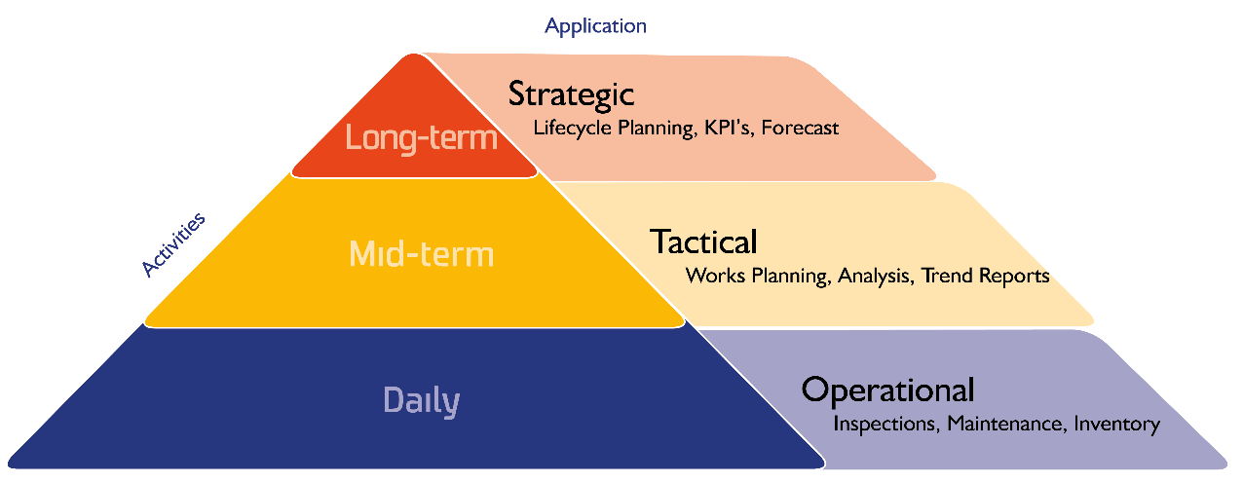

  - 6.2 Maintenance Guidance
A maintenance plan is a routine program which could be daily, weekly and twice-yearly activities updates to keep the “fabric clear, and services with other more detailed works on a longer-term cycle of one year to five years” (BSI Standard Publication, 2013), Maintenance requirements will be identified and updated through:
a) condition surveys;
b) periodic inspections for key items including structure and services;
c) reporting by building users;
d) analysis of data from monitoring equipment;
e) analysis from data from breakdown and failures of components; and
f) lifecycle replacement.
(BSI Standard Publication, 2013)

listed buildings routine maintenance

The following tasks should be completed at least every six months.
- Check the roof – The School of Arts building must be checked for missing or slipped slates and tiles to prevent any damp or other weather damage.
- Unblock roof valleys, gutters, hoppers and downpipes – Blockages could cause damage to the building itself, especially with the School of Arts with old gutters and built of plants.
- Repaint – routine repainting of external wood is essential to prevent damp and the onset of rot. However, repainting should happen in suitable conditions prevent blow off paint. Make sure surfaces are dry before painting Do not change the colour significantly without reference to the Local Authority Planning Department.
- Remove plants - climbing plants and creepers, particularly ivy, can cause damage by creating persistently damp walls, as well as by blocking roof valleys and gutters. Such plants should therefore be removed but never aggressively pulled away from a wall as this could cause damage to both the masonry and mortar joints.
(Ecclesiastical, 2020)
The following maintenance should be undertaking annually on these tasks.
- Chimneys and flues - chimneys in use should be swept at least annually, preferably by a member of The Guild of Master Chimney Sweeps, and inspected once every three years by a HETAS approved chimney engineer.
- Heating – gas and oil- fired central heating systems should be subject to an annual maintenance contract with a GAS SAFE REGISTER™ or an OFTEC registered installer respectively.
- Electrical installation – Any defective wiring or systems should be brought up to the relevant standards under the institution of Engineering and technology (IET).
(Ecclesiastical, 2020)
  - 6.2.2 Why is maintenance important?
- Retain your building’s maximum value, particularly when original architectural features are still present.
- Save money through repair, rather than replacement, of features, such as windows.
- Prevent more serious problems, such as dry rot, and avoid the cost and disruption of major repairs.
- Maintain the appearance of your building and contribute to a sense of pride in your community.
- Promote sustainability by protecting your building for future generations to use and enjoy.
- Plan and budget for more expensive maintenance works, such as external redecoration.
(CADW, 2017)

  - 6.3 Asset management on a historic building (School of Arts) compared to Modern construction (Alex building)
Planned inspections and surveys will be different between the School of Arts building compared to the Alex building. Condition surveys of the School of Arts building must be performed by “competent persons with knowledge of traditional materials, construction techniques and decay processes” (BSI Standard Publication, 2013). As mentioned, modern construction methods solution is far different to traditional building techniques. This is in terms of not using impermeable barriers within the traditional building. Using impermeable barriers/materials may improve the energy efficient of the School of Arts building initially. However, it will cause huge dampness problems due to a decrease in circulation of ventilation and a hold up of moisture content in the building.

  - 6.3.1 Honest repair
Honest repairs should be carried out for the School of Arts building; the significance of the historic values should be considered when deciding on repairs. Do the positives outweigh the negatives? E.g., Window repair – Installing double glazed windows affect the atheistic of the building? However, overall will improve the energy efficient of the building. Contrasting to the Alex building, most likely the most energy efficient, simpler systems to manage and within cost will be chosen when making repairs to the building.
(BSI Standard Publication, 2013)

  - 6.3.2 Energy consumption
It has been stated previously, however, that the most effective way to ensure a historic building an efficiency and sustainable is by keeping it in good repair. The energy system should have minimal production of carbon by using “natural ventilation and light, and proper temperature and humidity control for individual rooms are ways of minimising energy usage” (BSI Standard Publication, 2013). Building service plant should be a simple solution which doesn’t have too much effect on the building environment, to allow for minimum maintenance and decay of the building. Energy consumption is going to be higher in the School of Arts building compared to the Alex building due to the energy efficient difference between the buildings. Greater energy will be needed to warm up the School of Arts building. Appropriate records of energy uses must be kept to “enable the comparative performance of the building and any changes to be evaluated”.

Figure 18. Example on how energy consumption could be spread over a building.
  - 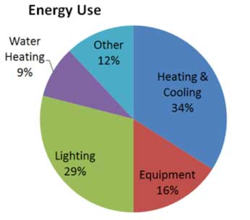

  - 6.3.3 Building management system
A building management system is an effective way to allow building technicians to “reduce energy costs and provide optimum comfort” end for users the students and teachers at the university. The initial cost of installation may be costly. Although it is a cost-effective way of “remote management of heating, ventilation, and air conditioning (HVAC)” (BMS control systems, 2021) therefore no need for maintenance staff to control each building or room to control the system. The system can control areas of the building to be “heated or cooled, what times of the day / days of the week and what temperatures are required”. This will be important between both the buildings as energy consumption will be different in managing them. Additionally, the uses of each room will have different energy consumptions. IT rooms in the Alex building depending on weather conditions might need less energy in terms of heating the room due to the heat output off the computers in the room. However, air conditioning may be needed to cool down the room. These are some of the considerations the maintenance technician will have to consider between the uses of the room? What part of the building is it, either the School of Arts or Alex building? What external factors will affect the conditions e.g., heat output of the computers and services technology.

Conclusion

This report has discovered the impacts the Alex building façade and refurbishment will have on the School of Arts building whilst considering the heritage significant potentially impacted. We have indicated the significant of the School of Arts building by completing a heritage impact statement. This indicating that the building is in conservation area with several grades ll building in its area. Additionally, we valued it with high evidential, positive aesthetic high historical value and medium communal. Second part of the report signified the importance on why we should retrofit correctly especially with a historic building. By using traditional methods to prevent deteriorating the building from using modern methods of construction. Lastly, evaluating the asset management approaches and how imperative it is to carry out the regular and correct maintenance checks. To minimise the number of repairs we have to perform on historic building such as School of Arts building to preserve its aesthetic and historic heritage.

Table 2. Summary Heritage Impact Statements
Proposed Work | Your objective | Significance of affected fabric | Assessing beneficial impact | Assessing harmful impact | Proposed Solution
New extension | Overall site more sustainable and economically. Designing it in a way, does not attract from the School of Arts building | Damage to brickwork and coarsen to attach the façade. Demolition to a 1936 caretakers and toilet area block. Might require listed building consent. | More economically used | Does change the appearance of the rear elevation | The building will be more economical and sustainable from the changes. More use for the university with extra rooms with special equipment which was not achievable in the school of Arts building.
Cleaning of Brickwork | Retain the brickwork original aesthetic value. | Excessive brushing could damage the brickwork. Using the wrong chemicals could also cause damage. | Minimum benefit. | Larger impact on damaging aesthetic value if done incorrectly. | Disagreement to do the proposed work.
Double glazed windows | Improve the energy efficiency of the school of Arts building. Minimise heat loss. | Removing of existing frame due to size difference in double glazing. | Improve energy efficient and heat loss of the building. | Alternations will require changes to the frame due to size different in glass. Affecting aesthetic value. | Check the conditions of windows before making changes. Secondary glazing could used to improve energy efficient up 75%.
Condition survey, potentially refixing of loose slates. | Prevent water ingress through the roof. Nails are accessible to rust and break, repair any loose slates | Potential slates damage which will need to be change for like for like repair. Listed building consent will be required. | Improving the safety of the roof. Prevent water ingress into the building which will cause internal damages. | Potential slates damaged or broken during the repair. | The roof must be fixed due to the damages it may cause to the rest of the building. Reuse existing slates where possible and use best match for replacement.
Installing Solar panels | To improve energy efficiency. | Required checks to where solar panels are being installed. Minimal damage should occur if fixing to the fabric of the school of Arts building. | Provide sustainable energy to power the buildings. Improve the energy efficient of the buildings. | Potential damage to external fabric if panels are fixed to brickwork or roof area. | Solar panels must be installed with minimal damage to any existing fabric of the School of Arts building.
Repaired atrium | Retain its original aesthetic value, making like for like changes if needed. | Replacement of existing material due to damage. | Prevent water ingress and available for public meetings, events, exhibition, and other activities. | Minimal damage as repairment is vitally needed. | Repairment will help retain the atrium original aesthetic value. Also allowing the community to use the services for events.
New radiators potentially | More efficient radiators, lighter and easier to service. | Potential damage to walls when fixing. | Improve energy efficient with improve radiators. Easier to carry maintenance on and lighter. | Minimal damage to the fabric. Aesthetic value damage with newer radiators compared to the original ones installed. | Potentially the radiators have already been changing. So, will not hold any historic value. More efficient radiators will be beneficial.
New ventilation system from the Alex building | Cleaner environment for the end users.  More energy efficient.  Easier to control with BMS system. | Could affect the School of Arts building due to change in climate. | Ventilation in the building will remove 'stale' air and replace it with 'fresh' air. | Shrinkage of wood / cracking around arches.  Dampness.  Condensation. | Recommended measuring humidity of the school of arts building. Before making the changes to prevent deterioration of the building occurring from the potential issues mentioned.

Reference list

alimcclary (2017). A guide to the repair of old brick walls. [online] The SPAB. Available at: https://www.spab.org.uk/advice/guide-repair-old-brick-walls [Accessed 11 May 2022].
ALUK (n.d.). AluK Aluminium Curtain Walling Systems at Alex House in Swansea - ALUK. [online] www.aluk.com. Available at: https://www.aluk.com/en/projects/alex-house [Accessed 25 May 2022].
Archisys Global Ltd (n.d.). The challenges of Higher Education in the MENA region. [online] Archisys Global. Available at: https://archisysglobal.com/blog-post/the-challenges-of-higher-education-in-the-mena-region/ [Accessed 25 May 2022].
BBC (2014). BBC - Wales - Arts - Doctor Who in Wales - Old Swansea Central Library. [online] www.bbc.co.uk. Available at: https://www.bbc.co.uk/wales/arts/sites/doctor-who-wales/alllocations/swansea-library [Accessed 9 May 2022].
BBC news (2012). Swansea’s old central library in £8m revamp by university. BBC News. [online] 4 Oct. Available at: https://www.bbc.co.uk/news/uk-wales-south-west-wales-19816621 [Accessed 9 May 2022].
BMS control systems (2021). What is BMS (Building Management Systems). [online] BMS Controls and Energy. Available at: https://bmscontrols.co.uk/what-is-bms/ [Accessed 26 May 2022].
Broad, S. (2015a). Case study: Trinity Saint David restores Central Library. [online] University Business. Available at: https://universitybusiness.co.uk/estates/case-study-trinity-saint-david-restores-central-library/ [Accessed 9 May 2022].
Broad, S. (2015b). Case study: Trinity Saint David restores Central Library. [online] University Business. Available at: https://universitybusiness.co.uk/estates/case-study-trinity-saint-david-restores-central-library/ [Accessed 25 May 2022].
BSI Standard Publication (2013). BSI Standards Publication BS 7913:2013 Guide to the conservation of historic buildings. [online] Available at: https://products.ihserc.com/tmp_stamp/400107125/ACPCHFAAAAAAAAAA.pdf?sess=400107125&prod=CIS1 [Accessed 25 Apr. 2022].
CADW (1987). Listed Buildings - Full Report - HeritageBill Cadw Assets - Reports. [online] cadwpublic-api.azurewebsites.net. Available at: https://cadwpublic-api.azurewebsites.net/reports/listedbuilding/FullReport?lang=&id=11551 [Accessed 9 May 2022].
CADW (2017). Why Maintenance Matters | Cadw. [online] cadw.gov.wales. Available at: https://cadw.gov.wales/advice-support/historic-assets/listed-buildings/looking-after-your-listed-building/why-maintenance [Accessed 26 May 2022].
CITY AND COUNTY OF SWANSEA (1986). CONSERVATION AREA Alexandra Road. [online] Available at: https://archive.swansea.gov.uk/media/2082/CA022---Schedule/pdf/CA022_-_Alexandra_Road.pdf [Accessed 15 Apr. 2022].
Ecclesiastical (2020). Historic and Listed Building Maintenance | Insights. [online] Ecclesiastical. Available at: https://www.ecclesiastical.com/risk-management/historic-and-listed-building-maintenance/ [Accessed 26 May 2022].
Fogo (2020). 5 Beautiful Buildings of Swansea. [online] Fogo’s Free Tours. Available at: https://www.fogosfreetours.com/post/beautiful-buildings-swansea [Accessed 9 May 2022].
Historic England (2013). Maintenance and Repair of Older Buildings | Historic England. [online] Historicengland.org.uk. Available at: https://historicengland.org.uk/advice/technical-advice/buildings/maintenance-and-repair-of-older-buildings/.
Historic England (2018). Energy Efficiency and Historic Buildings How to Improve Energy Efficiency. [online] Available at: https://historicengland.org.uk/images-books/publications/eehb-how-to-improve-energy-efficiency/heag094-how-to-improve-energy-efficiency/.
Institute of Historic Building Conservation (2017). Context 149 - May 2017. [online] ihbconline.co.uk. Available at: http://ihbconline.co.uk/context/149/#19/z [Accessed 25 May 2022].
Powell Dobson Architects Ltd (n.d.). Project ALEX (School of Industrial Design) by Powell Dobson Architects Ltd. [online] find-an-architect.architecture.com. Available at: https://find-an-architect.architecture.com/powell-dobson-architects-ltd/cardiff/project-alex-school-of-industrial-design [Accessed 9 May 2022].
Prior, N. (2011). Swansea Metropolitan University buys library building. BBC News. [online] 10 Jun. Available at: https://www.bbc.co.uk/news/uk-wales-13719371 [Accessed 10 May 2022].
RICS (n.d.). Investigation of Moisture and its Effects in Traditional Buildings. [online] Available at: RICS%20Historic%20England%20and%20PCA%20joint%20methodology%20with%20all%20endorsements%20and%20RICS%20approval.pdf [Accessed 25 May 2022].
THE BUILDING CONSERVATION DIRECTORY (2017). HERITAGE RETROFIT OLDER BUILDINGS AND SUSTAINABILITY. [online] Available at: https://moodle.uwtsd.ac.uk/pluginfile.php/565080/mod_resource/content/1/Heritage%20retrofit%20publication.pdf [Accessed 19 May 2022].
Thomas, G. (2018). Soft porn and secrets: The fascinating pasts of Swansea’s grand old buildings. [online] WalesOnline. Available at: https://www.walesonline.co.uk/news/wales-news/soft-porn-secret-passageways-fascinating-14547813 [Accessed 9 May 2022].
Turner, R. (2015). University defends budget on restoring Swansea’s former library. [online] WalesOnline. Available at: https://www.walesonline.co.uk/news/wales-news/swanseas-former-library-building-refurbishment-8968562 [Accessed 9 May 2022].
WalesOnline (2011). New role for Swansea’s former Central Library. [online] WalesOnline. Available at: https://www.walesonline.co.uk/news/wales-news/new-role-swanseas-former-central-1826668 [Accessed 10 May 2022].
Some images used for the report are from the following websites…
CADW (1987). Listed Buildings - Full Report - HeritageBill Cadw Assets - Reports. [online] cadwpublic-api.azurewebsites.net. Available at: https://cadwpublic-api.azurewebsites.net/reports/listedbuilding/FullReport?lang=&id=11551 [Accessed 9 May 2022].
RICS (n.d.). Investigation of Moisture and its Effects in Traditional Buildings. [online] Available at: RICS%20Historic%20England%20and%20PCA%20joint%20methodology%20with%20all%20endorsements%20and%20RICS%20approval.pdf [Accessed 25 May 2022].
Historic England (2018). Energy Efficiency and Historic Buildings How to Improve Energy Efficiency. [online] Available at: https://historicengland.org.uk/images-books/publications/eehb-how-to-improve-energy-efficiency/heag094-how-to-improve-energy-efficiency/.
Historic England (2013). Maintenance and Repair of Older Buildings | Historic England. [online] Historicengland.org.uk. Available at: https://historicengland.org.uk/advice/technical-advice/buildings/maintenance-and-repair-of-older-buildings/.
BSI Standard Publication (2013). BSI Standards Publication BS 7913:2013 Guide to the conservation of historic buildings. [online] Available at: https://products.ihserc.com/tmp_stamp/400107125/ACPCHFAAAAAAAAAA.pdf?sess=400107125&prod=CIS1 [Accessed 25 Apr. 2022].
BBC (2014). BBC - Wales - Arts - Doctor Who in Wales - Old Swansea Central Library. [online] www.bbc.co.uk. Available at: https://www.bbc.co.uk/wales/arts/sites/doctor-who-wales/alllocations/swansea-library [Accessed 9 May 2022].

