Abstract
This study presents an analysis and an evaluation to answer if adverse childhood experiences can determine criminality in looked after or care experienced children and young people. The analysis shows that influences such as your parent and peers can affect the way a child behaves or how they live their lives, it also showed that the public understood the long-term effects that ACEs may have on children and young people throughout their lives and how this may impact them. This study found that while children and young people may be influenced by their experiences such as ACEs or being in care not all of them will turn to criminality. Evidence suggests that a person can be influenced at a young age that they will only be as bad as the person who raised or taught them. Major issues with the study were that a lot of students were sending out surveys at the same time meaning the study did not achieve the desired number of responses. Recommendations suggest conducting a survey such as this on professionals as well as the public.
Can adverse childhood experiences determine criminality in looked after or care experienced children and young people.
Tammy Morris-Puttock (2100519)

Acknowledgements
A major thank you to my dissertation supervisor, Laura Knight, for her support and valuable feedback throughout this study. I am thankful for my friends who supported me and kept me on track, even during the late-night study sessions. I would like to say a massive thank you to my family for the support given when trying to stay focused and picking the topic.

Declarations
This work has not previously been accepted in substance for any degree and is not being concurrently submitted in candidature for any degree.
STATEMENT 1
This dissertation is being submitted in partial fulfilment of the requirements for the degree of BA/BSc.
STATEMENT 2
This dissertation is the result of my own independent work/investigation, except where otherwise stated.
Other sources are acknowledged in the Reference Section.
STATEMENT 3
I hereby give consent for my dissertation, if accepted, to be available for photocopying and for interlibrary loan, and for the title and summary to be made available to outside organisations.
STATEMENT 4
I hereby give consent for my dissertation, if accepted, to be available on the university’s IT system to those who have consent to use the system.

Student’s Name: Tammy Morris-Puttock

Signed:

Date: 07/05/2024

Contents
Acknowledgements 1
Declarations 2
1. Introduction 5
1.1 Aims and Objectives 6
1.2 Time scale 6
1.3 Methods 7
1.4 Value of research 7
2. Literature Review 9
2.2. Objective 1: To identify the prevalence of criminality in care experienced and looked after children and young people. 9
2.3. Objective 2: Evaluate the long-term effects adverse childhood experiences have on children and young people who are in care or are care experienced. 11
2.4 Objective 3: Evaluate public perception on the link between adverse childhood experiences and crime as well as what can be done to reduce criminality. 14
3. Research Methods 16
3.1 Research Philosophies 16
3.2 Research Approach 17
3.3 Research Strategies 17
3.4 Choices 18
3.5 Time horizon 18
3.6 Technique and Procedures 19
3.7 Limitations 20
4. Analysis 21
4.1. Findings 21
4.2. Objective 1: To identify the prevalence of criminality in care experienced and looked after children and young people. 23
4.3. Objective 2: Evaluate the long-term effects adverse childhood experiences have on children and young people who are in care or are care experienced. 23
4.4. Objective 3: Evaluate public perception on the link between adverse childhood experiences and crime as well as what can be done to reduce criminality. 26
4.5. Summary 29
5. Conclusion 30
5.1 Objective 1: To identify the prevalence of criminality in care experienced and looked after children and young people. 30
5.2 Objective 2: Evaluate the long-term effects adverse childhood experiences have on children and young people who are in care or are care experienced. 31
5.3 Objective 3: Evaluate public perception of the link between adverse childhood experiences and crime as well as what can be done to reduce criminality. 31
5.4 Implications 32
5.5 Recommendations 32
5.6 Limitations 33
5.7 Finishing statement 33
6. References 34
7. Appendix 42
Research survey. 42

Introduction

Simkiss (2019, p 26) states that those within the public care system have significantly higher rates when it comes to offending behaviours, with the convicted and final warning rate being double that of the general population. Furthermore, the Children’s Commissioner (2022) states that children in care are 4.5 times more likely to receive criminal sentences than those who are not in care. The idea that the criminality rate within this demographic shows that something needs to be done to help prevent crime and lower crime rates.

The Ministry of Justice (2023) states females within the care system or those who have left are often highly represented within the criminal justice system even though they do not get involved with them. This conveys a lack of true representation regarding how many of those in care or who are care leavers become victims of criminality. Caldwell et al (2006) state that within their study they saw that adolescents go through a range of different changes; these changes and experiences can affect their behaviour and maturity. The way children view their experiences can affect their behaviour and lead to low self-esteem. Studies have identified that ACEs cause a lower perception of their future and some who have experienced violence may have a decrease in their future aspects (Craig 2018). Within his research Craig (2018) says that although recent studies are limited in their methodologies, none have seen a correlation between a decrease in future aspects. The idea that a lack of future goals may lead to criminality shows the effect of adverse childhood experiences and how they can affect someone so exponentially.

The focus of the research is on adverse childhood experiences and crime within this group. The term adverse childhood experiences (ACEs) refers to situations or experiences that are deemed to be significantly stressful and traumatic that happen during a person’s childhood or adolescence (NHS 2023). Centers for Disease Control and Prevention (2021(a)) says that adverse childhood experiences are often linked to mental illness, drug, and alcohol abuse as well as other health issues. These issues may affect the way children and young people interact with adults and peers. The way they interact with people may mean that they may fall into crime through gangs or peer pressure if they are made to feel a sense of worth. Studies have shown that around 50% of adults have experienced a single ACE whereas 13% have been seen to experience four or more ACEs (Scott 2020). Understanding what adverse childhood experiences are is difficult as they can manifest themselves in many forms; some ways are any form of abuse or violence, neglect, having divorced parents, seeing, or witnessing substance misuse, mental illness, or having a family member that is incarcerated (Psychology today 2023). While these experiences are seen as traumatic, they can happen to anyone, especially as previously stated by Scott (2020) 50% of adults experience them and not everyone is in care, this shows that children and young people are likely to be exposed to ACEs at some point in life. Nevertheless, many of the acts included within the topic of adverse childhood experiences may lead to mental illnesses and a change in the way they behave.

1.1 Aims and Objectives

This research aims to determine whether adverse childhood experiences can predetermine criminality in looked after and care experienced children and young people. This aim will be achieved by investigating three objectives, the first objective will be to identify the prevalence of criminality in care experienced and looked after children and young people. The second objective is to evaluate the long-term effects that adverse childhood experiences have on children and young people in care or those who are care experienced. The third and final objective of this research is to evaluate public perception on the link between adverse childhood experiences and crime as well as what can be done to reduce criminality.

1.2 Time scale

The time scale of this research starts from 3rd of October 2023 and will conclude on the 7th of May 2024. The research is split into five chapters which will all have individual deadlines. The proposal form and ethics form will both be completed by the 20th Of October 2023. The first two chapters will be due before the end of 2023; the introduction will be completed by the 10th of November 2023 and the literature review will be completed by the 8th of December 2023. The last three chapters will be submitted in 2024, the first being the research methodology with the deadline of 9th of February, the analysis of results by the 22nd of March and the conclusions and recommendations by the 19th of April. These deadlines will allow me to keep the research steady and on track to complete this research effectively and promptly.

1.3 Methods

Throughout, the research there will be the use of both primary and secondary data. Open and closed questions will be used within the questionnaire as it would make the time taken to partake in the questionnaire shorter and will help to understand others' opinions. Jones et al (2013) research questionnaires are useful tools when trying to gain knowledge and gather information based on a person’s perspective within a large group. All data collected from the questions such as the closed questions allow for data to be converted into quantitative data which will help aid statistical analysis (McLeod 2023). Using statistical analysis means that it will be able to utilize the data more efficiently and identify trends or inconsistencies. The participants of the survey will be those over the age of 18, as they can give consent, and they need to live in the UK; an age question will be given by starting the survey which would imply consent. This group will include family, friends, peers, and teachers. The ideal sample size would be around 100 to 200 responses; Andrade (2020) says that if a sample is bigger than initially needed it can help to improve the accuracy of the results.

1.4 Value of research

The research will help to identify the issues within children and young people who are care experienced and care leavers in the UK. By identifying the issues there will be some idea of what needs to be reviewed to give the correct support as well as help train people to become trauma informed. Office for Health Improvement & disparities (2022) states that trauma-informed practice is designed to help with understanding the impact that being exposed to trauma has on social development as well as other areas such as psychology, biology, or even neurology. Having trauma-informed practices is important as everyone may have come across someone who has been affected by adverse childhood experiences, they may have seen the effects it has but this practice helps to educate those who do not know. Throughout the research, the aim is to try to improve the idea of trauma-informed practice with a focus on children and young people who are in care or are care experienced. Improving these practices should allow authoritative figures to identify key triggers and reactions to trauma. If this research can help, it would allow them to understand why those in care or care experienced may turn to criminality and if it can be determined through the right practices. This information needs to be shared with parents, teachers, and public services as they are the people and services that handle potentially vulnerable children, young people, and adults. Having trauma-informed practices means that you can identify programs to help prevent reoffending, helping to educate those in a position of power on how they can help support these children and young people.

Literature Review

Through this research, the aim is to ascertain whether adverse childhood experiences can determine if a care-experienced child or young person is likely to turn to crime. The population of those in the care system in the year ending March 2022 was 82,170 (The Office for National Statistics 2022(b)). Those in the care system have different reasons for being there, such as those involved in adverse childhood experiences. However, not everyone turns to crime, according to the Office for National Statistics (2022(a)) when discussing those in the care system and the criminal justice system says that 52% of children and young people in care are convicted of a criminal offence by the time they turn 24-years-old. This shows that over half of those in care will end up in the criminal justice system before the age of 24, this suggests that there is a need to understand why those who experience adverse childhood experiences turn to crime.

2.2. Objective 1: To identify the prevalence of criminality in care experienced and looked after children and young people.

When it comes to identifying the prevalence of adverse childhood experiences, it is important to identify the number of people who are affected by them. ACE Hub Wales (2022) said that out of 100 people, half of them have experienced a single ACE whereas 14 of them have experienced more than one. This demonstrates how society is affected by them and how prevalent adverse childhood experiences are within society. It also showed that out of the 100 people only 36 of them had not experienced an ACE. Adverse childhood experiences are not as unusual within society as people may think, the ACEs that have been experienced are often neglected whether it was witnessed or experienced or even having a family member attempt or commit suicide (Centers for Disease Control and Prevention 2021 (b), p1). When it comes to offending, the Prison Reform Trust (2016) said that in England those in care are six times more likely than those without care experiences to be convicted or cautioned of a criminal offence. The idea that there is a high level of children in care who are convicted of offences suggests that ACEs does impact criminality, as they are more likely to be convicted or cautioned. When it comes to criminal activity Zwokdiak-Myers (2007, p 40) states that people will predominantly turn to criminality in their teenage years. The idea that children and young people resort to criminality in their teenage years suggests the need to focus on them to find out why this may be. There are reasons why teenagers may turn to crime, Brezina et al (2009, p 1092) state that those with the belief that they do not have a future are said to have nothing to lose when it comes to the idea of criminality or violence. This can coincide with the age group especially as teenagers have a lot going on, especially with changes and having to keep up with schoolwork; it could be even worse if they have or are experiencing adverse childhood experiences. In terms of the crimes that are committed by children and young people, the Youth Justice Board (2022, p 9) stated that children and young people are more likely to be arrested for offences such as sexual offences, violence against a person and possession of a weapon. These types of offences may reflect what they have experienced or even witnessed; Vaswani (2018) states young people who offend often have a higher exposure rate to adverse childhood experiences than most people. This suggests a clear link between criminality and adverse childhood experiences.

Identifying the prevalence of criminality and adverse childhood experiences in the criminal justice system is important, the National Child Traumatic Stress Network (2023) states that 80% of those involved in juvenile justice have experienced a traumatic experience in the past. This shows that the majority of those within the criminal justice system have experienced an ACE, which also displays the prevalence of ACE within offending, this does not suggest offending solely during childhood. While it is no clear way to identify those with ACEs, those who are care-experienced make up, almost 25% of adults within the prison system in addition to the 50% of those under the age of 21 who are care-experienced had some form of interaction with the criminal justice system (Home for good 2023). Many of those in care have experienced adverse childhood experiences, suggesting they may require additional support to help deter them from crime, this however does not mean they will be criminals. The National Institute for Health and Care Excellence (2021, p 6) said that everyone in care has a unique reason for being there and the most common reason for being in care is due to abuse or neglect, it makes up 65% of those in care; this suggests that more than half of those in the care system have experienced a single ACE. In terms of offending, Ford et al (2019, p 18) found that 84.1% of those in prison suffered from at least a single ACE and around half had been exposed to four or more ACEs. The high level of people who experience ACEs within prison, questions what the government can do to try and prevent offending or reoffending; this may mean those in prison require additional support and need to re-assess why those who experience ACEs are more inclined to offend.

2.3. Objective 2: Evaluate the long-term effects adverse childhood experiences have on children and young people who are in care or are care experienced.

When looking into the long-term impact of adverse childhood experiences it is important to see how children and young people can be affected, Crandell et al (2019, p 1) stated that those who experience ACEs at an early age are vulnerable to the long-term impacts and can often lead to a range of different situations for the child or young person throughout their childhood such as addictions to illegal substances, a poor lifestyle and a lower life expectancy due to having experienced any abuse. The fact that children and young people are subjected to long-term effects, some of which could lead to criminality, means that there is a need for intervention. When It comes to care leavers, there is a greater risk of being exposed to exploitation which will increase the chance of someone being victimised, however, this also means that they have the potential to cause themselves harm as well as others (Gooch et al, 2022, p 5). The fact that those who experience ACEs or have been in care are more likely to be victimised means that they need support to help prevent offending or causing harm to themselves or others. Having experienced ACEs could lead to a child or young person being vulnerable to being exploited by criminal gangs, the NSPCC (2023) says that gangs will often exploit children and young people sexually, through human trafficking or even through gang and knife crime. Victimisation after having experienced ACEs growing up means that the government needs a way to prevent victimisation within those in care. When it comes to violent offending or aggression, it is often due to having seen it, this could suggest a predisposition to violence. This can be seen in Bandura's 1961 Bobo doll experiment, which showed that children and young people can be taught to be violent; those who observed violence can be elicited to more aggressive behaviour out of children (Galanaki and Malafantis 2022). This shows that seeing violence can lead to imitation, suggesting those who suffer domestic abuse or other violent adverse childhood experiences could convey that aggression may be due to psychological issues around their past experiences. The concept of violence being witnessed and imitated suggests that children and young people may respond to certain situations with a level of anger or aggression due to the violence they may have witnessed from domestic abuse or even experienced themselves (Gray et al 2021, p 10). Tending to resort to violence may mean that the child or young person ends up in situations that may be difficult to get out of, for example, they end up committing a crime and being convicted.

When evaluating the long-term effects that ACEs it is important to understand their effect. Corsaro (2015, p 289) said that neglect is one of the most common forms of abuse a child can experience this refers to parents not meeting the needs of a child regarding health, development, and safety. Neglect can impact the mental health and development of a child or young person; potentially leading to cognitive issues when handling situations based around their trauma. There are many different ways a child or young person can experience ACEs such as child abuse or neglect. People who have experienced emotional or even physical abuse, as well as neglect, will often have a greater chance of developing certain disorders, such as depression, compared to someone who has not experienced abuse (Norman et al 2012, p 31). Having experienced abuse or neglect and then dealing with mental health issues suggests that children and young people have a constant reminder of their trauma. When it comes to abuse, the National Institute for Health and Care Excellence (2021, p 6) states that around 48% of people suffer from physical care experienced nature of physical abuse, which could mean that the long-term effects could be issues with the brain as well as other parts of the body. The impact of emotional and sexual abuse could be that the child or young person may develop trust issues due to wanting to protect themselves.

Abuse is a massive part of adverse childhood experiences, the Office for National Statistics (2020) said that in 2019, there were around 227,500 recorded offences of child abuse. The concept that in one year alone there were so many cases of child abuse shows that adverse childhood experiences are a big part of society, children who suffer ACEs may suffer at the hands of their family causing them to lose faith and think that this is the right way to think and act. The number of children and young people who suffer child abuse is high and shows the severity of this specific type of abuse; it shows that something needs to be done to protect against child abuse and potential issues in the future related to trauma. The Scottish Government (2023) states that those who experience more than one adverse childhood experience have a greater potential of taking part in risky behaviour, which could lead to health issues in addition to an increased risk of criminality. The problem with taking risks could mean that you are turning to drugs or alcohol to cope with adverse childhood experiences, although it could also lead to many other issues. The Mental Health Foundation (2021) suggests that people use drugs due to stress or struggle to cope with what they have experienced in life. There are other reasons why people need coping mechanisms, Mind (2023) states that trauma can affect us in many different ways both emotionally and physically, they could take the form of “flashbacks”, “panic attacks”, “dissociation”, any thoughts of self-inflicted pain or death, as well as issues with drugs and alcohol. These forms are ways that trauma can resurface, they can be triggered or be random, but it is often a repetitive experience that replays trauma.

Other issues that could come from traumatic experiences could affect the people around them, the NSPCC (2019) states that looked after children and young people who have experienced neglect or abuse can often display “challenging behaviours” and that they may also have difficulties forming healthy relationships. Forming relationships is a significant milestone for a child or young person especially when in care as it often means being around new people and living with people whom you may not trust, making their jobs slightly more difficult. Challenging behaviours need to be looked at in a way where the child or young person is being given pity or potentially caused to have a flashback or panic attack as that would significantly affect the way they trust certain people. Traumatic experiences such as adverse childhood experiences can often lead to nightmares, the NHS (2020) states that nightmares or night terrors can be a product of fear meaning something that is seen as frightening. The idea that your nightmares can reflect the things that frighten them shows that those who go through adverse childhood experiences suffer not only while going through the trauma but also afterwards. Having yet another idea of the effect of trauma will mean they relive it causing more stress to the child or young person meaning they may develop unhealthy coping mechanisms.

2.4 Objective 3: Evaluate public perception on the link between adverse childhood experiences and crime as well as what can be done to reduce criminality.

There are methods that organisations have used to try to provide support for those who experience adverse childhood experiences; one method is trauma-informed practices, these refer to understanding how trauma can affect a person, how they learn and behave in school which can be affected by trauma (Compton et al 2023, p 1). Having an awareness of the impact of ACEs allows authority figures to understand why those around them behave in certain ways. Offending behaviour in children and young people may be affected by the influence of their parents and family, Gupta et al (2021, p 4) said that there is a known link between a parent having experienced ACEs and it having an effect on their children in the future. This suggests that people may offend due to having witnessed or being pressured but can also be due to having parents who have experienced ACEs themselves which may influence the way they behave themselves possibly leading to maltreatment. Tung et al (2018, p 6) say that maltreatment has a significant correlation with violence as well as non-violent delinquency and drug and alcohol use. The concept of maltreatment leading to substance misuse suggests that shows the impact they may have, as it may lead to unhealthy coping methods which can mean other issues in adulthood or death at a young age.
There are methods to prevent a child or young person from being labelled as a criminal due to adverse childhood experiences, factors that can help include having an adult who is trusted or a friend who can support them and engaging with the community through sports (Violence prevention unit 2023). In some cases, it is extremely difficult for children and young people in care or those with care experience to trust, it takes time and patience to build a relationship with them but also an understanding of what they went through and its effects. When it comes to government policies, Public Health England (2019) states that to help prevent people from offending or reoffending they need to try to support healthy relationships with family, try to prevent violence or exploitation and make looked after children a priority as well as support certain interventions. This means having an approach that is focused on the child or young people who had an adverse childhood experience, helping to combat crime at the root. Another approach by the Welsh Government (2021) said that they approach the issue by raising awareness focusing on supporting parents to avoid the consequences of ACEs or by having interventions in place. The literature surrounding ACEs and criminality often does not suggest how their effects could be lessened, it also does not give enough focus on the impact that certain influences have on children and young people.

Research Methods

A research methodology sets out the procedures and techniques used to identify and analyse certain topics (Heever 2022). Having a plan that sets out how and why the research will be conducted will help to answer the overarching question that the research aims to answer: Can adverse childhood experiences determine criminality in looked after or care experienced children and young people? The framework being used to demonstrate the process of this methodology is the research onion created by Saunders et al in 2007 as seen in Figure 1. Through the six layers, the research onion is designed to help guide a researcher when looking into how to structure and design their research (Mardiana 2020). The main focus of the methodology is to investigate the third and final objective which is to evaluate the public perception of the link between adverse childhood experiences and crime as well as what can be done to reduce criminality.
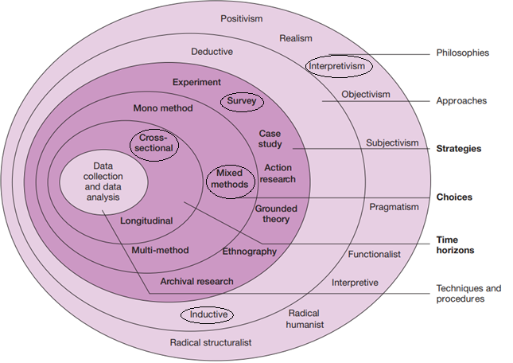
Figure 1 – The research ‘onion’ (Saunders, Lewis, and Thornhill 2007, p 132)

3.1 Research Philosophies

When it comes to looking at research philosophies it is important to identify what perspective is needed, this research study follows an epistemological philosophy. Epistemology refers to the study of knowledge, it investigates the what, why, and how of knowledge and how it may be affected (Greco 2021). Questioning current knowledge is what is needed within the question of this study, as it focuses on determining criminality based on Adverse childhood experiences within a specific demographic of people. Epistemology branches into interpretivism which will be used within this study. Interpretivism is the idea that reality is ever-changing and is different for everyone, as an individual’s experience changes the way reality is viewed based upon their perspective (University of Nottingham 2023). Due to the nature of the research, everyone may have a different viewpoint when it comes to this topic meaning that using an interpretive philosophy is the ideal approach. The idea of this research is to question the views and reality of children and young people in care and those who are care experienced.

3.2 Research Approach

The research approach that will be used throughout this study is inductive reasoning, Kim (2021, p151) says that inductive research involves starting with research and establishing a theory, followed by further observing and investigating to find an overall theory. Though researching you can identify a theory based on what has been seen or on the lack of what has been seen. Seeing where the research gaps are, allows for a focus to be put on what is missing, in this study it would be the perspective others have on children and young people in care or who have care experience. Hassan (2024) says inductive research is used when investigating a new theory and when there is not any or limited previous research. Inductive research will be used as the topic of the study needs to be investigated as it is based on adverse childhood experiences and public perception.

3.3 Research Strategies

Descriptive research is used to describe what or why something has happened, this can usually be done through observations or surveys when researching (Nassaji 2015, p131). The fact that this strategy is designed to describe what and why something is happening will help to evaluate the link between the public perception of ACEs and criminality as well as what can be done to reduce criminality in this area. Another reason for using the strategy of descriptive research is that it allows for the use of both qualitative and quantitative data during collection (Dudobskiy 2024). Throughout the process of collecting data, it will use a survey which will be designed to collect both qualitative and quantitative data to be able to evaluate more effectively through the use of both open and closed questions.

3.4 Choices

To investigate the public perception and how to combat criminality within children and young people; the research will use mixed methods. This choice was decided because it will be looking at the prevalence and long-term effects as well as the perspectives of those within society. Using mixed methods within research adds more value to the understanding and interpretation than it would be using singularly just qualitative or quantitative data alone (McKim 2017, p203). By creating a better understanding it allows for others to gain a more well-rounded knowledge of the topic, for example, it would allow for people to express feelings and opinions while still collecting data that can be measured. This would allow for the research to see prevalence and well as evaluate perspective. This also allows for a more in-depth understanding of the study as well as a collaboration of data (Schoonenboom and Johnson 2017, p 108).

3.5 Time horizon

Time horizon refers to the amount of time it will take to conduct and gather the data needed for the study in this case. A cross-sectional approach allows for an investigator to do data collection within a short timescale, often focusing on investigating the relationship between variables (Hulley et al 2013, p88). Having an approach that allows for data to be collected in a short time benefits this study because it is not only being conducted over a short period but also needs to investigate the relationship between ACEs and criminality which suggests this may be an ideal method. Cross-sectional studies are usually fast to conduct and inexpensive (Setia 2016). Due to the nature of this research, this is the ideal option due to the short time frame that it spans across as well as the fact that it is not funded.

3.6 Technique and Procedures

Techniques and procedures make up the final inner layer of the research onion, this layer covers data collection and analysis, and a survey will be used to collect relevant mixed data. The Office for Health Improvement and Disparities (2020) states that by using a mixture of qualitative and quantitative data it will allow the research to create a deeper understanding based on what has been collected. A deeper understanding allows for a more well-rounded analysis which may make it more accurate when answering the overall question. To collect mixed data a range of open and closed questions will be used, especially as the research is looking into perspective. Surveys can be used in a few ways such as by mail, over the phone, and in-person interviews (Scheuren 2004, p 11). The online survey will be conducted and created through Google Forms, which allows it to be cost-efficient and allows it to be done in the time period. Due to the short time period survey the use of an online survey will be ideal when collecting research data. This survey will consist of a mixture of both closed and open questions, this will ensure that both qualitative and quantitative data can be collected.

The sample size of the survey will depend upon the number of responses that it gains, an ideal number of responses would be between 100 to 200 although this is not guaranteed. The sampling method that will be used is exponential non-discriminative snowball sampling, which refers to one person starting the survey and sharing it with other people to complete allowing for a range of data to be collected (Dudovskiy 2019). This allows for a wide range of participants to be found which will allow for the survey to be inclusive and diverse. Before the survey begins there will be a question asking for the age of the participant because those over eighteen can consent to the information given being shared, the age also allows for to see the changes in perspectives for this topic. Once the data has been collected it will be analysed using thematic analysis. Thematic analysis refers to finding and analysing data by seeing if there are themes within the data that can help to answer a research question (Maguire and Delahunt 2017, p3353). By identifying themes, it makes it easier to answer the question and offer suggestions of what could be done to reduce criminality in children and young people. Slutsky (2014, p67) states that if the data collected shows trends or any correlation a graph is the best way to display the data. Through the use of charts and graphs, it will allow for both the researcher and the reader to identify themes, which can help to prove or disprove the question.

3.7 Limitations

Some limitations and reflections need to be considered, due to the survey topic being adverse childhood experiences. There will need to be a prewarning before the introduction of the survey, this will allow the participant to gain a brief understanding of the content covered in the survey. One issue that may arise is reliability, which refers to whether or not the research can be replicated and if it will get the same results (Leung 2015, p326). The reliability of the survey can be affected by many issues such as people misunderstanding the question or even showing bias. Bias could be shown depending on who participates in the survey as certain job roles may affect their knowledge and perspective of the topic. Another issue that can be affected by these issues is validity; Heale and Twycross (2015, p66) say that validity refers to the accuracy of the study. While trying to ensure validity, this means ensuring the responses are authentic to what the participants have said, this may be difficult due to incomplete answers.

Analysis

A data analysis is designed to systematically analyse data by describing what is shown and presenting it in a manner where it can be condensed down and evaluated (Sharma 2018). This chapter will analyse the findings from the research survey that was conducted online and interpret them as well as link them back to the literature used within the literature review. All data will be presented where necessary in a graph or chart where necessary, analysed, and then synthesised. The results of the research will be coded into one of the three objectives:

- To identify the prevalence of criminality in care experienced and look after children and young people.
- Evaluate the long-term effects adverse childhood experiences have on children and young people who are in care or are care experienced.
- Evaluate public perception of the link between adverse childhood experiences and crime as well as what can be done to reduce criminality.

4.1. Findings

While conducting the research survey the idea was to get around 100 to 200 responses, although due to the number of surveys that were released during this period, it only had a total of 87 participants. Participants were asked their age and gender, allowing for those under the age of 18 to be stopped from participating following the ethical considerations within this research study.
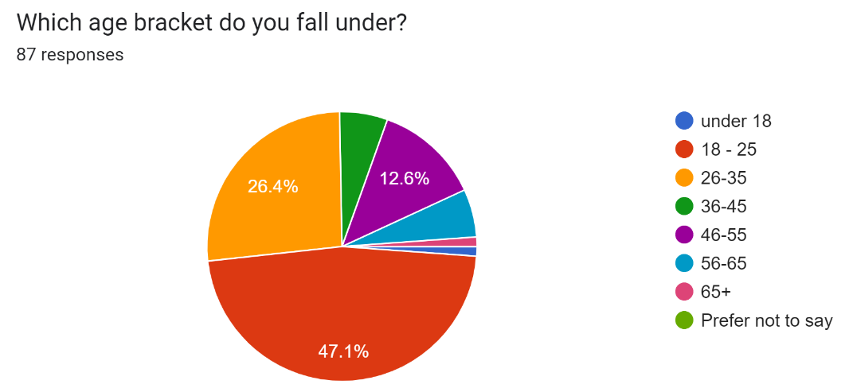
The pie chart above displays the responses given by participant when asked their age. It shows that 47.1% (41) of participants were aged 18 to 25, 26.4% (23) were aged 26 to 35, 5.7% (5) were aged 36 to 45, 12.6% (11) were aged 46 to 55, 5.7% (5) were aged 56 to 65, 1.1% (1) were 65+ and only 1.1% (1) were under 18 although they did not complete the survey. The use of exponential non-discriminative snowball sampling meant that the age range of those who answered, depended upon whom the survey was shared with, showing that those aged 18 to 25 were more likely to complete and share it with others, the age conveyed those who followed the account the survey was shared on.
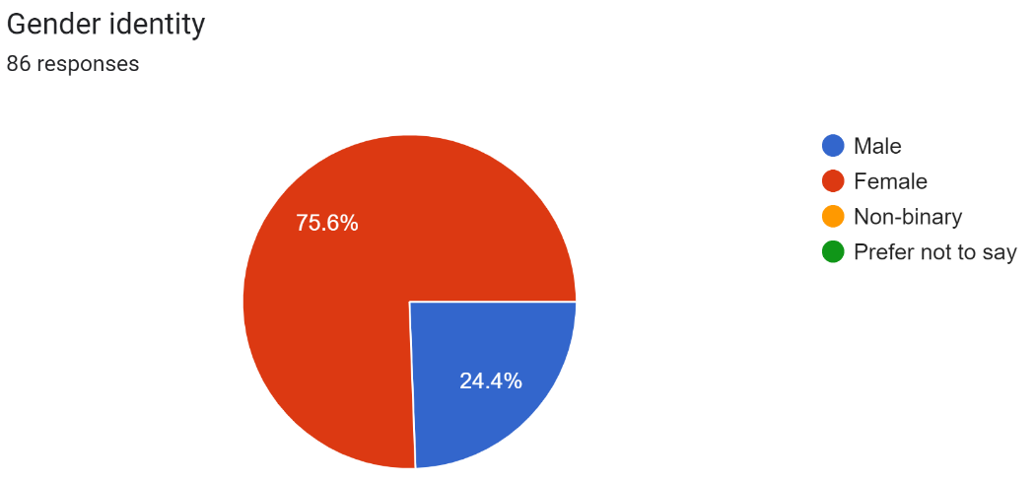
The pic chart showed that 75.6% (65) of the participants were female and 24.4% (21) of them were male. This shows that females may have been more likely to receive the link to the survey than men were, meaning that there could be bias due to having a predominantly female perspective. This could also be affected by the gender bias of those following the account where the survey was shared originally.

4.2. Objective 1: To identify the prevalence of criminality in care experienced and looked after children and young people.

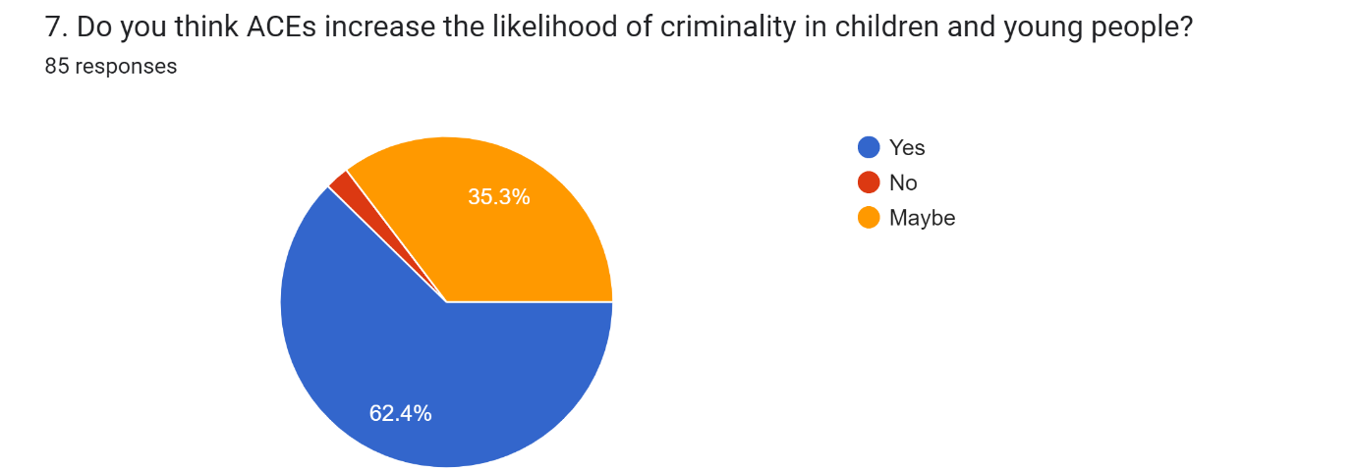In response to the first objective, this question was used to identify if the participant’s thought crime was prevalent in children and young people who have suffered ACEs. 35.3% (30) of respondents answered maybe, 62.4% (53) of respondents answered yes and 2.4% (2) of respondents answered no; showing that there is a significant belief that ACEs increase the likelihood of turning to crime, although a significant number of participants were unsure if it has any effect. This result suggests that there may be a lack of public awareness about the impact of ACEs on children and young people who are care experienced. In correspondence with the literature review of this study, the National Child Traumatic Stress Network (2023) said that around 80% of those involved in juvenile justice had experienced some form of traumatic event. This shows that the findings of the survey correlate with existing literature, showing that ACEs can be seen throughout the criminal justice system.

4.3. Objective 2: Evaluate the long-term effects adverse childhood experiences have on children and young people who are in care or are care experienced.

Question 4:
This question asks the participants “Why do you think children and young people turn to crime”. The results of this question several themes were identified, predominantly negative factors such as negative behaviours, poverty, past experiences such as ACEs, and being in care as well as negative influences. Some of these themes can be seen in the following responses from the participants:
- “It's what they've seen growing up, so they've seen it as normal, so their brain normalises it”.
- “Poverty, abuse, mental health problems”.
- “Peer pressure - substance misuse.”
The responses provided by the participants show the idea that the reason a child or young person may turn to crime is due to negative influences, poverty, ACEs, and a handful of other issues. Within the literature used in this study, the Scottish Government (2023) said that those who have experienced an ACE are more likely to partake in risky behaviour, which can impact health as well as criminality. This shows that negative factors such as influences, and abuse can be more inclined to turn towards criminal activities due to the risk involved.

Question 17:
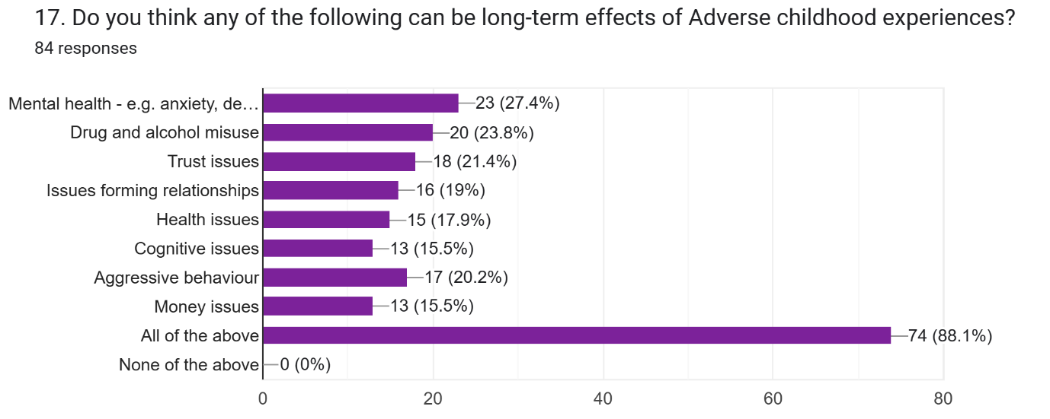
Question 17 was used to identify the public's thoughts about the long-term effects of adverse childhood experiences. The issue with this question was that the participants could select more than one answer meaning there were overlapped responses; regardless, it shows a clear distinction that many identified all the options as long-term effects. The graph shows that the public thought that the most predominant long-term effects of ACEs were mental health issues and drug and alcohol misuse. Compared to money issues and cognitive issues having the least number of selections. However, the public showed an understanding that all of the effects listed had an impact on children and young people who experienced ACEs. Crandell et al (2019) said that some of the long-term effects of ACEs can include Alcohol and drug addiction, a poor lifestyle and lower life expectancy due to the abuse experienced. This supports the idea that drug and alcohol misuse have a significant impact on those who experience ACEs. Norman et al (2012, p 31) support that ACEs can lead to mental health issues, stating that children and young people have a greater chance of developing disorders such as depression.

Question 18:
This question asks: “What do you think can be done to reduce the long-term effects of ACEs?”. This question tries to understand how the public thought the long-term impact of criminality could be reduced in children and young people. Throughout the responses to this question, there have been a handful of themes identified, they are therapy or counselling (19.3%), support (44.6%), intervention (10.8%), awareness (3.6%), and mental health (8.4%). These themes can be seen in the following responses from the participants:
- “More mental health support for care leavers and trauma-informed practice”.
- “Support and therapy”.
- “Create awareness about it all. Work with families, staff, friends to find ways to help children in day-to-day activities and encourage them with opportunities for their future”.
The participants clearly state in their perspectives showing that they believe that there is a need for awareness, support such as therapy, and trauma-informed practices as well as creating a level of awareness. Public Health England (2019) states that to help prevent people from offending or reoffending they try to support healthy relationships with family, try to prevent violence or exploitation and make looked after children a priority as well as support certain interventions. This supports the key findings as it shows that the government acknowledges the need to have support and interventions to help stop children and young people from offending or reoffending.

4.4. Objective 3: Evaluate public perception on the link between adverse childhood experiences and crime as well as what can be done to reduce criminality.

Question 6:
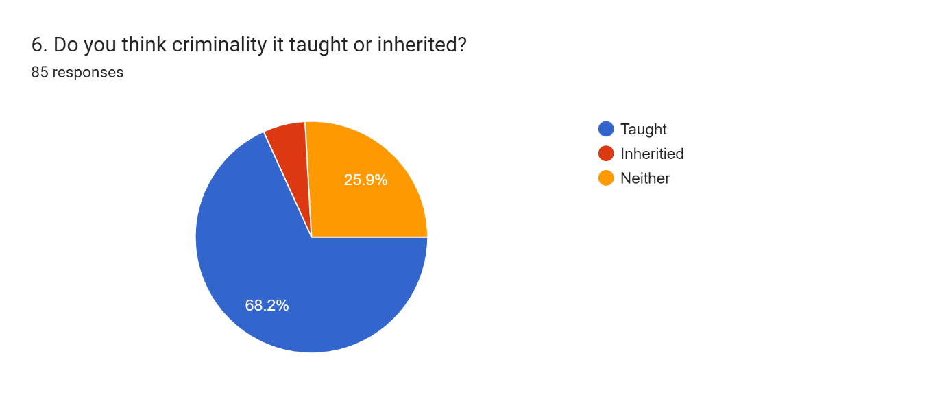
In response the third objective, this question was used to determine if the participants thought that criminality was taught or inherited. 68.2% (58) of respondents said that they thought it was taught, 25.9% (22) of respondents said that it was inherited and 5.9% (5) of respondents said that it was neither. This question brought about the idea of nature vs nurture; the responses showed that a sizeable proportion of respondents thought that criminality can be taught compared to the small amount that said it was inherited. In context to the literature review, the way that can prove that a child or young person is often taught behaviour is the 1961 Bobo doll experiment by Bandura, it showed how children could be taught to be violent; those who observed violence can be elicited to more aggressive behaviour out of children (Galanaki and Malafantis 2022, p 1). This supports the idea that behaviour can be taught and therefore suggests that criminality can be taught to a child or young person and that criminality may be determined by the environment children and young people are exposed to.

Question 10:
This question asks the participant to “Following on from the previous question. What do you think has the most significant influence and why?”. Question 9 gave ideas of themes for this question such as parents, parents who have separated, friends or peers, teachers, or lecturers, being in care, siblings, and wider family. The responses to question 10, showed that the most predominant themes that the participants think influence a child the most are parents, friends, and peers. Some of the participant responses that support the theme of parents and friends say:
- “Parents, because they nurture your first experiences.”
- “I believe parents or parents and that are separated, and friends has a massive influence because until you’re 18 you spend majority of your time around these two significant figures”.
- “Parents and peers influence behaviour a lot”.
These responses convey that from the participant's perspective both parents and peers have a significant influence on what children and young people do and how they behave. While parents are seen to have a significant influence towards children and young people it is important to understand that a parent’s behaviour can often be the cause of trauma. Corsaro (2015, p 289) supports this by stating that child neglect refers to a parent not meeting the needs of their child or young person when it comes to their health, development or even safety. These certain behaviours from parents can negatively impact a child or young person and cause them to act in the same way and have a disregard for their safety as well as others. This is conveyed in the Bobo doll experiment conducted by Bandura in 1961, which saw children reacting towards the doll in a similar way to what they observed (Galanaki and Malafantis 2022).

Question 11:
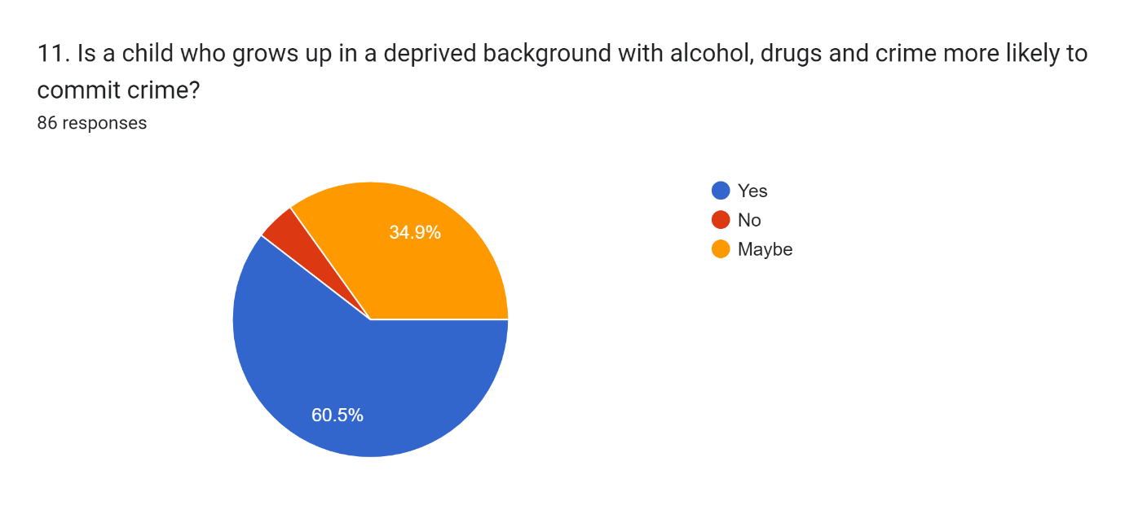
The pie chart above represents question 11’s results, this question was used in the survey to gain the perspective of the participants when it comes to the effect and impact that drugs, alcohol, and crime have on a child or young person and if it means they are likely to commit crime. 60.5% (52) of the respondents said yes, 34.9% (30) of the respondents said maybe and 4.7% (4) of the respondents said no. These percentages show that based on the perception of the participants most of them believe that these factors will make a child more likely to be involved in criminality than not. Tung et al (2018, p 6) suggest that those who experience maltreatment are likely to turn to violence, substance misuse as well as no-violent delinquency. The idea of violence suggests that this is how they may react in turn making them potentially commit violent crimes.

Question 14:
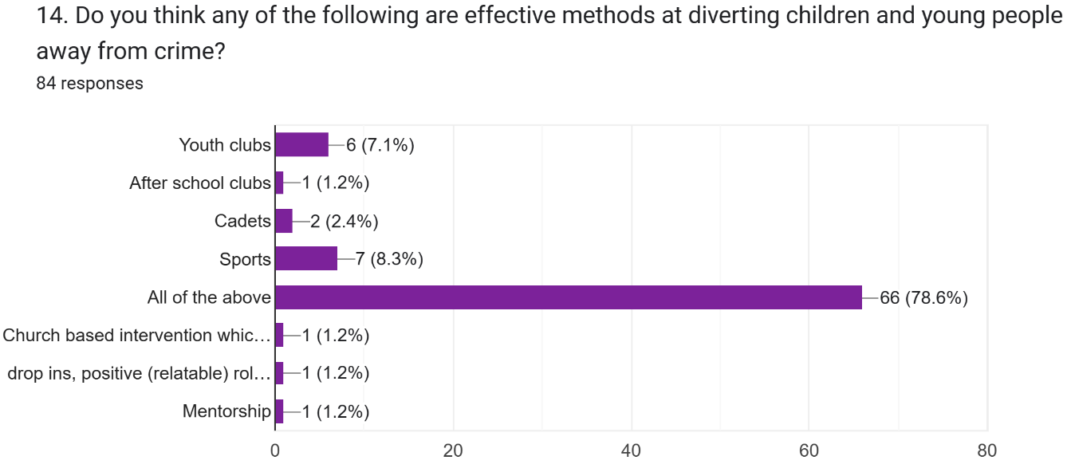
In response to the final part of the third objective, the graph above looks at what can be done to help divert and reduce criminality in children and young people. 7.1% (6) of respondents picked youth clubs; 1.2% (1) of respondents picked after-school clubs; 2.4% (2) of respondents picked cadets; 8.3% (7) of respondents picked sports; 78.6% of respondents picked all of the above. The participants in the study were given the option to add another option if they wanted therefore, 1.2% (1) selected church-based interventions that can give value to the young people; 1.2% (1) picked drop-ins, positive (relatable) positive role model speakers in school. The added options add value to the research, but the results of this question show that the participants believe that all the given options for this question are useful when looking to deter or prevent children and young people from turning to criminality. As previously stated in the literature review, the Violence Prevention Unit (2023) states that having a trusted adult or friend who can support them as well as getting engaged with community sports can help to prevent criminality in children and young people.

4.5. Summary

This chapter highlighted the prevalence of adverse childhood experiences having an impact on increasing criminality or not; the public's understanding of ACEs varied; however, they showed a slight understanding of the impact. For the second objective, the key finding was that criminality in children and young people had significant long-term impacts such as drug and alcohol misuse as well as mental health issues; it also suggested that there needs to be awareness and support. Objective three found that the public had an idea of the link that ACEs have to criminality as well as the impact certain influences have on children and young people as well as what the public thinks can be done to reduce criminality in children and young people.

Conclusion

This chapter will conclude the research study, this will be done through summarising the key findings. It will also state how the research met the aim; this research aims to determine whether adverse childhood experiences can predetermine criminality in looked after and care experienced children and young people. The key findings per the following objectives will be identified throughout this chapter.
- To identify the prevalence of criminality in care experienced and looked after children and young people.
- Evaluate the long-term effects adverse childhood experiences have on children and young people who are in care or are care experienced.
- Evaluate public perception of the link between adverse childhood experiences and crime as well as what can be done to reduce criminality.

5.1 Objective 1: To identify the prevalence of criminality in care experienced and looked after children and young people.

While identifying the prevalence of criminality in care experienced and looked after children and young people. The literature stated that 52% of children in care are convicted of an offence before they turn 24 (Office for National Statistics 2022(a)). This indicates that being in care and being exposed to ACEs may make a child or young person more susceptible to criminality. The Youth Justice Board (2022, p9) shows that children and young people are more likely to be arrested for offences such as sexual offences, violence against a person and possession of a weapon. These offences are often seen to be committed by adults rather than children or young people due to the nature of the crimes. Another scholar stated that those in care were seen to be six times more likely to turn to criminality (Prison Reform Trust 2016). This shows that being in care can impact if a person turns to crime this idea was also supported by the idea.

5.2 Objective 2: Evaluate the long-term effects adverse childhood experiences have on children and young people who are in care or are care experienced.

Long-term effects of ACEs can lead to drug and alcohol abuse and even lower life expectancy (Crandell et al 2019). This shows that the public has an awareness that drug and alcohol misuse are the potential effects of ACEs as well as mental health issues. While drug and alcohol misuse, in addition to mental health issues, are long-term effects of ACEs, there are others that impact behaviour. The Scottish Government (2023) showed that they understood that those who have experienced ACEs can partake in more risky behaviour. This can be seen due to the influence of those around us and our own personal experiences. The public identified a need for awareness and support for those affected by adverse childhood experiences. Compton et al (2023) conveyed the need for trauma-informed practices within schools, as trauma can impact the way a person learns. This objective saw there are many long-term impacts of ACEs for children and young people through their life all of which could lead to criminality or health issues.

5.3 Objective 3: Evaluate public perception of the link between adverse childhood experiences and crime as well as what can be done to reduce criminality.

A key finding of the research suggested that 62.4% of those involved stated there was a link between adverse childhood experiences and criminality, however, 35.3% were unsure. Further findings suggest a general lack of awareness in relation to what ACEs are and how they might impact children and young people. Regarding this, the public indicated that negative influences, such as mental health, background, and experiences, impact the way children and young people behave. The participants said that they could believe what they see as being normal when it is socially unacceptable. Another key finding was that behaviour such as criminality is taught rather than inherited and that behaviour is influenced by our parents and peers. If a child or young person experiences neglect then they can be taught or influenced to be more violent or misuse substances (Tung et al 2018, p6). A parent's or peer's influence is often there regardless of adverse childhood experiences. The NSPCC (2019) found that those who experience abuse or neglect often convey challenging behaviour, which often leads to them associating with certain groups of people. Showing that our peers and background can significantly influence criminal behaviour. When looking at prevention measures for ACEs it is important to keep children and young people busy enough and provide them with alternatives such as youth clubs, sports, mentoring and church-based interventions which participants suggested. Victim Prevention Unit (2023) stated that a trusted adult, supportive friends, and community sports are effective ways to deter a child away from criminality.

5.4 Implications

Implications of this study are that some of those who participated in the survey did not complete it, this was still an issue after the responses became required. It means the results do not show the full picture of the public perception. If this study were done again, it would need another method of gathering information such as a survey done over the phone or in person (Scheuren, 2004).

5.5 Recommendations

A recommendation for this study is that there needs to be more awareness of ACEs, especially when it comes to the impact and effects. Trauma-informed practices need to be available to everyone as it has a significant impact on people and their behaviour. The Welsh Government (2021) said that their approach to raising awareness focuses on supporting parents to avoid the consequences of ACEs or by having interventions in place. Interventions and policies such as these show that the government recognises that parents often influence our behaviour and may need additional support.

5.6 Limitations

Limitations of the research were that the social media platform used to share the survey, the survey only had 87 responses. However, there was bias with the gender of the participants which was seen with the 75.6% female responses and the age as 47.1% of the participants were 18-25 years of age.

5.7 Finishing statement

This study intended to answer the question: “Can adverse childhood experiences determine criminality in looked after or care experienced children and young people?”. This study showed that there is a link between ACEs and criminality in children and young people within the care system. However, further investigations could be done to support the idea that being in the care system has a further effect on criminality. Gray et al (2021, p 10) stated that children and young people often respond to situations with aggression due to being exposed to domestic abuse.
“By impersonating the aggressor, assuming his attributes or imitating his aggression, the child transforms himself from the person threatened into the person who makes the threat”. - (Galanaki and Malafantis 2022, p 2).

References

- ACE Hub Wales (2022) About ACEs and a trauma-informed approach. Available at: About ACEs and a trauma-informed approach - ACE Hub Wales (Accessed 08/12/2023)
- Andrade, I (2020) ‘sample size and its importance in research’ Indian Journal of Psychological Medicine. Vol 42, part 1. Ps 102-103 Available at: Sample Size and its Importance in Research - PMC (nih.gov)
- Brenzina, T., Tekin, E. and Topalli, V. (2009). ‘“MIGHT NOT BE A TOMORROW”: A MULTIMETHODS APPROACH TO ANTICIPATED EARLY DEATH AND YOUTH CRIME*’. Criminology, vol 47, issue 4, pp.1091–1129. Available at: https://doi.org/10.1111/j.1745-9125.2009.00170.x. (accessed 07/12/2023)
- Caldwell, R. Wiebe, R. Cleveland, H. (2006) ‘The influence of future certainty and contextual factors on delinquent behaviour and school adjustment among African American adolescents’ Journal of youth adolescence. Vol 35. Available at: The Influence of Future Certainty and Contextual Factors on Delinquent Behaviour and School Adjustment Among African American Adolescents | Journal of Youth and Adolescence (uwtsd.ac.uk) (Accessed 10/11/2023)
- Centers for Disease Control and Prevention (2021 (a)) Adverse childhood experiences (ACEs) Preventing early trauma to improve adult health. Available at: Adverse Childhood Experiences (ACEs) | Vitalising’s | CDC (Accessed 10/11/2023)
- Centers for Disease Control and Prevention (2021 (b)). Risk and protective factors. Available at: https://www.cdc.gov/violenceprevention/aces/riskprotectivefactors.html (Accessed 8/12/2023).
- Children’s Commissioner (2022) New findings on how children in care interact with the criminal justice system. Available at: New findings on how children in care interact with the criminal justice system | Children's Commissioner for England (childrenscommissioner.gov.uk) (Accessed 10/11/2023)
- Compton, A. Panlilio, C. Humphreys, K. (2023) ‘What’s the matter with ACEs? Recommendations for considering early adversity in educational context’ Child abuse & neglect: the international journal. Vol 142 part 1. Available at: https://doi-org.ezproxy.uwtsd.ac.uk/10.1016/j.chiabu.2023.106073
- Corsaro, W (2015). The sociology of childhood. 4th edition. California: Sage Publications, Inc.
- Craig, J (2018) ‘The Potential Mediating Impact of Future Orientation on the ACE–Crime Relationship’ Youth violence and juvenile justice, Vol 17, part 2. Ps 111-128. Available at: https://doi-org.ezproxy.uwtsd.ac.uk/10.1177/1541204018756470(Accessed 30/10/2023)
- Crandall, A. Miller, J. Cheung, A. Novilla, L. Glade, R. Novilla, N. Lelinneth, B. Magnusson, B. Leavitt, B. Barnes, M. Hanson, C. (2019) ‘ACEs and counter-ACEs: How positive and negative childhood experiences influence adult health.’ Child abuse & neglect: the international journal. Vol 96. Available at: https://doi-org.ezproxy.uwtsd.ac.uk/10.1016/j.chiabu.2019.104089 (Accessed 15/10/2023).
- Dudovskiy, J. (2019) Snowballing sampling. Available at: Snowball sampling (research-methodology.net) (Accessed 14/03/2024)
- Dudovskiy, J. (2024). Descriptive Research. Available at: https://research-methodology.net/descriptive-research/ (Accessed 7/02/2024)
- Ford, K., Barton, E., Newbury, A., Hughes, K., Bezeczky, Z., Roderick, J. and Bellis, M. (2019). Understanding the prevalence of adverse childhood experiences (ACEs) in a male offender population in Wales: The Prisoner ACE Survey. Available at: https://phw.nhs.wales/files/aces/the-prisoner-ace-survey / (Accessed 6/12/2023).
- Galanaki, E. Malafantis, K. (2022). Albert Bandura’s experiments on aggression modeling in children: A psychoanalytic critique. Available at: Albert Bandura's experiments on aggression modeling in children: A psychoanalytic critique (nih.gov) (Accessed 18/03/2024)
- Gooch, K. Masson, I. Waddington, E. Owens, A. (2022) ‘After Care, After Thought?: The Invisibility of Care Experienced Men and Women in Prison’. Prison Service Journal. Issue 258, p 4-12. Available at: PSJ 258, After care, after thought.pdf (crimeandjustice.org.uk) ( accessed 07/12/2023)
- Gray, P., Smithson, H. and Jump, D. (2021). Serious youth violence and its relationship with adverse childhood experiences. Available at: https://www.justiceinspectorates.gov.uk/hmiprobation/wp-content/uploads/sites/5/2021/11/Academic-Insights-Gray-et-al.pdf (Accessed 5/12/2023).
- Greco, J. (2021). ‘Epistemology’ Routledge Encyclopedia of Philosophy. Available at: https://www.rep.routledge.com/articles/overview/epistemology/v-3 (Accessed 7/02/2024).
- Gupta, R., Randell, K. and Dowd, M.D. (2021). ‘Addressing Parental Adverse Childhood Experiences in the Pediatric Setting’. Advances in Pediatrics. Vol 68, pp.71–88. Available at: Addressing Parental ACEs in the Pediatric Setting (nih.gov) (Accessed 04/05/2024)
- Hassan, M. (2024). Inductive Vs Deductive Research. Available at: https://researchmethod.net/inductive-vs-deductive-research/#:~:text=Inductive%20research%20is%20useful%20when%20a%20researcher%20wants (Accessed 25/11/2023).
- Heale, R. and Twycross, A. (2015). ‘Validity and Reliability in Quantitative Studies’. Evidence Based Nursing, volume 18, issue 3, pp.66–67. doi: http://dx.doi.org/10.1136/eb-2015-102129. (Accessed 08/02/2024)
- Heever, M.V.D. (2022). Research Support: Research Methodology. Available at: https://libguides.wits.ac.za/c.php?g=693518&p=4914913#:~:text=What%20is%20Research%20Methodology%3F (Accessed 5/02/2024)
- Home for good (2023) Statistics: National statistics for fostering and adoption. Available at: Home For Good | Care Leavers and care-experienced young people (accessed 08/12/2023)
- Hulley, S. Cummings, S. Newman, T. (2013) ’Designing Cross-Sectional and Cohort Studies’, in Gaertner, R, (eds) Designing Clinical Research, 4th edition. Philadelphia. Ps 88-97. Available at: Designing Clinical Research - Stephen B. Hulley, Steven R. Cummings, Warren S. Browner, Deborah G. Grady, Thomas B. Newman - Google Books (Accessed 07/02/2024)
Jones, TL. Baxter, MAJ. Khanduja, V (2013) ‘A quick guide to survey research’ The Annals of The Royal College of Surgeons of England. Vol 95. Available at: 10.1308/003588413X13511609956372 (accessed 10/11/2023)
- Kim, S.M. (2021). ‘Inductive or deductive? Research by maxillofacial surgeons’. Journal of the Korean Association of Oral and Maxillofacial Surgeons, volume 47, issue 3, pp.151–152. Available at: Inductive or deductive? Research by maxillofacial surgeons - PubMed (nih.gov) (Accessed 7/02/2024).
- Leung, L. (2015). ‘Validity, reliability, and Generalizability in Qualitative Research’. Journal of Family Medicine and Primary Care, volume 4, issue 3, pp.324–327. doi: https://doi.org/10.4103/2249-4863.161306. (Accessed 08/02/2024)
- Maguire, M. and Delahunt, B. (2017). ‘Doing a thematic analysis: A practical, step-by-step guide for learning and teaching scholars’. All Ireland Journal of Higher Education, volume 9, issue 3, pp.3351–33514. Available at: https://ojs.aishe.org/index.php/aishe-j/article/view/335/553 (Accessed 8/02/2024)
- Mardiana, S. (2020) ‘Modifying research onion for information systems research’, Solid State Technology. Available at: Please cite as follows: Mardiana, S. (2020) (researchgate.net) (Accessed: 07/02/2024).
- McKim, C. (2017). ‘The Value of Mixed Methods Research’. Journal of Mixed Methods Research, issue 2, pp.202–222. Available at: https://journals.sagepub.com/doi/epub/10.1177/1558689815607096 (Accessed 7/02/2024)
- McLeod, S (2023) Questionnaire: Definition, examples, design and types. Available at: What Is a Questionnaire and How Is It Used in Research? (simplypsychology.org)
- Mental Health Foundation (2021). Drugs and Mental Health. Available at: https://www.mentalhealth.org.uk/explore-mental-health/a-z-topics/drugs-and-mental-health (Accessed 4/05/2024)
- Mind (2023) Trauma. Available at: Effects of trauma - Mind(Accessed 8/12/2023).
- Ministry of Justice (2023) Female offender strategy delivery plan 2022-25. Available at: *Female Offender Strategy Delivery Plan 2022-25 (publishing.service.gov.uk) (accessed 09/11/2023)
- Nassaji, H. (2015). ‘Qualitative and descriptive research: Data type versus data analysis’. Language Teaching Research, volume 19, issue 2, pp.129–132. doi: https://doi.org/10.1177/1362168815572747. (Accessed 07/02/2024)
- National Child Traumatic Stress Network (2023) Essential elements. Available at: Essential Elements | The National Child Traumatic Stress Network (nctsn.org) (accessed 06/12/2023)
- National Institute for Health and Care Excellence (2021). Looked-after children and young people. Available at: https://www.nice.org.uk/guidance/ng205/resources/lookedafter-children-and-young-people-pdf-66143716414405 (Accessed 8/12/2023).
- NHS (2020). Night terrors and nightmares. Available at: https://www.nhs.uk/conditions/night-terrors/ (Accessed 8/12/2023).
- NHS (2023) Adverse childhood experiences (ACEs) and attachment. Available at: Adverse Childhood Experiences (ACEs) and Attachment - Royal Manchester Children's Hospital (mft.nhs.uk) (Accessed 31/10/2023)
- Norman, R. E., Byambaa, M., De, R., Butchart, A., Scott, J., & Vos, T. (2012) “The long-term health consequences of child physical abuse, emotional abuse, and neglect: a systematic review and meta-analysis.” PLoS medicine. Vol. 9, issue 11. Available at: 10.1371/journal.pmed.1001349 (accessed 23/11/2023)
- NSPCC (2019). Looked after children. Available at: https://learning.nspcc.org.uk/children-and-families-at-risk/looked-after-children#article-top. (Accessed 8/12/2023).
- NSPCC (2023). Protecting children from county lines. Available at: https://learning.nspcc.org.uk/child-abuse-and-neglect/county-lines#:~:text=County%20lines%20is%20a%20form%20of%20criminal%20exploitation (Accessed 4/05/2024)
- Office for Health Improvement & Disparities (2022) Working definitions of trauma-informed practice. Available at: Working definition of trauma-informed practice - GOV.UK (www.gov.uk) (Accessed10/11/2023)
- Office for Health Improvement and Disparities (2020). Mixed Methods Study. Available at: https://www.gov.uk/guidance/mixed-methods-study (Accessed 8/02/2024)
- Office for National Statistics (2020). Child abuse in England and Wales March 2020. Available at: https://www.ons.gov.uk/peoplepopulationandcommunity/crimeandjustice/bulletins/childabuseinenglandandwales/march2020 (Accessed 8/12/2023).
- Office for National Statistics (2022(a)) The education background of looked-after children who interact with the criminal justice system: December 2022. Available at: The education background of looked-after children who interact with the criminal justice system - Office for National Statistics (ons.gov.uk) (Accessed 15/10/2023).
- Office for National Statistics (2022(b)) Children looked after in England including adoptions. Available at: Children looked after in England including adoptions, Reporting year 2022 – Explore education statistics – GOV.UK (explore-education-statistics.service.gov.uk) (Accessed 15/10/2023).
- Prison Reform Trust (2016) Too many children in care ending up behind bars. Available at: Too many children in care ending up behind bars | Prison Reform Trust (accessed 08/12/2023)
- Psychology Today (2023) Adverse experiences. Available at: Adverse Experiences | Psychology Today (Accessed 10/11/2023)
- Public Health England (2019) Collaborative approaches to preventing offending and re-offending by children (CAPPICORN): summary. Available at: Collaborative approaches to preventing offending and re-offending by children (CAPRICORN): summary - GOV.UK (www.gov.uk)(Accessed 03/05/2024)
- Saunders, M. Lewis, P. Thornhill, A. (2007) The research ‘onion’ (diagram) Available at: research_methods_for_business_students (1).pdf (Accessed 06/02/2024)
- Scheuren, F. (2004). What is a Survey. Available at: https://fweil.com/s2211/whatisasurvey.pdf (Accessed 7/02/2024)
- Schoonenboom, J. Johnson, R. (2017) ‘How to Construct a Mixed Methods Research Design’ Kolner Zeitschrift fur Soziologie und Sozialpsychologie. Vol 69, p 107–131.Available at: How to Construct a Mixed Methods Research Design - PMC (nih.gov) (Accessed 06/05/2024)
- Scott, K (2020) ‘Adverse childhood experiences’ InnovAIT education and inspiration for general practice. Vol 14, issue 1. Available at: https://doi.org/10.1177/1755738020964498 (accessed 10/11/2023)
- Scottish Government (2023). UNDERSTANDING CHILDHOOD ADVERSITY, RESILIENCE AND CRIME. Available at: https://www.gov.scot/binaries/content/documents/govscot/publications/research-and-analysis/2018/05/understanding-childhood-adversity-resilience-crime/documents/00535550-pdf/00535550-pdf/govscot%3Adocument/00535550.pdf. (Accessed 6/12/2023).
- Setia, M.S. (2016). ‘Methodology Series Module 3: Cross-sectional Studies’. Indian Journal of Dermatology, volume 61, issue 3, pp.261–264. Available at: Methodology Series Module 3: Cross-sectional Studies - PubMed (nih.gov) (Accessed 7/02/2024).
- Sharma, B. (2018). ‘Processing of Data and Analysis’. Biostatistics and Epidemiology International Journal. Vol 1(1). Available at: https://ologyjournals.com/beij/beij_00003.pdf (Accessed 18/03/2024)
- Simkiss, D (2019) ‘The needs of looked after children from an adverse childhood experience perspective’ Paediatrics and child health. Vol 29, issue 1. Ps 25-33. Available at: https://doi.org/10.1016/j.paed.2018.11.005 (Accessed 07/11/2023)
- Slutsky, D. (2014). ‘The Effective Use of Graphs’. Journal of Wrist Surgery, Volume 3, issue 2, pp.67–68. Available at: 10-1055-s-0034-1375704.pdf (nih.gov) (Accessed 8/02/2024)
- Tung, I. Noroña-Zhou, A. Lee, S. (2018). ‘Childhood maltreatment affects adolescent sensitivity to parenting and close friendships in predicting growth in externalizing behaviour’. Development and Psychopathology. 31(4):1-17. Available at: (PDF) Childhood maltreatment affects adolescent sensitivity to parenting and close friendships in predicting growth in externalizing behavior (researchgate.net) (accessed 08/12/2023)
- University of Nottingham (2023). Understanding Pragmatic Research. Available at: https://www.nottingham.ac.uk/helmopen/rlos/research-evidence-based-practice/designing-research/types-of-study/understanding-pragmatic-research/section02.html#:~:text=Interpretivism%20is%20based%20on%20the (Accessed 5/02/2024)
- Vaswani, N (2018) Adverse Childhood Experiences in children at high risk of harm to others. A gendered perspective. Available at: https://cycj.org.uk/wp-content/uploads/2018/08/Adverse-Childhood-Experiences-in-high-risk_CYCJ-_Final-Version-proofed.pdf (accessed 07/12/2023)
- Violence Protection Unit (2023). Adverse Childhood Experiences (ACEs). Available at: https://www.violencepreventionwales.co.uk/research-evidence/adverse-childhood-experiences-aces (Accessed 3/12/2023).
- Welsh Government (2021) Review of Adverse Childhood Experiences (ACE) policy: report. Available at: Review of Adverse Childhood Experiences (ACE) policy: report (HTML) | GOV.WALES (Accessed 03/05/2024)
- Youth Justice Board (2022) Youth Justice Statistics 2021/22. England and Wales: Youth Justice Board. Available at:*Youth_Justice_Statistics_2021-22.pdf (publishing.service.gov.uk) (Accessed 03/05/2024)
- Zwozdiak-Myers, P (2007). Childhood and Youth Studies. Exeter: Learning Matters Ltd.

Appendix

Research survey.


