
building survey using digital technology.
ACBA4017

December 16, 2024
Miles Chilvers
2318123@student.uwtsd.ac.uk

Contents
Introduction 2
Survey Objectives 3
Scope of the Survey 3
Selection of Digital Tools and Technologies 5
Survey Planning 9
Risk Assessment and Method Statement 10
Challenges and Solutions 11
Recommendations 12
Conclusion and survey plan key points 12
Bibliography 13

Figure 1 Front Profile of the Y Fforwn building (Chilvers, 2024) 2
Figure 2 Side Profile of the Y Fforwn building (Chilvers, 2024) 2
Figure 3 Photo of fire zone plan (Chilvers, 2024) 4
Figure 4 Photo of BLK2GO (Chilvers, 2024) 5
Figure 5 RTC360 Laser Scanner (Chilvers, 2024) 6
Figure 6 Photo of surveying drone (Propeller Aero, ND) 7
Figure 7 BIM Model (LetsBuild, 2024) 8

Introduction
Surveys of buildings are very important in the assessment of the condition and behaviours of structures. They offer valuable data that can help in decision making on the maintenance, remodelling as well as meeting building regulations. Traditionally, building surveys have been conducted largely by manual means, which were associated with delays and inaccuracies. However, the use of digital technologies has changed the face of building surveying whereby technologies that increase precision and speed of surveying have been developed. This paper seeks to outline a detailed building survey plan incorporating digital technologies of choice on the UWTSD Trinity Saint David Y Fforwm (Library Building) situated on the Swansea SA1 campus.
This paper aims at presenting the advantages of applying digital tools in building surveys and present a real-world application of the method. Through the analysis of the terrestrial laser scanners, application of drones and Building Information Modelling (BIM), this paper will seek to show how these technologies can enhance the surveying process and provide useful information regarding the library’s structural condition.
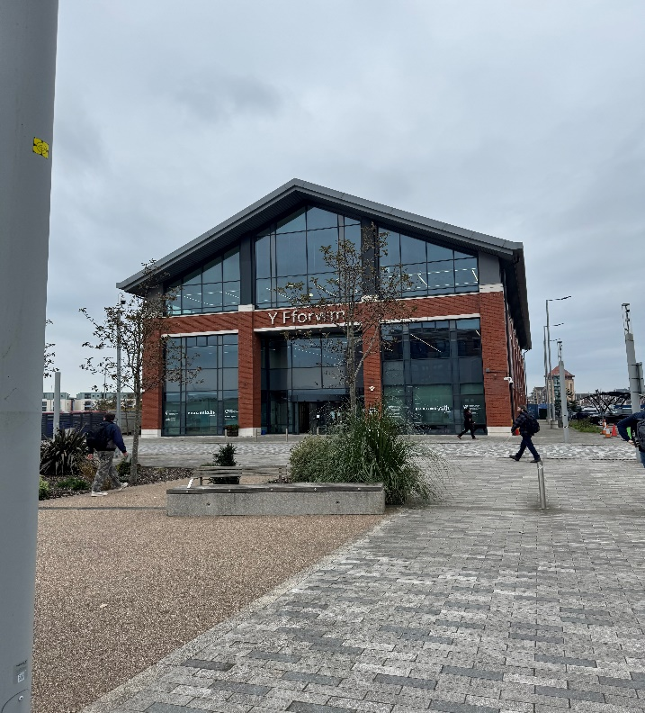
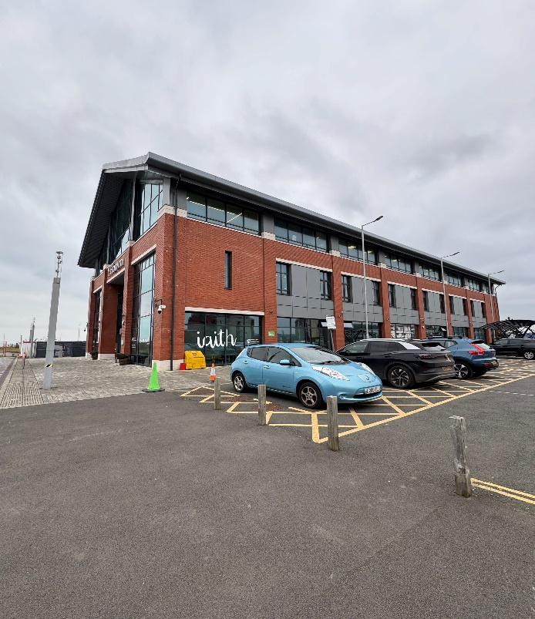
Figure 1 Front Profile of the Y Fforwn building (Chilvers, 2024)
Figure 2 Side Profile of the Y Fforwn building (Chilvers, 2024)

Survey Objectives
The main goals of the building survey for the UWTSD Trinity Saint David Y Fforwm Library are as follows.
Study of the structure to determine the current structural adequacy of the Y Fforwm building in order to assess possible weaknesses, defects or parts that require repair.
Compliance verification to ensure that the building adheres to relevant building standards, regulations, and safety standards.
Energy efficiency evaluation analyse the library’s energy performance to identify opportunities for improvement and sustainability.
Documentation for future reference, create a detailed record of the building’s condition, which can be referenced for future renovations, maintenance or during sale. (The Construction Wiki, 2022)

Scope of the Survey
The survey will be carried out on the UWTSD Trinity Saint David Y Fforwm which is a vital learning resource on the Swansea SA1 campus. It will form part of a detailed assessment of the building’s status and its performance in the view of several important factors.
  - Structural Assessment
This assessment will involve members of the structure part of the building including beams, columns and walls to check for any damage that may be evident in form of cracks or any form of damage to the member.
  - External Facades
The survey will assess the condition of the building including brickwork, stonework and cladding for any deterioration or damage that could have been caused by weather, special consideration will be given to this due to the site’s location and exposer to the costal elements. Also, the status of the windows and doors will be assessed as to the seals and the hardware regarding energy efficiency and security.
  - Roof Systems
The assessment will be to check on the condition of roofing materials for example, if they are worn out or damaged or if there are any leaks. The condition of structures that provide access to the roof will also be assessed to establish the safety of the structure and the legality of the structure.

  - Internal Systems
The mechanical, electrical, and plumbing (MEP) systems will be thoroughly assessed to determine their effectiveness and to establish whether there is a need for upgrades. The assessment will also involve checking on the interior finishes on the walls and floor since any form of wear or tear is likely to affect the usability of the room.
  - Energy Performance
The survey will assess the level of insulation as well as the possibility of air infiltration to determine the energy efficiency of the building. Utility bills and energy consumption information will be assessed to determine the energy usage of the building and potential areas that may need improvement to reduce energy usage and in term cost. A thermal imaging device would be best suited for this element although I will not discuss this in this report. (RICS, 2024)
  - Compliance and Safety
The survey will establish that the building is meet the local building regulation and the fire safety measures. As this site is open to special consideration will be given to the fire exits and their operability.
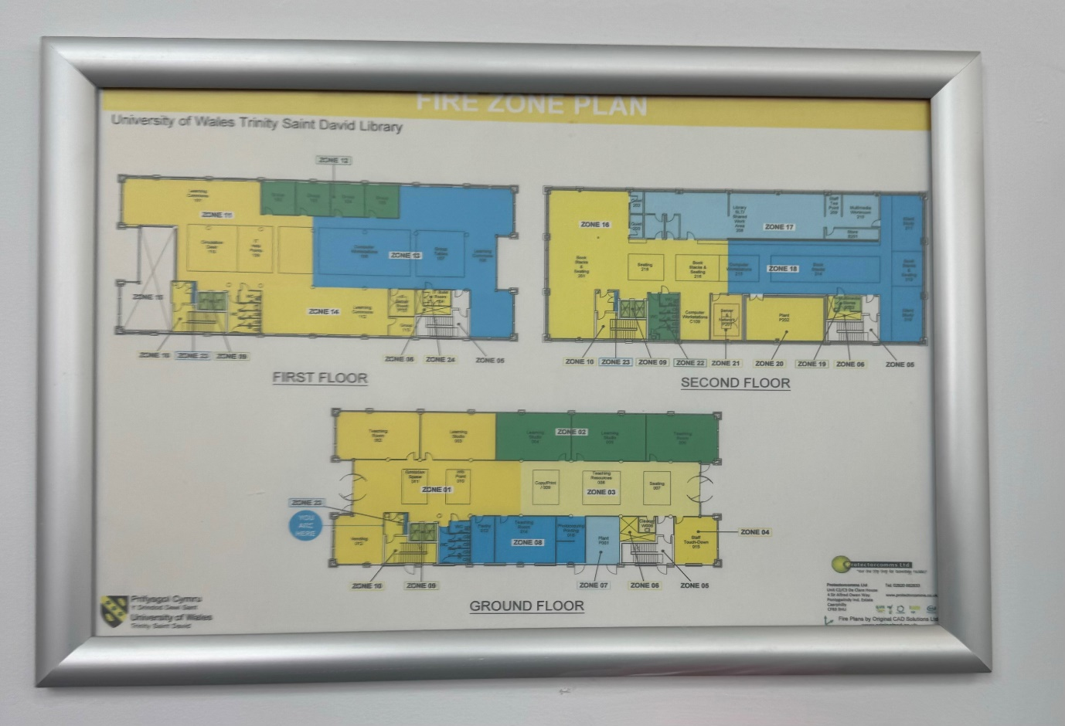
Figure 3 Photo of fire zone plan (Chilvers, 2024)

Selection of Digital Tools and Technologies
To meet the objectives of the building survey, the following digital tools and technologies will be used: terrestrial laser scanners, drones, and Building Information Modelling (BIM). All the tools provide benefits that are suitable for the requirement of the survey. The selection of these tools is based on their ability to efficiently capture detailed spatial information, create accurate as-built models, and integrate the data into a comprehensive BIM database. The combination of these technologies ensures that the survey will be thorough, precise, and capable of providing valuable insights into the building.
  - Terrestrial Laser Scanners
Terrestrial laser scanning is a form of surveying that employs laser beams to make measurements of objects and environments from the ground level. Laser scanner uses a laser beam that is transmitted thousands of times per second and determines the range by the time of flight of the reflected beam. The information collected gives a detailed spatial distribution of points which when combined gives a snapshot of the area that was scanned. The information that terrestrial laser scanners provide is very useful in building surveys especially because they offer high levels of accuracy and can capture even the most complicated shapes. They are capable of collecting data at a very fast rate and this makes them useful in the analysis of structures as well as identification of defects. The point cloud data can be used to generate 3D models that help in ensuring that the right standards are met and in the development of plans for the future. Also, the technology reduces the possibility of human error and enhances the efficiency of data acquisition thus giving the surveyors enough time to work on the results. (Survey Solutions, 2023)
Comparison of Handheld Scanners and RTC360
Handheld Scanners are devices are typically more portable and user-friendly, allowing for easier manoeuvrability in tight spaces. However, they often have a lower range and accuracy compared to stationary systems. Handheld scanners may require more time to collect data, which can lead to inconsistencies. Although this is a cheaper alternative to the RTC360, another benefit is that the handheld scanners are unbound and lower manual handling risk due to its lightweight build. (Leica-geosystems, 2023)
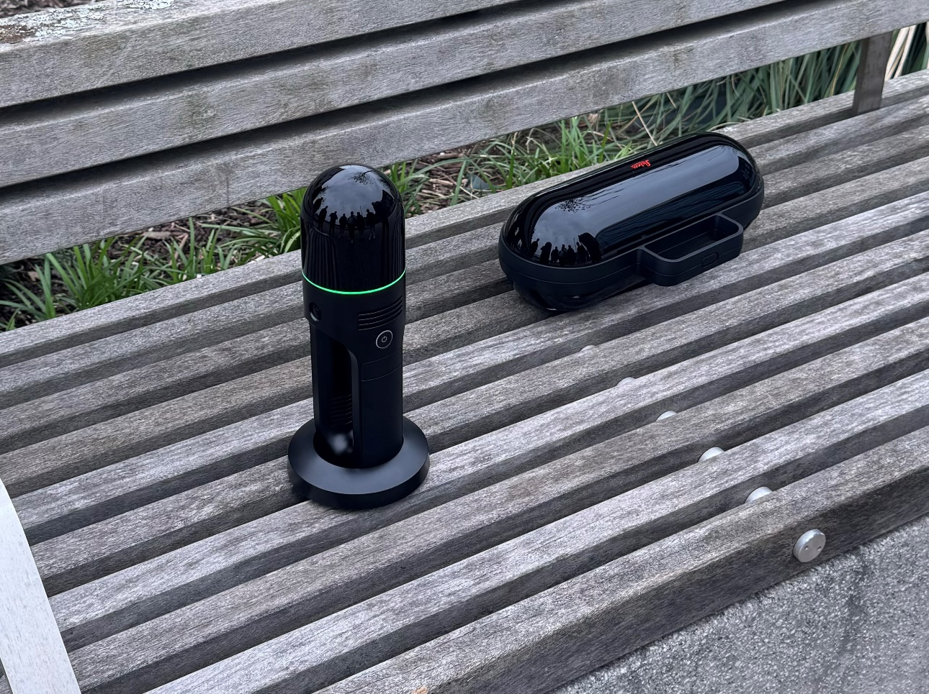
Figure 4 Photo of BLK2GO (Chilvers, 2024)
The RTC360 is an advanced laser scanner is designed for rapid 3D scanning of environments. It combines speed, precision, and advanced imaging capabilities, allowing it to capture high-resolution point clouds in a matter of minutes. The RTC360 is particularly effective in large-scale surveys, offering superior accuracy and the ability to process extensive data sets quickly. The integration of imaging technology further enhances the quality of the data collected, providing detailed visual information alongside the point cloud data. (Leica-geosystems, 2023)
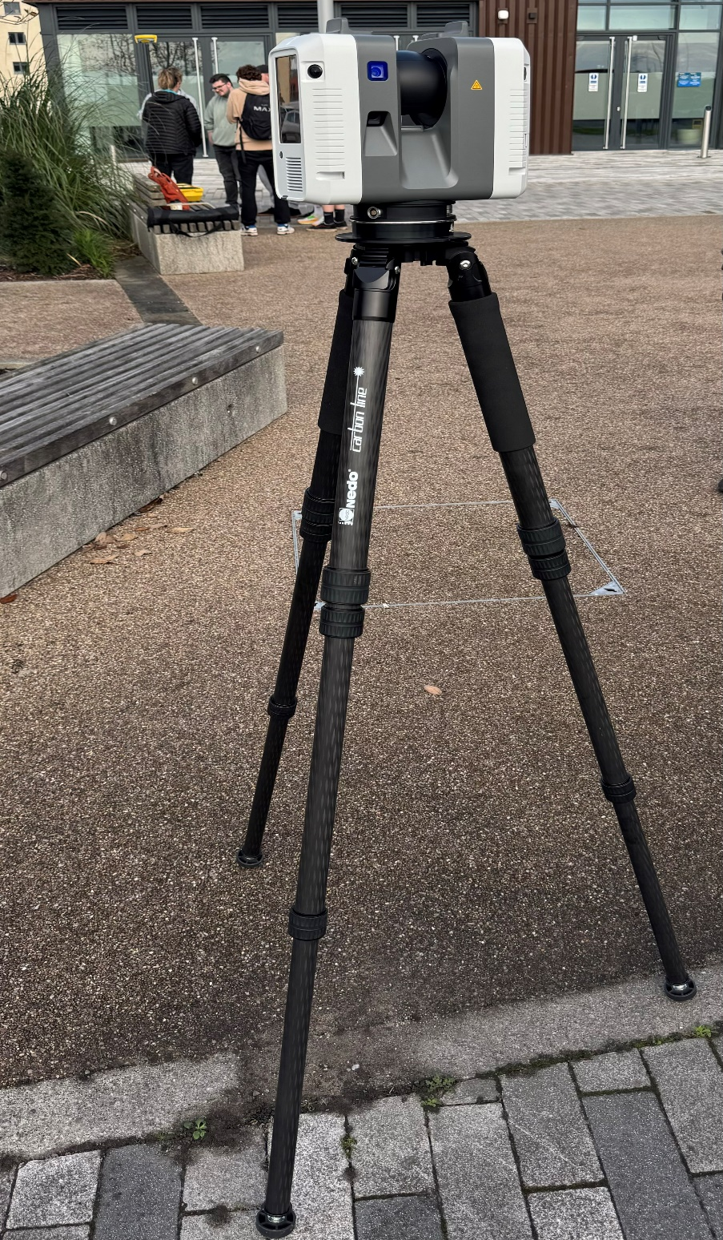
Figure 5 RTC360 Laser Scanner (Chilvers, 2024)
  - Drones
Drones or unmanned aerial vehicles (UAVs) are fitted with cameras and other sensing equipment that enables them to perform aerial surveying and mapping. These are equipped with cameras that are capable of taking high resolution photos and capturing information from different viewpoints of the building and its surroundings.
Drones are especially effective in surveying difficult to access areas that include roofs, cladding and guttering that may be difficult or dangerous to get to through other means. They help to capture visual information efficiently and with minimum risk, thereby minimizing the use of scaffolding. The view that the drones provide in a survey makes the survey more comprehensive as it helps in identifying certain conditions which would be difficult to notice when viewed from the ground.
For this building survey, drones will be used to examine the exterior walls, roofs and the general environment of the Y Fforwm Building. The images that are to be captured by the drones will be of high resolution and the analysis of the images will be made to look for areas that may require maintenance works such as damaged roofings or cladding. (RICS, 2023)

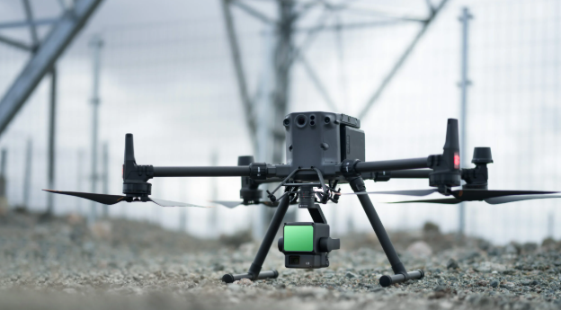
Figure 6 Photo of surveying drone (Propeller Aero, ND)
  - Building Information Modelling (BIM)
Building Information Modelling (BIM) is a logical representation of the building in the form of a database which includes the virtual representation of the building and its components. BIM is the use of various data sets such as architectural, structural, and MEP (Mechanical, Electrical, and Plumbing) in a combined database that is used for the analysis, planning, and management.
BIM improves the surveying process since it gives a holistic view of the building and all the elements that make it up. It also enhances coordination between the different disciplines and enables one to detect any conflict or potential problem prior to the survey. Also, BIM can help in the analysis of the energy performance and the integration of sustainability measures and thus support better decision making during the renovation and maintenance works. (Anderson, 2024)
At the UWTSD Trinity Saint David Y Fforwm, BIM will be applied in the creation of a three-dimensional model that will incorporate survey data gathered from terrestrial laser scanning and drones. This will assist the surveyors in understanding the structural condition of the building as well as the energy performance and will thus be of great use in future projects.

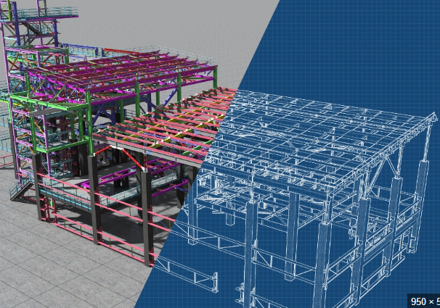
Figure 7 BIM Model (LetsBuild, 2024)

Survey Planning
The building survey will be conducted in several phases, utilizing the selected digital tools as follows.
  - Preparation Phase
Permissions and Access, obtain the necessary permissions and access to the building and surrounding areas. Preliminary Assessment, conduct an initial walkthrough to identify specific areas of concern and to plan the survey strategy. Look for potential health and safety hazards to add into the site-specific risk assessment.
  - Data Collection Phase
  - Terrestrial Laser Scanning In this phase, conduct a detailed 3D laser scan of the entire library with emphasis on structural parts including beams columns and walls. The scans will be processed, and the resulting model will be in the form of a point cloud.
  - Drone Surveying: Employ drones in taking high-definition pictures of the exterior of the library and the surrounding area. This will give a good view of the roof and the upper facades of the building and will be useful in the assessment of the condition of these parts of the building.
  - BIM Integration: The information from terrestrial laser scanning and drone surveyor is then imported into a BIM software to create a digital model of the building

  - Analysis Phase
Data Processing: Analyse the data that is collected in the form of point cloud data from terrestrial laser scanner and drone and integrate it with the BIM model. This will be useful in the creation of accurate and detailed 3D models.
Defect Identification: Identifying the defects, non-conformities and energy performance problems based on the analysis of the data collected.
  - Documentation Phase
Comprehensive Reporting: To create a detailed report of the survey, the findings, the 3D models, the thermal images and the recommendations for the improvements. This report will be useful in the future for maintenance and or renovations.

Risk Assessment and Method Statement
Given that the UWTSD Trinity Saint David Y Fforwm is situated on an active university campus, it is essential to conduct a thorough risk assessment and prepare a method statement prior to the commencement of the survey. This process will help identify potential hazards and establish control measure to ensure the safety of survey personnel and the public. (RICS, 2018)
Key risks include
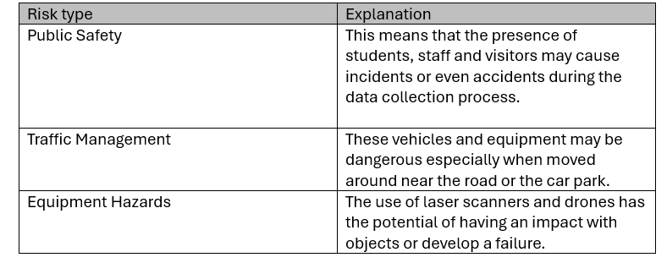
Figure 8 table of risk types.

The method statement will outline procedures to mitigate these risks, including:
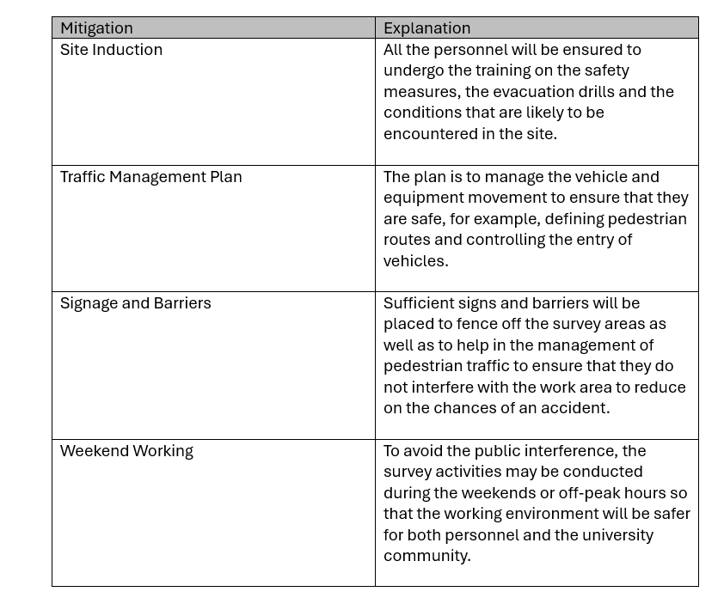
Figure 9 table of hazard mitigations.

Challenges and Solutions
Access Limitations
Some areas of the library especially the roof and the upper facade of the building may be inaccessible hence hampering the survey process.
Solution: Use drones with high resolution cameras to take pictures of these hard-to-reach areas from the air. This will make sure that no important information is left out and will also lower the risks that are involved in physical access.
  - Data Overload
The large quantity of data that is produced from laser scanning and drone photography can be very vast and therefore difficult to analyse.
Solution: The use of efficient software in data management and processing that can work with large data sets. Apply data filtering analysis and simpler
  - Environmental Factors
The weather can also affect the success of the survey especially when it comes to aerial photographs using drones.
Solution: Ensure that you check on the weather forecast frequently and conduct drone flights at the right time. It is therefore important to have backup plans in place to rearrange the data collection if necessary.

Recommendations
  - Regular Maintenance Surveys
It’s important to develop a routine of conducting building surveys to track variations and enhance the conditions of the building. Such assessments can help in the identification of potential problems before they become serious and more costly issue.
Leveraging Findings for Improvements
The findings from the survey should then be used to guide future enhancements and alterations especially around energy conservation as well as meeting the set building codes. The information collected from the survey can assist in making better decisions that will enhance the performance of the building.
  - Embrace Emerging Technologies
Always seek to know what is new in the market with regard to technology and innovations in building surveying. The application of new technologies in the conduct of the survey will enable the future surveys to be more precise and efficient.

Conclusion and survey plan key points
In conclusion, the integration of digital technology in building surveys offers numerous benefits, including enhanced accuracy, efficiency, and comprehensive data collection. The selected tools terrestrial laser scanners, drones along with Building Information Modelling provide a robust framework for conducting a thorough assessment of the UWTSD Trinity Saint David Y Fforwm building.
It is therefore important to state that proper preparation and planning are key to the success of any survey. This is where adequate planning comes in since the buliding has to be accessible and a plan proper has survey to be put in place to ensure that data is collected and passed on to the client smoothly.
Utilization of Advanced Technologies, this will allow the integration of terrestrial laser scanners, drones and BIM which will improve the quality of data collected and hence the survey.
Data Integration and Analysis, this will ensure that the library’s condition is well captured from all angles to help in the detection of defects and verification of the compliance standards.
Effective Communication therefore the stability of communication with the stakeholders will provide the necessary context and will help to share the information about the survey.

Bibliography
Anderson, M., 2024. Milwaukee Onkey. [Online]
Available at: https://onekeyresources.milwaukeetool.com/en/bim-in-surveying
[Accessed 06 December 2024].
Chilvers, M., 2024. BLK2GO Terrestrial Laser Scanner. [Art] (UWTSD Civils).
Chilvers, M., 2024. Photo of fire zone plan. [Art] (UWTSD Civils).
Chilvers, M., 2024. RTC360 Laser Scanner. [Art] (UWTSD Civil ).
Chilvers, M., 2024. Y Fforwn front profile. [Art] (UWTSD Civils).
Chilvers, M., 2024. Y Fforwn side profile. [Art] (UWTSD Civils ).
Leica-geosystems, 2023. Hexagon Leica-geosystems. [Online]
Available at: https://leica-geosystems.com/products/laser-scanners/autonomous-reality-capture/leica-blk2go-handheld-imaging-laser-scanner
[Accessed 06 December 2024].
Leica-geosystems, 2023. Hexagon Leica-geosystems. [Online]
Available at: https://leica-geosystems.com/products/laser-scanners/scanners/leica-rtc360
[Accessed 06 December 2024].
LetsBuild, 2024. Lets Build. [Online]
Available at: https://www.letsbuild.com/blog/what-is-bim-what-are-its-benefits-to-the-construction-industry
[Accessed 06 December 2024].
Propeller Aero, ND. Propeller Aero. [Online]
Available at: https://www.propelleraero.com/blog/how-lidar-drone-surveying-works/
[Accessed 06 December 2024].
RICS, 2018. RICS professional standards and guidance. [Online]
Available at: https://www.rics.org/content/dam/ricsglobal/documents/standards/surveying_safely_2nd_edition_rics.pdf
[Accessed 07 December 2024].
RICS, 2023. RICS. [Online]
Available at: https://www.ricsfirms.com/residential/moving-home/surveys/how-have-drones-impacted-building-surveying/
[Accessed 06 Decemeber 2024].
RICS, 2024. RICS. [Online]
Available at: https://www.ricsfirms.com/glossary/energy-performance-certificates-epcs/
[Accessed 05 December 2024].
Survey Solutions, 2023. Survey-Solutions. [Online]
Available at: https://www.survey-solutions.co.uk/building-survey/laser-scanning/
[Accessed 05 December 2024].
The Construction Wiki, 2022. Designing Buildings The Construction Wiki. [Online]
Available at: https://www.designingbuildings.co.uk/wiki/Building_survey
[Accessed 05 12 2024].

