

Emma Biggs
Student Number: 2308431

Instrumentation and Control:
Control System Design

ACDB5011

School of Applied Computing

Ordinance Munitions and Explosives

BEng

Academic Year: 2025 - 2026

Abstract
This paper presents the design of a closed-loop control system for the angular positioning of a Close-In Weapon System (CWIS) turret, requiring a settling time under 2 seconds and overshoot below 5%. The plant transfer function parameters were defined by the researcher’s student number (2308431).
The resulting control system was used to derive the overall transfer function and validate results. Analysis confirmed that the system is stable, meets all design requirements, and avoids unnecessary mechanical wear.

Table of Contents
Abstract 2
Table of Contents 2
Table of Equations 3
Table of Figures 4
1 Introduction 5
1.1 Overview of Control Systems 5
1.2 Description of Task 6
1.3 Overview of Software Packages Used 7
1.4 Additional Contextual Information 7
2 Simulation 8
2.1 Control System Design 8
2.2 Mathematical Validation 9
2.3 Control System Stability Analysis 13
2.3.1 Pole-Zero Plots 13
2.3.2 Root Locus Diagrams 13
2.3.3 Nyquist Diagrams 13
3 Results and Discussion 14
3.1 Block Tuning 14
3.2 Control System Response 15
3.3 Mathematical Validation 16
3.4 Control System Stability Analysis 16
4 Conclusion 20
5 References 21

Table of Equations
Equation 1 – General Transfer Function of the CWIS angular positioning system 6
Equation 2 – Specific Transfer Function of the CWIS angular positioning system 7
Equation 3 – General Transfer Function of the PID Controller 8
Equation 4 – Specific Transfer Function of the PID controller used within the control system 9
Equation 5 – Transfer Function of the PID Controller multiplied by the Transfer Function of the Angular Positioning System 9
Equation 6 - Transfer Function of the PID Controller multiplied by the Transfer Function of the Angular Positioning System: Expansion Step 1 9
Equation 7 - Transfer Function of the PID Controller multiplied by the Transfer Function of the Angular Positioning System: Expansion Step 2 10
Equation 8 - Transfer Function of the PID Controller multiplied by the Transfer Function of the Angular Positioning System: Expansion Step 3 10
Equation 9 - Transfer Function of the PID Controller multiplied by the Transfer Function of the Angular Positioning System: Expansion Step 4 10
Equation 10 - Transfer Function of the PID Controller multiplied by the Transfer Function of the Angular Positioning System: Expansion Step 5 10
Equation 11 - Transfer Function of the PID Controller multiplied by the Transfer Function of the Angular Positioning System: Expansion Step 6 10
Equation 12 - Transfer Function of the PID Controller multiplied by the Transfer Function of the Angular Positioning System: Expansion Step 7 10
Equation 13 - Transfer Function of the PID Controller multiplied by the Transfer Function of the Angular Positioning System: Expansion Step 8 10
Equation 14 – Forward Transfer Function of the Control System 11
Equation 15 – General Equation used to calculate the value of the Transfer Function of the Control System as a Whole 11
Equation 16 – Specific Equation used to calculate the value of the Transfer Function of the Control System as a Whole 11
Equation 17 – Transfer Function of the Whole System Calculation Step 1 11
Equation 18 – Transfer Function of the Whole System Calculation Step 2 11
Equation 19 – Transfer Function of the Whole System Calculation Step 3 11
Equation 20 – Transfer Function of the system as a whole 11

Table of Figures
Figure 1 – A Block Diagram of an Open Loop Control System depicting the process of toasting bread [3] 5
Figure 2– A Block Diagram of a Closed Loop Control System depicting the process of thermostatically controlling a heating system [5] 6
Figure 3 – Simulink Block diagram of the control system designed within MATLAB 8
Figure 4 – Values of the proportional, integral and differential terms of the PID controller selected as a result of the tuning process 9
Figure 5 – Transfer Function of the Control System as a whole inputted into the Simulink block diagram 12
Figure 6 - Graph comparing the response of the output behaviour of the PID controller before and after tuning 14
Figure 7 - Numerical comparison of the output behaviour of the PID controller prior to and after tuning 15
Figure 8 - Display of the Simulink Scope showing the output of the control system 15
Figure 9 - Display of the Simulink Scope comparing the output of the control system and calculated transfer function of the system to validate design 16
Figure 10 - Pole-Zero plots of the transfer functions associated to the control system 17
Figure 11 - Numerical Values of the roots represented by the Pole-Zero Diagram 17
Figure 12 - Root Locus diagram of the control system 18
Figure 13 - Nyquist Diagram of the Control System 18
Figure 14 - Numerical Gain and Phase Margins obtained from the Nyquist Diagram 19

1 Introduction
This paper examines the design of a closed-loop control system for the angular positioning of a CWIS turret. It draws on fundamental control system principles, which, along with contextual information relevant to the design task, are summarised in the following introduction.

1.1 Overview of Control Systems
A control system maintains a measurable variable at or near a desired reference value despite environmental changes [1]. Regulation may be achieved by directly setting the input (open-loop control) or by adjusting the input based on feedback from the system output (closed-loop control) [2].
An open-loop control system does not monitor system output, so control action is independent of system performance [3]. As a result, the input is manually set, making open-loop systems suitable for low-cost applications where operating conditions are predictable and deviations have minimal impact [4].
A common example of an open-loop system is a toaster, where inputs such as toasting time and temperature are user-defined, but toast quality is not monitored during operation. Consequently, the output is independent of feedback, as illustrated in Figure 1.

Toasting Process
System Input
Bread Position, Time Duration, Temperature
System Output
Toast Quality (change in colour and texture)
Figure 1 – A Block Diagram of an Open Loop Control System depicting the process of toasting bread [3]

A closed-loop control system measures the controlled variable and compares it with a reference value to produce an error signal, which is used to adjust the control action and minimise the deviation [5]. Although more complex than open-loop systems, closed-loop control offers greater efficiency and reduced risk of human error, making it suitable for applications where deviations could be detrimental [6].
A common example is a thermostatically controlled heating system, where the thermostat compares the room temperature to a set value and activates or deactivates heating to maintain the desired temperature despite external influences, as shown in Figure 2 [5].

Controller
Heating System Process
Temperature Sensor
Measured Temperature Output
System Output
System Input
Measured Temperature Difference
Thermostat Temperature Setpoint
+
-
Environmental Temperature Disturbances

Figure 2– A Block Diagram of a Closed Loop Control System depicting the process of thermostatically controlling a heating system [5]
In a control system, the controller receives the process variable (variable being maintained) and manipulates it relative to a desired reference value to minimise deviation [7]. The method of adjustment is dependent on the controller mode which include on–off, proportional, integral, or derivative [8]. The required controller mode is selected according to the process requirements.
To select an appropriate controller mode, the process must be mathematically modelled to understand the operating parameters. This involves using physical laws and assumptions to derive differential equations that describe system behaviour, from which a transfer function can be obtained for linear systems [9].
The transfer function is defined as the ratio of the Laplace transform of the system output to that of the input, representing the input–output relationship of a linear system [10]. It is used to model system behaviour and can be incorporated into block diagrams to show subsystem interconnections [11].

1.2 Description of Task
To enable the control of the angular positioning system of a Close-In Weapon System (CWIS), a closed loop control system was developed. Following the input of a unit step (power source), this system was required to bring the angular position system under control within 2 seconds with an overshoot of no greater than 5%.
The transfer function of this positioning system is given in Equation 1 where a, b and c are respectively equal to the final 3 digits of the researcher’s student number plus one.

$$G\left(s\right)=\frac{1}{as^{2}+bs+c}$$
Equation 1 – General Transfer Function of the CWIS angular positioning system
Given that the final three digits of the researcher’s student number are 4, 3 and 1 respectively, the transfer function forming the basis of the control system is shown in Equation 2.

$$G\left(s\right)=\frac{1}{5s^{2}+4s+2}$$
Equation 2 – Specific Transfer Function of the CWIS angular positioning system
Using the software programmes MATLAB and Simulink, Equation 2 was used to create a control system designed to meet the previously specified parameters.

1.3 Overview of Software Packages Used
MATLAB and Simulink were used to complete the mathematical modelling and stability analysis of the control system. MATLAB provides numerical computing capabilities for engineering applications such as control system design [12], while Simulink builds on MATLAB as a graphical environment for modelling, simulating, and analysing dynamic systems [13].

1.4 Additional Contextual Information
The Phalanx Close-In Weapons System (CIWS) is a Raytheon designed fast reaction, rapid fire computer-controlled system designed as a final defence against Anti-Ship Missiles (ASM) [14]. It combines a radar and a 20mm Gatling gun to provide operational capabilities including search, detection, threat evaluation, tracking and firing to automatically engage and defeat ASM [14]. The movement of the 6169kg gun requires between 18 and 70kw of power depending on the selected mode [15].

2 Simulation

2.1 Control System Design
To achieve the required level of control over the angular positioning system, a proportional integral derivative (PID) controller was selected. This controller can be mathematically represented by the transfer function shown in Equation 3 where K_{p} is the proportional term, K_{i} is the integral term, K_{d} is the differential term and N is the filter coefficient.

$$G\left(s\right)=K_{p}+K_{i}\frac{1}{s}+K_{d}\frac{s}{\frac{1}{N}s+1}$$
Equation 3 – General Transfer Function of the PID Controller
In this equation, the proportional term reflects the current error, the integral term accounts for the accumulated past error and the derivative term represents the rate of change of the error [16]. Each term is weighted by a tuning coefficient to achieve the desired system response.
The closed-loop control system was modelled in MATLAB Simulink using a block diagram comprising of a step input, a subtraction block to compute error, a PID controller, the transfer function of the CIWS angular positioning system, and a scope to display the results, as shown in Figure 3.

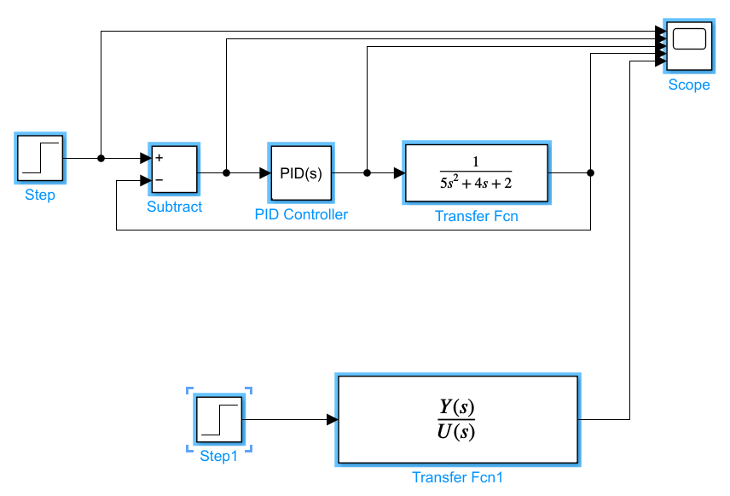
Figure 3 – Simulink Block diagram of the control system designed within MATLAB

The tuning function included within the Simulink software was used to alter the values of the proportional, integral and derivative terms of the PID controller to bring the response of the positioning system to within the required parameters. The value of each term selected as a result of the tuning process is shown in Figure 4.

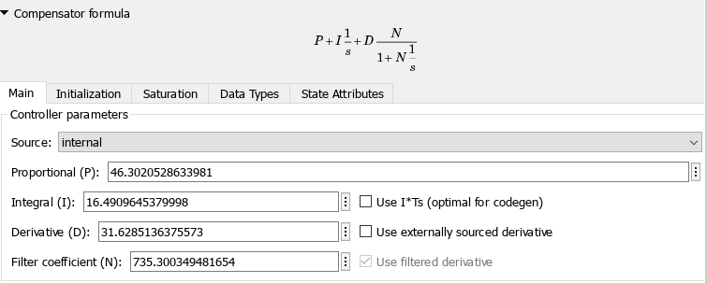
Figure 4 – Values of the proportional, integral and differential terms of the PID controller selected as a result of the tuning process

2.2 Mathematical Validation
To validate the results of the MATLAB and Simulink mathematical representation of the control system, the forward path transfer function and subsequently the transfer function of the complete system were manually calculated and compared to the original block diagram.
The values of the PID controller obtained through tuning were inputted into the general transfer function of the controller to create Equation 4.

$$46.3021+\frac{16.491}{s}+31.6285\frac{s}{\frac{1}{735.3003}s+1}$$
Equation 4 – Specific Transfer Function of the PID controller used within the control system
This equation was then multiplied by the transfer equation of the positioning system to determine the forward path transfer function (Equation 14). The calculations taken to achieve this equation are shown below in Equations 5 through 13.

$$\left(46.3021+\frac{16.491}{s}+31.6285\frac{s}{\frac{1}{735.3003}s+1}\right)\left(\frac{1}{5s^{2}+4s+2}\right)$$
Equation 5 – Transfer Function of the PID Controller multiplied by the Transfer Function of the Angular Positioning System
$$\left(46.3021+\frac{16.491}{s}+31.6285\frac{s}{\frac{s+735.3003}{735.3003}}\right)\left(\frac{1}{5s^{2}+4s+2}\right)$$
Equation 6 - Transfer Function of the PID Controller multiplied by the Transfer Function of the Angular Positioning System: Expansion Step 1

$$\left(46.3021+\frac{16.491}{s}+31.6285\left(s\left(\frac{735.3003}{s+735.3003}\right)\right)\right)\left(\frac{1}{5s^{2}+4s+2}\right)$$
Equation 7 - Transfer Function of the PID Controller multiplied by the Transfer Function of the Angular Positioning System: Expansion Step 2

$$\left(46.3021+\frac{16.491}{s}+\frac{23256.445539s}{s+735.3003}\right)\left(\frac{1}{5s^{2}+4s+2}\right)$$
Equation 8 - Transfer Function of the PID Controller multiplied by the Transfer Function of the Angular Positioning System: Expansion Step 3

$$\left(\frac{46.3021s\left(s+735.3003\right)+16.491\left(s+735.3003\right)+23256.445539s^{2}}{s^{2}+735.3003s}\right)\left(\frac{1}{5s^{2}+4s+2}\right)$$
Equation 9 - Transfer Function of the PID Controller multiplied by the Transfer Function of the Angular Positioning System: Expansion Step 4

$$\left(\frac{46.3021s\left(s+735.3003\right)+16.491\left(s+735.3003\right)+23256.445539s^{2}}{s^{2}+735.3003s}\right)\left(\frac{1}{5s^{2}+4s+2}\right)$$
Equation 10 - Transfer Function of the PID Controller multiplied by the Transfer Function of the Angular Positioning System: Expansion Step 5

$$\left(\frac{46.3021s^{2}+34045.948021s+16.491s+12125.83725+23256.445539s^{2}}{s^{2}+735.3003s}\right)\left(\frac{1}{5s^{2}+4s+2}\right)$$
Equation 11 - Transfer Function of the PID Controller multiplied by the Transfer Function of the Angular Positioning System: Expansion Step 6

$$\left(\frac{23302.747639s^{2}+34062.439021s+12125.83725}{s^{2}+735.3003s}\right)\left(\frac{1}{5s^{2}+4s+2}\right)$$
Equation 12 - Transfer Function of the PID Controller multiplied by the Transfer Function of the Angular Positioning System: Expansion Step 7

$$\frac{23302.747639s^{2}+34062.439021s+12125.83725}{5s^{4}+4s^{3}+2s^{2}+3676.5015s^{3}+2941.2012s^{2}+1470.6006s}$$
Equation 13 - Transfer Function of the PID Controller multiplied by the Transfer Function of the Angular Positioning System: Expansion Step 8

$$G=\frac{23302.747639s^{2}+34062.439021s+12125.83725}{5s^{4}+3680.5015s^{3}+2943.2012s^{2}+1470.6006s}$$
Equation 14 – Forward Transfer Function of the Control System
Using the previously calculated Forward Transfer Function of the Control System, the Transfer Function of the Control System as a whole (TF) was calculated using Equation 14 where G is the Forward Transfer Function, and H is the Transfer Function of the feedback loop. In the case of this control system H was given as the value 1.
$$TF=\frac{G}{1+GH}$$
Equation 15 – General Equation used to calculate the value of the Transfer Function of the Control System as a Whole
The following equations demonstrate the calculation steps taken to determine the Transfer Function of the system as a whole.

$$TF = \frac{\frac{23302.747639s^{2}+34062.439021s+12125.83725}{5s^{4}+3680.5015s^{3}+2943.2012s^{2}+1470.6006s}}{1+\left(\frac{23302.747639s^{2}+34062.439021s+12125.83725}{5s^{4}+3680.5015s^{3}+2943.2012s^{2}+1470.6006}\right)×1}$$
Equation 16 – Specific Equation used to calculate the value of the Transfer Function of the Control System as a Whole

$$= \frac{\frac{23302.747639s^{2}+34062.439021s+12125.83725}{5s^{4}+3680.5015s^{3}+2943.2012s^{2}+1470.6006s}}{\frac{5s^{4}+3680.5015s^{3}+2943.2012s^{2}+1470.6006s+23302.747639s^{2}+34062.439021s+12125.83725}{5s^{4}+3680.5015s^{3}+2943.2012s^{2}+1470.6006s}}$$
Equation 17 – Transfer Function of the Whole System Calculation Step 1

$$= \frac{\frac{23302.747639s^{2}+34062.439021s+12125.83725}{5s^{4}+3680.5015s^{3}+2943.2012s^{2}+1470.6006s}}{\frac{5s^{4}+3680.5015s^{3}+26245.948839s^{2}+35533.03962s+12125.83725}{5s^{4}+3680.5015s^{3}+2943.2012s^{2}+1470.6006s}}$$
Equation 18 – Transfer Function of the Whole System Calculation Step 2

$=\frac{23302.75s^{2}+34062.44s+12125.84}{5s^{4}+3680.50s^{3}+2943.20s^{2}+1470.60s}×\frac{5s^{4}+3680.50s^{3}+2943.20s^{2}+1470.60s}{5s^{4}+3680.50s^{3}+26245.95s^{2}+35533.04s+12125.84}$
Equation 19 – Transfer Function of the Whole System Calculation Step 3
$$=\frac{1.165e^{5}s^{6}+8.594e^{7}s^{5}+1.94e^{8}s^{4}+1.792e^{8}s^{3}+8.578e^{7}s^{2}+1.783e^{7}s}{25s^{8}+3.681e^{4}s^{7}+1.369e^{7}s^{6}+1.076e^{8}s^{5}+2.135e^{8}s^{4}+1.878e^{8}s^{3}+8.794e^{7}s^{2}+1.783e^{7}s}$$
Equation 20 – Transfer Function of the system as a whole

The Transfer Function of the system was then inputted into the previously created Simulink block diagram shown in Figure 5 to validate the results of the simulation. To create a fair comparison, a step input of the same value as used in the original block diagram was added to the transfer function. A scope was used to measure and display the outputs of each block diagram facilitating comparison.
Figure 5 – Transfer Function of the Control System as a whole inputted into the Simulink block diagram

2.3 Control System Stability Analysis
The output behaviour of a control system is characterised by its stability, accuracy, response speed and sensitivity to a given input [17]. A system is considered stable if its output reaches a specified value within a given time after an input change. Stability can be analysed using graphical methods such as pole–zero plots, root locus diagrams, and Nyquist diagrams [17], which were implemented by the researcher using MATLAB workspace commands.

2.3.1 Pole-Zero Plots
Pole–zero plots graph a transfer function’s response in the complex frequency (s) plane and provide insight into system stability [18]. Zeros (‘o’) indicate frequencies that make the numerator of the transfer function equate to zero, while poles (‘X’) indicate frequencies that make the denominator zero and subsequently cause the equation to tend toward infinity. System stability is determined by pole locations, with all poles in the left-hand (negative real) plane indicating a stable system [19].

2.3.2 Root Locus Diagrams
Root Locus Diagrams form graphical traces of the path taken by closed loop poles as a coefficient of the close loop system is altered (such as controller gain) [20]. From the plot produced, it is possible to study the effect of variation of system parameters and the subsequent stability of the system, as well as providing information regarding the damping of the system [21].

2.3.3 Nyquist Diagrams
A Nyquist diagram is a polar plot of frequency response used to assess closed-loop stability from the associated open-loop transfer function [22]. According to the left-hand criterion, stability requires the plot to pass to the left of the point (−1, 0) [23]. Each point represents the magnitude and phase at a given frequency. The diagram is used to determine gain and phase margins, with larger margins indicating greater stability.

3 Results and Discussion

3.1 Block Tuning
As previously described in Section 2.1, the PID controller was tuned using the inbuilt tuning feature in Simulink to facilitate the production of a response satisfying the specified conditions. The results of this tuning are shown graphically in Figure 6 and numerically in Figure 7.
The block response, shown by the solid line in Figure 6, demonstrates a more robust response with a slower response time than required by the task parameters. The tuned response of the PID controller, shown by the dotted line in Figure 6, demonstrates a more aggressive response meeting the task parameters.
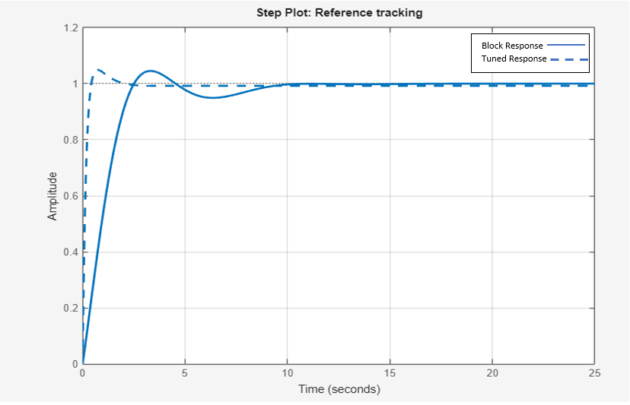
Figure 6 - Graph comparing the response of the output behaviour of the PID controller before and after tuning
The first table in Figure 7 compares the Proportional, Integral, Differential, and filter coefficient values for the tuned and untuned PID controllers. The tuned controller uses higher values to produce a more aggressive response that meets the required performance criteria.
Figure 7 also presents key system output metrics including: rise time (10–90% of steady-state value), settling time (time for output value to remain within a specified tolerance), maximum overshoot (percentage exceeding the steady-state value), gain margin (allowable gain increase before instability), phase margin (allowable phase variation before instability) and overall system stability [24].
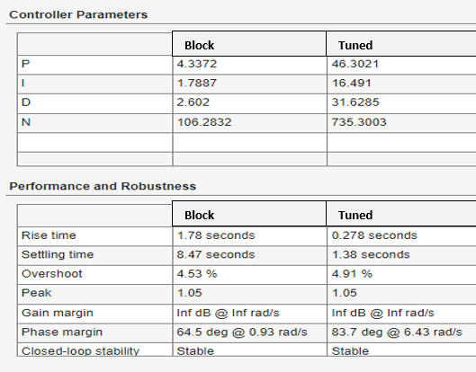
Figure 7 - Numerical comparison of the output behaviour of the PID controller prior to and after tuning
From observing the bottom table in Figure 7, the tuned controller provides the control system with a response time below 5 seconds, an overshoot of less than 5% in addition to a stable output given by both the infinite gain margin and the stability indicator. While the untuned block response is stable, the sum of the rise and settling time exceed the required 5 second response time. However, the untuned block exhibits a lower overshoot percentage.

3.2 Control System Response
Figure 8 shows the scope display within the Simulink control system, with each plot illustrating a different system variable. The first graph compares the reference setpoint with the plant output, shown in the final graph. The second graph displays the PID controller control signal (control effort), while the third graph shows the error signal used by the controller to compute the control action.
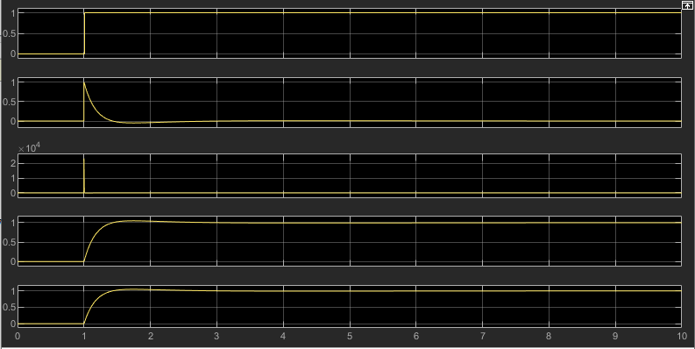
Figure 8 - Display of the Simulink Scope showing the output of the control system
Upon receipt of an angular position from the radar system, the reference set point increases from 0 to 1 causing a sharp increase in error signal. This subsequently increases controller effort to decrease the deviation between system output and the reference set point. As the system output gets closer to the reference set point, the controller effort decreases, resulting in the plateau shown in both the plant output and control signal graphs.

3.3 Mathematical Validation
The results of the mathematical validation of the control system can be obtained by looking at Figure 9. Figure 9 shows a graphical representation of the output behaviour of the control system and calculated transfer function respectively, with the top graph resulting from the control system and the bottom graph being generated by the calculated transfer function of the system as a whole.
Figure 9 - Display of the Simulink Scope comparing the output of the control system and calculated transfer function of the system to validate design
When compared, it can be observed that these functions have produced an identical output given the same step input, validating the original Simulink Block Diagram simulation of the control system.

3.4 Control System Stability Analysis
As outlined in Section 2.3.1, system stability can be evaluated by analysing pole locations on a pole–zero plot. Pole–zero diagrams for the plant, PID controller, forward transfer function, and overall system were generated in MATLAB (Figure 10), with pole values confirmed using extracted roots (Figure 11).
The plant only exhibits a complex conjugate pole pair in the left-hand plane, denoting decaying oscillations, with the rate of decay dictated by their horizontal position. The controller has a pole and zero at the origin meaning no system response will be produced upon the input of a frequency of zero. A remaining negative real pole is situated in the left-hand plane, indicating exponential decay and internal stability. As this pole lies furthest from the origin, it is dominant and has the greatest influence on controller stability [25].
As the forward transfer function consists of the transfer function of the plant multiplied by the transfer function of the controller, the Pole-Zero plot possesses poles and zeros in the same locations as previously described. This again indicates the stability of the forward transfer function as all non-cancelled poles lie in the real negative aspect of the plot.
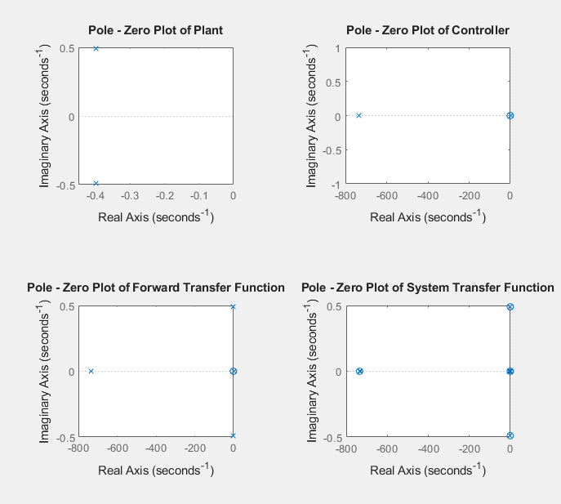
Figure 10 - Pole-Zero plots of the transfer functions associated to the control system
Given that the plant, controller, and forward transfer function are constituent parts of the overall system transfer function, Figure 10 includes all previously identified poles and zeros. However, the complex conjugate poles seen earlier are cancelled by corresponding zeros in the system pole–zero plot. Three additional poles on the real axis of the left-hand plane are present (numerically confirmed in Figure 11) indicating exponential decay. Two further zeros on the left-hand real axis affect transient response but not stability. As all poles are real and in the left-hand plane, the system is critically damped and stable.

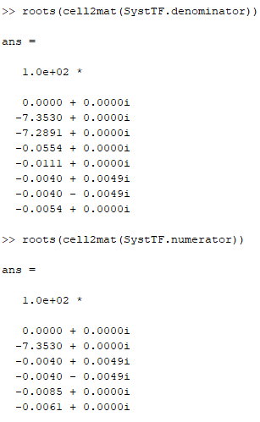
Figure 11 - Numerical Values of the roots represented by the Pole-Zero Diagram
To further assess system stability, a root locus diagram was generated in MATLAB as shown in Figure 12. As the proportional gain increases, the system transitions from overdamped to critically damped, and then to underdamped as the loci diverge. This results in an increased overshoot and oscillations that grow with distance from the divergence point.
Since all poles lie on the negative real axis, with the dominant pole far from the origin, the system is stable.
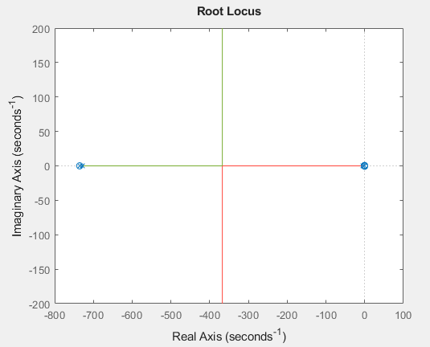
Figure 12 - Root Locus diagram of the control system
A Nyquist Diagram was created in MATLAB to understand the phase shift required to cause the system to become unstable, shown in Figure 13. From this diagram and the numerical values shown in Figure 14, a phase shift of 83.7° is required to cause the system to become unstable. As the phase margin is large and the gain margin is infinite, the system is stable.
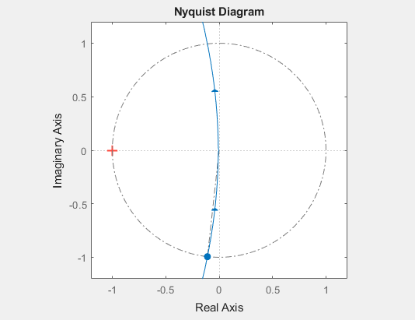
Figure 13 - Nyquist Diagram of the Control System

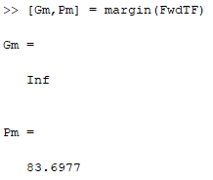
Figure 14 - Numerical Gain and Phase Margins obtained from the Nyquist Diagram

4 Conclusion
Within this paper, a stable closed loop control system was created for the angular positioning system of a CIWS, meeting the requirements of the task outline. This was achieved using a PID controller simulated and subsequently tuned using the software packages MATLAB and Simulink.
This simulation was successfully mathematically validated by comparing the calculated system transfer function’s output to the output produced by the control system, which generated identical responses upon receiving the same input signal.
A faster response time with lower overshoot could have been achieved using a more aggressive tuning approach on the PID controller within the Simulink workspace. However, given the weight of the CWIS system, increasing the response time would be unachievable in the real world and cause undesirable quantities of wear to the moving mechanics of the system.

5 References
[1] R. Kennaway, "Chapter 4 - When causation does not imply correlation: robust violations of the faithfulness axiom," in The Interdisciplinary Handbook of Perceptual Control Theory, W. Mansell, Ed., Academic Press, 2020, pp. 49–72. doi: 10.1016/B978-0-12-818948-1.00004-6Available: https://www.sciencedirect.com/science/article/pii/B9780128189481000046
[2] T. Dunn, "10 - Basics of Control Systems," in Flexible Packaging, T. Dunn, Ed., Oxford: William Andrew Publishing, 2015, pp. 103–110. doi: 10.1016/B978-0-323-26436-5.00010-2Available: https://www.sciencedirect.com/science/article/pii/B9780323264365000102
[3] T. Roskilly and R. Mikalsen, "Chapter One - Introduction," in Marine Systems Identification, Modeling and Control, T. Roskilly and Rikard Mikalsen, Ed., Oxford: Butterworth-Heinemann, 2015, pp. 1–13. doi: 10.1016/B978-0-08-099996-8.00001-XAvailable: https://www.sciencedirect.com/science/article/pii/B978008099996800001X
[4] N. Mehrabi and J. McPhee, "Chapter Four - Model-Based Control of Biomechatronic Systems," in Handbook of Biomechatronics, J. Segil, Ed., Academic Press, 2019, pp. 95–126. doi: 10.1016/B978-0-12-812539-7.00004-0Available: https://www.sciencedirect.com/science/article/pii/B9780128125397000040
[5] K. L. S. Sharma, "6 - Automation Strategies," in Overview of Industrial Process Automation (Second Edition), K. L. S. Sharma, Ed., Elsevier, 2017, pp. 53–74. doi: 10.1016/B978-0-12-805354-6.00006-2Available: https://www.sciencedirect.com/science/article/pii/B9780128053546000062
[6] E. Bonet Gil, "2 - State of the Art of Canal Control Algorithms," in Experimental Design and Verification of a Centralized Controller for Irrigation Canals, E. Bonet Gil, Ed., Elsevier, 2018, pp. 17–34. doi: 10.1016/B978-1-78548-307-3.50002-1Available: https://www.sciencedirect.com/science/article/pii/B9781785483073500021
[7] F. Giraud and C. Giraud-Audine, "Chapter Four - Control in the rotating reference frame," in Piezoelectric Actuators: Vector Control Method, F. Giraud and Christophe Giraud-Audine, Ed., Butterworth-Heinemann, 2019, pp. 137–160. doi: 10.1016/B978-0-12-814186-1.00008-9Available: https://www.sciencedirect.com/science/article/pii/B9780128141861000089
[8] J. Prasad, Jayaswal. M. N. and V. Priye, Instrumentation and process control, New Delhi: I. K. International Publishing, 2010.
[9] J. Moscinski and Z. Ogonowski, Advanced control with MATLAB and SIMULINK, London: Ellis Horwood, 1995.
[10] R. C. Dorf and R. H. Bishop, Modern control systems, Harlow: Pearson Education Limited, 2022.
[11] N. S. Nise, Control systems engineering, Hoboken, NJ: Wiley, 2019.
[12] C. Moler and J. Little, "A history of MATLAB," Proceedings of the ACM on Programming Languages. vol. 4, no. HOPL, jun 2020, doi: 10.1145/3386331. Available at: https://doi.org/10.1145/3386331.
[13] D. T. Valentine and B. D. Hahn, "Chapter 16 - SIMULINK toolbox," in Essential MATLAB for Engineers and Scientists (Eighth Edition), D. T. Valentine and Brian D. Hahn, Ed., Academic Press, 2023, pp. 335–349. doi: 10.1016/B978-0-32-399548-1.00023-0Available: https://www.sciencedirect.com/science/article/pii/B9780323995481000230
[14] M. R. Chaparro, "An analysis of spending patterns associated with the Phalanx close-in weapon system (CIWS) program," 2003,
[15] General Dynamics. "Naval Platform Systems PHALANX CIWS." [Online]. Available: https://www.gdots.com/armaments/naval-platforms-system/phalanx/
[16] M. Rashid, et al., "Chapter 15 - Automated closed-loop insulin delivery: system components, performance, and limitations," in Glucose Monitoring Devices, C. Fabris and Boris Kovatchev, Ed., Academic Press, 2020, pp. 293–326. doi: 10.1016/B978-0-12-816714-4.00015-6Available: https://www.sciencedirect.com/science/article/pii/B9780128167144000156
[17] C. J. Fraser, J. S. Milne and B. Noltingk, "3 - Microprocessors, instrumentation and control," in Mechanical Engineer's Reference Book (Twelfth Edition), E. H. Smith, Ed., Butterworth-Heinemann, 1994, pp. 3–87. doi: 10.1016/B978-0-7506-1195-4.50007-5Available: https://www.sciencedirect.com/science/article/pii/B9780750611954500075
[18] A. Butterfield and J. Szymanski, pole-zero plot, Oxford University Press, 2018. doi: 10.1093/acref/9780198725725.013.3658[Online]. Available: https://www.oxfordreference.com/view/10.1093/acref/9780198725725.001.0001/acref-9780198725725-e-3658
[19] M. Escudier and T. Atkins, pole-zero plot, Oxford University Press, 2019. doi: 10.1093/acref/9780198832102.013.4701 [Online]. Available: https://www.oxfordreference.com/view/10.1093/acref/9780198832102.001.0001/acref-9780198832102-e-4701
[20] M. A. Haidekker, "11 - The root locus method," in Linear Feedback Controls (Second Edition), M. A. Haidekker, Ed., Elsevier, 2020, pp. 157–176. doi: 10.1016/B978-0-12-818778-4.00019-4Available: https://www.sciencedirect.com/science/article/pii/B9780128187784000194
[21] W. R. Perkins, "15 - Feedback Control Systems," in Reference Data for Engineers (Ninth Edition), W. M. Middleton and Mac E. Van Valkenburg, Ed., Woburn: Newnes, 2002, pp. 15–33. doi: 10.1016/B978-075067291-7/50017-0Available: https://www.sciencedirect.com/science/article/pii/B9780750672917500170
[22] W. Bolton, "12 - Nyquist diagrams," in Instrumentation and Control Systems, W. Bolton, Ed., Oxford: Newnes, 2004, pp. 282–289. doi: 10.1016/B978-075066432-5/50012-7 Available: https://www.sciencedirect.com/science/article/pii/B9780750664325500127
[23] T. Roskilly and R. Mikalsen, "Chapter Six - Frequency Domain Analysis," in Marine Systems Identification, Modeling and Control, T. Roskilly and Rikard Mikalsen, Ed., Oxford: Butterworth-Heinemann, 2015, pp. 123–147. doi: 10.1016/B978-0-08-099996-8.00006-9Available: https://www.sciencedirect.com/science/article/pii/B9780080999968000069
[24] MathWorks Inc, "MATLAB Help Centre, Stepinfo." https://uk.mathworks.com/help/ident/ref/dynamicsystem.stepinfo.html.
[25] Massachusetts Institute of Technology: Department of Mechanical Engineering. "Understanding Poles and Zeros." [Online]. Available: https://web.mit.edu/2.14/www/Handouts/PoleZero.pdf

