Assignment 1

QIUSHI SONG

Totally word: 2900

Content

Blog 1： 3
Blog 2： 5
Blog 3： 7
Blog 4： 8
Blog 5： 9
Blog 6： 10
Blog 7： 12

Blog 1：
At the end of my first year of my DBA, I enrolled in a quantitative research course. The distinction between qualitative and quantitative academic analysis, as well as the comparison of advantages and disadvantages, elicits more emotional responses. I still struggle with the choice of research paradigm.

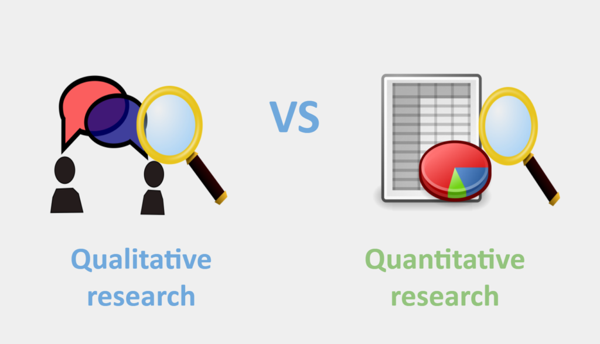
(Source: Yukti. 2020)

Because my research interests are academic procrastination and psychology, I pay special attention to the application of quantitative analysis in psychological research. Qualitative research still faces strong resistance from many people, especially within mainstream American psychology (Moller et al., 2021and Jackson, 2015). Part of this resistance, I believe, stems from a continuing and widespread misunderstanding of the nature of qualitative methods. In my previous business studies, quantitative analysis was widely applied in the business field (consumer behavior, consumer psychology, price survey and satisfaction survey (Greener,2008 and Johns,2010). And it's worth noting that the war of Paradigm is still brewing behind the scenes. The question of how to define qualitative and quantitative paradigms, when to apply them, and if they can be reconciled has long been a source of academic debate (Elshafie et al,2013).

When I begin my research journey, I find it necessary to acknowledge that research is valuable and that there may be biases. Start by asking some fundamental questions about what types of data need to be collected and what types of methodologies need to be utilised to explain or change awareness of the issue by becoming aware of one's own beliefs, attitudes, and prejudices. My research is focused on huge groups of people, such as students at a particular university or international students from China.

Second, as a newcomer, I realised that I had to embed myself in the existing literature, especially around the methodology I had chosen. In hybrid method research, given the growing evidence in the field, I quickly realised that I still needed to read a lot of literature to supplement my academic knowledge. I find that design evolves as research progresses. Like the teacher suggested, you need to refine the questions step by step, keep reading the literature until you find the place in which you are truly interested.

Finally, I have not made up my mind to choose quantitative research in my own research, even though the course has given me a lot of knowledge and confidence. I will try to use the method of quantitative analysis to verify some hypotheses, and then make the final decision of quantitative research according to the situation in my dissertation.

References:
Moller, N., Clarke, V., Braun, V., Tischner, I. and Vossler, A., 2021. Qualitative story completion for counseling psychology research: A creative method to interrogate dominant discourses. Journal of Counseling Psychology, 68(3), pp.286-298.

Jackson, M., 2015. Resistance to qual/quant parity: Why the “paradigm” discussion can’t be avoided. Qualitative Psychology, 2(2), pp.181-198.

Johns, R., 2010. Survey Question Bank: Methods Fact Sheet 1 (March 2010). Survey Resources Network.

Greener, S., 2008. Business research methods. BookBoon.

https://s3.us-west-2.amazonaws.com/us-west-2.files.campus.edublogs.org/sites.gsu.edu/dist/7/3504/files/2016/12/Elshafie-2013-Research-paradigms-The-novice-researchers-nightmare-ozgj12.pdf

Blog 2：
The qualitative research in traditional commercial field is different from that in academic field. Research in business is more practical. Management experts develop theoretical models of organisations and attempt to quantify these characteristics. Consider the SWOT analysis, which is often used to assess a company's competitiveness (Ciprian, 2018).


(Source: Cremades, 2019)
The corporate environment is more dynamic, flexible, and difficult to influence than academics. The trend of low survey response rate is common in empirical research on family business, and even a large number of business survey are proved to lack credibility and practical significance in many cases (Khan and Bohnsack, 2020). For example, many surveys on consumer satisfaction with FMCG did not result in any actual traffic (Greener,2008).

I have been working in international education for nearly ten years. The analysis of qualitative data allows me to assess the trend of the industry or the characteristics of students of a particular age group. For example, in the last five years, the number of Chinese students studying in the UK has increased, as has research on the amount of time students under the age of 18 spend playing mobile games (Li, Gao and Xu, 2020). These statistics support my business decision making process, although I am often not satisfied with the authenticity and validity of the data.

So far, I am still a novice in research, confused by paradigm research and choice. Researchers et al. claim that "investigative research is based on a positivist paradigm, according to which reality is objective, unbiased, and completely independent of researchers and research. In fact, this surge of interest has only increased more than 10 times in qualitatively oriented research, however, qualitative analysis and research has not been widely recognized and accepted by mainstream psychology in China and the United States (Jackson, 2015).

A real culture transformation is possible, from a scientific-dominated intellectual environment to one that recognises a broader and richer approach to study. This problem might be expressed in terms of the degree to which "quantitative methodologies and psychological research" have been adapted. For example, in academic research, quantitative is generally used for deductive results testing and evaluation, while qualitative is more used for analysis of the physical variability (Govender, 2019).

My quantitative issue stems from a lack of comprehension of terminology like reliability and validity, which are used in quantitative research. I can probably only describe the definitions of academic terms at the moment. Another aspect comes from the use of mathematical and quantitative software, such as SPSS. In fact, in the 15 years after I graduated from university, I rarely used advanced mathematical models. Meanwhile, the successful installation of SPSS in the last week brought me extra pressure and anxiety. As a result, I am not proficient in using quantitative paradigms and models to verify my assumptions. The final reason is that most of my previous psychological training was from humanistic psychology and consulting psychology, and my limited experience in quantitative analytical knowledge was limited to business analysis.

Earlier this year, I was certain that I would pursue qualitative research in my own right, but now this idea is somewhat wavering. My concern mainly comes from the fact that according to my previous plan, I will select 3-4 Cases of Academic procrastination of Chinese international students in the way of case study for in-depth long-term follow-up research through a case study. At present, it seems that such sampling has certain reliability and validity problems. This kind of obvious quantitative research has obvious advantages in sampling and statistics, which is also the reason why the mainstream psychological circles in the United States and China prefer quantitative research.

References:
Ciprian, I. (2018). DEMOGRAPHIC AGING IN FRANCE AND ROMANIA. A COMPARATIVE STATISTICAL ANALYSIS. Scientific Annals of the 'Al. I. Cuza' University, Iasi. Sociology & Social Work / Analele Stiintifice ale Universitatii 'Al. I. Cuza' Iasi Sociologie si Asistenta Sociala., 2018, Vol. 11(Issue 2), pp. p7-32. 26p.

Li, L., Gao, H. and Xu, Y., 2020. The mediating and buffering effect of academic self-efficacy on the relationship between smartphone addiction and academic procrastination. Computers & Education, 159, p.104001.

Govender, P., 2019. Use of Mixed Methods and Reflection: A Novice Researcher’s Perspective. Global Journal of Health Science, 11(13), p.8.

Blog 3：
Sampling has many statistical implications. For example, in the face of a large sample size, global statistics is nearly hard to complete in the face of a huge sample size, whereas sampling statistics can fully comprehend the global statistical features. Reliable data is the basis of all quantitative analysis. Quantitative research strategies emphasize "quantification in data collection and analysis". However, there are different types of data, and it is also possible to consider the statistical significance of different sampling methods. For example, simple sampling, stratified sampling and systematic sampling should have their advantages and disadvantages in different sample sets.

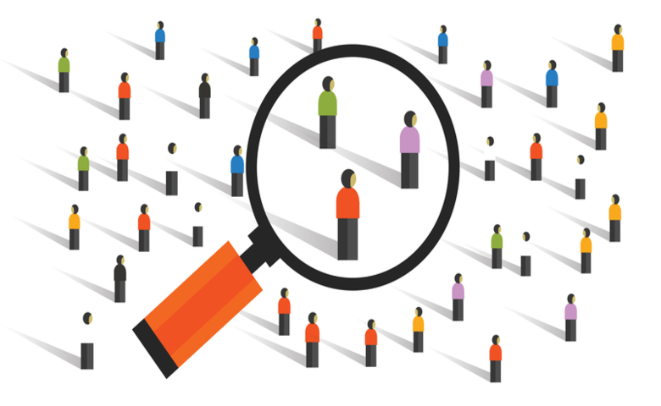
(Source: Tim 2021 )
Researchers can gather, evaluate, and display data in a variety of ways. Sampling is arguably one of the most common strategies. What is sampling?

A sample is a part or subset of a larger group called a population. A good sample is a microcosm of its part of the population. It must be representative of the people , with samples drawn from a larger group sharing many of the same features or qualities. At the same time, it is necessary to demonstrate why this study tends to focus more on these particular characteristics.

It's important to note that populations change depending on the environment. The nature of the relationship between the sample and the wider population is of fundamental importance to how we understand the nature and purpose of quantitative research. Dual inquiries, such as those involving two attitude objects, and rules involving leading questions, should be avoided. Typically, questionnaire designers are required to be fair in their approach and ask questions from a neutral standpoint.

Li, Gao and Xu, (2020) constructed a mediating model to investigate the influence of smartphone addiction on academic procrastination among college students and the mediating role of academic self-efficacy. (Li, Gao and Xu, 2020) A total of 483 college students were surveyed by using the Smartphone Addiction Shorthand Scale, the College Academic Self-efficacy Scale and the Tukman Academic Procrastination Scale. (Li, Gao and Xu, 2020) Correlation analysis shows that smartphone addiction is positively correlated with academic procrastination and negatively correlated with academic self-efficacy.

Blog 4：
It is unclear what content Netflix's Big Data and Machine Learning approach refers to. However, the ethical issues of general video websites mainly focus on several aspects: whether the privacy of users' personal data is protected, whether users' personal data is used and traded, whether big data and artificial intelligence violate users' personal will and so on (Li, Gao and Xu, 2020). There's been some interesting debate about whether big data and push are enslaving users. The content pushed to users by big data analysis and autonomous learning is the content that users are interested in, which virtually blocks users' exploration and pursuit of videos and media in new fields (Şahin, 2014). This has an impact on the user's autonomous experience.


(Source: Gabriela, 2019)

Netflix is the world's most popular subscription streaming entertainment service, uses an artificial intelligence (AI) -based system that analyses customer preferences and applies algorithms to boost click-through rates. "Specifying what the system can do," according to the AI design guide's "beginning" section, indicates that the platform should allow people to acknowledge what the AI system can achieve. In fact, Netflix didn't tell users in advance. Whatever actions the user takes, the AI system uses those actions to make a relevant impact. In the "initiative" content makers can use AI to develop content for even the most basic jobs. Without realising it, you're probably reading articles generated by artificial intelligence algorithms. Robots are being used by a lot of big corporations to create automated content. They will be able to report the most recent news and updates more swiftly as a result of this. Content automation provides an opportunity to focus on more challenging tasks without compromising distribution consistency. These similar studies also exist on similar video platforms in China. The gathering and commercial exploitation of customers' private data, as well as the big data drive, have sparked fierce debate.

Blog 5：
Hypothesis testing is a form of detective rather than judge of results. We might start by talking about what a significance test is and then look at the significance of a significance test.

It is important to note that the significance test is called the "significance test". However, this does not mean that the statistical results that pass the significance test are "significant", or even that a corresponding causal relationship can be drawn. Its significance lies only in identifying "significant" differences in statistical results.

A related argument is that statistically significant does not mean significant in reality, and discussing Ordinal Numbers (ranking, percentage) without reference to cardinality (absolute number) is in a sense not practical (Uher, 2021).

Figure 1 is an example of a research of academic procrastination among Facebook users conducted by Sahin in 2014. As can be seen from the picture, there is a low and significant positive correlation between the frequency of Facebook use and students' academic procrastination (r=0.204, P <01). When examining these sub-dimensions, it is clear that the social relationship uses case of Facebook (r=0.205, P <.01) and the daily work use case (r=0.126, P <.01) have the greatest impact on academic procrastination. This result can be described as the higher the amount of time an individual uses Facebook socially and for daily work, the higher the degree of academic procrastination (Sahin, 2014).

References:
Uher, J., 2021. Quantitative psychology under scrutiny: Measurement requires not result-dependent but traceable data generation. Personality and Individual Differences, 170, p.110205.

Şahin, Y.L., 2014. Comparison of users' adoption and use cases of Facebook and their academic procrastination. Digital Education Review, (25), pp.127-138.

Blog 6：
I am particularly concerned about academic procrastination because of my personal experience. According to Steel's application of TMT theory, academic procrastination versus research, time management and self-management should be used to influence factors (Steel,2007 and Steel et al., 2019). Abidi(2020) analysed the learning behaviors of middle school students in online education through big data and found that the total time of contact or communication with procrastination LMS (online learning system) was closely associated. Like how well students finish their homework on a daily basis, extra reading time. Due to face-to-face teaching, the earlier measurement of students' self-supervision was not adequately reflected. Big data analysis clearly offers a significant advantage when it comes to time management. It is difficult to obtain the most direct data of students' time management from questionnaire survey before this. For example, ask whether it is a serious problem for students to rush their homework before the deadline. The answers ranged from none to very serious. The results of similar data surveys are mostly subjective responses of students (Dias, et al. ,2020).This is influenced by cultural differences, prejudice, and the emotions of the respondents. The big data of online education platform and online learning system will more objectively and comprehensively reflect students' time management and learning behavior. Big data can even analyse students' mood, sleep, attention in class and other related factors.

I think passive online education during the pandemic provides a new platform and opportunity for academic procrastination. Previously, college or high school students have not used online education platforms to complete undergraduate or high school courses.

Most of the qualitative analysis data come from questionnaires or interviews, and some of them come from the teaching system of the school. The correlation and reliability of the data are low. For example, according to academic procrastination research conducted by scholars during COVID-19, students who take online courses have less detailed understanding of deadlines and assignment requirements than those who take offline courses.

This is just the previous study that insufficient self-supervision of students will have a negative impact on academic procrastination (Goroshit and Hen, 2019). More people are identifying themselves as chronic procrastinators or decision procrastinators.

Big data and AI were mentioned in Blogs 4 and 5. Whether procrastination data collecting, and assessment can be integrated into present online learning systems, particularly in university teaching systems. Based on the student's learning behaviour, AI estimates the degree of procrastination and provides external assistance and reminders (submission date, homework requirements, big task breakdown) (Naz, Hassan,and Luqman, 2021).

References:
Steel, P., 2007. The nature of procrastination: A meta-analytic and the- oretical review of quintessential self-regulatory failure. Psychological Bulletin, 133(1), 65–94.

Steel, P., Svartdal, F., Thundiyil, T. and Brothen, T., 2018. Examining Procrastination Across Multiple Goal Stages: A Longitudinal Study of Temporal Motivation Theory. Frontiers in Psychology, 9.

Abidi, S., Zhang, W., Haidery, S., Rizvi, S., Riaz, R., Ding, H. and Kwon, S., 2020. Educational Sustainability through Big Data Assimilation to Quantify Academic Procrastination Using Ensemble Classifiers. Sustainability, 12(15), p.6074.

Dias, S. B., Hadjileontiadou, S. J., Diniz, J., & Hadjileontiadis, L. J. (2020). DeepLMS: a deep learning predictive model for supporting online learning in the Covid-19 era. Scientific reports. [Online] 10 (1), 19888–19888.

Naz, S., Hassan, G. and Luqman, M., 2021. Influence of perfectionism and academic motivation on academic procrastination among students. Journal of Educational Sciences & Research, 8(1), pp.13-20.

Blog 7
My recent focus has been on examples of the combination of academic procrastination and quantitative research methods in psychology. Qualitative analysis is considered to be an effective research method in mainstream American psychology. Quantitative analysis is widely used in academic procrastination. For example, Bashir and Gupta analysed academic procrastination and four influencing factors (time management; Task aversion degree; Sincere; Individual initiative) (Bashir and Gupta, 2019).

Tavakoli's research has proved that interest, gender and age all have an impact on academic procrastination (Tavakoli,2013). There is a lot of qualitative research on the impact of the early Internet on academic procrastination, as the author mentioned earlier. For example, Sahin's study found that It is found that people who use Facebook are more likely to delay school Sahin than people based on their social relationships (Sahin, 2014). This is a classic case of SPSS quantitative academic procrastination.

Another recent focus of my is on the judgment and intervention of academic procrastination in big data research. For example, Abidi et al., in his article published in Sustainability in 2020, proposed a new idea on the data-based application of online learning behaviour to judge academic procrastination and intervention.

Tandon et al., 2020 found that during the COVID-19 lockdown, the boundary between rest and study or work was no longer clear due to online study or work from home. Whether to consider helping members deal with procrastination in new online social interactions is a very popular area of management and psychology.

My current research focuses on the new situation and effective means of academic procrastination in online education. For example, Dias et al. Proposed in 2020 that DeepLMS would improve the efficiency of online education, especially the improvement of community activity, and improve students' learning engagement (Tandon et al.).

The study in the first stage of DBA has come to an end, and I am still considering whether to choose qualitative, quantitative or mixed research methods for my research project. Although I know that I still have serious deficiencies in my academic ability, I still hope that my research can make some new theoretical contributions to the study of academic procrastination.

I try to keep myself from addressing the huge business value of academic procrastination and how it improves my company's business. Remind yourself that you are doing academic research, asking questions, refining questions, not thinking about solutions and business value.

References:
Bashir, L. and Gupta, S., 2019. Measuring Academic Procrastination: Scale Development and Validation. Ilkogretim Online, 18(2).

TAVAKOLI, M.A., 2013. A study of the prevalence of academic procrastination among students and its relationship with demographic characteristics, preferences of study time, and purpose of entering university.

Şahin, Y.L., 2014. Comparison of users' adoption and use cases of Facebook and their academic procrastination. Digital Education Review, (25), pp.127-138.

Yukti. 2020. Know the Difference between Quantitative and Qualitative Research. | Yukti. [online] Available at: https://www.yukti.io/know-the-difference-between-quantitative-and-qualitative-research/ [Accessed 18 November 2021].
Cremades, A., 2019. How To Start A Business. [online] Forbes. Available at: https://www.forbes.com/sites/alejandrocremades/2019/02/13/how-to-start-a-business/?sh=2eea86c06e1a [Accessed 19 November 2021].
Tim Bock, 2021. What is Random Sampling? [online] Available at: https://www.displayr.com/what-is-random-sampling/ [Accessed 19 November 2021].
Li, L., Gao, H. and Xu, Y., 2020. The mediating and buffering effect of academic self-efficacy on the relationship between smartphone addiction and academic procrastination. Computers & Education, 159, p.104001.
Şahin, Y.L., 2014. Comparison of users' adoption and use cases of Facebook and their academic procrastination. Digital Education Review, (25), pp.127-138.
Gabriela Gavrailova, 2019. Big Data: What Is It and How Does It Work? - Mailjet. [online] Available at: https://www.mailjet.com/blog/news/what-is-big-data/ [Accessed 19 November 2021].

