Analyse the role of independent bodies (i.e. IOPC/HMICFRS) in holding the police accountable to those they serve. Consider how and why it is necessary to hold the police to account, and the effectiveness of these independent bodies at fulfilling this task. You should also consider how else the police might be held to account, including whether any policies are in place internally to prevent this.
Throughout this essay, I will aim to analyse the role of independent bodies such as the Independent Office for Police Conduct (IPOC) and Her Majesty’s Inspectorate of Constabulary and Fire & Rescue Services (HMICFR) in holding the police accountable to those they serve, considering how and why it is necessary and the positive effects that this can have.
(Independent Office for Police Conduct, 2019) investigate and oversee complaints within the police service, whether they are small complaints or extreme ones, against police or police staff. As outlined by the IPOC, police must refer their most serious cases automatically to the IPOC and their role is to help implement positive changes to policing by investigating these complaints to ensure that police are always able to take accountability for their actions. Their role is also to “engage with the police and the public to make sure their work reflects where they can add the most value to policing and public confidence”, as detailed in their business plan. The IOPC is an important organisation because they are entirely independent from all police forces and thus are 0% biased.
The police hold a high responsibility when it comes to public welfare and safety and therefore hold the key to the public having trust and confidence in the police force. Because of this, it is absolutely necessary and of prime importance that the police are held accountable for their actions and are constantly able to justify them.
There are many ways that police officers individually can hold themselves accountable for their own actions, every day, by following the 9 policing principles. The 9 policing principles are:
- Accountability – Must ensure that they are answerable for the decisions that they choose to make
- Selflessness – To act solely in the public’s interest
- Honesty – Must be truthful in everything they say and do and as a result are entirely trustworthy
- Integrity – Must always do the right thing and own up to any mistakes that are made
- Fairness – Police must treat all people fairly, regardless of their ethnic or social background
- Leadership – All must always lead by impeccable standards
- Openness – Actions must be utterly transparent in their decision making
- Objectivity – Must use their professional judgement
- Respect – Police treat everyone with respect, regardless of their ethnic or social background
These 9 policing principles are important because they reflect the public’s expectations of the police. They set a threshold of behaviour that police must meet and if police demonstrate these principles with every action they take, they are therefore always able to account for their actions by following what the public expects of them. There are quite a number of additional organisations that ensure we adhere to the 9 policing principles, for example HMIC and College of Policing.
Another hugely important role in the police holding themselves accountable are by remembering and demonstrating the Peelian Principles. The Peelian principles originated from Robert Peel, the founder of the Metropolitan Police Service and were introduced by Peel include the quote, which (The Great Australian Dream, 2020) touch upon “based on the philosophy that the power of the police comes from the common consent of the public, as opposed to the power of the state.”
Again reinforcing the belief that in order to execute their duties, the police must always have the consent of the police and must not act in a way that they know the public would not approve of.
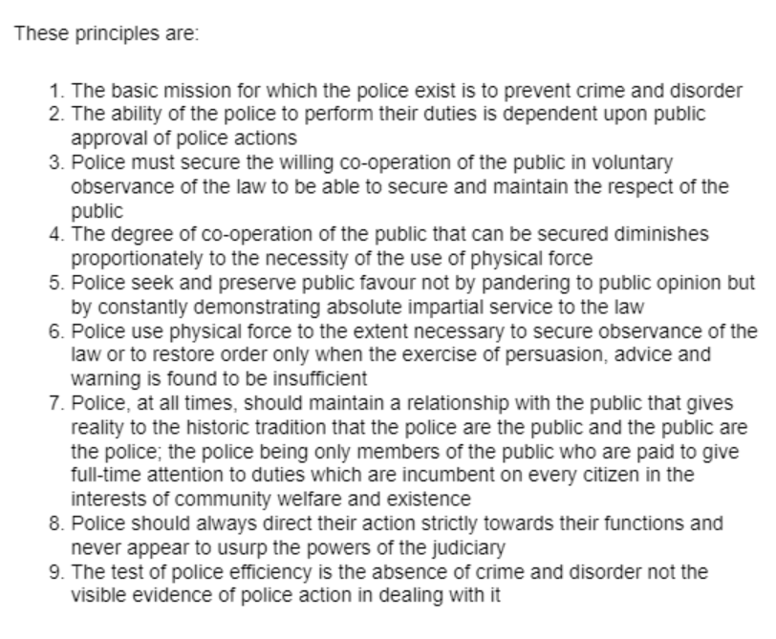
(The Crime Prevention Website, 2013)
The Peelian principles are still very much demonstrated today and as per (The Crime Prevention Website, 2013), have helped determine an approach that the HMIC takes to find out the positive and negatives of what is working well in terms of how the police force serves the public.
An important Peelian principle is number 2: “The ability of the police to perform their duties is dependent on public approval of police actions”. This is especially important in this case, because it is important that police can always justify the decisions they make and they can do this by ensuring their actions are justified, proportionate, legal, necessary and ethical. If they can ensure these fundamental parts of their decision making then they can assure and be assured that their actions are entirely accountable leaving them with a higher level of support and backing of the public. When police fail to provide this transparent and openness, is when bodies such as the IPOC step in and take a course of action.
In addition to the IPOC being an independent body for police complaints, the police have internal processes and policies for holding themselves accountable for their actions which is via their professional standards department who internally manage police complaints. The professional standards department have their own set of 10 standards of professional behaviour:
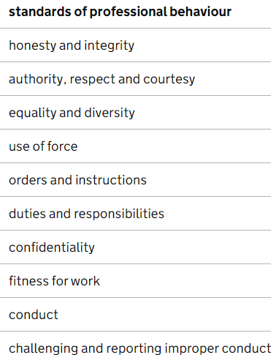
(Home Office, 2014)
Considering my research, findings and the information throughout my essay, it is therefore necessary for the police to be held accountable in order to continuously hold public confidence and trust to an incredibly high standard. Without the trust of the public, the police would fail to maintain a relationship with the public which is vital to safe and reliable policing. The IPOC and their role to investigate police complaints and hold them accountable is a thorough and confident service that aim to investigate complaints in a timely manner. An example of this is during 2018/19 within a 12 month period, the IOPC closed nearly 80% of their cases, compared to 69% the previous year as documented by (Brembor, 2019), and while a great amount of the complaints that reach the IPOC result in the police having done nothing wrong, there are a small amount where complaints have led to criminal convictions of police and considering all of this, thus proves their effectiveness.
Word count: 967 words

Evaluate the effect of multi-culturalism on policing ethics and values, and examine how officers police diverse communities. Your answer should be based on academic research, rather than personal experience.

In this essay, I will aim to evaluate the effect of multi-culturalism on policing ethics and values. I will then aim to examine how officers police diverse communities.
(Patil, 2019) says multi-culturalism can be defined as “cultural diversity or the evolution of it, where people from different ethnicities coexist; it can also refer to an integrative policy adopted by a multicultural nation.”
(Andreas, 2020) explains the advantages and disadvantages of multi-culturalism. A few examples of the benefits of multi-culturalism that they suggest, which I agree with, is that multi-culturalism makes society more harmonious when it works and this can lead to making many different connections with many different backgrounds and therefore lowers tensions amongst these diverse communities. However, as wonderful as it would be for all ethnic and minority backgrounds to co-exist together entirely harmoniously, there are many disadvantages of multi-culturalism that do exist. One of the most important disadvantages of multi-culturalism, I feel, is the substantial risk of conflict between these minority groups and between different ethnic groups in general. This could be because of difference of opinions regarding race, religion, sexual orientation etc and therefore this naturally increases these tensions and need for conflict between groups. Taking all of this into consideration, this has a huge effect on policing ethics and values. (College of policing, 2014) documents very clearly the Code of Ethics and what is expected of police officers when dealing with equality and diversity. This section of the Code of Ethics states that police must treat all people fairly and with respect while being entirely impartial. Examples of ways this can be demonstrated by police are by using all opportunities to promote equality and diversity and by treating people with compassion and empathy, no matter their ethnic background or beliefs. It is also important for police officers to remember the 9 Policing Principles by Robert Peel when policing diverse communities. The 9 policing principles are:
- Accountability
- Selflessness
- Honesty
- Integrity
- Fairness
- Leadership
- Openness
- Objectivity
- Respect
Whilst these principles are all as important as each other, in particular, the following are important in how officers police diverse communities
- Fairness
- Accountability
- Respect
It is important to act with fairness and respect, as already discussed, police must treat all people fairly and with the upmost amount of respect, no matter who they are. By doing this and making many decisions, police must be able to be answerable for their decisions and be able to justify them at all times.
Robert Peel said at the very beginning of the creation of the Metropolitan Police Service that
“The police are the public and the public are the police”.
(South Wales Police, 2022) make an extremely coherent point that in order to value the difference amongst one another then we must create a representative workforce of all those that we serve in order to be inclusive and understanding of diverse and minority backgrounds. A more representative workforce can only be beneficial towards gaining the trust of the public that belong to diverse communities and in obtaining and retaining their confidence. Achieving the trust and confidence of these communities is a hugely positive gateway into other benefits when it comes to crime reporting and preventing, amongst many other things. It is also crucial that police make the utmost amount of effort to start to really learn about the different cultures that make up society and the underlying causes of conflict between different minorities. Understanding these differences will ultimately make it easier and more genuine for police to help solve problems and provide a more efficient service to the public.
(Police.uk, 2019) shows just how little police officers represent black and minority ethnic backgrounds and they demonstrate this via the graph below:
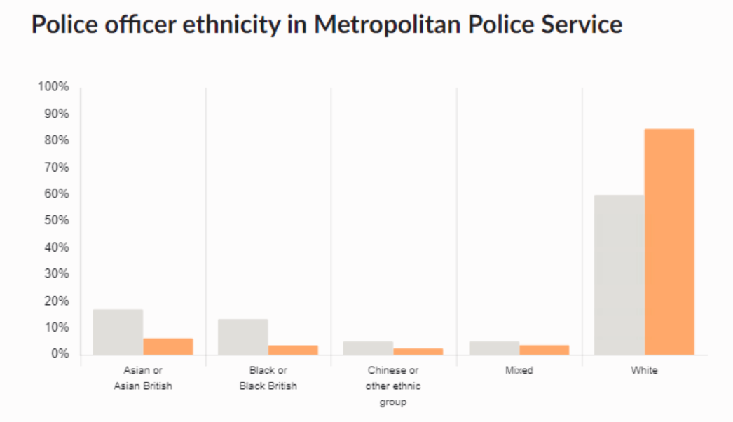
(Police.uk, 2019)

An example of how officers police diverse communities is policing Female Genital Mutilation. (Metropolitan Police, 2021) go into depth about what Female Genital Mutilation is and the law surrounding it. This is just one example of policing diverse communities and working with third party agencies to help offer support surrounding these types of cases. (BAWSO, 2022) is a third party agency/charity that police occasionally work with to help police these communities and to offer constant support, help and advice in relation to these types of incidents. Police officers are receiving a substantial amount more training in relation to equality and diversity in contemporary society including types of crimes such as forced marriage, FGM and honour based violence. Again, (South Wales Police, 2022) are continuing to implement education where ethnic minority communities are concerned and do so via their social media accounts, website, police fairs and internally through training. South Wales Police have created one, of many, videos in order to demonstrate how they are working towards a more educated and representative workforce.

After evaluating the effects of multi-culturalism on policing ethics and values and examining how officers police diverse communities, contemporary policing is clearly moving towards a more representative workforce, greatly impacting the relationships between the police and those that belong to diverse communities in an extremely positive way. It does have its demands and through the research I have explored it is clear that this demand has an effect on policing values and ethics. However, these effects are positive and the ones that aren’t are being improved upon and I have discovered this by examining how officers police diverse communities. There is a substantial commitment from police to become more inclusive and aware of the surrounding ethnic minority groups and this is evidenced via new statistics from (The Police Foundation, 2013) showing that police forces are becoming more diverse and representative of minority groups, slowly but steadily. (The Police Foundation, 2013) shows that since 1999 the proportion of police officers recruited from an ethnic minority background has increased by 2%. While this has increased marginally, this evidence is a sign of great movement to ensuring that somewhere in the future, these effects will all become the desired outcome.

Word count: 1,000

Assess the impact of early intervention and partnership approaches in reducing re-offending in relation to gang-related activity. Your answer should consider theories relating to the onset of offending, and comment on how these influence relevant interventions and approaches.

During my essay, I will aim to assess the impact of early intervention and partnership approaches in reducing re-offending in relation to gang-related activity. I will aim to include and consider theories relating to the onset of offending and touch upon how these influence relevant interventions and approaches.
(Law Insider, 2022) defines gang-related activity as “any incident or actions that is gang motivated, caused by gang membership or involved gangs during the occurrence. A gang is defined as an organized group that engages in delinquent or illegal activity.”
Early intervention is, as explored by (Early Intervention Foundation, 2017), a route people can take to identify problems early on before these problems escalate into bigger and more dangerous issues. If problems are identified at an early stage, steps can be taken to find the underlying causes of them and to help prevent such things arising in the future. For example, when young people offend and commit crimes, there is usually an underlying root cause of this. Early intervention can have a huge impact on helping to identify these underlying root causes, identify any risks and target a problem early on.
A hugely beneficial tool available to use when tackling re-offending in relation to gang-related activity is partnership working. Partnership working is when agencies work together in order to tackle an issue, together. For example, as discussed by (gov.uk, 2011), the police might work in partnership with the Youth Offending Team (YOT) who are completely separate from the police. Similarly to early intervention, the youth offending team works with young people who get into trouble with crime and this can absolutely include gang-related activity. The Youth Offending Team may look into this young person’s upbringing or background to try to establish why and where the problems are originating from. They will also then work with that young person to help prevent them from committing crime or getting into trouble in the future.
The strengths I have identified from early intervention, as expressed by (Benefits of, 2022) are that when there is early intervention, it can help a number of things. It can help prevent young offenders developing into committing serious and odious crimes thus spending a long time in prison or on probation. It can help secure young offenders jobs in the future without the hindrance of a serious criminal record and gives hope to that young person in the process. (Early Intervention Foundation, 2018) evidences that youths that are involved in gang-related activity were vulnerable to being exploited because of the deprivation that their family background was from, leaving familys stressed and helpless when it came to providing support and aid for their children.
However, there are some downfalls to early intervention, the main one being that it simply might not work. (Early Intervention Foundation, 2018) goes on to say that these young people from these deprived backgrounds often have a lack of role models in their lives as they grow up and therefore do not have the right immediate support or guidance. They also are at risk of other potential hindrances such as poor mental and physical health and therefore simply do not have a stable enough environment to direct them onto a healthy path away from crime and offending.
It is important to consider, that amongst this young offending, are young people who are troubled throughout their early life with many different struggles and this has an effect and influence on early intervention and partnership approaches. (HMA, 2016) elaborates on the theories behind offending in gang-related activity. These theories include:
- Social Location Theory: Criminal behaviour in youths can be a result of where they are in the social food chain. Those with less money and wealth are more likely to offence
- Differential Association Theory: This is based on the attitude that a youth adopts through exposure to those who are from criminal backgrounds
- Psychodynamic Theory: Down to youth personality and their environment such as psychological immaturity and through this immaturity comes a lack of self-control
In addition to these theories, there are other impacting factors when it comes to the onset of offending. (Whitaker, 2020) suggests that peer pressure from family, friends, colleagues or pupils at school can cause onset offending resulting in them falling into the wrong groups that link back to gang-related activity. Young people can also have an incredible lack of knowledge and can be easily influenced or led astray. A change in circumstances such a death in immediate family and also even boredom can all contribute to onset offending in youths.
Peer pressure and manipulation in particular, can therefore have a huge impact on early intervention and partnership approaches. This is because peer pressure can be incredibly hard to resist and therefore despite efforts, help and guidance from early interventions, youths continue to be peer pressured into crime.
To conclude my findings, I researched data in relation to whether or not early interventions actually work and help to reduce youth offending. (Ministry of Justice, 2022) corroborates these findings as they explain that reoffending rate for youths is currently at it’s lowest as of 2022. The graph below shows that youth first time entrants into the criminal system as drastically decreased – showing that early intervention does help and prevent youths offending in the first place or re-offending.

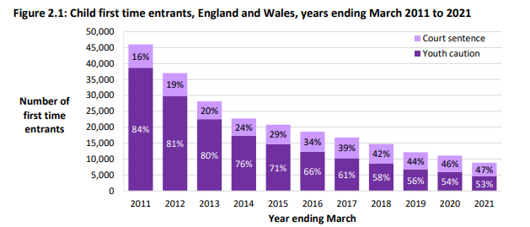
(Ministry of Justice, 2022)
Statistics by (Ministry of Justice, 2022) also shows that the most common offences committed by youths in the age group of 10 – 17 are summary only offences consisting of mainly common assault and low level criminal damage. This is a great example that early intervention is helping to prevent further offending and offending escalating to more serious and violent crimes associated with gang-related activity.
Word count: 952 words

Analyse potential links between serious and organised crime and public protection issues, and evaluate the effectiveness of current public protection practices in investigating such incidents. Your answer should indicate why certain groups might be targeted by S/OCGs. Rather than relying on personal experience, support your answer with relevant evidence drawn from academic sources.

Throughout this essay I will aim to analyse the potential links between serious organised crime and public protection issues. I will then aim to evaluate the effectiveness of current public protection practices investigating such incidents including why certain groups might be targeted by OCGs.
(CPS, 2019) describe an organised crime group as “a group which: has at its purpose, or one of its purposes, the carrying on of criminal activities, and consists of three or more people who agree to act together to further that purpose.”
An example of organised crime groups can involve drug and human trafficking, fraud, slavery and many more. This is also known as county lines. (CPS, 2019) goes onto to demonstrate via statistics just how serious these organised crime groups are. For example, the drug trade which is controlled by these organised crime groups is worth £3.7 billion per annum. This can also provide additional devastating effects such as the drug trade causing over 2000 drug-related deaths in 2012 alone.
There are groups of people who are a part of normal society that, in particular, can be more susceptible and vulnerable to being targeted by serious organised crime groups and therefore exploited. These groups of people include young people, people with disabilities such as poor mental health or physical disabilities, to name a few.
There are several ways in which these people can be exploited:
- Sexual – Forced to see many clients in brothels etc

- Forced labour – Forced to work very long hours and hand over all their wages to their traffickers or controllers

- Criminal – Can be coerced into dealing drugs, controlling cannabis farming, getting involved in organised crime, fraud

- Domestic Servitude – victims who live and work in households where they are forced to work through threats of serious harm and physical and sexual assaults

- Organ harvesting – Where victims are trafficked in order to sell their body parts and organs for transplant e.g eggs, kidneys, eyes

Young people and those with disabilities or limited access to help and support are more likely to be targeted by organised crime groups due to these vulnerabilities. This is because something is usually offered, such as a gift or reward, as an exchange for that young or vulnerable person doing something criminal to benefit the organised crime group. For example, selling drugs in exchange for money or other rewards such as friendship or affection.
These serious organised crime groups tend to target these groups of people due to some of the following examples:
- Social isolation
- Lack of support from family and friends
- Lack of family
- Physical or learning difficulties
- Poor mental health
- Economic vulnerability
- Drug or alcohol dependant
- Homelessness
There are many multi agencies involved in the tackling of organised crime groups including the National Crime Agency and VCS (Voluntary and Community Sector) organisations. The National Crime Agency, for example, work largely with international authorities providing intelligence, training and other levels of support to help tackle and reduce crime led by organised crime groups as detailed by (National Crime agency, 2022). Of course, the police are heavily involved in the attempt to reduce organised crime group activity and to reduce the demand. The National Referral Mechanism is a “process set up by the Government to identify and support victims of trafficking in the UK”. (National Referral Mechanism, 2021) show that at least 14.5% of referrals were flagged as county lines in 2020 compared to 11% in 2019, showing a clear increase and 10,613 potential victims were identified through the referral scheme in 2020. In addition to a frightening amount of victims, serious organised crime groups have a great impact on other members of public and this is influenced and deteriorated via the influence of social media resulting in the general public fearing organised crime related violence.
In conclusion to my findings, it is quite clear that there is still a vast amount of work to do in terms of tackling organised crime groups and that these organised crime groups are a huge problem in the world today. There are many public protection practices in place for the vulnerable who are victims of exploitation/crime and these include:
- Social Services
- Child protection conferences
- Phone helplines such as the Modern Slavery helpline
- Youth Offending Team
- Crime stoppers
- Action Fraud
- Police
- National Crime Agency

However, despite these available agencies it is very clear that there are public protection issues in relation to organised crime. This is evidenced via the increase in organised crime activity and the young and vulnerable people that they are recruiting and exploiting. (NCA, 2016) document that between the months of January and June during the year of 2016, 80% of areas across the country that involved organised crime groups had recruited children into gangs. The children’s ages ranged from 12-18 years. These groups are presenting a dangerous threat to vulnerable groups of people and there is not much evidence to suggest that there is much public protection for these people that is successful and after evaluating the available public protection practices that are currently in place and available, I do not think that they are effective in supporting the vulnerable and the general public in feeling safe against the violent and serious crimes that they groups commit and are involved in.
(Crocker et al. 2017) developed a strategy to “strengthen the response” to serious and organised crime, using four P’s:
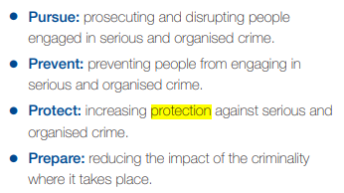
It evidences that there are strategic plans in place to continue to tackle the serious organised crime groups along with ensuring the safety of victims and the general public by increasing the protection against them.

Word count: 948 words

Bibliography
2021. Of Serious and Organised Crime National Strategic Assessment. 2021.
Andreas. “26 Key Pros & Cons of Multiculturalism.” E&C, 3 Aug. 2020, environmental-conscience.com/multiculturalism-pros-cons/.
BAWSO. “Bawso | Free Helpline: 0800 7318147.” BAWSO, 2022, bawso.org.uk/en/.
Benefits of. “Benefits of Early Intervention – Benefits Of.” Benefitof.net, 2016, benefitof.net/benefits-of-early-intervention/#:~:text=The%20following%20are%20some%E2%80%99%C3%82%20benefits%20of%20early%20intervention%3A. Accessed 1 Aug. 2022.
Brembor, Sara. Efficiency, Effectiveness and Profile of the IOPC. 2019.
College of Policing. “CODE of ETHICS.” July 2014.
CPS. “Gang Related Offences - Decision Making in | the Crown Prosecution Service.” Www.cps.gov.uk, 4 Nov. 2021, www.cps.gov.uk/legal-guidance/gang-related-offences-decision-making.
---. “Organised Crime - Strategy | the Crown Prosecution Service.” Cps.gov.uk, 14 Nov. 2019, www.cps.gov.uk/organised-crime-strategy.
cps. “Organised Crime Group: Participating in Activities of an | the Crown Prosecution Service.” Www.cps.gov.uk, Sept. 2019, www.cps.gov.uk/legal-guidance/organised-crime-group-participating-activities.
Early Intervention Foundation. Intervening Early to Prevent Gang and Youth Violence. 2018, file://swp.police.int/data/home/swp6907/Downloads/intervening-early-gang-youth-violence-primary-schools.pdf.
---. “What Early Intervention Is About.” Early Intervention Foundation, 9 Dec. 2017, www.eif.org.uk/what-its-about.
gov.uk. “Youth Offending Teams.” GOV.UK, 6 Dec. 2011, www.gov.uk/youth-offending-team.
HMA. Theories to Explain Offending Behaviour Offending Behaviour -Why Do People Do It? 2016.
Home Office. “Code of Ethics Launched.” GOV.UK, Home Office, 15 July 2014, www.gov.uk/government/news/code-of-ethics-launched.
---. “Code of Ethics Launched.” GOV.UK, Home Office, 15 July 2014, www.gov.uk/government/news/code-of-ethics-launched.
---. “Criminal Exploitation of Children and Vulnerable Adults: County Lines.” GOV.UK, 7 Feb. 2020, www.gov.uk/government/publications/criminal-exploitation-of-children-and-vulnerable-adults-county-lines/criminal-exploitation-of-children-and-vulnerable-adults-county-lines.
Independent Office for Police Conduct. “Who We Are.” Policeconduct.gov.uk, 2019, www.policeconduct.gov.uk/who-we-are.
IPOC. “StackPath.” Policeconduct.gov.uk, 2020, policeconduct.gov.uk/who-we-are.
Law Insider. “Gang Related Definition.” Law Insider, 2022, www.lawinsider.com/dictionary/gang-related.
Metropolitan Police. “Female Genital Mutilation (FGM) | the Met.” Www.met.police.uk, 2021, www.met.police.uk/advice/advice-and-information/caa/child-abuse/female-genital-mutilation-fgm/.
Ministry of Justice. Youth Justice Statistics 2020/21. 27 Jan. 2022.
Ministry of justice. “Youth Justice Statistics: 2019 to 2020.” GOV.UK, 2021, www.gov.uk/government/statistics/youth-justice-statistics-2019-to-2020.
National Crime agency. “What We Do - National Crime Agency.” Nationalcrimeagency.gov.uk, 2022, nationalcrimeagency.gov.uk/what-we-do.
NCA. County Lines Gang Violence, Exploitation & Drug Supply 2016 0346-CAD National Briefing Report Authoring Department/Team: Drug Threat Team, Organised Crime Command Date. 2016.
Patil, Rujuta. “Advantages and Disadvantages of Multiculturalism with Examples.” OpinionFront, OpinionFront, 2019, opinionfront.com/advantages-disadvantages-of-multiculturalism-with-examples.
Police.uk. “Workforce Diversity.” Www.police.uk, 2019, www.police.uk/pu/your-area/metropolitan-police-service/performance/workforce-diversity/.
Research Gate. “Theories of Gang Behaviour.” Research Gate, 2010, www.researchgate.net/publication/287633206_Theories_of_gang_behavior_and_public_policy/link/5682b92a08aebccc4e0e075b/download.
South Wales Police. “Working towards a Representative Workforce.” Www.south-Wales.police.uk, 2022, www.south-wales.police.uk/police-forces/south-wales-police/areas/careers/careers/working-towards-a-representative-workforce/.
The Crime Prevention Website. “The Peelian Principles | the Crime Prevention Website.” Thecrimepreventionwebsite.com, 2013, thecrimepreventionwebsite.com/police-crime-prevention-service---a-short-history/744/the-peelian-principles/.
The Great Australian Dream. “Sir Robert Peel’s Policing Principles – the Great Australian Dream.” Http://Greataustraliandream.net.au/Sir-Robert-Peels-Policing-Principles/, 2020, greataustraliandream.net.au/sir-robert-peels-policing-principles/.
The Police Foundation. “Policing and Diversity.” The Police Foundation, 8 Apr. 2013, www.police-foundation.org.uk/2013/04/policing-and-diversity/.
Whitaker, Ashley. “Theories around Onset Offending Techniques.” Majestic Grades, 31 Aug. 2020, www.majesticgrades.com/theories-around-onset-offending-techniques/.
Youth.gov. “Risk & Protective Factors | Youth.gov.” Youth.gov, 2019, youth.gov/youth-topics/juvenile-justice/risk-and-protective-factors.

