Research Proposal Form
MSc Public Health and Social Care in Practice Dissertation (LCHS7004)

Student Name | Student ID
Jahanara Begum | 1813593

Proposed Research Topic:

Investigating the significance of self-management awareness of type 2 Diabetes in South Asian community members in the UK

Research question:

How aware are South Asian community members (individuals aged 40+) in the UK about individual practices that help prevent type 2 Diabetes?

Research methodology:

This research will follow a systematic review method so that selected scholarly research articles would be reviewed carefully and derive appropriate evidence on selected areas of the research. The key benefit of using this method of evidence finding is its reliability and validity is very high which is useful for the decision-making process. Moreover, systematic review is very useful to find out right journal articles which have already been conducted and interpret deeply so that propre outcomes could drive on a selected research topic. This research will follow interpretive research philosophy and it is found useful for deeply investigating the selected research issues. Moreover, research has also intended to analyze behavioral issues of the target group of population and interpretive is appropriate philosophy for analyzing human behavior. Positivism derives specific values which could not analyze issues deeply, so interpretation is the right choice for the research work.

Data Collection method: This research will follow systematic review for data collection. This research will conduct database searches. To get secondary data research would find out the right journal articles from the electronic database. Researchers would use some keywords for finding some specific journal articles. Cinahl Plus Full Text, PubMed, Medline, and Google Scholar will be used for finding right journal articles. Inclusive and exclusion criteria would follow for narrowing down the searching process and finding the right journal article. The findings from the journal article would follow “Thematic Content Analysis' ' method for analyzing data. Content analysis is an easy method of data analysis.

Data collected from the selected journals are already in the public domain so no ethical issues would be followed for the research. The findings of the research would be useful for the adults over 40 years of age for changing their behavior to remain safe from type 2 diabetes and ensure their well-being.

Implication of the research
The research will benefit the people who are suffering from Type-2 diabetes. Moreover, it will also benefit the friends and families of the type-2 diabetes patients. On top of that, the people of the nation will be benefited as if self-awareness of type-2 diabetes people enhanced it will contribute to minimizing the overall expenses of the NHS. The number of diabetes patients frequently visiting will reduce. The target population for this research work is people with diabetes in the UK over 40 years.

Ethical Issues
The sources of the selected journal article will be declared in this research work. Moreover, researchers will read all areas of the selected journal articles, not only those issues which are agreed by the researcher. All the work would be read carefully. The researcher will consider three criteria for a systematic review journal article like, rigorous, explicit and reproducible.

A brief overview
Due to the high prevalence of diabetes the numbers of cardiovascular patients are also increasing significantly. According to Chrvala, Sherr and Lipman (2016), diabetes makes the health issues complicated which worsen the health condition of the patients. It was found from the research that long term diabetes causes the damage of retinopathy which causes eye disease. In particular, the poor control of blood pressure is considered as the key cause of eye disease. Diabetes also causes the leakage of protein in urine which leads to chronic kidney disease (Carpenter, DiChiacchio and Barker, 2019). It finds that controlling blood pressure level could minimize the risk of chronic kidney disease. Diabetes is directly linked with the increase of blood pressure level, so controlling diabetes would also help to reduce risk of chronic kidney disease. Moreover, Al-Khawaldeh, Al-Hassan and Froelicher (2012) stated that diabetes patients gradually lose their sensation ability which increases aches in their feet. Most of the time people with type 2 diabetes find themselves unaware about the complications of their health disease.

Diabetes is a non-returning disease but people could maintain it to remain safe for a longer time period. According to Steinsbekk, et al., (2012), self-management of the people could help to minimize the risk of type 2 diabetes and people with diabetes could live a longer life. Moreover, regular exercise could help the people to reduce their anxiety level and also strengthen their bones. Research found that people who do two hours of exercise in a week could live a sedentary life and those who exercise for 3 -4 hours could reduce risk to a greater extent (He, et al., 2017). Daily food charts also have a strong impact on the prevalence of type 2 diabetes. Particularly, people from the minority group are less interested in participating in regular exercise and having balanced food. The behavioral change is important for this minority group of people to remain safe from diabetes and ensure their well-being.

Aim
The aim of the research is to evaluate the lifestyle and behavior of the South Asian community people in the UK for remaining safe from Type-2 diabetes for their wellbeing.

Objectives
The objectives of the research area as below:
- To evaluate the prevalence of Type-2 diabetes among the South Asian community people in the UK over 40 years age
- To evaluate the significance of self-management knowledge of the South Asian community people to remain safe from Types-2 diabetes
- To explore behavioral challenges that the South Asian community people faces to overcome type-2 diabetes and provide some suggestions for their well-being.

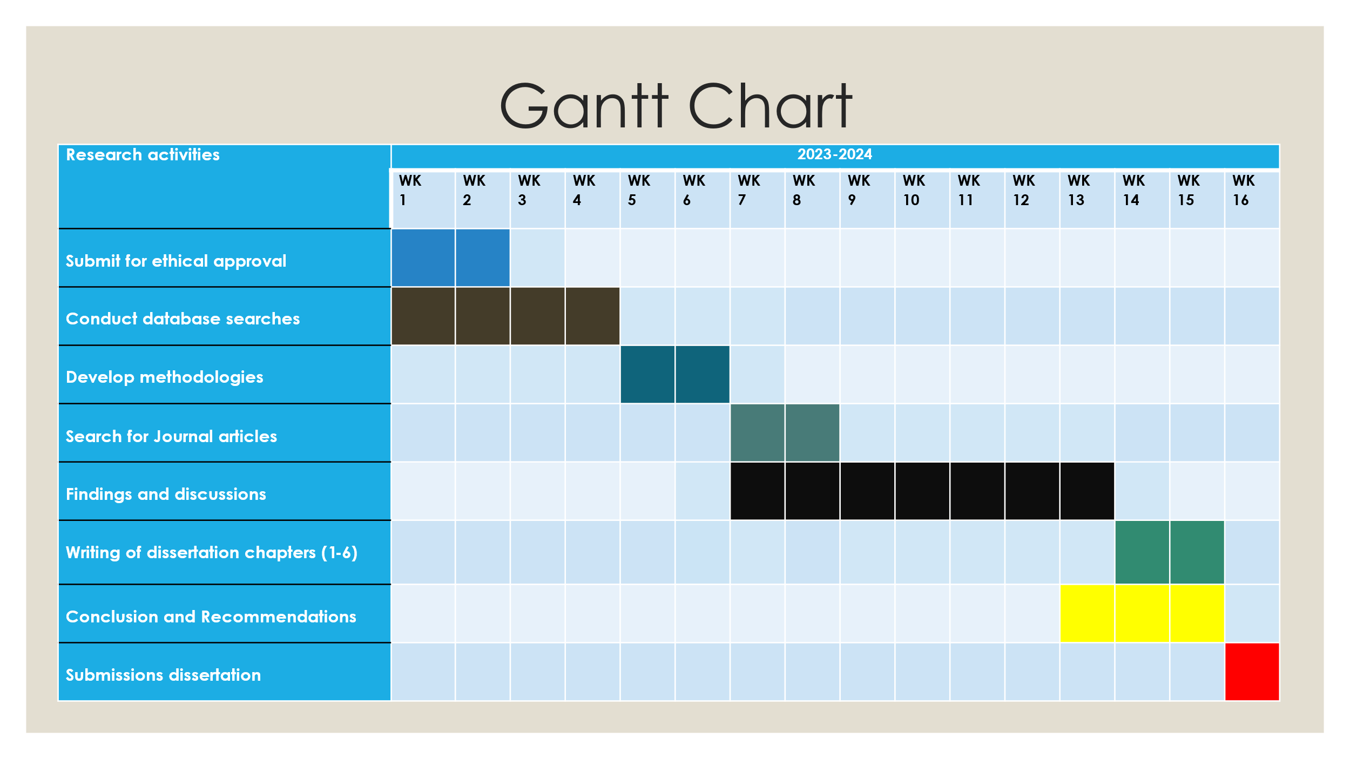

Ethical considerations
I will submit my research proposal and the UWTSD ethics form to my supervisor to receive ethical approval.  I will develop a research information letter and consent form to be handed to each participant.  Voluntary informed Consent will be asked of each participant:  I will ensure participants will not be subjected to coercion, intimidation, and undue influence to participate in this research.  I will ensure participants will be informed they have the right to withdraw and their data from this research.  I will ensure to store the obtained signed consent forms securely and anonymously.  I will ensure the collected data will be protected and stored securely and deleted after ending this study program.  I confirm that I have discussed and agreed every section of this form with my supervisor and will only conduct my research in line with what has been agreed in this document  Signature………J.Begum…………………………. Date:…………12/02/2024………………………..  Supervisor:  Signature…………………………………. Date:………………………………….. | Yes  No  No  No  No  No  No  No

Reference List add here below
Al-Khawaldeh, O. A., Al-Hassan, M. A., Froelicher, E. S., (2012). Self-efficacy, self-management, and glycemic control in adults with type 2 diabetes mellitus. Journal of Diabetes and its Complications. Volume 26, Issue 1, Pages 10-16
Carpenter, R., DiChiacchio, T., Barker, K., (2019). Interventions for self-management of type 2 diabetes: An integrative review. International Journal of Nursing Sciences. Volume 6, Issue 1, Pages 70-91
Chrvala, C. A., Sherr, D., Lipman, R. D., (2016). Diabetes self-management education for adults with type 2 diabetes mellitus: A systematic review of the effect on glycemic control. Patient Education and Counseling. Volume 99, Issue 6, Pages 926-943
Diabetes.org.uk (2023) Ethnicity and Type 2 Diabetes. [Online] Available at: https://www.diabetes.org.uk/diabetes-the-basics/types-of-diabetes/type-2/diabetes-ethnicity (Accessed on 3rd November 2023).
He, X., Li, J., Wang, B., Yao, Q., Li, L., Song, R., Shi, X., Zhang, J-A., (2017). Diabetes self-management education reduces risk of all-cause mortality in type 2 diabetes patients: a systematic review and meta-analysis. Endocrine. 55, pages712–731
Steinsbekk, A., Rygg, L., Lisulo, M., Rise, M. B., Fretheim, A., (2012). Group based diabetes self-management education compared to routine treatment for people with type 2 diabetes mellitus. A systematic review with meta-analysis. BMC Health Services Research Article. 12, Article number: 213.

