Strategic Events Management
Event Feasibility Study
Reagan Cartwright
P150503
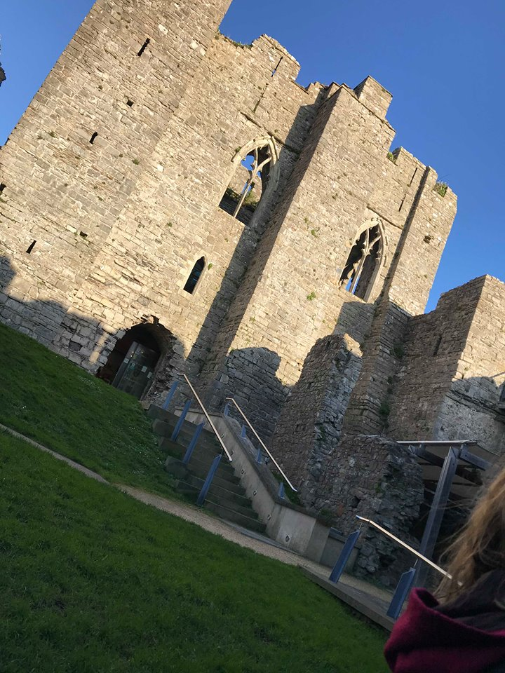

Contents
Executive Summary 2
Rationale 3
Findings 3
Expenditure 6
Market Analysis 6
Stakeholder Analysis 6
Swot Analysis 7
PEST Analysis 7
Conclusion 10
Recommendations 11
Appendices 13
Financial Summary of The White Lady festival in 2018. 13
The White Lady Festival Expenditure 14
Turnout in 2018 of The White Lady Festival 15
Stakeholder Analysis 15
Swot Analysis 15
PEST Analysis 16
Bibliography 19

Executive Summary
Within this report there will be an evaluation of the feasibility of The White Lady Festival which is situated Oystermouth Castle within Swansea area. There will be a brief introduction about the event and It will include the strategic impact analysis for social/cultural, economic/developmental political and environmental management and leverage in the festival. There will be positive and negative impacts of the festival and concluding recommendations for the festival in the future to make it more successful and feasible. I will be looking online to see how successful The White Lady festival has been over the years and using journals and books which includes theorists to compare what they have stated for events/festivals.

Rationale
Festivals are astonishing hobbies/activities that people all go to meet up with friends and family or to see a band they adore or just to escape their everyday life, and to be shown to new cultural forms or just to be basically entertained. Like all people’s activities any festival would require resources such as water, land, energy, equipment, food and products of many types. Many festivals or even a local can involve hundreds of thousands of attendees these requirements bring with them the possibility for bad environmental impacts.

Findings
Bowdin. G et al states “before committing to an event, its organisers need to determine how feasible or otherwise it would be to conduct that event” as The White Lady festival was not feasible last year they need to do a lot more planning to make it a success. Chris Williams (2018) cited “The aim of White Lady is to put on something for the locals and to encourage visitors to come down for the weekend to enjoy a festival atmosphere in the beautiful grounds of the castle. Hopefully this festival will grow and grow so we can extend it, book bigger acts and make it a real pull so that people will come down and stay for the full weekend and boost tourism with local businesses.” Which shows they want this festival to be like one of those popular local festivals within Wales for example, ‘Glastonselfy’. They want it to grow and be the best it can be and to be very successful. Within the events industry festivals play a large role and it is important that staging events and festivals that are more sustainable and environmentally responsible has led to quite a few developments in recent years. Events take a substantial toll on any resources, society and the environment. The White Lady festival all began by the history of a ghost at Oystermouth Castle which was call The White Lady, she is known for crying and people say she was a prisoner at Oystermouth Castle that was whipped to death as there is whipping post within the castle. That’s how the festival got the name, they host The White Lady festival around summer time every year and it is a weekend event and it is to raise the money to keep the castle well-preserved and if the castle needs any work done as it is a piece of history. Mark Ramsey states “The main aim of the White Lady Festival was to give back to the community by entertaining locals and to encourage visitors and tourists to come down for the weekend. The genres of music featured a variety of classical ,rock, blues, pop and Flamenco jazz with the aim of catering for all” they want the castle and their town to have more recogniton as it will attract more people and tourists to come and see what they have got on offer for example a piece of history which is the castle.
Getz. D et al states “research in wales on local authority involvement with events demonstrated that goals for local or community events were primarily related to community well-being, economic development, image enhancement, extension of tourism season, local culture” it shows that small scale festivals have a major impact on the local community as it brings in tourism and increases profits throughout the community and gives the community a good image, The White Lady festival wants to get the word out about the festival and trying to get more people to go as the profit of the festival would help out with the community and Oystermouth Castle. There is not much events/festivals surrounding Swansea area. The only ones are The Gower Walking Festival which happens in June and is ran by volunteers and sponsors. Wassail Cider, Food & Music Festival which happened January this year which was the celebration of the ancient Welsh tradition etc. there is not really much going on, showing that is a key benefit for The White Lady festival as the festival is something different around their community and people can experience a festival and the local hertiage of the castle as well. The aim of White Lady is to put on something for the locals and also to encourage visitors to come down for the weekend to enjoy a festival atmosphere in the grounds of the castle. Rob Marshall states “hopefully this festival will grow and grow so we can extend it, book bigger acts and make it a real pull so that people will come down and stay for the full weekend and boost tourism with local businesses.” Showing he wants The White Lady festival to be succesful as possible and to bring in a lot of profit to help out with the castle and recognition within their community and businesses, Glastonselfy festival is a good example of a local festival as the festival brings everyone together even and gives recognition to their local community businesses and the festival attracts more than 1000 attendees every year showing they are never low on numbers.
Christine states “Festivals bring communities together to celebrate a common theme.” Small festivals focus on a certain theme whether its cultural or charity awareness or a festival that people like for example, food or drink festivals.
In figure 3. The White Lady Festival was not a complete success in 2018 as it was such a bad turn out. There was a lot of rain and 50mph winds which had some of the people who bought tickets not show up due to the weather and most of the food and beverage businesses did not turn up as the weather would have damaged their tents and other items. The festival was a complete disaster and the festival was entirely run by members of the community council and volunteers from other organisations who generously helped but it still was not enough to make The White Lady festival a success. Mrs Townsend Jones said: “Everybody who came said it was fantastic” showing that the festival can be good fun, but she conceded that “some things could have been done better, and that more planning would take place for next summer’s White Lady Festival.” Implying that things could have gone a lot better, but they did not which shows they need to plan and do a lot of planning ready for next year to make The White Lady festival a success. Many people that go to festivals are the younger generation and they want to go to a festival that suits their music interests and it seems like The White Lady festival links in with the older generation as they have more rock and roll and orchestra music. They would need to get the younger generation involved by getting music acts that sits well with them as it would get more consumers involved with the event which will increase their profit and give The White Lady festival more recognition as they spent an increasing amount in 2018, they need to plan a lot more in advance to make sure they do not do it again and possible moving it closer to the time if there is a bad chance of rain, or hiring a large marque to put all the attendees in and the bands which would be beneficial as it will get more people going as it will get them out of the rain as many people to go large scale festivals as there is a lot of shelter there just in case they have bad weather so The White Lady festival should set up a large marque and a few small ones for people to eat and have a drink.
They do have an event around halloween time in Oystermouth castle called Haunted Castle of Horrors at night time as it’s much more scarier at night to give people that chill feeling once there and tickets are £6 which includes a hot chocolate, they have three sessions and roughly lasts half an hour each session. Maybe in the future they could offer more events to do with the castle and the history about it as it would get more people involved as there is a lot of interest in spirits and scary places to see which can increase tourism within the local community.

Expenditure
Within figure 1 and 2 it shows Mumbles community council was aiming the expenditure target would be just short of £18,000 but to rocketed to just over £26,000 which is a lot of money for a festival that had a poor turn out all weekend due to the weather and strong winds. They did save some money on the festival services for example insurance policies which was £1,000 to spend but only spend £84 which saved them £916. Another sector where they saved money was on the music acts they booked, and they save £496 out of the £9,400 they aimed to spend. Within some areas they have aimed to pay, they have saved a bit of money showing that they can save a bit more money when they plan the next festival in 2019 as they need all the money they can get to put in to their local community and the castle as it costs a lot to preserve the history of the castle.

Market Analysis

Stakeholder Analysis
Figure 4 of the appendices you can see the stakeholder table from internal, external and connected stakeholders within The White Lady festival. A stakeholder is anyone with an interest in a business such as a festival. Stakeholders are individuals, groups or organisations that are affected by the activity of the business. Which are…
- The Event Organiser – Mark Ramsey
- Employees – Volunteers, staff supplied by the owners of the event
- Suppliers – Food & Drink and Merchandise
- Customers – Fans
- Sponsors – The Community Council
- Community – Local Community
- Entertainment– Performers and Bands
An event stakeholder can be well-defined as “Persons or groups who can influence the organisation or are influenced by it” Getz. D et al showing stakeholders are very important within the event industry as if there were no stakeholders there would not be an event.

Swot Analysis
In figure 5. Within the table it shows what The White lady festival strengths, weaknesses, opportunities and threats are. There is a lot more opportunities for them than there is for strengths and the main opportunity for the council is to plan to get more people going and to connect with a new and wider audience as it will attract more attendees, it is very beneficial as it will even attract more people for example attendees bringing family and friends, giving local businesses more recognition and even giving the festival a good image which will make people go back again the year after. Another opportunity would be to do a competition on social media months before the festival date as it will get more people interested and people love freebies which will get a lot of people involved. There are a few weaknesses within the table that could give The White Lady festival a bad image for example, not having enough attendees as within 2018 hardly anyone turned up for the weekend festival due to the bad weather which cost them a lot of money after it was finished. The festival had bad luck in 2018 as the festival was held in July and it hardly rains around that time due to it being summer time so it was not like they were taking a risk of having the festival on that weekend.

PEST Analysis
Allen. J et al states that “Events have a range of positive and negative impacts on their host communities and stake holders. It is the task of the event manager to identify and predict these impacts then manage to achieve the best outcomes for all parties so that the overall impact of the event is positive” showing when planning an event or festival they always come across negative impacts on the day or before it so they always need to plan to prevent any negative impacts on happening.
Political
- Richard Youle (online,2018) states “Some people have criticised the event, which was run by a paid graduate trainee, with one Newton resident describing it as the White Elephant Festival.” Implying when the event happened people thought it was running by a trainee graduate as not many turned up to the festival and they lost a lot of money as it was bad weather and not planned out properly.
- Mrs Townsend Jones (Online,2018) states “the festival was expected to bring in around £9,000 in revenue, but that the final figure would be lower.” Shows the festival had an aim to raise £9,000 but lost a lot of money due to less people not turning up and suppliers due to weather.
Economic/Environmental
John. S et al states “economic factors can range from big to small, from local to national to international, from current to future. From rising costs of raw materials to market entry of new rival” which states The White Lady festival must frequently take matters into account when planning and economics can be divided into two categories for the economic environment which is the microeconomic environment and the macroeconomic environment.
- Richard Youle (online,2018) states “The community council precept in Mumbles rose sharply this year because councillors raised the budget from £248,136 to £573,613 to finance more projects that would benefit the seaside community.” showing they are trying to raise more money to put more projects in mumbles as there is not many going on there and they want more people traveling over to see their local culture and heritage. It would boost their economy and give them a lot of recognition.
- Mark Ramsey states that he “suggest for the next event that the council provide the correct labelling and that we are able to couple the general waste with a recycling bin, as all the recycling waste was mixed with general waste and this had to be sorted at the end of the festival duration” showing on the next festival they have this year the council should provide the correct labels as rubbish onsite would have been recycled more efficiently.
- When the festival is on the grass it’s getting damaged over the weekend and since it is only once a year it does give the ground to grow back, but if they decide to have more events over the year they will need to make sure they ground is having time to grow back.
- Mark Ramsey states “During this year’s event we ran out of power from the source nearest to the toilets, therefore if we had anymore vendors that side we would be unable to cater for them and they would have to source power from the supply closest to the castle; therefore, a generator may be required for future events as there is only a limited supply from both sources” shows that they could not have any more vendors close to the toilets as they cause problems with the power so they would need to source their own or the council would need to supply a generator for future events.
Social/cultural
- The locals could be complaining about the noise and there are a few that live quite close to the castle, so they should stop music around midnight on Friday and Saturday and around 8pm Sunday when the festival finishes as people would probably be leaving before as many people work week days.
- There is not any parking close to the castle and it can be stressful but there are a few close to the promenade which is only a 10 minute walk there and back, there are busses every 15 minutes if you was traveling further away and it can be a bit better as it is less pollution and it is only a 5 minute walk off the bus.
- Since the castle is further up town and no car parking spaces, it can be beneficial as there does not need to be any road closures and people would have to travel by foot.
- the community council are trying to bring the local community together by getting all the local businesses involved and sell their products or food and beverage in the festival as it gives the businesses recognition as they can sell inside the festival with a free pitch or if they live outside Swansea it would be £50 pitch fee and then £25 admin fee.
Technological
- Mark Ramsey states “For next year’s festival MCC will need
- to hire a greater amount of lighting, one suggestion could be to utilise festoon lighting across the whole site, with a greater emphasis of lighting around the licensed bar changing rooms, toilets and entrances.” As from last year they ran out of power and was not much lighting, so they would need to buy a generator as there is only a limited supply from each source.
- They have been advertising a lot of over social media and on the radio. Mark Ramsey states “it should be mandatory for all stallholders, vendors and musical acts to promote the scheduled activities on social media and offline methods to further increase our reach and awareness of the festival” shows that when the council and the event organiser books in the bands and stalls they should all have a social media business page so they should promote the festival on their page to get people interested.

Conclusion
To conclude there is a lot of issues within The White Lady festival, they must plan a lot more get more people involved with the event to make it a success. There are many other local festivals that have been successful including in bad weather, the council needs to think about the main ideas for example, if there is bad weather how can they resolve it and what can they do to get more people to buy tickets and turn up. Planning a festival costs a lot of money and they need to make sure they have the right people for the position. It is an awkward place to have a festival as there is no car parking outside the castle it is not quite feasible to host a festival within the castle as it is very dangerous on the inside and the steps are quite steep and could be a serious hazard if there were children unattended or if someone was drunk. There is not any wheel chair access to go into the castle and they should really install a ramp as it would get more people to go in. Overall if they done a bit more planning and thinking about what people want and possible doing a survey around schools/colleges to see what they want they’ll get more people involved. It did cost them thousands of pounds last year for an unsuccessful festival, and they want to make sure they do not have a repeat of it this year. The council and the event organiser need to stick with a budget and make sure they do not go over this year’s festival as it could cause money problems within the community and give the community a bad image.

Recommendations
Within figure 6. in the appendices you can see they layouts of the castle and the open area outside the castle where The White Lady festival is held. To recommend for The White Lady festival they should increase in their community engagement for the next time, possibly by going into schools as guest speakers or by holding competitions for kids like a poster competition, on via on social media or around the local community for example a raffle. Also, if they buy an early bird ticket the ticket price be cheaper or if you buy a normal price ticket it will include one free soft drink. Maybe if purchasing a family ticket, they get discounted food and beverage on a one-time purchase, or additionally have more recurrent newsletters going out to within the community as it will get the festival heard about and it will get more people interested. When planning the festival, it should be held early July as it normally gets hotter now around June time and since no one can predict the weather they should still hire a large marque and a few small ones that would hold the food and beverage stands in as there is more of a chance people would still attend if everything is under a marque or a massive tent.
The festival it should run from Friday to Sunday but have an adult’s night on Friday and possibly an 80’s fancy dress themed night and listening to rock and roll genres, then Saturday and Sunday have a family’s day out with everything catered for everyone from beer garden to rides and as you can see within figure 7. There is also access into the castle on that weekend as well and people can go in and explore the history of it and listen to stories about it within the tent. If they wanted to raise more money then they should have a camping weekend as there is a lot of greenery next to the castle and it is a very big open space, also do deals for camping tickets for example, buy a weekend camping ticket for £50 it will include weekend ticket =as people that buy that ticket can go in and out of the festival with a wrist band and can go into town which will increase profit for local businesses as they are spending more money into the town. They should get more involved with 17 to 25-year olds involved by hiring bands that age group listens to or possible hiring a DJ that plays at nightclubs around Swansea area as that could be beneficial as it’ll get more attendees and increase profit. Very tricky to park cars when traveling to Oystermouth castle but there are some car parks by the sea front which is only a 10-minute walk from the castle. It costs around £6 a day, if you’re coming from Swansea town a bus is only £4.50 and a 6-minute walk roughly to the castle and it will be less pollution getting a bus. Alexandra states, “Many communities stage traditional festivals and events that have always played an important role in building and maintaining community relationships and community social capital” and The White Lady festival links very well as they are getting people together for a festival around local heritage and culture and the history of the castle.
As there is many steep steps within the castle, on the day of the event maybe close off certain parts of the castle and keep the main part where you walk in as there is plenty of room to hold seats and a band or possible a gin bar as that is a favourite for everyone and it’ll get more people to pay to go into the castle, have people dress up in historic clothes serving food and beverage in the castle to give it that historic theme. Or putting children’s activities in the castle main area and whilst people are inside they can go to the gift shop. There could be people to perform inside the castle and play out a historic battle every 3 hours on the weekend as it’ll get attendees want to go into the castle. As there isn’t any wheelchair access, they could install a ramp to go into the castle. As the council needs money to raise for Oystermouth castle they should do charity buckets throughout the festival so people can donate money on their arrival and when they leave as every little help towards preserving the castle. If they need to raise a lot of money and if the festival becomes more feasible this year, then they should plan to do more within one year as it gets more people in the city and boosts their economy which is very beneficial to local businesses and the city council. Mark Ramsey believes for next year that there should be a lot more going on and more music so that there are not any awkward silences, he states “Suggestions have included a battle of the bands competition with judges and prizes, more local bands performing and DJ’s in the intervals to avoid silence on site”. They could bring in student performers and bands or even media students to help with the festival as it does cost much less or even have them to volunteer to perform and help as it boosts their CV on experience and it also gives them more money to work with in making the festival a success. Overall the festival can be feasible but just needs more planning and researching ideas or going to schools and colleges and see what their opinions are and what they think would work in the festival and they do need a younger audience.

Appendices

Financial Summary of The White Lady festival in 2018.
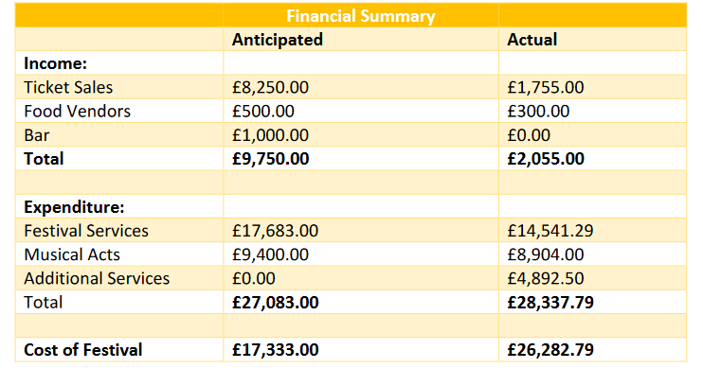
Figure 1. Mark Ramsey created this table, and this shows how much the festival was supposed to cost them but also shows what it cost in the end. Over all the festival cost a lot more than they anticipated.

The White Lady Festival Expenditure
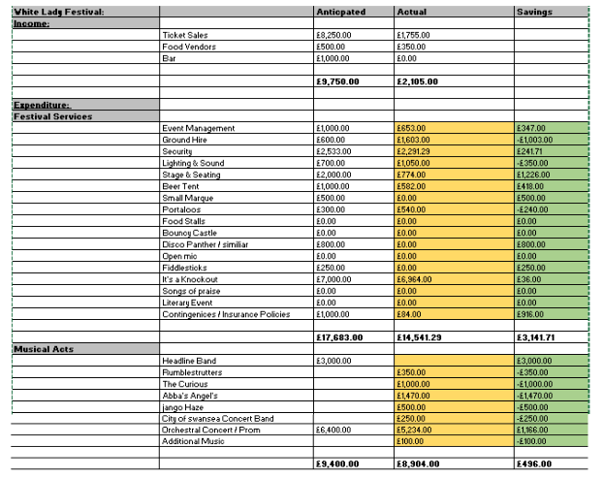
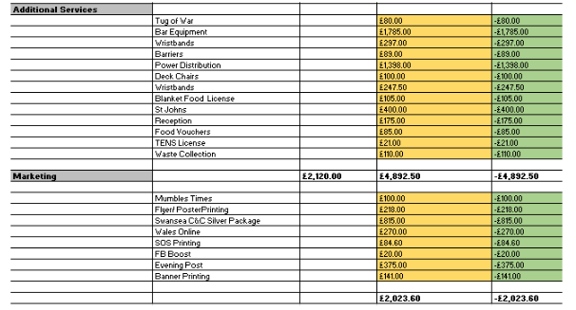
Figure 2. this is the table of all their expenditure and how much things were and how much money they saved on a few sectors.

Turnout in 2018 of The White Lady Festival
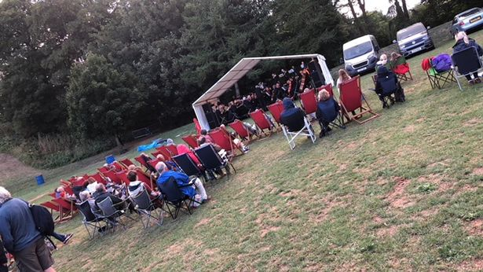
Figure 3. This is what the turn out of the festival looked like in 2018.

Stakeholder Analysis
Internal Stakeholders  - Mark Ramsey – Event Organiser  - Community Council  - City Council  - Erica which is the council officer | External Stakeholder  - Attendees  - Volunteers  - Staff  - Local Community
Connected Stakeholders
- Suppliers
- Security
- Sponsors
- Entertainment
Figure 4. Stakeholder Analysis shows who are the internal, external and connected stakeholders are within The White Lady festival.

Swot Analysis
Strengths  - Loads of room to have a festival  - Getting the local community involved  - Bringing the community together  - Increased participation | Weaknesses  - Not enough attendees  - Did not plan enough as they went over budget  - Not enough of the younger generation going
Opportunities  - Connect with a new and wider audience as it will attract more attendees.  - New themes to be distinguished  - Getting the festival to be a high-profile event which could raise a good deal of interest from press, radio and TV which can get the festival more noticed within Wales.  - Raise awareness of local produce and encourage community to buy locally as it will help a lot.  - Get the word out about the festival and to raise money to help with reserving the history of the castle. For example, maybe doing a competition on social media as it will get a lot more people involved as everyone like freebies. | Threats  - A festival being on the same day  - Poor weather.  - Lack of planning which can make the festival unsuccessful.  - It can also be costly due to the fact if they did not plan it properly.  - Does not have a wider audience like with other festivals out there.
Figure 5. SWOT analysis table showing the strengths, weaknesses, opportunities and threats within The White Lady festival as you can see there is a lot of opportunities for The White Lady festival and showing what could help in the future to make it more successful.

PEST Analysis
Political  - Attendees that went to the festival thought it was planned out by a graduate trainee as the festival was unsuccessful in 2018.  - The festival was supposed to bring in £9,000 in revenue but the figure was a lot lower. | Economic/Environmental  - Raised the budget to just over £500,000 to do more projects in mumbles as it gets more people to travel there which increases recognition.  - Brining more of the locals to get involved with the festival, local beer or local snacks  - Damage to the grass  - A lot of pollution if people are traveling by car.  - Litter
Social/Cultural  - Noise complaints from the locals  - No parking  - Traffic  - Road closures  - Brining the community together  - Good imagine on Swansea  - Increase in tourism  - Less pollution | Technological  - Lighting  - Wires  - Bands  - Sound  - Staging  - Power  - Social media
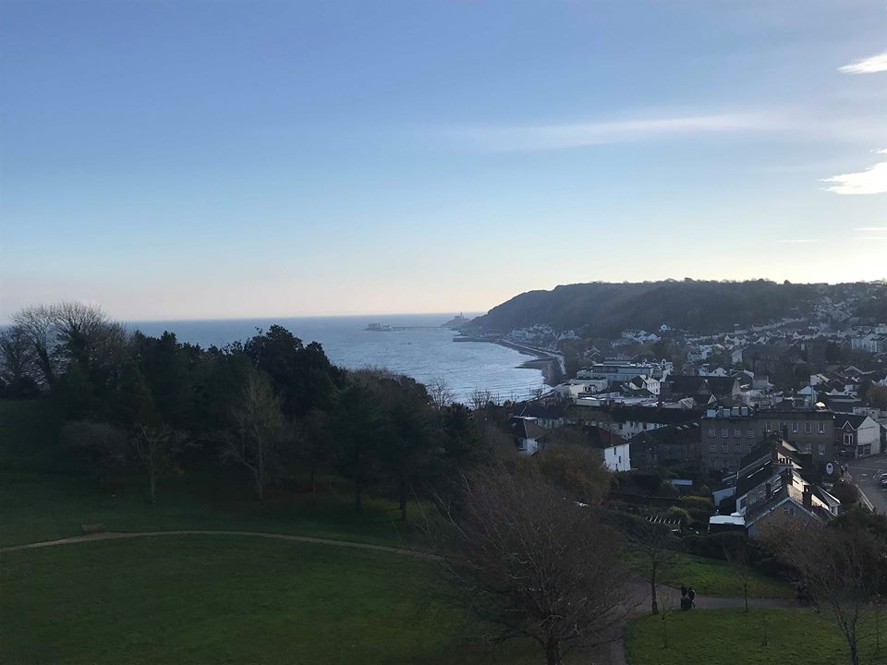
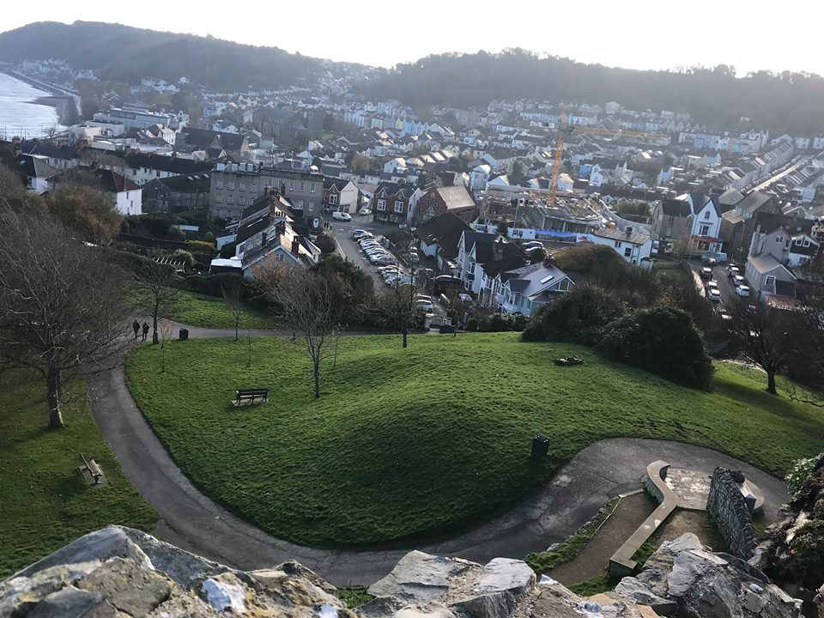
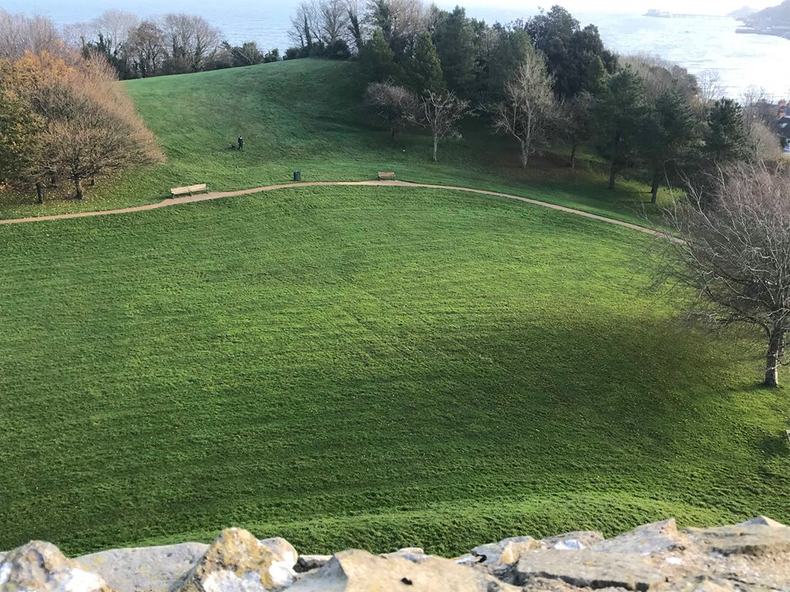

Figure 6. Within these pictures you can see how very spacious and open the area is outside the castle which is very beneficial as you can hire a lot of things to go onto it and a large tent or marque would fit perfectly. As when you go into the castle whilst being at the festival you can take in that beautiful scenery which shows what mumbles has to offer which is beautiful beach and scenery.

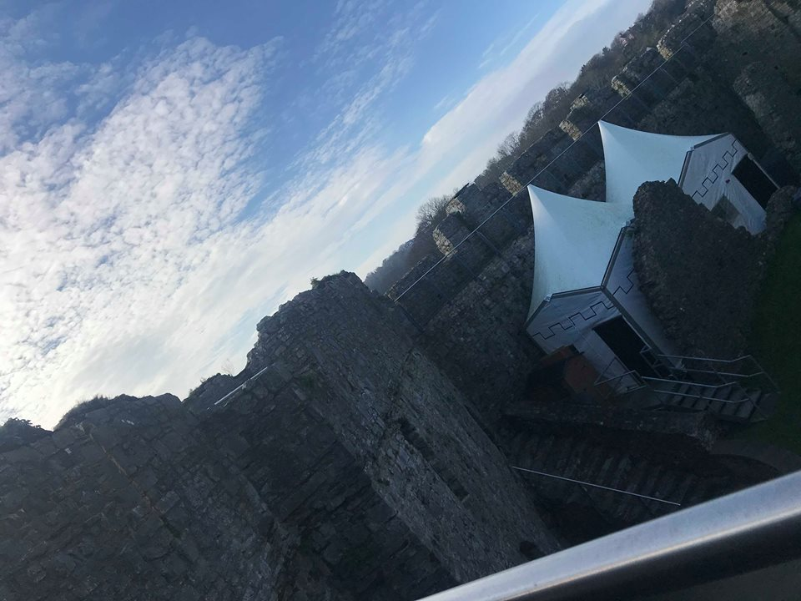
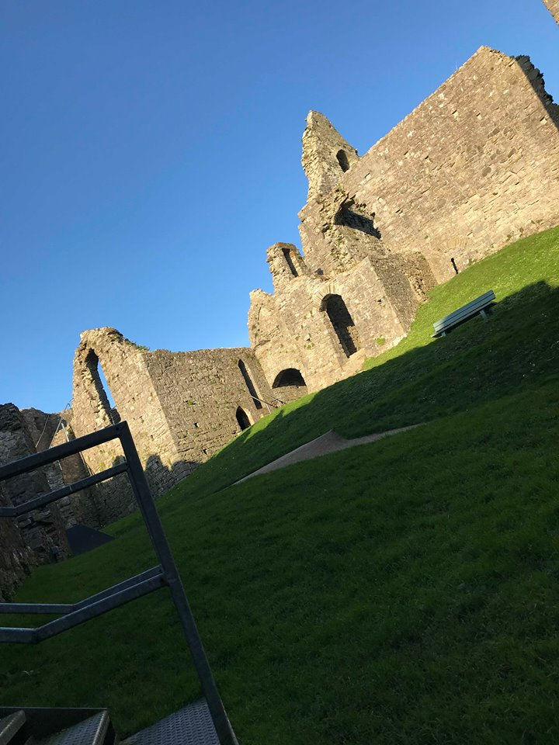
Figure 7. In the castle there is a tent, within in the tent, you can hold roughly 30 people seated in there and they tell stories about the history of the castle. In the other picture you can see the castles gift shop and a lot of greenery which shows how much space there is to hold activities in the main part of the castle.

Bibliography
Alexandra Coghlan. (2018). BE MORE, KNOW MORE: AN EVALUATION OF STUDENTS’ LEARNING IN A COMMUNITY EVENTS COURSE. Events Management. 22 (1), 583-594.
Chris Williams. (2018). The White Lady Festival. Available: http://www.enjoyswanseabay.com/the-white-lady-festival/. Last accessed 17/12/18.
Christine. M and Van Winkle. (2014). Sense of community and perceptions of festivals social impacts. International Journal of event and festival management. 5 (1), 22-28.
Donald Getz (2012). Event Studies. 2nd ed. Milton Park: Routledge. p138-139.
Glenn Bowdin (2006). Events Management. 2nd ed. Great Britain: John Wiley & Sons. 397.
John Sloman, Kevin Hinde and Dean Garratt (2010). Economics for Business. 5th ed. Edinburgh: Pearson Education. p5- 10
Johnny Allen, William O'Toole, Ian Mcdonnell, Robert Harris (2011). Festival and Special Event Management. 5th ed. Australia: John Wiley & Sons. p61- 656.
Mark Ramsey. (2018). The White Lady Festival Review. Available: https://www.mumbles.gov.uk/wp-content/uploads/2018/10/The-White-Lady-Festival-Review-2018-FINAL-Edited-SH.pdf. Last accessed 21/02/19.
Richard Youle. (2018). Mumbles council is accused of 'squandering' £26,000 taxpayer cash on 'washout' event. Available: https://www.walesonline.co.uk/news/wales-news/mumbles-council-accused-squandering-26000-15007524. Last accessed 17/01/19.

